[**VISVESVARAYA TECHNOLOGICAL UNIVERSITY**](http://www.vtu.ac.in/)

**BELAGAVI, KARNATAKA**

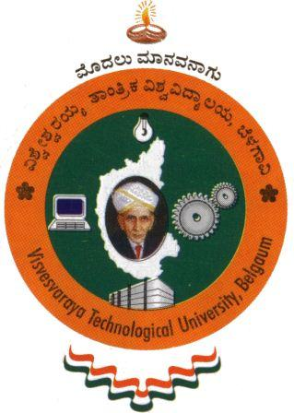

**A MINI PROJECT REPORT ON**

**“MECHANICAL GEAR”**

**A report submitted in partial fulfillment of the requirements for the**

**MINI PROJECT OF COMPUTER GRAPHCIS AND VISUALIZATION LAB (15CSL67)**

##### Submitted by

**PRASHANTH KUMAR RS**

**3BR15CS119**

**Under the guidance of**

**Prof. SUDHAKAR A**

**Department of CS&E, BITM, Ballari.**

**BASAVARAJESWARI GROUP OF INSTITUTIONS**

**BALLARI INSTITUTE OF TECHNOLOGY & MANAGEMENT**

** (Recognized by Govt. of Karnataka, approved by AICTE, New Delhi & Affiliated to**

**Visvesvaraya Technological University, Belgaum)**

**"JnanaGangotri" Campus, No.873/2, Bellary-Hospet Road, Allipur,**

**Bellary-583 104 (Karnataka) (India)**

**Ph: 08392 – 237100 / 237190, Fax: 08392 - 237197**

**DEPARTMENT OF COMPUTER SCIENCE & ENGINEERING**

**CERTIFICATE**

Certified that the mini project work entitled **“MECHANICAL GEAR”** carried out by **PRASHANTH KUMAR RS** bearing **3BR15CS119** a bonafide student of Ballari institute of technology and management, Ballari in fulfillment of the requirements for the mini project of **Computer Graphics And Visualization Lab (15CSL67)** of the Visvesvaraya Technological University, Belgaum during the year 2017-2018. It is certified that all corrections/suggestions indicated for internal assessment have been incorporated. The report has been approved as it satisfies the academic requirements in respect of mini project work prescribed for the VI semester.

Signature of the project guideSignature of the HOD

**Prof.SUDHAKAR A Dr.R.N.Kulakarni**

**External Viva:**

**Signature of the Examiners:**

**Internal: External:**

**1: 1:**

**2: 2:**