**CHAPTER 1**

**INTRODUCTION**

**1.1 Overview**

This report discusses the result of the work done in the development of "Road accident management system". The proposed project is designed using HTML, CSS and JavaScript as front end and PHP as back end programming language, along with Phpmyadmin database. This project is aimed at developing a web-based tool that facilitates users to view and access the accident vehicle records in electronic way.

**1.2 Background and motivation**

As cities across the world grow and the mobility of populations increases, there has also been a corresponding increase in the number of vehicles on roads. The result of this has been a proliferation of challenges for authorities with regard to road traffic management. A consequence of this has been congestion of traffic, more accidents, and pollution. Accidents are a still major cause of death, despite the development of sophisticated systems for traffic management and other technologies linked with vehicles. Hence, it is necessary that a common system for road accident management is developed. Road accident management is the centralized handling of a motorist’s claim following a road traffic collision or other damages or mishaps that happen to a vehicle while on or off road. Hence this project deals in storing the information about the vehicle details in digital way and can be accessed at any moment.

It has been proven that vehicle accidents are one of the main causes of fatalities with more than 100 deaths being reported in the India on a daily basis. The report indicates that the year 2007 experienced more than 43,000 deaths as a result of over 10 million reported accidents. Moreover, in most of the countries in the world, a major cause of accidents is poor infrastructure for managing traffic. The concept of traffic management systems refers to intelligent public transport mechanisms founded on information obtained in real-time.

**1.3 Problem Statement**

To design and develop a ROAD ACCIDENT RECORD SYSTEM that facilitates the transport authority officials to provide the stored details of the accident vehicle at any given date.

**1.4 Objective**

* To manage the accident vehicle record in electronic or digital way.
* □ provide a systematic way of giving the data in a relevant manner.
* To provide easy access to the stored data to the transport officials.

**1.5 Methodology**

To implement the objectives the following methodologies needs to be followed:

* Appropriate front end and back end tools and frameworks are to be selected and implemented accordingly.
* Appropriate middle-wares are to be selected according to the functionality and implemented.
* There should be solid authentication framework for the entire project.
* The availability of the hosting platforms is of prime importance.
* Data requirements in case of the participants have to be precise and adequate.
* Validation of the data received or entered should be the highest priority in order to collect genuine data.
* Real-time updation of the system should be aligned in the list of priority requirements.
* Easy user experience and availability should be provided.

**CHAPTER 2**

**TOOLS DESCRIPTION**

**2.1 User Interface**

* The tool is very user friendly and intuitive and uses a GUI interface implemented using HTML, CSS to communicate with the user. Various features are self – explanatory.
* Forms are easy to fill in and components can be added, removed and updated very easily through a single dialog box.
* List boxes are used to display all the components at once so that user can see all the components of a particular type at once. One can just select the component and modify and remove the component.

**2.2 Features**

1. Data is stored in electronic or digital way.
2. Separate login for admin and user/transport officials.
3. Enables simple and advanced search for searching the records.
4. Provides two types of accident category i.e. minor & major.

**2.3 Software and Hardware Requirements**

* Processor: Intel core I3 and above.
* 8GB Memory.
* Keyboard.
* Mouse.
* Back End: Phpmyadmin.
* Front End: HTML, CSS, JavaScript.
* Editor: Text Editor (preferably Atom).
* Browser (Google Chrome/Mozilla Firefox).

**2.4 Functional Requirements**

There are six modules in this project, they are

1. Home page
2. Admin login
3. User login
4. Display form
5. Add details form
6. Search
7. **Home page:** This module allows users to select the login type. Users have to click any one of the login type i.e. Admin or user.
8. **Admin login:** This module allows user to login as an admin. Once the user has logged in as an admin he/she can add the details of the accident vehicle in the website.
9. **User login:** This module allows user to login as a User. Once the user has logged in as an User he/she can view the data added by the admin anywhere and at any time in the website.
10. **Display form:** This module helps users to view the stored data digitally in the website. This module is used in both user & admin login type.
11. **Add details form:** This module is displayed only to the admin. Here the user is allowed to enter the name of the vehicle owner, type and date of accident , registered number of the accident vehicle, vehicle type, number of persons wounded & killed.
12. **Search:** This module allows user to search the stored data among various. There are two types of search provided in our project i.e. simple and advanced search. In simple search the user is allowed to enter the place of accident. Whereas in advanced search the user is allowed to enter the place of accident and the date of accident.

**2.5 Non-functional Requirements:**

* Performance: The system must be interactive and the delays involved must be minimum, so that in every action-response of the system, there are no unacceptable delays.
* Reliability: The system provides right tools for discussion, problem solving it must be made sure that the system is reliable in its operation.
* Security: The main security concern is for user/admin account hence proper login mechanism should be used for authentication.
* Usability: The system is easy to handle and navigates in the most expected way with no delays thereby providing usability.

**CHAPTER 3**

**ANALYSIS (MODULE DESCRPTION)**

**3.1 System design:**

Display records

Add records

Admin login page

Simple search

Advanced search

Logout

page

Home

page

Display records

Simple search

User login

page

Advanced search

Fig 3.1: Block diagram

There are six modules in this project, they are

1. Home page
2. Admin login
3. User login
4. Display form
5. Add details form
6. Search
7. **Home page:** This module allows users to select the login type. Users have to click any one of the login type i.e. Admin or user.
8. **Admin login:** This module allows user to login as an admin. Once the user has logged in as an admin he/she can add the details of the accident vehicle in the website.
9. **User login:** This module allows user to login as a User. Once the user has logged in as a User he/she can view the data added by the admin anywhere and at any time in the website.
10. **Display form:** This module helps users to view the stored data digitally in the website. This module is used in both user & admin login type.
11. **Add details form:** This module is displayed only to the admin. Here the user is allowed to enter the name of the vehicle owner, type and date of accident , registered number of the accident vehicle, vehicle type, number of persons wounded & killed.
12. **Search:** This module allows user to search the stored data among various. There are two types of search provided in our project i.e. simple and advanced search. In simple search the user is allowed to enter the place of accident. Whereas in advanced search the user is allowed to enter the place of accident and the date of accident.

**CHAPTER 4**

**SCREENSHOTS**

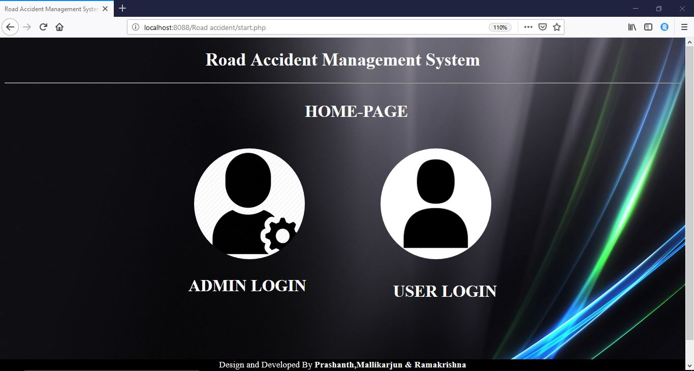

Fig 4.1: Home-page

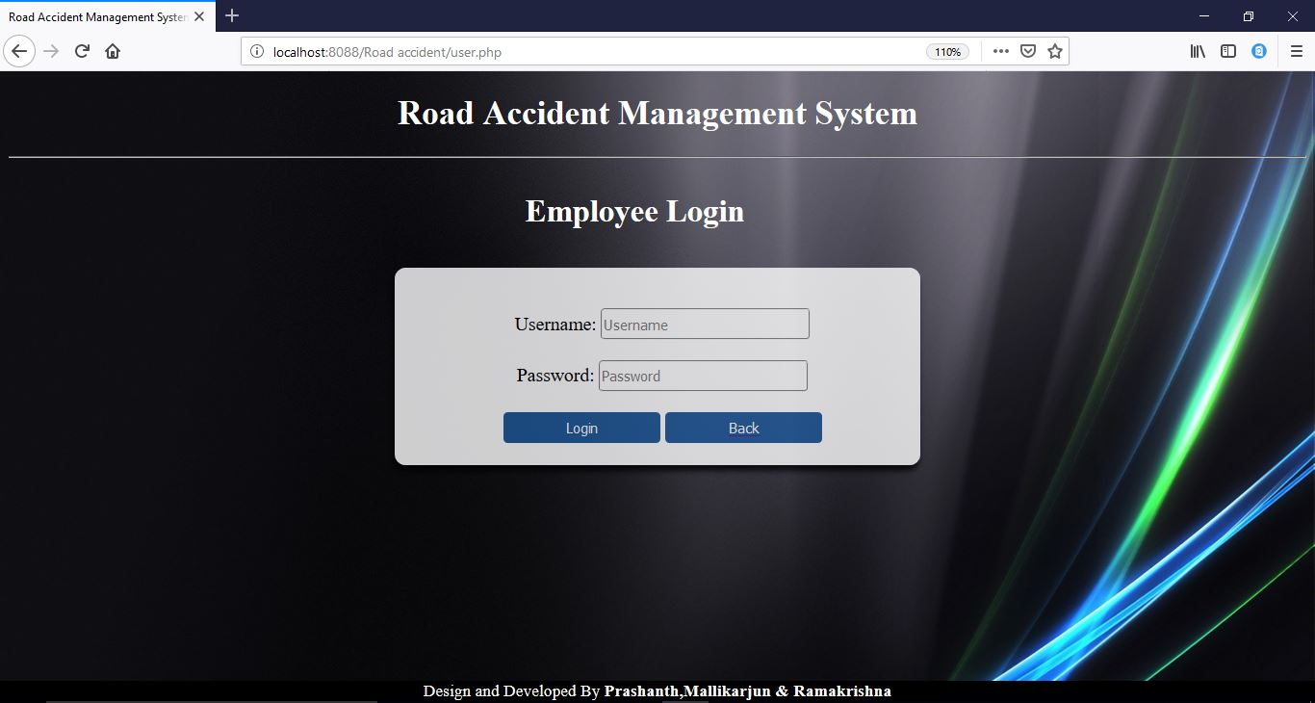

Fig 4.2: Employee login

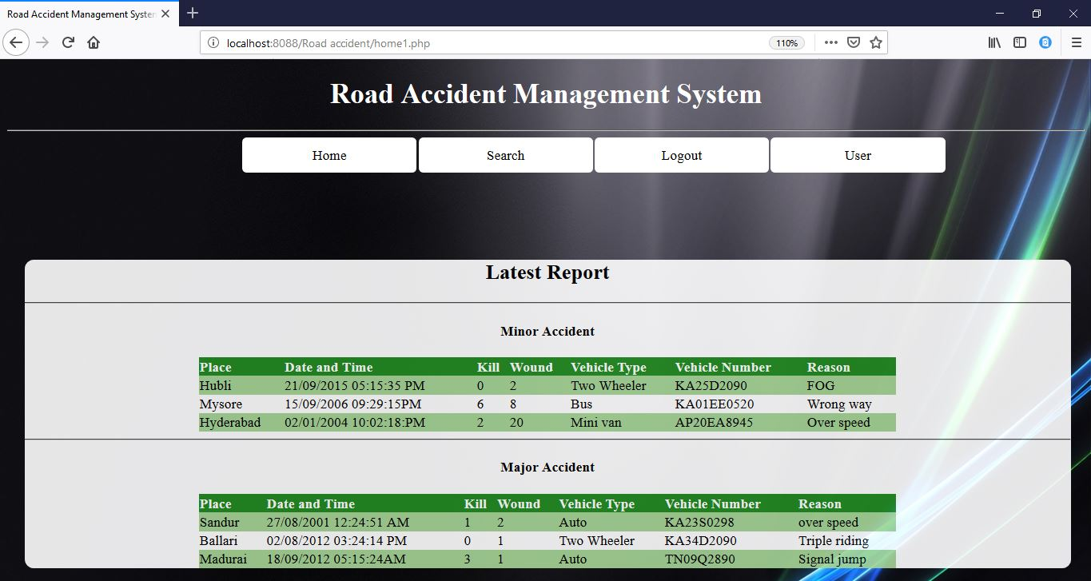

Fig 4.3: User records display

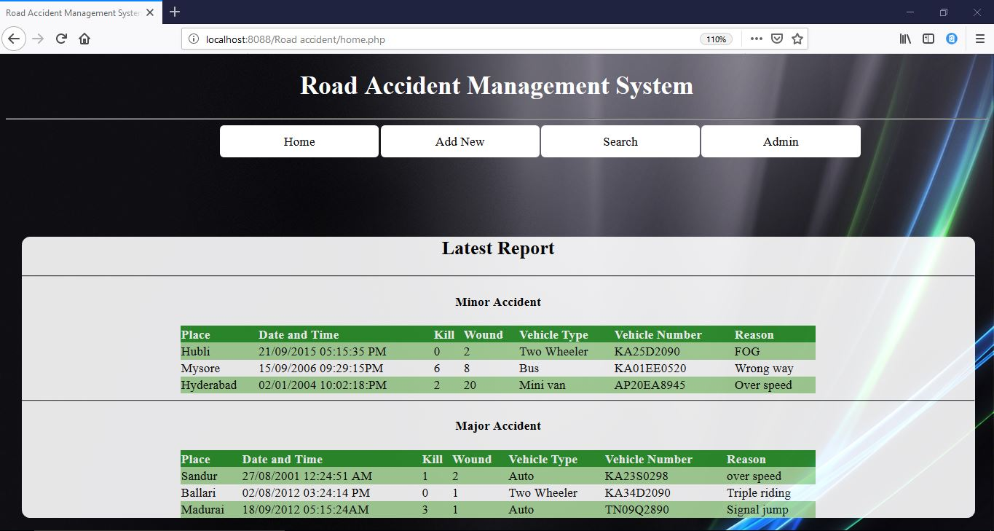

Fig 4.4: Admin records display

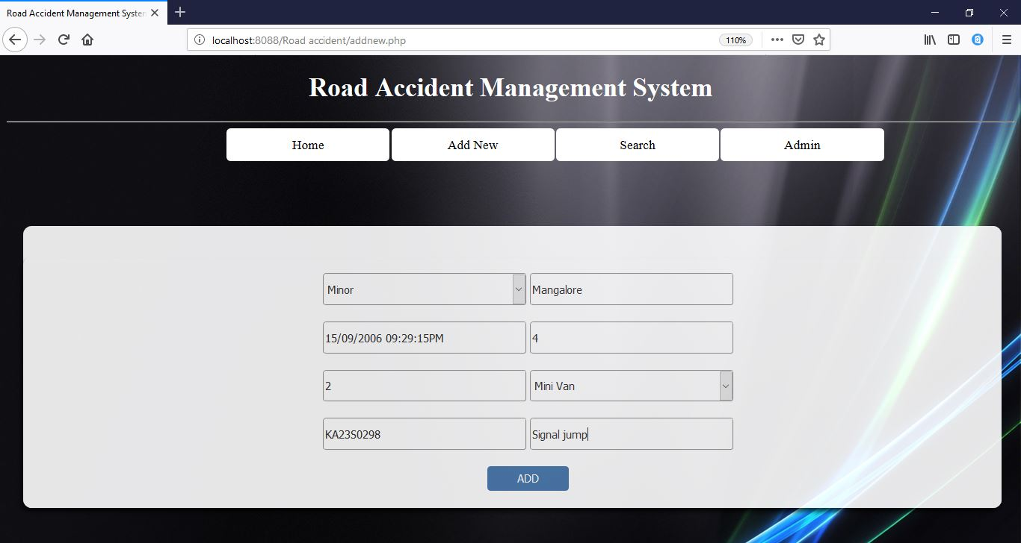

Fig 4.5: Adding a record in admin login

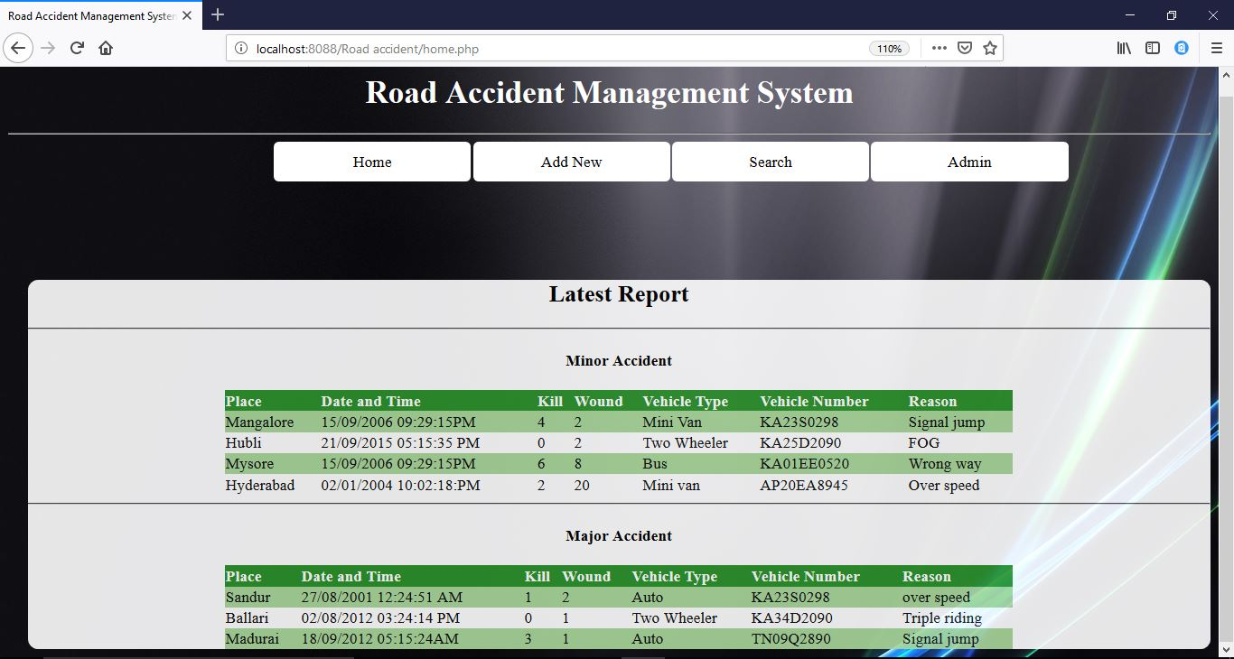

Fig 4.6: Records display after adding a record

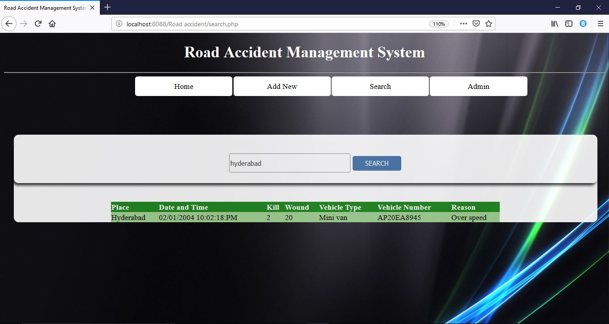

Fig 4.7: Simple search

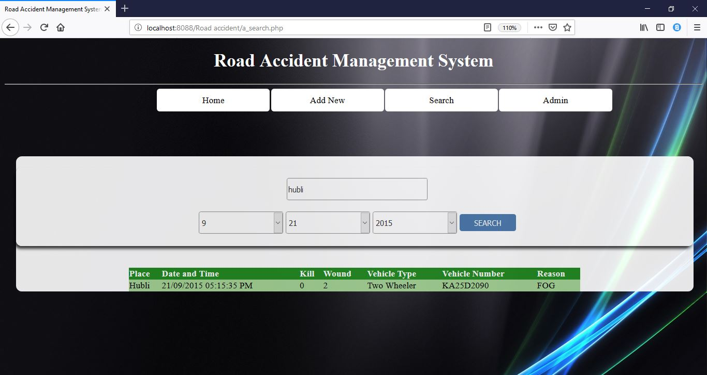

Fig 4.8: Advanced search

**CHAPTER 5**

**RESULTS AND DISCUSSIONS**

The project ‘Road accident management system’ is developed with an idea of storing the records in digital or electronic way rather than manually. It is a platform where the records are maintained in the web site and are available at any time. This project is developed for the transport officials in order to record and maintain all the details of the vehicle that has met with an accident. This project gives us a clear picture on how the data is stored and accessed digitally. The project has been effective in giving all the required information of the accident vehicle. Users are also provided with the facility to search a particular record among all the stored records. The friendly interface guides users across different pages and makes it easier to understand the flow.

**CHAPTER 6**

**CONCLUSION AND FUTURE WORK**

The main purpose of the project is to provide the logged in users to view the record that is stored digitally at any time. Every application has its own merits and demerits. The project has covered almost all the requirements. Further requirements and improvements can easily be done since the coding is mainly structured in nature. Changing the existing modules or adding new modules can append improvements. Further enhancements can be made to the application, so that the web site functions very attractive and useful manner than the present one.

**CHAPTER 7**

**REFERENCES**

1. ‘Fundamentals of web development’ by Randy Connolly and Ricardo Hoar, 1st edition, Pearson Education India.
2. <https://en.wikipedia.org/wiki/Accident_management>
3. ‘w3schools.com’ website.