🚀 RDA 2.0 — Executive Success Journey

From Complex Workflow

to Clickable Executive Experience
How one Business Analyst, with Copilot, turned a four-module enterprise process into 31 connected wireframes — and a productized delivery model.

🖥️  31  Connected wireframes | 🧩  4  Functional modules | 🌐  1  Index URL to share | ⚡  1  Working week to deliver

👤 Prepared by | Prashanth Patil — Senior Business Analyst
🏢 Team | [Your Team / Department]
📅 Date | May 2026
🎯 Audience | Vice President · Department Heads · Business Analytics Leadership
🔐 Classification | Internal · For Executive Review

Why this document exists
RDA 2.0 is more than a wireframe project. It is the first proof point that any department — using only the Copilot we already have — can convert a complex workflow into an executive-ready, browser-based demo in days. This document captures the journey, the method, and the case for scaling it across the enterprise.

📚 Contents

An executive-ready walkthrough of how a single business analyst, using only Microsoft Copilot, transformed the RDA 2.0 process into a clickable demo — and a productized model the rest of the enterprise can reuse.
From Complex Workflow 1
to Clickable Executive Experience 1
📚 Contents 2
⭐ Executive Snapshot 3
📊 By the numbers 3
🎯 What changes for the business 3
🧩 The Challenge 5
🚫 What we needed to avoid 5
🎯 The bar I set for myself 5
🌍 Why this matters beyond RDA 2.0 5
🛠️ The Method — Six Disciplined Phases 6
💡 The single biggest learning 6
🎬 The Five Hero Screens 7
🏠 Hero 1 — Risk Analyst Upload Dashboard 8
⚠️ Hero 2 — Validation Errors & Warnings 10
🎯 Hero 3 — Manual Adjustment · EC Dashboard 12
✅ Hero 4 — Approver Dashboard 14
📜 Hero 5 — Audit Trail Dashboard 16
🪄 The Prompt-Engineering Magic 18
⛰️ Struggles & How I Solved Them 19
📈 Business Impact 20
🌟 Why senior stakeholders responded to this approach 20
🚀 Strategic Ask — From Project to Product 21
🏗️ Three concrete proposals 21
🎯 What we want from the Vice President 21
📎 Appendix A — Full Screen Inventory 22
📎 Appendix B — Validation Rules Implemented 23

⭐ Executive Snapshot

If you read only one page of this document, read this one.

🏆 The headline
A non-developer business analyst — using only Microsoft Copilot — built a clickable, browser-based, four-module enterprise demo of the RDA 2.0 process. The Vice President receives a single link, opens it without installing anything, and walks through the entire future-state journey in under ten minutes.

📊 By the numbers
Metric | Result | Why it matters
🖥️ Wireframe screens delivered | 31 | Every business state is visible — nothing left to imagination
🧩 Modules covered | 4 | RA Upload · Manual Adjustment · Approver · Audit Trail
🔁 Business stages covered | 6 | Upload → Validate → Calculate → Adjust → Approve → Audit
🌐 Number of links to share | 1 | One URL. The entire experience. No setup.
⚡ Time to first demo-ready URL | ~1 working week | Spec to clickable demo, end to end
🤖 Tooling used | Microsoft Copilot | No design tool. No developer. No new licenses.
👤 Headcount required | 1 Business Analyst | The product is the method — not the team size

🎯 What changes for the business
- 📈 Stakeholder feedback moves from "imagine it" to "react to it" — same day, not next sprint.
- 🧭 Process clarity is no longer trapped in slide decks or use-case documents — it lives in a clickable demo.
- 🔄 The same method works for any workflow: claims, inventory, onboarding, audit, finance close, vendor approvals.
- 🏗️ The output is a repeatable internal capability — a Copilot Wireframe Factory, productized for any department.

✅ The strategic ask: formally adopt this method as an internal capability and run a second department through it as a proof of repeatability.

🧩 The Challenge

RDA 2.0 is a multi-actor process: Risk Analysts upload templates, validations run, calculations trigger, manual adjustments happen at three portfolio levels, results are submitted for approval, and every action is audited. Explaining that in a slide deck is exhausting. Explaining it in twenty pages of use-case prose is dry. Building a real prototype in a design tool requires designer time we did not have.

🚫 What we needed to avoid
- Stakeholders nodding politely through a workflow they could not actually picture.
- Twenty pages of process narrative that no Vice President will read end to end.
- Waiting weeks for a designer or developer before we could even start the conversation.
- The classic trap of "once we build it, we will show you" — feedback arriving too late to be cheap to act on.

🎯 The bar I set for myself
THE SUCCESS BAR
✉️ A leader receives one link.
🖱️ They click it without installing anything.
⏱️ Within five minutes, they see the full RDA 2.0 journey — upload, validate, calculate, adjust, approve, audit.
🔁 Every reaction can be turned into a prompt change, and a new version of the demo is ready the same day.

🌍 Why this matters beyond RDA 2.0
If a single analyst can do this for one workflow, the same method can be applied to inventory, claims, onboarding, audit, vendor approvals, regulatory submissions — every department that has actors, states, and decisions. The wireframes are the artefact. The real product is the method.

🛠️ The Method — Six Disciplined Phases

I did not start by asking Copilot to "build wireframes" — that approach produces decorative, generic screens. Instead, I worked through six phases. Each phase reduced ambiguity for the next. By the time Copilot was asked to generate HTML, every decision it needed to make had already been made by a human.

# | Phase | What it produces | Why it exists
1 | 🧠 Understand the business process | Actors, states, decisions | A wireframe must have a real reason to exist
2 | 📝 Build the use case blueprint | Modules, screens, pre/post conditions | The contract that protects the demo from drift
3 | 🎨 Study the existing experience | Colour, fonts, layout, icon patterns | Familiarity = credibility, demo feels like the next version
4 | ✏️ Sketch in Paint, then move on | Rough layout direction per screen | Paint is fast for thinking; insufficient for sharing
5 | 🤖 Generate HTML/CSS with Copilot | Browser-ready wireframes per state | Prompt precision is the accelerator, not Copilot alone
6 | 🌐 Connect through one index URL | One link, full clickable journey | Stakeholders explore in any order without help

💡 The single biggest learning
A vague prompt produces a vague screen. A precise prompt produces a near demo-ready experience. Prompt quality is directly proportional to output quality.

🎬 The Five Hero Screens

From the 31 connected wireframes, these five hero screens tell the entire RDA 2.0 business story end-to-end. For each screen, the exact Copilot prompt that produced it is included alongside the rendered output — so the document doubles as a worked example of the reusable playbook.

📌 How to read this section
Each hero screen is shown as a captioned image followed by the Copilot prompt that generated it. The prompts follow the Master Prompt 2 pattern from the Reuse Template — Theme Lock at the top, screen details in the middle, explicit constraints at the bottom. Anyone can lift these prompts and adapt them to their own workflow.

🏠 Hero 1 — Risk Analyst Upload Dashboard
The landing screen. Every Risk Analyst lands here to see the state of the three EC templates — LowerBound, UpperBound, and RefPortCode. The status vocabulary is controlled (Uploaded, Updated, Errors / Warnings) so the state of every template is readable at a glance. This is the screen the Vice President sees first when they open the demo — it must establish credibility immediately.
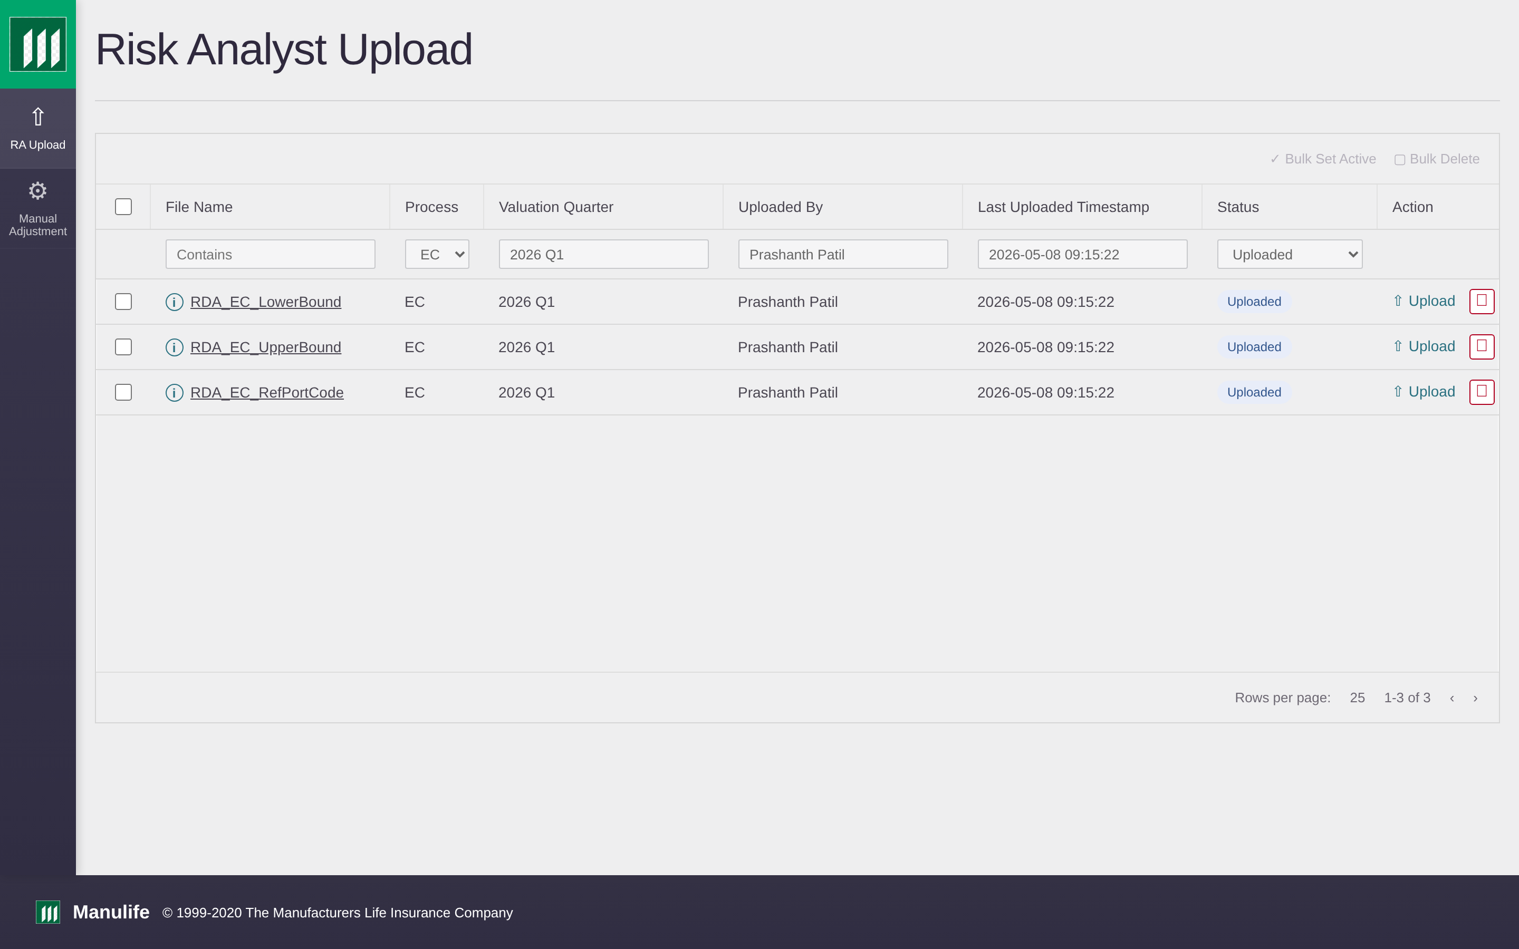
Figure 1 — Risk Analyst Upload Dashboard (rda_url_01).

The Copilot prompt that produced this screen:
▸ COPILOT PROMPT · rda_url_01_ra_upload_dashboard
Generate a single self-contained HTML file: rda_url_01_ra_upload_dashboard.html

=== THEME LOCK ===
Brand primary: #00A758 Accent: #0B6B3A
Background: light off-white (#F7FAFC), card surfaces white
Primary heading: #2C3E50 Body text: #33475B
Sidebar: 80px wide, primary background, white icons + labels
Logo: Manulife mark top-left, above sidebar nav, 32px tall
Font: Calibri, weights 400 / 600
Buttons: filled primary in brand green, outlined secondary, text tertiary
Tables: striped rows, 1px #D7DEE8 borders, header row in brand green with
white text, 12px padding
Status pills: rounded, coloured background, white text
Footer: small grey line with Manulife mark + copyright
=== END THEME LOCK ===

PRIMARY ACTOR: Risk Analyst
OBJECTIVE: View the state of the three EC templates and take action.
HEADER: "Risk Analyst Upload" (h1)

FILTER STRIP (above the table): File Name (Contains), Process,
Valuation Quarter, Uploaded By, Last Uploaded Timestamp, Status,
Bulk Set Active, Bulk Delete.

PRIMARY DISPLAY: a table with columns —
checkbox · File Name · Process · Valuation Quarter · Uploaded By ·
Last Uploaded Timestamp · Status · Action

SAMPLE DATA (exactly three rows):
RDA_EC_LowerBound · EC · 2026 Q1 · Prashanth Patil · 2026-05-08 09:15:22 · Uploaded
RDA_EC_UpperBound · EC · 2026 Q1 · Prashanth Patil · 2026-05-08 09:15:22 · Uploaded
RDA_EC_RefPortCode · EC · 2026 Q1 · Prashanth Patil · 2026-05-08 09:15:22 · Uploaded

STATUS VOCABULARY (controlled list): Uploaded · Updated · Errors/Warnings
PER-ROW ACTION: "⇡ Upload" link + red Delete icon
PAGINATION: "Rows per page: 25" + "1-3 of 3"
EMPTY STATE: "No templates uploaded yet. Start by clicking Upload."

DO NOT INCLUDE: an "Approved By" column, additional templates beyond the
three listed, or any reference to RDA 1.0.

⚠️ Hero 2 — Validation Errors & Warnings
After a file is uploaded, it runs against predefined validation rules. When errors or warnings are found, the user sees this summary view: counts at the top, the affected rows in the middle, and a Download Error Report button to inspect offline. The design uses light amber and red tints on a white background — high contrast, low visual fatigue. This screen demonstrates how the demo handles imperfect data without breaking the user's trust.
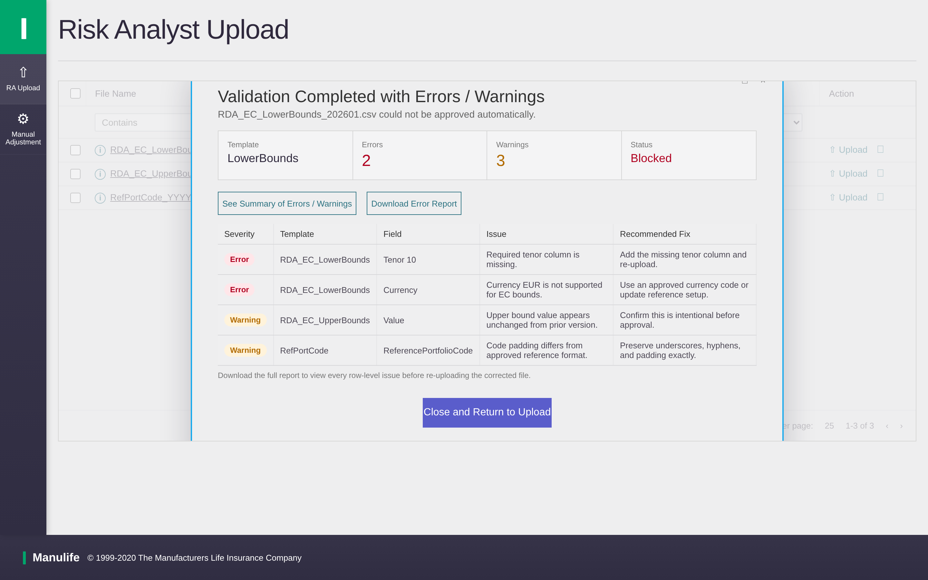
Figure 2 — Validation Errors & Warnings (rda_url_05).

The Copilot prompt that produced this screen:
▸ COPILOT PROMPT · rda_url_05_validation_errors_warnings
Generate: rda_url_05_validation_errors_warnings.html

=== THEME LOCK === (paste the same block as Hero 1)

PRIMARY ACTOR: Risk Analyst
OBJECTIVE: Show file validation results when errors or warnings exist,
so the analyst can inspect issues and fix the file offline.

HEADER: "Validation Errors & Warnings" (h1)
SUB-TITLE: "3 Errors · 1 Warning detected in RDA_EC_LowerBound_202601.csv"

PRIMARY DISPLAY: a two-section layout —
1) Counts strip with three pills:
🔴 Errors: 3 🟡 Warnings: 1 🟢 Rows Passed: 1,447
2) Issues table with columns:
# · Row · Column · Issue · Severity

SAMPLE DATA (5 rows):
1 · 47 · LowerBound · Value cannot be negative · Error
2 · 92 · Currency · ISO code 'XYZ' not in approved list · Error
3 · 178 · Tenor · Value '7Y' not in allowed buckets · Error
4 · 311 · Date · Date 2025-11-15 outside reporting period · Warning
5 · 419 · LowerBound · LowerBound > UpperBound on same row · Error

ACTION BUTTONS:
📥 Download Error Report (primary, top-right)
← Back to Upload (secondary)

VALIDATION RULES BANNER (subtle, near top):
"File checked against 10+ validation rules — file-name pattern,
column order, currency codes, tenor buckets, numeric parsing,
primary keys, reference codes, and bound consistency."

DO NOT INCLUDE: any approve or trigger-calculation actions on this screen.
Validation results only — fix and re-upload is the only path forward.

🎯 Hero 3 — Manual Adjustment · EC Dashboard
This is the heart of the workflow. The Risk Analyst selects a QE Date, sees the locked Process field, runs a Trigger Calculation, and then drills into three levels — LLP (Lowest Level Portfolio), Division, and Company. The Review Results section always shows the last triggered values — never an empty state — so the user is never confused about where they are in the workflow. This screen carries the most complexity in the entire demo, and getting the prompt right took the most iteration.
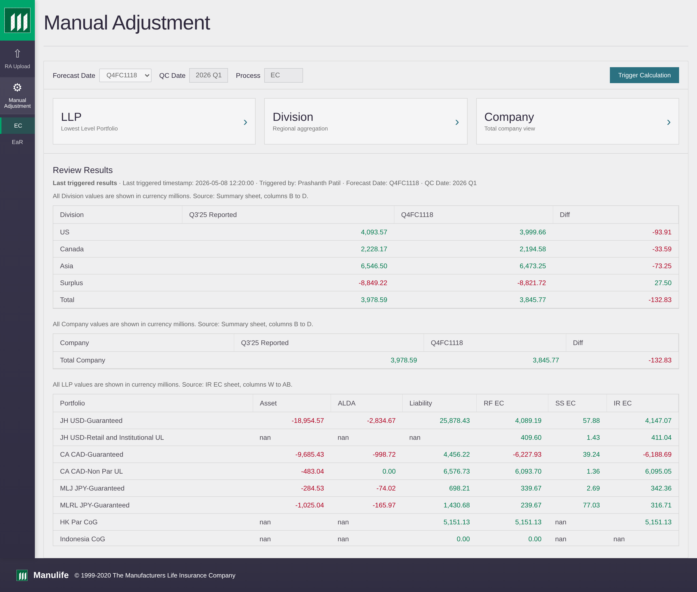
Figure 3 — Manual Adjustment EC Dashboard (rda_url_07).

The Copilot prompt that produced this screen:
▸ COPILOT PROMPT · rda_url_07_manual_adjustment_ec_dashboard
Generate: rda_url_07_manual_adjustment_ec_dashboard.html

=== THEME LOCK === (paste the same block as Hero 1)

PRIMARY ACTOR: Risk Analyst
OBJECTIVE: Run trigger calculations, drill into three portfolio levels,
and review the last triggered results without ever seeing an empty state.

HEADER: "Manual Adjustment — EC" (h1)
CONTROL STRIP (left to right):
- QE Date (dropdown, default 2026 Q1)
- Process (locked, value: EC, non-editable)
- Trigger Calculation (primary button)
- Last Triggered: 2026-05-08 13:02 by Prashanth Patil (muted text, right-aligned)

DRILL-DOWN CARDS (three equal cards side-by-side):
Card 1 — LLP
sub-label: "lowest level portfolio" (small caps under LLP)
button: View / Adjust
Card 2 — Division
button: View / Adjust
Card 3 — Company
button: View / Adjust

REVIEW RESULTS SECTION (below the cards):
Heading: "Review Results"
Sub-label: "Last Triggered Results · 2026-05-08 13:02"
Always populated — never empty. Show the Summary Report table:
Region · Q3'25 Reported · Q4'25 FC1118 · Diff
US · 4,100 · 4,000 · (100)
Canada · 2,200 · 2,200 · 0
Asia · 6,500 · 6,500 · 0
Total Company · 12,800 · 12,700 · (100)
Values in C$ millions.

BEHAVIOUR: clicking any of the three drill-down cards opens its detail screen.
LLP card → rda_url_08a_llp_level_detail.html
Division card → rda_url_08b_division_level_detail.html
Company card → rda_url_08c_company_level_detail.html

DO NOT INCLUDE: any approve / reject actions. Approval is downstream.
Do not show an empty Review Results state. Always render last triggered values.

✅ Hero 4 — Approver Dashboard
Once the Risk Analyst submits, the Approver lands here. The dashboard shows the submitted package, highlights the level that was adjusted (Division, in pink), and exposes three level cards: LLP, Division, Company. Crucially, approve and reject actions are only available at the adjusted level — preventing accidental approvals of unchanged data. This screen demonstrates the disciplined approval logic that comes straight from the use case blueprint.
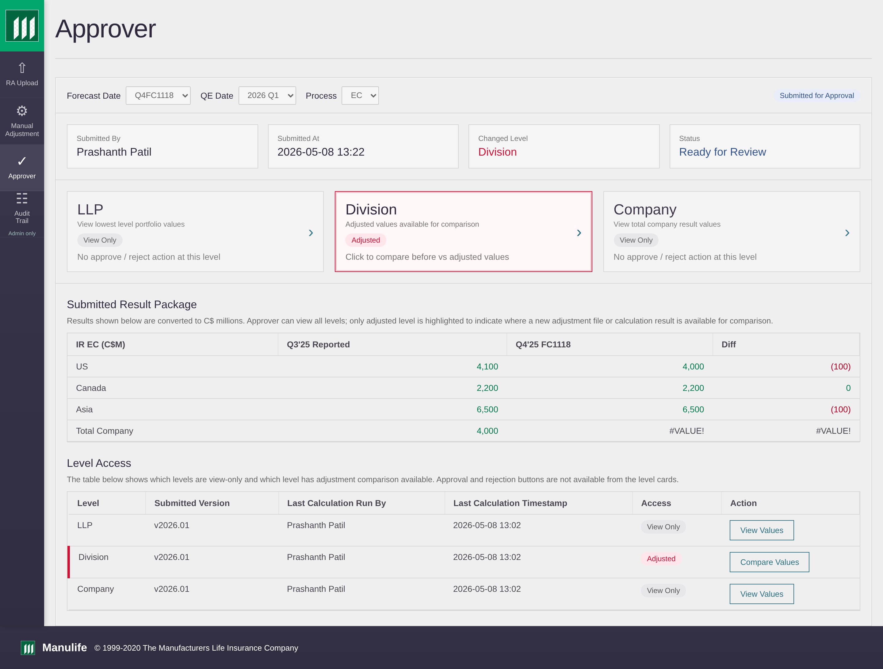
Figure 4 — Approver Dashboard (rda_url_17).

The Copilot prompt that produced this screen:
▸ COPILOT PROMPT · rda_url_17_approver_dashboard
Generate: rda_url_17_approver_dashboard.html

=== THEME LOCK === (paste the same block as Hero 1)

PRIMARY ACTOR: Approver
OBJECTIVE: Review the submitted RDA package, see what changed, and approve
or reject only at the level that was actually adjusted.

HEADER: "Approver" (h1) · top-right link: "Submitted for Approval"
CONTROL STRIP: Forecast Date · QE Date · Process (all locked to submission)

SUBMISSION META PANEL (four small fact cards in a row):
Submitted By: Prashanth Patil
Submitted At: 2026-05-08 13:22
Changed Level: Division (highlighted red/pink)
Status: Ready for Review

LEVEL CARDS (three side-by-side):
LLP — view only ("No approve / reject action at this level")
Division — HIGHLIGHTED in pink border + "Adjusted" badge
Sub-text: "Click to compare before vs adjusted values"
Company — view only ("No approve / reject action at this level")

SUBMITTED RESULT PACKAGE TABLE:
Columns: IR EC (C$M) · Q3'25 Reported · Q4'25 FC1118 · Diff
Rows: US (4,100→4,000, -100) · Canada (2,200→2,200, 0) ·
Asia (6,500→6,500, 0) · Total Company (showing #VALUE!)
Note above: "Approver can view all levels; only the adjusted level is
highlighted to indicate where a new adjustment file or calculation
result is available for comparison."

LEVEL ACCESS TABLE (below):
Columns: Level · Submitted Version · Last Calculation Run By ·
Last Calculation Timestamp · Access · Action
Rows: LLP / Division / Company; Division row marked Adjusted in red
Action buttons: View Values (LLP, Company) · Compare Values (Division)

DO NOT INCLUDE: approve / reject buttons on the LLP or Company cards.
Only the adjusted level (Division) exposes approve / reject — this is
a deliberate guardrail.

📜 Hero 5 — Audit Trail Dashboard
Visible only to Site Admins, the Audit Trail records every action on the platform — uploads, validations, trigger calculations, submissions, approvals, rejections, comments, and email notifications. Each event is filterable by actor, module, and timestamp, and the full log is downloadable for compliance review. This screen closes the loop: every business action on the demo is auditable, governed, and traceable.
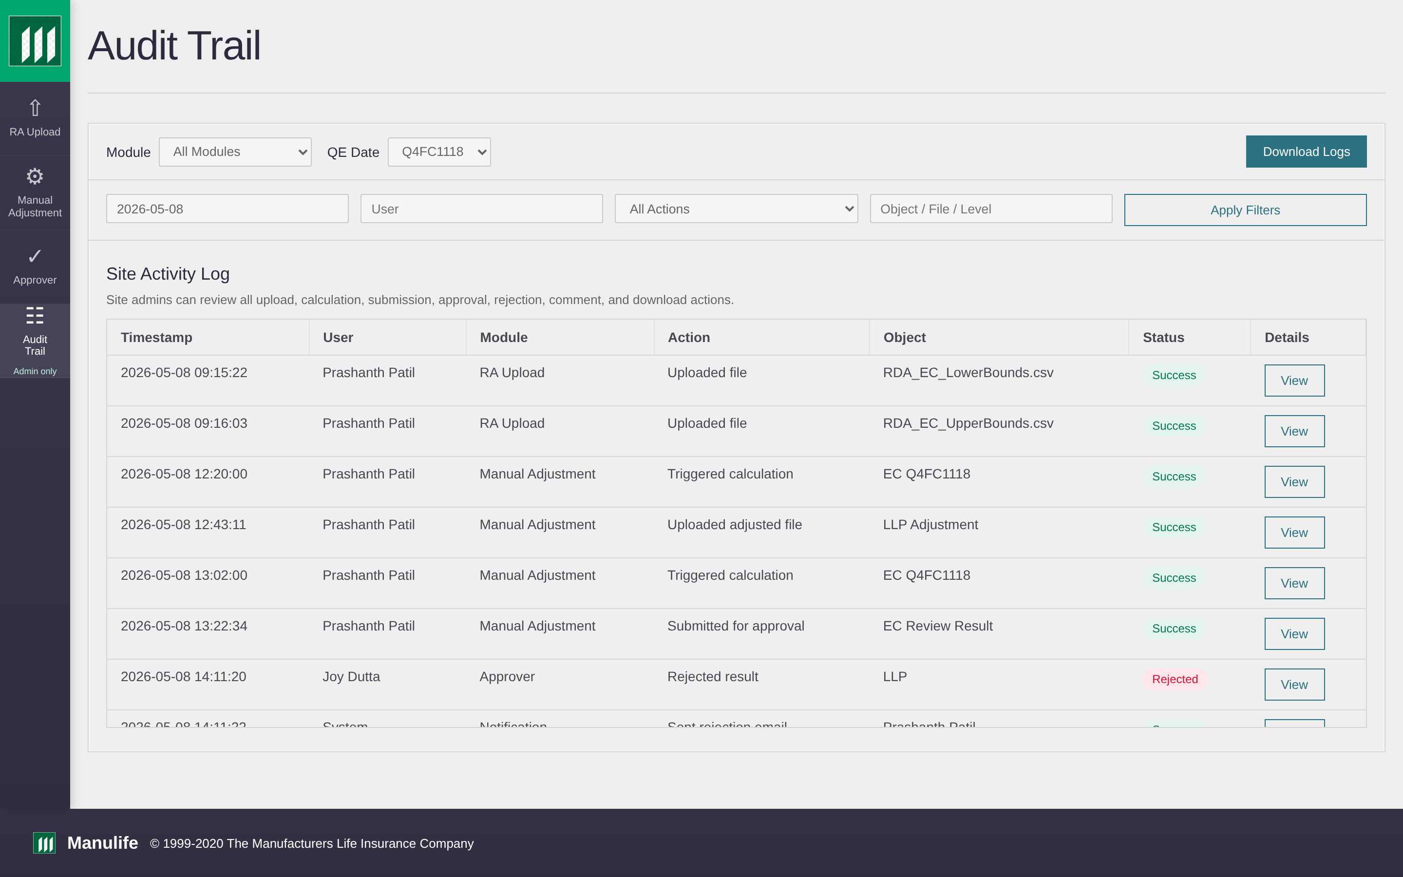
Figure 5 — Audit Trail Dashboard (rda_url_30).

The Copilot prompt that produced this screen:
▸ COPILOT PROMPT · rda_url_30_audit_trail_dashboard
Generate: rda_url_30_audit_trail_dashboard.html

=== THEME LOCK === (paste the same block as Hero 1)

PRIMARY ACTOR: Site Admin (audit-only role)
OBJECTIVE: Single pane of glass for every action taken on the platform.
Admin can filter, drill in, and download logs for compliance review.

HEADER: "Audit Trail" (h1) · sub-title: "All activity across RDA 2.0"

FILTER STRIP:
- Date range (from / to)
- Module (dropdown: All · RA Upload · Manual Adjustment · Approver)
- Actor (search / dropdown of user names)
- Event type (dropdown: Upload · Validation · Trigger Calc · Submit ·
Approve · Reject · Comment · Email Notification · Download)
- Reset Filters (text button)
- 📥 Download Logs (primary button, right-aligned)

PRIMARY DISPLAY: audit log table with columns —
Timestamp · Actor · Module · Event Type · Description · Details

SAMPLE DATA (8 rows, mixed events):
2026-05-08 13:22 · Prashanth Patil · Manual Adjustment · Submit ·
"Submitted Division-level adjustment for QE Q1 2026" · [View]
2026-05-08 13:02 · Prashanth Patil · Manual Adjustment · Trigger Calc ·
"Re-ran EC calculation post-adjustment" · [View]
2026-05-08 12:45 · Prashanth Patil · Manual Adjustment · Upload ·
"Uploaded adjusted Division CSV (v2026.01)" · [View]
2026-05-08 09:15 · Prashanth Patil · RA Upload · Upload ·
"Uploaded RDA_EC_LowerBound_202601.csv" · [View]
2026-05-08 09:15 · System · RA Upload · Validation ·
"Validation passed — 1,447 rows, 0 errors" · [View]
2026-05-08 09:14 · System · RA Upload · Validation ·
"Validation failed — 3 errors detected" · [View]
2026-05-08 08:30 · Admin · Approver · Email Notification ·
"Rejection email sent to Prashanth Patil" · [View]
2026-05-07 17:42 · Approver Smith · Approver · Reject ·
"Rejected Division with comment" · [View]

BEHAVIOUR: clicking [View] opens rda_url_31_audit_event_detail.html
The Download Logs button routes to rda_url_32_audit_download_logs.html

PERMISSIONS NOTE: visible only to users in the Site Admin role.
Add a small "Admin Only" badge in the sidebar nav next to the Audit Trail label.

DO NOT INCLUDE: edit / delete actions on audit events — this is an
append-only log by design. No event is mutable.

🪄 The Prompt-Engineering Magic

Across the five hero prompts, the same architecture repeats. This is the architecture other departments will reuse:

# | Section | Purpose
1️⃣ | THEME LOCK | Identical block in every prompt — guarantees visual consistency
2️⃣ | PRIMARY ACTOR | Anchors the screen to the right user
3️⃣ | OBJECTIVE | One sentence — what the user does on this screen
4️⃣ | HEADER / FILTERS | What appears at the top of the screen
5️⃣ | PRIMARY DISPLAY | Table, card grid, or detail panel — the body of the screen
6️⃣ | SAMPLE DATA | 3–8 realistic rows — never lorem ipsum
7️⃣ | BEHAVIOUR / LINKS | Where each button or card leads
8️⃣ | DO NOT INCLUDE | Explicit constraints — saves 3 iterations every time

🔑 The single biggest unlock
The Theme Lock block — the same paragraph pasted at the top of every prompt — is the single biggest reason 31 different screens look like one product. Copilot does not have memory between prompts. So you give it the same memory yourself, in every prompt.

⛰️ Struggles & How I Solved Them

The polished demo you see hides a series of obstacles — most of them mine, not Copilot's.

Struggle | Symptom | Solution
😤 "Make it look like Manulife" | First screens drifted on colour, sidebar width, logo placement | Wrote a reusable Theme Lock block and pasted it at the top of every prompt
🌫️ Vague prompts produced decorative screens | Screens looked pleasant but had no link to the actual workflow | Translated every line of the use case into a constraint in the prompt
♻️ Iteration broke earlier work | New screens regressed details from previous versions | Treated every prompt as version-controlled — kept, diffed, refined
🪟 Modals, overlays, layered states | Copilot rendered popups inline instead of overlaid | Described modal behaviour explicitly: backdrop, width, close affordance
🧵 31 separate files ≠ a demo | A folder of HTML files is not something to share | Built a connected index URL — one link opens the whole journey
✨ Polish vs. demo-readiness | Tempted to keep refining instead of sharing | Shipped earlier than comfortable; stakeholder feedback decides polish priority

If I had to summarise the struggles in one sentence: every problem I hit was a prompt problem, not a Copilot problem. Improve the prompt and the screen improves.

📈 Business Impact

What did this demo actually change for the business?

Dimension | ❌ Before | ✅ After
Stakeholder review | Slide-by-slide walkthrough | One URL · self-paced · click through the journey
Feedback quality | General reactions | Targeted, screen-specific feedback
Feedback turnaround | Days to weeks | Same-day prompt refresh
Visual consistency | Drifts across documents | Locked theme · identical across 31 screens
Traceability | Disconnected screenshots in Word | Every screen ties back to a use case
Reusability | One-time delivery | Method is reusable for any workflow
Headcount required | BA + designer + developer | 1 BA with Copilot access
Cost to demo a workflow | Weeks of designer + dev time | About one working week of one analyst

🌟 Why senior stakeholders responded to this approach
Three things made this demo land with leadership: it was tangible (a real experience, not a description), it was complete (covering all four modules so the future state felt thought through), and it was theirs to explore at their own pace (the demo kept working in their inbox, their meetings, and their conversations with their own teams long after the walkthrough).

🚀 Strategic Ask — From Project to Product

RDA 2.0 is finished. The bigger opportunity is to take the method that produced it and make it available to every department — productized, documented, and ready to use.

🏗️ Three concrete proposals
- 📘 Publish this playbook as an internal capability. Make the reuse template available alongside this document so any analyst can start tomorrow.
- 🎓 Run a 60-minute enablement session with each department head — walk them through this story, show the demo, hand over the reuse template.
- 🧪 Run a second wireframe project end-to-end with one volunteer department as a proof of repeatability. Measure the time and quality and turn it into the second case study.

🎯 What we want from the Vice President
THE ASK
✅ Endorse the method as an internal capability.
✅ Sponsor one volunteer department for the second case study.
✅ Allow this playbook and the reuse template to be shared across departments.

The biggest success of RDA 2.0 is not the 31 screens. It is proof that one business analyst with Copilot can stand up a clickable enterprise demo, and the method behind it is reusable across the company.

📎 Appendix A — Full Screen Inventory

All 31 connected screens. The five Hero screens are highlighted.

# | Screen | Module | Hero
01 | RA Upload Dashboard | RA Upload | ⭐
02 | Template Details Popup | RA Upload
03 | Upload New Version | RA Upload
04 | Upload In Progress | RA Upload
05 | Validation Errors / Warnings | RA Upload | ⭐
06 | RA Calculation Complete | RA Upload
07 | Manual Adjustment EC Dashboard | Manual Adjustment | ⭐
08A | LLP Level Detail | Manual Adjustment
08B | Division Level Detail | Manual Adjustment
08C | Company Level Detail | Manual Adjustment
09A-C | Upload Adjusted CSV (3 levels) | Manual Adjustment
10A-C | Upload In Progress (3 levels) | Manual Adjustment
11A-C | Validation Errors (3 levels) | Manual Adjustment
12A-C | Upload Success (3 levels) | Manual Adjustment
13 | Manual Calculation Complete | Manual Adjustment
14 | Review Results After Recalc | Manual Adjustment
15 | Submit Review | Manual Adjustment
16 | Submission Complete | Manual Adjustment
17 | Approver Dashboard | Approver | ⭐
18 | Approver Review LLP | Approver
19 | Approver Review Division | Approver
20 | Approver Review Company | Approver
21 | Approve Confirmation | Approver
22 | Reject with Comments | Approver
23 | Rejection Complete / Email Sent | Approver
24 | Approval Complete | Approver
25 | MA Rejection Comments (read-back) | Manual Adjustment
26 | Approver Dashboard — Approval Complete | Approver
30 | Audit Trail Dashboard | Audit Trail | ⭐
31 | Audit Event Detail | Audit Trail
32 | Download Audit Logs | Audit Trail

📎 Appendix B — Validation Rules Implemented

# | Validation Rule | Severity
1 | File-name convention matches RDA_<Template>_YYYYMM.csv | Error
2 | File type is CSV — no XLSX, XLSM accepted | Error
3 | All required columns present in expected order | Error
4 | Header row matches controlled vocabulary | Error
5 | No duplicate primary keys in the file | Error
6 | Currency codes are within approved ISO list | Error
7 | Tenor values within allowed buckets (1Y · 3Y · 5Y · 10Y) | Error
8 | Numeric fields parseable; no text in numeric columns | Error
9 | LowerBound ≤ UpperBound, row-by-row | Error
10 | Reference portfolio codes resolve against the master list | Error
11 | Date stamps fall within active reporting period | Warning
12 | Row count is within expected range for the template | Warning

