RDA UI and Manual Adjustments — Business Use Case Document
Contents
Process Flow Diagram 3
End-to-End User Journey Summary 3
RA Upload 4
URL 1 — RA Upload Dashboard 4
URL 2 — Template Details Popup 4
URL 3 — Upload New Version 5
URL 4 — Upload In Progress 6
URL 5 — Validation Errors / Warnings 6
URL 6 — RA Calculation Complete 7
Manual Adjustment 8
URL 7 — Manual Adjustment EC Dashboard 8
URL 8A — LLP Level Detail 8
URL 8B — Division Level Detail 9
URL 8C — Company Level Detail 10
URL 9A — LLP Upload Adjusted CSV 10
URL 9B — Division Upload Adjusted CSV 11
URL 9C — Company Upload Adjusted CSV 12
URL 10A — LLP Upload In Progress 12
URL 10B — Division Upload In Progress 13
URL 10C — Company Upload In Progress 14
URL 11A — LLP Validation Errors 14
URL 11B — Division Validation Errors 15
URL 11C — Company Validation Errors 16
URL 12A — LLP Upload Success 16
URL 12B — Division Upload Success 17
URL 12C — Company Upload Success 17
URL 13 — Manual Adjustment Calculation Complete 18
URL 14 — Review Updated Results 18
URL 15 — Submit Review 19
URL 16 — Submission Complete 20
URL 25 — Manual Adjustment Rejection Comments 20
Approver 21
URL 17 — Approver Dashboard 21
URL 18 — Approve Confirmation 22
URL 19 — Reject with Comments 22
URL 20 — Rejection Submitted / Email Sent 23
URL 21 — Approval Complete 24
Audit Trail 25
URL 30 — Audit Trail Dashboard 25
URL 31 — Audit Event Detail 25
URL 32 — Download Audit Logs 26

This document provides a high-level business view of the RDA user journey from screen to screen. Each use case includes the actor, objective, preconditions, postconditions, URL link, and the corresponding screenshot rendered from the URL screen.

Process Flow Diagram
The process begins with the Uploader completing uploads and file checks, moves through forecast calculation and review, and then routes the submitted results to the Approver for approval/sign-off or rejection with comments. Rejection returns the workflow to the Uploader / Manual Adjustment user for correction; approval completes the sign-off path.
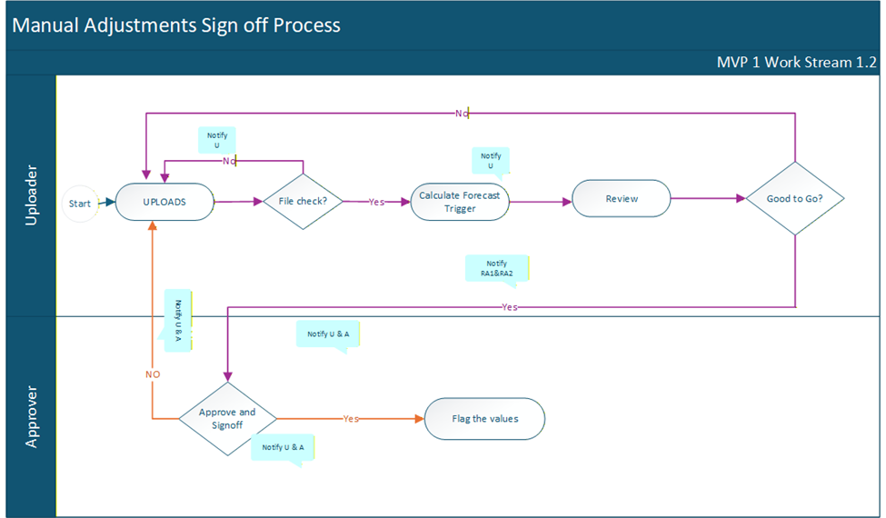

End-to-End User Journey Summary
Journey Step | Business Meaning
RA Upload | Uploader uploads and validates template files, reviews file details, and resolves validation issues if required.
Manual Adjustment | Manual Adjustment user selects Forecast End Date and QE Date, reviews LLP/Division/Company values, uploads adjusted files, triggers calculation, reviews results, and submits for approval.
Approver | Approver reviews submitted LLP, Division, and Company results, approves the package, or rejects with comments.
Manual Adjustment Correction | If rejected, RA / Manual Adjustment user views comments at the relevant level and uploads corrected data.
Audit Trail | Site admin reviews complete activity history and downloads logs for audit review.

RA Upload

URL 1 — RA Upload Dashboard
URL Link: rda_url_01_ra_upload_dashboard.html
Actor | Objective | Preconditions | Postconditions
Uploader / Risk Analyst | View uploaded EC template files and identify file-level actions such as details review or upload. | User is authenticated as an uploader and EC template context is available. | Relevant screen information is reviewed, and the next user action is available.
Screen-to-screen context: This screen is part of the connected URL journey in the latest index and supports the business process flow shown at the start of the document.
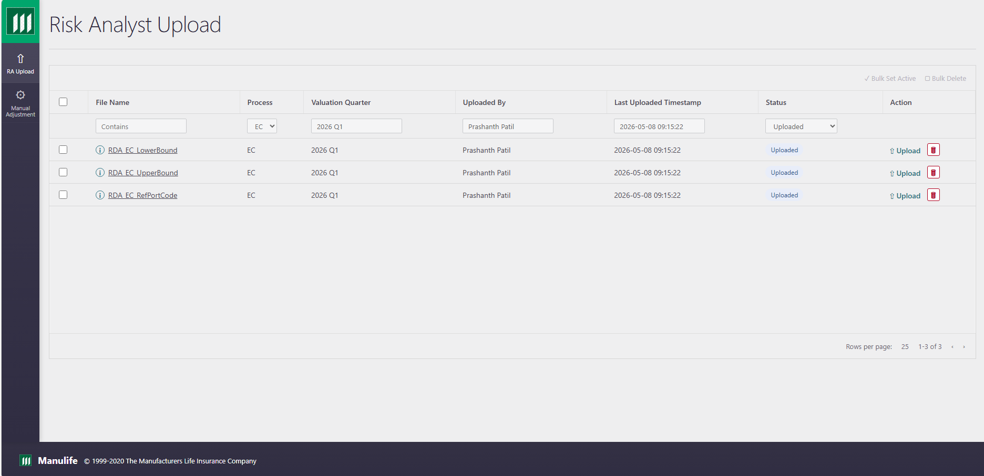

URL 2 — Template Details Popup
URL Link: rda_url_02_template_details_popup.html
Actor | Objective | Preconditions | Postconditions
Uploader / Risk Analyst | Review template metadata and file contents before deciding whether a new version is required. | User is authenticated as an uploader and EC template context is available. | Relevant screen information is reviewed and the next user action is available.
Screen-to-screen context: This screen is part of the connected URL journey in the latest index and supports the business process flow shown at the start of the document.
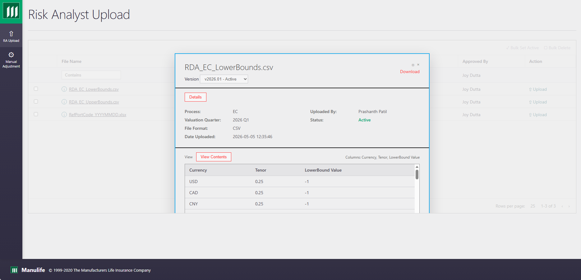
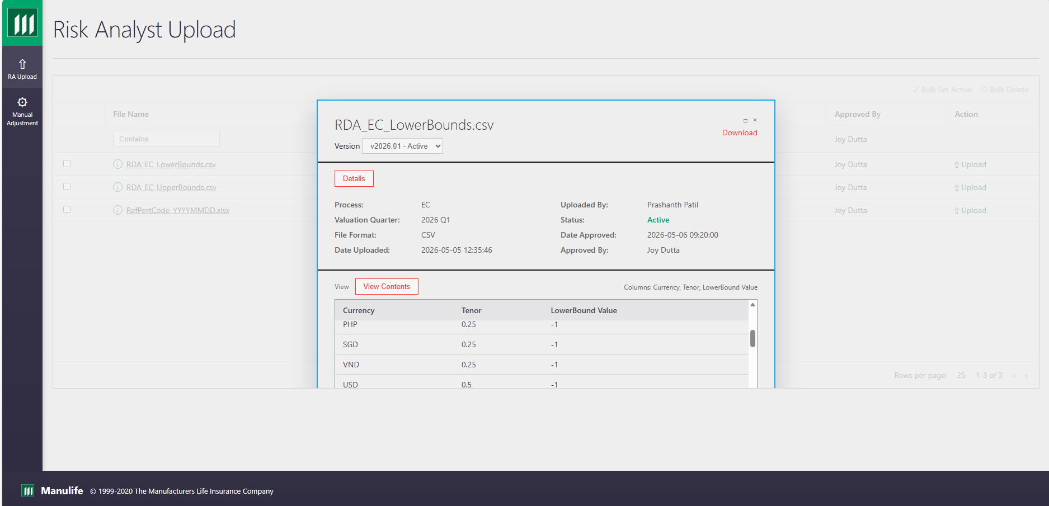

URL 3 — Upload New Version
URL Link: rda_url_03_upload_new_version.html
Actor | Objective | Preconditions | Postconditions
Uploader / Risk Analyst | Upload a new version of the selected EC template file. | User is authenticated as an uploader and EC template context is available. | Relevant screen information is reviewed and the next user action is available.
Screen-to-screen context: This screen is part of the connected URL journey in the latest index and supports the business process flow shown at the start of the document.
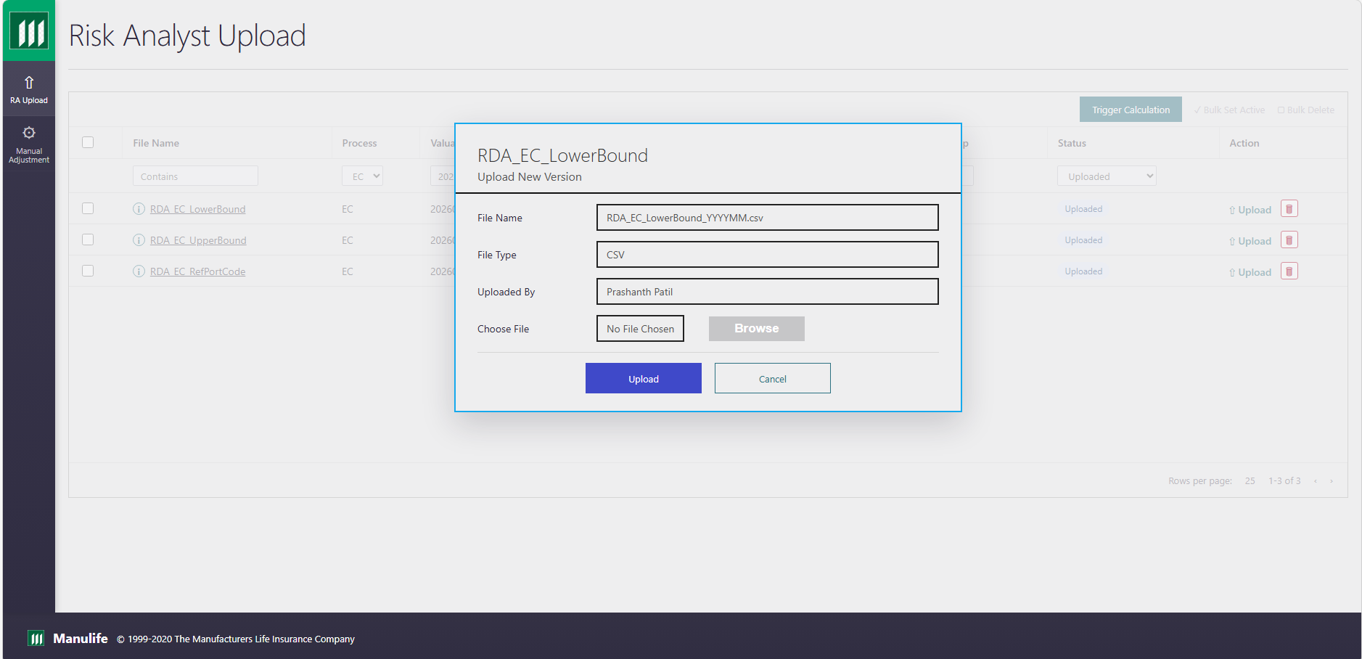

URL 4 — Upload In Progress
URL Link: rda_url_04_upload_in_progress.html
Actor | Objective | Preconditions | Postconditions
Uploader / Risk Analyst | Monitor upload progress while the system processes the selected file. | User is authenticated as an uploader and EC template context is available. | Relevant screen information is reviewed and the next user action is available.
Screen-to-screen context: This screen is part of the connected URL journey in the latest index and supports the business process flow shown at the start of the document.
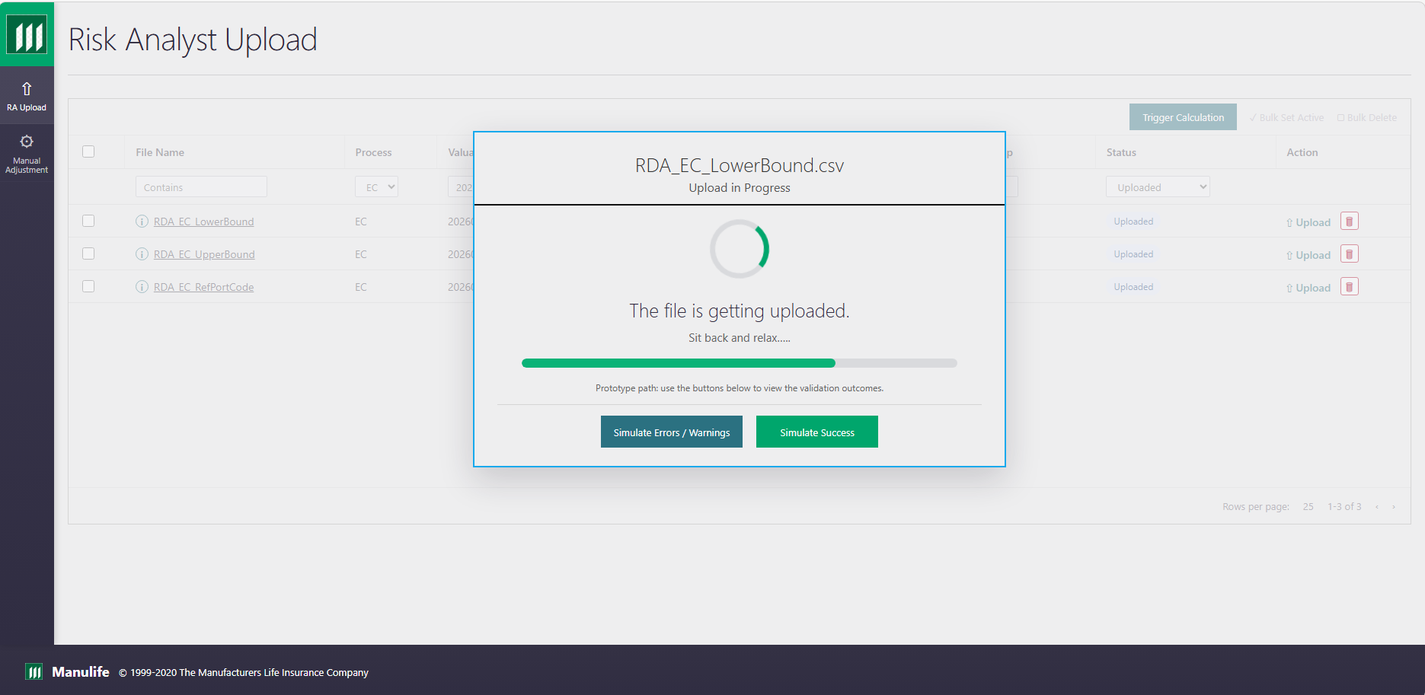

URL 5 — Validation Errors / Warnings
URL Link: rda_url_05_validation_errors_warnings.html
Actor | Objective | Preconditions | Postconditions
Uploader / Risk Analyst | Review validation errors and warnings that block automatic approval of the uploaded file. | User is authenticated as an uploader and EC template context is available. | Validation findings are visible and user can correct or re-upload the relevant file.
Screen-to-screen context: This screen is part of the connected URL journey in the latest index and supports the business process flow shown at the start of the document.
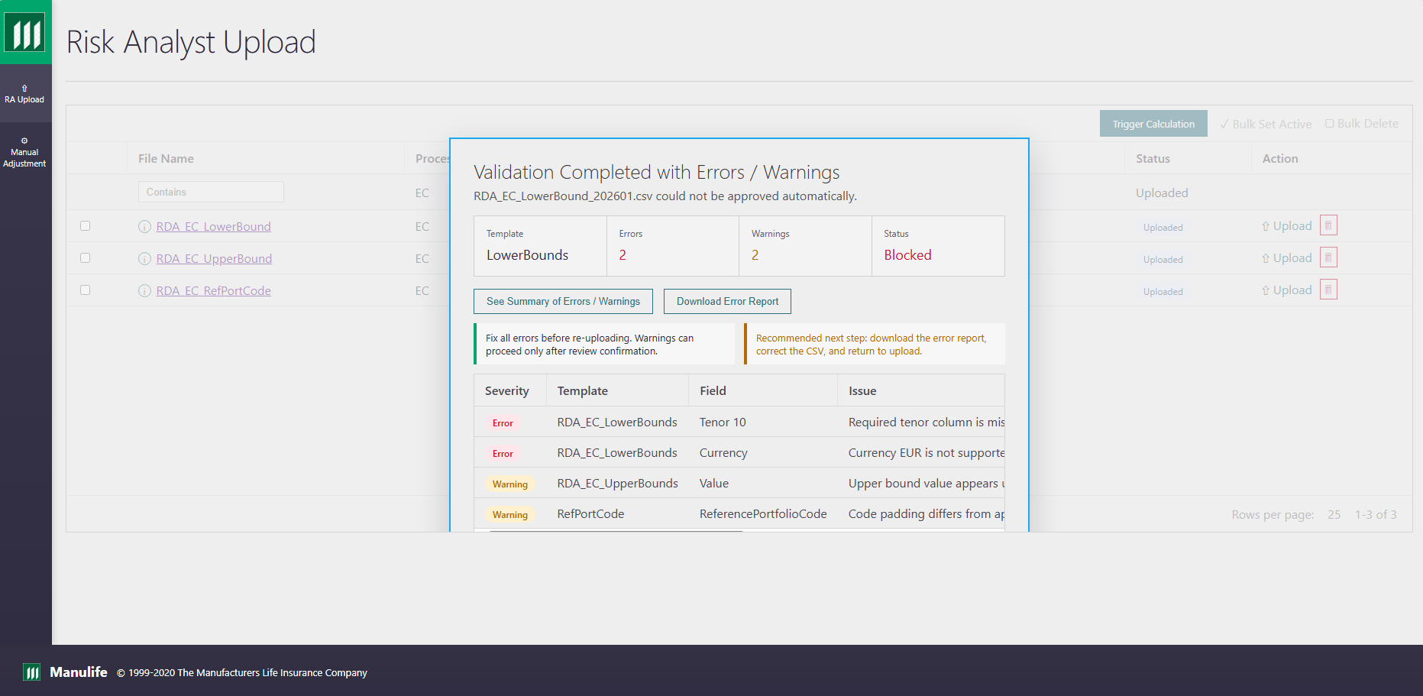

URL 6 — RA Calculation Complete
URL Link: rda_url_06_ra_calculation_complete.html
Actor | Objective | Preconditions | Postconditions
Uploader / Risk Analyst | Confirm the RA Upload step has completed successfully. | User is authenticated as an uploader and EC template context is available. | Workflow status is updated and the user can proceed to the next screen.
Screen-to-screen context: This screen is part of the connected URL journey in the latest index and supports the business process flow shown at the start of the document.

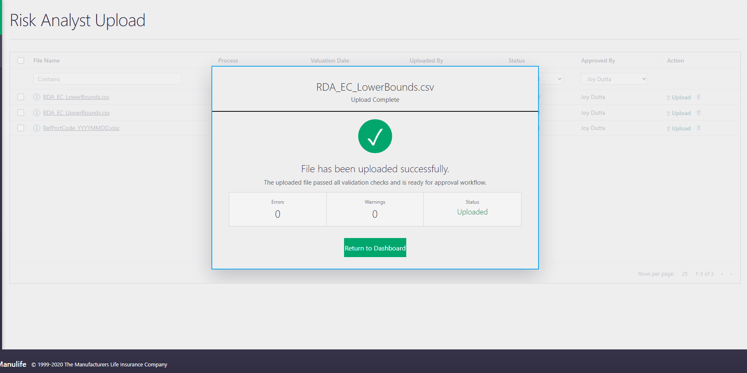

Manual Adjustment

URL 7 — Manual Adjustment EC Dashboard
URL Link: rda_url_07_manual_adjustment_ec_dashboard.html
Actor | Objective | Preconditions | Postconditions
Manual Adjustment User / Risk Analyst | Select Forecast End Date, QE Date, and EC level for manual adjustment review. | User is authenticated, EC workflow is available, and Forecast End Date / QE Date context is selected. | Relevant screen information is reviewed and the next user action is available.
Screen-to-screen context: This screen is part of the connected URL journey in the latest index and supports the business process flow shown at the start of the document.
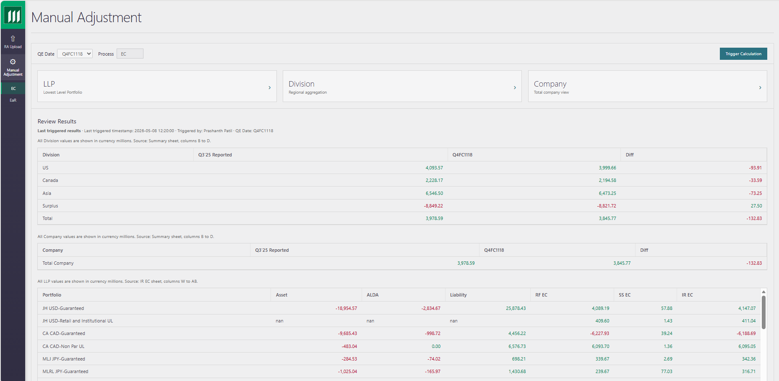

URL 8A — LLP Level Detail
URL Link: rda_url_08a_llp_level_detail.html
Actor | Objective | Preconditions | Postconditions
Manual Adjustment User / Risk Analyst | Review current values for the selected EC level and decide whether an adjusted file is required. | User is authenticated, EC workflow is available, and Forecast End Date / QE Date context is selected. | Relevant screen information is reviewed and the next user action is available.
Screen-to-screen context: This screen is part of the connected URL journey in the latest index and supports the business process flow shown at the start of the document.
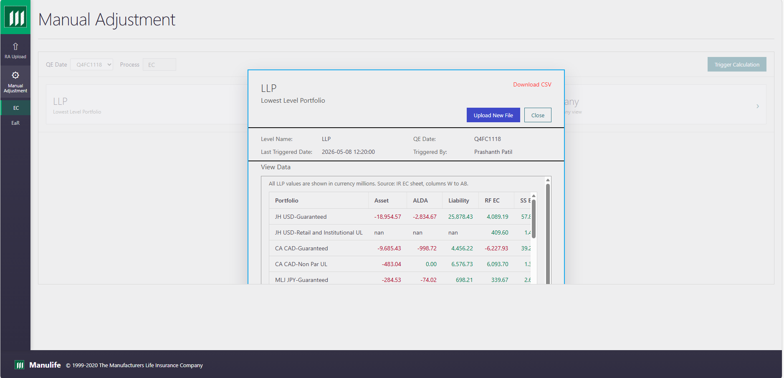

URL 8B — Division Level Detail
URL Link: rda_url_08b_division_level_detail.html
Actor | Objective | Preconditions | Postconditions
Manual Adjustment User / Risk Analyst | Review current values for the selected EC level and decide whether an adjusted file is required. | User is authenticated, EC workflow is available, and Forecast End Date / QE Date context is selected. | Relevant screen information is reviewed and the next user action is available.
Screen-to-screen context: This screen is part of the connected URL journey in the latest index and supports the business process flow shown at the start of the document.
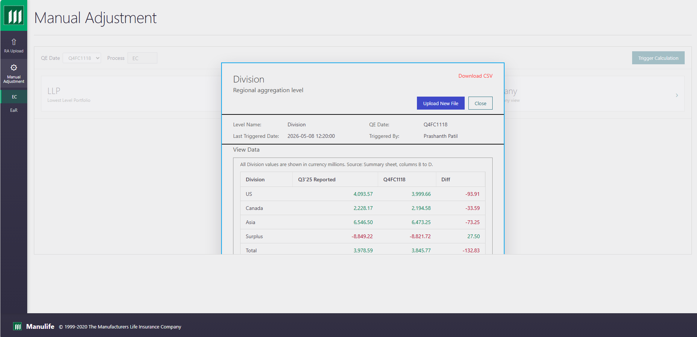

URL 8C — Company Level Detail
URL Link: rda_url_08c_company_level_detail.html
Actor | Objective | Preconditions | Postconditions
Manual Adjustment User / Risk Analyst | Review current values for the selected EC level and decide whether an adjusted file is required. | User is authenticated, EC workflow is available, and Forecast End Date / QE Date context is selected. | Relevant screen information is reviewed and the next user action is available.
Screen-to-screen context: This screen is part of the connected URL journey in the latest index and supports the business process flow shown at the start of the document.
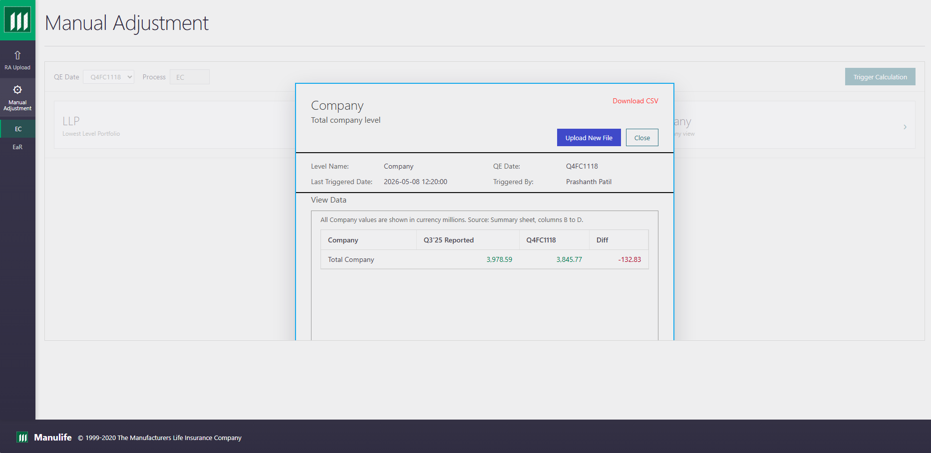

URL 9A — LLP Upload Adjusted CSV
URL Link: rda_url_09a_llp_upload_adjusted_file.html
Actor | Objective | Preconditions | Postconditions
Manual Adjustment User / Risk Analyst | Upload an adjusted CSV for the selected level and date context. | User is authenticated, EC workflow is available, and Forecast End Date / QE Date context is selected. | Relevant screen information is reviewed and the next user action is available.
Screen-to-screen context: This screen is part of the connected URL journey in the latest index and supports the business process flow shown at the start of the document.
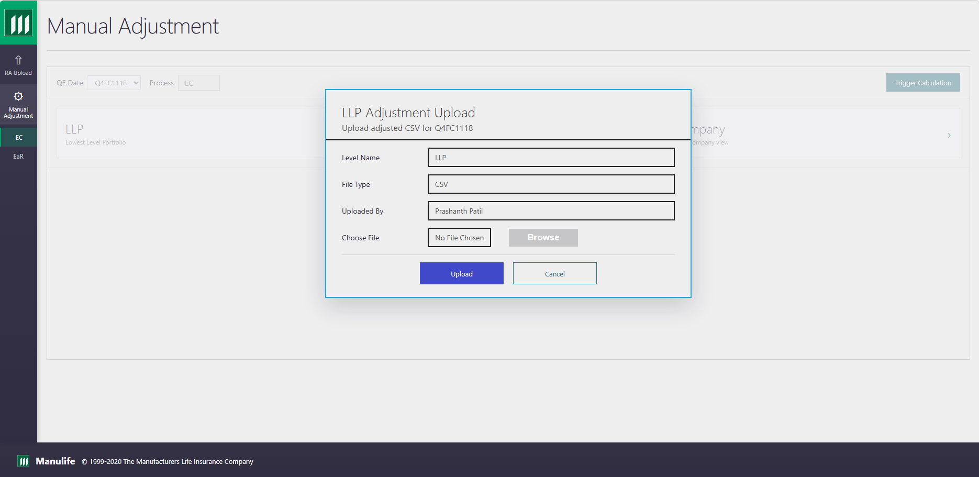

URL 9B — Division Upload Adjusted CSV
URL Link: rda_url_09b_division_upload_adjusted_file.html
Actor | Objective | Preconditions | Postconditions
Manual Adjustment User / Risk Analyst | Upload an adjusted CSV for the selected level and date context. | User is authenticated, EC workflow is available, and Forecast End Date / QE Date context is selected. | Relevant screen information is reviewed and the next user action is available.
Screen-to-screen context: This screen is part of the connected URL journey in the latest index and supports the business process flow shown at the start of the document.
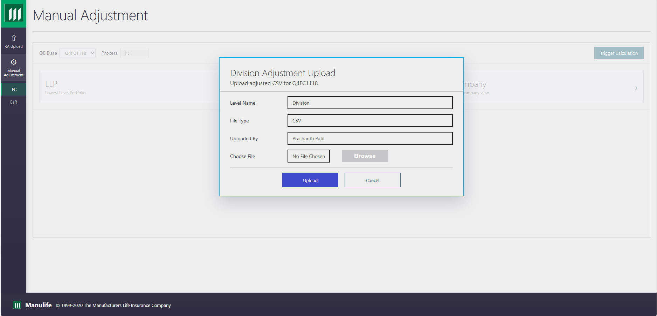

URL 9C — Company Upload Adjusted CSV
URL Link: rda_url_09c_company_upload_adjusted_file.html
Actor | Objective | Preconditions | Postconditions
Manual Adjustment User / Risk Analyst | Upload an adjusted CSV for the selected level and date context. | User is authenticated, EC workflow is available, and Forecast End Date / QE Date context is selected. | Relevant screen information is reviewed and the next user action is available.
Screen-to-screen context: This screen is part of the connected URL journey in the latest index and supports the business process flow shown at the start of the document.
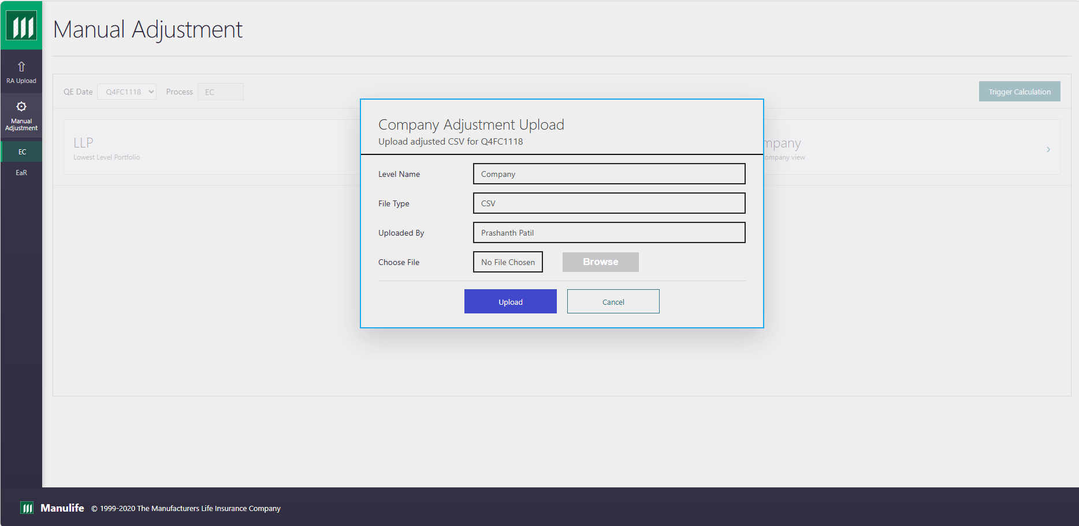

URL 10A — LLP Upload In Progress
URL Link: rda_url_10a_llp_upload_in_progress.html
Actor | Objective | Preconditions | Postconditions
Manual Adjustment User / Risk Analyst | Monitor adjusted file upload and processing status. | User is authenticated, EC workflow is available, and Forecast End Date / QE Date context is selected. | Relevant screen information is reviewed and the next user action is available.
Screen-to-screen context: This screen is part of the connected URL journey in the latest index and supports the business process flow shown at the start of the document.
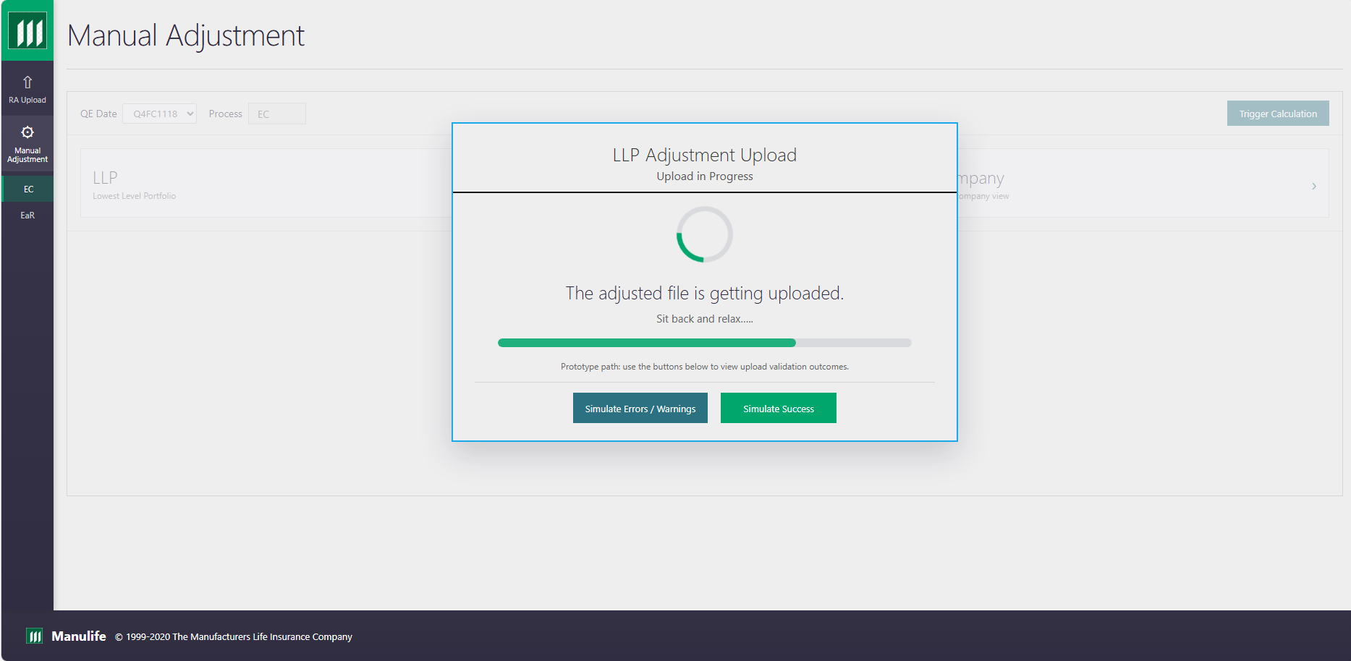

URL 10B — Division Upload In Progress
URL Link: rda_url_10b_division_upload_in_progress.html
Actor | Objective | Preconditions | Postconditions
Manual Adjustment User / Risk Analyst | Monitor adjusted file upload and processing status. | User is authenticated, EC workflow is available, and Forecast End Date / QE Date context is selected. | Relevant screen information is reviewed and the next user action is available.
Screen-to-screen context: This screen is part of the connected URL journey in the latest index and supports the business process flow shown at the start of the document.
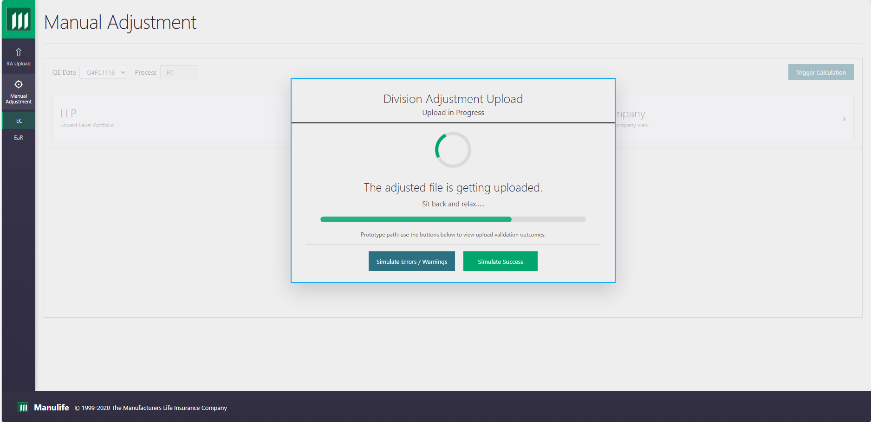

URL 10C — Company Upload In Progress
URL Link: rda_url_10c_company_upload_in_progress.html
Actor | Objective | Preconditions | Postconditions
Manual Adjustment User / Risk Analyst | Monitor adjusted file upload and processing status. | User is authenticated, EC workflow is available, and Forecast End Date / QE Date context is selected. | Relevant screen information is reviewed and the next user action is available.
Screen-to-screen context: This screen is part of the connected URL journey in the latest index and supports the business process flow shown at the start of the document.
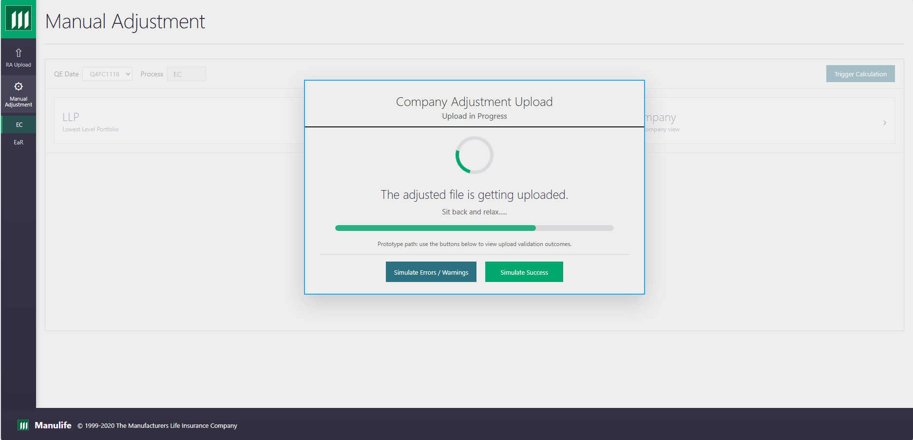

URL 11A — LLP Validation Errors
URL Link: rda_url_11a_llp_validation_errors.html
Actor | Objective | Preconditions | Postconditions
Manual Adjustment User / Risk Analyst | Review level-specific validation errors or warnings for the adjusted file. | User is authenticated, EC workflow is available, and Forecast End Date / QE Date context is selected. | Validation findings are visible and user can correct or re-upload the relevant file.
Screen-to-screen context: This screen is part of the connected URL journey in the latest index and supports the business process flow shown at the start of the document.
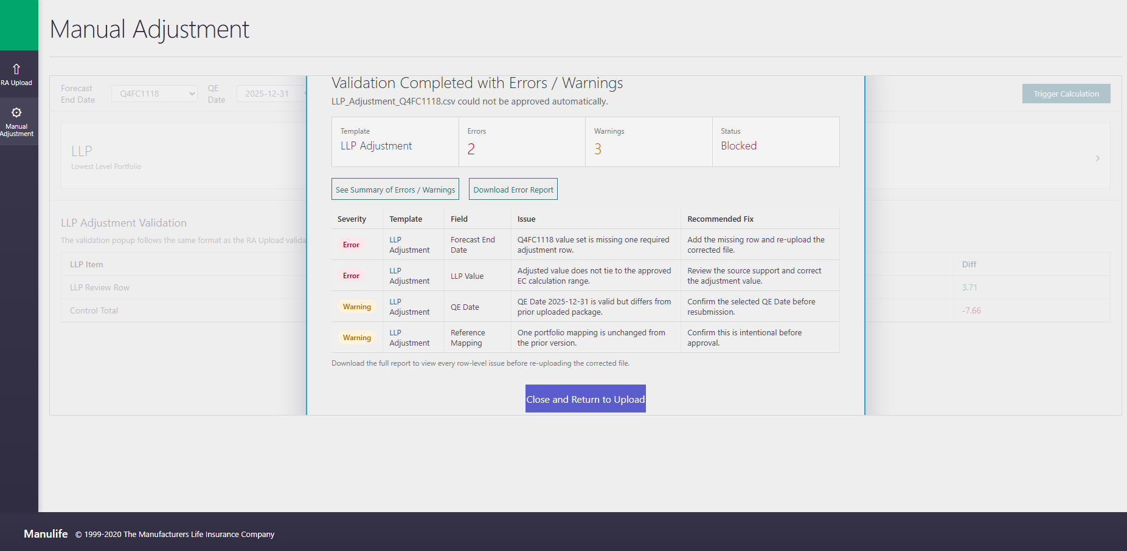

URL 11B — Division Validation Errors
URL Link: rda_url_11b_division_validation_errors.html
Actor | Objective | Preconditions | Postconditions
Manual Adjustment User / Risk Analyst | Review level-specific validation errors or warnings for the adjusted file. | User is authenticated, EC workflow is available, and Forecast End Date / QE Date context is selected. | Validation findings are visible and user can correct or re-upload the relevant file.
Screen-to-screen context: This screen is part of the connected URL journey in the latest index and supports the business process flow shown at the start of the document.
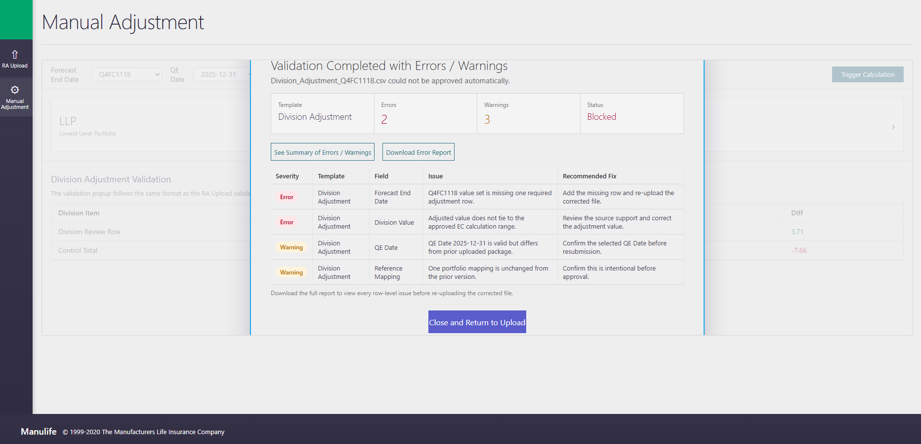

URL 11C — Company Validation Errors
URL Link: rda_url_11c_company_validation_errors.html
Actor | Objective | Preconditions | Postconditions
Manual Adjustment User / Risk Analyst | Review level-specific validation errors or warnings for the adjusted file. | User is authenticated, EC workflow is available, and Forecast End Date / QE Date context is selected. | Validation findings are visible and user can correct or re-upload the relevant file.
Screen-to-screen context: This screen is part of the connected URL journey in the latest index and supports the business process flow shown at the start of the document.
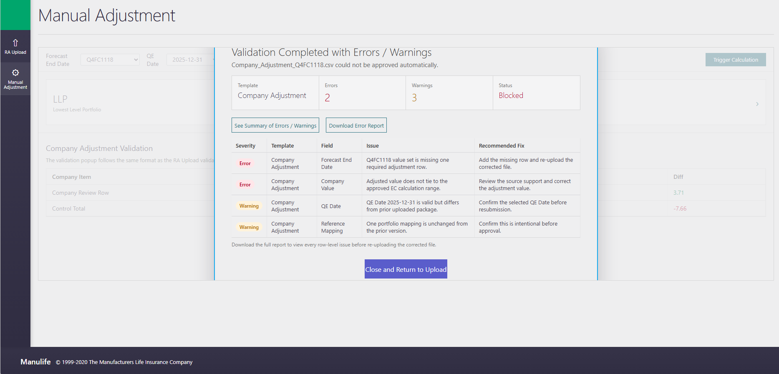

URL 12A — LLP Upload Success
URL Link: rda_url_12a_llp_upload_success.html
Actor | Objective | Preconditions | Postconditions
Manual Adjustment User / Risk Analyst | Confirm the adjusted file was accepted for the selected level. | User is authenticated, EC workflow is available, and Forecast End Date / QE Date context is selected. | Workflow status is updated and the user can proceed to the next screen.
Screen-to-screen context: This screen is part of the connected URL journey in the latest index and supports the business process flow shown at the start of the document.
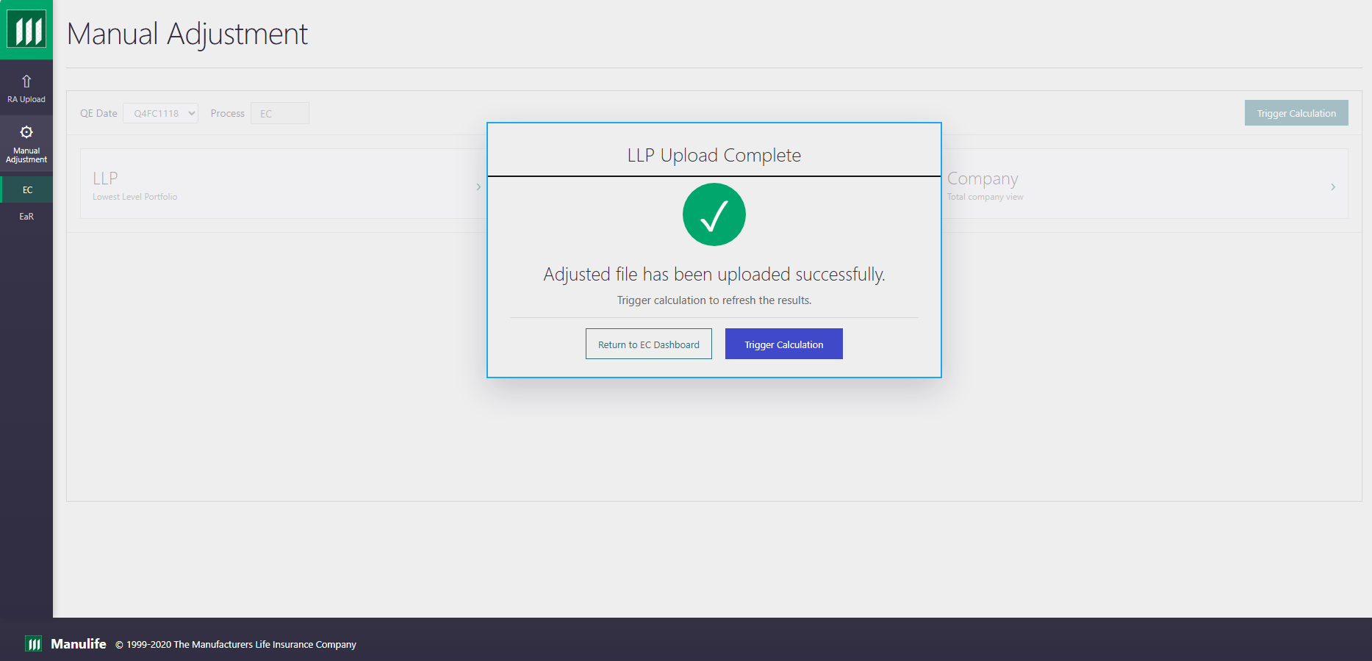

URL 12B — Division Upload Success
URL Link: rda_url_12b_division_upload_success.html
Actor | Objective | Preconditions | Postconditions
Manual Adjustment User / Risk Analyst | Confirm the adjusted file was accepted for the selected level. | User is authenticated, EC workflow is available, and Forecast End Date / QE Date context is selected. | Workflow status is updated and the user can proceed to the next screen.
Screen-to-screen context: This screen is part of the connected URL journey in the latest index and supports the business process flow shown at the start of the document.
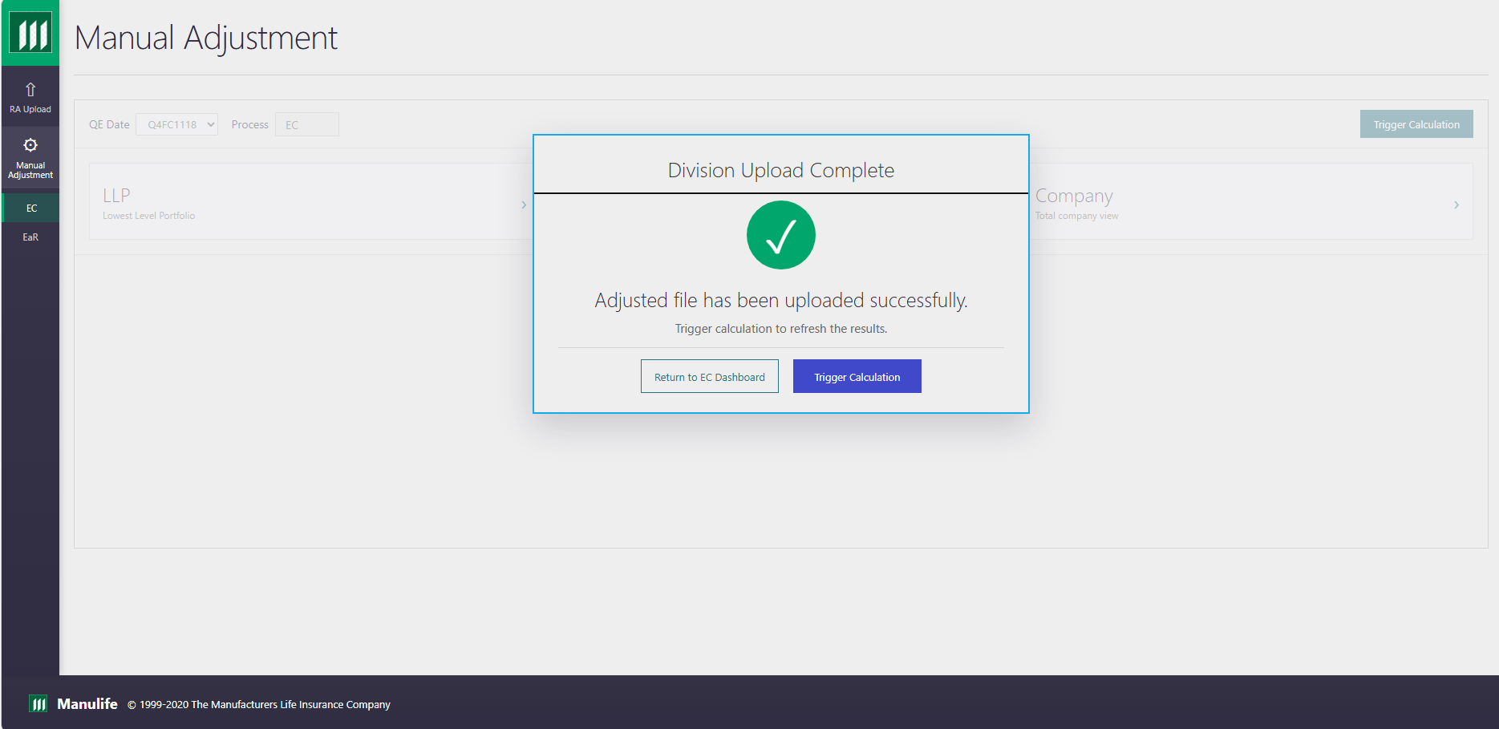

URL 12C — Company Upload Success
URL Link: rda_url_12c_company_upload_success.html
Actor | Objective | Preconditions | Postconditions
Manual Adjustment User / Risk Analyst | Confirm the adjusted file was accepted for the selected level. | User is authenticated, EC workflow is available, and Forecast End Date / QE Date context is selected. | Workflow status is updated and the user can proceed to the next screen.
Screen-to-screen context: This screen is part of the connected URL journey in the latest index and supports the business process flow shown at the start of the document.
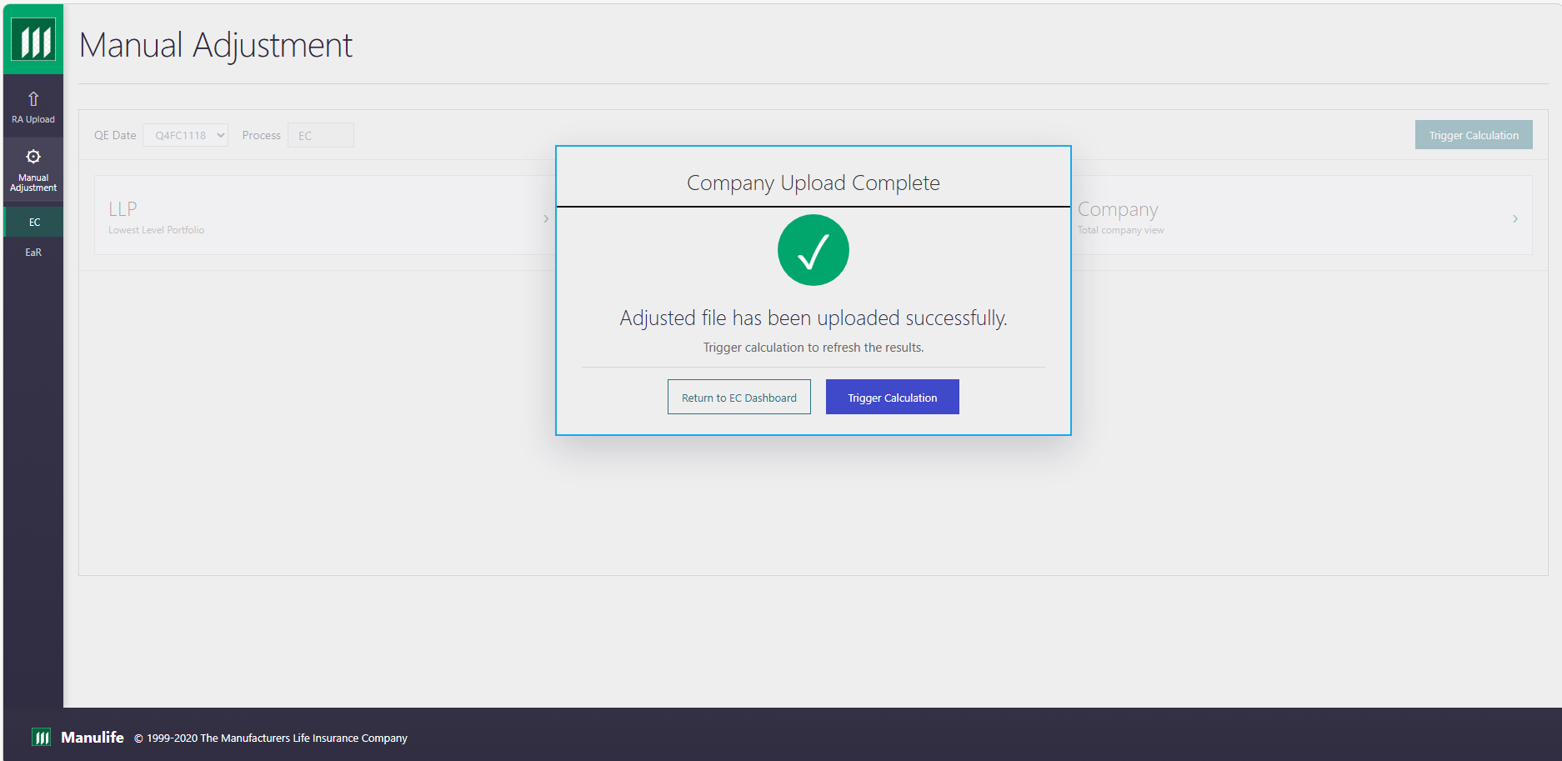

URL 13 — Manual Adjustment Calculation Complete
URL Link: rda_url_13_manual_calculation_complete.html
Actor | Objective | Preconditions | Postconditions
Manual Adjustment User / Risk Analyst | Confirm recalculation completed after manual adjustments. | User is authenticated, EC workflow is available, and Forecast End Date / QE Date context is selected. | Workflow status is updated and the user can proceed to the next screen.
Screen-to-screen context: This screen is part of the connected URL journey in the latest index and supports the business process flow shown at the start of the document.
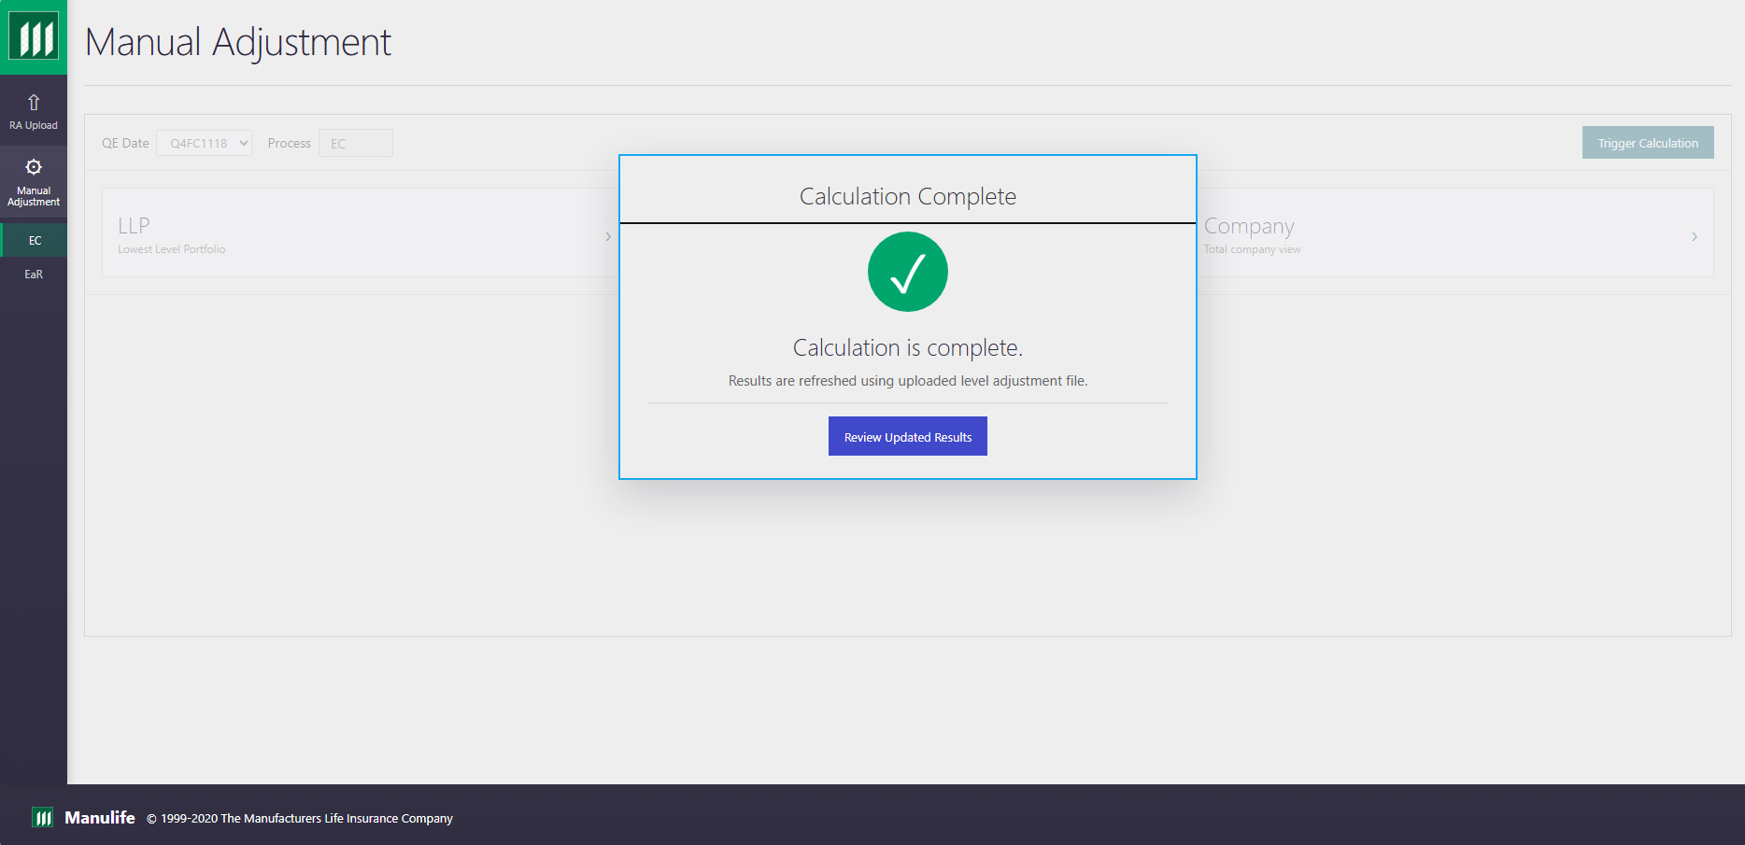

URL 14 — Review Updated Results
URL Link: rda_url_14_review_results_after_recalc.html
Actor | Objective | Preconditions | Postconditions
Manual Adjustment User / Risk Analyst | Review recalculated EC results before submitting to approver. | User is authenticated, EC workflow is available, and Forecast End Date / QE Date context is selected. | Relevant screen information is reviewed and the next user action is available.
Screen-to-screen context: This screen is part of the connected URL journey in the latest index and supports the business process flow shown at the start of the document.
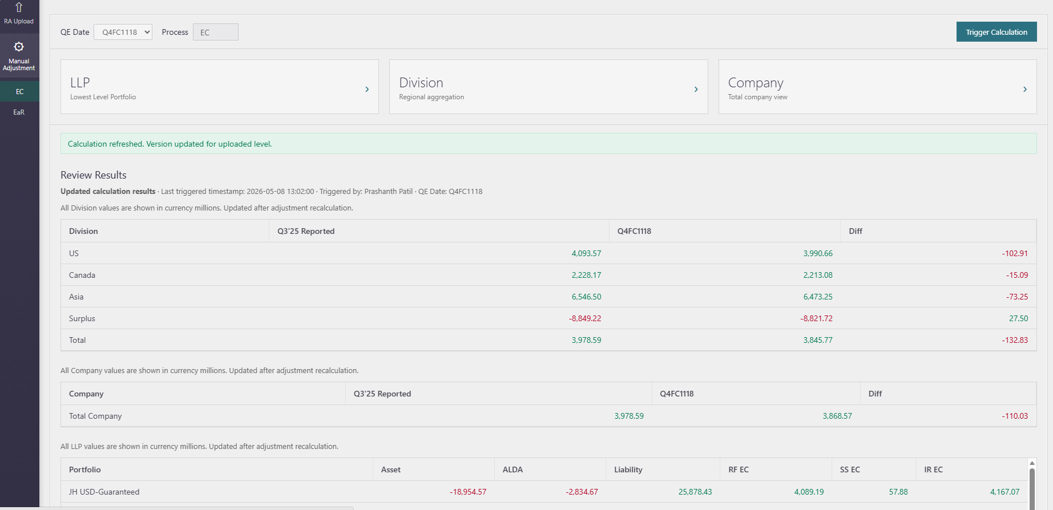

URL 15 — Submit Review
URL Link: rda_url_16_submission_complete.html
Actor | Objective | Preconditions | Postconditions
Manual Adjustment User / Risk Analyst | Submit final EC results for approver review. | User is authenticated, EC workflow is available, and Forecast End Date / QE Date context is selected. | Relevant screen information is reviewed and the next user action is available.
Screen-to-screen context: This screen is part of the connected URL journey in the latest index and supports the business process flow shown at the start of the document.
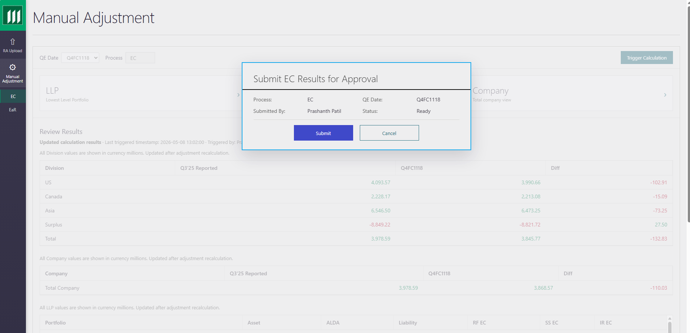

URL 16 — Submission Complete
URL Link: rda_url_16_submission_complete.html
Actor | Objective | Preconditions | Postconditions
Manual Adjustment User / Risk Analyst | Confirm the final EC result package was submitted successfully. | User is authenticated, EC workflow is available, and Forecast End Date / QE Date context is selected. | Workflow status is updated and the user can proceed to the next screen.
Screen-to-screen context: This screen is part of the connected URL journey in the latest index and supports the business process flow shown at the start of the document.
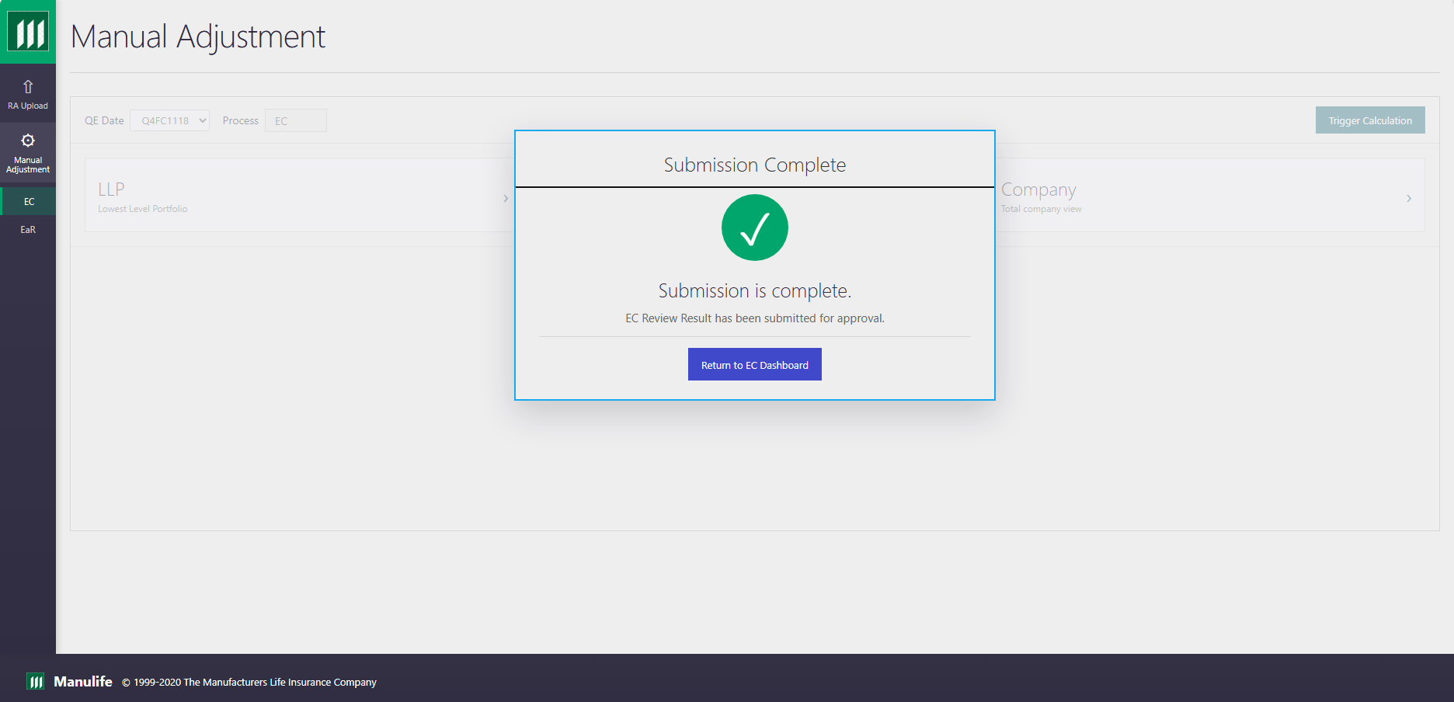

URL 25 — Manual Adjustment Rejection Comments
URL Link: rda_url_25_manual_adjustment_rejection_comments.html
Actor | Objective | Preconditions | Postconditions
Manual Adjustment User / Risk Analyst | Review approver rejection comments and determine corrections required before resubmission. | User is authenticated, EC workflow is available, and Forecast End Date / QE Date context is selected. | Rejection comments are captured, notification is generated, and comments are available for RA correction.
Screen-to-screen context: This screen is part of the connected URL journey in the latest index and supports the business process flow shown at the start of the document.
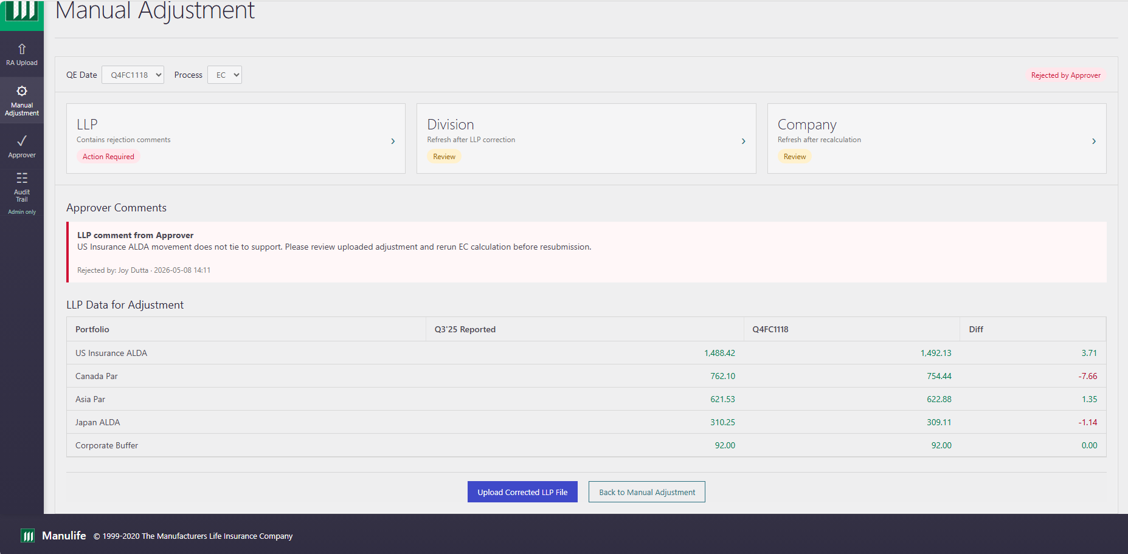

Approver

URL 17 — Approver Dashboard
URL Link: rda_url_17_approver_dashboard.html
Actor | Objective | Preconditions | Postconditions
Approver | Open the submitted EC package and determine which levels require review. | Approver is authenticated and a Manual Adjustment result package has been submitted for review. | Submitted result package is approved and the approval event is audit logged.
Screen-to-screen context: This screen is part of the connected URL journey in the latest index and supports the business process flow shown at the start of the document.
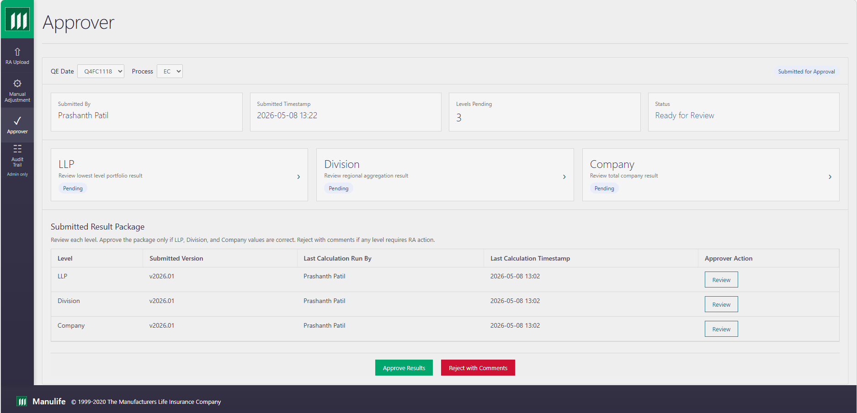

URL 18 — Approve Confirmation
URL Link: rda_url_21_approver_approve_confirmation.html
Actor | Objective | Preconditions | Postconditions
Approver | Approve the submitted EC result package when values are correct. | Approver is authenticated and a Manual Adjustment result package has been submitted for review. | Submitted result package is approved and the approval event is audit logged.
Screen-to-screen context: This screen is part of the connected URL journey in the latest index and supports the business process flow shown at the start of the document.
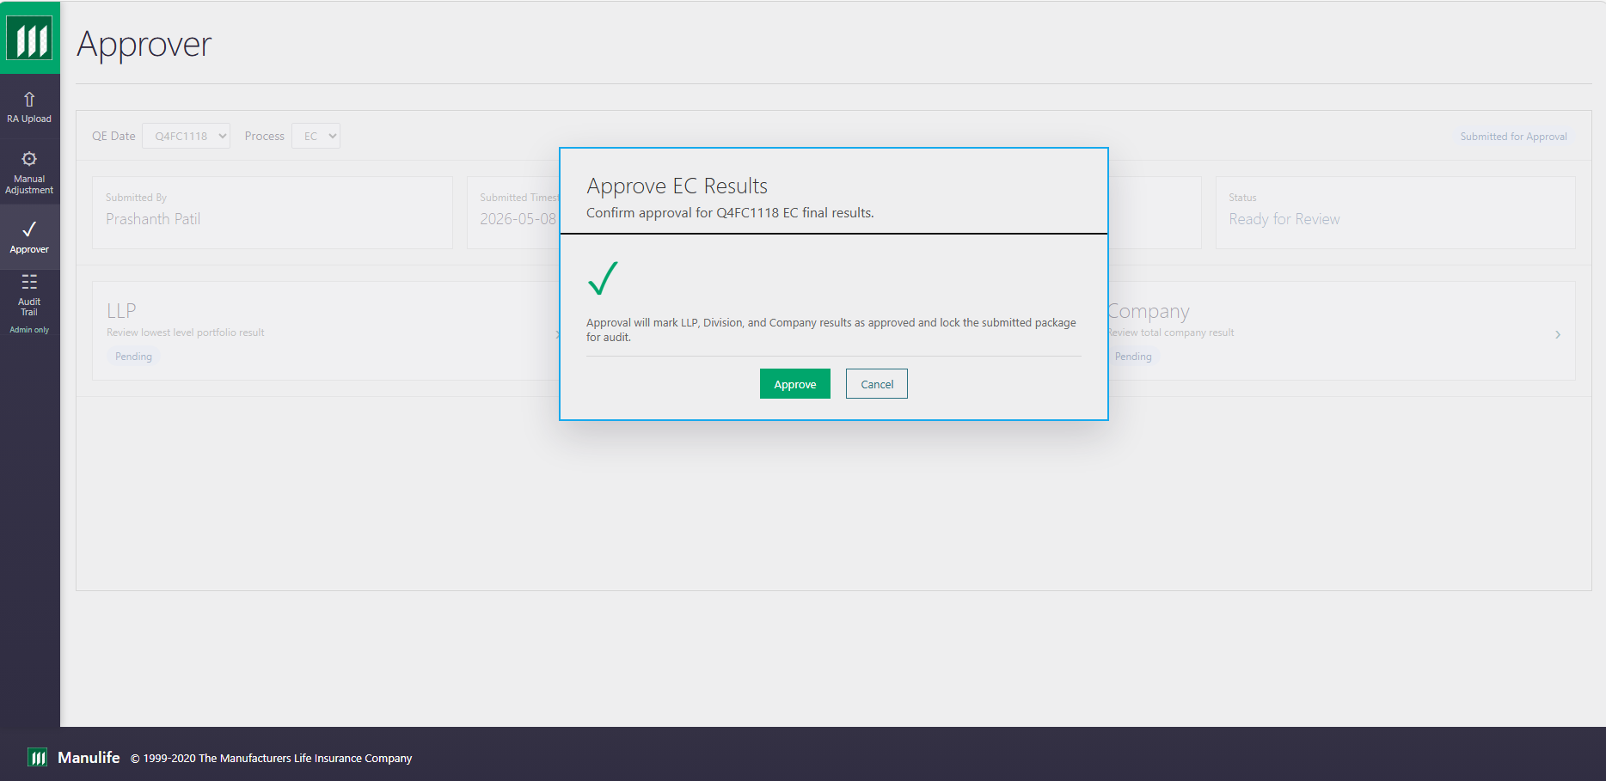

URL 19 — Reject with Comments
URL Link: rda_url_22_approver_reject_comments.html
Actor | Objective | Preconditions | Postconditions
Approver | Reject the submitted EC result package with actionable level-specific comments. | Approver is authenticated and a Manual Adjustment result package has been submitted for review. | Rejection comments are captured, notification is generated, and comments are available for RA correction.
Screen-to-screen context: This screen is part of the connected URL journey in the latest index and supports the business process flow shown at the start of the document.
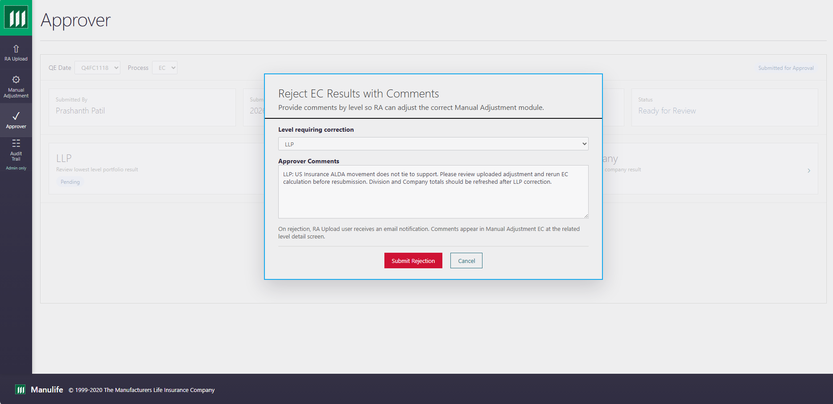

URL 20 — Rejection Submitted / Email Sent
URL Link: rda_url_23_approver_rejection_complete.html
Actor | Objective | Preconditions | Postconditions
Approver | Reject the submitted EC result package with actionable level-specific comments. | Approver is authenticated and a Manual Adjustment result package has been submitted for review. | Rejection comments are captured, notification is generated, and comments are available for RA correction.
Screen-to-screen context: This screen is part of the connected URL journey in the latest index and supports the business process flow shown at the start of the document.
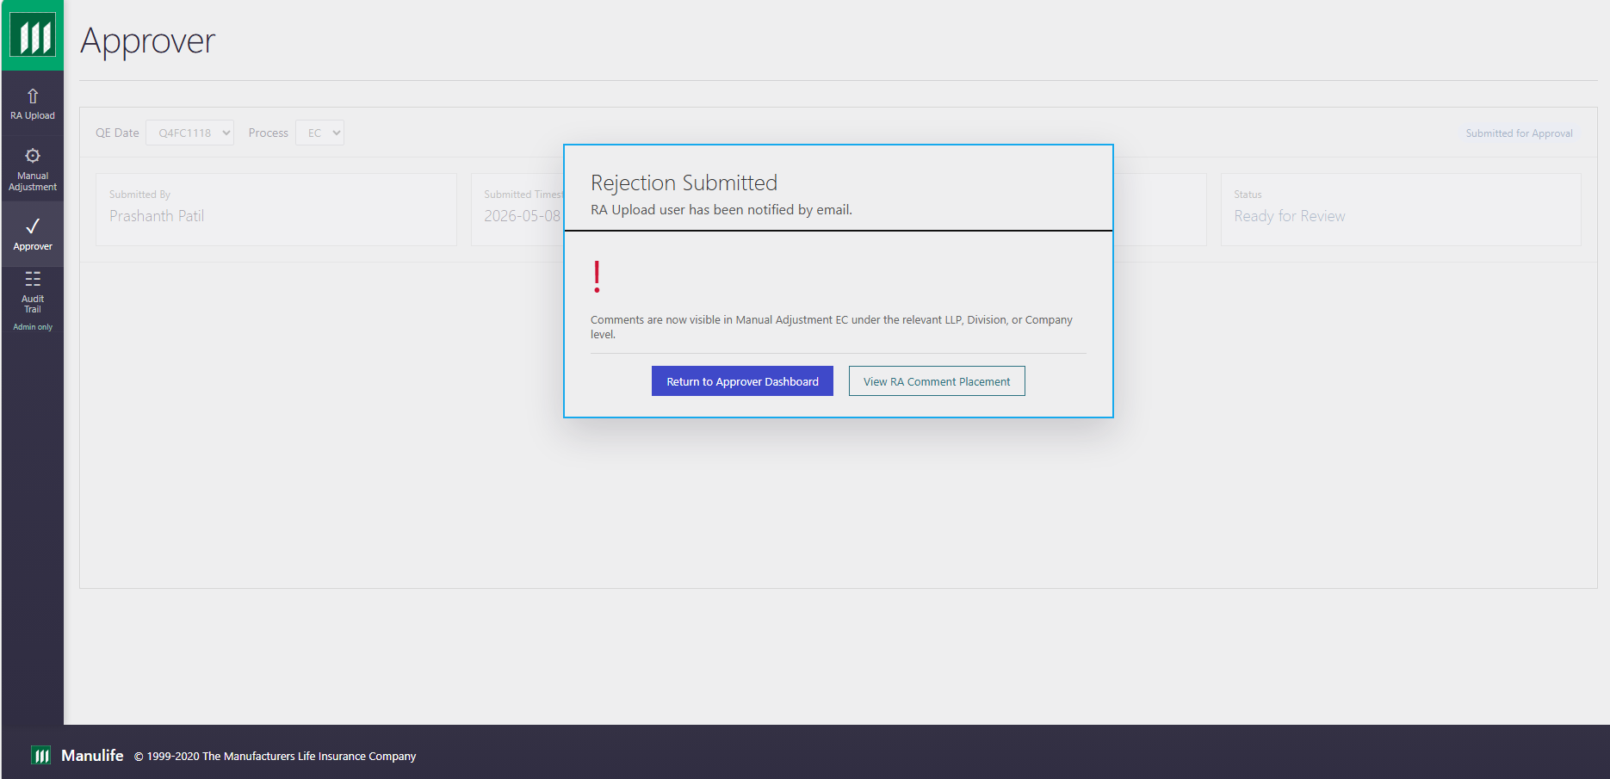

URL 21 — Approval Complete
URL Link: rda_url_24_approver_approval_complete.html
Actor | Objective | Preconditions | Postconditions
Approver | Approve the submitted EC result package when values are correct. | Approver is authenticated and a Manual Adjustment result package has been submitted for review. | Workflow status is updated and the user can proceed to the next screen.
Screen-to-screen context: This screen is part of the connected URL journey in the latest index and supports the business process flow shown at the start of the document.
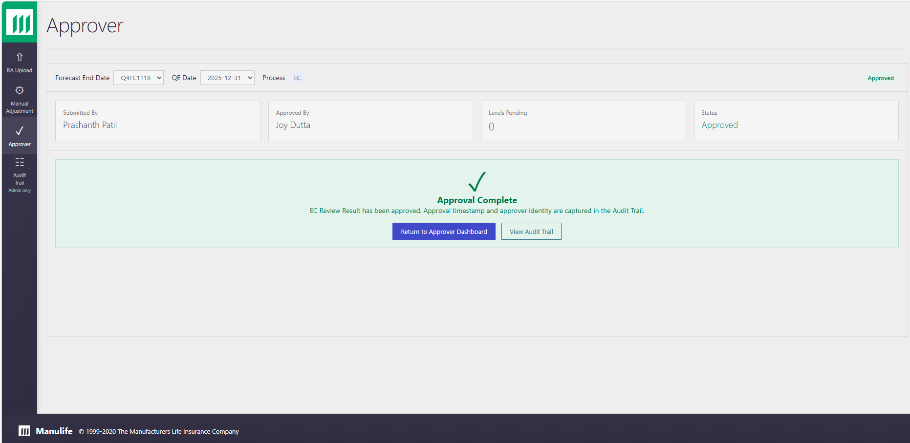

Audit Trail

URL 30 — Audit Trail Dashboard
URL Link: rda_url_30_audit_trail_dashboard.html
Actor | Objective | Preconditions | Postconditions
Site Admin | Review end-to-end site activity logs using admin filters. | Site admin is authenticated and audit logging data is available. | Relevant screen information is reviewed and the next user action is available.
Screen-to-screen context: This screen is part of the connected URL journey in the latest index and supports the business process flow shown at the start of the document.
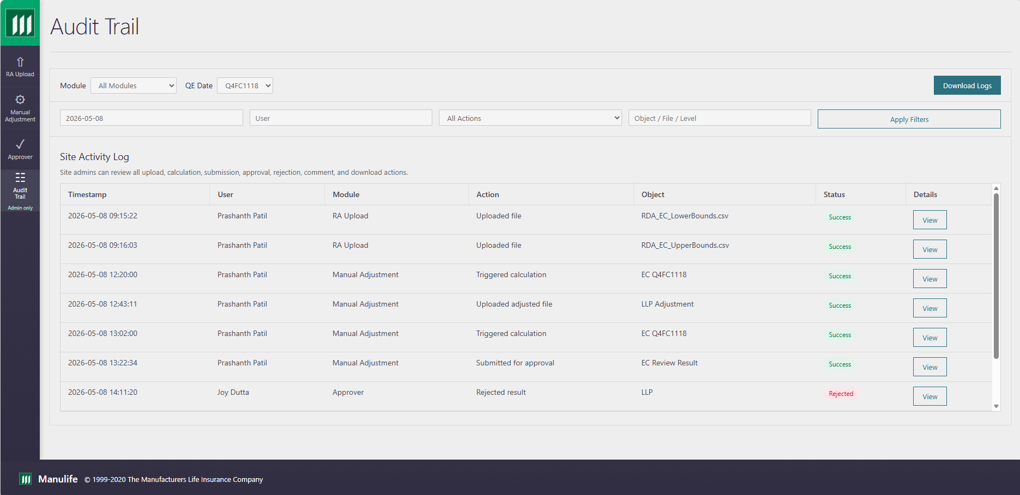

URL 31 — Audit Event Detail
URL Link: rda_url_31_audit_event_detail.html
Actor | Objective | Preconditions | Postconditions
Site Admin | Inspect the timeline and details for a selected audit event. | Site admin is authenticated and audit logging data is available. | Relevant screen information is reviewed and the next user action is available.
Screen-to-screen context: This screen is part of the connected URL journey in the latest index and supports the business process flow shown at the start of the document.
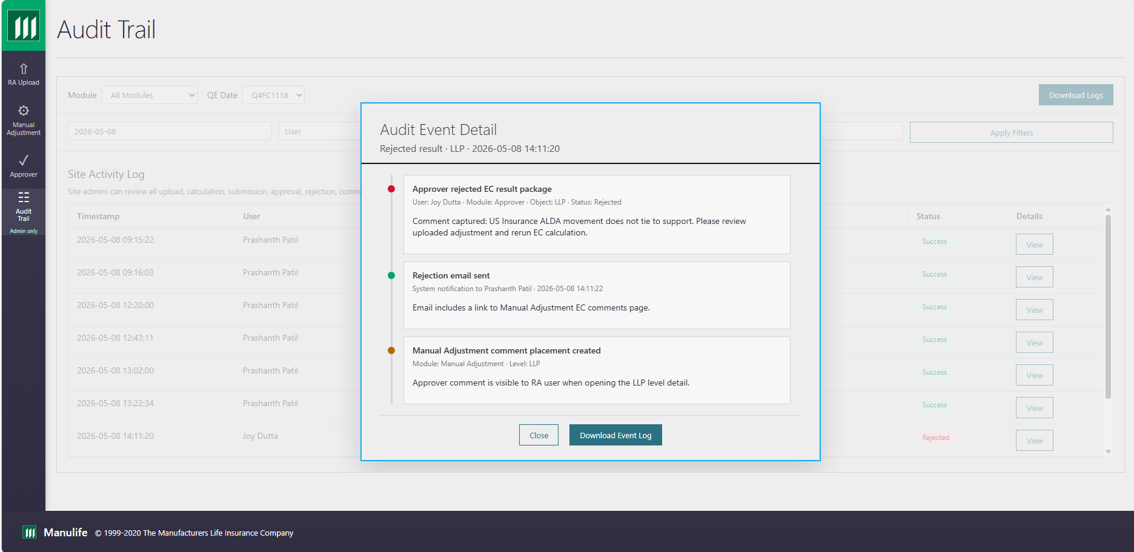

URL 32 — Download Audit Logs
URL Link: rda_url_32_audit_download_logs.html
Actor | Objective | Preconditions | Postconditions
Site Admin | Download filtered audit logs for admin review and evidence retention. | Site admin is authenticated and audit logging data is available. | Audit log extract is available for admin review.
Screen-to-screen context: This screen is part of the connected URL journey in the latest index and supports the business process flow shown at the start of the document.
