Business Process Diagram
This module deals with the Hedge Accounting Ineffectiveness for EAR workflow

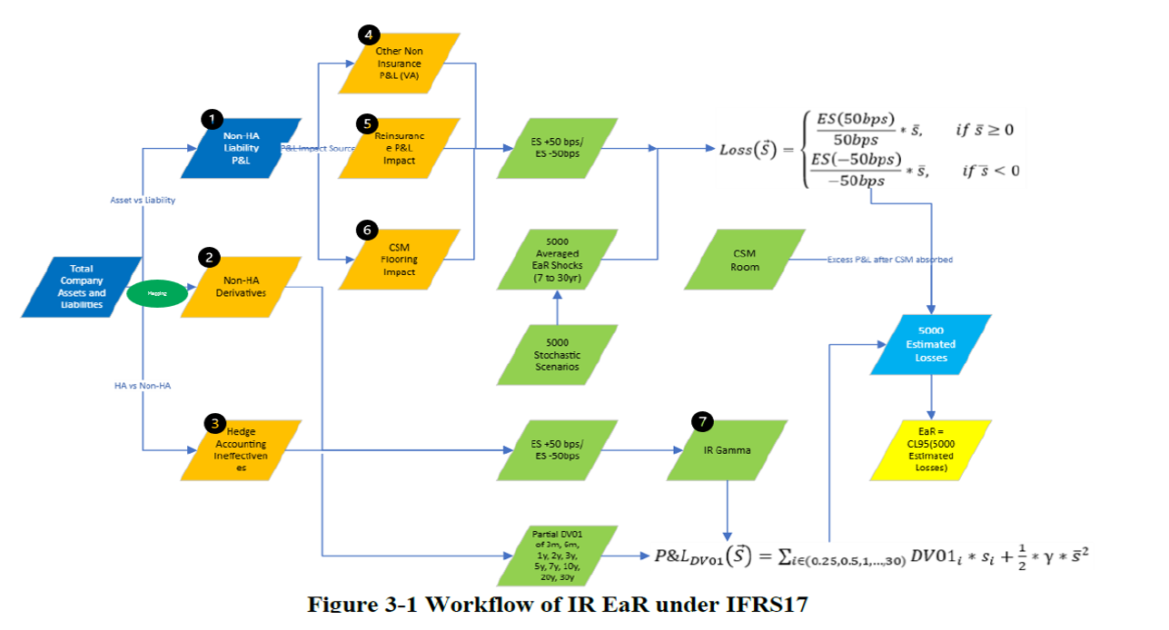

Excel files for reference
Output File | Output Worksheets
EaR Losses Ranking 2025.2.0 2026Q1 HA | #2. Partial DV01 - HA
 | #3. Losses - HA Liab no gamma
 | #3. Losses - HA Liab w gamma
 | #3. Losses - HA Liability
 | #3. Losses - HA Bond
 | #3. Losses - Manubank
 | #3. Losses - HA
 | EaR Losses

RDA Inputs
We have to load 3 datasets from ALM
 | Input
1 | ALM query:  - select top 10 * from alm_rpt.[frm].[v_ha_partial_dv01_derivatives]  where inception_date = '2026-05-01'  - select top 10 * from alm_rpt.[frm].[v_ha_partial_dv01_fixed_income]  where inception_date = '2026-05-01'  - select top 10 * from alm_rpt.[frm].[ v_ha_partial_dv01_liability]  where inception_date = '2026-05-01
2 | Monthly GAAP Rates Distribution file 20251031.xlsx - gfdo_dev_catalog.gft_rda_raw.irr_ec_forecasting_ifs_fx_rates_raw
3 | 2026 Q1 Tax Rates (A&R).xlsx -  gfdo_dev_catalog.gft_rda_semantic.irr_mapping_heirarchy_mapping_latest

Data Loading process steps summary:
There are two steps involved in data ingestion process
Step1: Data loading into Raw Layer where the data is from the source system from the ALM data to the raw layer in ADB.
Schema: gft_rda_raw
Refresh Frequency: Quarterly
Refresh Time: BD7, 9 AM EST
Mapping details:
Description: | Here we are loading the three data sets from the source ALM DV01 query to the table as is into the raw table for the asofdate equal to the latest quarter end date
Source Table: | Source data is fetched from the FRM Query in ALM Database
Target Table: | irr_ear_reporting_dv01_fi_raw, irr_ear_reporting_dv01_derivatives_raw, irr_ear_reporting_dv01_liab_post_hp_raw.
S2TM link: | S2TM_DV01_Raw_tables.xlsx

Step 2: Do the computation and store the computed data in intermediate tables in curated layer to derive the final output for Ineffectiveness module
Schema: gft_rda_curation
Refresh Frequency: Quarterly
Refresh Time: TBD
Mapping details:
2.1
Description: | Here we are calculating Partial_DV01 sum based on the calculation provided. The calculation from where the data will be picked up based on rules defined by business based on program_code, legal_id and security_currency which are defined here - HA DV01 mapping_NT_LLP.xlsx
Source Tables: | irr_ear_reporting_dv01_fi_raw, (row 1) irr_ear_reporting_dv01_derivatives_raw, (row 2) irr_ear_reporting_dv01_liab_post_hp_raw, (row 4) gfdo_dev_catalog.gft_rda_raw.irr_ec_forecasting_ifs_fx_rates_raw  gfdo_dev_catalog.gft_rda_semantic.irr_mapping_heirarchy_mapping_latest
Target Table Name: | Irr_ear_forecating_partial_dv01
S2TM link: | STM_HA_Ineffectiveness.xlsx

2.2
Description: | Here we are calculating the Losses for different segments which are losses_ha_no_gamma, losses_ha_wth_gamma, losses_ha_liab, losses_ha and ear_losses
Source Tables: | irr_ear_reporting_partial_dv01, irr_ear_reporting_rf_ear_shocks_raw, irr_ear_reporting_csm_flooring_avg_shocks
Target Table Name: | irr_ear_reporting_losses
S2TM link: | STM_HA_Ineffectiveness.xlsx

2.3
Description: | Here we are calculating the 95th percentile of the losses of each segment
Source Tables: | irr_ear_reporting_losses
Target Table Name: | irr_ear_reporting_percentile
S2TM link: | STM_HA_Ineffectiveness.xlsx

2.4
Description: | This is the static csv file which will be uploaded from UI
Format: | csv
Link: | ha_dv01_llp_csv.csv

