**Event severity**

The severity of an event determines if a problem should be raised and if Davis AI should determine the root cause of the given event.

| **Severity** | **Problem raised** | **Davis analysis** | **Semantic** |
| --- | --- | --- | --- |
| Availability | Yes | Yes | Reports any kind of severe component outage. |
| Error | Yes | Yes | Reports any kind of degradation of operational health due to errors. |
| Slowdown | Yes | Yes | Reports a slowdown of an IT component. |
| Resource | Yes | Yes | Reports a lack of resources or a resource-conflict situation. |
| Info | No | Yes | Reports any kind of interesting situation on a component, such as a deployment change. |
| Custom alert | Yes | No | Triggers an alert without causation and Davis AI involved. |

<https://www.dynatrace.com/support/help/platform-modules/infrastructure-monitoring/networks/how-to-monitor-network-communication>

<https://www.dynatrace.com/support/help/observe-and-explore/purepath-distributed-traces#expand--what-are-attributes--5>  
<https://www.dynatrace.com/hub/detail/remote-linux-monitoring/?_ga=2.213608476.964917701.1687851526-861211586.1678159883#overview>

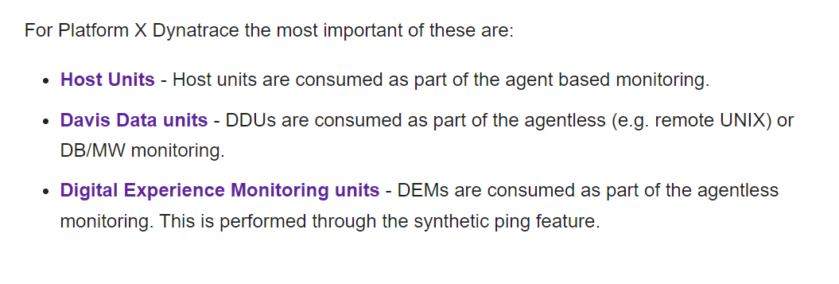

<https://community.dynatrace.com/t5/Alerting/Alarm-threshold-based-on-number-of-worker-processes/m-p/121603#M1695>

<https://docs.dynatrace.com/docs/observe/digital-experience/synthetic-monitoring/private-synthetic-locations/create-a-private-synthetic-location#rh-centos--red-hat-8>

|  |  |  |  |  |
| --- | --- | --- | --- | --- |
| **Default Ports** | **Ports** | **Category** | **Monitor Type** | **Rule Context** |
| HTTPS 443 | HTTPS 443 | Vcenter / ESX | Vcenter Monitoring | ActiveGate ->Managed Device |
| TCP 22 | TCP 22 | Linux/Unix Agentless | HPUX Monitoring Solaris - Unsupported or EOL Linux - Unsupported or EOL Unsupported UNIX | ActiveGate ->Managed Device |
| TCP/UDP 162 | TCP/UDP 162 | Network/Storage | SNMP Managed Device (SNMPTrap) | Device -> Activegate |
| TCP 1521 | TCP 1521 | Database | Oracle Monitoring | ActiveGate ->Managed Device |
| TCP 1433 | TCP 1433 | Database | MSSQL | ActiveGate ->Managed Device |
| TCP 50000 TCP 25000 | TCP 50000 TCP 25000 | Database | DB2 | ActiveGate ->Managed Device |
| TCP 5432 | TCP 5432 | Database | PostgreSQL | ActiveGate ->Managed Device |
| TCP 3306 | TCP 3306 | Database | MySQL / MariaDB | ActiveGate ->Managed Device |
| TCP 10514 UDP 514 | TCP 10514 UDP 514 | Log Monitoring | Syslog | Managed Device->ActiveGate |
| HTTPS 8443 | HTTPS 8443 | Log Monitoring | Dell Power Protect Data Manager | ActiveGate ->Managed Device |
| TCP 1556 | TCP 1556 | Log Monitoring | NetBackup | ActiveGate ->Managed Device |
| TCP 449 TCP 8470-8476 (NON SSL) TCP 9470-9476 (SSL) | TCP 449 TCP 8470-8476 (NON SSL) TCP 9470-9476 (SSL) | IBM i | IBM I (AS400) Monitoring | ActiveGate ->Managed Device |
| ICMP (Ping) | ICMP (Ping) | Synthetic Ping (NAM) | Availability | ActiveGate ->Managed Device |
|  |  |  |  |  |

<https://www.dynatrace.com/hub/detail/ibm-i/?query=ibm-i&filter=all&offered=dynatrace>

<https://www.ibm.com/support/pages/ibm-i-access-client-solutions>

IBM i Access - Client Solutions

IBM i Access

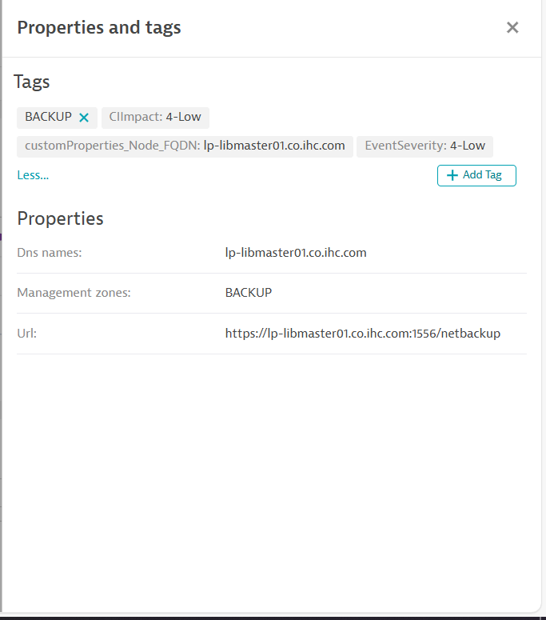

[Kubernetes API Monitoring — Dynatrace Docs](https://docs.dynatrace.com/docs/ingest-from/setup-on-k8s/guides/operation/k8s-api-monitoring#connect--connect-manually)<https://www.youtube.com/@BMCdocs/playlists>

[Ansible collections | Ansible Documentation](https://docs.ansible.com/collections.html)

Ansible collections | Ansible Documentation

Ansible Documentation

[Collection Index — Ansible Community Documentation](https://docs.ansible.com/ansible/latest/collections/index.html)

Collection Index — Ansible Community Documentation

[Ansible.Builtin — Ansible Community Documentation](https://docs.ansible.com/ansible/latest/collections/ansible/builtin/index.html)

Ansible.Builtin — Ansible Community Documentation

***--set-monitoring-mode=infra-only***