**Case-Study-Ansible**

1. Create 3 EC2 instances

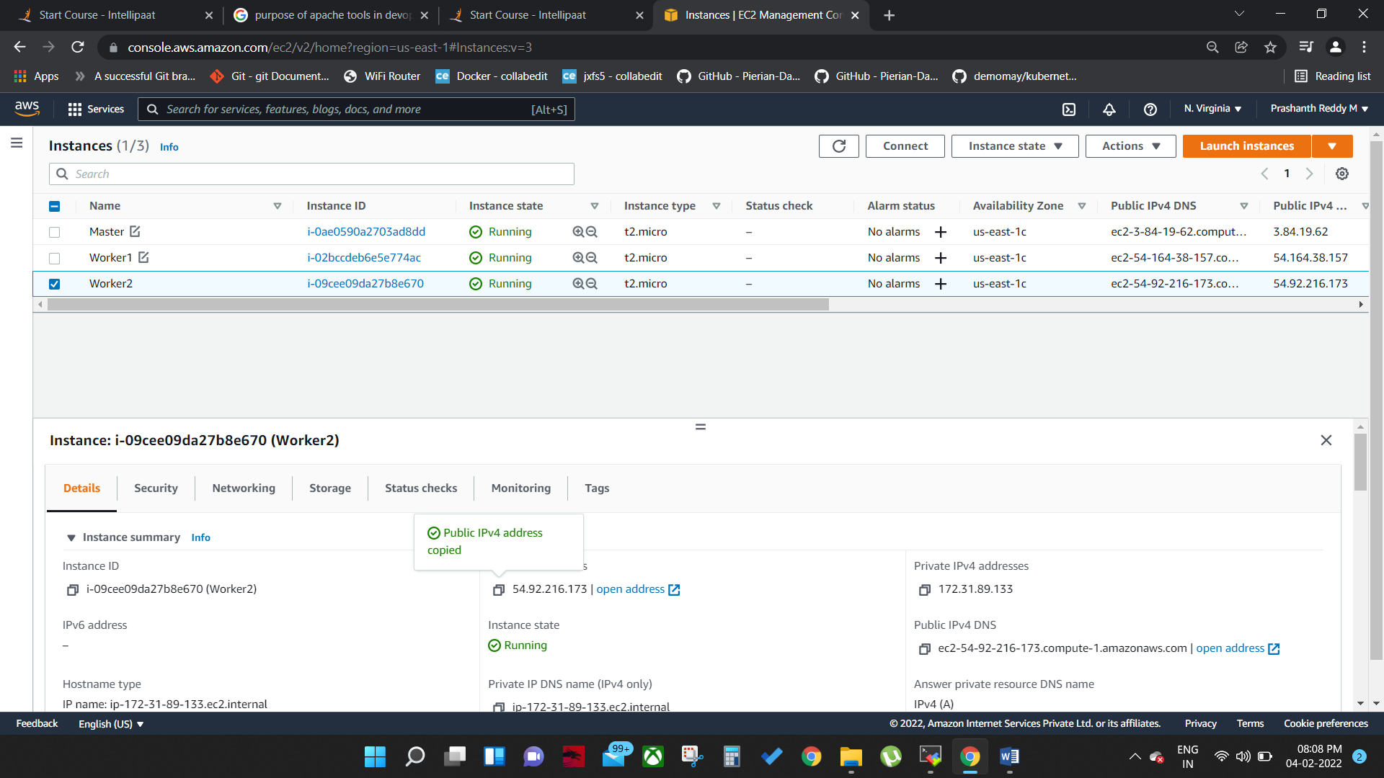

1. Open all instances in terminal
2. Update all instances

***#sudo apt-get update***

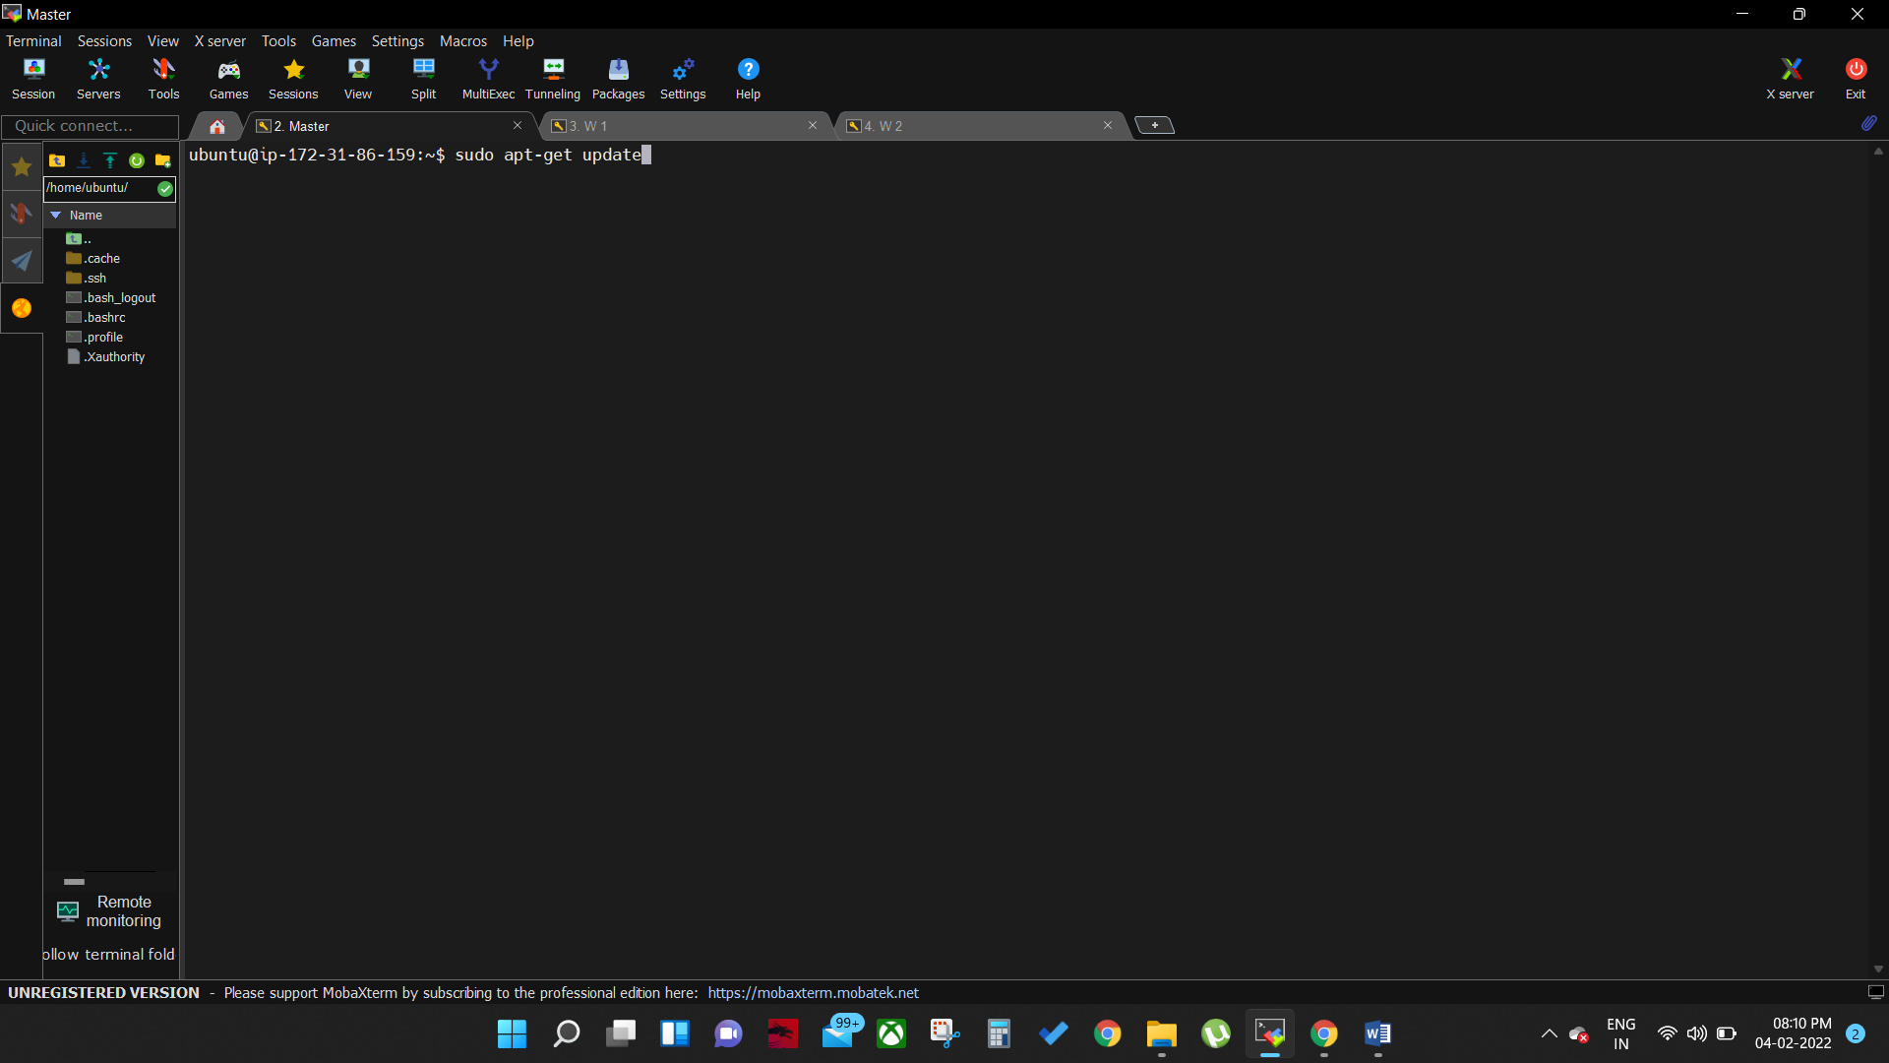

1. Enter following command to setup Ansible in master machine

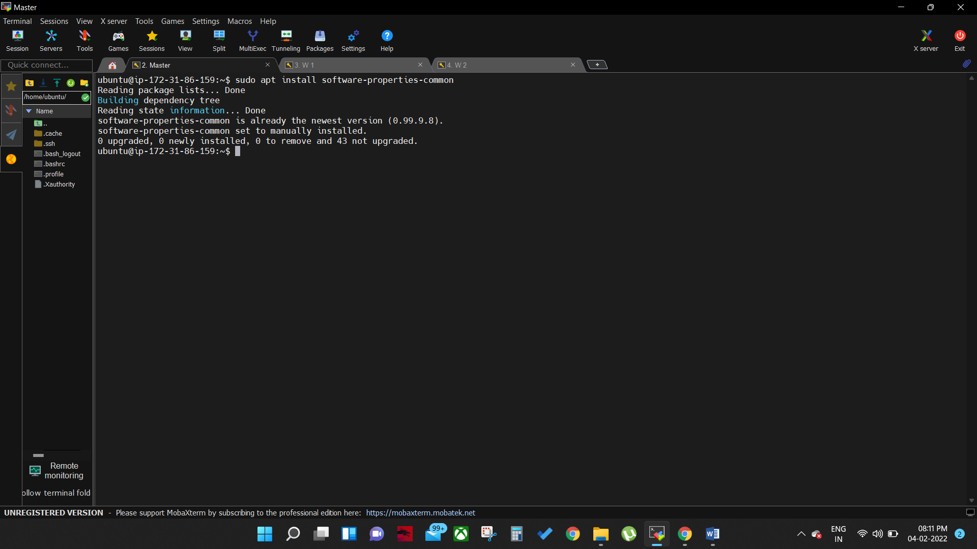

***#sudo apt install software-properties-common***

***#sudo apt-add-repository ppa:ansible/ansible*** (add ansible repo)

***#sudo apt-get update***

***#sudo apt install ansible***

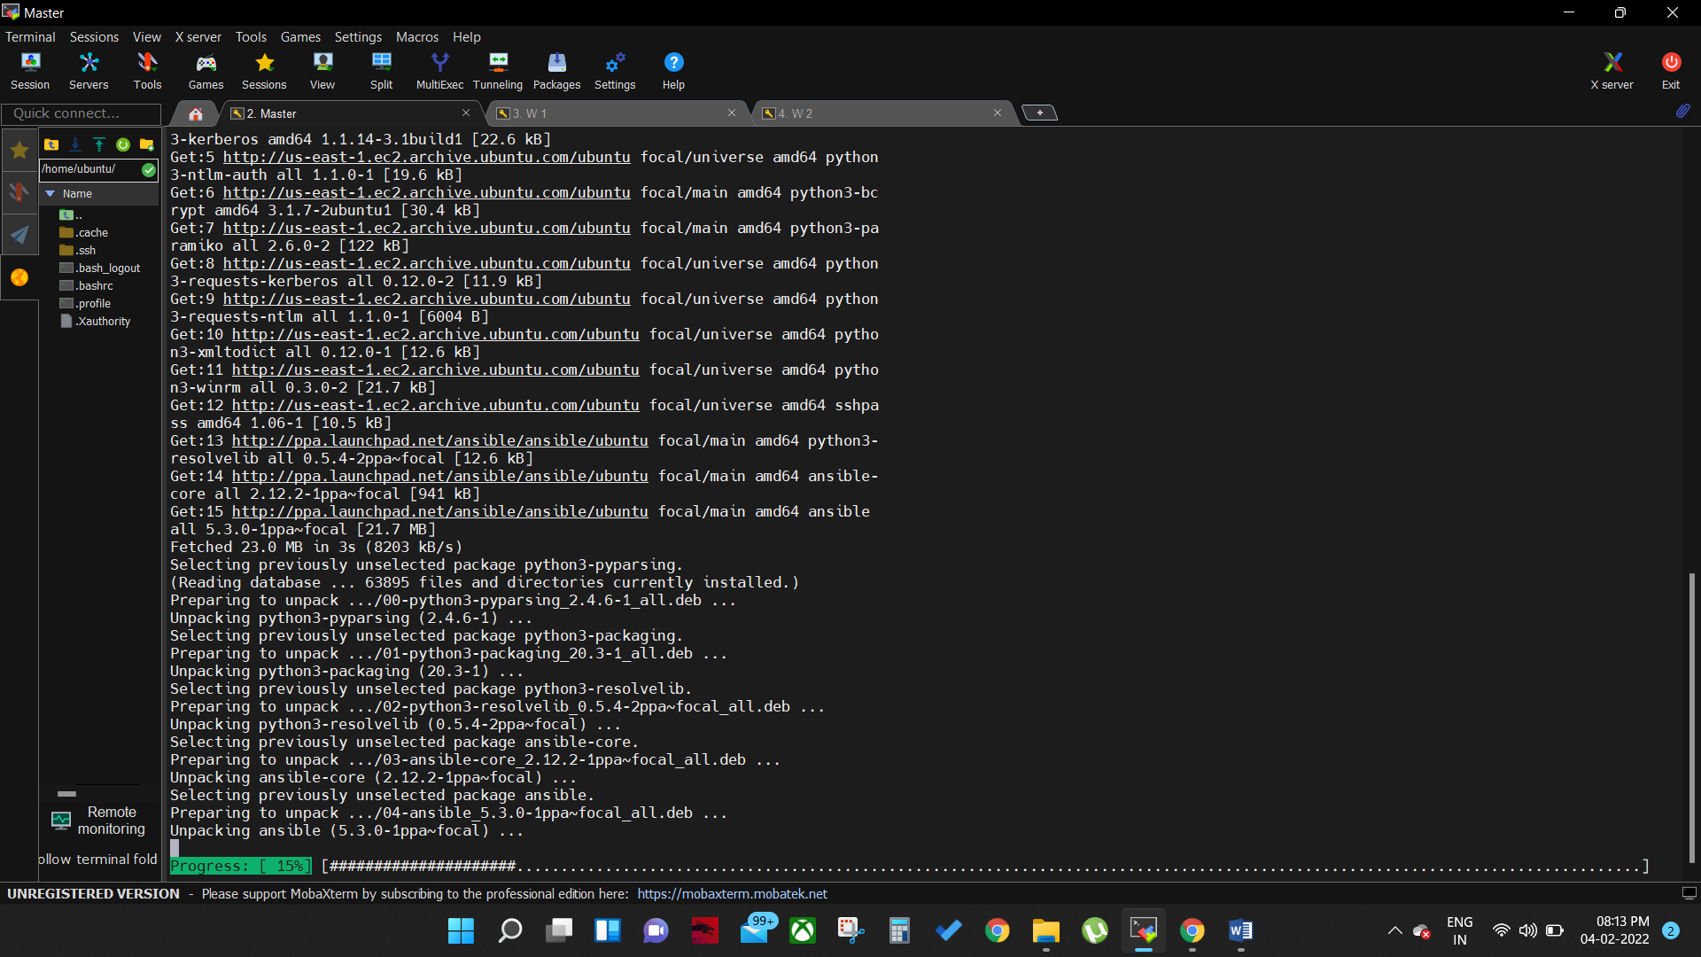

1. Now update and install python In slave machines

***#sudo apt install python***

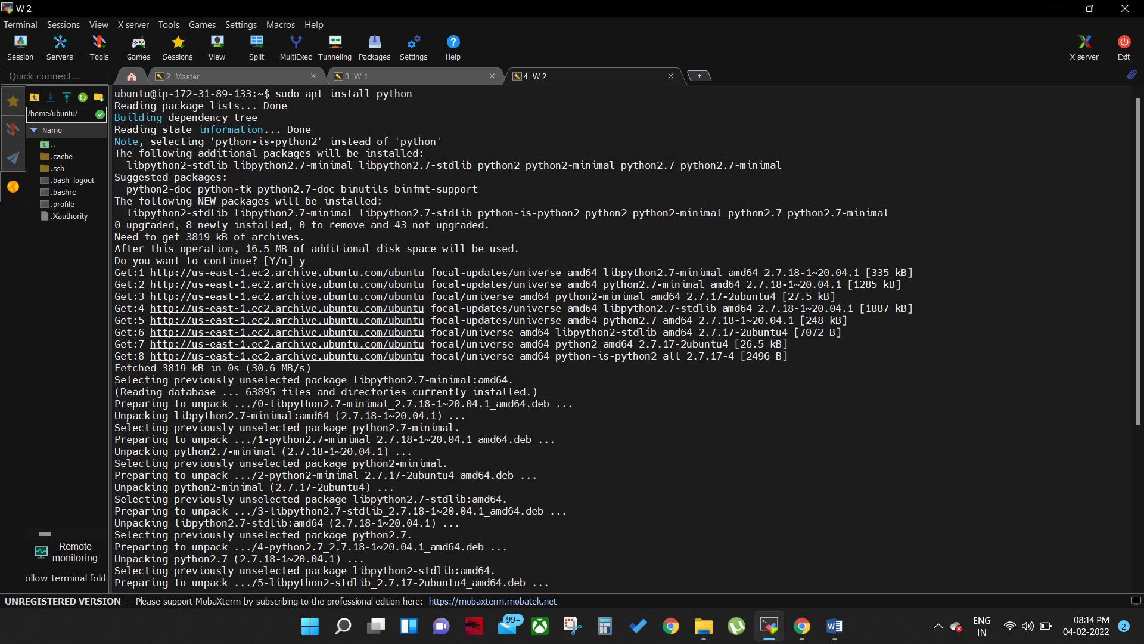

1. Now do this in master to comunicate master with worker1 and worker2 machines
2. In master

***#cd .ssh***

***#ls*** (authorised_key)

***#ssh-keygen*** (enter) (enter) (enter)

***#ls*** (authorised_key) (id_rsa.pub) (id_rsa)

***#cat id_rsa.pub***

1. Copy the generated key and paste it in worker 1& 2 machines

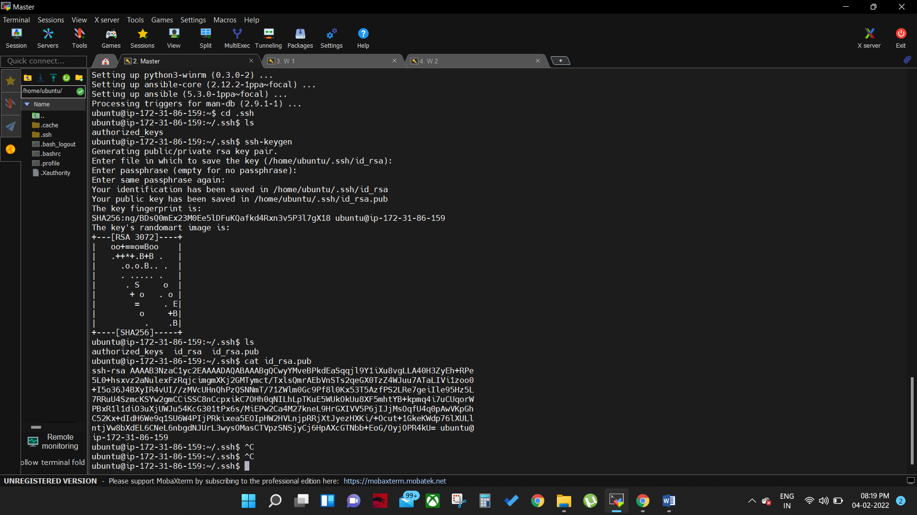

1. In slave machines

***# cd .ssh***

***# nano authorised_key***

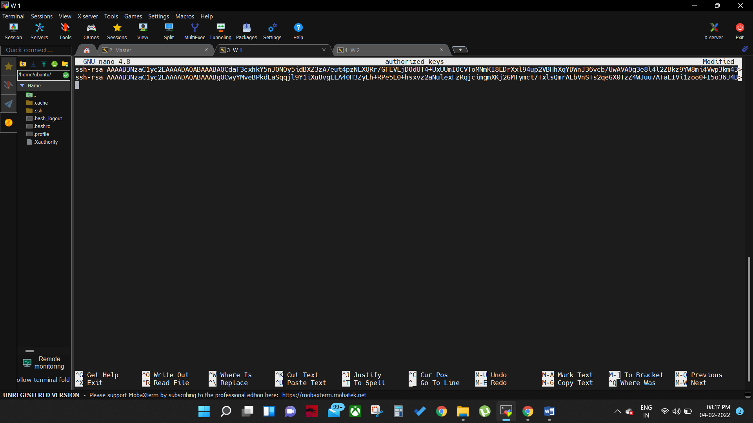

1. To check the connection between the master and workse machines

***# ssh ubuntu@54.164.38.157***

1. Now master machines are sucessesfully connected to worker machines
2. to set up ansible in worker machines copy the rip (do this in master)

***# sudo nano /etc/ansible/hosts***

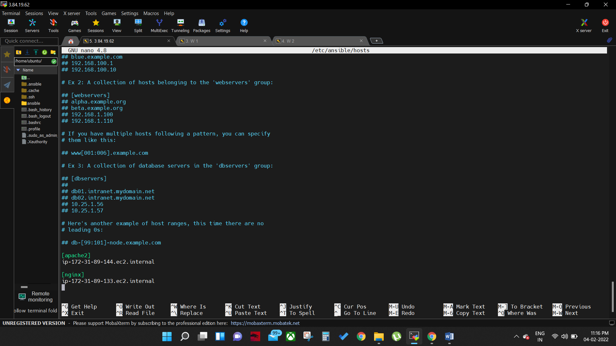

1. chech the conncetion with worker nodes

***#ansible –m ping all***

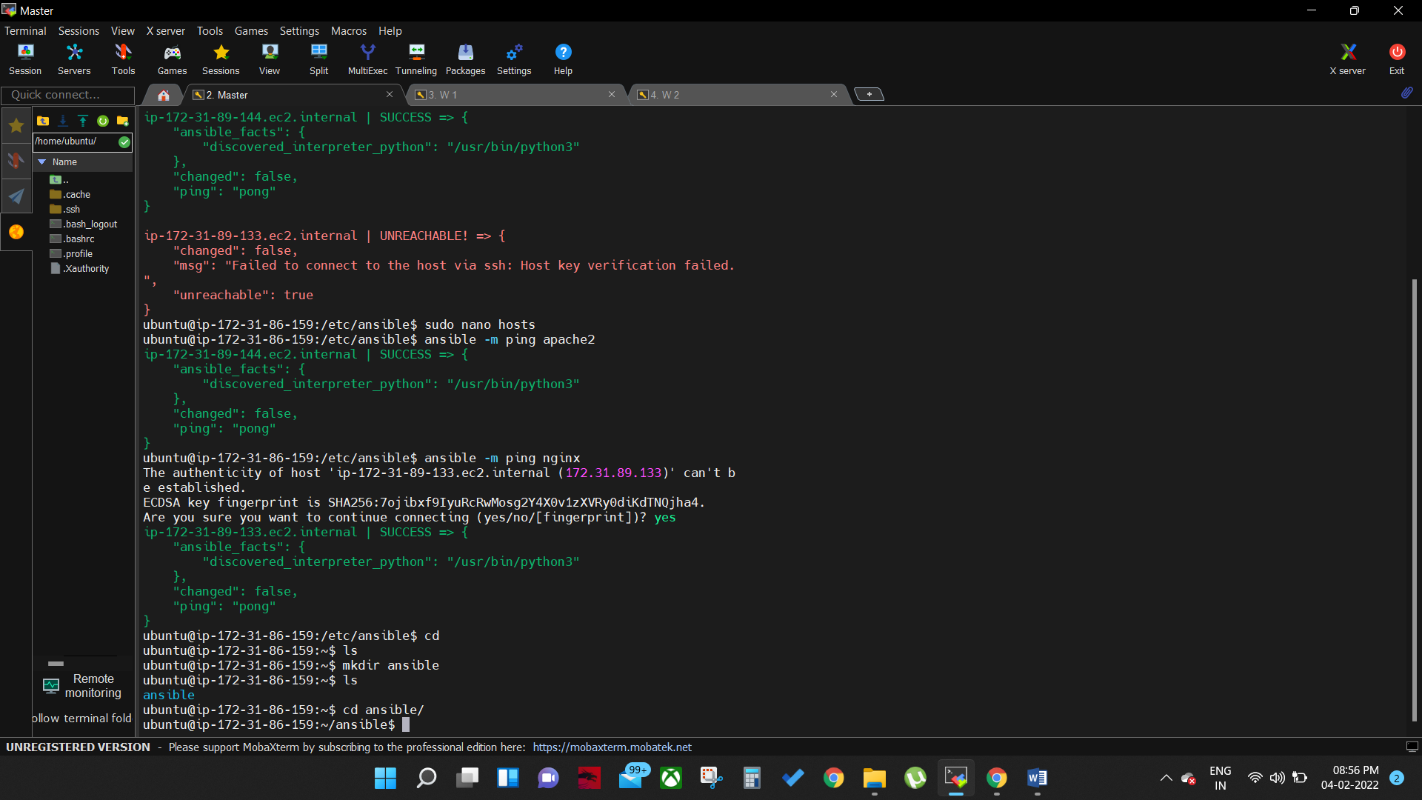

1. Now create ansible rolles

***# cd /etc/ansible/roles***

***#sudo ansible-galaxy init role1***

***#sudo ansible-galaxy init role2***

***#cd /etc/ansible/roles***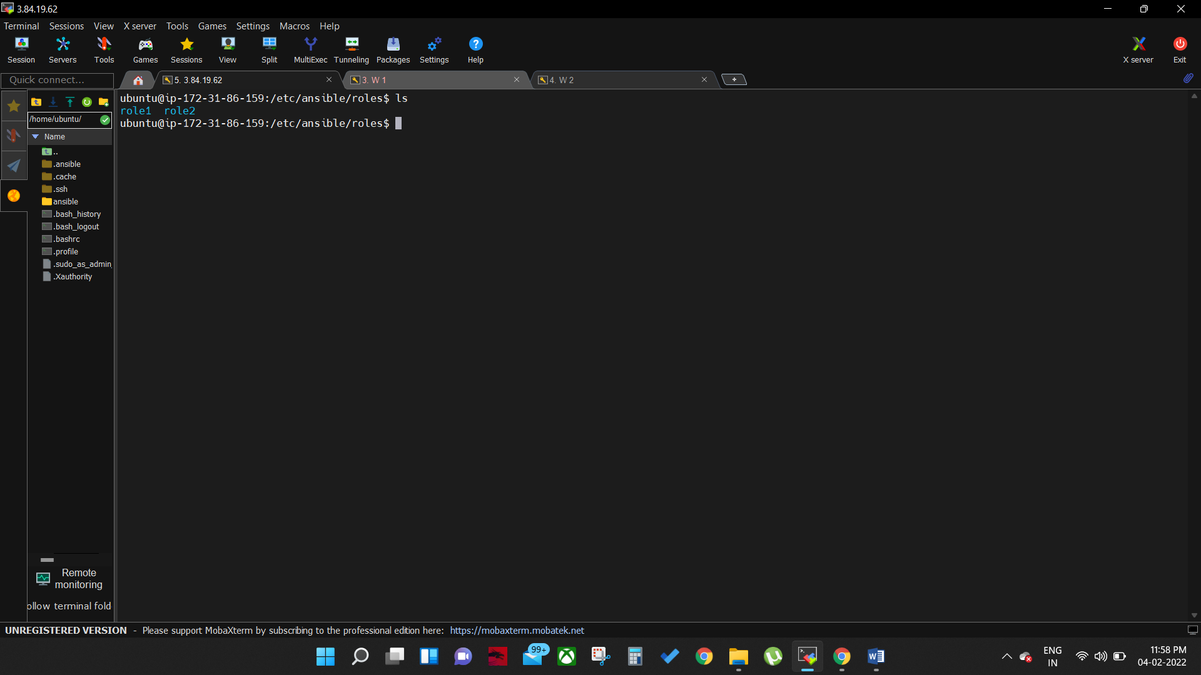

1. Now two roles are created in master, setup the work to role1 i.e install apache and java

***#cd role1/tasks***

1. Create install.yml file

***#sudo nano install.yml***

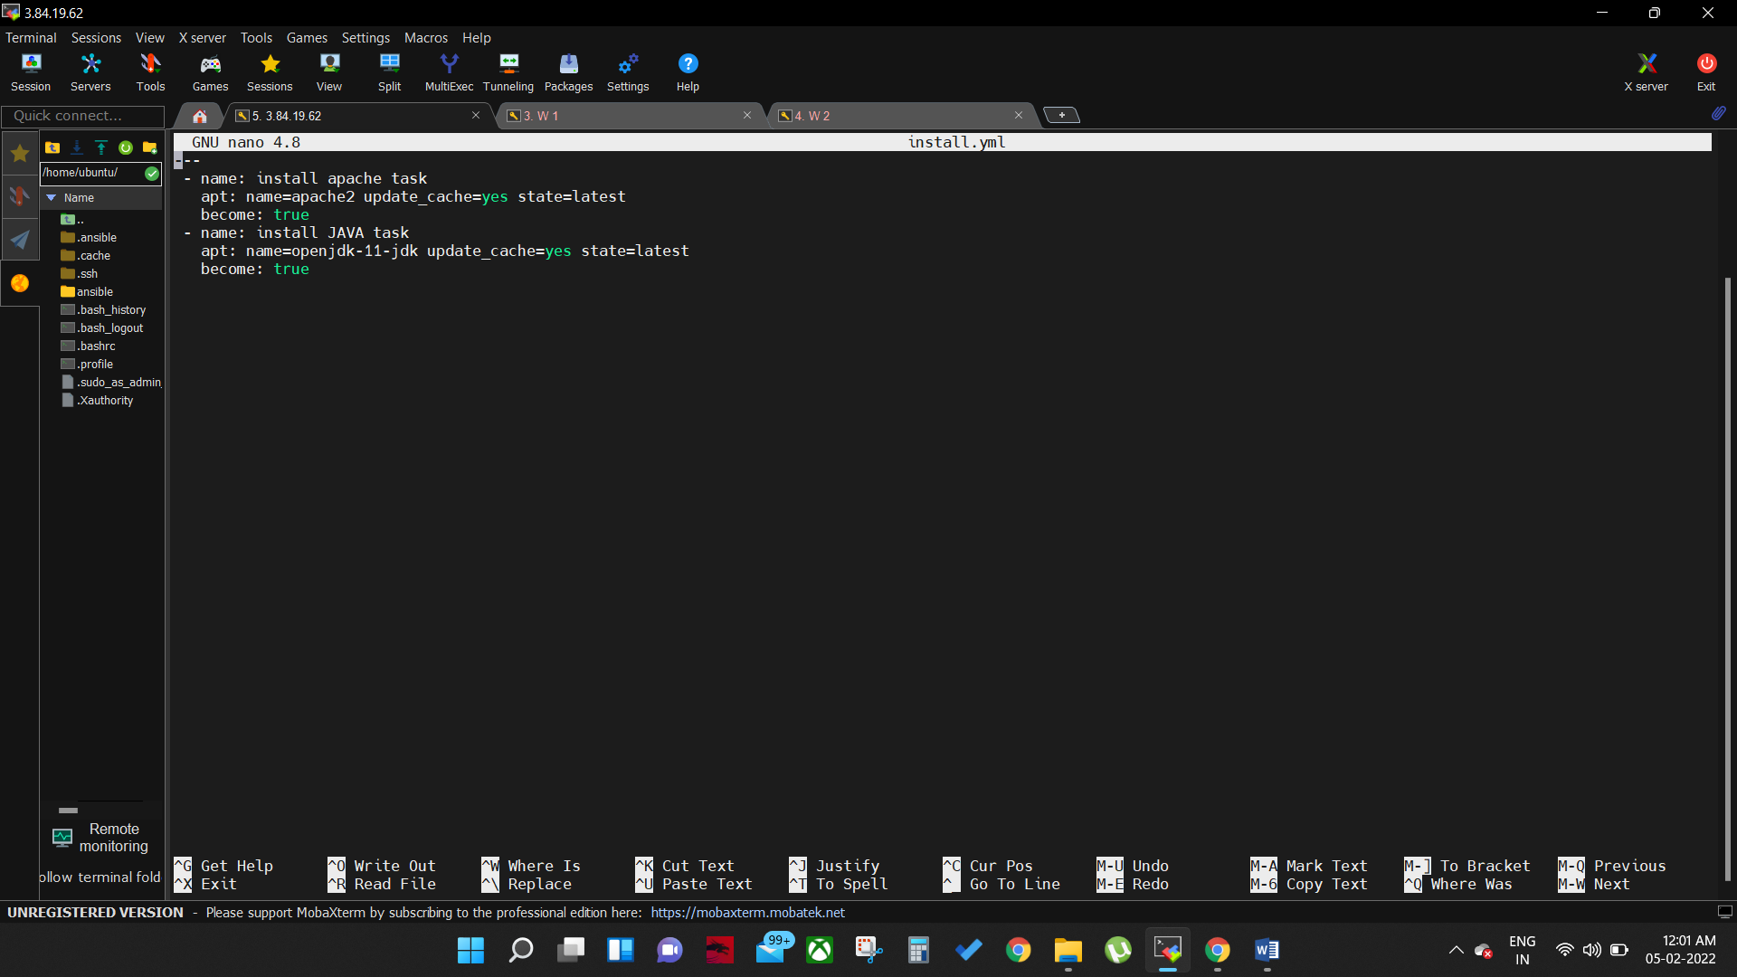

1. Save and exit then create confiuration yaml file

***#sudo nano config.yml***

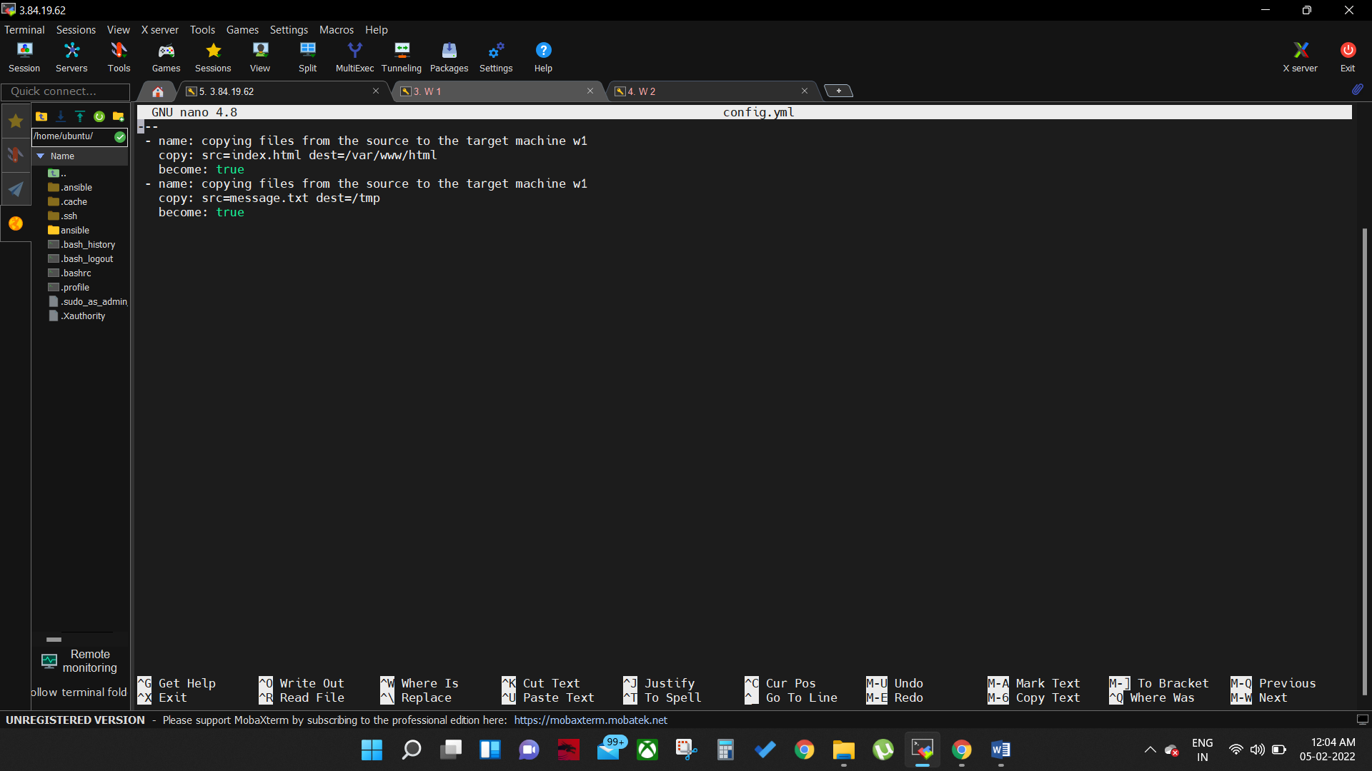

1. Create service.yml file

***#sudo nano service.yml***

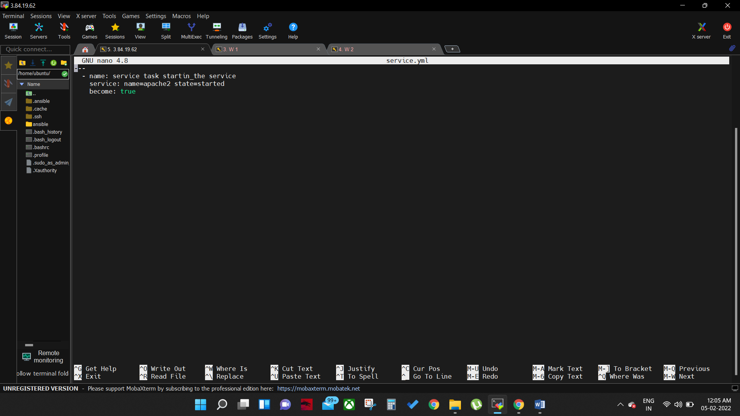

1. Create java.yml file

***#sudo nano java.yml***

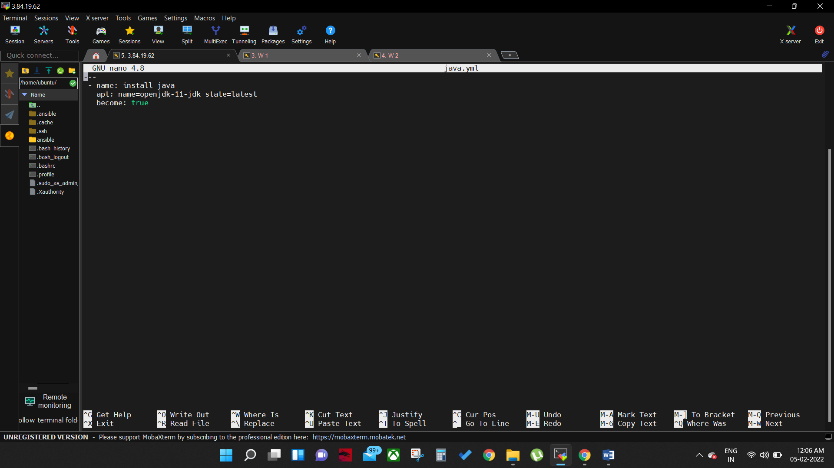

1. Now add these all files in main.yml

***#sudo nano main.yml***

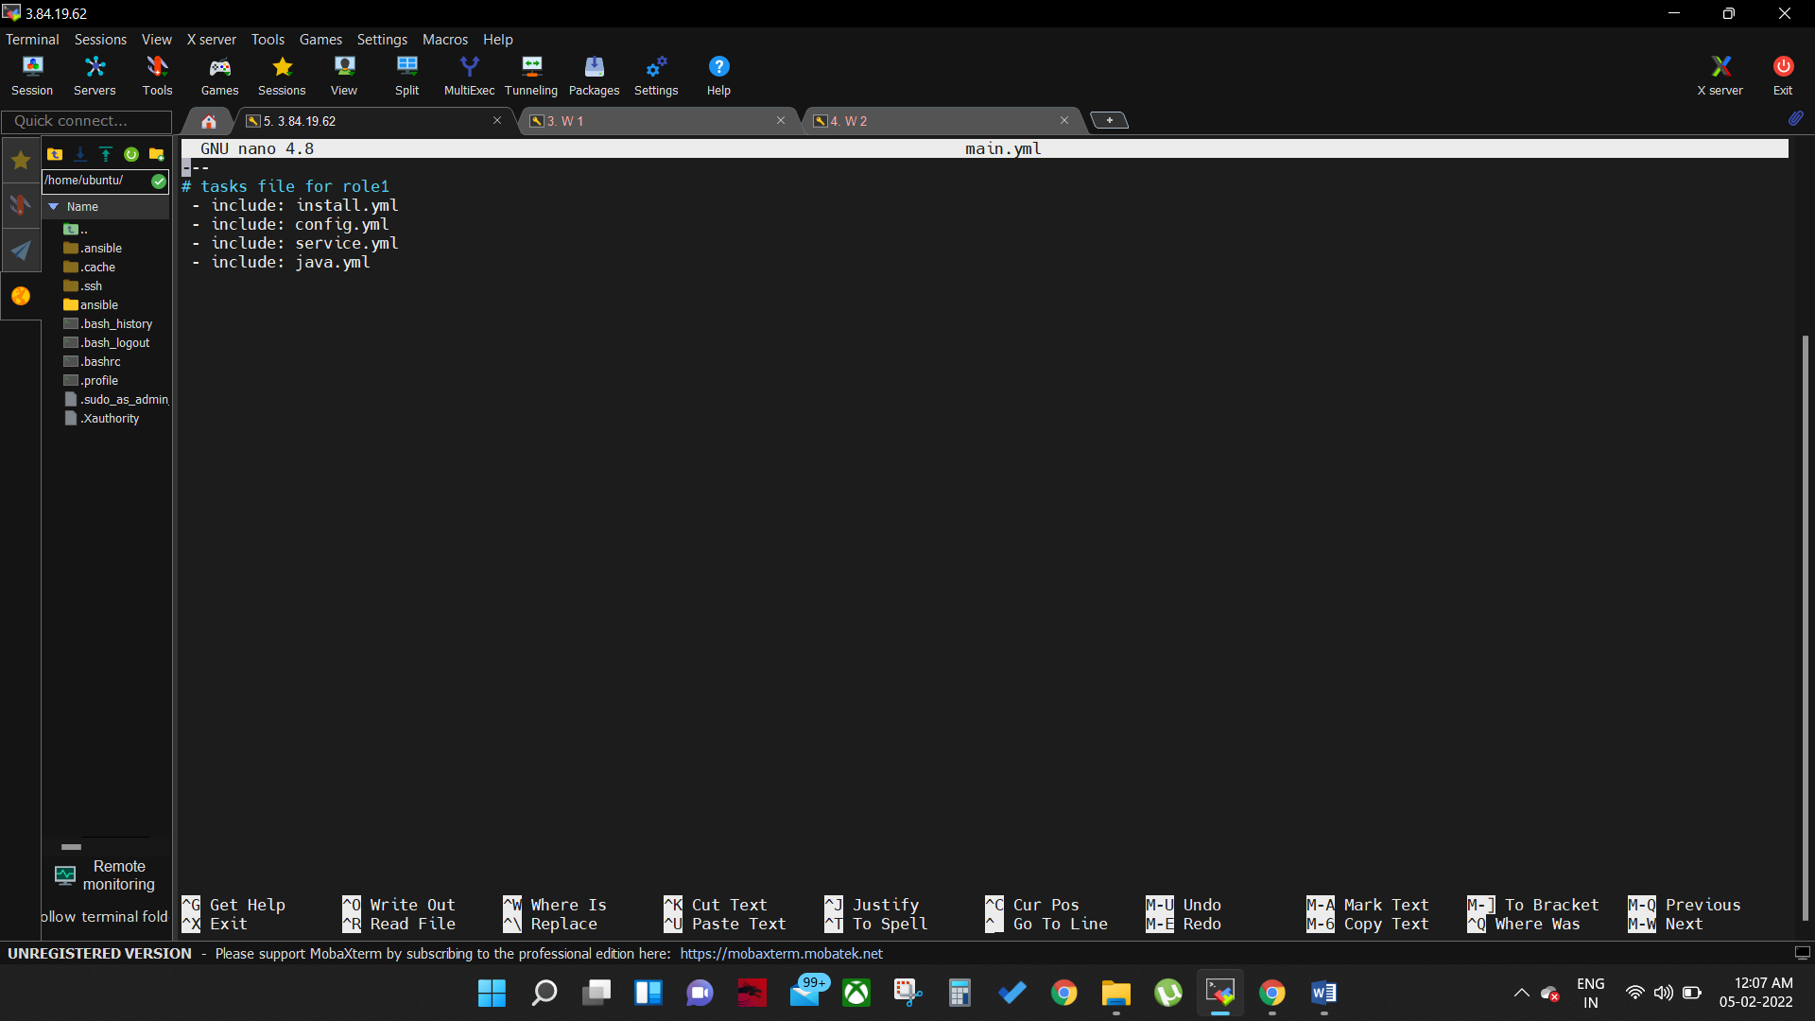

1. Go back to the role1 folder then add files index.html and message.txt

***#sudo nano index.html (add web page content here)***

***#sudo nano message.txt (add master message heare)***

1. Create playbook.yml file

***#sudo nano playbook.yml***

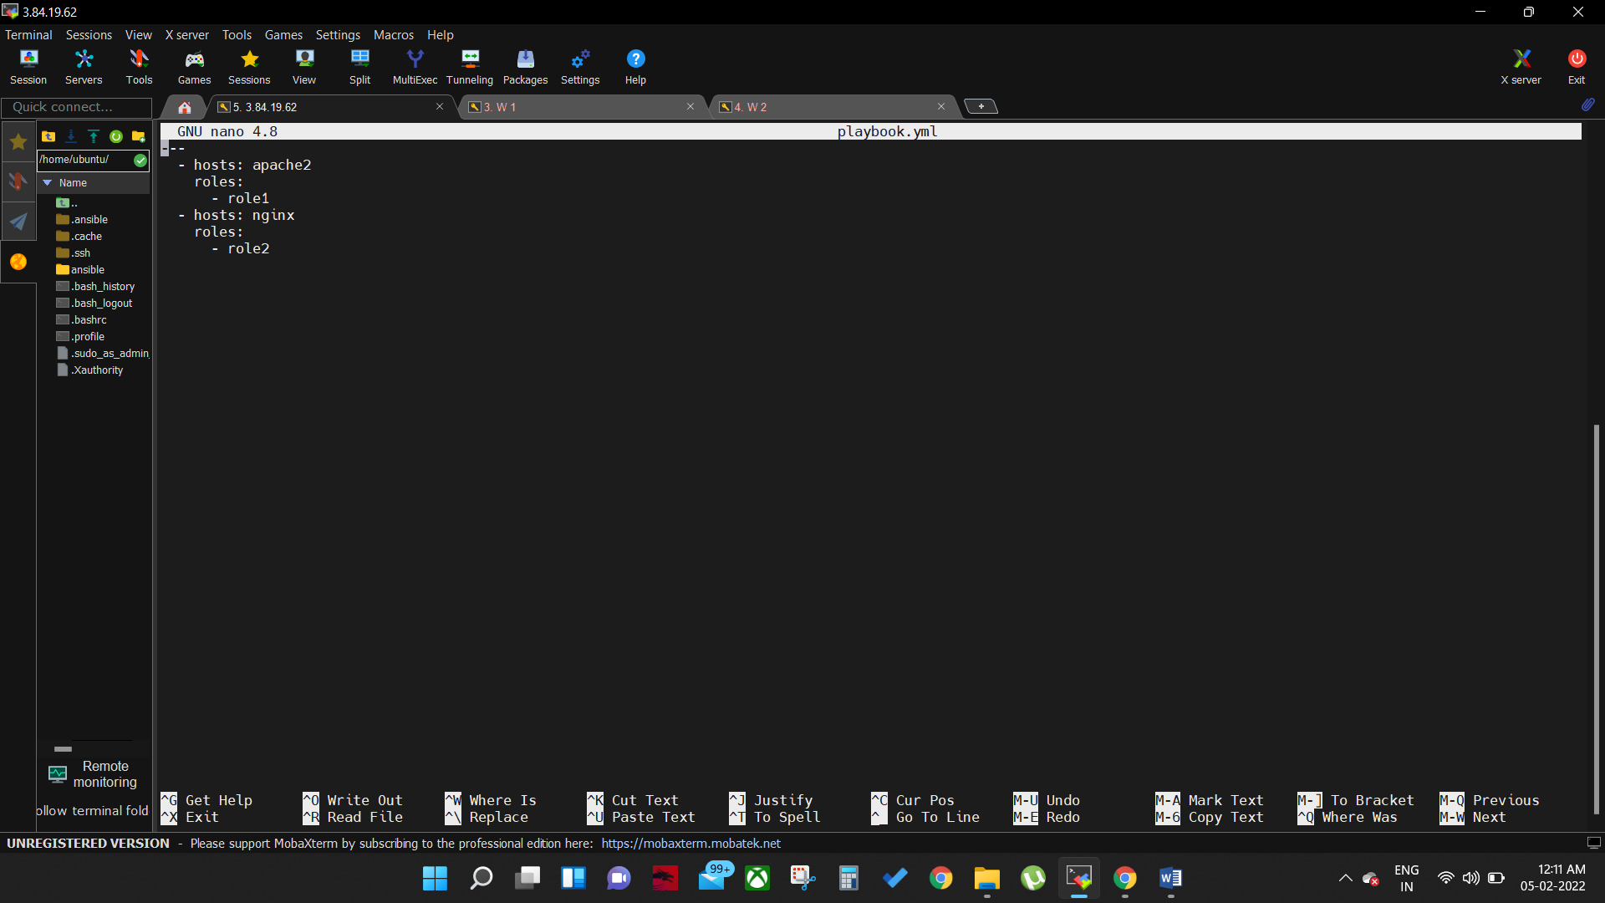

1. Run the ansible now

***#ansible-playbook playbook.yml***

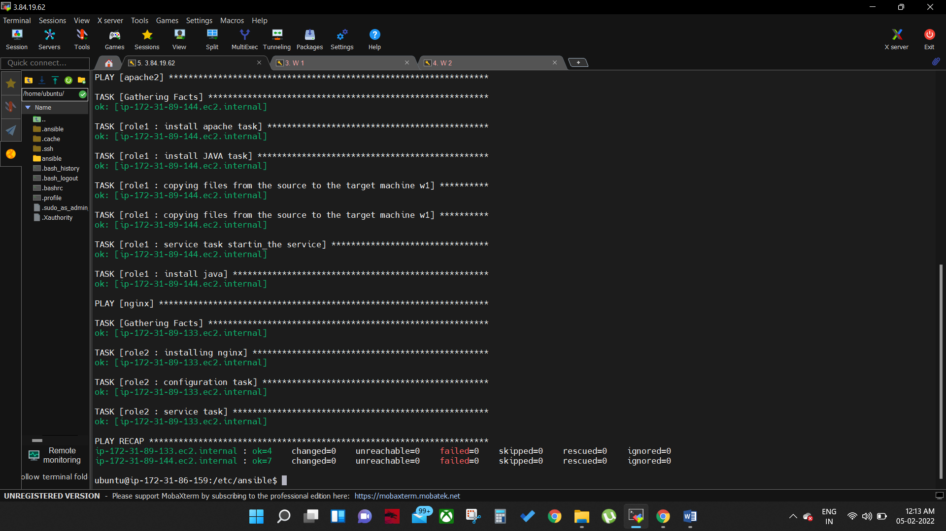

1. Do the same for role2 and install nginx server