1. Launch an AWS Instance
2. Connect through SSH
3. Execute the following commands:

**Jenkins Installation:**

***#sudo apt-get update***

***#sudo apt install openjdk-8-jdk***

***#wget -q -O - https://pkg.jenkins.io/debian/jenkins.io.key | sudo apt-key add -***

***#sudo sh -c 'echo deb http://pkg.jenkins.io/debian-stable binary/ > /etc/apt/sources.list.d/jenkins.list'***

***#sudo apt update***

***# sudo apt install Jenkins***

1. <I.P Address>:8080

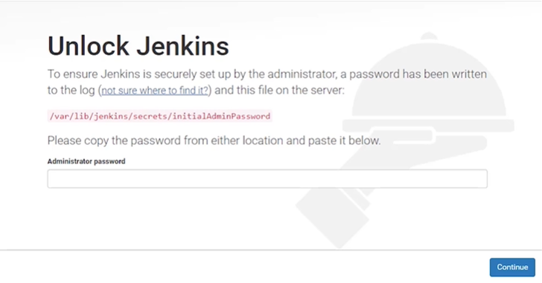

1. Copy /var/lib---- path and paste in terminal

#sudo cat /var/lib/Jenkins/secrets/installadminpassword

asgeuy3agbiwuW62Y791TG9UQ9WYE

1. Copy the password and paste it in web
2. Install suggested plugins
3. Now plugins are start download
4. Give username password name and email id
5. Start using Jenkins
6. Manage Jenkins 🡪 Configure global security 🡪 Agents 🡪 TCP Port for JNLP agent 🡪 Random 🡪 Save
7. Manage Jenkins 🡪 Manage Nodes 🡪New Node 🡪Give the name to the node
8. Remote root directory 🡪 /home/ubuntu/Jenkins
9. Click slave 2 🡪 download 2 files 🡪agent.jar and launch(slave agent.jar)
10. Update slave machine
11. Using the file Zella transfer the that 2 downloaded files
12. In slave do this

***#sudo apt-get update***

***#sudo apt install openjdk-8-jdk***

1. Now go to web and copy the link from slave machine
2. Create directory Jenkins in slave

***#mkdir Jenkins***

***#sudo <link from slave machine( java –jar agent.jar –jnlpUrl---->***

1. Create new job 🡪 freestyle project (Give Name) 🡪git hub project (paste git url) Restrict where this project can be (Select Slave1) 🡪 source code management 🡪 git 🡪save
2. Now git job is create in Jenkins web
3. Click build now to build git project in slave machine

Now integrate with Docker

#cd wesite

#nano Dockerfile

From gitname/webapp

RUN rm /var/www/html/inde.html

ADD ./index.html /var/www/html

1. On website folder

#sudo docker build . –t test

#sudo docker run –it –p 80:80 –d test

#sudo docker ps to test container

#sudo docker stop <Docker I.D>

#sudo docker start<Docker I.D>

1. Now do this by using jrnkins
2. Create new job free style project and specify the name
3. Give git url, restrict
4. Build 🡪 Execute Shell

sudo docker rm –f $(docker ps –a –q)

sudo docker build /home/ubuntu/jenkins/workspace/buil-website/ -t new

sudo docker run –it –p 80:80 –d new

1. If we get error first push Docker file to git hub repository
2. Add the file , commit and push
3. Now run the docker

#sudo docker run –it –d ubuntu (if any error in Jenkins web solve that)

1. If you done any changes in index.html add that commit and push in git repo
2. And click build in jenkins
3. N

Instigation with selenium (25:13 min)

CI/Cd with Jenkins

1. Git hub 🡪select the file 🡪 settings🡪webhooks🡪add web hooks🡪paste jenkins url (http://<I.P Address>:8080/github-webhook/) 🡪 add webhook
2. Jenkins 🡪 git job🡪configure🡪Build Triggers 🡪GitHub hook trigger for GITScm polling 🡪post- build actions 🡪 Build other project 🡪wesite-test🡪 save
3. Mange Jenkins 🡪Manage plugins 🡪Available 🡪Build Pipeline 🡪 instal without restart
4. Cleck + 🡪build pipeline view 🡪 name it (first-cicd) 🡪ok
5. Layout 🡪 select initial job 🡪ok