ECOPROSUS SMART AGRICULTURE IoT PROJECT GUIDE
Complete step-by-step reference for ESP32 DHT11, ESP32 Soil Sensor, Raspberry Pi, MQTT, Mosquitto and Node-RED.

Phase 1: Prepare Raspberry Pi
Update OS and find IP address.
Step1:
sudo apt update
sudo apt upgrade –y
Step2:
Reboot

Step3:
Find Raspberry Pi IP Address use this command hostname –I
My Raspberry Pi IP is 172.16.0.132
Step4
Enble static IP : Note ( before enble need to check this )
1. Prerequisites to Check Before Setting It Up
- Active Network Interface: Check whether you are using Ethernet (eth0) or Wi-Fi (wlan0).
- Router Gateway IP & Subnet Mask: Find your router's IP address (typically 192.168.1.1 or 192.168.0.1) and subnet (usually /24 or 255.255.255.0).
- Current IP Address: Run hostname -I in the terminal to see your Pi's current assigned IP.
- Router DHCP Range: Ensure the static IP you choose is outside your router's active DHCP assignment pool (or reserve it in your router settings) to prevent IP address conflicts with other devices on your network.
Step 5
After Static IP Configuration successfully
will get this details
Raspberry Pi Ip : 172.16.0.132
Subnet : /24
Gateway : 172.16.0.1
DNS : 172.16.0.1
Wi-Fi : Ecopro
Interface : wlan0

Phase 2: Install MQTT Broker
Step1: Install Mosquitto MQTT broker.
for installation use this command
sudo apt install -y mosquitto mosquitto-clients
Step2 : after install check status use this command
sudo systemctl status mosquitto it should be Active and Enble after that move to next step
Setp 3 : Enable Auto Start
Use this command
sudo systemctl enable mosquitto
sudo systemctl start mosquitto
Phase 3: Test MQTT
Verify publish and subscribe.
Setp3 : Test MQTT locally means workign in Rpi or not
Step1: Open Terminal 1 (The Subscriber):Listening Mode.
Open your first terminal window. This terminal will subscribe to a topic called test/topic and wait for incoming messages.
Run the following command:
mosquitto_sub –h 127.0.0.1 –t “ecoprosus/test”
after running leave terminal 1
Step2: Open Terminal 2 (The Publisher Test Message ):Sending Data.
Open a second terminal window (or a second SSH session/tab). This terminal will publish a test payload to the exact same topic.
Run the following command:
mosquitto_pub –h 127.0.0.1 –t “ecoprosus/test” –m “Hello Ecoprosus”
Expected Result in Termianl 1is
Hello Ecoprosus

Phase 4: Device Naming
Before Device Naming have to do this steps
Step 1: Before Changing the configuratoin, let’s check how Mosquitto is currently listening
Run belwo command
sudo ss –lntp | grep 1883
Configure Mosquitto for ESP32
Step2 : First’lets’s create a separate configuration file rather than modifying the main Mosquitto configurtion
Run this commond
sudo nano /etc/mosquitto/conf.d/ecoprosus.conf
A blank editor will open
Put this inside :
listener 1883 0.0.0.0 - (allow MQTT connections on port 1883 from your network interfaces.)
allow_anaymous true – (allows your ESP32 devices to conncect without an MQTT username/ password)
Then save
Press Ctrl + O
Press Enter
Press Ctrl + X
Verify the configuration fiel
run this command
sudo cat /etc/mosquitto/conf.d/ecoprosus.conf
you shoul get this
listener 1883 0.0.0.0
allow_anaymous true
Step 3 : Test MQTT from yoru laptop
if your laptop windows
open PowerShell and run this command
Test-NetConnection 172.16.0.132 –Port 1883
Will get this
ComputerName : 172.16.0.132
RemoteAddress : 172.16.0.132
RemotePort : 1883
InterfaceAlias : Wi-Fi
SourceAddress : 172.16.0.197
TcpTestSucceeded : True
Actul flow (All are Connected in Sam Network (Wifi))
Laptop ➔Wi-fi ➔Raspberry Pi
|
|
➔ MQTT1883

Use ECO_DHT01, ECO_SOIL01, ECO_RPI01.

Phase 5: Install PubSubClient
Install Arduino MQTT library.
This has to install in Arduino IDE
you will get serial monitor output

Phase 6: Connect ESP32 WiFi
Configure WiFi credentials. This should be you have update in could pubsubclient code
Follow should be like this
ESP32 #1
│
Wi-Fi
│
▼
Ecopro Network
│
▼
Raspberry Pi
172.16.0.132
│
│ MQTT : 1883
▼
Mosquitto
│
▼
ecoprosus/esp32-01/soil/moisture
For Getting Soil Moisture Data
Command for Checking data of Soil moisture sensor
mosquitto_sub -h 127.0.0.1 -t "ecoprosus/esp32-01/soil/moisture"(This is For Moisture)
in terminal you will recevive every 5sec data from ESP32-01 like this (Because ESP32 -01Publishing 50(data ) every 5 seconds )
86
86
86
For Getting DTH11 Data
Command for Checking data of DTH11 Temp & Humidity
mosquitto_sub -h localhost -t "ecoprosus/esp32-02/temperature/humidity" (this for Temperature & Humidity Data)
If want to see Both data at time use Run this Command
mosquitto_sub -h localhost -t "ecoprosus/#" -v

in terminal you will recevive every 5sec data from ESP32 like this (Because ESP32 Publishing 50(data ) every 5 seconds )
86
86
86
Today I have completed

Phase 7: Connect MQTT
Connect to Raspberry Pi broker.
this work testing purpose after completing Phase 8, Phase9 &Phase 10 few commads and test process I have below
Step 1 : Check Mosquitto Service
Run Command : sudo systemctl status mosquitto
Step 2 : Verify Broker is Listening on Port 1883
Run Command : sudo netstat -tlnp | grep 1883
Step 3 : See All MQTT Messages(you will see in RPI terminal both sensor data)
Run Command : mosquitto_sub -h localhost -v -t "#"
Step 4 : Monitor Only ESP32-01 Soil Sensor (only soil data in Rpi Terminal)
Run Command : mosquitto_sub -h localhost -v -t "ecoprosus/esp32-01/soil/moisture"
Step 5 : Monitor Only ESP32-02 DHT11 Sensor
Run Command : mosquitto_sub -h localhost -t "ecoprosus/esp32-02/temperature/humidity"
Step 6 : Test Broker Manually
Run Command : mosquitto_sub -h localhost -t "test/topic"
Step 7 : Verify ESP32 Can Reach Raspberry Pi
Run Command : mosquitto_sub -h localhost -v -t "#" this commanl use for all
Run Command : mosquitto_sub -h localhost -t "ecoprosus/#" -v (Our project I have set in before # )

Phase 8: Publish DHT11
Send temperature and humidity JSON.
This is my JSON format in ESP32-02.
{
"device_id": "ESP32_Node_01",
"online": true,
"timestamp": "2026-09-21T05:36:00Z",
"temperature_c": 27.0,
"humidity_pct": 58.0,
"logs": [
"NTP_SYNC_OK",
"MQTT_CONNECTED"
]
}
Phase 9: Publish Soil Data
Phase 9 :
Send soil Moisture sensor JSON.
This is my JSON format in ESP32-01.
{
"device_id": "ESP32_Node_01",
"timestamp": "2026-09-21T06:46:00Z",
"readings": {
"soil_moisture_pct": 100.0,
"soil_moisture_raw": 1767
},
"status": {
"sensor": "wet",
"reading_valid": true
}
}

Phase 10: LED Blink
Blink LED during transmission.
Here I am Using External Red Colour for esp32 led to blink, while Data Transmission Double blink led status
GPIO – 18 Pin in ESP32 used for data Transmission
GPIO -23 Pin in ESP32 used for Acknowledgement.

Phase 11: ACK
Double blink after acknowledgement.
This one have to one Function Node (in function have to add java script) & MQTT_OUT Node in Node-red and Need work and add led part off the code in ESP32 also
GPIO23 we are reading led pin

Phase 12: Install Node-RED
Install Node-RED dashboard platform.
Before instaling that we have to update
sudo apt update
sudo apt upgrage –y
Run This Command to Install
https://raw.githubusercontent.com/node-red/linux-installers/master/deb/update-nodejs-and-nodered
Verify Node Red : Run this Command
node-red –version
Check the status of Nod-Red : Run this Command
sudo systemctl status nodered
Start Node-Red : Run this Command
sudo systemctl start nodered
enable Node-Red : Run this Command
sudo systemctl enable nodered
Phase 13: Create Dashboard
Before this you open Node-Red web browser in chorme
Step 1: you do in web
Step 2 — Configure MQTT
In Node-RED on your PC:
Drag mqtt in onto the workspace.
Double-click it.
For Server, click the pencil ✏️.
Enter:below details
| Setting | Value |
| ---------- | ----------------------------------------- |
| **Server** | `localhost:1883` |
| **Action** | Subscribe to single topic |
| **Topic** | `ecoprosus/esp32-02/temperature/humidity` |
| **QoS** | `0` |
| **Output** | `auto-detect` |
| **Name** | `ESP32-02 Temp Humidity` |
Step 3 :

Drag Debug onto the workspace
Connect output of mqtt to input of Debug like this we have do
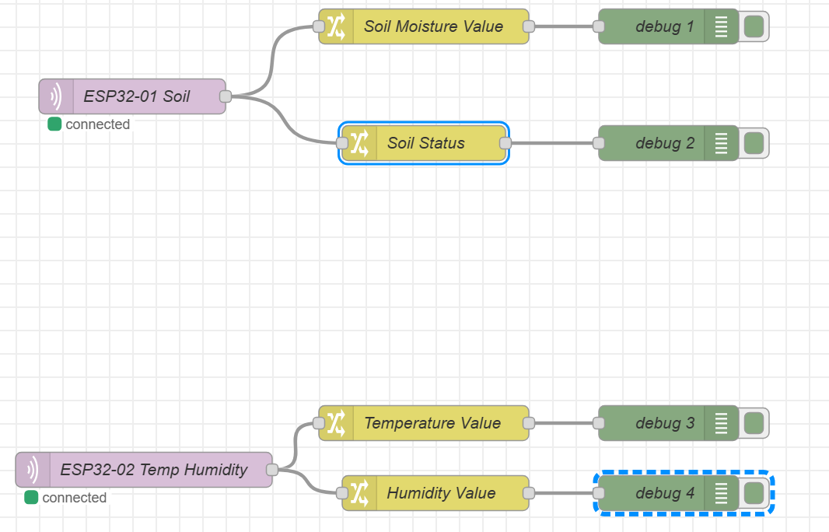

Phase 14: Dashboard Layout
Create Ecoprosus monitoring screen.
I have already Created Layout, Need to create group, page,ect in Node-Red

Phase 15: Data Storage
Use SQLite/InfluxDB.

Phase 16: Cloud Upgrade
Move to AWS IoT in future.

PHASE 1: Raspberry Pi
│
├── 1.1 Update OS
│
├── 1.2 Find IP
│
└── 1.3 Static IP ← YOU ARE HERE
│
▼
PHASE 2: Mosquitto MQTT
│
▼
PHASE 3: MQTT Test
│
▼
ESP32 + DHT11 + FC-28
│
▼
MQTT
│
▼
Raspberry Pi
│
▼
Node-RED
│
▼
Ecoprosus Dashboard

