**07-08-2022**

**Bayana: 1,48,000/- PhonePay**

**2000/- Cash**

**Dawat: 2000/-**

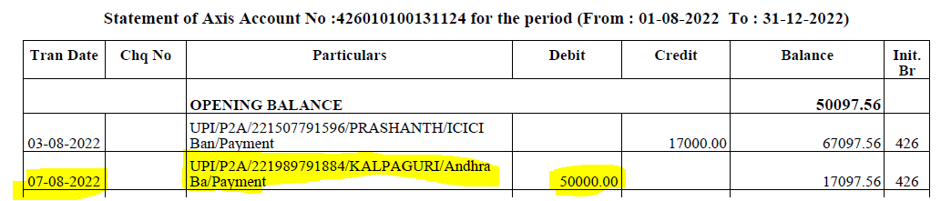



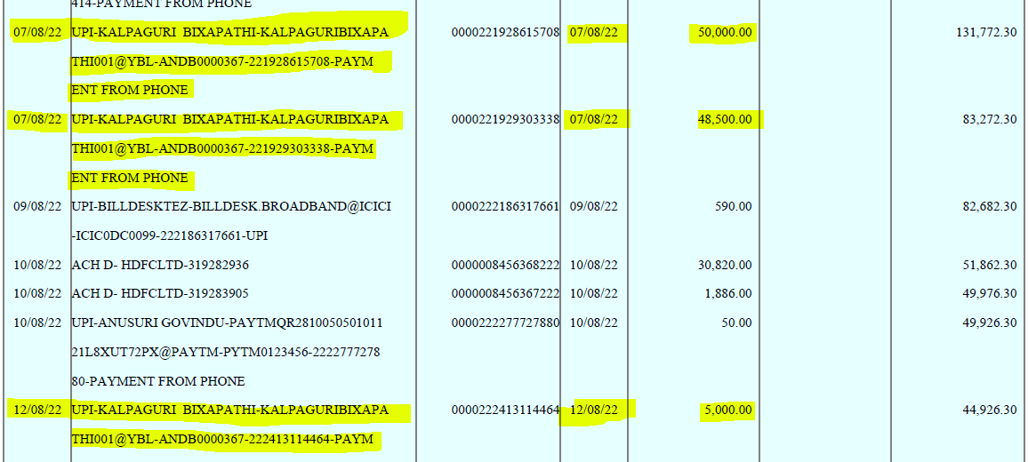

**20-08-2022**

**Mid Payment: 1,50,000/- PhonePay**

**2,00,000/- Cash**

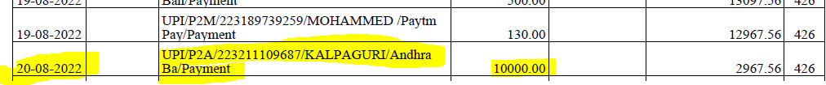

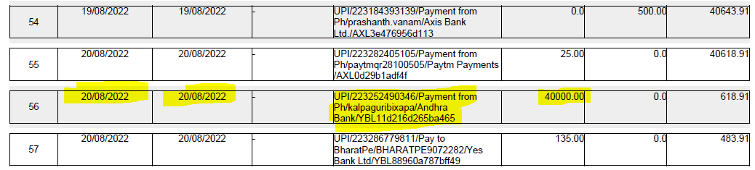

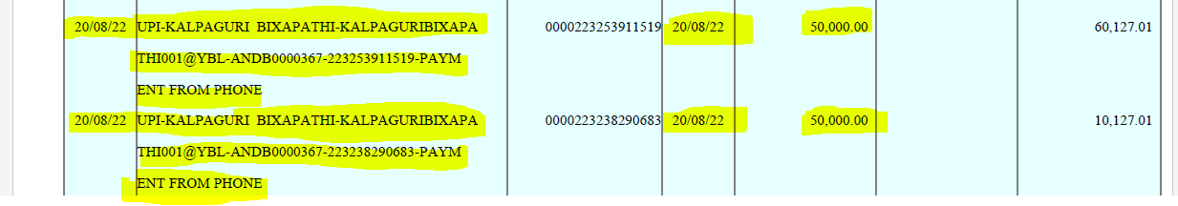

**19-09-2022**

**Payment: 24,50,000/- Bank Deposit**

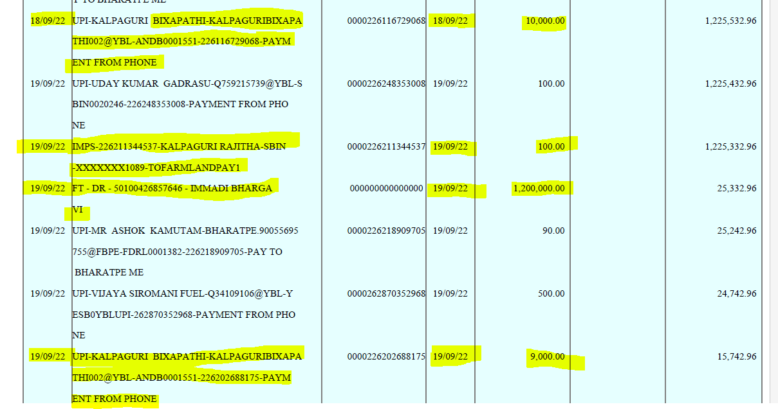

**Bikshapthi:**

