WEEK 4 TASK
SUPERVISED LEARNING MODEL IMPLEMENTATION
Binary Classification using the Breast Cancer Wisconsin (Diagnostic) Dataset
Yuva Internship | Machine Learning Project

1. Executive Summary
This project develops a complete supervised learning pipeline for binary classification using the Breast Cancer Wisconsin (Diagnostic) dataset. The objective is to predict whether a tumor is malignant or benign from 30 numeric diagnostic measurements. A Logistic Regression model was selected because it provides a transparent baseline, produces class probabilities, and is well suited to standardized numerical features. The implementation combines median imputation, feature standardization, stratified 80/20 train-test splitting, and five-fold stratified cross-validation. On the held-out test set, the model achieved 96.5% accuracy, 97.5% precision, 92.9% recall, 95.1% F1 score, and 0.996 ROC-AUC.

2. Problem Definition
The supervised learning problem is a binary classification task: determine the diagnosis class of a breast tumor from measurements derived from digitized fine-needle aspiration images. The target has two classes: malignant (1) and benign (0). In a screening-oriented context, recall is important because missed malignant cases can be more consequential than false alarms.

3. Dataset Description
The selected public dataset is the Breast Cancer Wisconsin (Diagnostic) dataset, distributed through scikit-learn from the original UCI repository. It contains 569 observations and 30 numeric predictor variables. The variables are computed from cell nuclei characteristics and include measurements such as radius, texture, perimeter, area, smoothness, compactness, concavity, symmetry, and fractal dimension.
Item | Value
Observations | 569
Predictive features | 30
Classes | Malignant / Benign
Missing values | 0
Split | 80% train / 20% test
Random state | 42

4. Data Preparation and Feature Engineering
Initial inspection confirmed a fully numeric feature matrix. Although the supplied dataset contains no missing values, median imputation was included inside the pipeline as a robustness measure so that the same transformation is learned from the training data and applied consistently to future data. StandardScaler was then applied to place all predictors on a comparable scale. No target-derived information was used during preprocessing.

5. Model Selection Rationale
Logistic Regression was chosen as the primary classifier because it is computationally efficient, interpretable, and provides probabilistic outputs. Standardized coefficients can be examined to understand which features have the strongest association with the model decision. More complex models can be compared in future iterations, but the transparent baseline makes it easier to explain the modeling pipeline and identify opportunities for improvement.

6. Training and Validation Strategy
The data was split using a stratified 80/20 train-test split so that the class proportions were preserved. Model selection and reliability checks were performed on the training portion with five-fold StratifiedKFold cross-validation. The test set was held out until the final evaluation to provide an unbiased estimate of generalization performance.

7. Evaluation Metrics
Metric | Purpose | Test Score
Accuracy | Overall fraction of correct predictions | 0.965
Precision | Share of predicted malignant cases that are actually malignant | 0.975
Recall | Share of actual malignant cases correctly detected | 0.929
F1 Score | Harmonic mean of precision and recall | 0.951
ROC-AUC | Ranking quality across classification thresholds | 0.996
Because the target encoding is 1 = malignant, recall in the metric table refers to correct detection of the malignant class under the default decision threshold. In an operational medical screening setting, threshold choice should be revisited so that clinically appropriate sensitivity to malignant cases is explicitly optimized.

8. Cross-Validation Results
Metric | Mean | Std. Dev.
Accuracy | 0.974 | 0.015
Precision | 0.977 | 0.028
Recall | 0.953 | 0.040
F1 Score | 0.964 | 0.021
ROC-AUC | 0.996 | 0.005
The small cross-validation standard deviations indicate that the pipeline is reasonably stable across the five folds. Cross-validation results should be considered alongside, not instead of, the final held-out test result.

9. Results and Visual Analysis
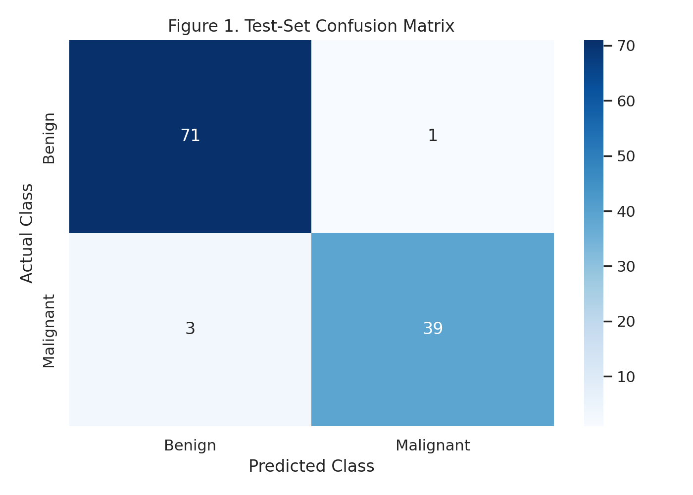
Figure: Confusion Matrix. The matrix summarizes correct and incorrect predictions on the held-out test set.
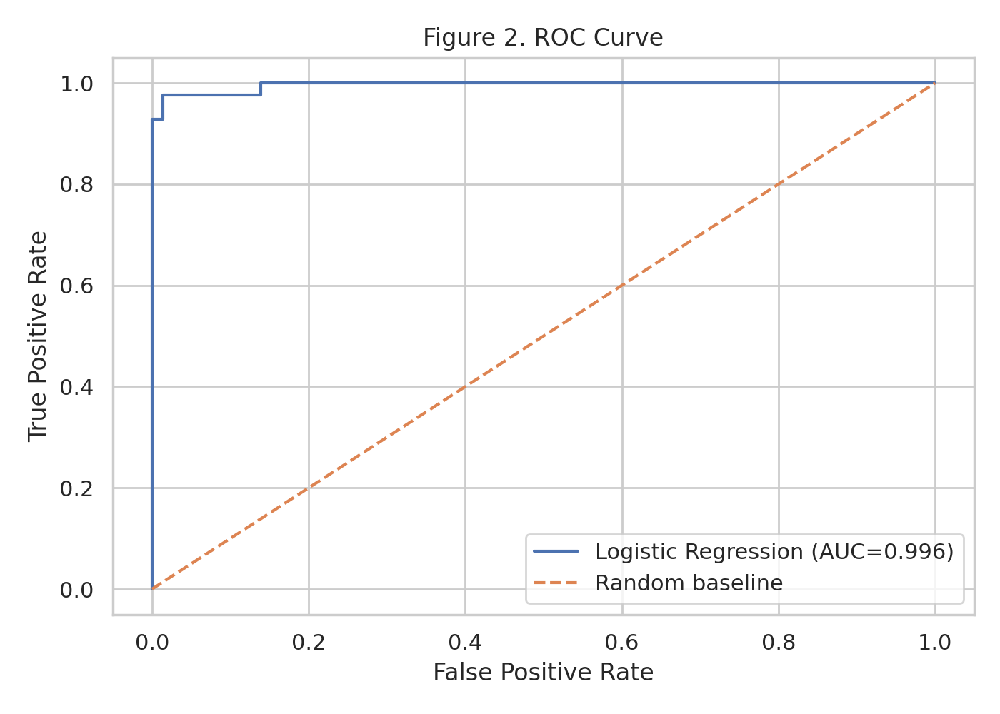
Figure: ROC Curve. The ROC curve shows the trade-off between true-positive and false-positive rates across thresholds.
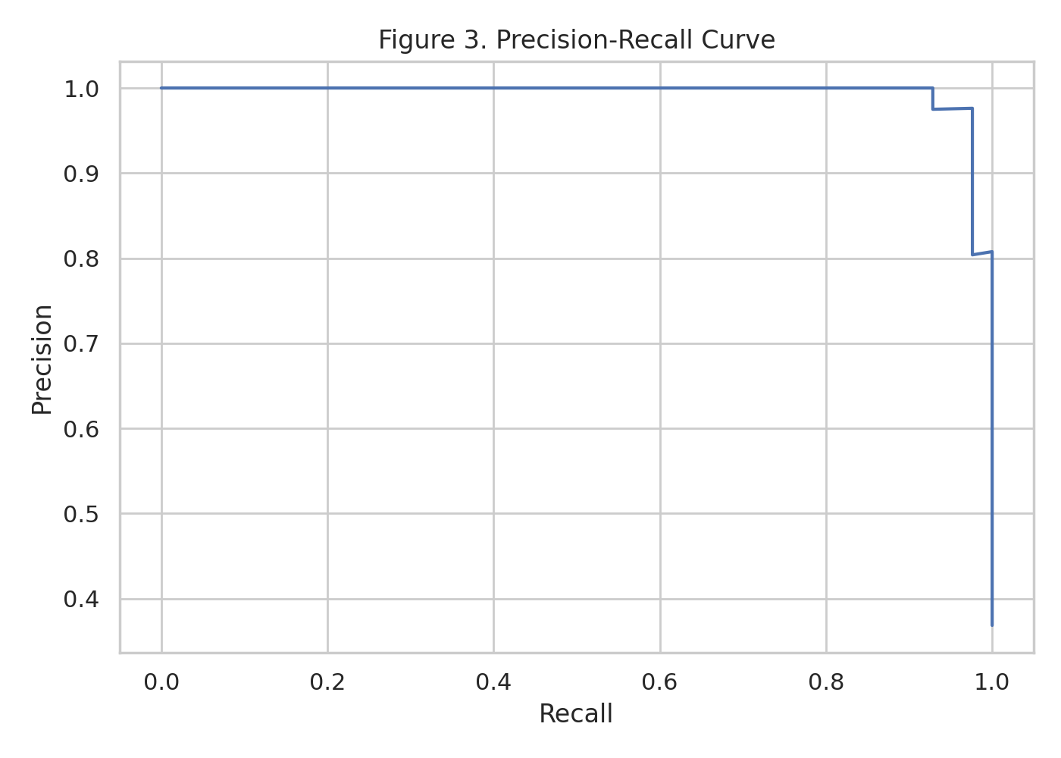
Figure: Precision-Recall Curve. This curve highlights precision and recall behavior across decision thresholds.
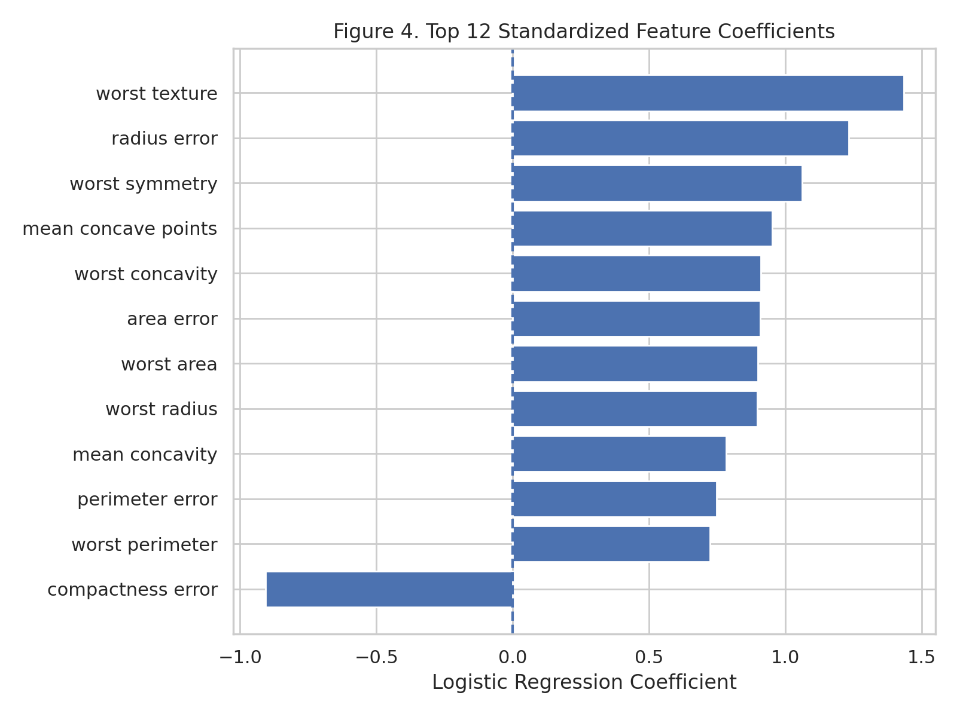
Figure: Feature Coefficients. The largest standardized coefficients provide an interpretable view of influential predictors.
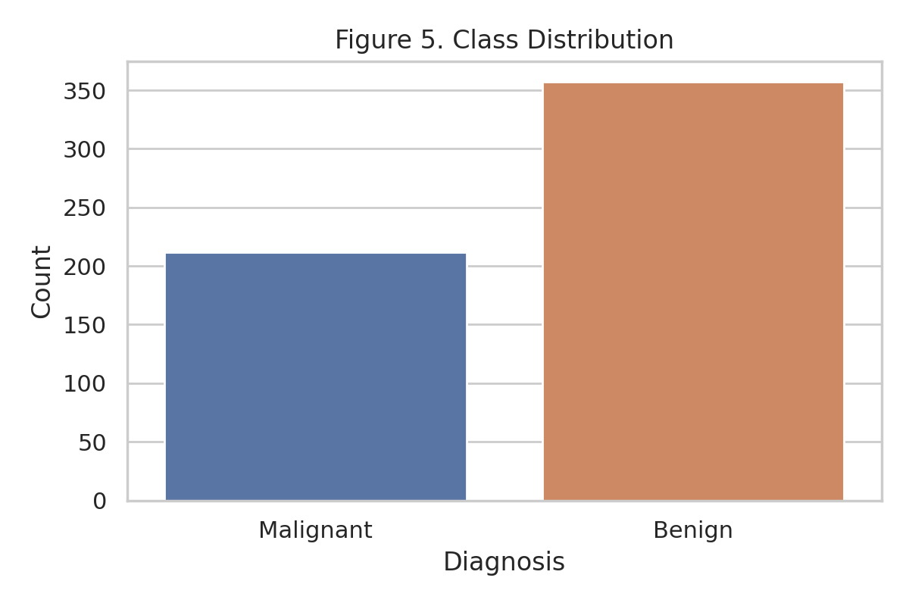
Figure: Class Distribution. The target distribution shows the relative frequency of the two diagnosis classes.
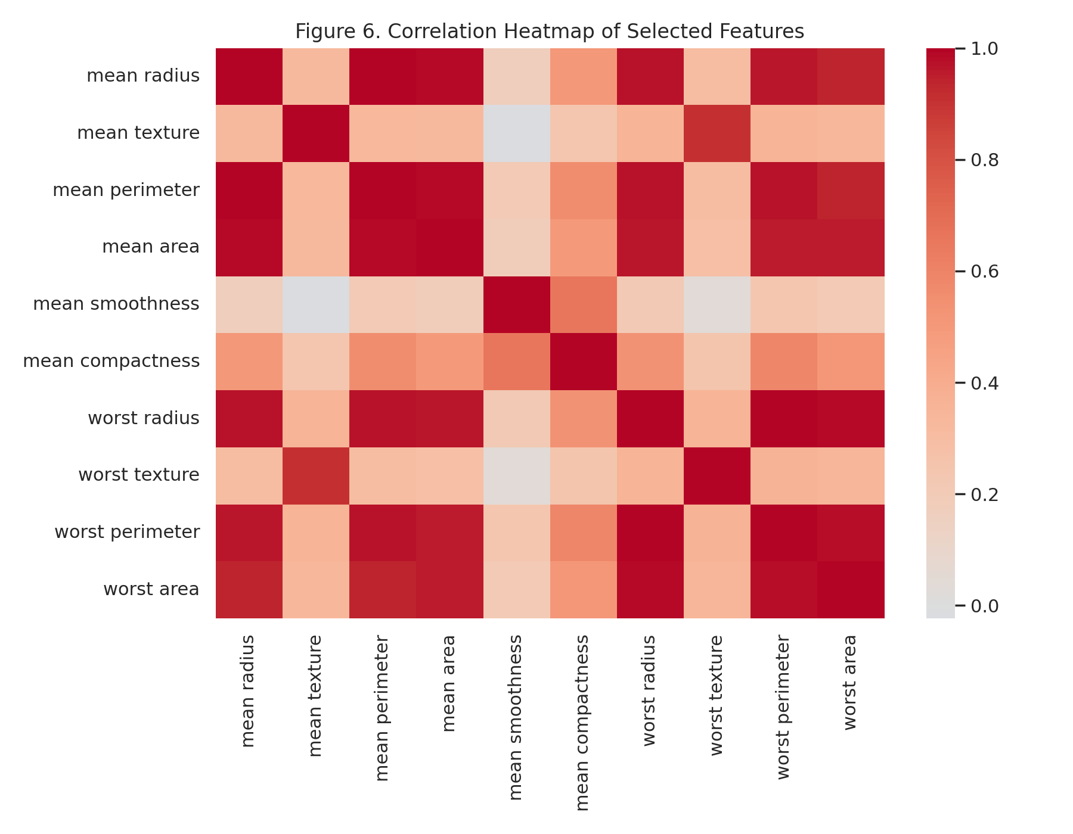
Figure: Correlation Heatmap. Selected features show substantial correlation, which is relevant when interpreting coefficient-based models.

10. Feature Interpretation
The coefficient table shows the relative influence of standardized predictors in the fitted Logistic Regression model. Because the predictors have been standardized, coefficient magnitudes are more directly comparable than they would be on their original scales. The sign indicates the direction of the association with the model target encoding, while the magnitude indicates the strength of contribution within the fitted linear decision function.
Rank | Feature | Coefficient
1 | worst texture | 1.4341
2 | radius error | 1.2333
3 | worst symmetry | 1.0613
4 | mean concave points | 0.9528
5 | worst concavity | 0.9114
6 | area error | 0.9090
7 | compactness error | -0.9069
8 | worst area | 0.9005
9 | worst radius | 0.8970
10 | mean concavity | 0.7823

11. Discussion of Strengths
The model is simple, reproducible, and interpretable. The use of a scikit-learn Pipeline prevents data leakage by fitting preprocessing steps only on training folds. Stratification protects the class balance during splitting and cross-validation. The model also produces probabilities, enabling threshold tuning and ROC/precision-recall analysis.

12. Limitations
The model assumes a linear separation pattern in standardized feature space and may not capture nonlinear interactions. The dataset is relatively compact and originates from a specific diagnostic setting, so performance should not be assumed to generalize to different populations or clinical workflows. The positive class encoding in this implementation is malignant, so recall directly measures the fraction of malignant cases correctly detected at the default decision threshold.

13. Possible Improvements
Future experiments should compare Logistic Regression with Random Forest, Support Vector Machine, Gradient Boosting, and calibrated ensemble models. Hyperparameter tuning with nested cross-validation can improve model selection. Threshold optimization should explicitly target malignant-case sensitivity if the model is framed as a screening aid. Feature selection or dimensionality reduction may also be studied to reduce redundancy among highly correlated predictors. Finally, an independent external dataset is necessary for meaningful deployment-level validation.

14. Reproducibility and Code
The repository includes an executable Jupyter notebook at `code/supervised_learning_classification.ipynb`. It contains data inspection, splitting, preprocessing, training, five-fold cross-validation, test evaluation, visualization, feature interpretation, and result export. All result CSV files in `results/` are generated from the same workflow.

Code Snippet 1: Data Split and Preprocessing
X = df[feature_cols]
y = df['target']
X_train, X_test, y_train, y_test = train_test_split(
X, y, test_size=0.20, random_state=42, stratify=y
)
model = Pipeline([
('imputer', SimpleImputer(strategy='median')),
('scaler', StandardScaler()),
('classifier', LogisticRegression(max_iter=5000, random_state=42))
])

Code Snippet 2: Cross-Validation
cv = StratifiedKFold(n_splits=5, shuffle=True, random_state=42)
cv_results = cross_validate(
model, X_train, y_train, cv=cv,
scoring=['accuracy', 'precision', 'recall', 'f1', 'roc_auc']
)

Code Snippet 3: Test Evaluation
model.fit(X_train, y_train)
y_pred = model.predict(X_test)
y_prob = model.predict_proba(X_test)[:, 1]
accuracy = accuracy_score(y_test, y_pred)
precision = precision_score(y_test, y_pred)
recall = recall_score(y_test, y_pred)
f1 = f1_score(y_test, y_pred)
roc_auc = roc_auc_score(y_test, y_prob)

15. Conclusion
This project demonstrates the full supervised learning lifecycle required by the Week 4 task. The Logistic Regression classifier provides a strong and interpretable baseline, with cross-validation used to assess stability and a held-out test set used for final evaluation. The analysis also emphasizes that model performance must be interpreted in context: metric choice, class encoding, threshold selection, dataset limitations, and external validation all matter when translating a predictive model into a practical decision-support system.

16. References
- Scikit-learn documentation: Breast Cancer Wisconsin (Diagnostic) dataset and supervised learning utilities.
- UCI Machine Learning Repository: Breast Cancer Wisconsin (Diagnostic) dataset.
- Scikit-learn documentation: LogisticRegression, StandardScaler, Pipeline, cross_validate, and classification metrics.

