WEEK 5
Deep Learning Application in Data Science
PyTorch Neural Network for Handwritten Digit Classification
Dataset | Scikit-learn Digits Dataset
Model | PyTorch Multilayer Perceptron (MLP)
Task | Multiclass classification: digits 0–9
Test Accuracy | 98.9%

1. Executive Summary
This project implements a complete deep learning workflow for handwritten digit classification using the publicly available scikit-learn Digits dataset. The task is a ten-class classification problem in which each observation is an 8×8 grayscale image represented by 64 pixel-intensity values. A compact feed-forward neural network was developed in PyTorch, combining dense layers, ReLU activations, Batch Normalization, Dropout, Adam optimization, and cross-entropy loss. The workflow covers data preparation, feature standardization, architecture design, training, validation, held-out testing, cross-validation, visualization, and critical analysis.
The final model achieved 98.9% accuracy on an unseen test set, with weighted precision of 98.9%, weighted recall of 98.9%, weighted F1 of 98.9%, and weighted one-vs-rest ROC-AUC of 0.9998. A separate five-fold cross-validation experiment produced a mean accuracy of approximately 97.8%, showing that the model remains strong across alternative data partitions.

2. Problem Statement
The goal is to automatically recognize handwritten digits from small grayscale images. Manual recognition is straightforward for humans but provides a useful benchmark for demonstrating the practical stages of a neural-network workflow. The problem is formulated as multiclass classification with ten mutually exclusive labels, 0 through 9.

3. Dataset Description
The scikit-learn Digits dataset contains 1,797 observations, 64 numerical pixel-intensity features, and ten digit classes. The images have only 8×8 pixels, which keeps training computationally light while still providing enough structure to demonstrate deep learning concepts. There are no missing values in the feature matrix.

4. Data Preparation and Feature Engineering
A stratified split was used to create 70% training, 15% validation, and 15% held-out test sets. Stratification preserves the class distribution across the splits. Feature standardization was then performed with StandardScaler. Importantly, the scaler was fitted only on the training set and applied to validation and test sets, preventing information leakage. No synthetic features were required because the 64 pixel measurements already form a direct numeric representation of the images.

5. Architecture Design
The selected model is a compact multilayer perceptron (MLP). The architecture was chosen because the dataset is small and vector-based, making a dense network easy to train and interpret while still supporting nonlinear decision boundaries.
Layer | Units / Setting | Activation | Purpose
Input | 64 | — | One value per pixel
Dense 1 | 128 | ReLU | Learn nonlinear feature combinations
BatchNorm | 128 | — | Stabilize activations
Dropout | 0.30 | — | Reduce overfitting
Dense 2 | 64 | ReLU | Compress learned representation
Dropout | 0.20 | — | Additional regularization
Output | 10 logits | — | One class score per digit
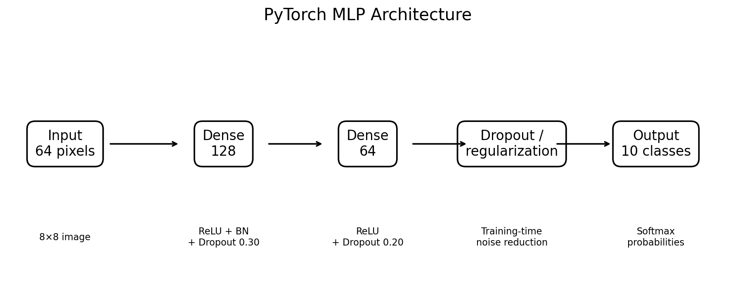
Figure 1. Network architecture used in the main experiment.
Hyperparameters were selected to balance performance and resource use: Adam optimizer, learning rate 0.001, weight decay 0.0001, batch size 32, cross-entropy loss, and up to 100 epochs with early stopping after 12 validation-loss checks without meaningful improvement.

6. Training Process
During each epoch, mini-batches were passed through the network, cross-entropy loss was computed, gradients were backpropagated, and Adam updated the weights. After each epoch, validation loss and accuracy were measured. The model checkpoint with the lowest validation loss was retained and restored before final testing. This prevents the final model from depending on the last training epoch when validation performance may have started to degrade.
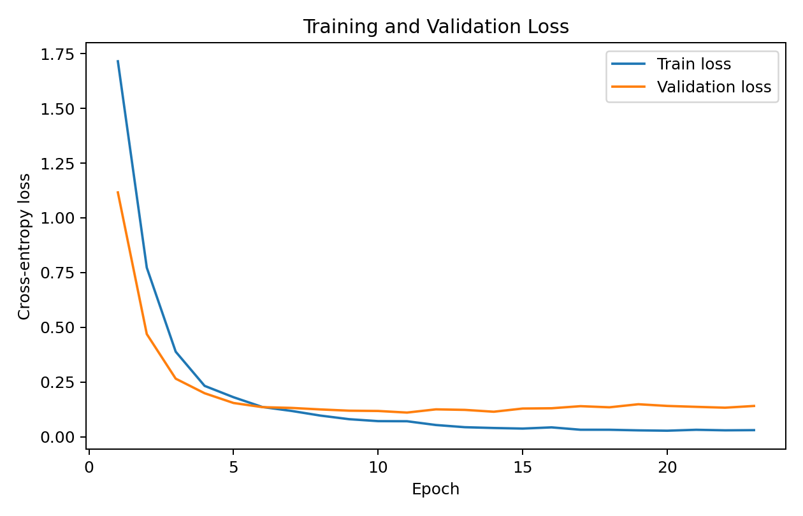
Figure 2. Training and validation loss across epochs.
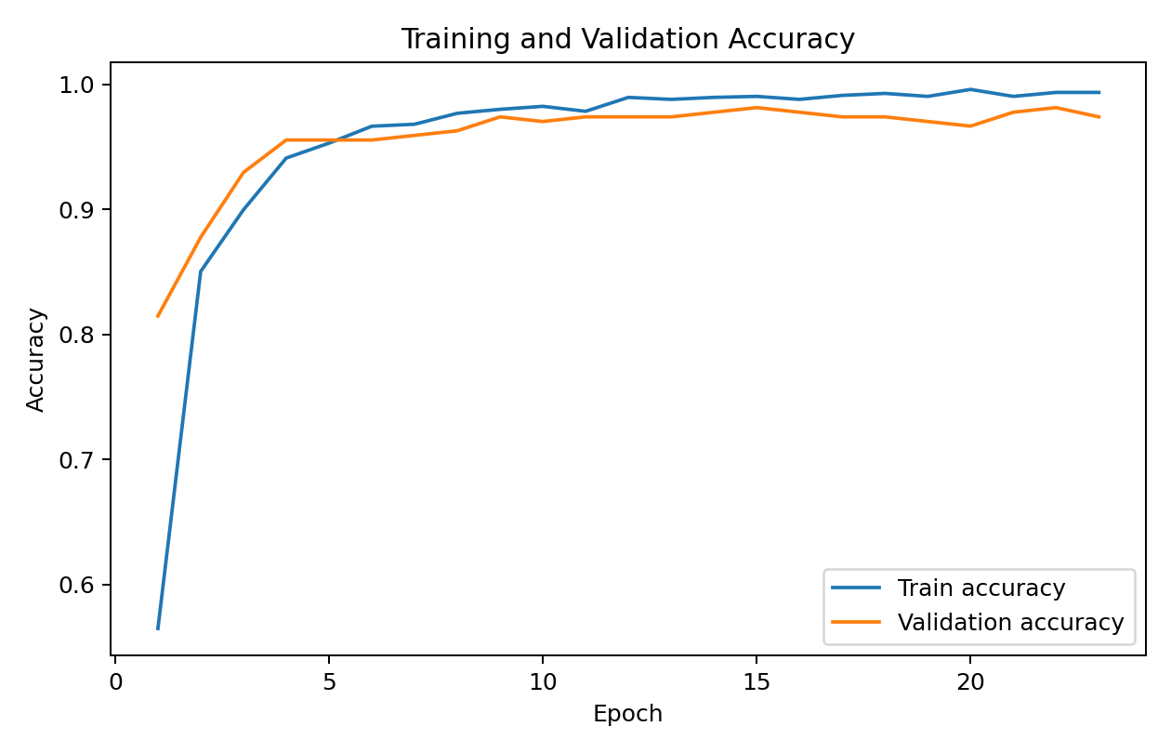
Figure 3. Training and validation accuracy across epochs.
The learning curves show rapid improvement in the early epochs followed by convergence. The close relationship between training and validation performance indicates that the selected regularization strategy was effective and that severe overfitting was not evident in the final checkpoint.

7. Evaluation Metrics and Results
Metric | Test value
accuracy | 0.9889
weighted_precision | 0.9893
weighted_recall | 0.9889
weighted_f1 | 0.9889
weighted_roc_auc | 0.9998
Accuracy measures the proportion of all test samples classified correctly. Weighted precision, recall, and F1 summarize class-wise performance while accounting for class frequencies. The weighted ROC-AUC of 0.9998 indicates excellent probability ranking in a one-vs-rest multiclass interpretation.
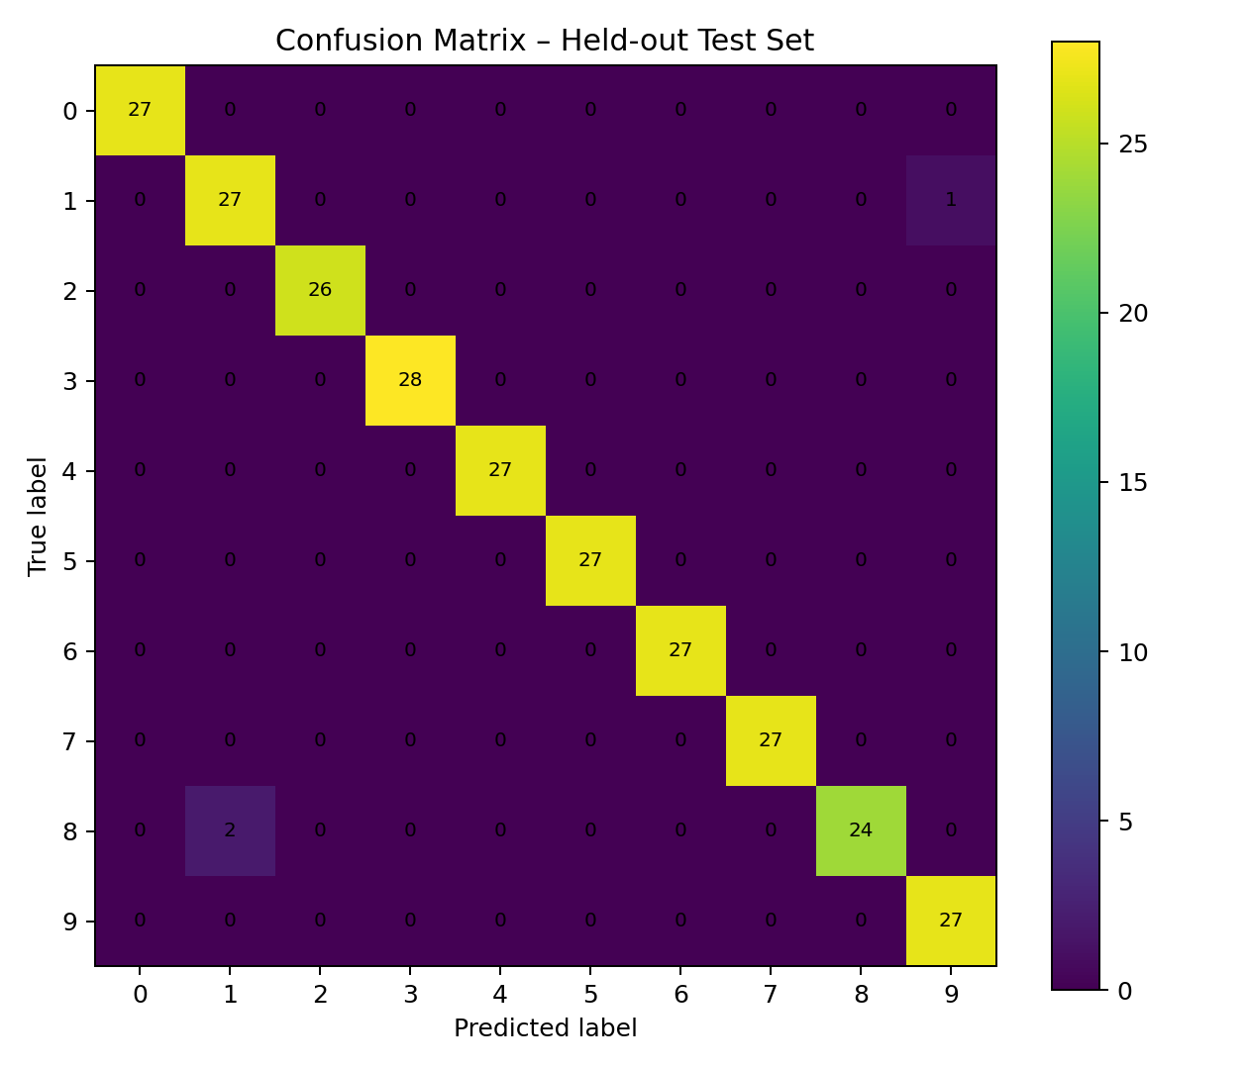
Figure 4. Confusion matrix for the held-out test set.

8. Cross-Validation
Metric | Mean | Std. Dev.
accuracy | 0.9783 | 0.0069
weighted_precision | 0.9791 | 0.0064
weighted_recall | 0.9783 | 0.0069
weighted_f1 | 0.9783 | 0.0069
Five-fold stratified cross-validation was used as a robustness check. The mean accuracy was 97.83% with a standard deviation of 0.69 percentage points. This suggests that model performance is consistently high and not dependent on one favorable random split.

9. Example Predictions
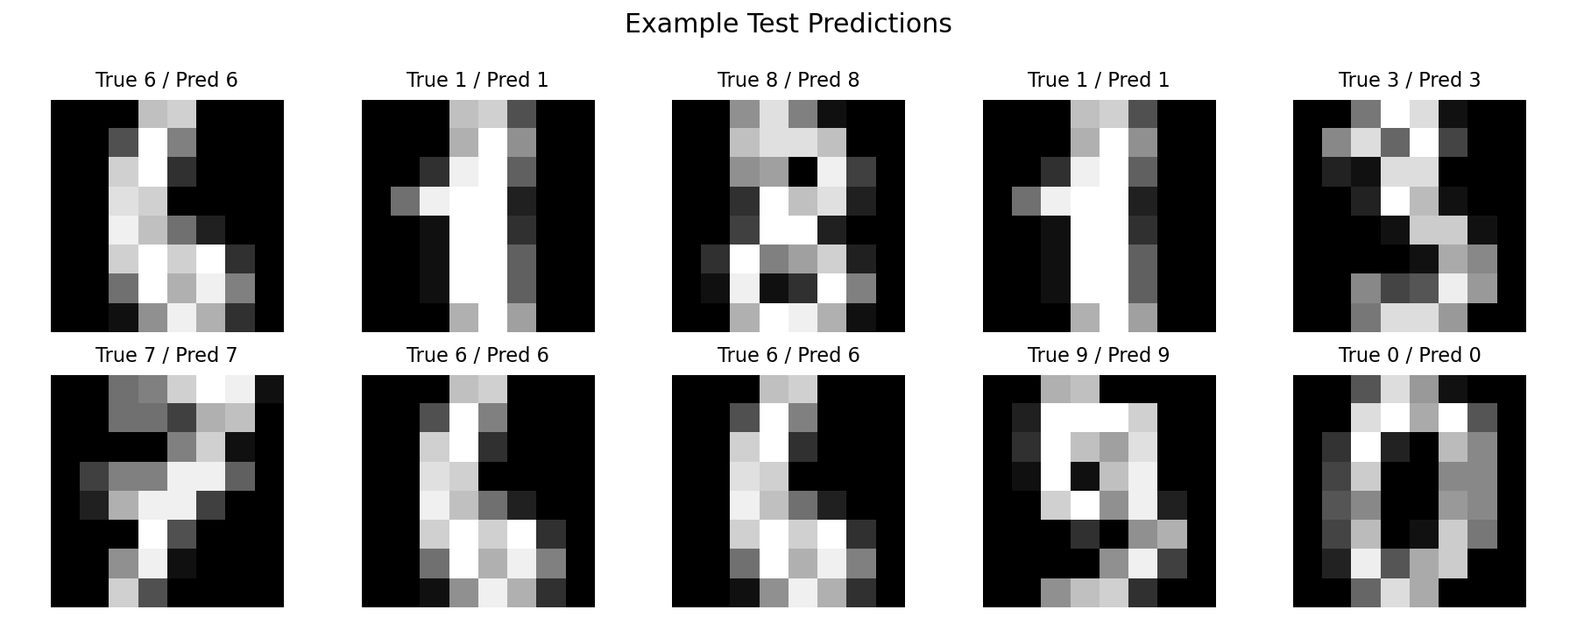
Figure 5. Sample held-out predictions.
The visual examples show that the trained network can correctly separate handwritten shapes with high confidence. Misclassifications are expected to cluster around visually similar digits, where a low-resolution 8×8 representation can make handwriting distinctions ambiguous.

10. Class Distribution and Dataset Characteristics
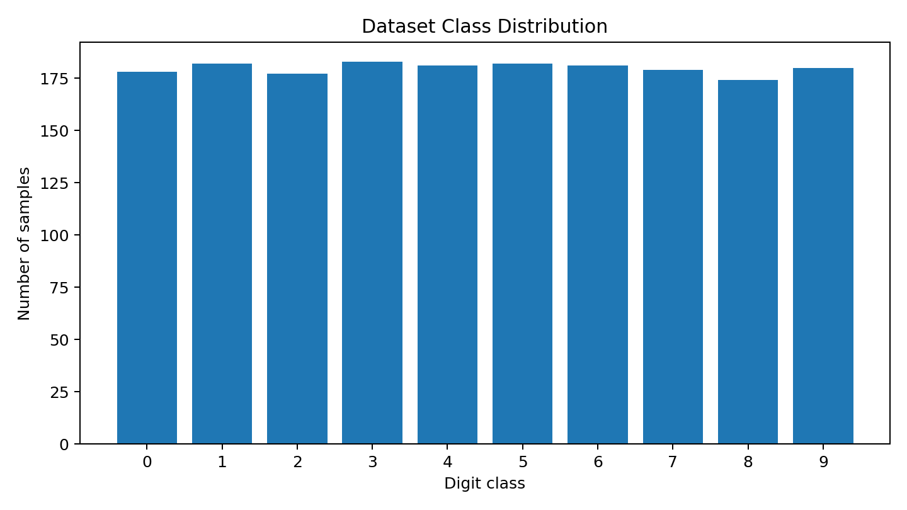
Figure 6. Class distribution across digits 0–9.
The dataset is reasonably balanced across the ten classes, so a weighted metric summary remains informative and there is no strong need for class weighting. The relatively small dataset also explains why a compact network is preferable to a very deep architecture.

11. Challenges and Mitigation
Overfitting risk: Small datasets can allow neural networks to memorize training examples. Dropout, Batch Normalization, weight decay, validation monitoring, and checkpoint selection were combined to reduce this risk.
Data leakage: Standardization can leak information when fitted on all samples. The scaler was therefore fitted only on training data.
Resource constraints: The dataset is compact enough for CPU training. A moderate MLP was chosen to keep memory and training time low while maintaining high predictive performance.
Interpretability: Neural networks are less transparent than simple linear models. Confusion matrices, learning curves, and example predictions were included to make the behavior easier to inspect.
Spatial structure: A dense MLP treats the 64 pixels as a vector and does not explicitly encode local spatial relationships. This is a limitation rather than a failure and motivates a CNN as a future improvement.

12. Possible Improvements
Several improvements are possible. A small convolutional neural network (CNN) would better exploit local image structure and is likely to outperform an MLP on image data. Hyperparameter tuning could explore hidden-layer width, dropout rates, learning rate schedules, and batch size. Data augmentation could be considered for more challenging digit datasets. Finally, calibration analysis and per-class ROC/precision-recall curves could provide a more detailed view of probabilistic behavior.

13. Code Example
class DigitMLP(nn.Module):
def __init__(self):
super().__init__()
self.net = nn.Sequential(
nn.Linear(64, 128),
nn.ReLU(),
nn.BatchNorm1d(128),
nn.Dropout(0.30),
nn.Linear(128, 64),
nn.ReLU(),
nn.Dropout(0.20),
nn.Linear(64, 10)
)

def forward(self, x):
return self.net(x)

model = DigitMLP()
criterion = nn.CrossEntropyLoss()
optimizer = torch.optim.Adam(
model.parameters(), lr=1e-3, weight_decay=1e-4
)
The complete reproducible implementation is provided in `code/deep_learning_digits.ipynb`.

14. Strengths and Limitations
Strengths | Limitations
High predictive performance with a compact model | Low-resolution 8×8 images constrain visual detail
End-to-end reproducible PyTorch workflow | MLP does not exploit spatial locality as a CNN would
Explicit train/validation/test separation | Small benchmark dataset is less representative of production scale
Regularization and early stopping included | Neural-network decisions are less interpretable than simple baselines

15. Conclusion
This project demonstrates the practical application of deep learning to a real classification task. The PyTorch MLP successfully learned to classify handwritten digits with 98.9% held-out test accuracy and a weighted ROC-AUC of 0.9998. The combination of standardized inputs, nonlinear hidden layers, batch normalization, dropout, Adam optimization, validation monitoring, and five-fold cross-validation produced a reliable and well-documented workflow. The main technical limitation is the use of a fully connected network for image data; a CNN is the clearest next step for improving architecture suitability.

16. References
- Scikit-learn documentation: Digits dataset and dataset utilities.
- PyTorch documentation: neural-network modules, optimizers, and tensor operations.
- Goodfellow, Bengio, and Courville, Deep Learning, MIT Press.
- Velastegui, Deep learning regularization concepts: dropout and normalization (conceptual reference).

