Week 6: Integrative Capstone Project and Evaluation
End-to-End Data Science Pipeline with Python
This capstone demonstrates a complete data science workflow: data acquisition, data cleaning, exploratory analysis, supervised predictive modeling, cross-validation, unsupervised segmentation, evaluation, interpretation, and recommendations. The project uses the public scikit-learn Diabetes regression dataset as a compact, reproducible case study. The dataset is used for learning and methodology demonstration; the resulting models should not be interpreted as clinical decision tools.

Executive Summary
The project analyzes 442 observations with 10 quantitative predictor variables and a continuous target representing a quantitative measure of disease progression. The workflow compares Linear Regression, Ridge Regression, and Random Forest regression models on a held-out test set and through five-fold cross-validation. The best test-set model is Ridge Regression, with R² = 0.454, RMSE = 53.78, and MAE = 42.81.
Unsupervised learning is used as a complementary descriptive step. K-Means clustering is evaluated for k=2 through 6 using inertia and silhouette score, with k=2 selected by the highest silhouette score (0.237). The clusters reveal distinct feature-profile patterns that can be used for exploratory segmentation.

1. Problem Statement
Build an end-to-end data science pipeline that predicts a continuous disease-progression target from baseline quantitative measurements and, where useful, segments the observations into data-driven profiles. The problem therefore combines a supervised regression task with an unsupervised clustering task so that the final analysis covers both predictive and descriptive perspectives.

2. Dataset Acquisition and Description
The dataset is obtained directly through scikit-learn using load_diabetes(as_frame=True, scaled=False). The official documentation describes 442 samples, 10 real-valued input features, and an integer regression target in the range 25–346. The feature names include age, sex, body mass index (bmi), average blood pressure (bp), and six serum-measurement features (s1–s6).
Source: scikit-learn load_diabetes documentation: https://scikit-learn.org/stable/modules/generated/sklearn.datasets.load_diabetes.html
Descriptive statistics (selected columns shown):
feature | count | mean | std | min | 25% | 50% | 75% | max
age | 442.0000 | 48.5181 | 13.1090 | 19.0000 | 38.2500 | 50.0000 | 59.0000 | 79.0000
sex | 442.0000 | 1.4683 | 0.4996 | 1.0000 | 1.0000 | 1.0000 | 2.0000 | 2.0000
bmi | 442.0000 | 26.3758 | 4.4181 | 18.0000 | 23.2000 | 25.7000 | 29.2750 | 42.2000
bp | 442.0000 | 94.6470 | 13.8313 | 62.0000 | 84.0000 | 93.0000 | 105.0000 | 133.0000
s1 | 442.0000 | 189.1403 | 34.6081 | 97.0000 | 164.2500 | 186.0000 | 209.7500 | 301.0000
s2 | 442.0000 | 115.4391 | 30.4131 | 41.6000 | 96.0500 | 113.0000 | 134.5000 | 242.4000
s3 | 442.0000 | 49.7885 | 12.9342 | 22.0000 | 40.2500 | 48.0000 | 57.7500 | 99.0000
s4 | 442.0000 | 4.0702 | 1.2904 | 2.0000 | 3.0000 | 4.0000 | 5.0000 | 9.0900
s5 | 442.0000 | 4.6414 | 0.5224 | 3.2581 | 4.2767 | 4.6200 | 4.9972 | 6.1070
s6 | 442.0000 | 91.2602 | 11.4963 | 58.0000 | 83.2500 | 91.0000 | 98.0000 | 124.0000
target | 442.0000 | 152.1335 | 77.0930 | 25.0000 | 87.0000 | 140.5000 | 211.5000 | 346.0000

3. Data Cleaning and Preprocessing
Data quality checks found 0 missing cells and 0 duplicate rows. No missing-value problem was present in the packaged dataset. The modeling workflow nevertheless contains a median imputer so that the pipeline remains robust to future missing inputs. StandardScaler is used for scale-sensitive linear modeling and for K-Means, because the clustering algorithm is distance-based and the original variables are measured on different scales.
No target leakage is introduced: preprocessing for supervised models is fitted inside a scikit-learn Pipeline, so transformations are learned only from the corresponding training folds during cross-validation.
preprocess = Pipeline([('imputer', SimpleImputer(strategy='median')), ('scaler', StandardScaler())])

4. Exploratory Data Analysis
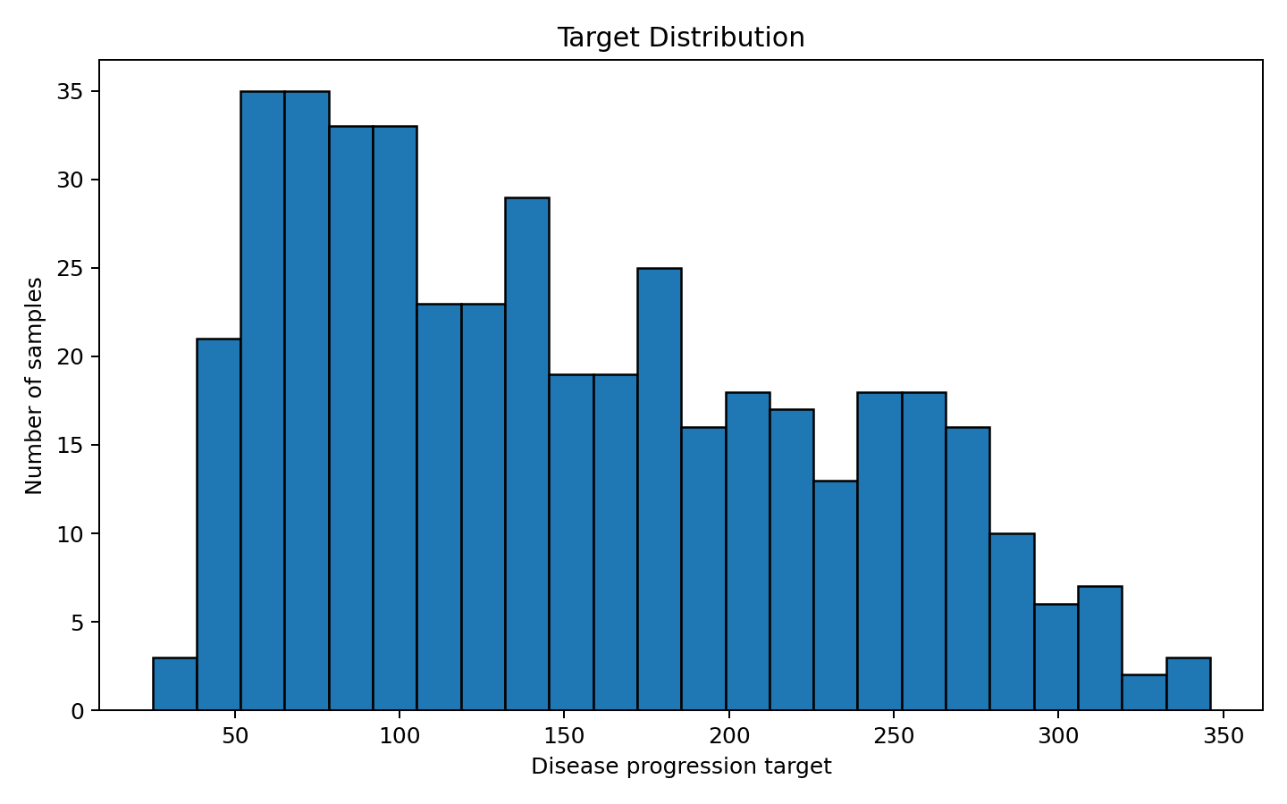
Figure 1. Distribution of the continuous target variable.
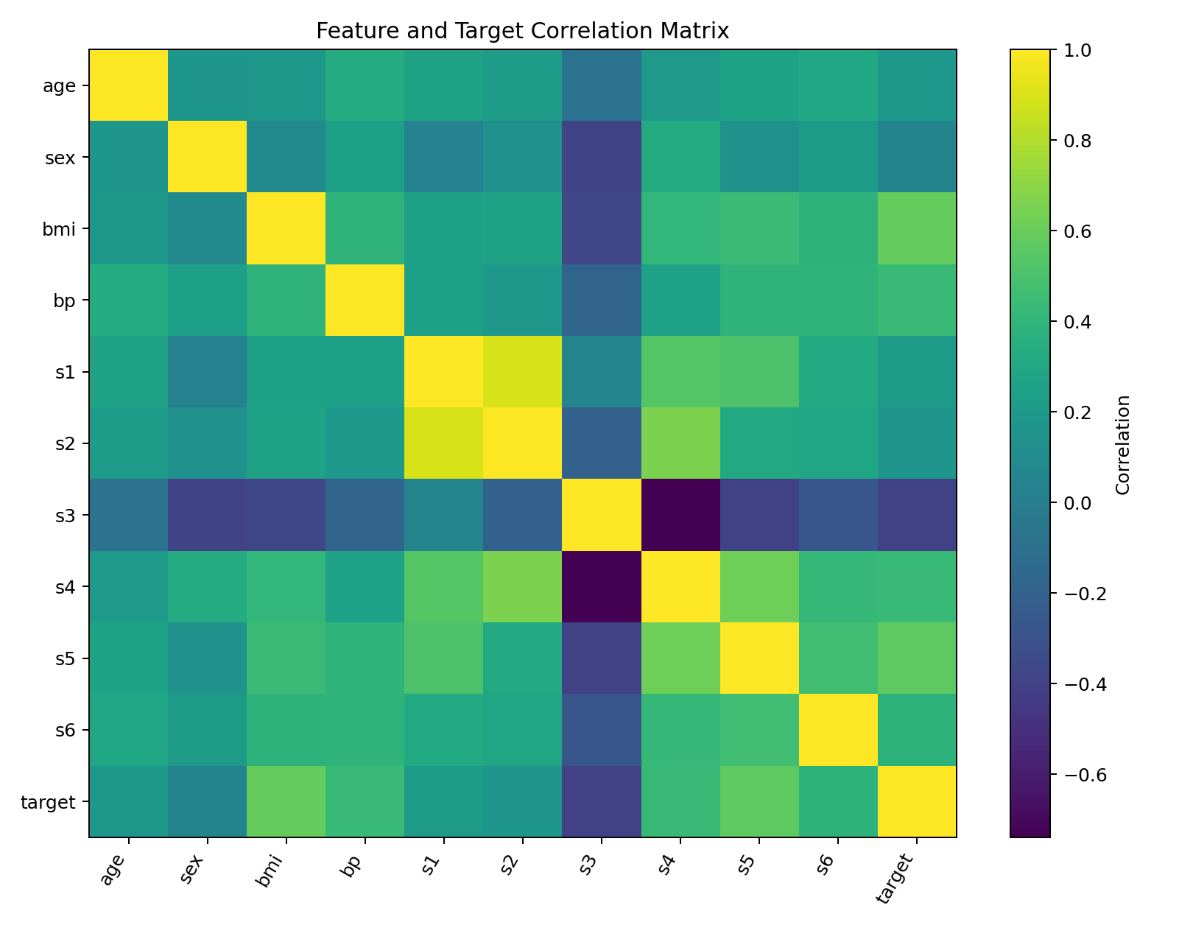
Figure 2. Correlation matrix for features and target.
The strongest absolute feature-to-target correlations are: bmi (0.586), s5 (0.566), followed by bp (0.441). Correlation is useful for exploratory screening, but it is not sufficient by itself to establish causal relationships or guarantee predictive performance.
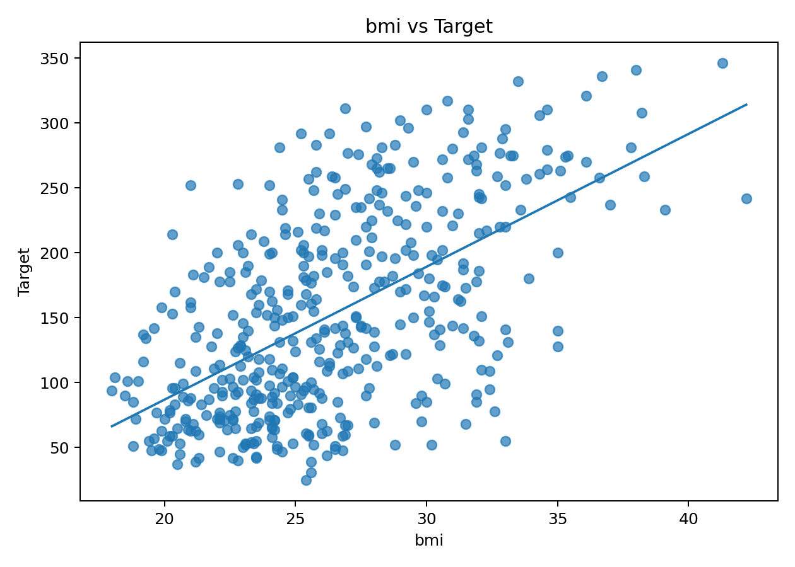
Figure 3. Relationship between bmi and the target.
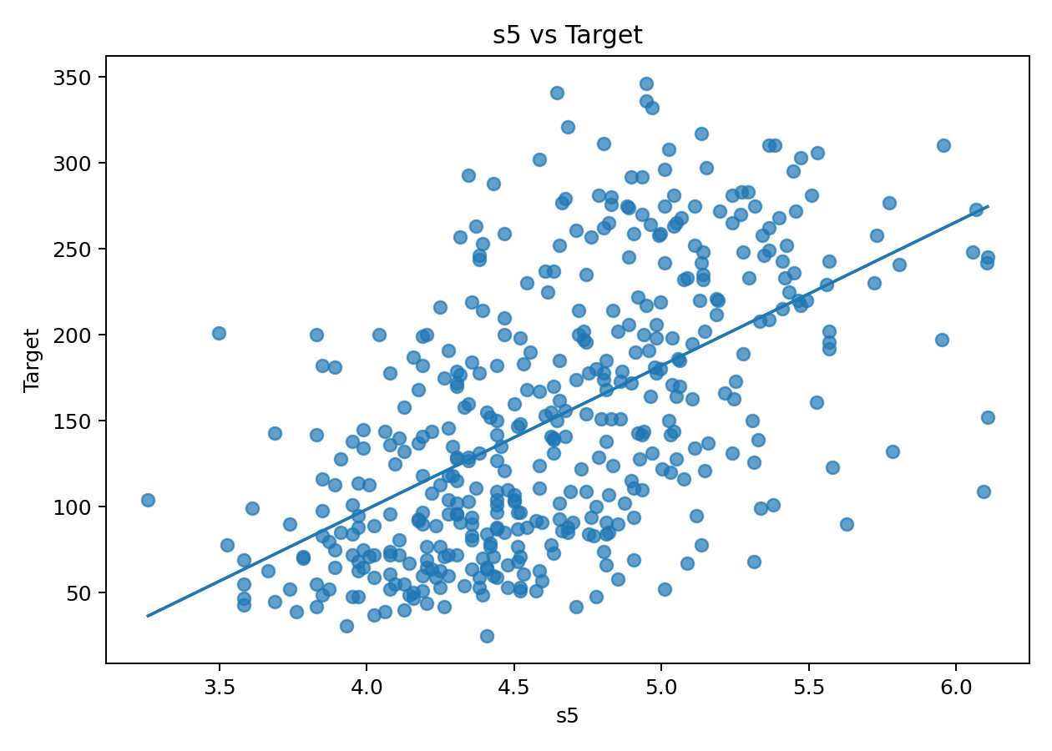
Figure 4. Relationship between s5 and the target.

5. Supervised Modeling Approach
Three regression models were compared. Linear Regression provides an interpretable baseline. Ridge Regression adds L2 regularization to reduce instability from correlated predictors. Random Forest Regression provides a nonlinear ensemble model that can capture interactions and non-monotonic patterns without requiring feature scaling.
models = {
'Linear Regression': Pipeline([('prep', preprocess), ('model', LinearRegression())]),
'Ridge Regression': Pipeline([('prep', preprocess), ('model', Ridge(alpha=1.0))]),
'Random Forest': Pipeline([('prep', SimpleImputer(strategy='median')),
('model', RandomForestRegressor(n_estimators=500, random_state=42, min_samples_leaf=3))])
}

6. Evaluation and Validation
The dataset is split into 80% training and 20% test data using random_state=42. The models are evaluated using Mean Absolute Error (MAE), Root Mean Squared Error (RMSE), and R². Five-fold cross-validation is then used on the full dataset to estimate how consistently each model generalizes across different training/validation partitions.
Held-out test-set performance:
model | MAE | RMSE | R2
Ridge Regression | 42.8120 | 53.7775 | 0.4541
Linear Regression | 42.7941 | 53.8534 | 0.4526
Random Forest | 43.7049 | 53.9163 | 0.4513
Five-fold cross-validation summary:
model | CV_R2_mean | CV_R2_std | CV_MAE_mean | CV_MAE_std | CV_RMSE_mean | CV_RMSE_std
Ridge Regression | 0.4791 | 0.0834 | 44.2435 | 2.5338 | 54.8271 | 2.5636
Linear Regression | 0.4785 | 0.0850 | 44.2697 | 2.6077 | 54.8489 | 2.6411
Random Forest | 0.4346 | 0.0925 | 46.3828 | 3.3817 | 57.1899 | 3.5287
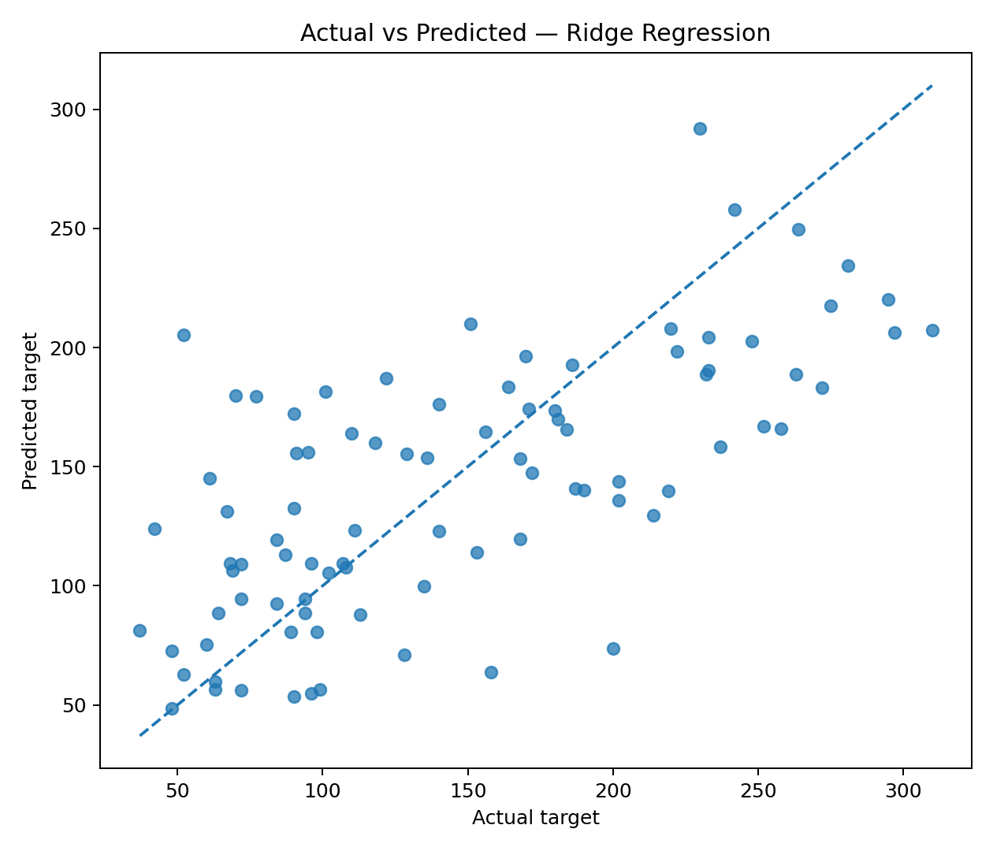
Figure 5. Actual vs predicted values for the selected model (Ridge Regression).
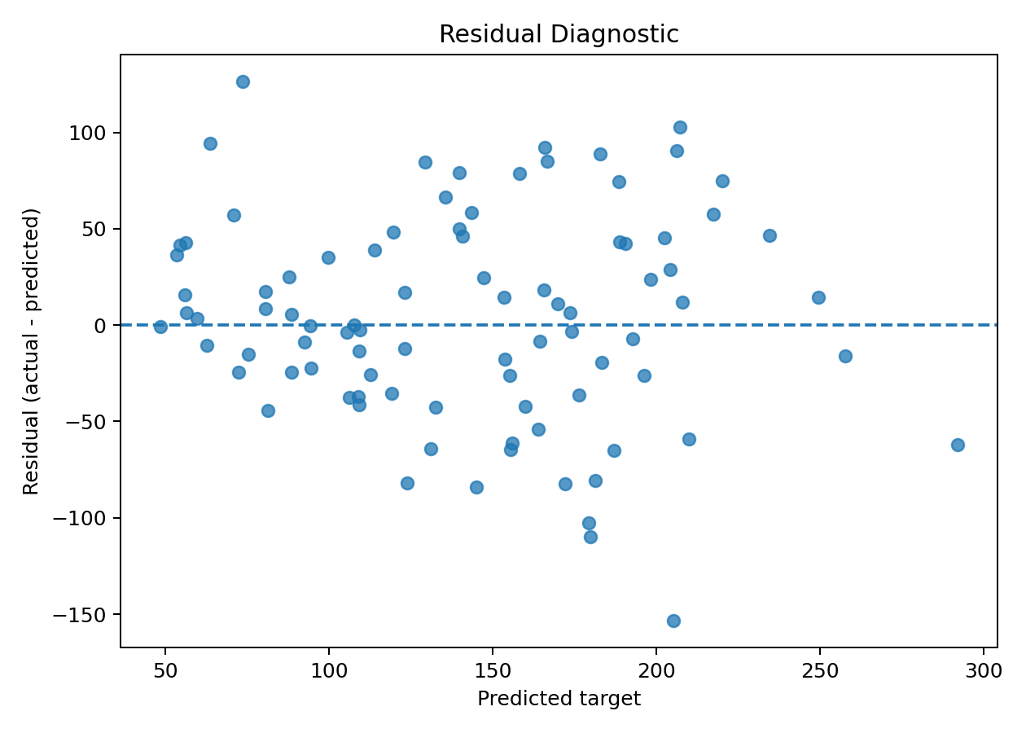
Figure 6. Residual diagnostic for the selected model.
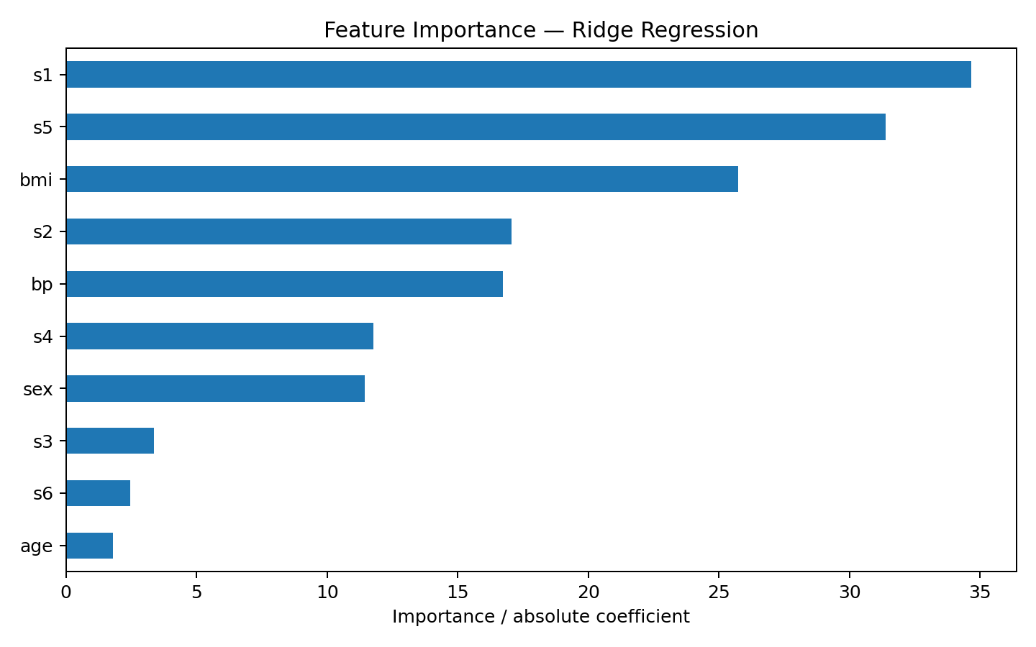
Figure 7. Feature contribution ranking for Ridge Regression.
The selected model achieved a test R² of 0.454. Its five-fold cross-validation R² was 0.479 ± 0.083. The close relationship between hold-out and cross-validation performance provides a stronger basis for judging generalization than a single split alone.

7. Unsupervised Learning: Profile Segmentation
To complement prediction with descriptive insight, all ten input features are standardized and clustered using K-Means. The number of clusters is not assumed in advance: k values from 2 through 6 are evaluated with inertia and silhouette score. The silhouette coefficient is higher when observations are dense within clusters and well separated from neighboring clusters.
K-Means model-selection metrics:
k | inertia | silhouette
2.0000 | 3176.6549 | 0.2370
3.0000 | 2879.2112 | 0.1535
4.0000 | 2639.9737 | 0.1404
5.0000 | 2453.2386 | 0.1467
6.0000 | 2303.9354 | 0.1440
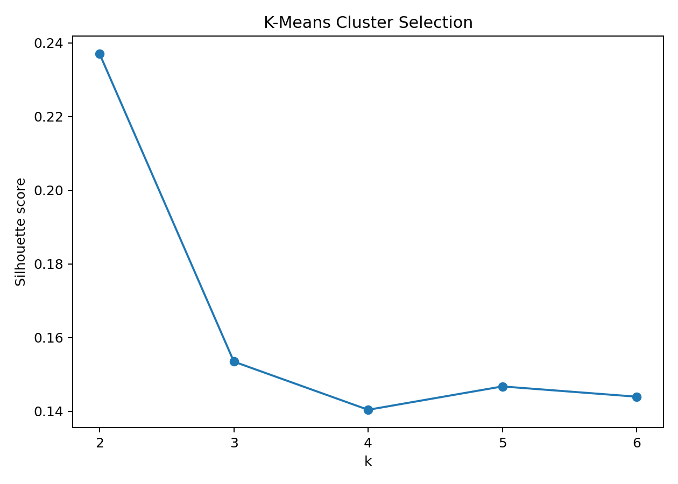
Figure 8. Silhouette scores used to select k=2.
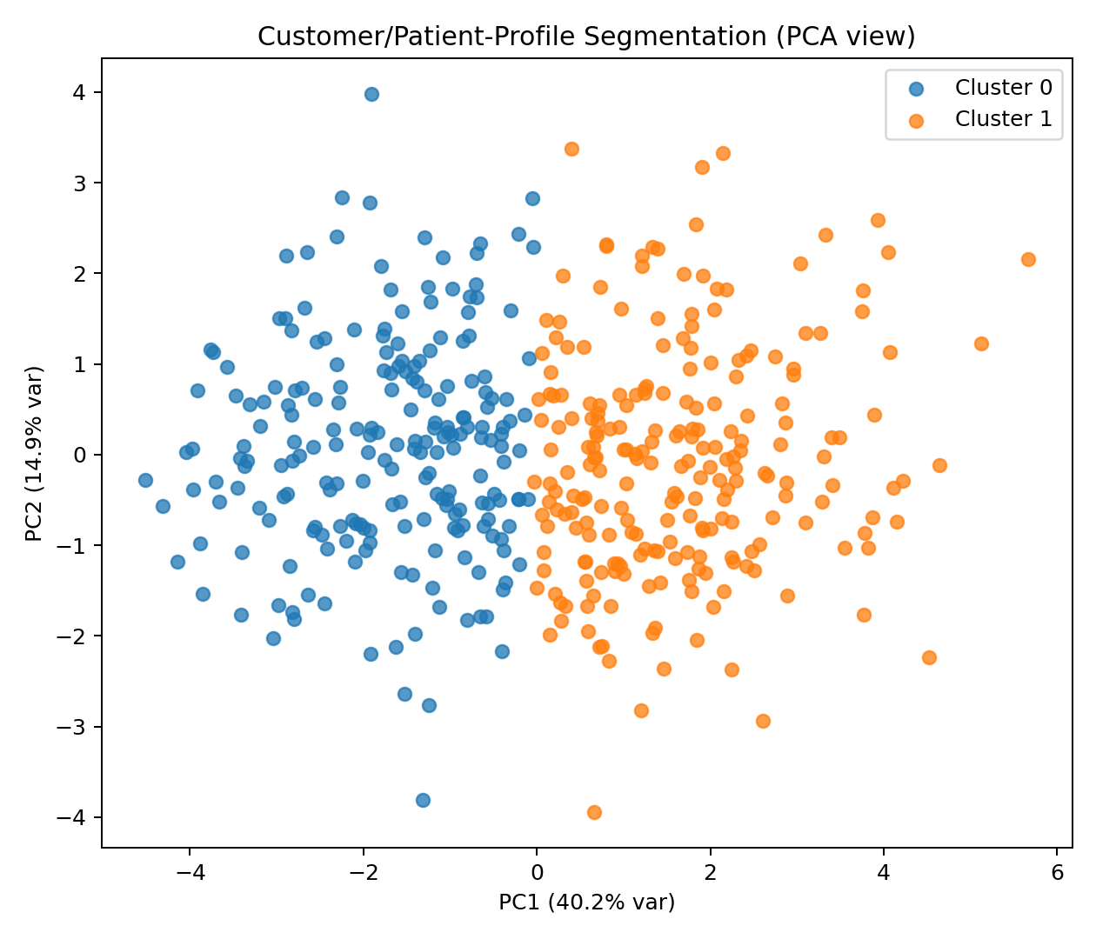
Figure 9. PCA projection of the unsupervised cluster assignments.
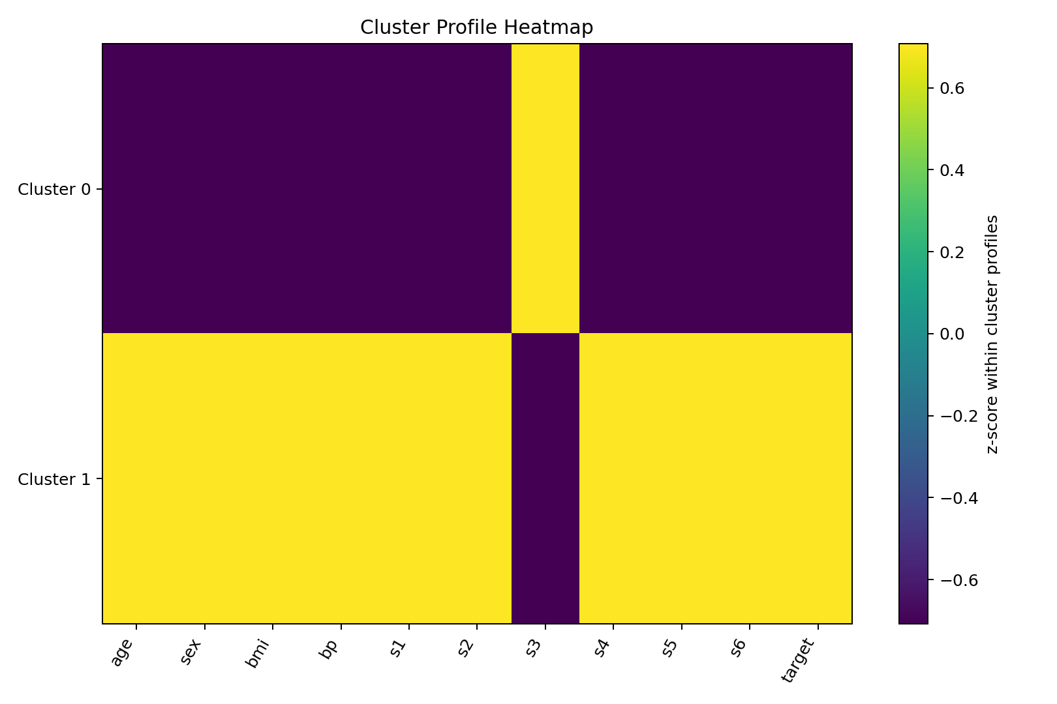
Figure 10. Standardized cluster-profile heatmap.
Mean feature values by cluster (first rows shown):
cluster | age | sex | bmi | bp | s1 | s2 | s3 | s4 | s5 | s6 | target
0.0000 | 43.6028 | 1.2991 | 24.0407 | 88.2850 | 170.4065 | 97.8285 | 56.9556 | 3.1071 | 4.2910 | 84.9486 | 113.5514
1.0000 | 53.1316 | 1.6272 | 28.5675 | 100.6184 | 206.7237 | 131.9684 | 43.0614 | 4.9743 | 4.9703 | 97.1842 | 188.3465
The clustering is exploratory. The cluster labels should be interpreted as data-driven profiles, not disease diagnoses or risk categories. Their main value is to reveal combinations of measurements that can guide further analysis or hypothesis generation.

8. End-to-End Pipeline
- Acquire the public dataset reproducibly through scikit-learn.
- Inspect shape, types, missing values, duplicates, distributions, and correlations.
- Apply leakage-safe preprocessing through pipelines.
- Train and compare multiple regression models.
- Validate generalization with a held-out test set and five-fold cross-validation.
- Standardize features and perform K-Means clustering with model-selection diagnostics.
- Use PCA and cluster profiles to interpret the segmentation.
- Translate model performance and cluster structure into practical recommendations while clearly stating limitations.

9. Key Insights and Recommendations
1. Use the Ridge Regression model as the strongest candidate within this small benchmark, because it produced the best observed test-set R² (0.454) and strong cross-validation consistency. It should still be treated as a baseline rather than a deployment-ready clinical model.
2. Preserve the pipeline architecture in future work. Separating acquisition, preprocessing, modeling, and evaluation makes the workflow easier to audit and prevents accidental train-test leakage.
3. Use the clusters for exploratory stratification. Cluster profiles can help identify groups with systematically different baseline measurements, but the groups require domain validation before being used for decisions.
4. For a stronger predictive project, expand model comparison with Gradient Boosting or XGBoost, tune hyperparameters within cross-validation, quantify prediction intervals, and assess calibration or uncertainty where appropriate.
5. For a richer capstone, connect the model to an interactive dashboard or API, add experiment tracking, and automate data-quality checks so the same pipeline can be rerun on future datasets.

10. Challenges, Limitations, and Ethical Considerations
- The dataset is relatively small (442 rows), which limits the complexity of models that can be justified without stronger external validation.
- The target is a continuous progression measure from the underlying benchmark dataset; it should not be reinterpreted as a diagnostic label.
- The dataset is historical and does not guarantee representativeness for modern populations or operational settings.
- A single public benchmark cannot establish real-world clinical utility. External validation and domain review would be required before any high-stakes use.
- K-Means assumes compact, roughly isotropic clusters and can produce segments even when natural cluster boundaries are weak; silhouette score should therefore be interpreted alongside PCA and profile analysis.

11. Reproducibility and Repository Contents
All project artifacts are organized for GitHub submission. The notebook contains the reproducible Python workflow, while the dataset, figures, model metrics, clustering outputs, and report are stored separately for easy review.
Required environment: Python 3.x with pandas, numpy, scikit-learn, matplotlib, scipy, jupyter, and python-docx.
pip install -r code/requirements.txt
jupyter notebook code/capstone_pipeline.ipynb

12. Conclusion
This capstone integrates the major stages of a data science project into one coherent workflow. It demonstrates how a public dataset can be acquired reproducibly, cleaned and explored, modeled with supervised learning, validated rigorously, and supplemented with unsupervised segmentation. The result is not just a model score: it is a documented analytical pipeline that connects data preparation, modeling choices, evaluation, visualization, interpretation, and practical next steps.

References
1. Scikit-learn Developers. load_diabetes dataset documentation. https://scikit-learn.org/stable/modules/generated/sklearn.datasets.load_diabetes.html
2. Scikit-learn Developers. K-Means clustering documentation. https://scikit-learn.org/stable/modules/clustering.html
3. Scikit-learn Developers. Silhouette analysis documentation. https://scikit-learn.org/stable/auto_examples/cluster/plot_kmeans_silhouette_analysis.html

