Exploratory Data Analysis & Visualization
Netflix Movies & TV Shows Dataset
Virtual Internship — Week 2 Task Submission
Submitted by: Prashant Jedhe
B.Tech (Data Science), G.H. Raisoni College of Engineering and Management, Nagpur
Tools Used: Python, Pandas, Matplotlib, Seaborn
Date: August 2026

1. Objective
This report documents an end-to-end Exploratory Data Analysis (EDA) performed on the Netflix Movies and TV Shows dataset. The goal is to understand the structure and composition of Netflix's content catalog, identify trends in content growth, and uncover patterns across countries, genres, durations, and content ratings using Python libraries — Pandas for data manipulation and Matplotlib/Seaborn for visualization.

2. Dataset Description
The dataset used is the publicly available "Netflix Movies and TV Shows" dataset (originally sourced from Kaggle, distributed via the TidyTuesday open-data project). It contains a snapshot of titles available on Netflix, along with metadata for each title.

2.1 Dataset Overview
Attribute | Value
Total records | 7,787 titles
Total columns (original) | 12
Content types | Movie, TV Show
Release year range | 1925 – 2021
Countries represented | 82 (primary country)
Genres represented | 36 (primary genre)

Key columns include: show_id, type, title, director, cast, country, date_added, release_year, rating, duration, listed_in (genre), and description.

3. Data Cleaning & Transformations
Before analysis, the raw data required several cleaning and transformation steps, since real-world catalog data is rarely analysis-ready:
- Missing 'director', 'cast', and 'country' values were filled with the label 'Unknown' rather than dropped, since removing them would have discarded a large portion of usable rows (director alone was missing for ~31% of records).
- 'date_added' was parsed from text into a proper datetime type; 10 rows with unparseable/blank dates were retained but excluded only from the date-based charts.
- 7 rows with a missing 'rating' were imputed with the dataset's mode rating (TV-MA).
- 3 rows had corrupted/shifted values in the 'duration' column (a known data-entry issue in this dataset) and were dropped after inspection.
- 'duration' (a mixed text field like "90 min" or "3 Seasons") was split into a numeric 'duration_num' and a categorical 'duration_unit', since Movies and TV Shows use incomparable units.
- 'country' and 'listed_in' (genre) are multi-value comma-separated fields; a 'primary_country' and 'primary_genre' were derived by taking the first listed value, so each title contributes to exactly one category in the country/genre charts and avoids double-counting.
- 'year_added' and 'month_added' were derived from 'date_added' to analyze catalog-growth trends over time.
- A derived 'gap_years' feature (year_added − release_year) was created to study how quickly titles reach Netflix after their original release.
After cleaning, the working dataset contains 7,787 rows and 18 columns (12 original + 6 derived).

4. Basic Statistics
Metric | Value
Total titles | 7,787
Movies | 5,377 (69.1%)
TV Shows | 2,410 (30.9%)
Average movie duration | 99.3 minutes
Median movie duration | 98 minutes
Average TV show seasons | 1.78 seasons
Most common content rating | TV-MA (2,870 titles)
Top country by content volume | United States (2,883 titles)
Most common genre | Dramas (1,384 titles)

5. Visualizations, Patterns & Interpretation

5.1 Content Type Distribution
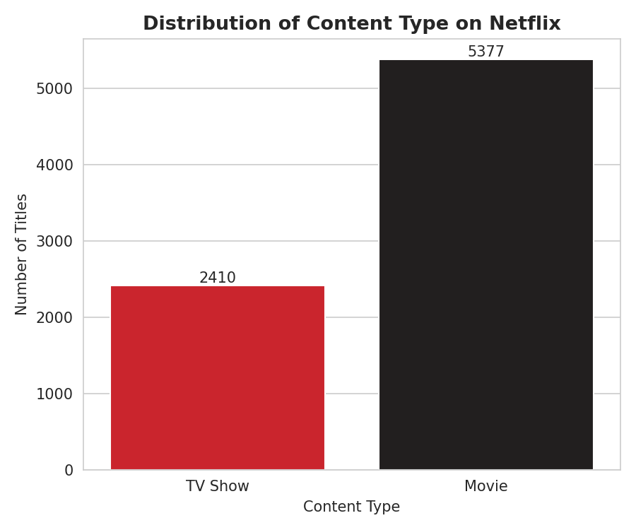
Figure 1: Distribution of Movies vs TV Shows
Movies make up nearly 69% of the catalog compared to about 31% for TV Shows. This likely reflects Netflix's historical acquisition strategy: movies are cheaper and faster to license in bulk than producing or licensing multi-season TV series, so the platform's catalog skews toward film content even as original TV production has grown in recent years.

5.2 Catalog Growth Over Time
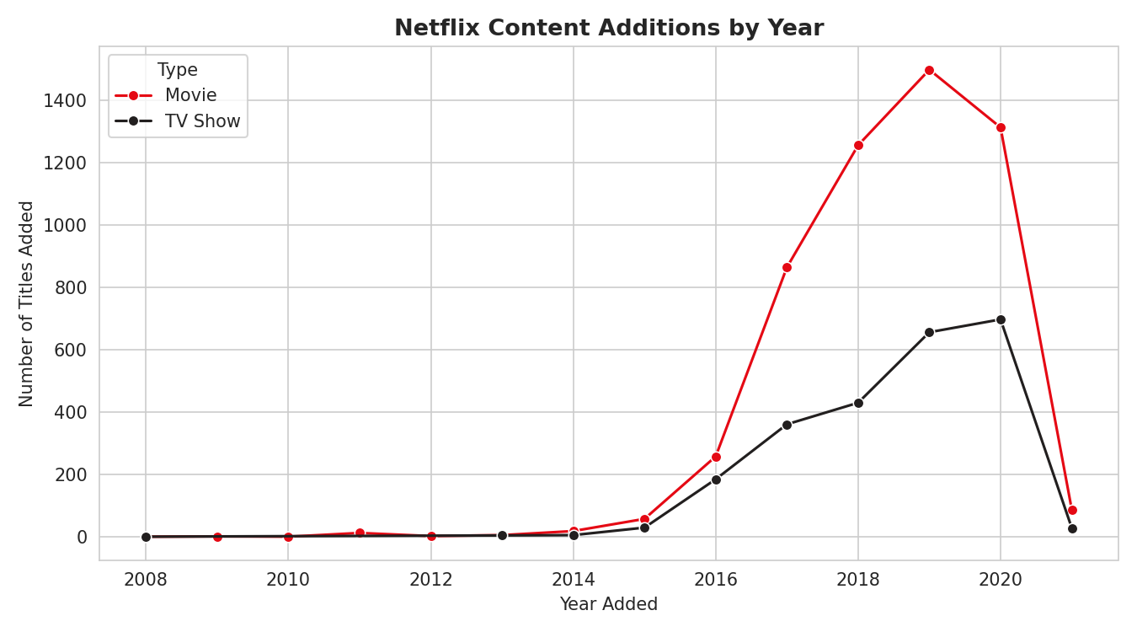
Figure 2: Number of titles added to Netflix per year, by type
Content additions were negligible before 2015 and then grew sharply, peaking around 2019 for movies (~1,500 titles added that year) with TV shows peaking slightly later in 2020. This mirrors Netflix's well-documented global expansion and heavy content-licensing/production investment between 2016 and 2020. The steep drop shown for 2021 is an artifact of the dataset's collection cutoff (mid-2021) rather than an actual slowdown.

5.3 Top Content-Producing Countries
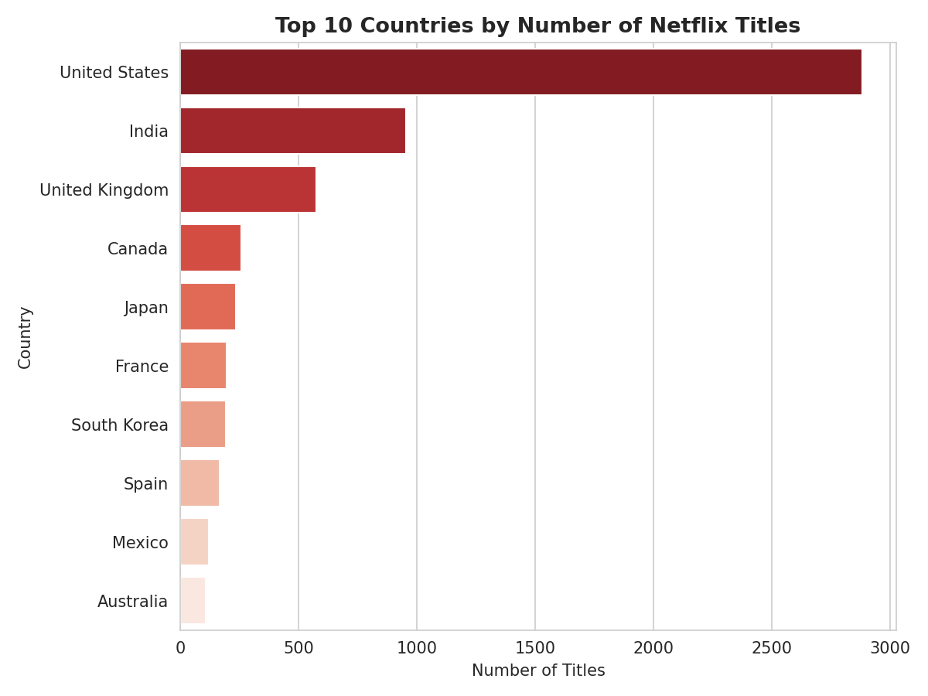
Figure 3: Top 10 countries by number of titles (primary country)
The United States dominates with 2,883 titles, more than double the next largest contributor, India (956). The UK, Canada, and Japan follow. This concentration reflects both Netflix's US origins and its major regional production hubs — India for South Asian content and Japan for anime — which the platform has invested in to serve large international subscriber bases.

5.4 Movie Duration Distribution
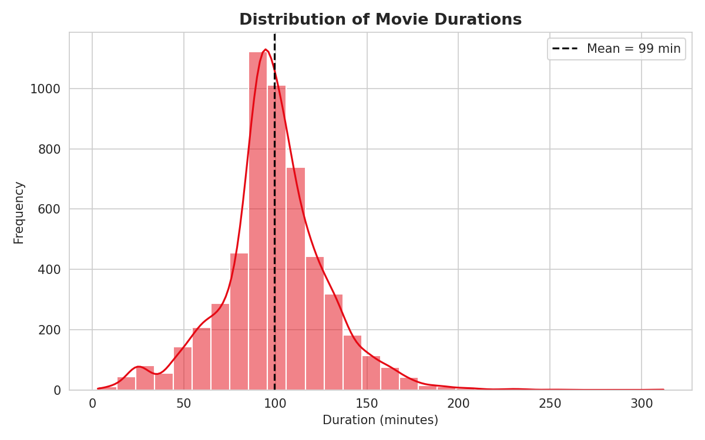
Figure 4: Histogram of movie durations with mean line
Movie runtimes cluster tightly around 90–115 minutes, close to the conventional theatrical feature length, with a mean of 99.3 minutes. The right-skewed tail (a small number of titles exceeding 180 minutes) represents documentaries and epics, while a handful of very short titles (under 30 minutes) are likely stand-up specials or short films misclassified as movies.

5.5 Top Genres
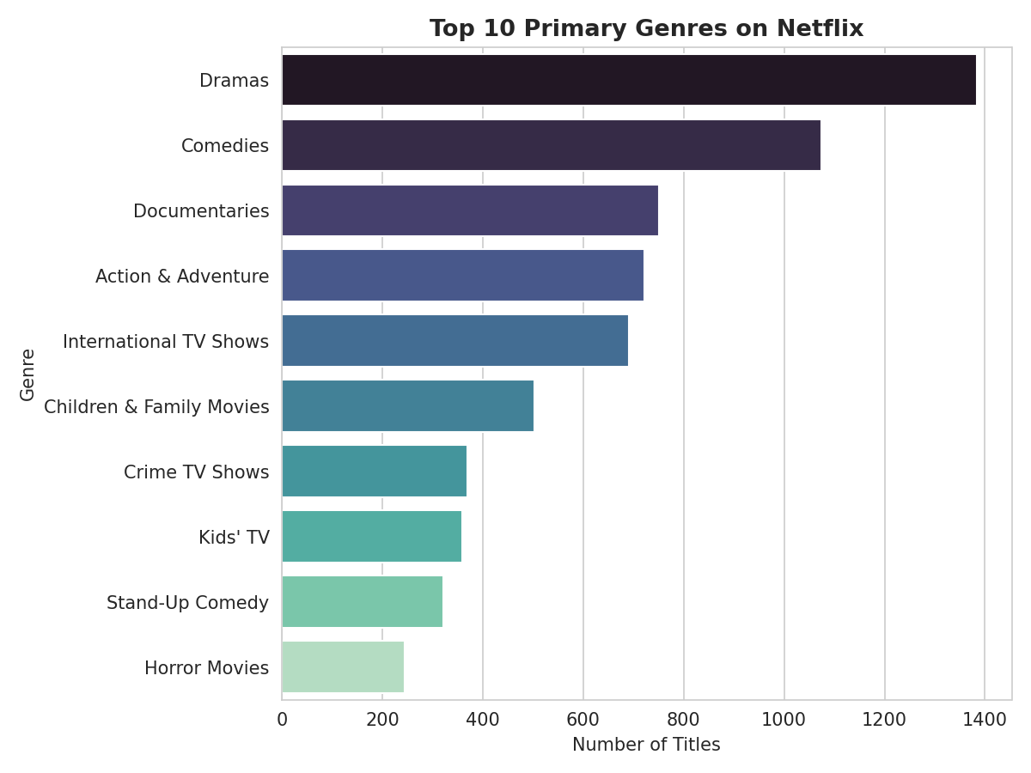
Figure 5: Top 10 primary genres by title count
Dramas (1,384), Comedies (1,074), and Documentaries (751) are the three largest genres. This aligns with broad-audience streaming strategy: dramas and comedies have the widest general appeal, while the strong documentary presence reflects Netflix's push into non-fiction/true-crime content, a category that has been comparatively low-cost to produce and popular for engagement.

5.6 Content Rating Distribution
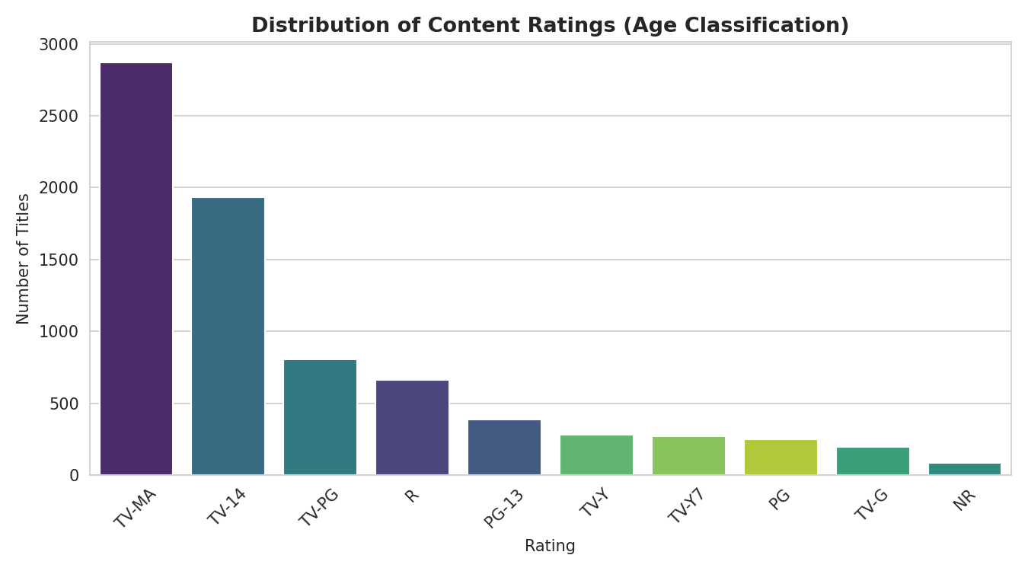
Figure 6: Count of titles by content (age) rating
TV-MA (mature audiences) and TV-14 together account for over 60% of the catalog, indicating that Netflix's content mix skews toward adult and teen audiences rather than young children. This is consistent with Netflix's positioning against competitors like Disney+, which target family content more heavily.

5.7 TV Show Season Counts
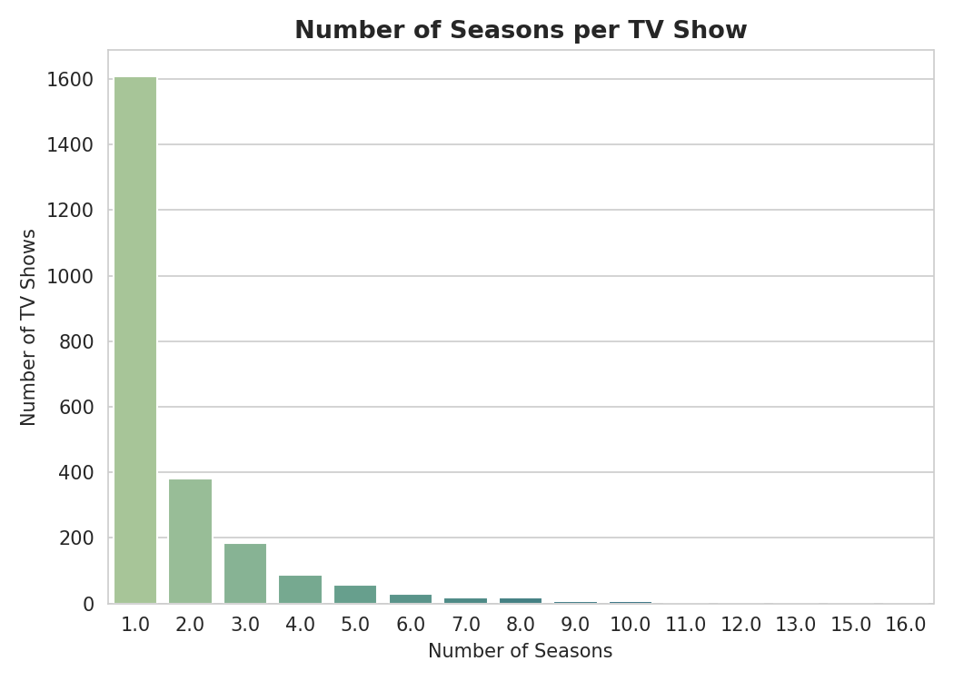
Figure 7: Number of seasons per TV show
The overwhelming majority of TV shows on the platform have only 1 season, with counts dropping off sharply for each additional season. This reflects a common streaming pattern: many shows are either limited series by design, or newer shows that simply haven't accumulated multiple seasons yet, and renewal for long-running series is comparatively rare and reserved for proven hits.

5.8 Seasonality of Content Additions
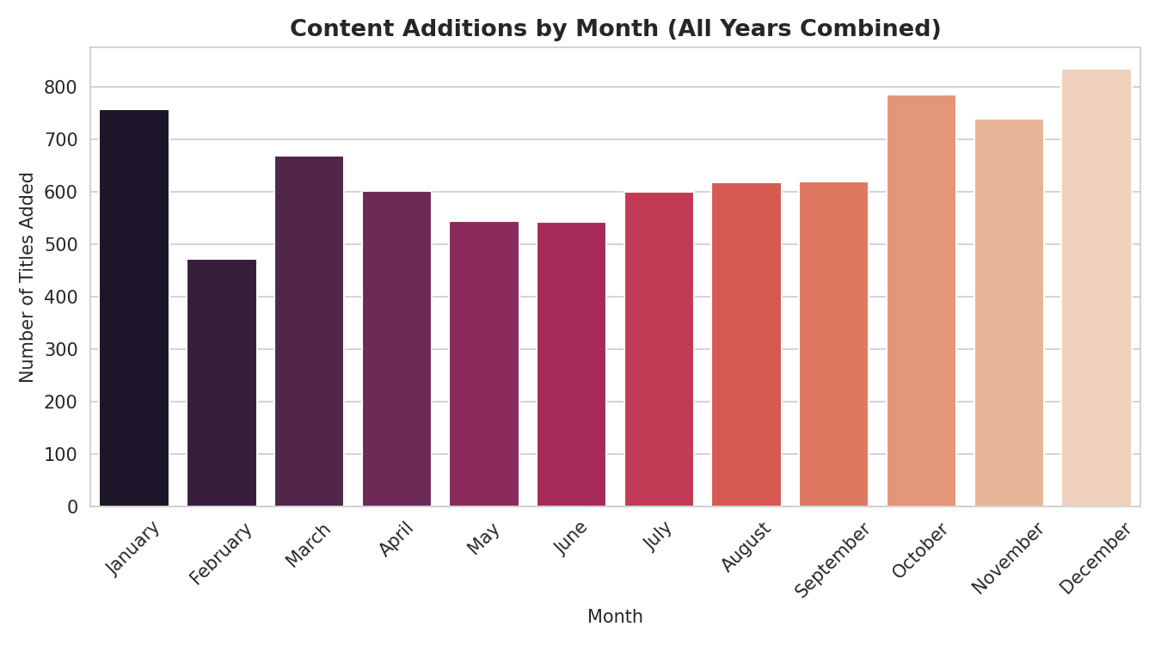
Figure 8: Total titles added by calendar month (all years combined)
Additions are relatively evenly spread across months, with a mild uptick around December/January and July. This suggests Netflix deliberately staggers new content releases across the year rather than concentrating them, though modest increases around year-end/New Year and mid-year may align with holiday viewing seasons.

5.9 Genre vs Content Type Relationship
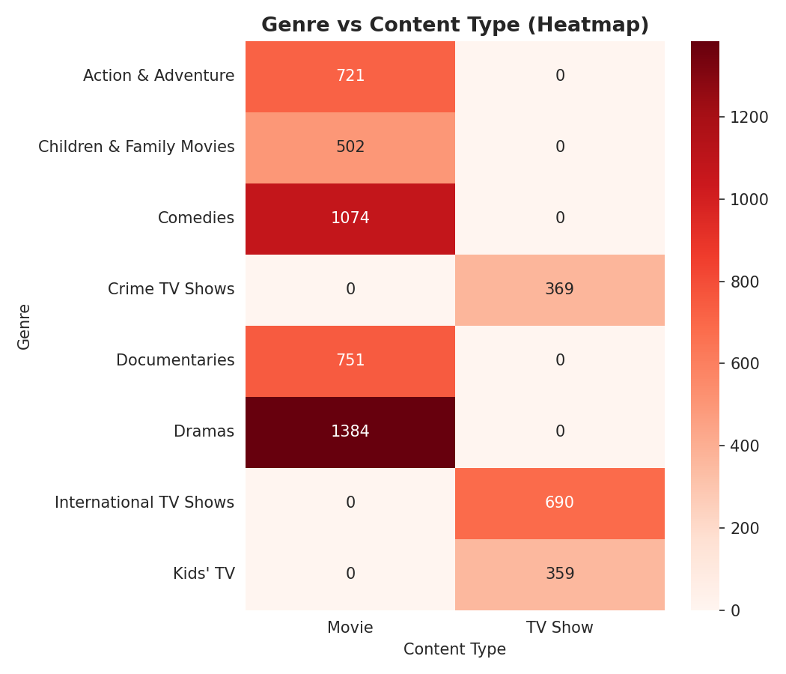
Figure 9: Heatmap of the top 8 genres split by Movie vs TV Show
The heatmap highlights that genres are not evenly shared between content types — for example, 'International TV Shows' and "Kids' TV" are almost exclusively TV Show categories by definition, while 'Dramas', 'Comedies', and 'Action & Adventure' are dominated by movies. This confirms that genre and content-type are correlated categorical variables rather than independent.

5.10 Release-to-Addition Gap (Anomaly Check)
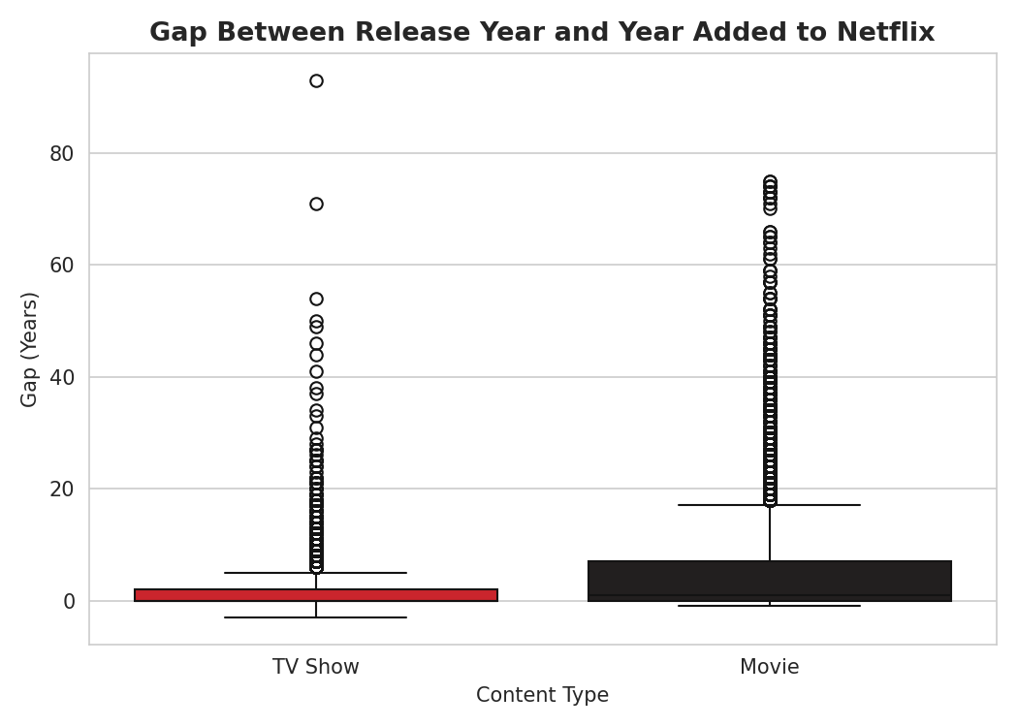
Figure 10: Boxplot of years between original release and addition to Netflix
Most movies reach Netflix within 0–7 years of release (median ≈ 1 year), while TV shows tend to appear faster (median ≈ 0 years), likely because many are Netflix Originals added the same year they are produced. Both distributions show long right-tails and outliers exceeding 70–90 years — these are classic films/shows added long after their original release, an expected and legitimate pattern rather than a data error.

6. Key Insights Summary
- Netflix's catalog is movie-heavy (69%) but TV Show additions have been growing at a comparable rate since 2016, suggesting a gradual strategic shift toward series content.
- Content growth exploded between 2016–2020, consistent with Netflix's global subscriber expansion and increased original-content spending.
- The US and India are by far the largest content contributors, reflecting Netflix's core market and its major international production hub.
- Movie runtimes are highly standardized (~90–115 min), while TV shows are dominated by single-season series, indicating many limited/anthology-style productions.
- The catalog skews toward mature audiences (TV-MA/TV-14), positioning Netflix differently from family-focused competitors.
- Dramas, Comedies, and Documentaries are the leading genres, balancing broad appeal with lower-cost non-fiction content.

7. Data Transformations Recap
The following transformations were applied prior to visualization (see Section 3 for detail):
- Missing categorical fields imputed as 'Unknown' or mode value
- Date parsing and derivation of year_added / month_added
- Splitting of the mixed 'duration' field into numeric value + unit
- Extraction of primary_country and primary_genre from multi-value fields
- Derivation of gap_years = year_added − release_year for anomaly analysis

8. Code Snippets

8.1 Loading & Cleaning
import pandas as pd
df = pd.read_csv("netflix_titles.csv")
df['director'] = df['director'].fillna('Unknown')
df['cast'] = df['cast'].fillna('Unknown')
df['country'] = df['country'].fillna('Unknown')
df['date_added'] = pd.to_datetime(df['date_added'].str.strip(), errors='coerce')
df['rating'] = df['rating'].fillna(df['rating'].mode()[0])
df = df.dropna(subset=['duration'])
df['year_added'] = df['date_added'].dt.year
df['duration_num'] = df['duration'].str.extract('(\d+)').astype(float)
df['duration_unit'] = df['duration'].apply(lambda x: 'min' if 'min' in x else 'Season(s)')
df['primary_country'] = df['country'].apply(lambda x: x.split(',')[0].strip())
df['primary_genre'] = df['listed_in'].apply(lambda x: x.split(',')[0].strip())

8.2 Example Visualization (Seaborn)
import seaborn as sns
import matplotlib.pyplot as plt
plt.figure(figsize=(9,5))
by_year = df.dropna(subset=['year_added']).groupby(
['year_added','type']).size().reset_index(name='count')
sns.lineplot(data=by_year, x='year_added', y='count',
hue='type', marker='o')
plt.title('Netflix Content Additions by Year')
plt.xlabel('Year Added'); plt.ylabel('Number of Titles Added')
plt.legend(title='Type')
plt.tight_layout()
plt.savefig('titles_by_year.png')

9. Conclusion
This EDA shows how straightforward statistical summaries combined with well-annotated visualizations can reveal meaningful business patterns in a content catalog — from strategic shifts in content mix, to geographic production hubs, to audience-targeting choices reflected in ratings and genres. The cleaning steps (handling missing values, splitting mixed-unit fields, and deriving new features) were essential prerequisites that made accurate, comparable visualization possible. Together, the ten visualizations provide a well-rounded picture of Netflix's content strategy as captured in this dataset snapshot (through mid-2021).

10. Reproducibility: Source Code & Notebook
The complete analysis — data loading, cleaning, statistics, and all ten visualizations — was implemented and executed interactively in a Google Colab notebook (task_2.ipynb). The notebook mirrors the code and figures presented in this report and can be re-run end-to-end to reproduce every result.
Live Colab Notebook: https://colab.research.google.com/drive/1E4_vwx0AHH-TQeuMJMsZ880MVCSt1SZw?usp=sharing
Notebook file: task_2.ipynb (submitted alongside this report).
The notebook is organized into clearly labeled sections matching this document:
- Installing libraries and imports
- Loading the dataset
- Handling missing values and data cleaning
- Basic statistics summary
- Movies vs. TV Shows distribution chart
- Content additions by year (peaked in 2019)
- Top 10 countries by number of titles
- Movie duration distribution
- Genre vs. content-type heatmap
- Gap between release year and year added to Netflix

