WEEK 3 TASK

Unsupervised Learning and
Clustering Analysis
A reproducible K-Means study of the UCI Wine dataset

Course / Module | Machine Learning – Week 3
Technique | K-Means clustering + hierarchical comparison
Dataset | UCI Wine dataset (178 samples, 13 chemical features)
Analysis date | 11 September 2026

Purpose
Segment multivariate wine measurements into meaningful groups without using the supplied cultivar labels during clustering, then interpret the resulting cluster profiles.

Executive Summary
Problem. Unsupervised learning is useful when the analyst needs to discover structure without a target label. This report investigates whether 13 physicochemical measurements of wine samples naturally form interpretable groups.
Approach. The UCI Wine dataset was standardized, evaluated for candidate cluster counts k=2…8, clustered with K-Means, visualized using PCA, and cross-checked with Ward hierarchical clustering. The supplied cultivar target was deliberately excluded from fitting and used only for post-hoc validation.
Finding. k=3 is the preferred solution. It gives the highest silhouette score in the tested range (0.285), while also preserving strong external agreement with the original reference groups (ARI=0.897). The three clusters have distinct chemical signatures rather than simply differing in one feature.
Interpretation. Cluster 0 is lower-alcohol/lower-proline with relatively restrained color intensity; Cluster 1 has the highest malic acid and color intensity but markedly lower phenolics/flavanoids; Cluster 2 is high in alcohol, phenolics, flavanoids, magnesium, and proline. These patterns can support exploratory wine profiling, quality-control investigations, and hypothesis generation about cultivar chemistry.
Metric | Result | Interpretation
Dataset | UCI Wine | 178 samples; 13 numeric features
Chosen k | 3 | Highest tested silhouette
Silhouette | 0.285 | Higher is better; moderate separation
PCA variance | 55.4% | PC1 + PC2
K-Means vs reference | ARI 0.897 | Post-hoc validation only

1. Introduction
Clustering is a family of unsupervised learning methods that partitions observations so that samples within a group are more similar to one another than to samples in other groups. Unlike supervised learning, the algorithm does not optimize against a known target class. This makes clustering appropriate for exploratory segmentation, anomaly investigation, pattern discovery, and early-stage scientific analysis.
K-Means was selected as the primary algorithm because the dataset is compact, fully numeric, and suitable for a centroid-based distance objective. The method requires k to be specified and minimizes within-cluster squared distances (inertia). Because Euclidean distance is scale-sensitive, standardization is essential before clustering. Silhouette analysis was then used as the main internal criterion for choosing k. These choices follow the practical guidance documented by scikit-learn. [1,2]

2. Dataset Selection and Understanding
Source. The Wine dataset is maintained by the UCI Machine Learning Repository. UCI reports 178 instances, 13 features, no missing values, and measurements such as alcohol, malic acid, magnesium, phenols, flavanoids, color intensity, hue, and proline. The observations were derived from wines grown in the same region of Italy but from three cultivars. [3]
Why it is appropriate. All clustering inputs are numeric, there are no missing values to impute, and the features represent multiple chemical dimensions, making distance-based segmentation meaningful after scaling. The dataset also contains a reference class label, which is useful for a responsible post-hoc validation check while preserving a genuinely unsupervised fitting process.
# | Feature | Type | Meaning / role
1 | Alcohol | Continuous | Alcohol concentration
2 | Malic acid | Continuous | Organic acid measure
3 | Ash | Continuous | Ash-related chemistry
4 | Alcalinity of ash | Continuous | Ash alkalinity
5 | Magnesium | Integer | Mineral concentration
6 | Total phenols | Continuous | Total phenolic content
7 | Flavanoids | Continuous | Flavanoid content
8 | Nonflavanoid phenols | Continuous | Nonflavanoid phenolic content
9 | Proanthocyanins | Continuous | Polyphenol content
10 | Color intensity | Continuous | Color-related intensity
11 | Hue | Continuous | Color hue measure
12 | OD280/OD315 | Continuous | Optical-density ratio
13 | Proline | Integer | Amino-acid concentration
Table 1. Input features used for unsupervised clustering. The cultivar target was not included in the clustering matrix.

3. Methodology
- Load the dataset using scikit-learn's packaged copy of the UCI Wine data and separate the 13 feature columns from the target label.
- Check data quality. The dataset has no missing values, so no imputation is necessary.
- Standardize every feature with StandardScaler so each variable has mean 0 and unit variance. This prevents high-variance measurements such as proline from dominating Euclidean distance. [4]
- Fit K-Means for k=2 through k=8 using k-means++ initialization, n_init=20, max_iter=500, and random_state=42 for reproducibility.
- Evaluate candidate k values with inertia, silhouette score, Calinski-Harabasz score, and Davies-Bouldin score. Silhouette is emphasized because it jointly reflects within-cluster cohesion and between-cluster separation; values closer to +1 are better. [2]
- Select k=3, visualize the clusters in two-dimensional PCA space, and profile the clusters using both raw feature means and standardized centroid signatures.
- Fit Ward hierarchical clustering at k=3 as a robustness check. The reference cultivar labels are used only after clustering for an Adjusted Rand Index (ARI) comparison.

3.1 Core Code Snippet
from sklearn.datasets import load_wine
from sklearn.preprocessing import StandardScaler
from sklearn.cluster import KMeans
from sklearn.metrics import silhouette_score

data = load_wine()
X = data.data

X_scaled = StandardScaler().fit_transform(X)

results = []
for k in range(2, 9):
model = KMeans(
n_clusters=k, init="k-means++", n_init=20,
max_iter=500, random_state=42
)
labels = model.fit_predict(X_scaled)
results.append((k, model.inertia_,
silhouette_score(X_scaled, labels)))

# Final model
final_model = KMeans(n_clusters=3, n_init=20,
max_iter=500, random_state=42)
clusters = final_model.fit_predict(X_scaled)

4. Choosing the Number of Clusters
The elbow curve shows progressively smaller gains in inertia as k increases. The silhouette curve provides the stronger decision signal in this small experiment: k=3 produces the highest average silhouette score among k=2…8.
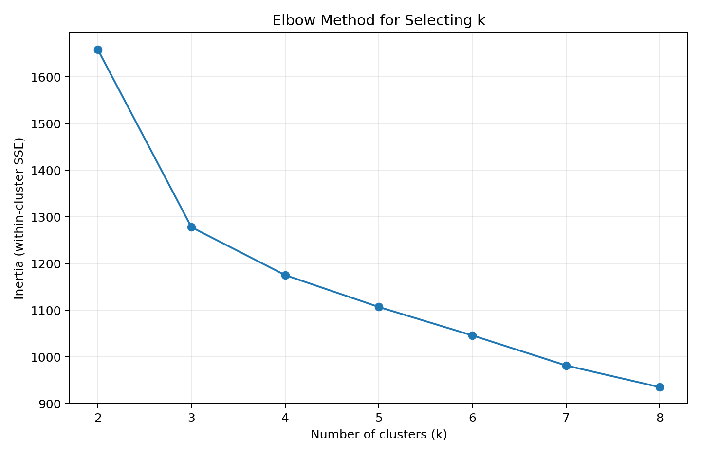
Figure 1. Elbow method: inertia decreases as additional clusters are introduced.
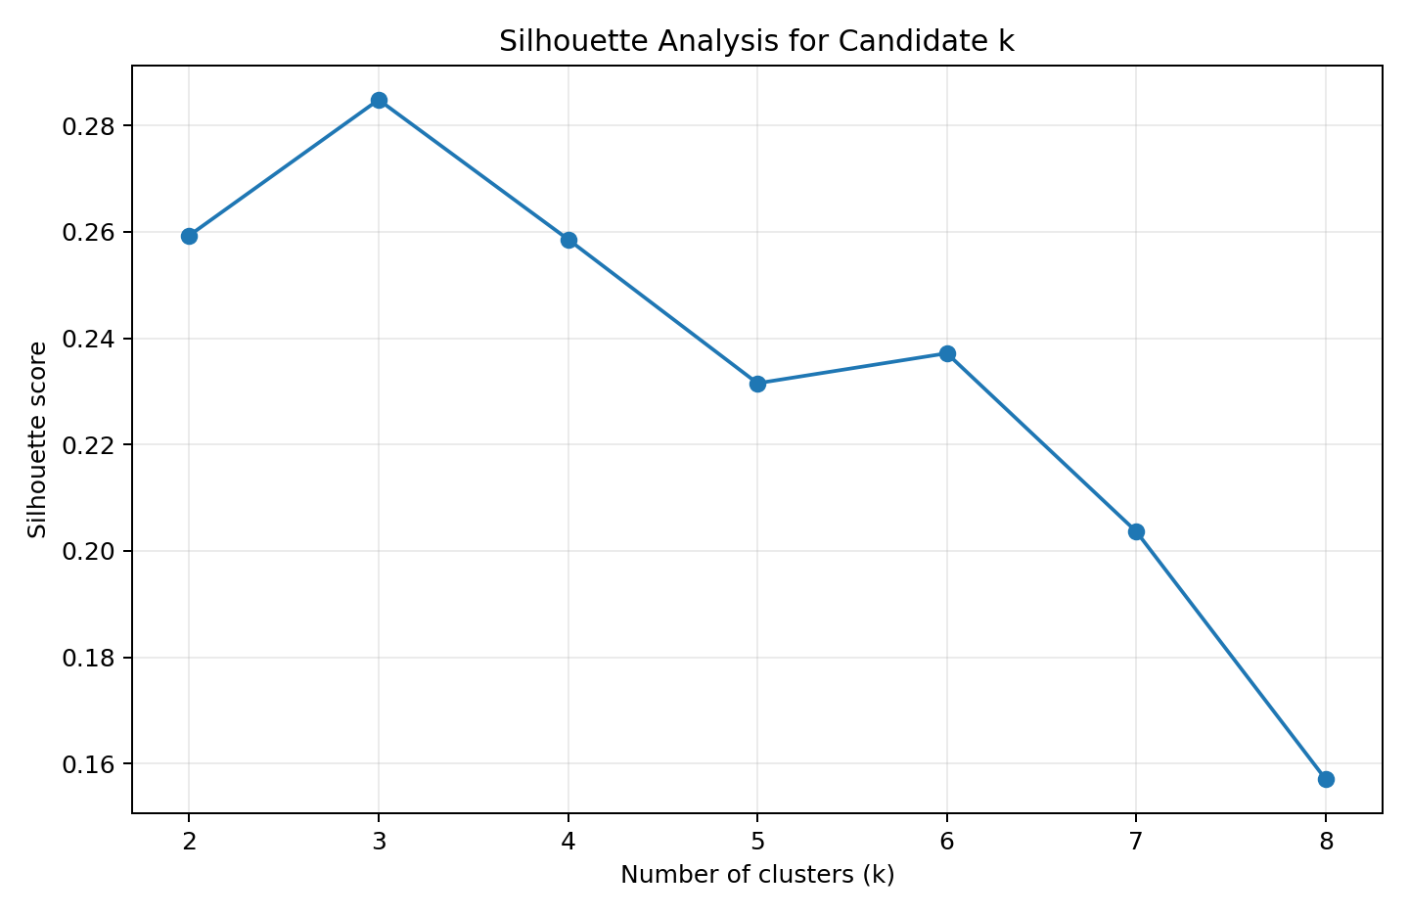
Figure 2. Average silhouette score across candidate cluster counts. k=3 is the best tested value.
k | Inertia | Silhouette | Calinski-Harabasz | Davies-Bouldin
2 | 1658.8 | 0.259 | 69.5 | 1.526
3 | 1277.9 | 0.285 | 70.9 | 1.389
4 | 1175.4 | 0.259 | 56.2 | 1.817
5 | 1107.0 | 0.232 | 47.2 | 1.681
6 | 1046.0 | 0.237 | 41.7 | 1.554
7 | 981.6 | 0.204 | 38.7 | 1.661
8 | 935.2 | 0.157 | 35.8 | 1.741
Table 2. Candidate-k evaluation metrics. Silhouette is maximized at k=3; Davies-Bouldin is also lowest at k=3 among the tested values.
Decision rationale. No single metric should be treated as a universal truth. Here, k=3 is supported by the best silhouette, the lowest Davies-Bouldin score in the tested range, and a meaningful elbow in the inertia curve. The agreement between K-Means and hierarchical clustering further strengthens the choice.

5. Clustering Results
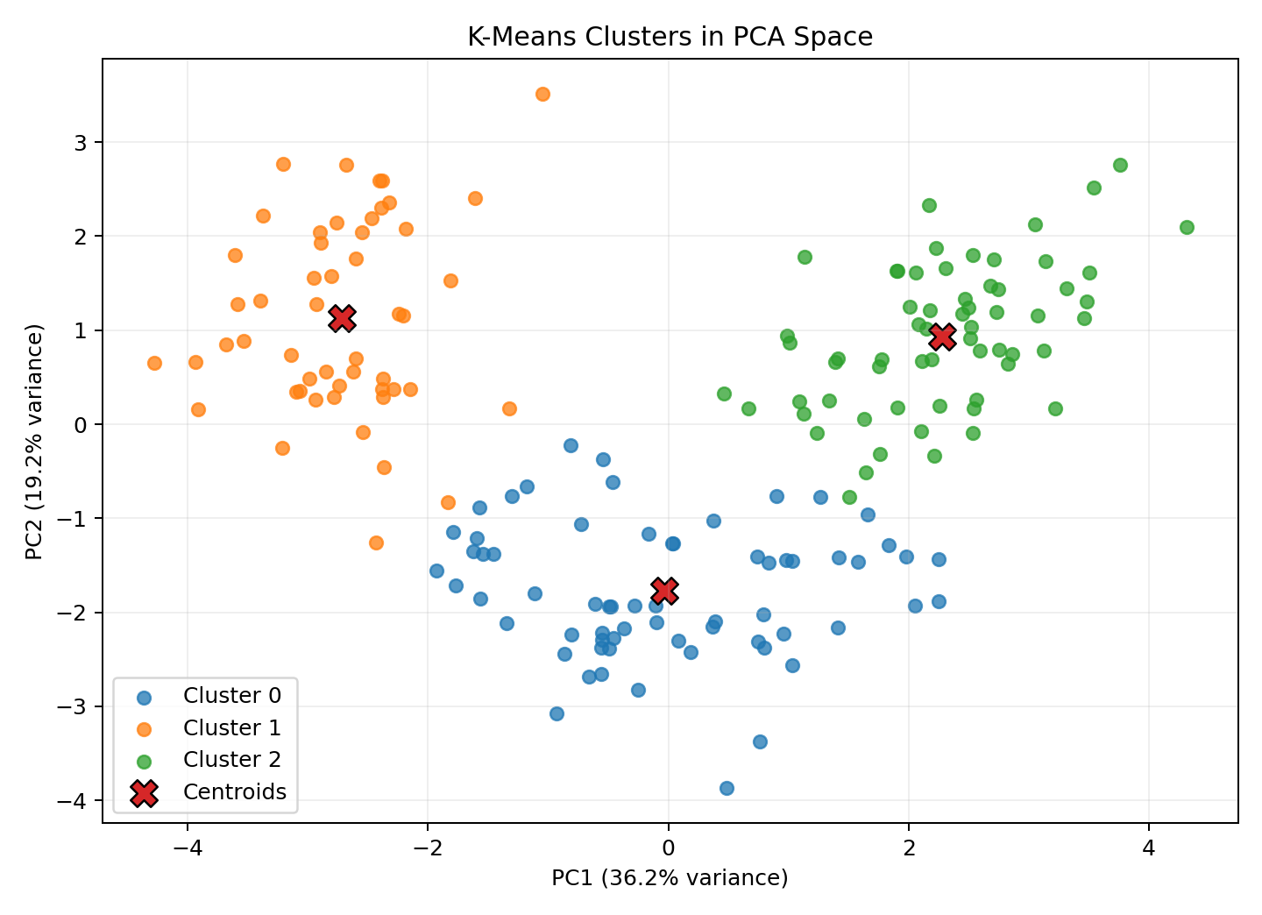
Figure 3. K-Means clusters projected into the first two principal components. PC1 and PC2 together explain 55.4% of standardized feature variance.
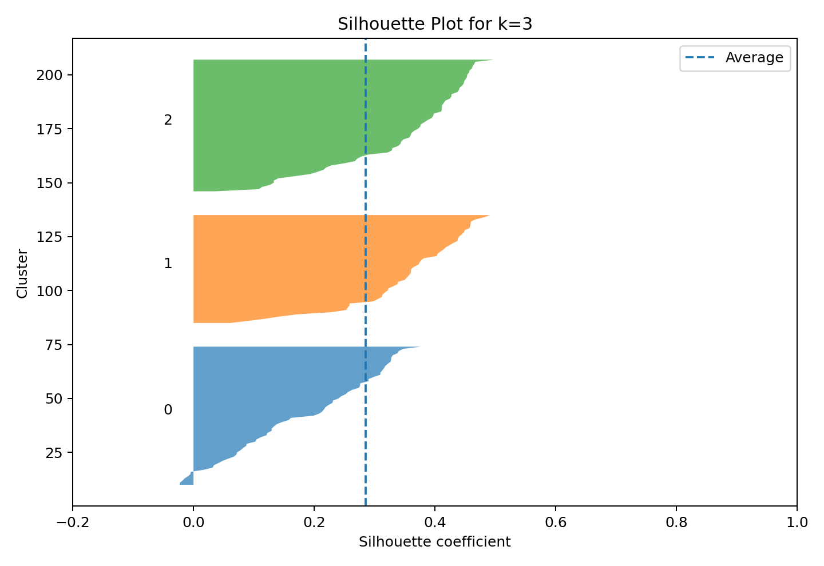
Figure 4. Sample-level silhouette coefficients for the selected k=3 solution.
Cluster sizes. Cluster 0 contains 65 samples (36.5%), Cluster 1 contains 51 samples (28.7%), and Cluster 2 contains 62 samples (34.8%). The sizes are reasonably balanced, reducing concern that one cluster simply acts as a catch-all.
Cluster | Samples | Share
0 | 65 | 36.5%
1 | 51 | 28.7%
2 | 62 | 34.8%

6. Cluster Characterization and Interpretation
The most interpretable comparison is obtained by combining raw means with standardized centroid values. Raw means describe the physical scale of each chemistry measure; standardized values indicate whether the cluster is above or below the dataset average for that feature.
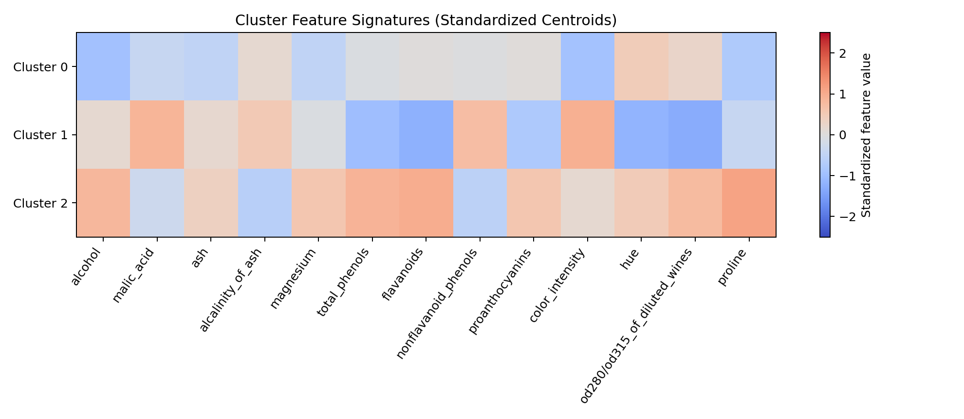
Figure 5. Standardized centroid signatures. Positive values are above the dataset mean; negative values are below the dataset mean.
Cluster | Alcohol | Malic acid | Magnesium | Total phenols | Flavanoids | Color intensity | Hue | OD ratio | Proline
Cluster 0 | 12.25 | 1.90 | 92.74 | 2.25 | 2.05 | 2.97 | 1.06 | 2.80 | 510.17
Cluster 1 | 13.13 | 3.31 | 98.67 | 1.68 | 0.82 | 7.24 | 0.69 | 1.70 | 619.06
Cluster 2 | 13.68 | 2.00 | 107.97 | 2.85 | 3.00 | 5.45 | 1.06 | 3.16 | 1100.23
Table 3. Selected raw-scale cluster means. Values are descriptive, not predictive targets.

Cluster 0 — Lower-intensity / lower-proline profile.
This group has the lowest mean alcohol (12.25) and proline (510.17), as well as the lowest color intensity (2.97). Malic acid is relatively low (1.90), while hue and the OD280/OD315 ratio are comparatively positive after standardization. The profile therefore looks chemically restrained relative to the other groups.
Potential implication: these samples can be treated as a lower-intensity chemical segment for exploratory comparison, quality-control dashboards, or laboratory follow-up. The cluster should not be interpreted as a direct label for taste or consumer preference because the dataset contains chemistry measurements rather than sensory scores.

Cluster 1 — High malic-acid / high-color-intensity, lower-phenolic profile.
This cluster has the highest malic acid (3.31) and color intensity (7.24), but the lowest total phenols (1.68), flavanoids (0.82), proanthocyanins (1.15), hue (0.69), and OD280/OD315 ratio (1.70). Its standardized centroid is strongly positive for malic acid and color intensity and strongly negative for several phenolic measures.
Potential implication: this is the most distinctive contrast group and could motivate research into whether these chemical combinations correspond to particular production, cultivar, or aging conditions. Any causal interpretation would require additional metadata and experimental validation.

Cluster 2 — Higher-phenolics / higher-proline profile.
This group has the highest alcohol (13.68), magnesium (107.97), total phenols (2.85), flavanoids (3.00), proanthocyanins (1.92), and proline (1100.23). It also has low alcalinity of ash (17.46). Its standardized signature is consistently positive across several phenolic and structural measures.
Potential implication: this cluster represents a chemically concentrated profile that may be useful for comparative laboratory studies or as a reference group in quality-monitoring workflows.

7. Hierarchical Clustering Cross-Check
Ward hierarchical clustering was fitted at k=3 using the same standardized feature matrix. Its silhouette score is 0.277, close to K-Means at 0.285. This small difference suggests that the broad three-group structure is not solely an artifact of the K-Means centroid optimization.
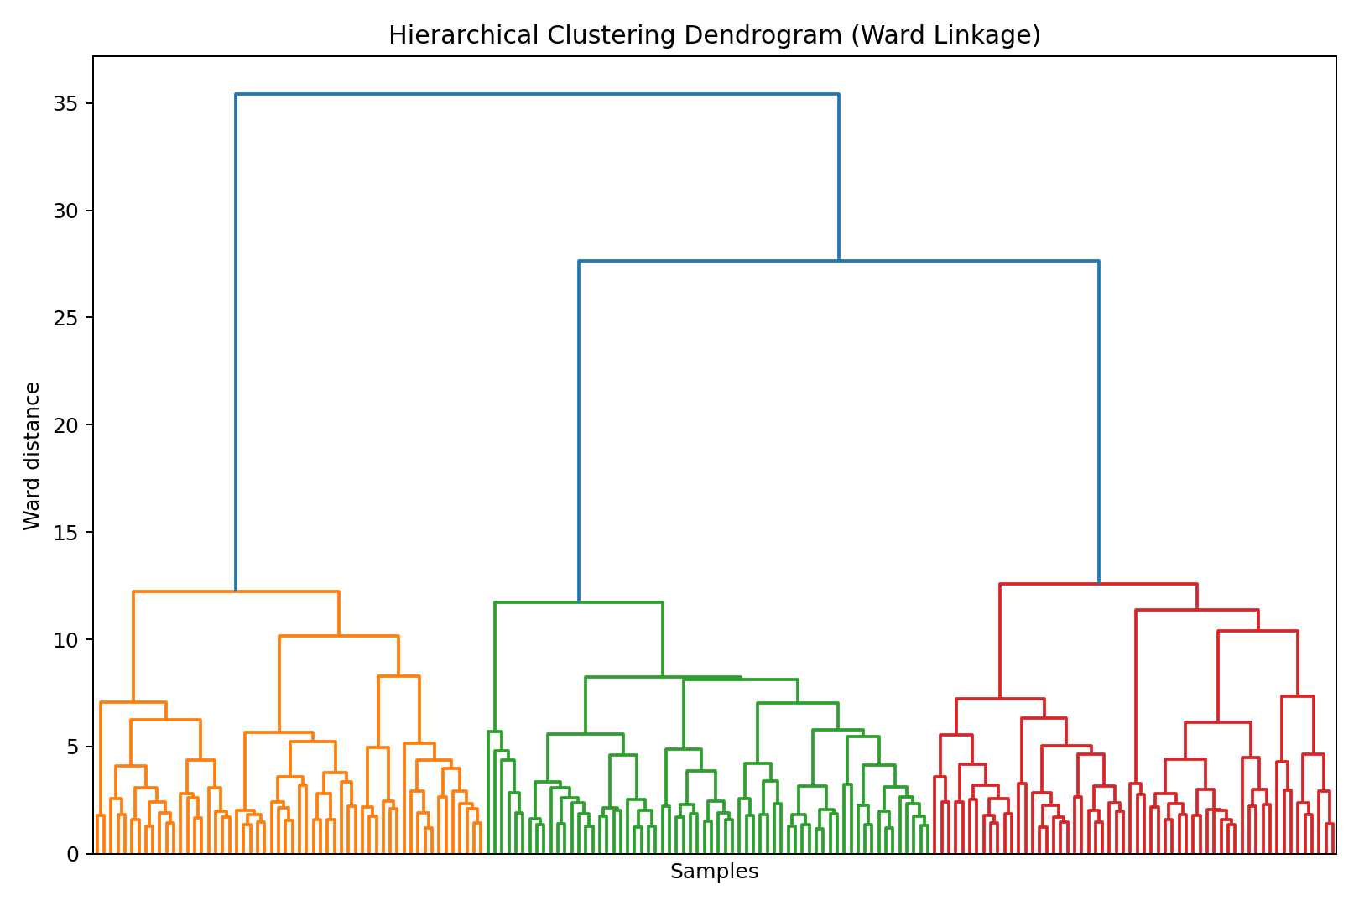
Figure 6. Ward-linkage hierarchical clustering dendrogram. The full tree shows how observations merge as distance thresholds increase.
Method | k | Silhouette | ARI vs reference
K-Means | 3 | 0.285 | 0.897
Hierarchical (Ward) | 3 | 0.277 | 0.790
Table 4. Model cross-check. ARI is reported only as a post-hoc validation measure because the reference target was not used during clustering.

8. Business and Research Implications
- Exploratory product segmentation: wineries or beverage laboratories could use chemistry-based clusters to organize samples into internally consistent profiles before deeper analysis.
- Quality assurance: cluster membership can act as a screening signal for samples that deviate from the dominant chemical patterns, prompting laboratory inspection rather than an automatic pass/fail decision.
- Research hypothesis generation: the feature contrasts suggest hypotheses around cultivar chemistry, fermentation or production practices, and other latent factors that cannot be inferred from the clustering alone.
- Communication: PCA and cluster profiles provide a compact visual language for discussing complex multivariate measurements with non-specialist stakeholders.

9. Limitations and Responsible Interpretation
- The dataset is small by modern standards (178 observations), so the exact cluster boundaries may not generalize to a different wine-growing region or future production data.
- K-Means assumes convex, roughly isotropic clusters under Euclidean distance. Other datasets with elongated, irregular, or density-based structure may need hierarchical clustering, DBSCAN/HDBSCAN, or Gaussian mixture models. [2]
- PCA is used for visualization, not as the basis for the reported K-Means fit. Two components explain 55.4% of variance, so the 2-D plot is a projection, not the full clustering geometry.
- The cultivar labels are known in the original dataset and therefore enable an ARI sanity check. They must not be used to claim that the clustering algorithm discovered a “correct” ground truth; unsupervised clusters are descriptive groupings defined by the chosen feature space and distance metric.
- No business conclusion should be interpreted as causal. Additional metadata such as producer, vineyard, year, processing conditions, sensory outcomes, or price would be required for operational recommendations.

10. Reproducibility and Implementation Notes
All reported K-Means results use random_state=42, k-means++ initialization, n_init=20, and max_iter=500. The analysis is deterministic given the same Python/scikit-learn environment. The generated project folder contains the figures, metric tables, cluster assignments, and this report for inspection.

Appendix A — Extended Reproducible Code
import pandas as pd
import matplotlib.pyplot as plt
from sklearn.datasets import load_wine
from sklearn.preprocessing import StandardScaler
from sklearn.cluster import KMeans, AgglomerativeClustering
from sklearn.metrics import (silhouette_score, calinski_harabasz_score,
davies_bouldin_score, adjusted_rand_score)
from sklearn.decomposition import PCA

# 1. Load public dataset
data = load_wine(as_frame=True)
df = data.frame.copy()
X = df.drop(columns=["target"])
y_reference = df["target"] # used only for post-hoc validation

# 2. Standardize features
scaler = StandardScaler()
X_scaled = scaler.fit_transform(X)

# 3. Compare candidate k values
rows = []
for k in range(2, 9):
model = KMeans(n_clusters=k, init="k-means++", n_init=20,
max_iter=500, random_state=42)
labels = model.fit_predict(X_scaled)
rows.append({
"k": k,
"inertia": model.inertia_,
"silhouette": silhouette_score(X_scaled, labels),
"calinski_harabasz": calinski_harabasz_score(X_scaled, labels),
"davies_bouldin": davies_bouldin_score(X_scaled, labels)
})
metrics = pd.DataFrame(rows)

# 4. Final K-Means model
final_model = KMeans(n_clusters=3, init="k-means++", n_init=20,
max_iter=500, random_state=42)
clusters = final_model.fit_predict(X_scaled)

# 5. PCA visualization
pca = PCA(n_components=2, random_state=42)
X_pca = pca.fit_transform(X_scaled)
plt.figure(figsize=(8, 6))
for cluster_id in sorted(set(clusters)):
idx = clusters == cluster_id
plt.scatter(X_pca[idx, 0], X_pca[idx, 1],
s=35, alpha=0.75, label=f"Cluster {cluster_id}")
plt.xlabel("PC1")
plt.ylabel("PC2")
plt.title("Wine Clusters in PCA Space")
plt.legend()
plt.show()

# 6. Cluster profiles
profile = X.copy()
profile["Cluster"] = clusters
print(profile.groupby("Cluster").mean())

# 7. Hierarchical cross-check
hc = AgglomerativeClustering(n_clusters=3, linkage="ward")
hc_labels = hc.fit_predict(X_scaled)
print("K-Means silhouette:", silhouette_score(X_scaled, clusters))
print("Hierarchical silhouette:", silhouette_score(X_scaled, hc_labels))
print("K-Means ARI:", adjusted_rand_score(y_reference, clusters))
print("Hierarchical ARI:", adjusted_rand_score(y_reference, hc_labels))

Appendix B — References
[1] scikit-learn. “Clustering — K-means.” User Guide, current documentation. https://scikit-learn.org/stable/modules/clustering.html
[2] scikit-learn. “Selecting the number of clusters with silhouette analysis on KMeans clustering.” https://scikit-learn.org/stable/auto_examples/cluster/plot_kmeans_silhouette_analysis.html
[3] Aeberhard, S. & Forina, M. (1992). Wine [Dataset]. UCI Machine Learning Repository. DOI: 10.24432/C5PC7J. https://archive.ics.uci.edu/dataset/109/wine
[4] scikit-learn. “StandardScaler.” Preprocessing API documentation. https://scikit-learn.org/stable/api/sklearn.preprocessing.html

Conclusion
The Week 3 objective is met through a complete unsupervised workflow: a public dataset was selected, numeric features were standardized, candidate cluster counts were compared, K-Means was fitted and visualized, cluster characteristics were interpreted, and the result was cross-checked with hierarchical clustering. The evidence supports a three-cluster solution that is both internally coherent and strongly aligned with the dataset’s known reference structure when evaluated after the fact. The most important practical lesson is methodological: meaningful clustering depends not only on the algorithm, but on feature preparation, parameter selection, multi-metric validation, visualization, and careful interpretation of what the clusters can—and cannot—claim.

