roid

217, Sheikh Rashid Building

P.O Box 56272, Dubai

United Arab Emirates

Tel: +971 4 2973236 / 04 2974007

Email: uae@verbat.com

PROJECT   
PROPOSAL

**Datwyler Design**

|  |  |
| --- | --- |
| **Prepared for:**  **Ahmed Obaid Al Tunaiji** | **Submission Date:**  22 May 2017  **Proposal ID:** AD/BP/22052017/1343/1 |

________________________________________________________________________________________________________________________________  
Conﬁdentiality Notice: This Proposal is conﬁdential and contains proprietary information and intellectual property of Verbanet Technologies LLC. Neither this proposal nor any of the information contained herein may be reproduced or disclosed under any circumstances without the express written permission of Verbanet.

© 2017 by Verbanet Technologies LLC. All rights reserved. Confidential.

________________________________________________________________________________________________________________________________

Project Contacts

|  |  |
| --- | --- |
| Client Information | |
| Project Name | Datwyler Design Tool |
| Client Name | Datwyler Cables |
| Client Address |  |
| Contact Person |  |
| Contact Person Email |  |
| Contact Person Phone Number |  |
| Verbat Information | |
| Contact Person | Joyce Daniel |
| Contact Person Phone Number | +971 42973236 |
| Contact Person E-Mail | [joyce.daniel@verbat.com](mailto:joyce.daniel@verbat.com) |
| Address | PO Box 56272, Dubai, United Arab Emirates |
| Physical Address | 217, Sheikh Rasheed Building, Hor Al Anz East |
| Project Information | |
| Proposed Technology/Methodology | Angular5.0, C#, MSSQL, IIS, Typescript |
| Anticipate Start Date | NA |
| Proposal Valid For | 30 Calendar days from the submission of the proposal |

**Table of Content**

1 Scope of Work 6

1.1 Proposed Solution Model 7

1.2 Solution Objective 7

1.3 Advantages of Proposed Solution 8

1.4 Why Verbat 9

1.5 Key Differentiators 10

1.6 Technology & Services 11

2 Functional Specification 12

3 Application Architecture 15

3.1 Single page application (SPA) using Web API (.Net) Architecture 15

3.2 Visio Diagrams 16

3.3 Office Documents 17

3.3.1 LOB Systems and Data 18

3.3.2 LOB Software or Components 19

3.3.3 Front-end Web Server 19

3.3.4 Client Applications 19

3.4 SAP Integration 19

3.5 PDF Integration 20

3.6 Application Level features 21

3.7 System Level Features 21

3.8 Technology Overview 22

4 Nonfunctional Requirement (Others) 24

5 Assumptions 24

6 Out of Scope 25

7 Technology Solution 27

7.1 Proposed System Environment 27

7.2 Technical Configurations 28

7.2.1 Development Tools 28

7.2.2 Recommended Web Hosting Package 28

7.2.3 Browser Compatibility 28

7.2.4 Hardware Interface 28

8 Commercials 29

8.1 Web Application 29

8.2 Payment Terms 29

8.3 Mode of Payment 29

9 Delivery Management 30

9.1 Project Management 30

9.2 Roles and Responsibilities 30

9.3 Delivery Activity Summary 32

9.4 Project Implementation Plan 32

9.5 Deliverables 32

9.6 Estimated Delivery Time 33

9.7 Deployment Details (at Clients Behest) 34

9.8 Release Planning 34

9.9 Risk and Contingency Planning 34

10 Change Management 35

11 Miscellaneous 37

11.1 Acceptance Criteria 37

11.2 General Terms and Conditions 37

11.3 Assumptions and Dependencies 38

11.4 Source Code & Intellectual Property Rights 39

11.5 Maintenance & Support 39

11.6 Service Level Agreement 40

12 Our Clients 41

# Scope of Work

Datwyler Cabling (Reffered to as the client hereafter) has contacted Verbat to provide technical proposal in response to their RFP for developing a Design tool. The client has provided Verbat with a detailed Requirements Specification that shall be used to determine the effort estimate. The proposed tool consists of 2 parts.

1. Generate quotation by designing a new solution. This capability will have the below features:

* Capture Project Details
* Input Design Specifications
* Generate Schematic Diagrams
* View Project location Map
* Get Solution Output
* Generate BOQ
* Generate Quote
* Show Logistics Details
* View Product Availability

1. Generating quotation directly from the Product pricelist. This capability will have the below features:

* View Product / Item Price List
* Generate BOQ from Pricelist
* Generate Quote
* Show Logistics Details
* View Product Availability

Verbat is pleased to submit the proposal and values it as a great opportunity to have a long term & mutually beneficial association with the client. Verbat has gone through the requirement and presents a proposal for the requested system.

In Addition to the above the software tool will have capability to create predefined solutions,

Create solutions based on Service Provider Guideline, Track order status, View user dashboard,

View system usage analytics and also post any new events and announcements related to the organization

## Proposed Solution Model

**Stand-Alone Fixed Bid**

Verbat will be following a stand–alone fixed bid solution delivery model wherein the required solution would be devised and a suitable pricing would be offered.

## Solution Objective

Verbat intends to build a one stop solution to design and develop the Datwyler Design tool. This includes in entirety everything covered in the requirements specification document. Any Item or detail that will not be covered under design or development shall be called out under the section titled “Out of Scope”.

Verbat will develop the application with functionality to

* Integrate with SAP
* Integrate with Visio to generate diagrams
* Integrate with Adobe PDF, MS Word and MS Excel so that documents can be exported
* Future proof the application, so that it can be integrated with PIM

Application will be developed in 2 phases. The first phase will contain all of the features described in the requirements document. Phase 2 will be used for integration with PIM.

Verbat’s Solution architects have conducted a thorough research on the requirements and have come to the conclusion that our proposed solution, which is detailed further in this document, will meet the requirements put forth by the client. And the proposed solution will be delivered in a phased approach as per Verbat’s stand-alone fixed bid solution model.

**Strong and Scalable platform:** The platform proposed will be strong and scalable enough to accommodate future enhancements.

**Accelerated solution:** The framework would act as a solution accelerator. It would provide the basic building blocks which could be reused in future for building new components and features.

**High performance:** The light weight framework used consumes fewer system resources thereby making the application perform faster.

**Security:** The application will be developed considering various aspects of security.

## Advantages of Proposed Solution

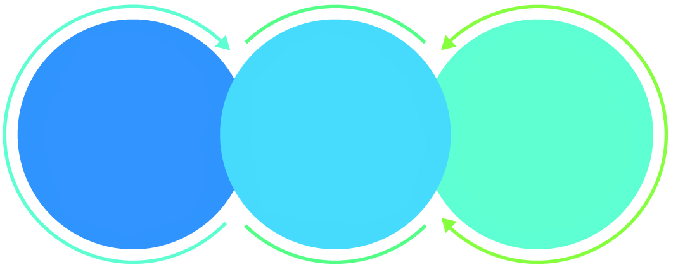

01

Agile development offering reliable, secure solution

02

Smooth transition and quicker completion of processes

03

User friendly interfaces enabling easy navigation between screens

## Why Verbat

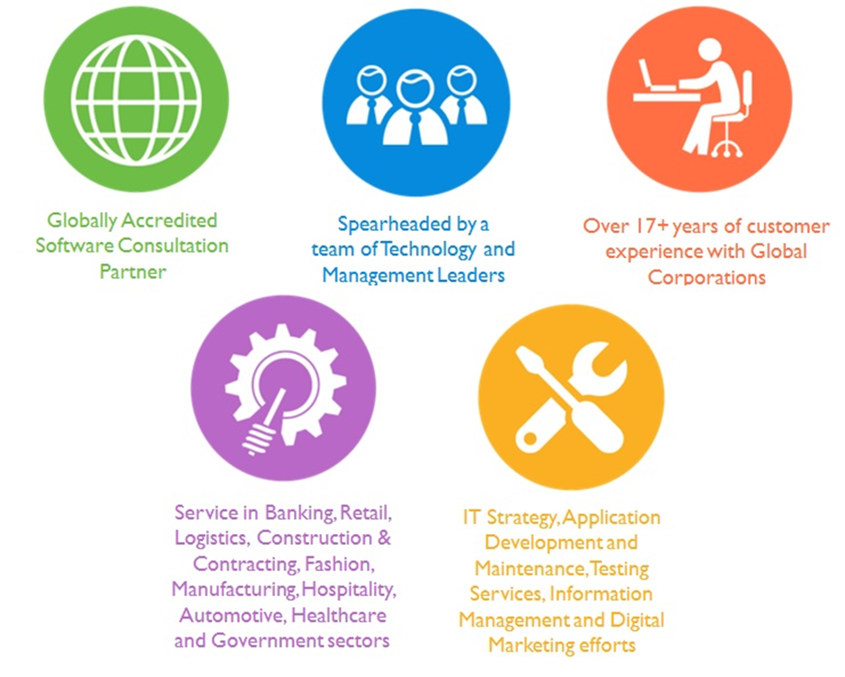

## Key Differentiators

Delivered digital transformation expertise to global customers for over a decade by following industry best practices to maximize ROI for client

Keen technology intelligence combined with aggressive market research to deliver solutions that achieve results with measurable value

Enable access to global consulting expertise with strong local market and business knowledge

Commercial Model that is customizable for your business needs

Services that are designed to optimize applications for improved performance and overall efficiency

1,000,000 plus man-hours of expertise in technology frameworks spanning Microsoft, Open Source, mobility platforms and other proprietary IT technology

Partners top technology vendors to bring in the latest and best services in integration, collaboration, and development

Commercial Model that is customizable for your business needs

Proven Methodologies & Processes

Investment in R & D

Strong Local Presence

Flexible commercial Models

Technology Associations

Software Development Experience

Offshore Development Centre

Quality Assurance & Testing

## Technology & Services

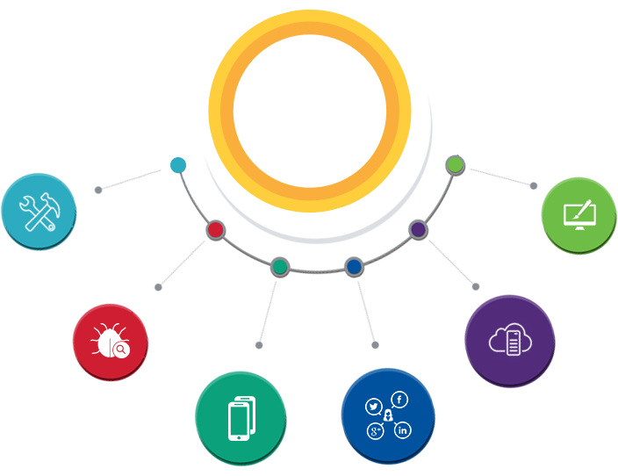

Technology  
&  
Services

Cloud/Traditional Hosting

User Interface & Design

Digital Marketing

Mobility Solutions

Testing Services

Application  
Development

# Functional Specification

|  |
| --- |
| **Admin** |
| Assign roles |
| Manage Users |
| Manage Fees |
| Manage inspection check list |
| Manage Fines |
| Configure scheduler, gateways etc. |
| Upload documents as proxy |
| **General Pages** |
| Privacy Policy |
| Announcements |
| About |
| Help |
| **New Permit** |
| Submit Documents |
| Documents Review |
| Vehicle inspection results validation |
| Pay fees and fines |
| Print Permits and sticker |
| **Permit Renewal** |
| Workflow adjustment for renewal |
| **Re print Sticker** |
| Submit request with required documents |
| Review Documents |
| Review Fines and complaints |
| Custom printing on special printers |
| Approve or reject |
| Pay fees and fines |
| disable previous permit no |
| Notify results |
| Issue new sticker |
| **Cancel Permit** |
| Verify and review current permit |
| Review pending fees or fines |
| Pay fines |
| approve / reject request |
| Notify permit holder |
| **Inspection and Fines** |
| Assign Inspector , inspection date and time |
| Retrieve inspection list for vehicle and vehicle history |
| Record inspection results |
| Add inspection evidence via photos |
| Scan bar codes (License, Vehicle permits etc.) |
| Update inspection location via Mobile GPS |
| Determine fines based on inspection results |
| print fines per vehicle |
| Send SMS and emails to permit holder |
| **Mobile App development (IOS)** |
| **IOS API Development** |
| **Reports (10 reports)** |
| Report template customizations for printing |
| **Third party API Integration (SMS, Muroor, Tahseel)** |
| **General application features** |
| search |
| dashboard for applicants, Permit holder, TSD Staff, TSD Manager & inspector |
| application tracking |
| Complaints management |
| **System features** |
| Authentication & authorization |
| Auditing & logging |
| Exception handling |
| Scheduled jobs |
| On Screen guides |
| Workflow management |
| Localization (English & Arabic) |
| Document Archival |

# Application Architecture

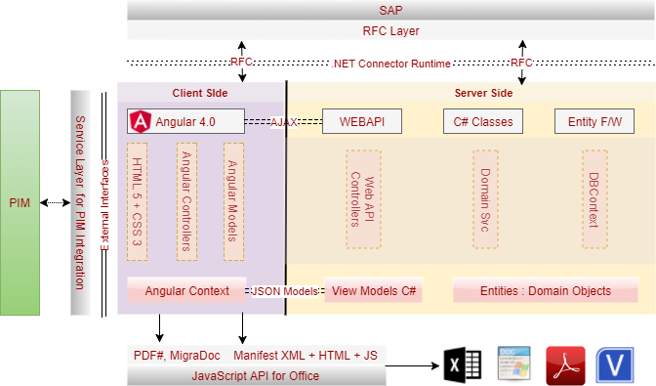

## Single page application (SPA) using Web API (.Net) Architecture

The core of the proposed application architecture is based on the following technologies.

* ASP.NET MVC
* Angular 4.0
* Web API
* Entity Framework

In the diagram, the first row depicts the commmunication between the Client and the server. Communication between the client and server is established using Ajax (Asynchronous JavaScript And XMLHttpRequest), i.e. Web applications can send and retrieve data from a server asynchronously (in the background) without interfering with the display and behavior of the existing page. AJAX Requests are typically bound to a Web API Service controller. The service controller analyses the AJAX request to determine the action to be taken.

The data contained in the request is automatically translated to C# View models. The Web API is also capable of translating the view models to domian objects that can be consumed by domain services.

Data that is trnsmitted via AJAX calls are encoded in JSON format. JSON format is an XML like data format used to exchange data between the client and server application. JSON formattted files are automatically converted to C# view models via the Web API controller. The View Models are a subset of the Domain Objects. Ultimately these domain objects are mapped to the Entity farmework, which are responsible for persisting / retrieving data to / from the underlying database.

Domain Services contain the business logic needed to process the requests. They could be participants in a workflow or contain functionality that are discrete units.

## Visio Diagrams

You can add shapes to a Microsoft Office Visio document by retrieving the masters from a stencil and dropping the shapes on the active page. To add shapes to a Visio document, on an active document, retrieve the masters from the "Documents.Masters" collection and drop the shapes on the active document. You can retrieve a master by using the index or master name.

Sample Code to create a reactangle and label it

*this.Application.Documents.Add("");*

*Visio.Documents visioDocs = this.Application.Documents;*

*Visio.Document visioStencil = visioDocs.OpenEx("Basic Shapes.vss",*

*(short)Microsoft.Office.Interop.Visio.VisOpenSaveArgs.visOpenDocked);*

*Visio.Page visioPage = this.Application.ActivePage;*

*Visio.Master visioRectMaster = visioStencil.Masters.get_ItemU(@"Rectangle");*

*Visio.Shape visioRectShape = visioPage.Drop(visioRectMaster, 4.25, 5.5);*

*visioRectShape.Text = @"Rectangle text.";*

## Office Documents

Using OpenXML, web applications can generate first class MsOffice documents on the server side. The OpenXML package defines the Office Document (Excel or Word) as a set of XML files (document parts) and also defines the relationship between these parts. The document parts make up the contents of the file. Stitching together these document parts, using their relationships, to create a Word document is done using the Office Business Applications (OBA).

The following code sample shows how you can create a simple document package with a main document part and simple WordprocessingML content by using Visual C#

*// Create a package as a Word document.*

*public static void CreateNewWordDocument(string document)*

*{*

*using (WordprocessingDocument wordDoc = WordprocessingDocument.Create(document, WordprocessingDocumentType.Document))*

*{*

*// Set the content of the document so that Word can open it.*

*MainDocumentPart mainPart = wordDoc.AddMainDocumentPart();*

*SetMainDocumentContent(mainPart);*

*}*

*}*

*// Set content of MainDocumentPart.*

*public static void SetMainDocumentContent(MainDocumentPart part)*

*{*

*const string docXml =*

*@"<?xml version=""1.0"" encoding=""UTF-8"" standalone=""yes""?>*

*<w:document xmlns:w=""http://schemas.openxmlformats.org/wordprocessingml/2006/main"">*

*<w:body><w:p><w:r><w:t>I love coffee</w:t></w:r></w:p></w:body>*

*</w:document>";*

*using (Stream stream = part.GetStream())*

*{*

*byte[] buf = (new UTF8Encoding()).GetBytes(docXml);*

*stream.Write(buf, 0, buf.Length);*

*}*

*}*

OBA’s can be used for document integration, which is the process of automating the generation of documents with data from another system or processing documents to extract data.

**Conceptual Architecture for server side document integration solution**

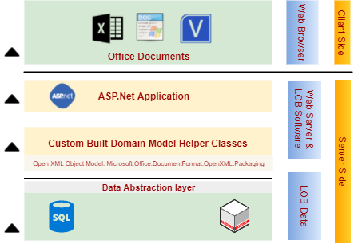

A server-side document integration solution has four tiers:

* Line of Business (LOB) systems and data
* Line of Business (LOB) software and components
* Front-end Web server
* Client applications

### LOB Systems and Data

The LOB systems and data encapsulate the data layer logic of an application. Companies can store data in different cross-platform LOB systems such as SAP, Siebel etc. Data can also be stored in database systems such as Microsoft SQL Server or Oracle. You can create custom data helper classes to encapsulate the process of retrieving data from different LOB systems. The data helper classes can use Web services, third-party APIs, or ODBC connections to access the different LOB back-end systems and data.

### LOB Software or Components

The LOB software and components encapsulate the business logic tier of an application. Custom classes that define business processes can consume existing LOB services or can be used in conjuct to create a service oriented architecture.These classes use the Open XML object model to generate document packages and output document content based on LOB data.

### Front-end Web Server

A front-end Web server encapsulates the productivity layer of the web application. The front-end Web server can provide Web pages that have buttons or predefined custom actions that enable users to export data to Word or Excel.

### Client Applications

The client application represents the presentation layer of the solution. After the server-side solution creates the documents, you can open the document using Microsoft Office programs.

## SAP Integration

SAP offers several technologies to interface with it. Of those varied technologies, RFC (or Remote Function Call) is one of the most popular. SAP has developed many implementation for the RFC, including COM, Java and .Net. SAP has created a RFC Connector for.Net, titled Nco (.Net Connector).

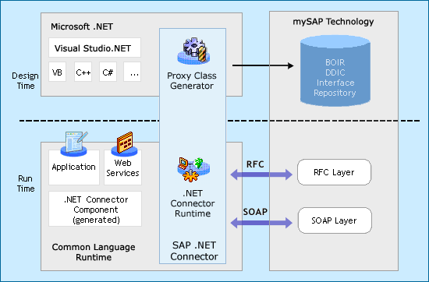

The connector can be downloaded from the SAP marketplace web site. Creating, invoking and extracting data from either a structure or table is very easy.

**Note:** SAP BAPI explorer needs to be provided by the client as well as valid credentials to download the connector from the SAP marketplace

## PDF Integration

**PDFsharp** is the Open Source .NET library that easily creates and processes PDF documents on the fly from any .NET language. The same drawing routines can be used to create PDF documents, draw on the screen, or send output to any printer.

**MigraDoc** Foundation the Open Source .NET library that easily creates documents based on an object model with paragraphs, tables, styles, etc. and renders them into PDF or RTF.

## Application Level features

* Site Administration: An enterprise site administrator will manage various aspects of the site. Site administration consists of activities such as (but not limited to)
  + Adding new users, assigning roles
  + Uploading documents
  + Mining logs to identify system issues
* Directory and Document Management: The application tracks and manages the documents uploaded by the users. Documents are filed into directories (conceptually) that are uniquely identifiable and assigned to the user. Directories may also contain other attachments
* Search: An integrated search can be used within various modules t
* Dashboard with Reporting: Custom dashboards shall be provided to the various stakeholders of the system. Depending up on their entitlements, reports and analytics shall be available.
* Forms processing: The system has various forms. These forms have various pieces of functionality/information that are common. Common data management and retrieval techniques will enable the application to be more scalable and adaptable

## System Level Features

* Authentication and Authorization: The system will validate the identity of the user and then authorize the user and assign a specific role that they have been mapped to by the admin
* Auditing and Logging: The system will log the activity of the logged in user so that it can be tracked for security purposes. The system will also log the actions being performed by the system so that it can identify issues caused by systemic application failures
* Scheduled Jobs: The system will have scheduled jobs running at specific intervals.
* Exception Handling: As a part of managing user expectations, exceptions or inadvertent application failures will be handled by providing user friendly and contextual error messages. All exceptions will be logged for future reference so that it can be handled better.
* Web Service integrations: Web service framework to integrate various third party integrations will allow for the application to freely exchange information.
* Document Archival: An application that must handle a large amount of documents for its various users, must find a way to archive documents that are no longer used or documents that belong to expired accounts. Archival provides a means by which these documents can be securely stored on a resource dedicated for it. Verbat will provide the mechanism for archival, but the client will have to provide hardware or software necessary to fulfil this requirement
* Security: Security of the site is managed through a combination of the logs maintained by the system as well as additional functions such as
  + Password salting
  + Provision to secure the site against Cross Site Scripting attacks (and reflected XSS), SQL Injection attacks, Code Injection , buffer overflow vulnerability
* Messaging: A messaging framework to support communication via email and SMS messages for the various function points in the system.

## Technology Overview

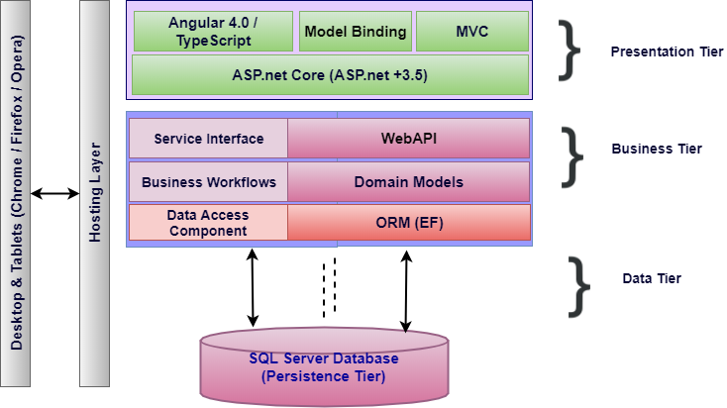

The proposed architecture combines the classic MVC architecture along with elements drawn from Service Oriented Architecture (SOA). SOA compliments the requirement of the client’s needs to extend the functionality of the application by retrofitting add-on services in the future.

The business layer represented in the figure above is a service layer that is modelled by the business domain. Hence it becomes easy to contain and isolate workflows. Each service layer results from the culmination of a broad range of granular micro services that work in concert to deliver the desired functionality. If there is a future need for adding new services, this can easily be accommodated by building a parallel pipeline.

Traditionally front end design of .net based applications had been done using ASP.net web forms or web pages, but now a days most web applications take advantage of Single Page Applications (SPA) like Angular, a framework that loads a single HTML page and dynamically updates the page as the user interacts with the app. SPAs use AJAX and HTML5 to create fluid and responsive Web apps, without constant page reloads. This is particularly useful, since one of the requirements for the application is a state-full page that supports persistence.

MSSQL is preferred relational database. For Rapid Application Development (RAD), most application frameworks employ Object Relational Mappers (ORM). .Net supports the Entity framework, which is an ORM. It supports rapid application development by side stepping the work related to managing the intricacies of a relational database. ORM’s also make the application agnostic to database technologies (Such as Oracle, MySql, MSsql etc.).

In order to support portable devices that needs to communicate with the application, Web API’s are implemented and are exposed using restful web services. To enhance and enrich the mobile experience Web services are clubbed with SignalR, a library that simplifies the process of adding real-time web functionality to applications. Real-time web functionality is the ability to have server code push content to connected clients instantly as it becomes available, rather than having the server wait for a client to request new data.

# Nonfunctional Requirement (Others)

|  |  |
| --- | --- |
| **Requirement** | **Details** |
| User Experience and  UI Design | * The application will be developed only in English and Arabic * The layout and graphical components will be created considering the usability factors |
| Performance | * Application will allow users to have smooth and quick access to the information or services they require. |
| Security | * The system will be protected against attempts of security breaching that may arise. * Web security standards will be followed. |

# Assumptions

The project solution and technology is created from the initial understanding of the requirement shared with Verbat through mails and meetings. The proposed solution is based on the following assumptions:

* Client to provide Verbat with the branding guidelines.
* The proposed application front end and backend would be in English
* Client will purchase the necessary templates needed for development
* Client shall provide licensed images and logos in specified size & format
* Super Admin can manage all the users within the application.
* Requirements should be well defined, agreed and signed-off by the client
* Internet connectivity is required for the functioning of the web application.
* UI development effort is 4-6 hrs. per screen (For additional screens not covered in the provided requirements document)
* Reporting and analytics may require external tools. Current assumption is that analytics will be minimal and simple.
* Testing will be done in latest versions of Google Chrome, Mozilla Firefox & IE web browsers only
* Development Contingent upon timely feedback from client
* Client shall provide access to the SAP marketplace to download the SAP connectors
* Client shall provide information on the database fields in SAP that can be used to harvest information related to application being developed
* Client shall provide Verbat with appropriate libraries needed to create PDF’s, Visio diagrams and Office documents (Word & Excel)
* No Provision shall be made in the application to secure communication with server
* No provision shall be made to accommodate online payment processing
* This proposal shall not cover integration with PIM
* SAP integration shall be covered as part of the development activity, however this is contingent upon timely feedback from the client regarding data retrieval and integration tasks

# Out of Scope

With the ever evolving digital market, the requirement needs should be clear to both the parties involved, hence the importance of mentioning the out of scope details of the project. Following are considered to be out of scope while creating this proposal.

* Purchase of images, fonts
* Adding new features to the application other than mentioned in the functional specification.
* Any language other than English
* Manual data entry
* Hardware Integrations / procurement and purchase
* Database migration
* Content writing
* Content or image procurement or uploading or editing.
* Hosting Infrastructure and Maintenance
* Annual Maintenance of the application (Bug fixing, debugging) - For AMC details, please refer section titled “Maintenance and Support”
* Physical deployment at client’s site
* Backup solution and Disaster recovery

# Technology Solution

## Proposed System Environment

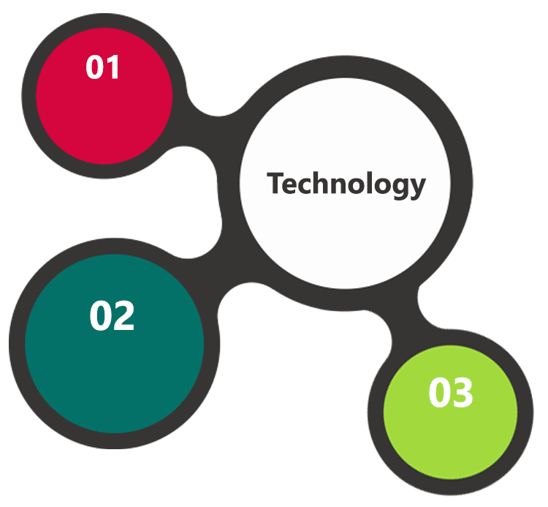

HTML / CSS3

/ JQuery

IIS..Net 4.5  
MSSQL / MVC /

EF

Angular / C#

/ Typescript

**MS SQL2012  
Windows 8/10  
Web Services**

## Technical Configurations

### Development Tools

* Visual Studio, MVC, c#, Angular
* MSSQL, IIS
* HTML / CSS 3
* Ajax, JavaScript, JQuery

### Recommended Web Hosting Package

* Medium CPU power – single to dual CPU
* Single Domain
* Windows Sever 2012R2 Data Center
* Disk Space: 5 GB
* Monthly Bandwidth: 10 GB
* Web site Server Software – IIS 8.0

### Browser Compatibility

* Chrome version: 56
* Firefox version: 51
* Edge version: 39

### Hardware Interface

**Desktop**

The application is reliant on hardware interfaces to provide a seamless automated user experience.

* Computer with Windows 8 or 10 OS
* Compatible Browsers as specified in section 7.2.3

# Commercials

## Web Application

|  |  |  |
| --- | --- | --- |
| **No** | **Description** | **Amount (USD)** |
| 01. |  | 00,000.00 |
| 02. |  | 00,000.00 |
|  |  |  |

*Note:*

* *The above cost does not include Application hosting, integration, Project Management or deployment*
* *For change management cost, please refer to section 10 titled Change Management*

## Payment Terms

* Payment terms
* Payment terms
* Payment terms

*Note: Payment should be made within 7 days from the date of the invoice*

## Mode of Payment

By Cheque / DD to Verbanet Technologies LLC

OR

Wire transfer to our bank account

Bank Name : Emirates NBD

Account Name : Verbanet Technologies LLC

Account Number : 1011492858201

IBAN Number : AE61 0260 0010 1149 2858 201

Swift Code : EBILAEAD

Bank Address : Mamzar Branch, Dubai

*Note: Bank charges incurred during wire transfer to be borne by the client. Any local taxes applicable to be borne by the client*

# Delivery Management

## Project Management

The Verbat development center strictly follows industry standards on quality. The project management is process governed by the Verbat Quality Management system and is put to verification through internal audit programs that happen from time to time.

Verbat will dedicate a project manager for the proposed implementation. Verbat proposes Client to identify one project manager who will be driving activities to be undertaken by Client to be the single point of contact for Verbat.

## Roles and Responsibilities

Verbat will assign a dedicated Project Manager/Project Lead to lead the project, who will be the first point contact for Client. He/she will be responsible for planning and managing the various activities within the project. He/she will work closely with Client Project Manager, to give periodic status updates and ensure high level of visibility and comfort on the progress of the project.

The Project Manager/Project Lead will lead the co-ordination between Verbat and Client, thus enabling smooth transitioning of Client requirements to the Verbat’s offshore delivery team, and provide visibility as well as comfort on the progress of the services to Client.

He/she will have periodic meetings with Verbat’s Senior Management, thus ensuring Verbat’s Management commitment and focus on Client initiatives.

## Delivery Activity Summary

|  |  |
| --- | --- |
| Activities | Description |
| Detailed requirement Analysis | Verbat team to conduct detailed study of requirement for the phase. If clarification is required, team will reach out to Client for more information and/or time for discussions. |
| DB Design | DB design for central and test DB. |
| Software Requirement Specification document (SRS) | Once the requirement analysis is completed, Verbat team will submit the SRS document for approval |
| UI/UX Design, Prototyping | Based on the SRS, Verbat UX/UI team will work on the UI/UX of the screens and submit a prototype for approval |
| Functional Specification Document (FS) | Once the Prototype. UI/UX is approved, Verbat shall submit an FS document for approval. |
| Development | Actual system development starts based on the FS. This involves detailed design and software development of Web Application. |
| Testing | Test Planning, test plan creations, internal, integration testing and user acceptance testing. |
| Deployment | Deploying the latest built in the Verbat Test Server. |

## Project Implementation Plan

Verbat will be providing the solution in a stand-alone fixed bid approach which ensures minimum viable solution for quick wins with core focus on the long-term business objective and outcome. Once the implementation is over, Verbat will initiate the application maintenance process (once the maintenance contract is signed) which continues to extend after the implementation.

## Deliverables

* Scope Document
* Project Plan
* Presentation for SCTDA Management
* Functional Specification Document
* System Analysis & User Specification Document
* Design Specification Document
* Prototype of the application
* Test Plan Document
* User Manual
* Source Code
* Fully Developed & Tested Application

## Estimated Delivery Time

The effort estimated for delivering the application as specified in section 2 will be as below:

**UAE working days for prototype from the date of Approval of the project (LPO/Signed proposal) with advance payment: 15 working man days**

**UAE Working days for the development of the application from the Date of Approval of the Prototype: 3 working man months**

| **Activity** | **Deliverables** | **Timeline** |
| --- | --- | --- |
| Project Initiation | Scope Document, Project plan, Presentation to SCTDA Management | 2 days |
| Requirement Specification & System Design | System Analysis & User Specification, Updated project plan, Design Specification document, prototype | 15 days |
| Prototype  (parallel stream ) | Working prototype | Month 1 |
| Development | Test Plan Document | Month 1 - 3 |
| Testing | User Manuals | Month 2 - 3 |
| Deployment | Tested Web, Tablet & Mobile  Application in IOS, Source Code | Month 3 |

## Deployment Details (at Clients Behest)

* Client can opt for hosting the application at Verbat’s Server.
* If deployment is at the client’s server, responsibility of deploying the application onto the production environment after conducting the necessary acceptance testing will lie with the client unless and until Verbat’s support is contracted for deployment.

***Note****: Hosting the application at Verbat’s server will call in for additional charges.*

## Release Planning

* Client will be informed about the release date and time through email.
* Client performs the UAT

## Risk and Contingency Planning

Verbat has identified various risk factors associated with this assignment and understands the impact of these risk factors on the project schedules. The objective of this section is to highlight for both Verbat and client, the risk factors, to analyze the impact of the risks on project execution, and to propose strategies to control and reduce the impact of the risk factor.

These various risks, which could arise during the project, are tabulated below along with mitigation implementation.

| Type of risk | Impact | Risk Mitigation | Risk Handling |
| --- | --- | --- | --- |
| Scope Creep | H | Functions and features will be detailed in system requirement documents and will go through client approval. Once this document is approved, any change to requirement will go through change management review for possible impact assessment. | Proper change management procedure will be implemented. |
| Delay in customer feedback | H | The plan is prepared with enough lead-time for customer reviews and approvals.  The customer is indicated with the dates when the document is expected after review and approval. | The request for feedback will be escalated if not attended at the right time so that the schedules are not affected. Deemed acceptance criterion is set up front and will be followed. |
| Non-availability of necessary software’s, frameworks, database instances and infrastructure at client’s hosting environment(If hosting support is provided by Verbat) | M | Client will be informed in advance on these requirements. | Possible impact to schedule. |
| Manpower attrition | L | All efforts would be made to ensure process dependence rather than being person dependent. As a risk mitigation plan Verbat will train backups. | A new person will be identified as early as possible, provided the required project-specific training and mentored by the senior members of the team to minimise impact of attrition on the project. |

*H-High, M-Medium, L-Low, NA-Not Applicable*

# Change Management

Any addition which comes out of the project scope, upon and after the launch of the tool will be considered as change management. Verbat recommends the following change management procedure for the same.

* Any change which comes out of the project scope, which was discussed, documented, and mutually approved by both the parties in the requirement stage, will be carried out only through raising a change request.
* Change request will be studied and an impact analysis on the existing work flow will be performed.
* On finalizing the impact, effort estimation for the change will be calculated and raised as additional requirement.
* Verbat will initiate the change request only after getting a formal approval from the client for the additional changes raised.
* Any change from the scope will be charged at **USD ----- per man day effort** and approval from the clients will be availed before commencing on any change management.

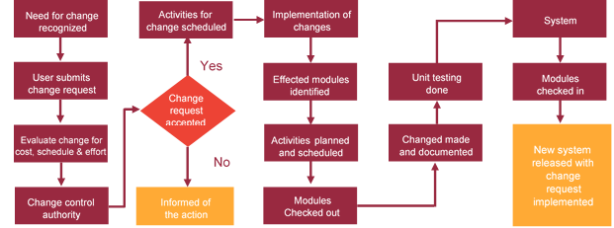

# Miscellaneous

## Acceptance Criteria

* UAT sign off should happen within 7 Days from the release of the application/ Phase and the acceptance confirmation needs to be mailed to Verbat failing which Verbat will consider the project as approved by the client.
* Any comments or reason for rejection need to be documented and the same needs to be sent as an email from the official mail id of client to Verbat.

## General Terms and Conditions

* An average of 20 working days are assumed in a month
* All the projects activities will be carried out from our off-shore development center in India
* The scope of the project is to develop the Application as detailed in the scope of the project and mentioned in this proposal. Any changes or additions will have to go through change management.
* This proposal and all technical/ functional specifications have been derived or concluded from the data shared via email / information's transferred during the initial requirement analysis meetings and conversations. Verbat reserves the right to amend the terms of this proposal, should the SOW terms, functional features and functionalities change during the course of the project
* Application will be best viewed only in the environment mentioned in the section 7.2.3
* All the documentation will be provided in English.
* Third party components may be used to develop this application.
* All Source Code and other project artefacts would adhere to the Verbat document templates and internal coding standards
* Acceptance criteria shall be based on the clauses which were mutually discussed between Verbat and client at the Requirement Analysis phase and the same will be documented and approved by both parties through official emails
* In case Client requires any extension of the proposed acceptance schedule, the associated effort and cost of such extension can be mutually reviewed.
* For any circumstances if project needs to be put on Hold / Stop it requires minimum request notice period of 1 week along with duration for which request will be addressed by management and final decision on the request will be based on that
* If deployment is done in client’s server, Verbat cannot be held responsible for any performance issues arising due to hardware malfunctions.
* Client is responsible for data backup in case the application is not hosted on Verbat server.
* Source code will only be delivered or uploaded on the Production Server once the due payments are made.

## Assumptions and Dependencies

* Detailed system study is required before the start of the project.
* During the requirement gathering phase, authorized personnel from the Client’s side is expected to be available for discussion and finalizing the HLD (High Level Design), before development commences.
* Type of reports and formats, if under the scope of the project, needs to be specified by Client before project sign off.
* Workflows if under the scope of the project, need to be specified/ confirmed by client before project signoff.
* All queries regarding the client requirement and any queries which may hinder the project advancement at any stage should be answered by the client within 24 hours from the time of initiation, failing which the time delay will get added to the actual effort which was estimated.
* Verbat assumes that all sign-offs from Client will be provided within agreed and specified timeframe.
* Client will provide all the necessary contents, both text and image, before starting the project in the format suggested by Verbat (if any).
* The client should provide the relevant information and data well in time for the execution of a related activity. Non- availability of this information or data may lead to an interruption of work which may result in a delay in delivery as well as additional costs to the client.
* Client should have/possess server with technical specifications as suggested by Verbat for the proposed application.

## Source Code & Intellectual Property Rights

* Upon completion of the Project and 100% completion of the payment, client will have access to the source code except for propriety codes, developer tools and third party application etc.
* The solution offered will be the intellectual property of the client and will be made available to the client on an “unlimited license” basis.
* Modifications by third party/person: No person or organization, other than Verbat or any person authorized by Verbat in writing, has any permission to modify/change the software Solution to be eligible to get continued support from Verbat as per the support terms defined under this document.
* Liabilities/Damages: Verbat accepts no liability or damages of any kind arising out of use or non-use of the software delivered. The responsibility of testing of software lies with Client.

## Maintenance & Support

* Maintenance contracts by default are supported as per the basic SLA terms.
* **AMC with Basic SLA is charged at 20 % of the total project value**. Additional Effort/change management request will be added towards Total Value of the Project to determine the AMC value.
* Maintenance support is limited to providing application support for ensuring the consistency of the look-and-feel, bug fixes and user issues i.e. maintenance and support of the existing features of the application.
* Support does not in any way cover providing technical or other support to the end users. The maintenance agreement does not include functionality changes or feature additions which are handled as change requests which will be charged AED 1200 per man day. AMC does not include server support, maintenance and application deployment.
* AMC charges will cover Off-Site Support and Debugging. Support includes E-mail, Telephone and Chat unless explicitly specified. In the event, the application is hosted with the client; necessary remote desktop connectivity should be provided for carrying out maintenance activity.
* Gap in AMC - In case if the client does not opt an AMC for a year and want to renew it after that period, 50% of the AMC amount for the year for which AMC is not taken will also be payable if the client wishes to renew the AMC contract.
* Note:
  + Please note that the AMC support shall start only after all the necessary sign-offs (AMC Document) to this effect have been given.
  + It is not mandatory that the client should opt for an AMC. The client will still be supported on an ad-hoc basis on an agreed man-day rate.
  + AMC Payment Terms: 100% to be paid as advance.

## Service Level Agreement

|  |  |  |  |  |
| --- | --- | --- | --- | --- |
| **Key** | **Max Response Time** | | **Max Resolution Time** | **Target** |
| Basic | 1  working day | 3 working days | | Request / incident / problem tickets |
| Advanced | 5 Business Hours | 12 Business Hours | | Request / incident / problem tickets |
| Priority | 3 Business Hours | 5 Business Hours | | Request / incident / problem tickets |

Note:-

* We provide Basic SLA as standard with AMC while Advanced and Priority SLAs attract additional charges.
* Time zone applicable as per India time zones (3:30 AM GMT to 12:30 PM GMT- Monday to Friday).

# Our Clients

**UAE University**

Education

Transportation

**Canada Cartage**

Construction

Services

Finance

We look forward to hearing from you soon and hope that you will give us the privilege to work with you in meeting your business goals. Thank you.

Thank You



©   
1999 - 2017. All Rights Reserved   
Verbanet Technologies LLC  
www.verbat.com