roid

217, Sheikh Rashid Building

P.O Box 56272, Dubai

United Arab Emirates

Tel: +971 4 2973236 / 04 2974007

Email: uae@verbat.com

PROJECT   
PROPOSAL

**Photo App**

|  |  |
| --- | --- |
| **Prepared for:**  **EDC** | **Submission Date:**  04 April 2018  **Proposal ID:** AD/BP/04042018/1343/1 |

___________________________________________________________________________________________________________________________________________  
Conﬁdentiality Notice: This Proposal is conﬁdential and contains proprietary information and intellectual property of Verbanet Technologies LLC. Neither this proposal nor any of the information contained herein may be reproduced or disclosed under any circumstances without the express written permission of Verbanet.

© 2017 by Verbanet Technologies LLC. All rights reserved. Confidential.

___________________________________________________________________________________________________________________________________________

Project Contacts

|  |  |
| --- | --- |
| Client Information | |
| Project Name | Photo App |
| Client Name | EDC |
| Client Address | -------------------------- |
| Contact Person |  |
| Contact Person Email |  |
| Contact Person Phone Number |  |
| Verbat Information | |
| Contact Person | Joyce Daniel |
| Contact Person Phone Number | +971 42973236 |
| Contact Person E-Mail | [joyce.daniel@verbat.com](mailto:joyce.daniel@verbat.com) |
| Address | PO Box 56272, Dubai, United Arab Emirates |
| Physical Address | 217, Sheikh Rasheed Building, Hor Al Anz East |
| Project Information | |
| Proposed Technology/Methodology | AngularJS, NodeJS, ExpressJS, MongoDB |
| Anticipate Start Date | NA |
| Proposal Valid For | 30 Calendar days from the submission of the proposal |

**Table of Content**

1 Scope of Work 6

1.1 Solution Objective 7

1.2 Features of Mobile Application module. 7

1.2.1 Mobile App Process Flow 7

1.3 Features of Web Portal Application: 8

1.3.1 Web application process flow 9

1.4 Advantages of Proposed Solution 10

1.5 Why Verbat 10

1.6 Key Differentiators 11

1.7 Technology & Services 12

2 Functional Specification 13

2.1 Mobile application (Android + IOS) 13

2.2 Web Application 14

3 Agile Development Mode 14

4 Nonfunctional Requirement (Others) 14

5 Assumptions 15

6 Out of Scope 15

7 Technology Solution 17

7.1 Proposed System Environment 17

7.2 Technical Configurations 18

7.2.1 Development Tools 18

7.2.2 Recommended (minimum) Web Hosting Package 18

7.2.3 Browser Compatibility 18

7.2.4 Hardware Interface 18

8 Commercials 19

8.1 Web Application 19

8.2 Payment Terms 19

8.3 Mode of Payment 19

9 Delivery Management 20

9.1 Project Management 20

9.2 Roles and Responsibilities 20

9.3 Delivery Activity Summary 21

9.4 Project Implementation Plan 21

9.5 Deliverables 21

9.6 Estimated Delivery Time 22

9.7 Deliverables 22

9.8 Release Planning 22

9.9 Risk and Contingency Planning 22

10 Change Management 23

11 Miscellaneous 25

11.1 Acceptance Criteria 25

11.2 General Terms and Conditions 25

11.3 Assumptions and Dependencies 26

11.4 Source Code & Intellectual Property Rights 26

11.5 Maintenance & Support 27

11.6 Service Level Agreement 28

12 Our Clients 29

# Scope of Work

EDC wishes to provide a mobile app for individual customers in UAE and neighboring countries where by they can upload their Photos from their smart mobile phone using this App in order to physically print those photos individually or in a photo album. EDC receives the photos through their mobile app and prints them in a photo paper and convert it into an album and dispatch to the end customer.

The mobile app shall have the functions listed below,

* Upload photos through mobile app for printing.
* Online Payment options ( Pay as you go/ Subscription model)
* Order different sizes of photos with different price options
* Delivery option of photo album
* Collection of photo album from stores.

**Stand-Alone Fixed Bid**

Verbat will be following a stand–alone fixed bid solution delivery model wherein the required solution would be devised and a suitable pricing would be offered.

## Solution Objective

EDC require a Smart Phone Application along with an Internal web portal to track and complete the orders

## Features of Mobile Application module.

1. Login / Registration
2. Manage Profile
3. Subscription model
4. Menu List
5. Home screen/Dashboard with all the possible photo print options
6. Add an Order
   1. Select the type of Print
   2. Load photos from gallery
   3. Select photos from Gallery
   4. Edit the album, rearrange the photos according to the selected option
   5. Preview the album/photo
   6. Add to Cart
7. Cart listing
8. Checkout
9. Payment Gateway Integration
10. Manage various Push notifications based on the order status
11. General app settings
12. Feedback/Contact Us
13. Additional Inner Pages like About Us, Terms and Conditions, How to Use, FAQ etc.

### Mobile App Process Flow

Mobile app where individuals should be able to download this app and

* Upload selected photos from their mobile phone gallery for printing.
* The app will be developed on both Android and IOS.
* The app will be bilingual ( Arabic/ English)
* The app will be available globally (or with certain regions only.)
* The mobile app should have the features of subscription model and pay as you go option.
  + Based on the model selected (Both the models will have options available based on no. of photos for the booklet e.g. 15 / 30 / 60 photo per booklet)
    - Subscription Model – user will get the selected number of photo booklet once a month for 1 year
    - Pay as you Go Model – user can select any option any time
  + Once registration is over, user will add / shoot photos, options like “delete”, “Group”
  + should be available to manage / manipulate the photos
* Once they upload the photos accordingly the total cost will be derived through the app and guide the individual for delivery Option.
* The App should have the option to include special promotional packages which will run for certain period.
* The special promotion content and products needs to be updated by EDC according to the business requirement.
* Options for two delivery methods. ( Collection at store/ delivery through courier)
* If courier Customer needs to update the delivery address with location Pin selection.
* Based on the options the total cost to be derived for the package.
* The mobile app will be integrated with a Payment gateway for payment.
* The Payment gateway needs to have multiple currency acceptance.
* Cash on delivery also an option for the payment.
* The App will be connected to a server or cloud where the photos will be stored.
* On successful payment an order reference number to be created and notification to be send to individual through mobile app.

## Features of Web Portal Application:

1. Login
2. Dashboard
3. Admin settings
4. Customer management
5. Order management
6. Reports
7. Special Promotion management

### Web application process flow

A web portal needs to be developed for EDC digital print unit for order management.

* Web Portal shall get a notification on the order Placed by the customer with order reference number.
* EDC shall download the photos related to the order and does the print fulfillment.
* EDC to generate an AWB Number if the delivery mode is by courier.
* EDC to update the job completion for the order reference number along with the AWB number if the delivery mode is by courier
* Once updated, a notification to be triggered to the customer mobile app with the AWB number details or notification for pickup timing.
* Once the booklet is delivered, the details to be updated across the order reference number
* EDC should be able to update the special promotion page with products and different pricing which needs to be integrated and reflected in the mobile app for the end customer.

Verbat’s Solution architects have conducted a thorough research on the requirements and have come to the conclusion that our proposed solution, which is detailed further in this document, will meet the requirements put forth by the client. And the proposed solution will be delivered in a phased approach as per Verbat’s stand-alone fixed bid solution model.

**Strong and Scalable platform:** The platform proposed will be strong and scalable enough to accommodate future enhancements.

**Accelerated solution:** The framework would act as a solution accelerator. It would provide the basic building blocks which could be reused in future for building new components and features.

**High performance:** The light weight framework used consumes fewer system resources thereby making the application perform faster.

**Security:** The application will be developed considering various aspects of security.

## Advantages of Proposed Solution

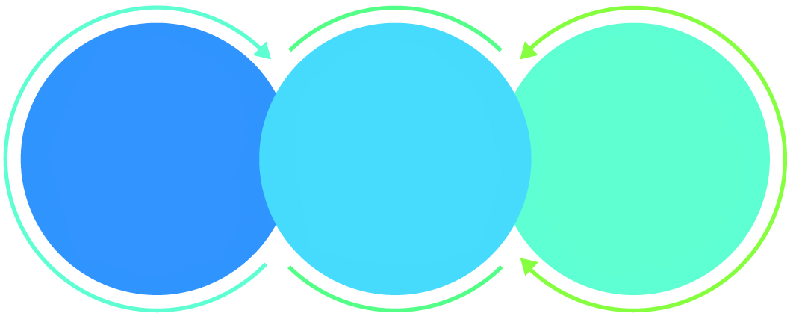

01

Agile development offering reliable, secure solution

02

Smooth transition and quicker completion of processes

03

User friendly interfaces enabling easy navigation between screens

## Why Verbat

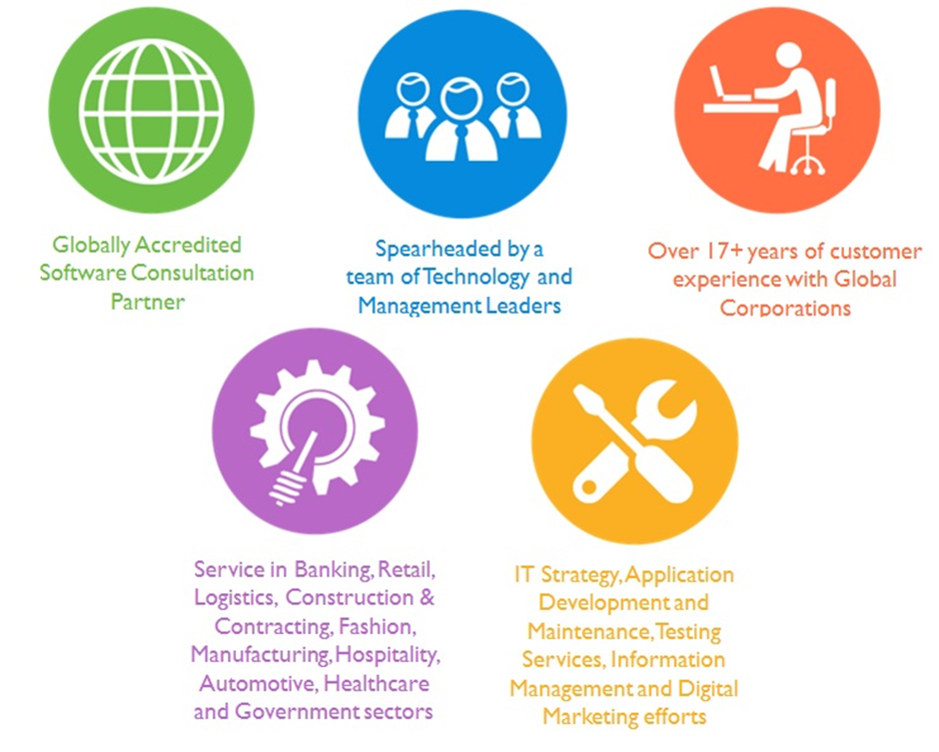

## Key Differentiators

Delivered digital transformation expertise to global customers for over a decade by following industry best practices to maximize ROI for client

Keen technology intelligence combined with aggressive market research to deliver solutions that achieve results with measurable value

Enable access to global consulting expertise with strong local market and business knowledge

Commercial Model that is customizable for your business needs

Services that are designed to optimize applications for improved performance and overall efficiency

1,000,000 plus man-hours of expertise in technology frameworks spanning Microsoft, Open Source, mobility platforms and other proprietary IT technology

Partners top technology vendors to bring in the latest and best services in integration, collaboration, and development

Commercial Model that is customizable for your business needs

Proven Methodologies & Processes

Investment in R & D

Strong Local Presence

Flexible commercial Models

Technology Associations

Software Development Experience

Offshore Development Centre

Quality Assurance & Testing

## Technology & Services

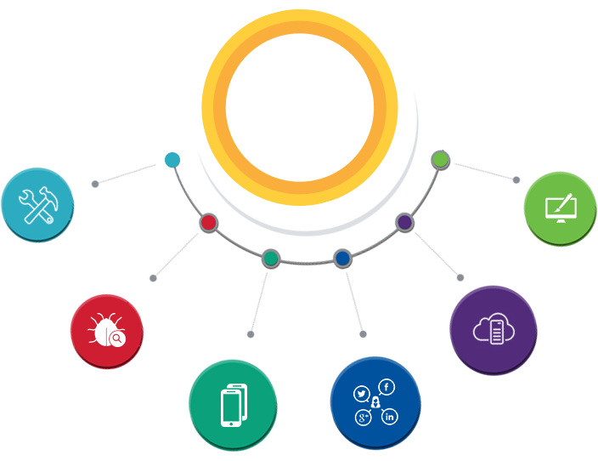

Technology  
&  
Services

Cloud/Traditional Hosting

User Interface & Design

Digital Marketing

Mobility Solutions

Testing Services

Application  
Development

# Functional Specification

## Mobile application (Android + IOS)

|  |
| --- |
| **Development** |
| Basic Setup |
| Splash Screen |
| Login page |
| Dashboard |
| Registration page |
| Manage profile (delivery address, credit card details) |
| Model type listing |
| Subscription Model |
| On the Pay As You Go Model |
| Menu List |
| Menu List Details page |
| Home Screen with photo print options |
| Add and Order |
| - Select the type of Print |
| - Load photos from gallery |
| - Select photos from Gallery |
| - Edit the album, rearrange the photos according to the selected option Preview the album/photo |
| - Contribution to album through invitation |
| - Add to Cart |
| Order Management |
| Cart listing |
| Cart list details page |
| Checkout, Pricing |
| Delivery Options (subscription, pay as you go, cash on delivery) |
| Payment gateway integration |
| Push notification based on order status |
| Settings page |
| Feedback/Contact Us |
| Multiple Currency/ Bilingual |
| Inner Pages like About Us, Terms and Conditions, How to Use, FAQ etc. |
| **API Integration** |
| Api Integration |

## Web Application

|  |
| --- |
| **Development** |
| Basic Setup |
| Admin Settings |
| Auditing + logging + exception handling |
| Contact US |
| Dashboard |
| Manage subscription models |
| Manage delivery options |
| Manage prices (delivery + print/image etc.) |
| Manage users (Web users + Authentication + authorization) |
| Customer management |
| invoice management |
| Courier vendor management |
| Order management |
| Reports management (4 reports @ 6 Hrs) |
| Manage special promotions |
| Update job status changes |
| SMS / email messages |
| Generate Order reference numbers & AWB |
| Mobile API Development |

# Vendor Selection Criteria

## Mobile Application Details

|  |  |  |  |  |
| --- | --- | --- | --- | --- |
| **Mobile Application Module Requirements** | **Importance** | **Design Possibilities** | **Charges Included in proposal** | **Additional Cost If applicable** |
| Login Page | Mandatory | YES | YES | NO |
| Manage Profile | Mandatory | YES | YES | NO |
| Subscription Model | Mandatory | YES | YES | NO |
| Menu List | Mandatory | YES | YES | NO |
| Dash Board | Mandatory | YES | YES | NO |
| Order Management | Mandatory | YES | YES | NO |
| Cart Listing | Mandatory | YES | YES | NO |
| Payment Gateway Integration | Mandatory | YES | YES | NO |
| Push Notifications | Mandatory | YES | YES | NO |
| General App Configuration settings | Mandatory | YES | YES | NO |
| Feedback / Contact Page | Mandatory | YES | YES | NO |
| Terms and Conditions , FAQ , How to Use App pages | Mandatory | YES | YES | NO |
| Contributions to album through invitation | Mandatory | YES | YES | NO |
| SMS Gateway Integration | Mandatory | YES | YES | NO |
| Logo Designing | Mandatory | YES | YES | NO |
| Promotions in Social Media of the Product | Mandatory | YES | YES | NO |
| Any Limitation in Number of Pages or Forms in mobile app | Mandatory | YES | YES | NO |

## Mobile Dev Environment

|  |  |  |
| --- | --- | --- |
| **Mobile Application (IOS)** | **Software & System** | **Comments** |
| Language(s) | Obj-C |  |
| Development Environment | X-Code |  |
| Application Version Minimum Compatibility | IOS 8 |  |
| Back End Database | Any |  |
| **Mobile Application (Android)** |  |  |
| Language(s) | Java |  |
| Development Environment | Android Studio |  |
| Application Version Minimum Compatibility | Kitkat and above |  |
| Back End Database | Any |  |

## Mobile Development Details

|  |  |
| --- | --- |
| **Mobile Development ‐ Breakup Details** | **Number of Man Days for Each Process** |
| Brand Logo Designing, and Promotion | 2 |
| Detailed Analysis and Design | 2 |
| Mobile Page Design, Define Navigation and Implementation | 20 |
| Web Service Extension | 5 |
| Android Development | 39 |
| IOS Development | 40 |
| Quality Assurance, Quality Control, Integration Testing, Unit Testing | 6 |
| Deployment | 1 |
| Total Mobile Development Days | 115 |

## Web Application Details

|  |  |  |  |  |
| --- | --- | --- | --- | --- |
| **Web Application Module Requirements** | **Importance** | **Design Possibilities** | **Charges Included in proposal** | **Additional Cost If applicable** |
| Web Login Page | Mandatory | Yes | Yes | NO |
| Web Dash Board | Mandatory | Yes | Yes | NO |
| Admin Settings | Mandatory | Yes | Yes | NO |
| Customer Management | Mandatory | Yes | Yes | NO |
| Order Management | Mandatory | Yes | Yes | NO |
| Reports Management | Mandatory | Yes | Yes | NO |
| Invoice Management | Mandatory | Yes | Yes | NO |
| Promotions Management | Mandatory | Yes | Yes | NO |
| Delivery Management | Mandatory | Yes | Yes | NO |
| Courier Vendor Management | Mandatory | Yes | Yes | NO |
| Contact Us | Mandatory | Yes | Yes | NO |

## Web Development Environment

|  |  |  |
| --- | --- | --- |
| **Web Application** | **Software & System** | **Comments** |
| Language(s) | PHP, CodeIgnitor |  |
| Development Environment | Eclipse |  |
| Application Version Minimum Compatibility | Modern Web Browser |  |
| Back End Database | MySQL |  |

## Web Development Details

|  |  |
| --- | --- |
| **Web Development ‐ Breakup Details** | **Number of Man Days for Each Process** |
| Detailed Analysis and Design | 11 |
| Web Design, Define Navigation and Implementation | 1 |
| Web Site Development | 30 |
| Quality Assurance, Quality Control, Integration Testing, Unit Testing | 6 |
| Deployment | 1 |
| Total Web Site Development Days | 49 |

## Vendor Information Detail

## Financial Details

# Agile Development Mode

Verbat Practices distributed Agile development methodology, because we realize that communication between geographically distributed teams becomes cumbersome if the project is not supplemented by ancillary documents such as project plan, SRS, wireframes, prototypes etc. Based on past experience, our clients have appreciated the prospect of knowing upfront what is being built at a reasonably high level of detail, while still having the flexibility to mediate change in requirements or priorities.

While this is our general approach, Verbat can adapt and comply with development standards that are agreeable to the client.

# Nonfunctional Requirement (Others)

|  |  |
| --- | --- |
| **Requirement** | **Details** |
| User Experience and  UI Design | * The application will be developed only in English and Arabic * The layout and graphical components will be created considering the usability factors |
| Performance | * Application will allow users to have smooth and quick access to the information or services they require. |
| Security | * The system will be protected against attempts of security breaching that may arise. * Web security standards will be followed. |

# Assumptions

The project solution and technology is created from the initial understanding of the requirement shared with Verbat through mails and meetings. The proposed solution is based on the following assumptions:

* Client to provide Verbat with the branding guidelines.
* The proposed application will be bilingual (English & Arabic)
* Client will purchase the necessary templates needed for development
* Client shall provide licensed images and logos in specified size & format
* Requirements should be well defined, agreed and signed-off by the client
* Internet connectivity is required for the functioning of the web application.
* Testing will be done in latest versions of Google Chrome, Mozilla, Safari, & Edge web browsers only
* Development Contingent upon timely feedback from client
* Application shall support SDK version 19 (KitKat) and above
* Application designed for mobiles in portrait mode
* Cloud hosting of images shall be provided by client
* Multicurrency implementation for payment processing subject to the provisions made by the payment gateway

# Out of Scope

Following are considered to be out of scope while creating this proposal.

* Purchase of images, fonts
* Adding new features to the application other than mentioned in the functional specification.
* Any language other than English & Arabic
* Manual data entry
* Hardware Integrations / procurement and purchase
* Database migration
* Content writing
* Content or image procurement or uploading or editing.
* Hosting Infrastructure and Maintenance
* Annual Maintenance of the application (Bug fixing, debugging) - For AMC details, please refer section titled “Maintenance and Support”
* Physical deployment at client’s site
* Backup solution and Disaster recovery
* Time and attendance module is not included within this proposal

# Technology Solution

## Proposed System Environment

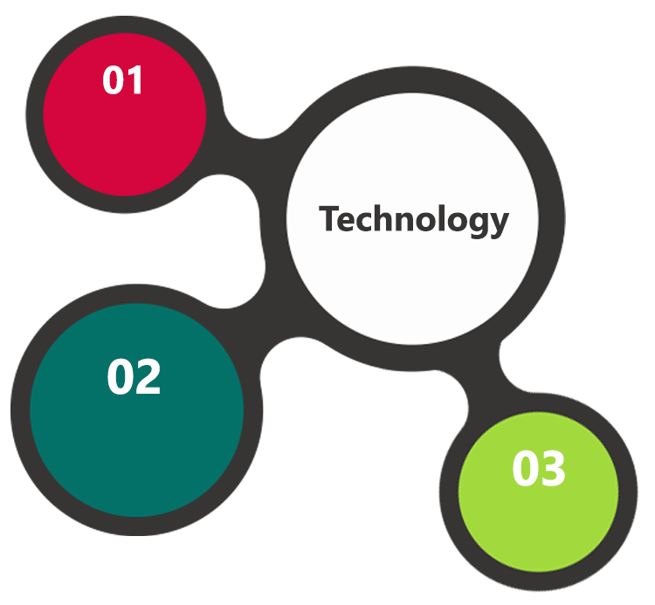

Mysql, Apache

PHP / Code Ignitor

Objective C, Android SDK, IOS SDK

HTML / CSS3/ Jquery

**MS SQL2012  
Windows 8/10  
Web Services**

## Technical Configurations

### Development Tools

* PHP , codeignitor, Objective C, Java
* MySQL, APACHE
* HTML / CSS 3
* Ajax, JavaScript, JQuery

### Recommended (minimum) Web Hosting Package

* OctaCore CPU
* RAM: 32 GB
* Disk Space: 1 TB
* Monthly Bandwidth: 20 TB
* Web site Server Software – Apache

### Browser Compatibility

* Chrome version: 56
* Firefox version: 51
* Edge version: 39
* Safari version 10.1

### Hardware Interface

**Desktop**

The application is reliant on hardware interfaces to provide a seamless automated user experience.

* Computer with Windows 8 or 10 OS
* Compatible Browsers as specified in section 7.2.3

# Commercials

## Web Application

|  |  |  |
| --- | --- | --- |
| **No** | **Description** | **Amount (USD)** |
| 01. |  | 00,000.00 |
| 02. |  | 00,000.00 |
|  |  |  |

*Note:*

* *The above cost does not include Application hosting, integration, Project Management or deployment*
* *For change management cost, please refer to section 10 titled Change Management*

## Payment Terms

*Note: Payment should be made within 7 days from the date of the invoice*

## Mode of Payment

By Cheque / DD to Verbanet Technologies LLC

OR

Wire transfer to our bank account

Bank Name : Emirates NBD

Account Name : Verbanet Technologies LLC

Account Number : 1011492858201

IBAN Number : AE61 0260 0010 1149 2858 201

Swift Code : EBILAEAD

Bank Address : Mamzar Branch, Dubai

*Note: Bank charges incurred during wire transfer to be borne by the client. Any local taxes applicable to be borne by the client*

# Delivery Management

## Project Management

The Verbat development center strictly follows industry standards on quality. The project management is process governed by the Verbat Quality Management system and is put to verification through internal audit programs that happen from time to time.

Verbat will dedicate a project manager for the proposed implementation. Verbat proposes Client to identify one project manager who will be driving activities to be undertaken by Client to be the single point of contact for Verbat.

## Roles and Responsibilities

Verbat will assign a dedicated Project Manager/Project Lead to lead the project, who will be the first point contact for Client. He/she will be responsible for planning and managing the various activities within the project. He/she will work closely with Client Project Manager, to give periodic status updates and ensure high level of visibility and comfort on the progress of the project.

The Project Manager/Project Lead will lead the co-ordination between Verbat and Client, thus enabling smooth transitioning of Client requirements to the Verbat’s offshore delivery team, and provide visibility as well as comfort on the progress of the services to Client.

He/she will have periodic meetings with Verbat’s Senior Management, thus ensuring Verbat’s Management commitment and focus on Client initiatives.

## Delivery Activity Summary

|  |  |
| --- | --- |
| Activities | Description |
| Detailed requirement Analysis | Verbat team to conduct detailed study of requirement for the phase. If clarification is required, team will reach out to Client for more information and/or time for discussions. |
| DB Design | DB design for central and test DB. |
| Software Requirement Specification document (SRS) | Once the requirement analysis is completed, Verbat team will submit the SRS document for approval |
| UI/UX Design, Prototyping | Based on the SRS, Verbat UX/UI team will work on the UI/UX of the screens and submit a prototype for approval |
| Functional Specification Document (FS) | Once the Prototype. UI/UX is approved, Verbat shall submit an FS document for approval. |
| Development | Actual system development starts based on the FS. This involves detailed design and software development of Web Application. |
| Testing | Test Planning, test plan creations, internal, integration testing and user acceptance testing. |
| Deployment | Deploying the latest built in the Verbat Test Server. |

## Project Implementation Plan

Verbat will be providing the solution in a stand-alone fixed bid approach which ensures minimum viable solution for quick wins with core focus on the long-term business objective and outcome. Once the implementation is over, Verbat will initiate the application maintenance process (once the maintenance contract is signed) which continues to extend after the implementation.

## Deliverables

* Project Plan
* Software Requirements
* Prototype of the application
* Test Plan Document
* Source Code
* Fully Developed & Tested Application

## Estimated Delivery Time

The effort estimated for delivering the application is as follows;

* **20 UAE working man days for application prototypes**
* **Days for the development of the application from the Date of Approval of the Prototypes: 45 working man days**

## Deliverables

The list below is a brief overview of the items that will be delivered mainly for referral purposes. The actual items delivered will be vary based on the decisions made at the time.

1. Working IOS Mobile application
2. Working Android IOS application
3. Working Web application

## Release Planning

* Client will be informed about the release date and time through email.
* Client performs the UAT

## Risk and Contingency Planning

Verbat has identified various risk factors associated with this assignment and understands the impact of these risk factors on the project schedules. The objective of this section is to highlight for both Verbat and client, the risk factors, to analyze the impact of the risks on project execution, and to propose strategies to control and reduce the impact of the risk factor.

These various risks, which could arise during the project, are tabulated below along with mitigation implementation.

| Type of risk | Impact | Risk Mitigation | Risk Handling |
| --- | --- | --- | --- |
| Scope Creep | H | Functions and features will be detailed in system requirement documents and will go through client approval. Once this document is approved, any change to requirement will go through change management review for possible impact assessment. | Proper change management procedure will be implemented. |
| Delay in customer feedback | H | The plan is prepared with enough lead-time for customer reviews and approvals.  The customer is indicated with the dates when the document is expected after review and approval. | The request for feedback will be escalated if not attended at the right time so that the schedules are not affected. Deemed acceptance criterion is set up front and will be followed. |
| Non-availability of necessary software’s, frameworks, database instances and infrastructure at client’s hosting environment(If hosting support is provided by Verbat) | M | Client will be informed in advance on these requirements. | Possible impact to schedule. |
| Manpower attrition | L | All efforts would be made to ensure process dependence rather than being person dependent. As a risk mitigation plan Verbat will train backups. | A new person will be identified as early as possible, provided the required project-specific training and mentored by the senior members of the team to minimise impact of attrition on the project. |

*H-High, M-Medium, L-Low, NA-Not Applicable*

# Change Management

Any addition which comes out of the project scope, upon and after the launch of the tool will be considered as change management. Verbat recommends the following change management procedure for the same.

* Any change which comes out of the project scope, which was discussed, documented, and mutually approved by both the parties in the requirement stage, will be carried out only through raising a change request.
* Change request will be studied and an impact analysis on the existing work flow will be performed.
* On finalizing the impact, effort estimation for the change will be calculated and raised as additional requirement.
* Verbat will initiate the change request only after getting a formal approval from the client for the additional changes raised.
* Any change from the scope will be charged at **USD ----- per man day effort** and approval from the clients will be availed before commencing on any change management.

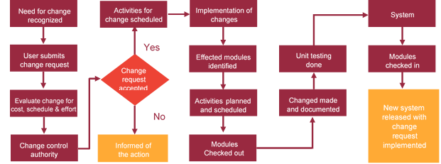

# Miscellaneous

## Acceptance Criteria

* UAT sign off should happen within 14 Days from the release of the application/ Phase and the acceptance confirmation needs to be mailed to Verbat failing which Verbat will consider the project as approved by the client.
* Any comments or reason for rejection need to be documented and the same needs to be sent as an email from the official mail id of client to Verbat.

## General Terms and Conditions

* All the projects activities will be carried out from our off-shore development center in India
* The scope of the project is to develop the Application as detailed in the scope of the project and mentioned in this proposal. Any changes or additions will have to go through change management.
* This proposal and all technical/ functional specifications have been derived or concluded from the data shared via email / information's transferred during the initial requirement analysis meetings and conversations. Verbat reserves the right to amend the terms of this proposal, should the SOW terms, functional features and functionalities change during the course of the project
* Application will be best viewed only in the environment mentioned in this document
* All the documentation will be provided in English.
* Third party components may be used to develop this application.
* All Source Code and other project artefacts would adhere to the Verbat document templates and internal coding standards
* Client shall provide the respective enterprise apple store and Google play store accounts for development and production
* Acceptance criteria shall be based on the clauses which were mutually discussed between Verbat and client at the Requirement Analysis phase and the same will be documented and approved by both parties through official emails
* In case Client requires any extension of the proposed acceptance schedule, the associated effort and cost of such extension can be mutually reviewed.
* For any circumstances if project needs to be put on Hold / Stop it requires minimum request notice period of 2 weeks along with duration for which request will be addressed by management and final decision on the request will be based on that
* If deployment is done in client’s server, Verbat cannot be held responsible for any performance issues arising due to hardware malfunctions.
* Source code will only be delivered or uploaded on the Production Server once the due payments are made.

## Assumptions and Dependencies

* Detailed system study is required before the start of the project.
* During the requirement gathering phase, authorized personnel from the Client’s side is expected to be available for discussion and finalizing the HLD (High Level Design), before development commences.
* Type of reports and formats, if under the scope of the project, needs to be specified by Client before project sign off.
* Workflows if under the scope of the project, need to be specified/ confirmed by client before project signoff.
* All queries regarding the client requirement and any queries which may hinder the project advancement at any stage should be answered by the client within 24 hours from the time of initiation, failing which the time delay will get added to the actual effort which was estimated.
* Verbat assumes that all sign-offs from Client will be provided within agreed and specified timeframe.
* Client will provide all the necessary contents, both text and image, before starting the project in the format suggested by Verbat (if any).
* The client should provide the relevant information and data well in time for the execution of a related activity. Non- availability of this information or data may lead to an interruption of work which may result in a delay in delivery as well as additional costs to the client.

## Source Code & Intellectual Property Rights

* Upon completion of the Project and 100% completion of the payment, client will have access to the source code except for propriety codes, developer tools and third party application etc.
* The solution offered will be the intellectual property of the client and will be made available to the client on an “unlimited license” basis.
* Modifications by third party/person: No person or organization, other than Verbat or any person authorized by Verbat in writing, has any permission to modify/change the software Solution to be eligible to get continued support from Verbat as per the support terms defined under this document.
* Liabilities/Damages: Verbat accepts no liability or damages of any kind arising out of use or non-use of the software delivered. The responsibility of testing of software lies with Client.

## Maintenance & Support

* Maintenance contracts by default are supported as per the basic SLA terms.
* **AMC with Basic SLA is charged at 20 % of the total project value**. Additional Effort/change management request will be added towards Total Value of the Project to determine the AMC value.
* Maintenance support is limited to providing application support for ensuring the consistency of the look-and-feel, bug fixes and user issues i.e. maintenance and support of the existing features of the application.
* Support does not in any way cover providing technical or other support to the end users. The maintenance agreement does not include functionality changes or feature additions which are handled as change requests which will be charged AED 1200 per man day. AMC does not include server support, maintenance and application deployment.
* AMC charges will cover Off-Site Support and Debugging. Support includes E-mail, Telephone and Chat unless explicitly specified. In the event, the application is hosted with the client; necessary remote desktop connectivity should be provided for carrying out maintenance activity.
* Gap in AMC - In case if the client does not opt an AMC for a year and want to renew it after that period, 50% of the AMC amount for the year for which AMC is not taken will also be payable if the client wishes to renew the AMC contract.
* Note:
  + Please note that the AMC support shall start only after all the necessary sign-offs (AMC Document) to this effect have been given.
  + It is not mandatory that the client should opt for an AMC. The client will still be supported on an ad-hoc basis on an agreed man-day rate.
  + AMC Payment Terms: 100% to be paid as advance.

## Service Level Agreement

|  |  |  |  |  |
| --- | --- | --- | --- | --- |
| **Key** | **Max Response Time** | | **Max Resolution Time** | **Target** |
| Basic | 1  working day | 3 working days | | Request / incident / problem tickets |
| Advanced | 5 Business Hours | 12 Business Hours | | Request / incident / problem tickets |
| Priority | 3 Business Hours | 5 Business Hours | | Request / incident / problem tickets |

Note:-

* We provide Basic SLA as standard with AMC while Advanced and Priority SLAs attract additional charges.
* Time zone applicable as per India time zones (3:30 AM GMT to 12:30 PM GMT- Monday to Friday).

# Our Clients

**UAE University**

Education

Transportation

**Canada Cartage**

Construction

Services

Finance

We look forward to hearing from you soon and hope that you will give us the privilege to work with you in meeting your business goals. Thank you.

Thank You



©   
1999 - 2017. All Rights Reserved   
Verbanet Technologies LLC  
www.verbat.com