roid

217, Sheikh Rashid Building

P.O Box 56272, Dubai

United Arab Emirates

Tel: +971 4 2973236

Email: uae@verbat.com

PROJECT   
PROPOSAL

**Android & IOS Mobile App Development for**

**Electronic Documents Centre LLC**

|  |  |
| --- | --- |
| **Prepared for:**  **Electronic Documents Centre LLC** | **Submission Date:**  07 May 2018  **Proposal ID:** AD/BP/07042018/1913/3 |

___________________________________________________________________________________________________________________________________________  
Conﬁdentiality Notice: This Proposal is conﬁdential and contains proprietary information and intellectual property of Verbanet Technologies LLC. Neither this proposal nor any of the information contained herein may be reproduced or disclosed under any circumstances without the express written permission of Verbanet.

© 2018 by Verbanet Technologies LLC. All rights reserved. Confidential.

___________________________________________________________________________________________________________________________________________

Project Contacts

|  |  |
| --- | --- |
| Client Information | |
| Project Name | Mobile Application for Electronic Documents Centre LLC |
| Client Name | Electronic Documents Centre LLC |
| Client Address | P.O. Box 50000, Dubai, UAE |
| Contact Person | Paul Andrews |
| Contact Person Email | paul@edc.ae |
| Contact Person Phone Number | +971 4 3150080 / +971 503425219 |
| Verbat Information | |
| Contact Person | Darshana S |
| Contact Person Phone Number | +971 4 2973236 Ext:102 |
| Contact Person E-Mail | [darshana.s@verbat.com](mailto:darshana.s@verbat.com) |
| Address | PO Box 56272, Dubai, United Arab Emirates |
| Physical Address | 217, Sheikh Rasheed Building, Hor Al Anz East |
| Project Information | |
| Proposed Technology/Methodology | Android / IOS / PHP |
| Anticipate Start Date | NA |
| Proposal Valid For | 30 Calendar days from the submission of the proposal |

**Table of Content**

1 Executive Summary 5

1.1 Proposed Solution Model 6

1.2 Solution Objective 6

1.2.1 Features of Mobile Application module 6

1.2.2 Mobile App Process Flow 7

1.2.3 Features of Web Portal Application: 8

1.2.4 Web application process flow 8

1.3 Advantages of Proposed Solution 9

1.4 Why Verbat 10

1.5 Key Differentiators 11

1.6 Technology & Services 12

2 Functional Specification 13

2.1 Mobile application (Android + IOS) 13

2.2 Web Application 14

3 Nonfunctional Requirement (Others) 14

4 Assumptions 15

5 Out of Scope 17

6 Technology Solution 18

6.1 Proposed System Environment 18

6.2 Technical Configurations 19

6.2.1 Development Tools 19

6.2.2 Recommended Web Hosting Package 19

6.2.3 Browser Compatibility 19

6.2.4 Hardware Interface 19

6.2.5 Technical Standards 20

6.2.6 Technical Guidelines 20

7 Commercials 21

7.1 Mobile Application Development 21

7.2 Payment Terms 21

7.3 Mode of Payment 22

8 Delivery Management 23

8.1 Project Management 23

8.2 Roles and Responsibilities 23

8.3 Delivery Activity Summary 23

8.4 Project Implementation Plan 24

8.5 Deliverables 24

8.6 Estimated Delivery Time 25

8.7 Details (at Clients Behest) 26

8.8 Release Planning 26

8.9 Risk and Contingency Planning 26

9 Change Management 28

10 Miscellaneous 29

10.1 Acceptance Criteria 29

10.2 Warranty 29

10.3 General Terms and Conditions 29

10.4 Assumptions and Dependencies 31

10.5 Source Code & Intellectual Property Rights 31

10.6 Maintenance & Support 32

10.7 Service Level Agreement 33

11 Annexures 34

11.1 Details for Mobile Application Modules Charges in Proposal 34

11.2 Additional Details Required in Mobile Application Development 35

11.3 Mobile Development Timelines 35

11.4 Web Portal Requires the following modules in the web page 36

11.5 Additional Details Required in Mobile Application Development 36

11.6 Web Portal Development Timelines 37

11.7 Vendor Information Detail 37

12 Our Clients 39

# Executive Summary

**Electronic Documents Centre LLC** is a joint venture between Emirates Post (UAE National Post) and Abba Electronics offering end-to-end solutions in data processing, dynamic printing, card personalization, fulfilment and distribution in a highly secure environment.

Verbat is a Digital Technology Services company with over 18+ years of experience in delivering Internet and Mobile Solutions to Enterprises, through Agile Development and Application Management methodologies. Application Development is an area where Verbat has in-depth knowledge and expertise. Being the pioneers in Web based solution across the major verticals, we are sure to help customers drive differentiation. We bring proven methodologies and processes, global expertise in application development, and a legacy of best practices & ready-to-fit frameworks to expedite the development cycle in order to reduce the total cost of ownership.

**Electronic Documents Centre LLC** (here after referred to as “Client”), has requested **Verbanet Technologies** **LLC.**, trading as Verbat Technologies (hereafter referred as” Verbat”) to develop an IOS, Android Mobile and website application for the individual users to upload their Photos from their smart mobile phone for getting them printed as hard copies either individually or in a photo album. A web portal needs to be developed for the client for the order management.

The mobile app shall have the functions as listed below:

* Upload photos through mobile app for printing and uploads to cloud storage
* Order different sizes of photos / type of print
* Delivery option of photo album
* Online Payment options (Pay as you go/ Subscription model)
* Collection of photo album from stores
* Products grouped under categories and sub categories

Verbat is pleased to submit the proposal and values it as a great opportunity to have a long term & mutually beneficial association with the Client. Verbat has gone through the requirement and presents a proposal for the requested system.

## Proposed Solution Model

**Stand-Alone Fixed Bid**

Verbat will be following a stand–alone fixed bid solution delivery model wherein the required solution would be devised and a suitable pricing would be offered.

## Solution Objective

Client requires a Smart Phone Application along with an internal web portal to track and complete the orders.

### Features of Mobile Application module

* Login / Registration
* E-mail Id and mobile number authentication
* One time password or E-mail Id verification
* Push notification in mobile about registration
* I am not a Robot CAPTCHA checking process
* Bilingual (Arabic & English)
* Manage Profile
* Subscription model
* Menu List
* Home screen/Dashboard with all the possible photo print options
* Add and Order
  + Select the type of Print
  + Load photos from gallery
  + Select photos from Gallery
  + Edit the album, rearrange the photos according to the selected option
  + Preview the album/photo
  + Add to Cart
* Cart listing
* Checkout
* Payment Gateway Integration with EDC specified vendor
* SMS Gateway Integration
* Contributions to album through invitation
* Manage various push notifications based on the order status
* General app settings
* Feedback/Contact Us
* Additional Inner Pages like About Us, Terms and Conditions, How to Use, FAQ (maximum of 5 pages)

### Mobile App Process Flow

* The app will be available to UAE customers (based on client’s decision)
* The app will be bilingual ( Arabic/ English)
* The app will get updated automatically
* Mobile app users can view all products in guest mode by default
* User should be able to download the mobile app from the play store / apple store
* Upload selected photos from the mobile phone gallery for printing either as zip file or individual images are combination of both
* Upload directly printable documents in PDF format
* Selected photos should get stored in the cloud / server
* The mobile app should have the features of subscription model and pay as you go option. Both the models will have options available based on number of photos per booklet (eg. 15/30/60 photos per booklet)
  + - Subscription Model – user will get the selected number of photos in a booklet once a month for 1 year
    - Pay as you Go Model – user can select any option any time
* Once registration is over, user will add / shoot photos. Options like delete / group should be available to manage / manipulate the photos
* After uploading the photos, the total cost will be derived automatically through the app and the user will be guided for the delivery option
* The App should have the option to include special promotional packages which will run for limited time period
* The special promotion contents and products need to be updated by Client according to the business requirement.
* Options available for delivery methods - Collection at the store or delivery through the courier
* For delivery through courier, user needs to update the delivery address with location pin selection
* Based on the options the total cost will be derived automatically including VAT for the package
* The mobile app will be integrated with a Payment gateway for payment
* The Payment gateway will have multiple currency acceptance
* Cash on delivery option to be available for the payment
* On successful payment an order reference number will be created and push notification will be sent to individual through mobile app
* Order code generated will be available to EDC admin
* Connecting people page in mobile app

### Features of Web Portal Application:

1. Login
2. Dashboard
3. Admin settings
4. Customer management
5. Order management
6. Reports
7. Invoice Management (View, Print)
8. Special Promotion management
9. Delivery Management (View Delivery Mode, Update Delivery Status, Generate AWB)
10. Courier Vendor Management (Add / Edit / Delete Vendor)
11. Contact Us

### Web application process flow

A web portal needs to be developed for the client’s digital print unit for order management.

* Web Portal shall get a notification on the order placed by the user with order reference number.
* Additional modules to monitor and process the order placed by customers
* Application will get updated automatically
* Application will auto generate an invoice for each order
* Client shall download the photos related to the order from the cloud / server and does the print fulfillment.
* Integration of website with courier vendor application
* Client to generate / enter an AWB Number if the delivery mode is by courier.
* Client to update the job completion for the order reference number along with the AWB number if the delivery mode is by courier
* Once updated, a notification to be triggered to the user’s mobile app with the AWB number details or notification for pickup timing.
* On delivery of the booklet, the details to be updated across the order reference number
* Custom Vision- to reduce mammography image quality issues
* Content Moderator- for controlling explicit or offensive contents
* Image storage based on subscription package
* Website development using Microsoft Azure cognitive
* Client should be able to update the special promotion page with products and different pricing which needs to be integrated and reflected in the mobile app for the end user.
* Customer should be able to upload from DropBox, Google Drive, local hard drive, one drive accounts and SD card also
* Connecting people page in web app

Verbat’s Solution architects have conducted a thorough research on the requirements and have come to the conclusion that our proposed solution, which is detailed further in this document, will meet the requirements put forth by the client. And the proposed solution will be delivered in a phased approach as per Verbat’s stand-alone fixed bid solution model.

**Strong and Scalable platform:** The platform proposed will be strong and scalable enough to accommodate future enhancements.

**Accelerated solution:** The framework would act as a solution accelerator. It would provide the basic building blocks which could be reused in future for building new components and features.

**High performance:** The light weight framework used consumes fewer system resources thereby making the application perform faster.

**Security:** The application will be developed considering various aspects of security.

## Advantages of Proposed Solution

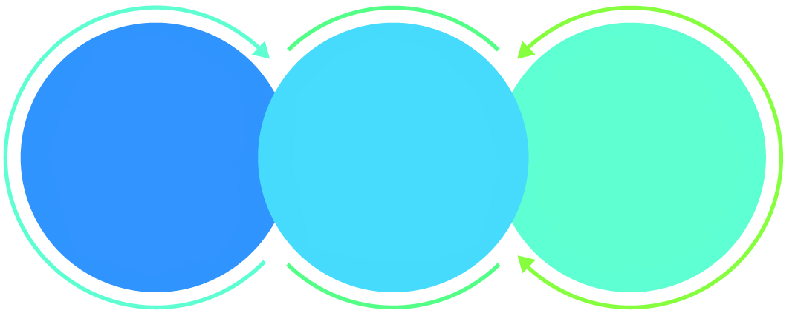

01

Agile development offering reliable, secure solution

02

Smooth transition and quicker completion of processes

03

User friendly interfaces enabling easy navigation between screens

## Why Verbat

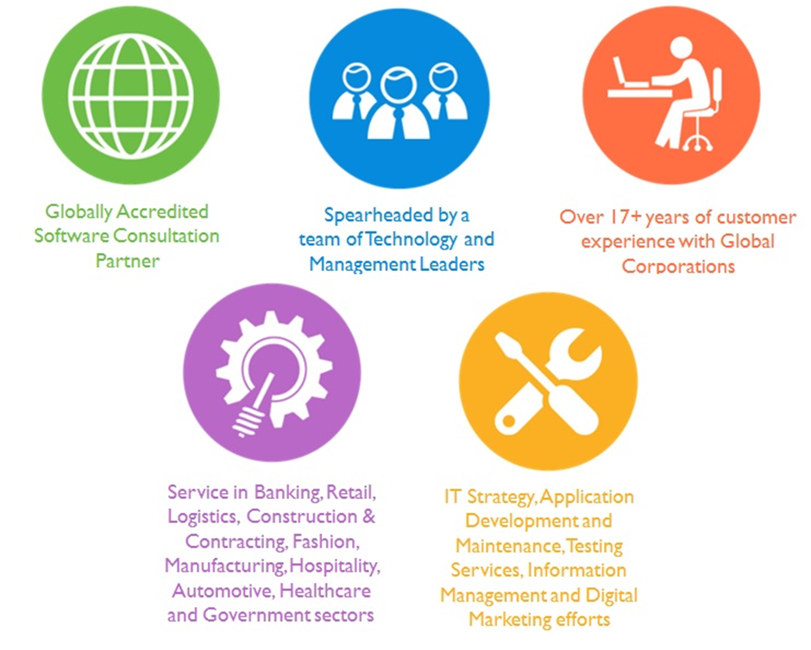

Over 18+ years of customer Experience with Global Corporations

## Key Differentiators

Delivered digital transformation expertise to global customers for over a decade by following industry best practices to maximize ROI for client

Keen technology intelligence combined with aggressive market research to deliver solutions that achieve results with measurable value

Enable access to global consulting expertise with strong local market and business knowledge

Commercial Model that is customizable for your business needs

Services that are designed to optimize applications for improved performance and overall efficiency

1,000,000 plus man-hours of expertise in technology frameworks spanning Microsoft, Open Source, mobility platforms and other proprietary IT technology

Partners top technology vendors to bring in the latest and best services in integration, collaboration, and development

Commercial Model that is customizable for your business needs

Proven Methodologies & Processes

Investment in R & D

Strong Local Presence

Flexible commercial Models

Technology Associations

Software Development Experience

Offshore Development Centre

Quality Assurance & Testing

## Technology & Services

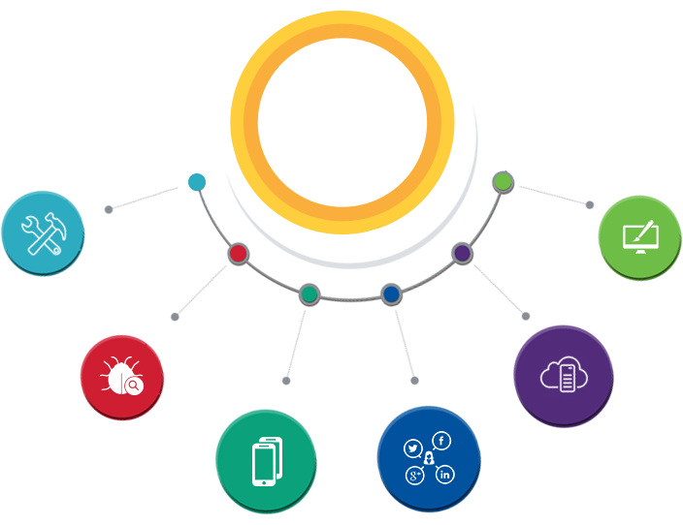

Technology  
&  
Services

Cloud/Traditional Hosting

User Interface & Design

Digital Marketing

Mobility Solutions

Testing Services

Application  
Development

# Functional Specification

## Mobile application (Android + IOS)

|  |
| --- |
| **Development** |
| Basic Setup |
| Bilingual (Arabic & English) |
| Login page |
| Dashboard |
| Registration page |
| Manage profile (delivery address, credit card details) |
| Model type listing |
| - Subscription Model |
| - Pay As You Go Model |
| Menu List |
| Home Screen with photo print options and special promotions if any |
| Add and Order (Order Management) |
| - Select the type of Print |
| - Add photos : Select photos from phone gallery and add them to the application |
| - Contribution to album through invitation |
| - Edit the album, rearrange the photos according to the selected option, preview the album/photo |
| - Add to Cart |
| Cart listing |
| Cart details page |
| Checkout, Pricing |
| Delivery Options (Store Pickup / Courier) |
| Payment Options ( Credit Card payment - Payment gateway integration / Cash On Delivery) |
| SMS Gateway Integration |
| Push notification based on order status |
| - Notification to be triggered to the user’s mobile app with the AWB  number details (if delivery mode is courier) or notification for pickup timing along with order reference number |
| General App Settings page |
| Feedback/Contact Us |
| Multiple Currency |
| Inner Pages like About Us, Terms and Conditions, How to Use, FAQ (max 5 pages) |
| **API Integration** |
| API Integration |

## Web Application

|  |
| --- |
| **Development** |
| Basic Setup |
| Admin Settings |
| Contact US |
| Dashboard |
| - View notifications |
| - Reports (maximum of 5 basic reports) |
| Manage internal users (Web users + Authentication + Authorization) |
| Manage products |
| Customer management (individual users) |
| - View registered customer details |
| Order management |
| - View orders placed (order details) |
| - Download photos |
| - Update status |
| Manage special promotions |
| - Add/edit/delete products and prices |
| Invoice Management |
| Update job status changes |
| SMS / email messages |
| Courier Vendor Management |
| Generate Order reference numbers & AWB |
| Mobile API Development |

# Nonfunctional Requirement (Others)

|  |  |
| --- | --- |
| **Requirement** | **Details** |
| User Experience and  UI Design | * The mobile app will be developed in English and Arabic * The layout and graphical components will be created considering the usability factors |
| Performance | * Application will allow users to have smooth and quick access to the information or services they require. |
| Security | * Web security standards will be followed. |

# Assumptions

The project solution and technology is created from the initial understanding of the requirement shared with Verbat through mails and meetings. The proposed solution is based on the following assumptions:

1. **Objective:** 
   * The requirement is to develop an Android & iOS Mobile Application along with an internal web portal with the functionalities as defined in the “Functional Requirements” section
2. **Design:**

* The Client shall provide the branding guidelines
* Color theme shall be provided by the Client
* Client shall provide licensed images and logos in specified size & format
* Client shall provide the text and associated images for English & Arabic language. Text should be provided in digital format preferably in MS Word 2013 or above
* Client will purchase the necessary templates needed for development
* This application designed for mobiles will be in portrait mode

1. **Development:**

* Development Contingent upon timely feedback from client
* Requirements should be well defined, agreed and signed-off by the Client
* The client will finalize the functional requirements before the commencement of the development of the project
* Client shall approve the prototype for the mobile application and web application before development work starts
* The proposed mobile application will be bilingual (English & Arabic). Option envisaged for mobile app is language selection under settings.
* The mobile app will be developed on both Android and IOS platform
* Client shall provide the developer accounts for both Android and IOS Store
* Email service will be managed via mobile app itself (Email setup details to be provided by the client)
* Web portal will be developed in English only
* The following items will be hardcoded / implemented in the web portal
  + Models (subscription model & pay as you go)
  + Payment options (COD & Credit card)
  + Delivery options (Courier & Store Pickup)
  + Print types / sizes
  + Prices relating to products (print type / sizes)
  + Multicurrency (for payment processing subject to the provisions made by the payment gateway procured by Client)
  + Status (order placed, in progress, printing completed, dispatched, delivered / collected)
* Reports will be in tabular format with maximum of 3 basic filters
* Client will procure the payment gateway and share the necessary documentation and details with Verbat for integration
* Client will procure the SMS gateway and share the necessary documentation and details with Verbat for integration
* Courier API (to generate Airway Bill no.) to be provided by the client for maximum of 2 couriers. Else Verbat will assume that the air way bill number generation is random and envisages no integration with any third party (courier) system.
* Client will procure templates, SSL certificates (if applicable)
* Client will provide sample data to test the entire application
* Testing of web application will be done in latest versions of Google Chrome, Mozilla, Safari & Edge web browsers only
* Testing of the mobile app will be executed on devices mentioned under Technical Standards
* Final data needs to be manually entered by the client
* Client will host and manage the application on infrastructure (server / cloud) recommended by Verbat for managing database and application backup inclusive of images
* Application and data backups are subject to the purchase of such services at an extra cost
* Internet connectivity is required for the functioning of the Mobile App & Web portal

# Out of Scope

With the ever evolving digital market, the requirement needs should be clear to both the parties involved, hence the importance of mentioning the out of scope details of the project. Following are considered to be out of scope while creating this proposal.

* Purchase of images, fonts
* Logo designing
* Any language other than English and Arabic
* Database migration
* Content writing / proof reading / Data Replication / Manual data entry
* Content or image procurement or editing
* Audit Trail
* Photo editing
* Adding new features to the application other than mentioned in the functional specifications. Such requests will be handled via change management. For Change management details, please refer section titled “Change Management” in the Proposal.
* Annual Maintenance Contract (Bug fixing, debugging, enhancements) – Please refer section titled “Maintenance and Support”.
* Hosting Infrastructure and Maintenance
* Application Deployment / Physical deployment onsite / installation of the application in devices and Physical connection, installation of system
* Integration with third-party, if any, other than mentioned in the functional specifications
* Hardware Integrations / procurement and purchase
* Procurement of SMS gateway / payment gateway / email gateway
* SSL Purchase and installation, if any
* Plugin purchases, if any
* Backup solution and Disaster recovery
* OS other than mentioned in the Hardware Interface
* Mobile offline access or operations
* Relevant / related software libraries
* Digital Marketing / Social Promotion / SEO
* Google Analytics set up

# Technology Solution

## Proposed System Environment

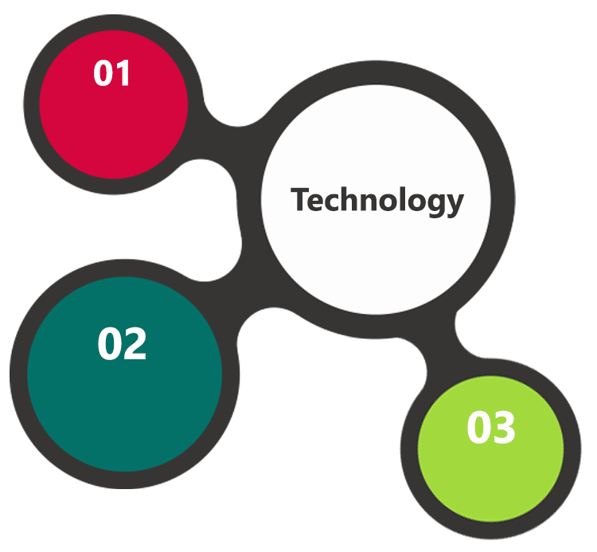

HTML / CSS3 /

JQuery

PHP / Code Ignitor

Objective C, Android SDK, IOS SDK

MySQL, Apache

**MS SQL2012  
Windows 8/10  
Web Services**

## Technical Configurations

### Development Tools

* PHP, Codeignitor, Objective C, Java
* MySQL, APACHE
* HTML / CSS 3
* Ajax, JavaScript, JQuery

### Recommended Web Hosting Package

* Octa Core CPU
* RAM: 32 GB
* Disk Space: 1 TB
* Monthly Bandwidth: 20 TB
* Web site Server Software – Apache

### Browser Compatibility

* Chrome version: 56
* Firefox version: 51
* Edge version: 39
* Safari version 10.1

### Hardware Interface

The application is reliant on hardware interfaces to provide a seamless automated user experience.

* Computer with Windows 8 or 10 OS
* iOS (9.0 and above) iPhone 5S and above
* Android Mobile Phones (OS Version KitKat and Above)

### Technical Standards

|  |  |
| --- | --- |
| Particulars | Specifications |
| Screen resolutions | 1080 x 1920, 720 x 1280, 750 x 1334, 640 x 1136 |
| Testing Devices | * Google Pixel - Android 7 * iPhone 5S - iOS10 |
| OS Version | * Android KitKat and above * IPhone 5S and above |

### Technical Guidelines

The guidelines provide instructions and conditions that will be adhered to during the development of the mobile application

* API will be used, as the case may be, in realizing the features and functionalities mentioned
* The Client will finalize the functional requirements and Prototype before the commencement of the project
* Verbat will be testing the app in the devices mentioned under Technical Standards.
* Testing on devices other than the ones mentioned under the “Technical Standards “will have to be specified and provided by the Client at the beginning of the development phase. The Client will have to provide the details of the testing devices they are using before the start of development phase
* Client should provide the relevant Developer's Account credentials before the development phase. In case Verbat needs to create the developer id, additional charges will be incurred by the Client
* The duration mentioned in the project time line is for development and testing and any delay or time taken by the review team to respond will not be Verbat’s responsibility
* The apps will be developed / created within the guidelines of Apple and Android.
* Verbat will strictly follow the guidelines provided by the respective stores. Verbat will inform the Client if the any of the Client requirements/ request deviates from it.
* Customization of the features of the app will be susceptible to the limitation imposed by the respective platform/store.
* Once development commences, the test device/screen sizes will not be susceptible to change. Any change requested by the Client will have to go through change management
* OS version support will be limited to the ones mentioned in the technical specifications. Further support will have to go through change management

# Delivery Management

## Project Management

The Verbat development center strictly follows industry standards on quality. The project management is process governed by the Verbat Quality Management system and is put to verification through internal audit programs that happen from time to time.

Verbat will dedicate a project manager for the proposed implementation. Verbat proposes Client to identify one project manager who will be driving activities to be undertaken by Client to be the single point of contact for Verbat.

## Roles and Responsibilities

Verbat will assign a dedicated Project Manager/Project Lead to lead the project, who will be the first point contact for Client. He/she will be responsible for planning and managing the various activities within the project. He/she will work closely with Client Project Manager, to give periodic status updates and ensure high level of visibility and comfort on the progress of the project.

The Project Manager/Project Lead will lead the co-ordination between Verbat and Client, thus enabling smooth transitioning of Client requirements to the Verbat’s offshore delivery team, and provide visibility as well as comfort on the progress of the services to Client.

He/she will have periodic meetings with Verbat’s Senior Management, thus ensuring Verbat’s Management commitment and focus on Client initiatives.

## Delivery Activity Summary

|  |  |
| --- | --- |
| Activities | Description |
| Detailed requirement Analysis | Verbat team to conduct detailed study of requirement for the phase. If clarification is required, team will reach out to Client for more information and/or time for discussions. |
| DB Design | DB design for central and test DB. |
| Software Requirement Specification document (SRS) | Once the requirement analysis is completed, Verbat team will submit the SRS document for approval |
| UI/UX Design, Prototyping | Based on the SRS, Verbat UX/UI team will work on the UI/UX of the screens and submit a prototype for approval |
| Functional Specification Document (FS) | Once the Prototype. UI/UX is approved, Verbat shall submit an FS document for approval. |
| Development | Actual system development starts based on the FS. This involves detailed design and software development of Web Admin, API & iOS and Android mobile app. |
| Testing | Test Planning, test plan creations, internal, integration testing and user acceptance testing. |
| Deployment | Deploying the latest built in the Verbat Test Server. |

## Project Implementation Plan

Verbat will be providing the solution in a stand-alone fixed bid approach which ensures minimum viable solution for quick wins with core focus on the long-term business objective and outcome. Once the implementation is over, Verbat will initiate the application maintenance process (once the maintenance contract is signed) which continues to extend after the implementation.

## Deliverables

* Project Plan
* Software Requirement Specification Document (SRS)
* Prototype for Mobile App and Web portal
* Functional Specification Document (FS)
* Fully Developed & Tested Application
* Source Code

## Details (at Clients Behest)

* Client can opt for hosting the application at Verbat’s Server.
* If deployment is at the Client’s server, responsibility of deploying the application onto the production environment after conducting the necessary acceptance testing will lie with the Client unless and until Verbat’s support is contracted for deployment.

*Note: Hosting the application at Verbat’s server will call in for additional charges.*

## Release Planning

* Client will be informed about the release date and time through email.
* Client performs the UAT

## Risk and Contingency Planning

Verbat has identified various risk factors associated with this assignment and understands the impact of these risk factors on the project schedules. The objective of this section is to highlight for both Verbat and client, the risk factors, to analyze the impact of the risks on project execution, and to propose strategies to control and reduce the impact of the risk factor.

These various risks, which could arise during the project, are tabulated below along with mitigation implementation.

| Type of risk | Impact | Risk Mitigation | Risk Handling |
| --- | --- | --- | --- |
| Scope Creep | H | Functions and features will be detailed in system requirement documents and will go through client approval. Once this document is approved, any change to requirement will go through change management review for possible impact assessment. | Proper change management procedure will be implemented. |
| Delay in customer feedback | H | The plan is prepared with enough lead-time for customer reviews and approvals.  The customer is indicated with the dates when the document is expected after review and approval. | The request for feedback will be escalated if not attended at the right time so that the schedules are not affected. Deemed acceptance criterion is set up front and will be followed. |
| Non-availability of necessary software’s, frameworks, database instances and infrastructure at client’s hosting environment(If hosting support is provided by Verbat) | M | Client will be informed in advance on these requirements. | Possible impact to schedule. |
| Manpower attrition | L | All efforts would be made to ensure process dependence rather than being person dependent. As a risk mitigation plan Verbat will train backups. | A new person will be identified as early as possible, provided the required project-specific training and mentored by the senior members of the team to minimise impact of attrition on the project. |

*H-High, M-Medium, L-Low, NA-Not Applicable*

# Change Management

Any addition which comes out of the project scope, upon and after the launch of the tool will be considered as change management. Verbat recommends the following change management procedure for the same.

* Any change which comes out of the project scope, which was discussed, documented, and mutually approved by both the parties in the requirement stage, will be carried out only through raising a change request.
* Change request will be studied and an impact analysis on the existing work flow will be performed.
* On finalizing the impact, effort estimation for the change will be calculated and raised as additional requirement.
* Verbat will initiate the change request only after getting a formal approval from the client for the additional changes raised.
* Any change from the scope will be charged at **AED 1200.00 per man day effort** and approval from the clients will be availed before commencing on any change management.

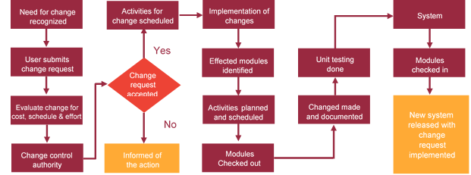

# Miscellaneous

## Acceptance Criteria

* UAT sign off should happen within 14 Days from the release of each module/ Phase and the acceptance confirmation needs to be mailed to Verbat failing which Verbat will consider the project as approved by the Client.
* Any comments or reason for rejection need to be documented and the same needs to be sent as an email from the official mail id of Client to Verbat on or before 14 days from the first release.
* Timeframe for acceptance for any further release will be mutually agreed and finalized between Client and Verbat depending on the UAT Comments.

## Warranty

* Verbat shall provide a bug ﬁx warranty at no additional cost for 30 days from the date of acceptance of the project, for correction of any errors in the developed application that may be attributed to Verbat.
* However, this does not cover modifications by Client, or use of the application on an environment other than the proposed environment, or other circumstances outside Verbat’s reasonable control. In such a case Verbat reserves the right to charge for its services.
* All error corrections will be executed at Verbat India office. In the event of any need for on-site work, all expenses incurred for such trips will be payable to Verbat by Client.

## General Terms and Conditions

* Offer Valid for 30 calendar days from the date of submission of the Proposal
* An average of 20 working days are assumed in a month
* All the projects activities will be carried out from our off-shore development center in India
* All the documentation will be provided in English.
* Third party components may be used to develop this application.
* The scope of the project is to develop the Application as detailed in the scope of the project and mentioned in this proposal. Any changes or additions will have to go through change management.
* This proposal would have been derived or concluded from either the RFQ /RFP/data shared via email / information transferred during an initial requirement analysis meeting / tele-conversation. Verbat Technologies reserves the right to change the terms of this proposal as the final terms (including the costing), features & functionalities and timeline could change during the course of the project. Hence any fees quoted / timeline committed in this proposal may not be considered as final unless agreed and signed by both parties.
* Web Application will be best viewed only in the environment mentioned in the section Browser Compatibility
* Mobile app will be best viewed only in the environment mentioned in the section Hardware Interface
* All Source Code and other project artefacts would adhere to the Verbat document templates and internal coding standards
* Acceptance criteria shall be based on the clauses which were mutually discussed between Verbat and Client at the Requirement Analysis phase and the same will be documented and approved by both parties through official emails
* In case Client requires any extension of the proposed acceptance schedule, the associated effort and cost of such extension can be mutually reviewed
* For any circumstances if project needs to be put on Hold / Stop it requires minimum request notice period of 14 days along with duration for which request will be addressed by management and final decision on the request will be based on that
* If deployment is done in Client’s server, Verbat cannot be held responsible for any performance issues arising due to hardware malfunctions.
* Client is responsible for data backup in case the application is not hosted on Verbat server
* Source code will only be delivered or uploaded on the Production Server once the due payments are made.

## Assumptions and Dependencies

* Detailed system study is required before the start of the project.
* During the requirement gathering phase, authorized personnel from the Client’s side is expected to be available for discussion and finalizing the HLD (High Level Design), before development commences.
* Type of reports and formats, if under the scope of the project, needs to be specified by Client before project sign off.
* Workflows if under the scope of the project, need to be specified/ confirmed by client before project signoff.
* Verbat assumes that all sign-offs from Client will be provided within agreed and specified timeframe.
* Client will provide all the necessary contents, both text and image, before starting the project in the format suggested by Verbat (if any).
* The client should provide the relevant information and data well in time for the execution of a related activity. Non- availability of this information or data may lead to an interruption of work which may result in a delay in delivery as well as additional costs to the client.
* Client should have/possess server with technical specifications as suggested by Verbat for the proposed application.
* Client will be provided with one time training (train the trainer) on how to use the application via video conference (maximum of 4 hours). Additional training requests will be charged.

## Source Code & Intellectual Property Rights

* Upon completion of the Project and 100% completion of the payment, client will have access to the source code except for propriety codes, developer tools and third party application etc.
* The solution offered will be the intellectual property of the client and will be made available to the client on an “unlimited license” basis.
* Modifications by third party/person: No person or organization, other than Verbat or any person authorized by Verbat in writing, has any permission to modify/change the software Solution to be eligible to get continued support from Verbat as per the support terms defined under this document.
* Liabilities/Damages: Verbat accepts no liability or damages of any kind arising out of use or non-use of the software delivered. The responsibility of testing of software lies with Client.

## Maintenance & Support

* Maintenance contracts by default are supported as per the basic SLA terms.
* **AMC with Basic SLA is charged of the total project value**. Additional Effort/change management request will be added towards Total Value of the Project to determine the AMC value.
* Maintenance support is limited to providing application support for ensuring the consistency of the look-and-feel, bug fixes and user issues i.e. maintenance and support of the existing features of the application.
* Support does not in any way cover providing technical or other support to the end users. The maintenance agreement does not include functionality changes or feature additions which are handled as change requests which will be charged AED 1200.00 per man day. AMC does not include server support, maintenance and application deployment.
* AMC charges will cover Off-Site Support and Debugging. Support includes E-mail, Telephone and Chat unless explicitly specified. In the event, the application is hosted with the client; necessary remote desktop connectivity should be provided for carrying out maintenance activity.
* Gap in AMC - In case if the client does not opt an AMC for a year and want to renew it after that period, 50% of the AMC amount for the year for which AMC is not taken will also be payable if the client wishes to renew the AMC contract.
* Note:
  + Please note that the AMC support shall start only after all the necessary sign-offs (AMC Document) to this effect have been given.
  + It is not mandatory that the client should opt for an AMC. The client will still be supported on an ad-hoc basis on an agreed man-day rate.
  + AMC Payment Terms: 100% to be paid as advance.

## Service Level Agreement

|  |  |  |  |  |
| --- | --- | --- | --- | --- |
| **Key** | **Max Response Time** | | **Max Resolution Time** | **Target** |
| Basic | 1  working day | 3 working days | | Request / incident / problem tickets |
| Advanced | 5 Business Hours | 12 Business Hours | | Request / incident / problem tickets |
| Priority | 3 Business Hours | 5 Business Hours | | Request / incident / problem tickets |

Note:-

* We provide Basic SLA as standard with AMC while Advanced and Priority SLAs attract additional charges.
* Time zone applicable as per India time zones (3:30 AM GMT to 12:30 PM GMT- Monday to Friday).

AMC Option:

* Client can opt for time and material based Annual Maintenance, the details of which will be shared post the completion of project.

# Annexures

## Details for Mobile Application Modules Charges in Proposal

|  |  |  |  |  |
| --- | --- | --- | --- | --- |
| Mobile Application Module Requirements | Importance | Design Possibilities | Charges Included in proposal | Additional Cost If applicable |
| Login Page | Mandatory | YES | YES | NO |
| Manage Profile | Mandatory | YES | YES | NO |
| Subscription Model | Mandatory | YES | YES | NO |
| Menu List | Mandatory | YES | YES | NO |
| Dash Board | Mandatory | YES | YES | NO |
| Order Management | Mandatory | YES | YES | NO |
| Cart Listing | Mandatory | YES | YES | NO |
| Payment Gateway Integration | Mandatory | YES | YES | NO |
| Push Notifications | Mandatory | YES | YES | NO |
| General App Configuration settings | Mandatory | YES | YES | NO |
| Feedback / Contact Page | Mandatory | YES | YES | NO |
| Terms and Conditions , FAQ , How to Use App pages | Mandatory | YES | YES | NO |
| Contributions to album through invitation | Mandatory | YES | YES | NO |
| SMS Gateway Integration | Mandatory | YES | YES | NO |
| Logo Designing | Mandatory | NA | NA | NA |
| Promotions in Social Media of the Product | Mandatory | YES | NO | YES |
| Any Limitation in Number of Pages or Forms in mobile app | Mandatory | YES | YES | NO |

## Additional Details Required in Mobile Application Development

|  |  |
| --- | --- |
| Mobile Application (IOS) | Software & System |
| Language(s) | Obj-C |
| Development Environment | xcode |
| Application Version Minimum Compatibility | 9.0 and above |
| Back End Database | MySQL |
| Mobile Application (Android) | **Software & System** |
| Language(s) | Java |
| Development Environment | Android Studio |
| Application Version Minimum Compatibility | Kitkat and above |
| Back End Database | MySQL |

## Web Portal Requires the following modules in the web page

|  |  |  |  |  |
| --- | --- | --- | --- | --- |
| Web Application Module Requirements | Importance | Design Possibilities | Charges Included in proposal | Additional Cost If applicable |
| Web Login Page | Mandatory | Yes | Yes | NO |
| Web Dash Board | Mandatory | Yes | Yes | NO |
| Admin Settings | Mandatory | Yes | Yes | NO |
| Customer Management | Mandatory | Yes | Yes | NO |
| Order Management | Mandatory | Yes | Yes | NO |
| Reports Management | Mandatory | Yes | Yes | NO |
| Invoice Management | Mandatory | Yes | Yes | NO |
| Promotions Management | Mandatory | Yes | Yes | NO |
| Delivery Management | Mandatory | Yes | Yes | NO |
| Courier Vendor Management | Mandatory | Yes | Yes | NO |
| Contact Us | Mandatory | Yes | Yes | NO |

## Additional Details Required in Web Application Development

|  |  |
| --- | --- |
| Web Application | Software & System |
| Web Server | Apache |
| Operating System | Linux |
| Language(s) | PHP, CodeIgnitor |
| Development Environment | Eclipse |
| Application Version Minimum Compatibility | Modern Web Browser |
| Back End Database | MySQL |

## Vendor Information Detail

|  |  |
| --- | --- |
| Vendor Portfolio Details | Vendor Feedback |
| Development Experience in Years | 18+ years of experience in delivering Internet and Mobile Solutions to Enterprises, through Agile Development and Application Management methodologies |
| Location of Vendor | PO Box 56272, Dubai, United Arab Emirates |
| Team Strength for Deliverables Managements | Verbat has taken into consideration the following resources for this project:   * On site (Verbat Dubai) - Business Analyst & Project Coordinators * Off shore (Verbat India) - Project Manager, Designers, Developers – Web, Android, iOS and QA team.   *Note: - The exact resource allocation details will be shared with Project Plan after the project is awarded.* |
| Turn Around Time for Request and Feedbacks | 3 types of SLA mentioned under Maintenance and support |
| Work References for mobile and Web Application Development | <http://www.verbat.com/casestudy/> |
|  |  |
| Vendor Services to be Delivered | Vendor Feedback |
| Application Development and Maintenance | Yes (Maintenance can be provided via AMC) |
| Testing Services | Yes |
| Digital Marketing | Yes (It is out of scope in this proposal but can be offered upon client’s request) |
| Ideas and Process Improvement for better delivery of Products | Yes |
| Weekly Report on Development | Yes |
| Source Code Delivery | Yes |
| Feedback on Milestones of Project | Yes |
| Copyright of Product | NA |
| Support Duration after Product Delivery | 30 days warranty |
| Cloud Hosting Service | Yes (It is out of scope in this proposal but can be offered upon client’s request) |
| Project Plan | Yes |
| Software Requirement Specification (SRS) Document | Yes |
| Functional Specification Document (FS) Final Fully Developed & Tested Application | Yes |
| Complete Process Documentation after Project Completion and Hand Over | User manual can be given upon client’s request |
| Timelines for Change Request Raised within an Year and After an Year | Please refer to change management, Maintenance & Support sections |

# Our Clients

**UAE University**

Education

Transportation

**Canada Cartage**

Construction

Services

Finance

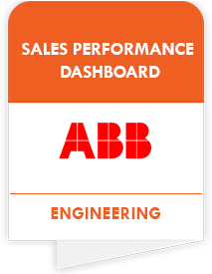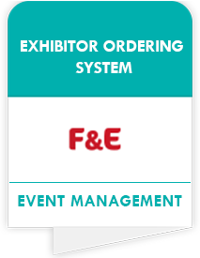

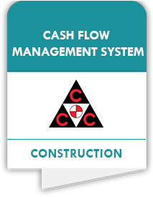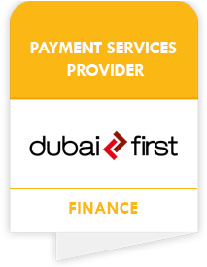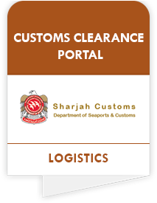

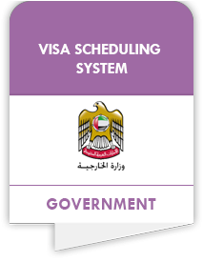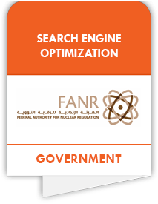

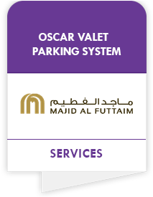

We look forward to hearing from you soon and hope that you will give us the privilege to work with you in meeting your business goals. Thank you.

Thank You



©   
1999 - 2018. All Rights Reserved   
Verbanet Technologies LLC  
www.verbat.com