# Introduction

The document is based on the information provided in the “MyFX Product Specification”. The purpose of the document is to provide support for a bare minimum implementation of the proposed application and as an aid in establishing the effort estimated for the project. As depicted in the screens below, the heart of the application consist of service proposition that endows its users an easy mechanism to conduct spot transactions. The users being consumers who are in need of forex and the providers (Money Changers). The consumers conduct their transactions using a web interface tailored to meet their needs while the “Money Changers” use a web interface to provide currency exchange services.

# Product Screens

The screens below are a depiction of various business scenarios as depicted in the product specification. The scenarios are described in the product specification and are not described at length in this document.

## Web Interface for consumer (Main Screen)

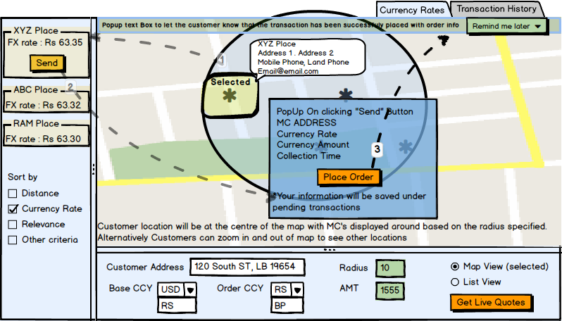

1. Consumer fills in the requisite information in the lower half of the screen and presses the “Get Live Quotes” button.
2. The map gets populated with the pins of “Money Changers” (here after referred to as MC) in the vicinity (radius). The map can be zoomed in or out and the map area will be repopulated with the relevant MC’s.
3. Consumer can select a single MC and its information will be highlighted on the panel in the left (similar to google maps).
4. Customer sends an RFQ for the highlighted MC or can send RFQ’s to multiple MC’s by selecting a group.
5. MC either agrees to the rate or changes the rate and resubmits the quote back to the consumer.
6. Consumer accepts, rejects or differs the order.
7. The order gets moved to the consumer’s transaction history.

**Assumptions:**

* In order to establish asynchronous communication with the client browser, the consumer should either be logged-in or be able to accept cookies to establish a session mechanism.

## Consumer Interface (Transactional View)

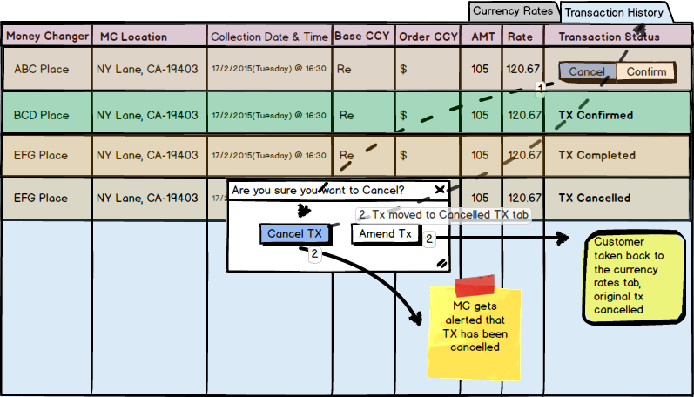

1. In this view the customer is able to view all transactions that has been placed. If the consumer wishes to cancel any transaction that has been placed, they can use the “Cancel” button to cancel the transaction.
2. The customer can edit the transaction and resubmit it if they wish to, in such cases the customer is taken back to the main screen
3. Once a transaction is cancelled completely, it cannot be altered
4. Any transaction that is confirmed cannot be modified further.
5. Transaction will be marked completed once the physical transaction has completed with the MC.

## Money Changer Web Interface: New Order

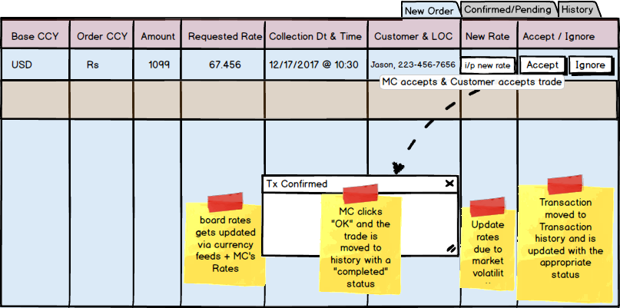

1. The money changer receives “New Orders” as a popup or if configured, may receive “New Orders” as a new line item on the MC blotter.
2. MC can accept the order as is or modify the rate and accept the order.
3. Alternatively they can ignore the order and it moves the order to history.
4. Any accepted order will be sent to the consumer who will accept the order or reject the order.
5. After the consumer responds to the order, the MC receives a popup notifying that the order was accepted or rejected or differed.
6. The order is then moved to history.
7. Accepted and deferred orders will be stored under “Confirmed/Pending” Orders.

## Order History blotter for MC

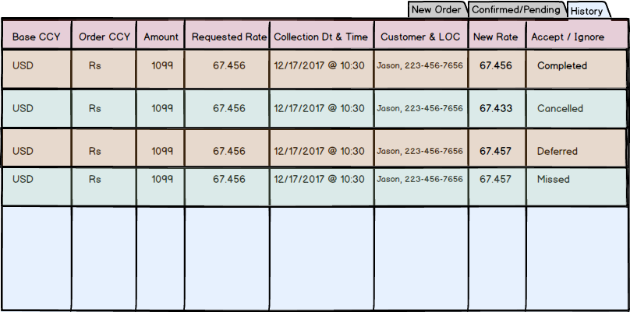

Order History blotter containing the orders with status

## Currency Rate Maintenance: Institution Wide Settings

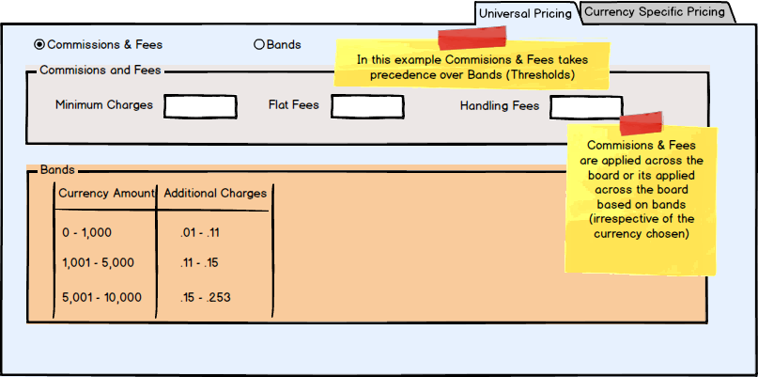

1. Each MC can manage and maintain their exchange rates as a companywide setting.
2. Rates are managed based on individual risk tolerance limits.
3. Alternately rates can be maintained based on different thresholds.

## Currency Rate Maintenance: Currency Specific

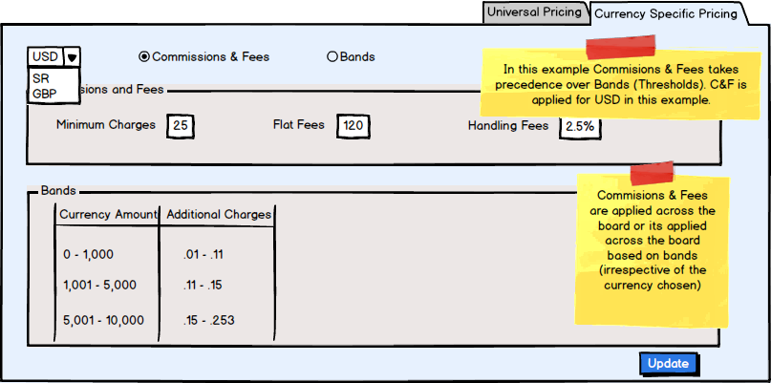

1. Currencies can be managed individually. This is accomplished by selecting a specific currency.
2. Define the commission and fees for the currency or apply currency specific bands.

## Sequence Diagram

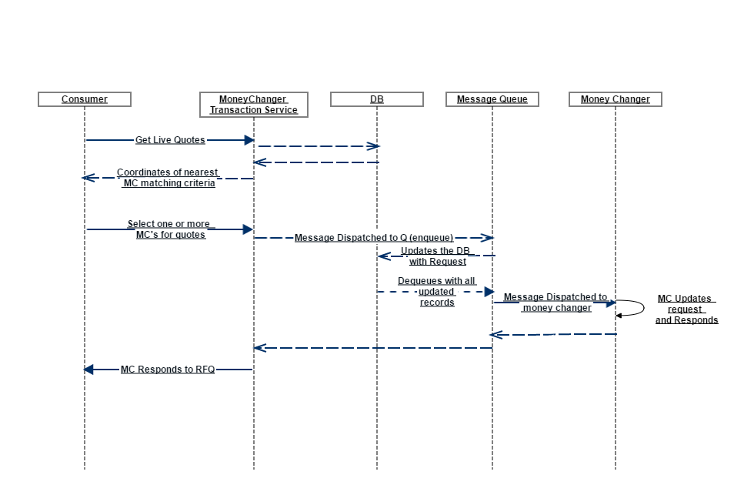

## Activity Diagram

