

217, Sheikh Rashid Building

P.O Box 56272, Dubai

United Arab Emirates

Tel: +971 4 2973236 / 04 2974007

Email: uae@verbat.com

PROJECT   
PROPOSAL

**EGMA Fundus Platform**

|  |  |
| --- | --- |
| **Prepared for:**  **Mr. djdkjkdcjkcd** | **Submission Date:**  31 May 2018  **Proposal ID:** SW/31052018/1245/1 |

___________________________________________________________________________________________________________________________________________  
Conﬁdentiality Notice: This Proposal is conﬁdential and contains proprietary information and intellectual property of Verbanet Technologies LLC. Neither this proposal nor any of the information contained herein may be reproduced or disclosed under any circumstances without the express written permission of Verbanet.

© 2017 by Verbanet Technologies LLC. All rights reserved. Confidential.

___________________________________________________________________________________________________________________________________________

Project Contacts

|  |  |
| --- | --- |
| Client Information | |
| Project Name | EGMA Fundus Eye Testing Platform |
| Client Name | EGMA |
| Client Address |  |
| Phone Number |  |
| Contact Person |  |
| Contact Person Email |  |
| Contact Person Phone Number |  |
| Contact Person Fax Number |  |
| Verbat Information | |
| Contact Person | Ms. Joyce Daniel |
| Contact Person Phone Number | 04 2973236 |
| Contact Person E-Mail | Joyce.daniel@verbat.com |
| Address | PO Box 56272, Dubai |
| Physical Address | Flat 217, Sheik Rasheed Building, Hor Al Anz East, Dubai |
| Project Information | |
| Proposed Technology/Methodology | PHP, Code Igniter, MySQL, CSS 3, HTML 5.0, JQUERY |
| Anticipate Start Date | NA |
| Proposal Valid For | 30 Calendar days from the submission of the proposal |

**Table of Content**

1 Executive Summary 5

1.1 State of the existing application 5

1.2 Targeted State 6

1.3 Advantages of Proposed Solution 9

1.4 Why Verbat 9

1.5 Key Differentiators 10

1.6 Underlying Support Services 11

2 Functional Specification 12

3 High Level Architecture 14

4 Assumptions 15

5 Out of Scope 15

6 Technology Solution 17

6.1 Technical Configuration 17

6.1.1 Development Tools 17

6.1.2 Browser Compatibility for Web Admin 17

6.1.3 Hardware Interface 18

7 Delivery Management 18

7.1 Project Management 18

7.2 Roles and Responsibilities 18

7.3 Phase Delivery Activity summary 20

7.4 Project Implementation plan 20

7.5 Deliverables 20

7.6 Release Planning 21

7.7 Risk and Contingency planning 21

8 Change Management 23

9 Delivery TimeLine 24

10 Commercial overview 24

11 Miscellaneous 25

11.1 Warranty 25

11.2 Acceptance Criteria 25

11.3 General Terms and Conditions 25

11.4 Assumptions and Dependencies 26

11.5 Source Code & Intellectual Property Rights 26

12 Our Clients 28

# Executive Summary

EGMA (Hereafter referred to as the client) is a full service optical industry solutions provider dedicated to serving the needs of the MENA region. With over 40 years of proven track record and heritage. The client partners with optical businesses of all sizes to help them grow and improve their bottom lines and profits.

The Client has an eye testing platform which consist of two portals

* Optometrist portal and
* Ophthalmologist portal

Both portals have been developed using PHP and MySQL. The client wishes to rebuild the portals such that it is scalable enough to accommodate varying data sources.

## Baseline Platform

The client has collaborated with “Al Jaber” Optical unit (having multiple local stores in various locations) to provide free eye test service for eye ailment (e.g. Fundus, Cataract, etc.) to their customers using specialized camera device installed within the stores.

There are mainly two major portals

* optometrist web portal and
* Ophthalmologist web portal

They serve the operational workflow between Optical Stores and Doctors Clinic.

Described below is the existing workflow of the above web applications

1. When the new customer or prospect enters the Al Jaber stores (to buy lens/glasses/specs, etc.), their record is created in Optometrist Portal.
2. They are then offered a free eye test (for any ailment e.g. fundus, cataract etc.)
3. Once the customer agrees, the approval note is shown to the customer and approval is taken on iPad for capturing the pictures and other info.
4. Once the approval is given; then the pictures of both the eyes are captured using the specialized handy camera device installed in each stores.
5. These images are then uploaded to the optometrist portal.
6. Once they are uploaded to the portal; they are available in ophthalmologist portal for the Doctors clinic.
7. Doctor analyzes the images for any ailments to determine whether the customer is required to visit the clinic for further investigation. If the images are not accurate; Doctor marks them as repeated case so as to get new images.
8. If the images are passed (i.e. no ailment detected); the doctor selects the pass option in portal and submits the record. A notification is sent to the customer with info using a predefined template. Further, the store can also see the record in store’s portal and closes the case.
9. If the images show some issues with the eye (i.e. some ailment detected); the Doctor selects the fail option. Then stores follow up with the customer for a Doctor’s visit.
10. Then appointment date and time is fixed in Doctors portal and a notification is sent to the customer. Further, it’s also visible in the Clinic that Doctor has fixed the appointment with the customer.
11. Stores follow up with the customers for appointment via calls.
12. If the customer is not available or not responding or not interested; the store closes the case in the portal.
13. If customer visits the doctor; doctor selects the appropriate option in the portal and closes the case.

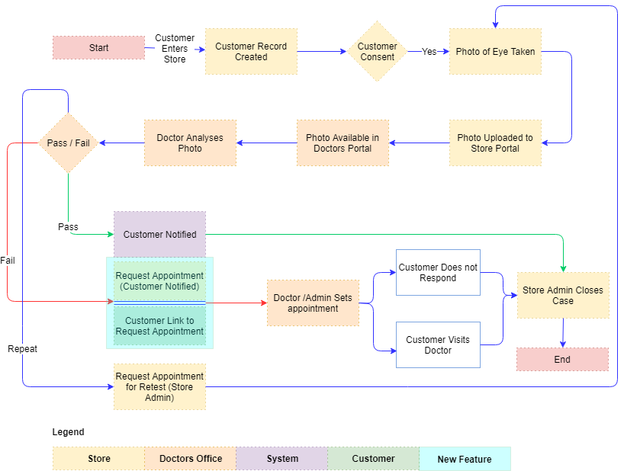

## Target Platform

The baseline platform has the following limitations

* Limited direct customer engagement
* The optometrist and doctor’s office are paired as a single outlet (e.g. “Al Jabar” brand). However it lacks the ability to manage multiple outlets (or Brands)
* It lacks an Admin module to set up and manage the system
* Lacks the ability to manage customers
* Lacks the ability to communicate (or send notifications) with customers using rich media
* Create or manage referrals
* Lacks reporting capability
* Lacks the ability to load data in bulk

The target platform being developed shall address these issues as well additional requirements listed in the functional requirements provided by the client. More details may be found in the functional specification section.

Application Development is an area where Verbat has in-depth knowledge and expertise. Being the pioneers in Web based and windows based solutions across the major verticals, we are sure to help you enhance your customer engagement to drive differentiation. We bring proven methodologies and processes, global expertise in application development, and a legacy of best practices and ready-to-fit frameworks to expedite the development cycle and reduce the total cost of ownership.

Verbat is pleased to have received the request to submit the proposal and values it as a great opportunity to have a long term & mutually beneficial association with the client. Verbat has gone through the requirement and presents a technical proposal for the requested system. With the focus of delivering value to client, Verbat proposes a managed solution model for this requirement.

Verbat’s Solution architects have conducted a thorough research on the requirements and have come to the conclusion that our proposed solution, which is detailed further in this document, will meet the requirements put forth by the client. And the proposed solution will be delivered in a phased approach as per Verbat‘s managed solution model.

**Strong and Scalable platform:** The platform proposed will be strong and scalable enough to accommodate future enhancements such as scheduling, auditing & logging, push notifications etc.

**Accelerated solution:** The framework would act as a solution accelerator. It would provide the basic building blocks which could be reused in future for building new components and features as part of enhancements

**High performance:** The light weight framework used consumes fewer system resources thereby making the application perform faster

* System shall be available 24/7
* System shall be performant without any lags or delays
* System should be accessible by up to 15 people at a time
* System Shall be able to store up to 10,000 soldier details at a time

**Security:** The application will be developed considering various aspects of security.

* Only authorized personnel shall have access to the system

## Advantages of Proposed Solution

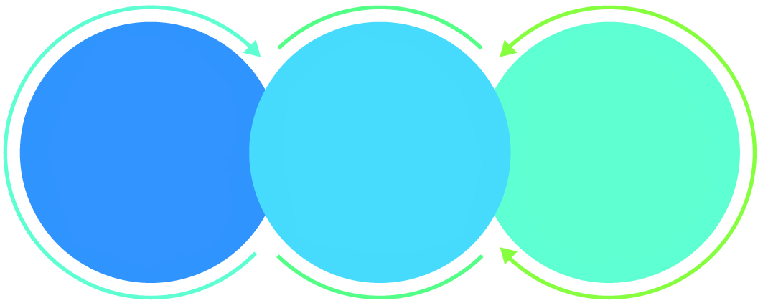

01

Agile development offering reliable, scalable and secure solution

02

Smooth transition and quicker completion of processes

03

User friendly interfaces enabling easy navigation between screens

## Why Verbat

Globally Accredited

Software Consultation Partner

Spearheaded by a   
team of Technology and   
Management Leaders



Over 16+ years of customer experience with Global   
Corporations

Service in Banking, Retail, Logistics, Construction & Contracting, Fashion, Manufacturing, Hospitality, Automotive, Healthcare and Government sectors

IT Strategy, Application Development and Maintenance, Testing Services, Information Management and Digital Marketing efforts



## Key Differentiators

Delivered digital transformation expertise to global customers for over a decade by following industry best practices to maximize ROI for client

Keen technology intelligence combined with aggressive market research to deliver solutions that achieve results with measurable value

Enable access to global consulting expertise with strong local market and business knowledge

Commercial Model that is customizable for your business needs

Reuse of code libraries for Rapid Application Development

1,000,000 plus man-hours of expertise in technology frameworks spanning Microsoft, Open Source, mobility platforms and other proprietary IT technology

Partners top technology vendors to bring in the latest and best services in integration, collaboration, and development

Commercial Model that is customizable for your business needs

Proven Methodologies & Processes

Investment in R & D

Strong Local Presence

Flexible commercial Models

Technology Associations

Code Repository

Software Development Experience

Offshore Development Centre

## Underlying Support Services

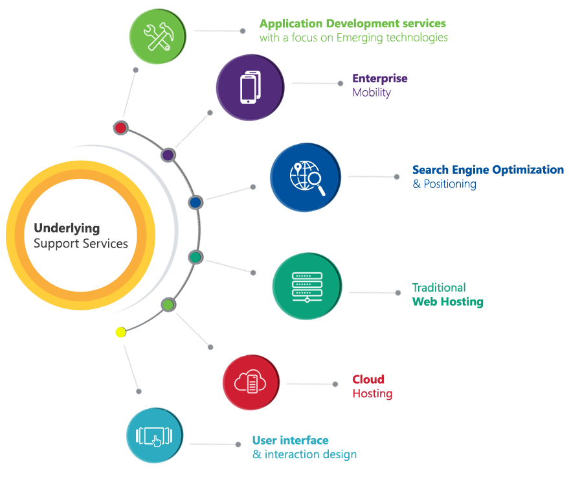

# Functional Specification

The project will be developed in a single phase. The application features to be developed are detailed below

|  |
| --- |
| **Optometrist Portal** |
| Register / Login / forgot Password / remember password |
| Manage Customer Profile |
| Create Customer Profile (Identify Prospects from Clients) |
| Receive notifications (on the portal) |
| Manage Photos |
| Manage Cases (Optometrist report, Ophthalmologist report, related invoice) |
| Manage Customer Documents |
| Manage Referrals |
| Customer Consent |
| Repeat customer reminders (Repeat business: Part of smart notification) |
| Manage Appointments |
| Send customer email link for appointment |
| View customer reports (summary and detail) |
| **Customer Appointment** |
| Create Appointments from email links (Acknowledge or accept) |
| **Doctors Portal** |
| Login / Forgot password/ Remember password |
| Manage Client Profile |
| Verify Customer Eye Condition (manage Cases) |
| Manage Appointments |
| Manage Referrals |
| Manage Documents |
| Manage Cases (Optometrist report, Ophthalmologist report, related invoice) |
| Send Customer email link for appointment |
| Create customer report |
| Create medical history |
| Create Eye test results |
| View customer reports (summary and detail) |
| Receive notifications (on the portal) |
| **Admin Portal** |
| Admin Dashboard |
| Outlet / Brand management (Outlet Master) |
| Manage doctors office within Outlets |
| Country, City & Store Master |
| Manage Optometrist shops within Outlets (Store Master) |
| Create & Manage Users |
| Create & manage Roles |
| News broadcast module (To Portals Not SMS) |
| Bulk data upload for outlets (Shops, doctors offices, users) |
| Portal admin Access to all stores , doctors offices |
| Upload & manage documents |
| Manage Appointments |
| BI Reports (Outlet wise, store wise, Doctors office wise, Region wise, customer wise) |
| Preformatted templates |
| Manage Referrals and Prospects |
| **System** |
| SMS & Emails |
| Desktop Notification |
| Image and file management (Document Management) |
| Scheduling |
| Authentication and authorization |
| Logging and auditing |
| Exception handling |
| Notifications based on triggers |
| Storefront workflow |
| Doctors Office Workflow |
| Security (SQL, Web) |
| **Administrative** |
| Data Migration |
| Documentation (User manuals) |

# High Level Architecture

The proposed architecture supports the management of multiple outlets under one management platform. Each outlet may have multiple optometrist and ophthalmology offices under it. Super admins can manage the whole infrastructure while local admins per outlet may manage its own offices, storefronts and users.

Although the users and roles are restricted by outlets, they are managed under one roof. The application supports the following functionalities per instance of the outlet

* Customer management
* Workflow management
* Document management
* Notification management
* MDM
* BI Reporting
* Configuration

Since the existing application is based on PHP & MySQL, it only makes sense to continue the development in PHP/MySQL as it will make allowance for refactoring and reusing of the existing codebase. This will reduce development time compared to the time it would take to develop from scratch on a different technology stack. PHP in association with MVC frameworks such as code igniter enables the development of powerful and fast web applications.

# Assumptions

The project solution and technology is created from the initial understanding of the requirement shared with Verbat through mails and meetings. The proposed solution is based on the following assumptions;

* Color theme shall be provided by the client
* The client shall provide the branding guidelines
* Client shall provide licensed images and logos in specified size & format
* Estimate consist of the development of one report. Each additional report will require an additional of 6 hours each
* Estimate based on the limited knowledge in master data. Additional master data elements will take an extra 2 hours per element
* Email server shall be provided by the client
* Development contingent upon timely approvals from the client
* Development shall not start until the prototype is confirmed
* Web Application developed shall be responsive. However some screens related to data may not scale well on small mobile phones
* Data migration from the old platform to the new platform for data that is less than one GB and less than 50 tables worth of data.
* User manuals pertaining to the functioning of Admin portal, Storefront and doctor’s portal
* Assumes the development of 4 reports per portal. Additional reports are estimated at 6 hrs. / report
* Assumes the development of up to 3 preformatted templates. Additional templates are 6 hrs. / template
* Notifications are based on emails or SMS (to Customers), followed by reminders/news/ alerts etc. on portal login There Will be NO Push Notifications to Mobile Devices.
* Application is meant to manage multiple outlets with each outlet having multiple optometrist and ophthalmologist offices

# Out of Scope

With the ever evolving digital market, the requirement needs should be clear to both the parties involved, hence the importance of mentioning the out of scope details of the project. Following are considered to be out of scope while creating this proposal.

* Purchase of images, fonts
* Adding new features to the application other than mentioned in this proposal
* Any language other than English
* Manual data entry
* Content writing
* Hosting Infrastructure
* Annual Maintenance Contract ( Bug fixing, debugging, enhancements, develop new modules)
* Physical deployment at client’s site

# Technology Solution

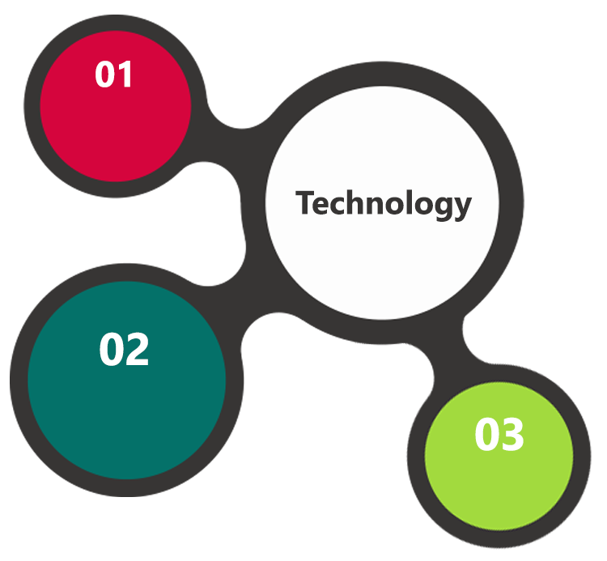

PHP, Code Ignitor

MySql, Apache

AJAX  
JavaScript  
CSS, HTML

The application will be developed using Microsoft technologies employing a mix of web services and a web interfaces. The admin portion of the application will be a web based application. The user portion of the application will be IOS/Android mobile phone application. The Mobile app shall sync with the web app.

## Technical Configuration

### Development Tools

* PHP, Code Igniter, CSS 3 , HTML 5
* MySQL
* Apache

### Browser Compatibility for Web Admin

* Chrome 56.0
* Firefox 51.0
* Internet Explorer 11

### Hardware Interface

The application is reliant on hardware interfaces to provide a seamless automated user experience.

* Computer with Windows 8 or 10 OS

# Delivery Management

## Project Management

The Verbat development center strictly follows industry standards on quality. The project management is process governed by the Verbat Quality Management system and is put to verification through internal audit programs that happen from time to time.

Verbat will dedicate a project manager for the proposed implementation. Verbat proposes Client to identify one project manager who will be driving activities to be undertaken by Client to be the single point of contact for Verbat.

## Roles and Responsibilities

Verbat will assign a dedicated Project Manager/Project Lead to lead the project, who will be the first point contact for Client. He/she will be responsible for planning and managing the various activities within the project. He/she will work closely with Client Project Manager, to give periodic status updates and ensure high level of visibility and comfort on the progress of the project.

The Project Manager/Project Lead will lead the co-ordination between Verbat and Client, thus enabling smooth transitioning of Client requirements to the Verbat’s offshore delivery team, and provide visibility as well as comfort on the progress of the services to Client.

He/she will have periodic meetings with Verbat’s Senior Management, thus ensuring Verbat’s Management commitment and focus on Client initiatives.

*Note: detailed qualification and experience of the persons involved in the project will be shared be finalizing the project on request*

## Phase Delivery Activity summary

|  |  |
| --- | --- |
| Activities | Description |
| Detailed requirement Analysis | Verbat team to conduct detailed study of requirement for the phase. If clarification is required, team will reach out to Client for more information and/or time for discussions. |
| Software Requirement Specification document (SRS) | Once the requirement analysis is completed, Verbat team will submit the SRS document for approval |
| UI/UX Design, Prototyping | Based on the SRS, Verbat UX/UI team will work on the UI/UX of the screens and submit a prototype for approval |
| Functional Specification Document (FS) | Once the Prototype. UI/UX is approved, Verbat shall submit an FS document for approval. |
| Development | Actual system development starts based on the FS. This involves detailed design and software development of Web Admin, API & iOS and Android mobile app. |
| Testing | Test Planning, test plan creations, internal, integration testing and user acceptance testing. |
| Deployment | Deploying the latest built in the Verbat Test Server. |

## Project Implementation plan

Verbat will be providing the solution in a phased approach which ensures minimum viable solution for quick wins with core focus on the long term business objective and outcome. Once the implementation of phase 1 is over, Verbat will initiate the application maintenance process which continues to extend after the implementation of successive phases.

## Deliverables

* Software Requirement Specification Document (SRS)
* Wire Frames for Key Screens
* Functional Specification Document (FS)
* Fully Developed & Tested Application
* Fully commented source code

## Release Planning

* Client will be informed about the release date and time through email.
* Client performs the UAT

## Risk and Contingency planning

Verbat has identified various risk factors associated with this assignment and understands the impact of these risk factors on the project schedules. The objective of this section is to highlight for both Verbat and client, the risk factors, to analyze the impact of the risks on project execution, and to propose strategies to control and reduce the impact of the risk factors.

These various risks, which could arise during the project, are tabulated below along with mitigation implementation.

| Type of risk | Impact | Risk Mitigation | Risk Handling |
| --- | --- | --- | --- |
| Scope Creep | H | Functions and features will be detailed in system requirement documents and will go through client approval. Once this document is approved, any change to requirement will go through change management review for possible impact assessment. | Proper change management procedure will be implemented. |
| Delay in customer feedback | H | The plan is prepared with enough lead-time for customer reviews and approvals.  The customer is indicated with the dates when the document is expected after review and approval. | The request for feedback will be escalated if not attended at the right time so that the schedules are not affected. Deemed acceptance criterion is set up front and will be followed. |
| Non-availability of necessary software’s, frameworks, database instances and infrastructure at client’s hosting environment(If hosting support is provided by Verbat) | M | Client will be informed in advance on these requirements. | Possible impact to schedule. |
| Manpower attrition | L | All efforts would be made to ensure process dependence rather than being person dependent. As a risk mitigation plan Verbat will train backups. | A new person will be identified as early as possible, provided the required project-specific training and mentored by the senior members of the team to minimise impact of attrition on the project. |

*H-High, M-Medium, L-Low, NA-Not Applicable*

# Change Management

Any addition which comes out of the project scope, upon and after the launch of the tool will be considered as change management. Verbat recommends the following change management procedure for the same.

* Any change which comes out of the project scope, which was discussed, documented, and mutually approved by both the parties in the requirement stage, will be carried out only through raising a change request.
* Change request will be studied and an impact analysis on the existing work flow will be performed.
* On finalizing the impact, effort estimation for the change will be calculated and raised as additional requirement.
* Verbat will initiate the change request only after getting a formal approval from the client for the additional changes raised.
* Any change from the scope will be charged at **AED 1200 per man day effort** and approval from the clients will be availed before commencing on any change management.

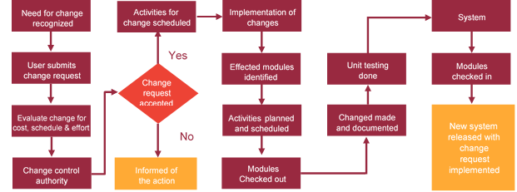

# Delivery TimeLine

The application prototypes will be developed in **1 weeks’** time. Upon the approval the prototype, applications shall be completed in **7 Weeks**

# Commercial overview

|  |  |  |
| --- | --- | --- |
| **Description** | | **Cost (USD)** |
| Web Application | USD XXX,XX.00 | |
| **Total** | | **$ X,XXXX.XX** |

# Miscellaneous

## Warranty

Verbat shall provide a bug ﬁx warranty at no additional cost for 30 days from the date of acceptance of the project, for correction of any errors in the developed application that may be attributed to Verbat.

However, this does not cover modifications by Client, or use of the application on an environment other than the proposed environment, or other circumstances outside Verbat’s reasonable control. In such a case Verbat reserves the right to charge for its services.

All error corrections will be executed at Verbat India office. In the event of any need for on-site work, all expenses incurred for such trips will be payable to Verbat by Client.

## Acceptance Criteria

* UAT sign off should happen within 14 Days from the release of each module/ Phase and the acceptance confirmation needs to be mailed to Verbat failing which Verbat will consider the project as approved by the client.
* Any comments or reason for rejection need to be documented and the same needs to be sent as an email from the official mail id of client to Verbat.

## General Terms and Conditions

* Offer Valid for 30 calendar days from the date of submission of the Proposal
* An average of 20 working days are assumed in a month
* This proposal and all technical/ functional specifications have been derived or concluded from the data shared via email / information's transferred during the initial requirement analysis meetings and conversations. Verbat reserves the right to amend the terms of this proposal, should the SOW terms, functional features and functionalities change during the course of the project
* The applications will be built as per the specifications agreed mutually. Any changes will be executed through a deﬁned change management process between both parties
* All Source Code and other project artefacts would adhere to the Verbat document templates and internal coding standards
* Acceptance criteria shall be based on the clauses which were mutually discussed between Verbat and client at the Requirement Analysis phase and the same will be documented and approved by both parties through official emails
* Final deployment to production server pursuant to completion of all payments

## Assumptions and Dependencies

* During the requirement gathering phase, authorized personnel from the Client’s side is expected to be available for discussion and finalizing the HLD (High Level Design), before development commences.
* Type of reports and formats, if under the scope of the project, needs to be specified by Client before project sign off.
* Workflows need to be specified/ confirmed by client before project signoff.
* All queries regarding the client requirement and any queries which may hinder the project advancement at any stage should be answered by the client within 24 hours from the time of initiation, failing which the time delay will get added to the actual effort which was estimated.
* Verbat assumes that all sign-offs from Client will be provided within agreed and specified timeframe.
* Client will provide all the necessary contents, both text and image, before starting the project in the format suggested by Verbat (if any).
* The client should provide the relevant information and data well in time for the execution of a related activity. Non- availability of this information or data may lead to an interruption of work which may result in a delay in delivery as well as additional costs to the client.

## Source Code & Intellectual Property Rights

* Upon completion of the Project and 100% completion of the payment, client will have access to the source code except for propriety codes, developer tools and third party application / modules like Microsoft Dynamics Products, Share Point LMS etc.
* The solution offered will be the intellectual property of the client and will be made available to the client on an “unlimited license” basis.
* Modifications by third party/person: No person or organization, other than Verbat or any person authorized by Verbat in writing, has any permission to modify/change the software Solution to be eligible to get continued support from Verbat as per the support terms defined under this document.
* Liabilities/Damages: Verbat accepts no liability or damages of any kind arising out of use or non-use of the software delivered. The responsibility of testing of software lies with Client.

# Our Clients

**UAE University**

Education

Transportation

**Canada Cartage**

Construction

Services

Finance

We look forward to hearing from you soon and hope that you will give us the privilege to work with you in meeting your business goals. Thank you.

Thank You



©   
1999 - 2017. All Rights Reserved   
Verbanet Technologies LLC  
www.verbat.com