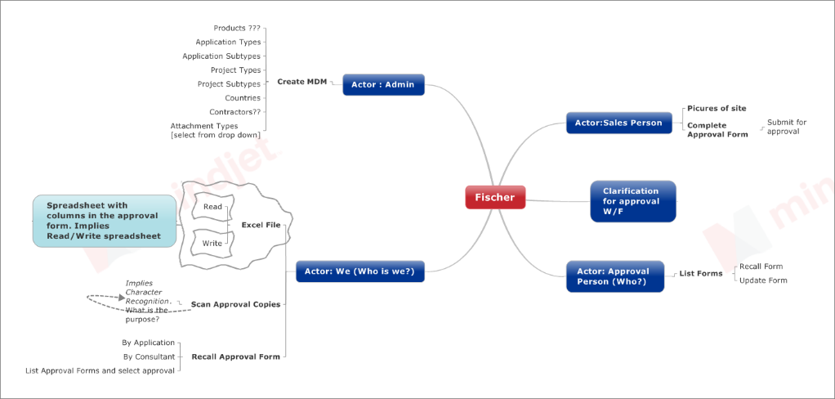

Please use the above image as a reference to estimating the effort. The details of the items listed below determines the overall effort in developing the application

Mobile App( user: Sales) : As per our understanding, this is a standard mobile application that will be used by the sales person. The effort is estimated to about a weeks’ time

In order to estimate the reminder of the work please provide the details below

1. Who are the actors in the system, aside from the sales person, who are the approvers, who are the other individuals to whom the approvals are shared?
2. Capture the high level workflow of the application from a back office perspective.
3. The “Approval Copy” AKA “Material Submitted” form has a list of attachments viz.
   1. Schedule of Items
   2. Reference drawings
   3. Manufacturer/Supplier Company Profile
   4. Technical Data Sheet / Catalogues
   5. Quality Certificates
   6. Other Certificates
   7. Previous approvals / Project Reference list
   8. Trade License

How are these attachments captured by the system? Are they related to the manufacturer, contractor, Suppliers, Consultants, supervisor consultants etc. and if so do they need to be stored (relationship realized in the app) against them?

1. Documents scanned for “Approval Copies”, are they stored for reference purposes. How is the data captured? (manual or automated)
2. Import/ Export of Excel spread sheets imply the reading and writing functionality of spreadsheets within the application. Is this the intended purpose? Please explain this with a use case?
3. What is the ideal application for back office functionality? If the application is strictly used in an office environment then our recommendation is to go for a windows application as it will be cheaper and faster to implement.
4. For Item 4 &5, would the spread sheet columns or data be mapped to the approval copy? If not please specify the data mapping
5. What is the purpose of the product data sheet? How is it related to the rest of the application? Would any of the items listed in the product data sheet, qualify for inclusion in the MDM?
6. What is the purpose of the different types of “Create submittal” (type 1 and Type 2) form?
7. For items 8 & 9 who are the actors involved and who are the forms being submitted to? Also a rough PDF format of the document would be needed (paper sketch will do)