**POS Objective**

The POS (Point of sale) system should automate the existing cash payment process, and provide one window solution to HAJT customers.

**POS Scope and Requirements**

The proposed software must be a Point-Of-Sales System that can effectively provide following mention requirements in a user-friendly way.

1. Hardware Requirements
2. Each PC must be connected to one POS machine. I.e. the POS connection must be establish in, one PC one POS machine format.
3. POS machine must be connected by LAN.
4. Refer “e-dirham POS RS232 Integration Specifications V 1.12” document for detailed hardware requirements.
5. Point-of-Sale Functional Requirements
6. The proposed POS System shall provide options for working offline as seamless as possible in the event of network outages, transaction times should not be impacted and all transactions must complete less than 5 seconds.
7. POS System shall automatically batch and settle payment transaction at the end of the day with no human interaction.
8. POS Units must be easily relocated from one counter to another counter
9. All POS transaction details should be stored in central database system (POS application database working as middleware).
10. POS system must export reports to an Excel spreadsheet or PDF, including variance reports that offer real-time and historical data
11. POS machine must display services details, total amount and BOE (Bill of entry) reference number, etc.
12. POS machine must print transaction receipts for Customer and Counter officer
13. All POS Transaction Termination Messages should be captured in centralized database for audit purposes. Please refer to 5.5 Transaction Termination Messages in “e-dirham POS RS232 Integration Specifications V 1.12”
14. POS Units: Data Network/Communication Requirements
15. POS System must be able to utilize Cat6 cable in an Ethernet configuration. All devices must be IP addressable using standard Ethernet topology.
16. POS Units must be networked to a central database, wherein each POS Unit communicates directly with the POS server.
17. All POS Units must operate independently, capable of running and storing data as a freestanding unit and shall meet below requirements:
    1. Must function in full operation with the POS server or network down.
    2. A single POS Unit failure must not affect any other POS Unit or its ability to communicate with the POS server
    3. POS Units must be able to process transactions with server down.
18. The POS system should follow similar .Net Architect:

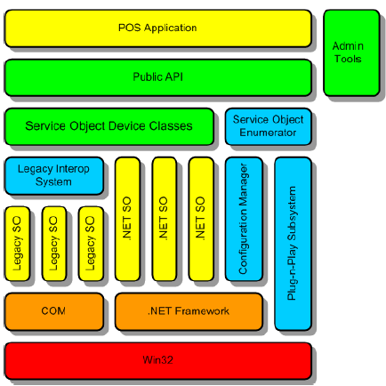

1. POS Unit: Environmental and Physical Requirements
2. All cabling must be concealed from view, and secured from tampering by cashier or customer.
3. POS Units must be mountable on the front counter.
4. Technical Requirements:

The POS system should cover following technical requirements:

* Capacity management
* System, network, and application monitoring
* Application updates
* DNS administration
* High availability environment
* Disaster recovery management
* Security
* Database backup utility

1. Integration Requirements
2. For integration requirements refer “e-dirham POS RS232 Integration Specifications V 1.12” document.

Document: 