

217, Sheik Rasheed Building, Hor Al Anz East, Dubai

www.verbat.com | uae@verbat.com

Tel: 00971 4 2973515 -301

|  |  |
| --- | --- |
| **Hutchinson Port Data Migration**  **Attn:**  Tel: 06 5026337 Email: [xxx@xxx.com](mailto:xxx@xxx.com) | **QUOTATION** |

|  |  |  |  |
| --- | --- | --- | --- |
| Quotation Date | Quotation No. | Contact Person | Contact No. |
| 25 07 2018 | Q/SW/MS/08112017/1556/1 | Ratheesh VS | 04 2973515-301 |

# Scope

Hutchinson Port requires the development of a data migration tool to read data from flat files and load it into their Operational Data Stores (ODS). A brief description of the work is detailed below

* Read data files form FTP server or Directory
* Validate data
* Insert data into Oracle Database (use SqlLoader tools)
* Write activity logs and move files to backup location
* The .dat file provided has the following properties
* The name of the file contains the target table along with the time stamp of file creation
* The first line of the file contains the header information
* The file is zipped and password protected (Password will be the same for all files)
* The utility shall be able to log all records that were rejected by the migration process. A selected user shall be able to view the data records that were rejected, correct them and push them back into the database.
* Activity Logs shall be maintained
* Files shall be moved to backup location once migration is completed
* Data Migration shall be a scheduled activity
* Ideally tools like Oracle’s SQLLoader shall be used to load the data coupled with a web interface that supports error correction, manual inserts after correction etc.

The solution steps are outlined below

* Unzip files in the shared network folder using password provided
* Scheduled job reads .dat files from a shared network folder
* Validate the file for errors
* Load the file in the target tables
* Log all errors
* Correct errors and reload data manually
* Move the files to a backup location after load

## High Level Workflow

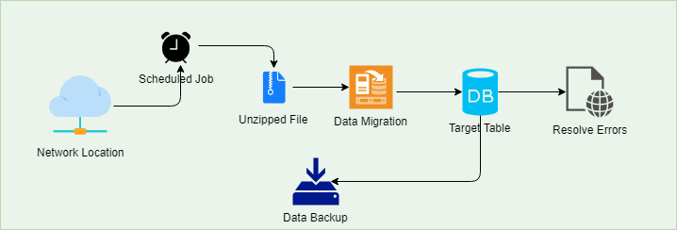

# Technology Used

* + MS Visual Studio
  + Microsoft .NET
  + Oracle Enterprise Suite, SqlLoader
  + JQuery / CSS / HTML 5

# Project Timeline

The time estimated for delivering the application is **18 working man days**

Effort: 37 man days.

Timeline: 37 UAE working days from the date of approval of quote and completion of necessary accounting

# Assumption

* The application will be a responsive web application
* Client shall provide access to the Oracle SQL Loader as well as the database tables responsible for migration

# Out of Scope

* Any functionality other than specified in the scope and features.
* Installation at the client’s location

**WITNESS WHEREOF** the parties hereto have executed this Agreement as of the date above written.

|  |  |
| --- | --- |
| **Customer:**  **Verbanet Technologies LLC** | **Contractor:** |
| Signature: | Signature: |
| Name: Deepthi Radha Krishna Title: Head – Middle East Business Date: | Name:  Title:   Date: |

# Terms & Conditions

* Offer Valid for 30 calendar days from the date of submission of the Quote
* **100 % Advance payment along with LPO**

|  |  |  |
| --- | --- | --- |
|  | Mode of Payment |  |

1. **By Cheque**: Should be in the name of **Verbanet Technologies LLC** and we will arrange our courier to collect the cheque from your office upon your request. (**This service avails to UAE Customers Only**).

1. **Pay by Direct Deposit** to the Bank Details given below

Bank Name: Emirates NBD  
Account Name: Verbanet Technologies LLC  
Account Number:   1011492858201  
Swift Code: EBILAEAD  
Bank Address: Mamzar Branch, Dubai

***Bank charges incurred during wire transfer to be borne by the client. Any local taxes applicable to be borne by the client.***

1. **Pay by Telegraphic Transfer** – Please transfer the FULL INVOICE VALUE to our Bank account (details above) paying both Beneficiary and Corresponding Bank transaction charges at your end, in-order for us to receive the full Invoice amount.
2. PLEASE DO REMEMBER TO FAX / EMAIL US THE BANK DEPOSIT SLIP, SO THE PAYMENT CREDITED CAN BE MARKED ACCORDINGLY.

* **The Receipt voucher will be emailed back to Client as soon as we receive the Payment**
* **Please note that we do not collect cash payment.**