

217, Sheik Rasheed Building, Hor Al Anz East, Dubai

www.verbat.com | uae@verbat.com

Tel: 00971 4 2973236

|  |  |
| --- | --- |
| **Emirates ID Integration for Jaheziya** |  |

|  |  |  |  |
| --- | --- | --- | --- |
| Quotation Date | Quotation No. | Contact Person | Contact No. |
|  |  |  |  |

# Emirates ID Integration - Feature List

# 

This application helps Jaheziya to capture the trainee details through the emirates ID scanning for booking them for different training programs. The features are as follows:

|  |
| --- |
| Registration Executive |
| * User logs into the application with predefined username and password * Client module will be a windows application that can be installed in Windows machine having OS, Windows 7 or above. * The module will use the API to list the training details like company name and trainee details. * The user can swipe the emirate card in the card reader connected to the windows machine. * The details in the card will be listed in the application. * User will be able to choose a particular trainee and submit to replace him with new user in the card. * If the user does choose any trainee the user will be added in the training as a new trainee. |

Assumptions

The proposed solution is based on the following assumptions

1. **Design:**

* Application supports only English language.

1. **Web Application:**

* Internet connectivity is required for the functioning of the application.
* The system should be enabled with windows 8 or above, Internet Explorer 11 and Active X functionalities
* Does not support offline access or operations

# Project Timeline

The effort estimated for delivering the application will be as below:

**10 Man Days**

### General Terms and Conditions

* All the documentation will be provided in English.
* Web Application will be best viewed only in the environment- Chrome version: 56, Firefox version: 51 and Edge version: 39

Annexure

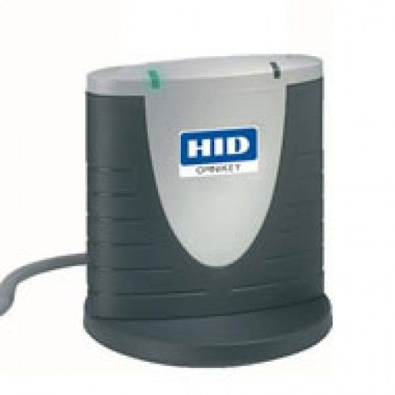

We look forward to hearing from you soon and hope that you will give us the privilege to work with you in meeting your business goals. Thank you.

Thank You



©   
1999 - 2018. All Rights Reserved   
Verbanet Technologies LLC  
www.verbat.com