

217, Sheik Rasheed Building, Hor Al Anz East, Dubai

www.verbat.com | uae@verbat.com

Tel: 00971 4 2973515 -301

|  |  |
| --- | --- |
| **Static Preference**  **Attn:**  Tel: 06 5026337 Email: [xxx@xxx.com](mailto:xxx@xxx.com) | **QUOTATION** |

|  |  |  |  |
| --- | --- | --- | --- |
| Quotation Date | Quotation No. | Contact Person | Contact No. |
| 09 Sept 2017 | Q/SW/MS/09112017/1556/1 | Ratheesh VS | 04 2973515-301 |

**Scope**

Client has requested Verbat to develop a Bi-lingual Windows based application that can capture information on Vehicle records. The application will have the following features

1. The application will have multiple screens to represent different forms that can capture information on vehicle records
2. The application will be windows executable that may be deployed on multiple desktops
3. The application shall be able to work offline without the need of an internet connection
4. Information saved from one desktop client shall be available on another desktop client
5. Application shall have designated users who shall have access to the system
6. Users shall be created by a super admin
7. Application shall be bi-lingual and the language can be toggled on screen
8. Data entry fields shall be free-form where needed
9. Users shall be able to lookup vehicle details, accident details etc.
10. Application shall be installed on client machines using a windows executable installation

The application forms that shall be developed are represented in the images below

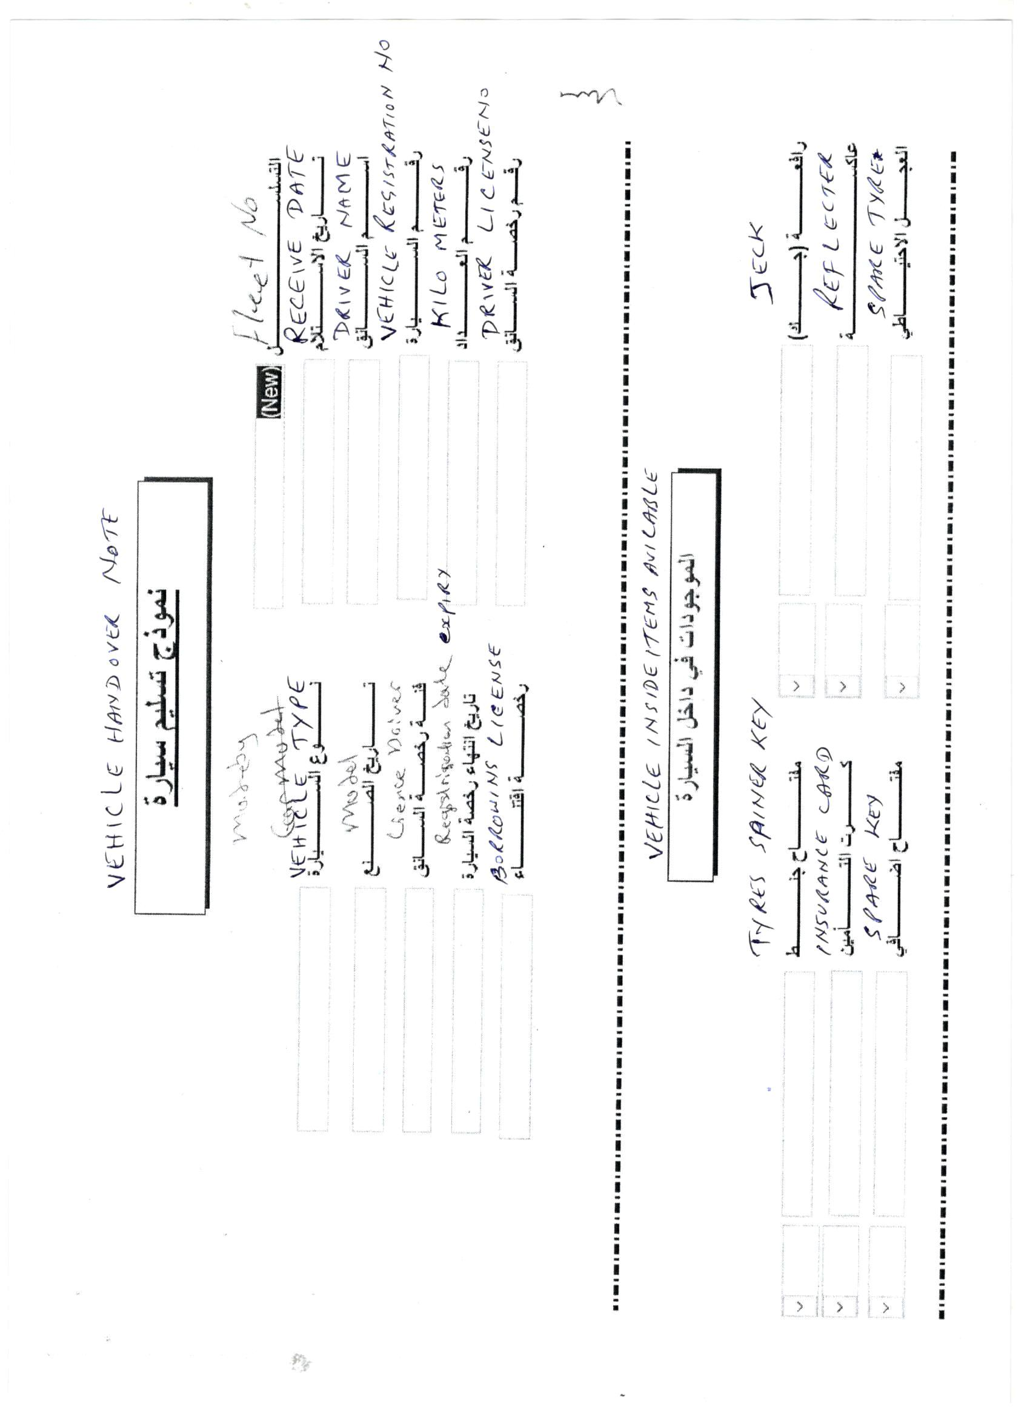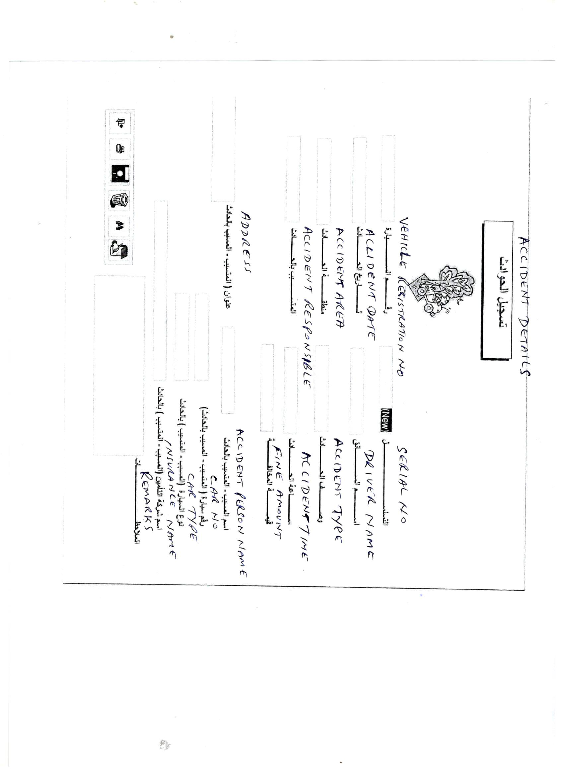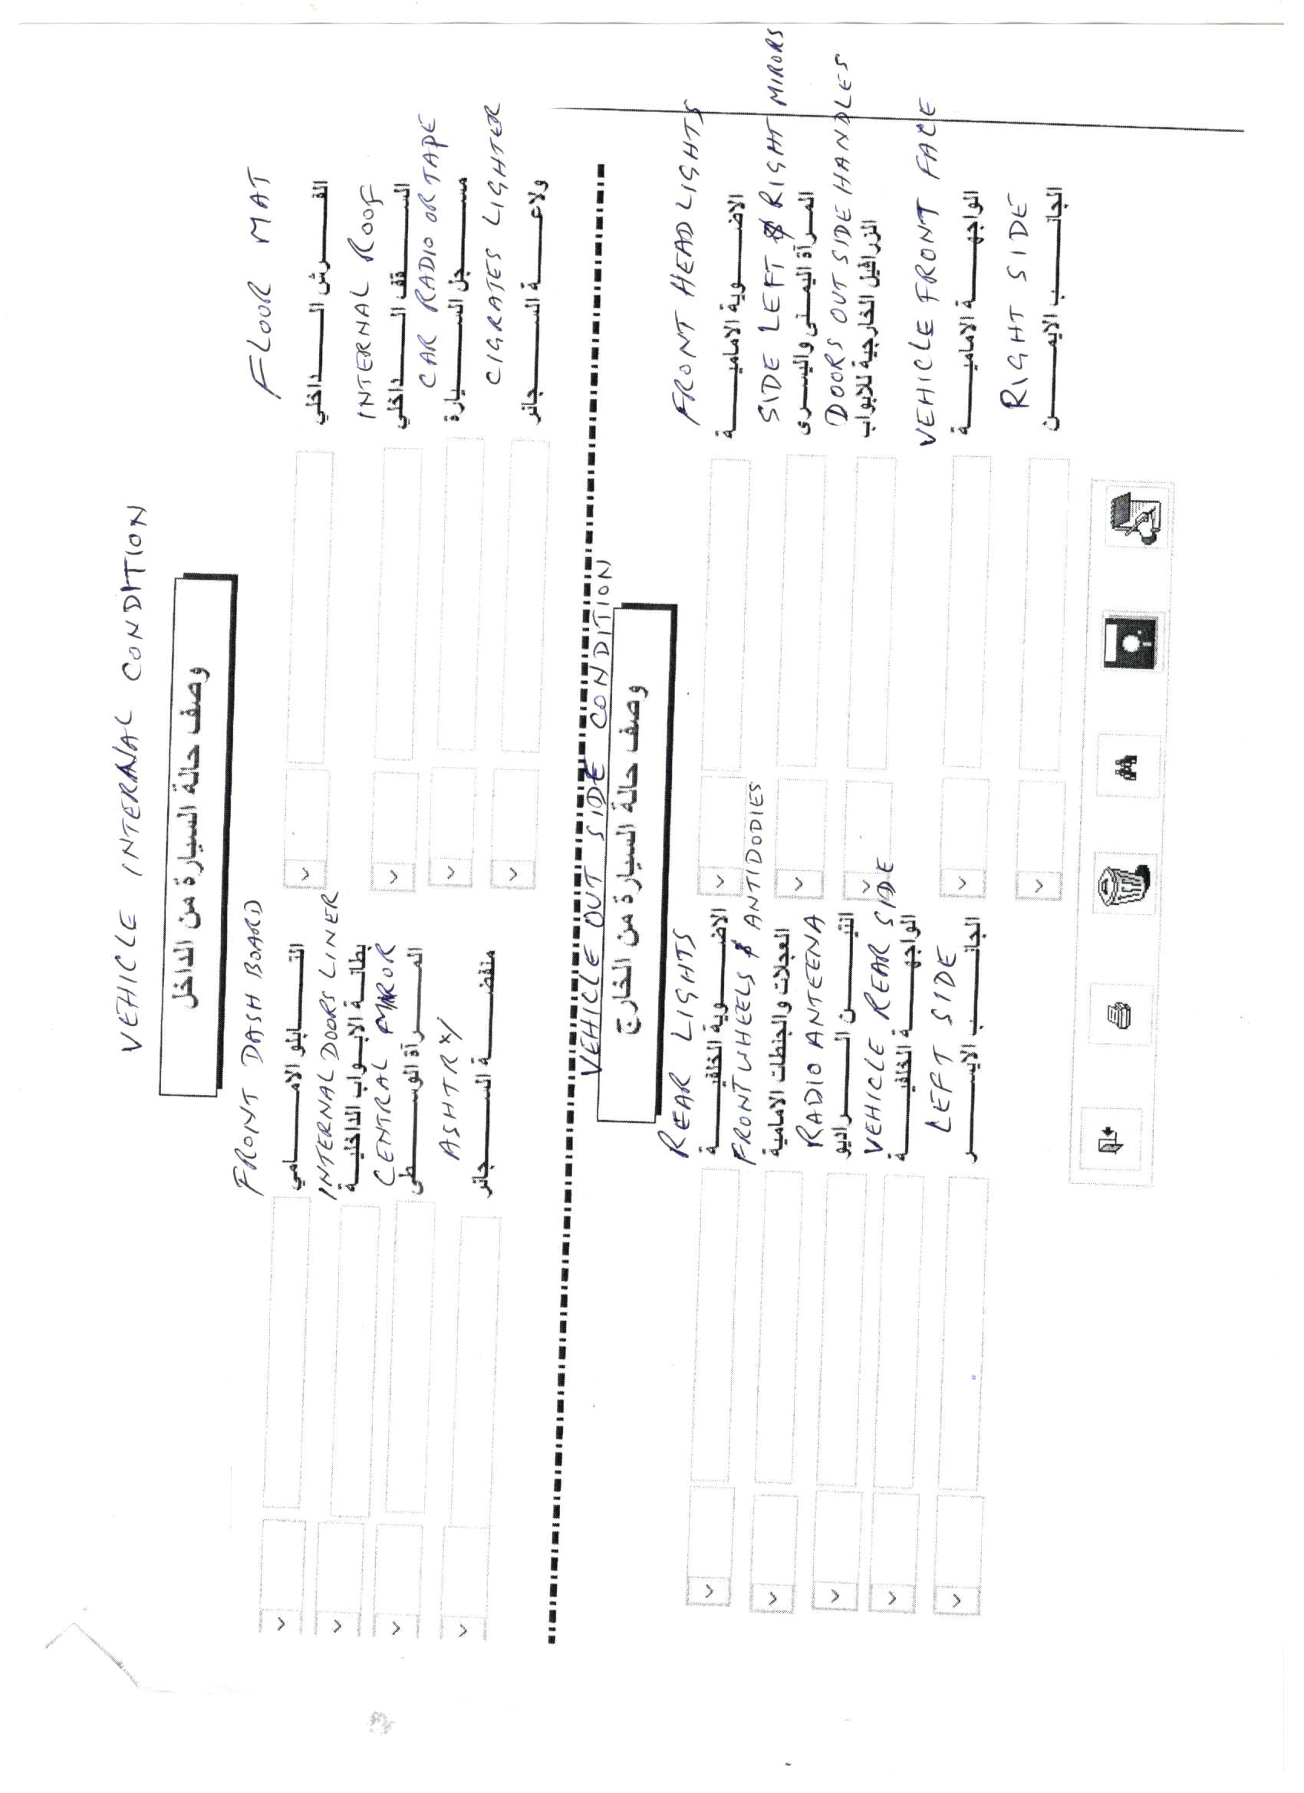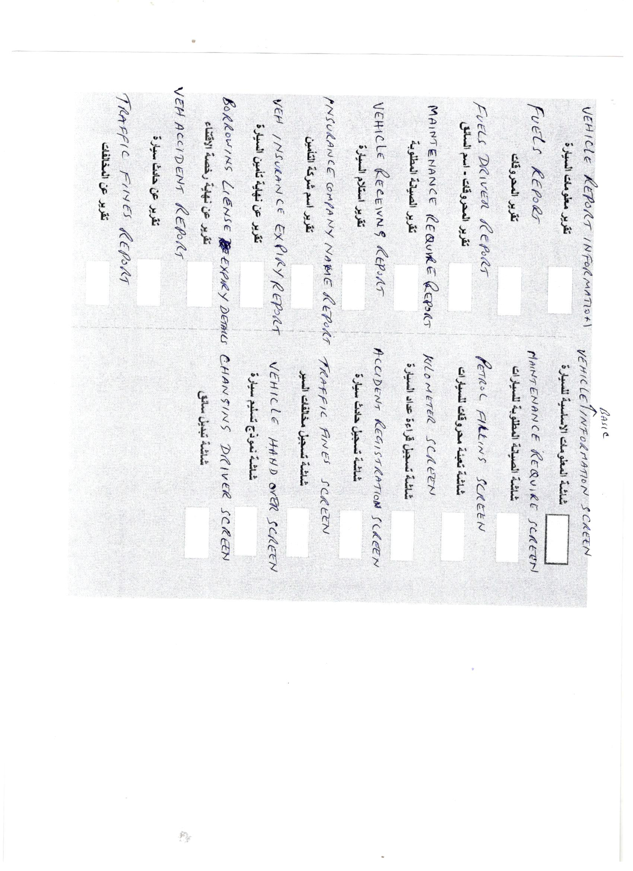

**Technology Used**

* + MS Visual Studio
  + Microsoft .NET/ Win Forms
  + MSSQL Server
  + JQuery / CSS / HTML 5

**Project Timeline**

The time estimated for delivering the application is **15 working man days**

Effort: 17 man days.

Timeline: 13 UAE working days from the date of approval of quote and completion of necessary accounting

**Assumption**

* The application will be a response web application
* The windows client machines shall be able to support the latest .net SDK and libraries
* The Client machine shall be able to access the local area network
* The client machine and the database server shall be in the same domain
* The client shall provide a MSSQL or MySQL database server with the latest edition of the database server installed
* Client machines shall be able to access the Database server using OLEDB, DSN’s or any other appropriate technology
* Client shall provide remote desktop access to the client desktops as well as the database server to install the application

**Out of Scope**

* Any functionality other than specified in the scope and features.
* Installation at the client’s location

**WITNESS WHEREOF** the parties hereto have executed this Agreement as of the date above written.

|  |  |
| --- | --- |
| **Customer:**  **Verbanet Technologies LLC** | **Contractor:** |
| Signature: | Signature: |
| Name: Deepthi Radha Krishna Title: Head – Middle East Business Date: | Name:  Title:   Date: |

# Terms & Conditions

* Offer Valid for 30 calendar days from the date of submission of the Quote
* **100 % Advance payment along with LPO**

|  |  |  |
| --- | --- | --- |
|  | Mode of Payment |  |

1. **By Cheque**: Should be in the name of **Verbanet Technologies LLC** and we will arrange our courier to collect the cheque from your office upon your request. (**This service avails to UAE Customers Only**).

1. **Pay by Direct Deposit** to the Bank Details given below

Bank Name: Emirates NBD  
Account Name: Verbanet Technologies LLC  
Account Number:   1011492858201  
Swift Code: EBILAEAD  
Bank Address: Mamzar Branch, Dubai

***Bank charges incurred during wire transfer to be borne by the client. Any local taxes applicable to be borne by the client.***

1. **Pay by Telegraphic Transfer** – Please transfer the FULL INVOICE VALUE to our Bank account (details above) paying both Beneficiary and Corresponding Bank transaction charges at your end, in-order for us to receive the full Invoice amount.
2. PLEASE DO REMEMBER TO FAX / EMAIL US THE BANK DEPOSIT SLIP, SO THE PAYMENT CREDITED CAN BE MARKED ACCORDINGLY.

* **The Receipt voucher will be emailed back to Client as soon as we receive the Payment**
* **Please note that we do not collect cash payment.**