# Background and Overview

Access to cabs has been disrupted by Uber and Ola. Commerce has been disrupted by marketplaces like Flipkart and Amazon. Lingerie has been disrupted by Zivame. How simple would it be if one could consult doctors online at the push of a button? But, can it be reliable? Can a previously unknown doctor really be able to solve health issues online and that too without seeing you?

Doctor-patient ratio in India is 1: 1,700 compared with 1: 1,000 suggested by World Health Organization (WHO). Britain has just 2.71 doctors per 1,000 people... which is fewer than Latvia, Estonia and Lithuania. In the U.S the ratio is 2.3 per 1000. India alone presents a $250 million opportunity for Online-healthcare services within the next three years while globally it is a $30 billion opportunity.

In most cases, specifically with regard to chronic medical conditions, multiple visits to doctors are not a necessity. The idea is not to substitute the hospital visit, but to supplement it. In the U.S, patients need to spend $300-400 for a follow-up visit to the doctor.

Online Medical Services is a virtual platform that brings doctors and patients together online in real time. Individuals can seek their advice online or consult with them over the phone and HD video if they have an urgent health concern that requires immediate consultation.

It allows users to communicate with doctors through text, voice and video from anywhere, anytime. People can get their health queries answered for free but, for a consultation from a doctor of their choice, they have to pay the consultation fee—determined by the specific doctor. Users can also book an appointment with the doctor of their choice, if they wish to visit the clinic.

***Irrespective of where one resides***, online medical consultations ***democratizes*** affordable healthcare options to large segments of the populations, which would otherwise have been unaffordable.

# Basic Business Model

The main business model behind Online Doctor consultation portal is explained below:

## Real time virtual consultations

* Users can make online appointments with doctors for a virtual consultation
* If the user is not sure which Doctor to set the appointment with, they may post questions about their needs. They will then be assigned to a practitioner by the Admin
* Once the Doctor is assigned to a patient, they can choose to have a virtual consultation via chat, audio or video (Services charges tiered based on the quality of interaction)
* Doctors may post their consultation charges on the website
* Clients can pay the fees online via payment processors

## Offline forum based consultations

* Users can post health related questions.
* Questions get assigned to doctors based on category of the question.
* High priority answers can be requested at a small fee
* All asked questions form a database which can be accessed by anyone.
* Follow up appointments with preferred doctors
* Setup generic appointments when the issue is not well known

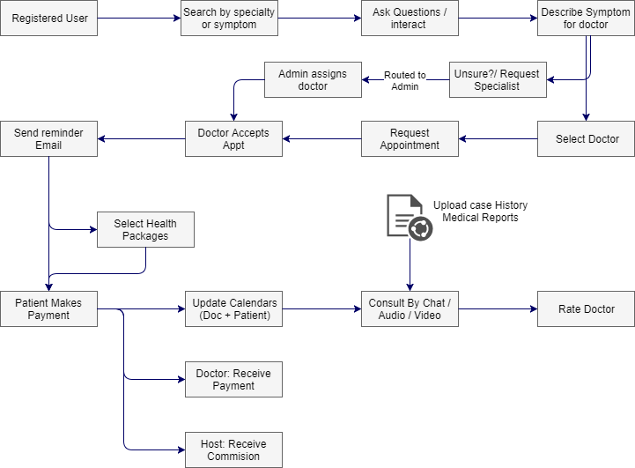

This unique business model offers different prospects for monetization.

# Revenue Generation Model

Growth of popular websites is driven by a solid revenue generation system. There are 2 types of revenue streams.

Google Adsense:

This method works brilliantly because every question asked by a user gets added in the database and is assigned a new page. More the number of pages, more the visibility of ads and more the revenue generated.

## Paid Ads or Advertisement Networks

Ad space can be sold to advertisement networks or dedicated space can be sold individually to insurance companies, hospitals, pharmacies, health networks etc.

## Paid services

### One-time Fee based consultation

Patients may consult with a doctor of their choosing by paying a one-time online fee. These fees may be tiered based on the quality of the interaction. For example chat vs. audio vs. video interactions

### Paid Questions:

This is another way to monetize doctor patient interaction. You can choose to charge small fee for quick answers or well-detailed answers.

The above two make smart revenue generation method which can easily be implemented. Keep the pricing low to get maximum paid answer queries.

### Tiered Consultation Packages

Patients can choose a monthly or tiered consultation packages which will provide cheaper services over a period of time.

# Other site features

## Homepage

The homepage will work best with simplicity. Reserve the top fold for sign-up and sign-in option along with a bar to ask question. Share impressive site numbers once you have built a user base. If you have partnered with experienced doctors, don’t hesitate to show their photo. Let’s dig deeper into homepage features:

## Sign-Up/Sign-In

Keep sign-in and sign-up separate. Make sure the forms are easy to fill and small in nature, Use field validation to help visitors fill the forms quickly.

## Sign Up as a Doctor

* Provision of admin approval for doctor accounts
* Education and experience verification process after initial sign up

## ‘Ask Questions’ / ‘Make Appointments’ functionality

The core functionality of the website is about asking questions and setting up appointments with doctors. So, you need to place the feature of posting question in the first fold of the website itself. Prominent features here are

* Make the question posting bar prominent
* Question category based on the medical field
* Option to add more details
* Recently Answered Questions

Give a clear idea of the type of questions posted and the answers given by doctors with recently answered and featured questions section on homepage. The option to up-vote answers and request edits can also be added to enhance answers.

## Footer Section

The footer section can contain links to different pages which include About Us, Blog, Contact, Legal Information and Careers. Also this space can be used for social media buttons and medical affiliations if any.

# Web Application Features and Functionality

The success of doctor consultation platforms lies in their ease of use. Certain impressive features have been listed below for your reference:

## The main players:

The main actors who will use the website and what features can be provided to each type.

### Guest visitors

* Can browse all questions and read through the answers.
* Can see the number of doctors online at a given time.
* Can access ‘ask a question’ page but cannot post a question.

### Registered Users (Patients)

* Can browse all questions on the website and read through the answers.
* Can see the number of patients and doctors online at a given time.
* Can post unlimited questions.
* Upload Case History, Medical reports
* Can pay the consultation to get an answer on priority basis.
* Can follow health topics for new questions posted in that topic.
* Have access to “My questions” within the account.
* Consult from anywhere 24/7, even when you are travelling
* Schedule multi-channel consultations with doctor of choice
* Make payments for services needed
* Upload case history medical history to the doctor being consulted
* Rate and comment on doctors service

Features for registered members have been explained in the upcoming section

### Registered Users (Doctors)

* Doctor accounts approval by the admin.
* Doctors can answer the questions.
* Number of questions answered is available for internal use.
* Respond to case history and medical reports with suggestions and expert advice
* Maintain a case history of patients with subscription packages
* Accept requests for consultations
* Receive payments for consultations
* Respond to patients ratings

### Admin

* Manages questions and answers.
* Manages registered members (Patients).
* Manages registered doctors.
* Can assign questions to doctors.
* Manages payments for priority questions
* Assign Doctors to patients
* Verify doctor credentials and trust worthiness

## Ask a Question Feature

Answering questions posted by users can be a major feature of the website as it generates page visits from casual users looking for generic advice. It should consist of the following

* A form for users to post their questions.
* An option to pay the fee to get answer on priority basis
* Rich accounts section
* Browse Question Answers (Database Section)
* A vast database of question and answers would generate more ad income through clicks.
* Provision should be made to add every question being asked by a user in the category chosen at the time of posting the question.

Other unique features could be:

* Intuitive arrangement of topics.
* Further categorization of questions in a particular topic based on Most Popular, Most Shared, etc.
* Linking of blog posts with questions
* Real time data sharing: Users love to engage with websites with an active audience. Sharing statistics on the number of doctors and patients who actively participate on the site acts as a motivational factor for a user to ask questions.
* Informative Blog powered by an easy to manage CMS as blogging increases the reach among targeted audience
* Powerful search: Question and Answer directory is a unique way to present the previously asked questions on the website. Auto-complete functionality can further enhance platforms search and appeal.
* UX focused design and navigation
* Android & IOS Mobile Apps to expedite communication between patients and doctors.
* Inclusion of local healthcare providers (hospitals, clinics, pharmacies, laboratories) to provide an extended network for additional services.

Doctor consultation platforms are based on a unique business model where the site pays doctors to answer questions posted by patients and in turn earns money from advertisements to compensate doctors. According to a survey, 44 million people in the USA do not have health insurance. This means there is a big set of people who would love to consult professional doctors for less.