

**TECHNICAL PROPOSAL:**

**WAREHOUSE MANAGEMENT SYSTEM**

**For: POM HOLDING LLC**

**Submitted by:**

Verbanet Technologies LLC  
27.07.20

**DIRECTORY.**

1 KEY DETAILS. 5

2 EXECUTIVE SUMMARY 6

2.1 PROPOSED SOLUTION MODEL 6

3 CONFIRMATION OF UNDERSTANDING 7

4 PROJECT REFERENCES 9

5 COMPANY PROFILE 12

5.1 Why Verbat 12

5.2 Strength and Diversity of our Capabilities 13

5.3 Key Differentiators 13

6 CONFIRMATION OF COMPLIANCE 14

7 REQUIREMENT IMPLEMENTATION 21

7.1 Warehouse Planning & Workforce Management 22

7.2 Warehouse Inbound Process 23

7.3 Inventory Management 23

7.4 Inventory Count 24

7.5 Internal Warehouse Workflow 24

7.6 Warehouse Outbound Process 25

7.7 User & Role Management 25

7.8 Mobile Application 25

7.9 Warehouse Activities 28

7.10 WAREHOUSE CONTROL SYSTEM 30

7.11 Feature functionality requested by application handling scenario 31

7.12 NON-FUNCTIONAL REQUIREMENT (OTHERS) 35

7.13 PROJECT ASSUMPTIONS 35

7.13.1 OBJECTIVE 35

7.13.2 DISCOVERY PHASE 35

7.13.3 DESIGN 36

7.13.4 DEVELOPMENT 36

7.14 OUT OF SCOPE 37

8 TECHNICAL ARHITECTURE 39

8.1 Minimum Viable Architecture (Default Implementation) 39

8.2 Optional Scalable Architecture (Reference) 40

8.3 Architecture Explanation 41

8.4 Network Topology 42

8.5 Release & Deployment Pipeline 43

8.6 Security Posture 44

8.7 Software Quality Assurance 45

9 PROJECT PLAN & PROJECT DELIVERY 46

9.1 PROJECT MANAGEMENT 46

9.2 ROLES & RESPONSIBILITIES 46

9.3 COMMUNICATION MANAGEMENT PLAN 46

9.4 SCOPE MANAGEMENT PLAN 48

9.5 CHANGE MANAGEMENT PROCESS 48

9.6 QUALITY MANAGEMENT PLAN 49

9.7 DELIVERY ACTIVITY SUMMARY 49

9.8 PROJECT IMPLEMENTATION PLAN 50

9.9 DELIVERABLES 50

9.9.1 IT Project Management Deliverables 50

9.9.2 Development Deliverables 50

9.10 ESTIMATED DELIVERY TIME 51

9.10.1 DISCOVERY PHASE 51

9.10.2 DEVELOPMENT TIMELINE 51

9.11 DEPLOYMENT DETAILS (AT CLIENT’S BEHEST) 53

9.12 RELEASE PLANNING 53

9.13 RISK CONTINGENCY PLANNING 53

9.14 TRAINING & KNOWLEDGE TRANSFER 54

10 TECHNICAL SPECIFICATION 55

10.1 DEVELOPMENT TOOLS 55

10.2 BROWSER COMPATABILITY 55

10.3 HARDWARE 55

11 ACCEPTANCE CRITERIA, WARRANTY & SUPPORT PLAN 56

11.1 ACCEPTANCE CRITERIA 56

11.2 APPLICATION WARRANTY 56

11.3 APPLICATION MAINTENANCE & SUPPORT 56

12 TERMS AND CONDITIONS 58

12.1 SOURCE CODE & INTELLECTUAL PROPERTY RIGHTS 58

12.2 GENERAL TERMS AND CONDITIONS 58

12.3 GENERAL ADMINISTRATIVE, TECHNICAL & FUNCTIONAL ASSUMPTIONS 59

13 ANNEXURE A: PROJECT REFERENCES 61

14 ANNEXURE B: VERBAT PROFILE 62

# KEY DETAILS.

**PROJECT NAME CLIENT**

Warehouse Management System POM Holding LLC

**CLIENT CONTACT CLIENT ADDRESS**

Carlos Gutierrez PO Box: 5351,

Carlos.Gutierrez@pom.ae Abu Dhabi, UAE,

C66 Building Mezzanine Floor,

Opposite Lulu Head Office,

Next to Al Mamoura Building

**PROPOSAL SUBMISSION PROPOSAL ID NO.**

27.07.20AD/BP/14072020/3424/2

**PROPOSAL VALID UNTIL ANTICIPATED START DATE**

26.08.20 TBD

**PROPOSAL SUBMITTED BY**

Simi Soosan Thomas

Verbanet Technologies LLC

Dubai, U.A.E

+971 4 297 3236

[simi.thomas@verbat.com](mailto:simi.thomas@verbat.com)

# EXECUTIVE SUMMARY

POM Holding LLC (hereafter referred to as “Client”) has approached Verbanet Technologies L.L.C., (hereafter referred under its trade / brand name as” Verbat”) to develop a Warehouse Management system in order to carry out the warehouse operations within the various warehouses of client. The objective of this proposal is to provide a brief on how Verbat aims to address this initiative in terms of a proposed solution approach towards the design, development and implementation of the solution.

Verbat is pleased to submit the proposal and values it as a great opportunity to have a long term & mutually beneficial association with the Client. Verbat has gone through the requirement and presents a Business Proposal for the requested system.

Verbat strongly recommends a discovery phase prior to the development phase.

## PROPOSED SOLUTION MODEL

**STAND- ALONE FIXED BID**

Verbat will be following a stand–alone fixed bid solution delivery model wherein a detailed discovery phase/system study will be conducted and post the discovery phase the required solution would be devised. If Verbat finds during the discovery phase that the actual requirements uncovered are different form the original, the same will be discussed with client and related efforts will be shared.

**KEY STRENGTHS OF OUR SOLUTION**

* Strong and Scalable platform accommodating to future enhancements
* A framework which acts as a solution accelerator with building blocks that can be re-used in the future for building new components and features.
* Our light weight framework used consumes fewer system resources thereby making the application perform faster.

# CONFIRMATION OF UNDERSTANDING

The scope of the requirement is to automate the current existing manual business process workflows of the warehouse operations within the various warehouses of client.

Below are the Business Processes and sub process of the Warehouse Operations to be automated:

* Warehouse Planning & Management
  + Warehouse Space Management
  + Warehouse Workforce Management
* Warehouse Inbound Workflow
  + Client Request for Client Location Pickup
  + Unloading / Receiving
  + Inventory Process
  + Storage / Location function
  + Inventory Posting to System
* Internal Warehouse Workflow
  + Inventory Reconciliation Procedure
  + Item Disposal Procedure
  + Internal Warehouse Transfer
* Warehouse Outbound Workflow
  + Client Request for Pickup from Warehouse
  + Loading and Dispatching
  + Inventory Posting to System
* WMS Reporting Management
  + Operational Reporting

And the roles of the different users that will need to interact with the solution are:

Operations Director

Warehouse Manager

Warehouse Supervisor

Database & Operations Supervisor

Inventory Database Administrator

Senior WH Assistant / WH Assistants

Office Assistant

Porters

Forklift Operators

Drivers

Administrative

Assistant

# PROJECT REFERENCES

**Client Name – Sharjah Commerce and Tourism Development Authority (Government of Sharjah)**

Project Name: Integrated Permit Issuance and Inspection Online System with SMS & Payment Gateway

Contract Type: Fixed Bid (association started in the year 2017. Contract ongoing)

Location: Sharjah, U.A.E

**Platform: Web, Mobile (IPAD)**

Established in 1996, the Sharjah Commerce and Tourism Development Authority (SCTDA) is tasked with promoting commercial and tourism activities in the emirate of Sharjah. Sharjah intends to provide a sustainable tourism product with a unique and distinct tourism experience in the desert areas of the emirate. This is geared towards attracting the interest of various tourism companies, specifically tour operators, to focus on Sharjah when organizing desert trips and desert adventures activities within these areas. Consequently, this would be beneficial to the tourism sector and will contribute further to Sharjah’s economy.

Hence, the Sharjah government decided to organize desert tourism activities through this project; the issuance of permits to all tour vehicles entering the desert areas of Sharjah for desert safari activities owned or operated by tour operators along with the day to day inspection tasks carried by inspectors who can issue fines and attach evidences for further actions.

**Workflows involved:**

* Tour operator company registration - approval and rejection by SCTDA
* Vehicle permit registration approval – approval and rejection by SCTDA
* Vehicle permit payment and sticker issuance
* Inspection of vehicles (registered and unregistered vehicles) and fine issuance- approval and rejection by SCTDA.
* Fine payment
* Company and vehicle cancellation.

During the registration of the companies and the vehicles, the tour operator should upload the **supporting documents (pdf/image).** The system will trigger **SMS and email** to the internal users and external users upon **approval/rejection of any workflow.**

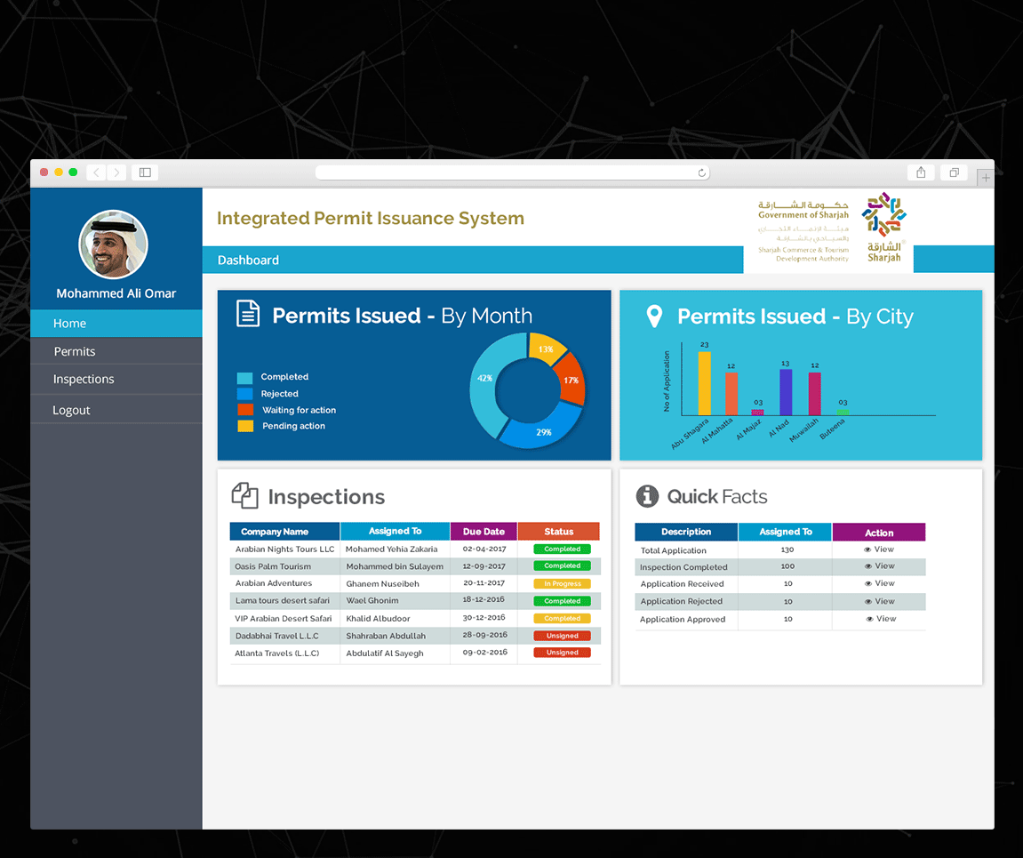

**Client Name – Rulers Representative Court (RRC)**

Project Name: Smart System

Contract Type: Fixed Bid (association started in the year 2018. Contract ongoing)

Location: Abu Dhabi, U.A.E

**Platform: Responsive Web.**

Verbat was assigned to develop a new Document Management and Archiving System titled Smart System. The SMART System offers an effective solution for RRC enterprises to manage activities like citizen’s affairs, protocol, support services etc. It enables internal users to log requests, approve and follow up until it completes the RRC document process cycle for the various day to day business operations. The Smart system app allows the client to submit documents using pre-designed templates and follow up on the status of petitions. It is a web application with mobile capability to facilitate the entire lifecycle of workflow activities related to document processing.

**Key application features:**

* Management of Internal Operations
* Correspondence Management
* HR Management
* Maintenance Management
* IT Support Management
* Citizen Affairs Management
* Memos Management
* Circulars Management
* Letters Management
* Meeting Scheduler
* Task Management
* Vehicle Management

The above modules include workflow management. (Approval & Rejection).

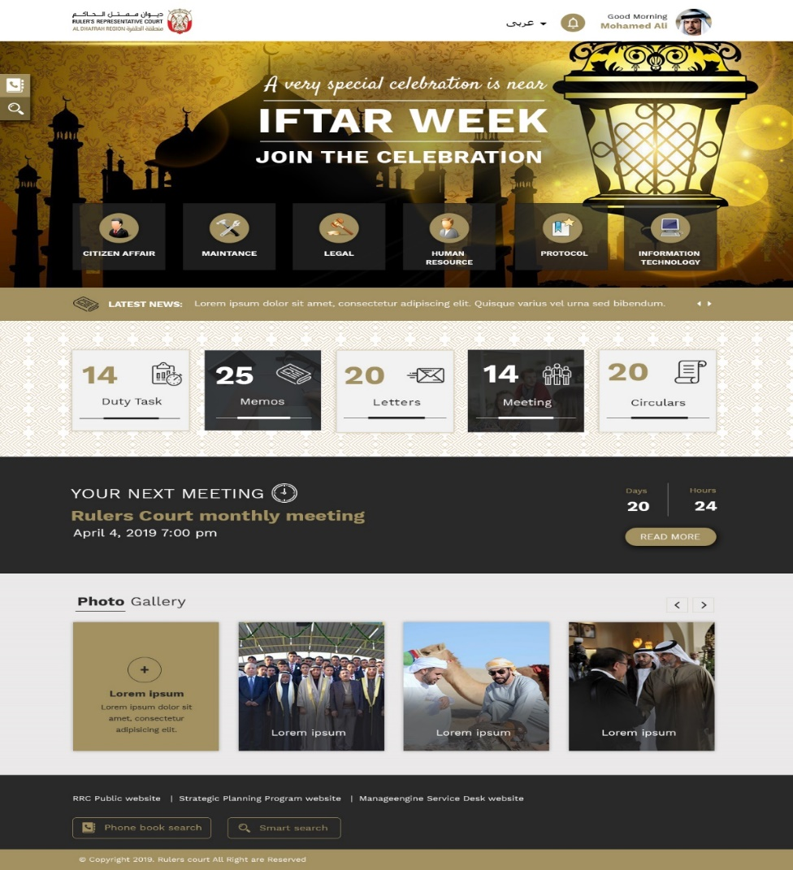

Note: For other project references, refer Annexure A.

# COMPANY PROFILE

## Why Verbat

With over 20+ years of experience in proving Digital Solutions to clients, we are committed to delivering world class solutions and exceptional client support on a local, regional and global scale. Our extensive portfolio of services spans every facet of digital solutions.

Our service portfolio includes Internet and Mobile Solutions to Enterprises, through Agile Development and Application Management methodologies. Application Development is an area where Verbat has in-depth knowledge and expertise. Being the pioneers in Web based solution across the major verticals, we are sure to help customers drive differentiation. We bring proven methodologies and processes, global expertise in application development, and a legacy of best practices & ready-to-fit frameworks to expedite the development cycle in order to reduce the total cost of ownership.

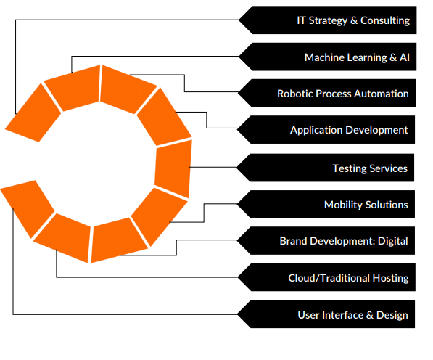

## Strength and Diversity of our Capabilities



## Key Differentiators

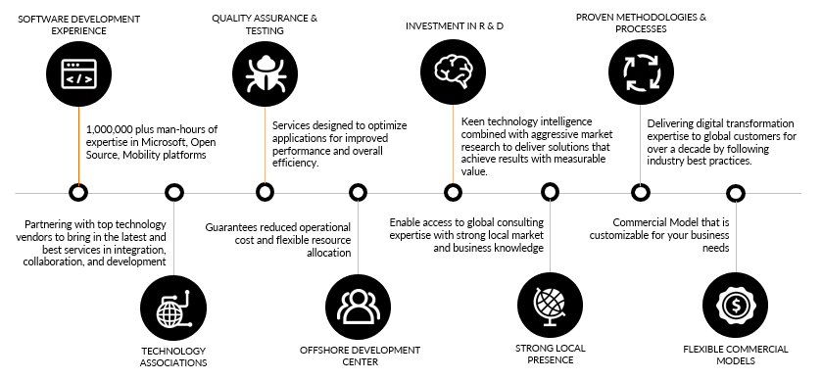

For more details related to Verbat Profile, refer Annexure B.

# CONFIRMATION OF COMPLIANCE

|  |  |  |
| --- | --- | --- |
| **Warehouse Planning & Workforce Management** | | |
| **Requirement** | **Compliance** | **Remarks** |
| The system shall be able to defining warehouses locations in a hierarchical manner (Country, Site,  warehouse, chamber, area, etc.) | Yes |  |
| The system shall allow the definition of items along with their attributes rules and put away zones, locations etc. | Yes |  |
| The system shall allow the definition of material categories and sub-categories and the specification of attribute rules per category, sub-category or material | Yes |  |
| The system shall allow the definition of suppliers, client, carriers, etc. | Yes |  |
| The system shall allow the definition of device groups | Yes |  |
| The system shall allow the assignment of locations, deliveries, issue requests, task request types, categories and sub-categories to mobile device groups. | Yes |  |
| The system shall allow the assignment of users to mobile device groups | Yes |  |
| The system will allow the configuration of users, groups, roles and permissions | Yes |  |
| The system shall be able to groups and assign the teams, such as:   * + Senior WH Assistant   + WH Assistants   + Warehouse Porters   + Drivers and Vehicle   + Forklift Operator and Equipment   + Office Assistant   for different tasks like Client’s Request, project request and reconciliation etc. | Yes |  |
| The system will allow the assignment, recording of time and full lifecycle management of tasks. | Yes |  |
| The system shall the filling out of daily checklists of Warehouse operations. | Yes |  |
| The system shall allow the maintenance of daily checklist of Forklift. | Yes |  |
| The system shall allow the maintenance of daily checklist of Vehicle. | Yes |  |
| The system shall allow the upload of all third party contractors’ documents and job completion reports. | Yes |  |
|  |  |  |
| **Warehouse Inbound Process** |  |  |
| **Requirement** | **Compliance** | **Remarks** |
| The system shall allow the recording of Inbound Requests from clients. | Yes |  |
| The system will allow Inventory Staff to take HD Photos of each item and also allow editing them. | Yes |  |
| The system will allow barcode labelling for all items. | Yes |  |
| The system will allow the creation of Delivery Notes against inbound orders and check-in through the system | Yes |  |
| The system will allow the reception of incoming items against delivery notes or inbound requests directly through any mobile, desktop or handheld device. | Yes |  |
| The system will allow the moving, put away and pick of items to and from the warehouse locations through  the usage of Mobile Application on barcode readable handheld devices and through the workstation application on Laptop. | Yes |  |
| Upon reception of a new item, an App will allow users to apply proper validations and barcode and receive  materials against pre-defined delivery orders or purchase orders. | yes |  |
| The App will ensure that users capture vital tracking such as …  - Item Description  - Item Dimension in Centimetres  - Quantity  - Weight  - Units  - Inner Packages  - Package Details  - Pack/Case Number  - Pack/Case Dimension (in Centimetres) (LxWxH)  - Pallet Number  - Pallet Dimension (in Centimetres) (LxWxH)  - Item Category  - Item Sub Category  - Item attributes  - Brand Name  - Owner Code  - Date Received  - Requisition number  - Requisition Date and Time  - Requested date/Time of delivery  - IGP # (Inbound Gate Pass)  - OGP # (Outbound Gate Pass)  - Client’s Location  - Project Name  - Location Inside Client’s Place  - Room Allocation  - Warehouse Site Name  - Sub Store Name  - Sub Store Number  - Rack Name  - Item Location (Bin Number)  - Item Condition  - Item Condition Details  - Client's Special Comments  - Status of Disposal  - Item Pick up & Delivery Status  - Other Remarks | yes |  |
| The system shall allow in the put away of Items based on a predefined strategy. | yes |  |
| The system shall allow the configuration of multiple put away strategies per Item. | yes |  |
| The system shall allow the reception of items based on an Inbound Request. | yes |  |
| The system shall allow to define items storage allocation rule (As per client inventory level). | Yes |  |
| The system shall support Blind Receiving process. | Yes |  |
| The system will enable the approval of any inbound shipment and of attached documentation | Yes |  |

|  |  |  |
| --- | --- | --- |
| **Internal Warehouse Workflow** | | |
| **Requirement** | **Compliance** | **Remarks** |
| The system shall allow the approval of inbound and outbound Inventory. | yes |  |
| The system shall allow the approval intra-Warehouse Transfers. | yes |  |
| The system shall allow the approval Warehouse-to-Warehouse Transfers. | yes |  |
| The system shall allow the edit and entering of data corrections as per physical check result. | yes |  |
| The system will be able to create, modify and track items by item unique code and include at minimum the  following information:  - Item Description  - Item Dimension in CM  - Quantity  - Units  - Inner Packages  - Package Details  - Pack/Case Number  - Pack/Case Dimension (in centimetres) (LxWxH)  - Pallet Number  - Pallet Dimension (in centimetres) (LxWxH)  - Item Category  - Item Sub Category  - Item Attributes  - Brand Name  - Owner Code  - Date Received  - Requisition number  - Requisition Date and Time  - Requested date/Time of delivery  - IGP # (Inbound Gate Pass)  - OGP # (Outbound Gate Pass)  - Client’s Location  - Project Name  - Location Inside Client’s Place  - Room Allocation  - Warehouse Site Name  - Sub Store Name  - Sub Store Number  - Rack Name  - Item Location (Bin Number)  - Item Condition  - Item Condition Details  - Client's Special Comments  - Status of Disposal  - Item Pick up & Delivery Status  - Other Remarks | ys |  |
| The system / App will allow the uploading and editing of HD photos (main product photo and damage photos) and photos to make 3D/360 preview. |  |  |
| The system shall be able to allow definition of dynamic attributes. |  |  |
| The system shall help in the counting of the occupied space on rack in CBM (Cubic Meters). | yes |  |
| The system shall help in conducting Cycle Count on the spot. | yes |  |
| The App will allow to perform a full physical count through hand held device for an area, zone or store using 2 or more separate teams. | yes |  |
| The system will allow to compare the results of physical counts from 2 teams and identify any discrepancies | yes |  |
| The system shall help in conducting full physical inventory. | yes |  |
| The system shall allow the in and out tracking of loaned items. | yes |  |
| The system shall allow the picking, reserving and shipping of items. | yes |  |
| The system shall allow the real-time inventory visibility. | yes |  |
| The system shall provide storage location visibility down to the Bin, Pallet, and carton. | yes |  |
| The system shall allow the utilization of Case ID, Pallet ID, and Rack ID to track all products. | yes |  |
| The app shall allow the printing of barcode labels of the items.  - Bar-coded labels can be designed by user in system.  - Bar-coded labels can be printed automatically from the App and Desktop version on user request. | yes |  |
| The system shall allow the relocation of items within the same warehouse or from other Warehouse. | yes |  |
| The system shall allow to track and monitor overall data entry and operation processes status in system. | yes |  |
| The system shall allow to data reconciliation and correction. | yes |  |
|  |  |  |
| **Warehouse Outbound Workflow** |  |  |
| **Requirement** | **Compliance** | **Remarks** |
| The system will allow the user to execute the picking tasks created against Outbound Requests, where the  picking tasks represent the items to be issued, required quantities, lots and storage location. | yes |  |
| The system will allow the creation of Outbound Requests. | yes |  |
| The system will allow to load items based on Outbound requests. | yes |  |
| The system will facilitate that picking items from racks for outbound requests | yes |  |
| The system will enable the approval of any outbound shipment and attached documentation | yes |  |
| The system will facilitate the PPE and packing material request and consumption. | yes |  |
| System will enable recording of complete Travel Log of vehicles. | yes |  |
| The system will assist in ensuring that deliveries are reaching the correct location and being accepted by the right person. This module should allow the recipient of item to accept the goods and sign directly on the mobile device provided to delivery drivers. This should be uploaded into the system associated with the correct delivery and kept in the transaction records of the item. | yes |  |
| The system shall manage returns to warehouse and to clients (to identify the barcode label if it is removed  at client’s location) | yes |  |

|  |  |  |
| --- | --- | --- |
| **Operational Reporting** | | |
| **Requirement** | **Compliance** | **Remarks** |
| The Warehouse Supervisor and Database Supervisor and Inventory Data Administrator will view all the  reports including the Inventory as per the level of access granted to view reports | yes |  |
| The system will allow the generation of flexible reporting and KPIs. | yes |  |
| * Inventory Summary by Category. * Inventory Summary by Sub Category. * Inventory Summary by Item Description. * Inventory Summary by Client & Inventory by Client (Detailed) * Inventory Warehouse Site-wise Report. * Inventory Warehouse Sub Store-wise Report * Location / Rack Number-wise Report. | yes |  |
| * Item Status of Disposal Report. * Client’s Comment-wise Report. * Photo Gallery’s Report with required details on photo. (Client wise, Category wise, Sub Category, Brand * Name, Room Allocation, etc.) * Inventory Register Visibility * Inventory Register by Condition * Full Inventory Register * Available Inventory * Item Number-Wise Report. (For Inbound & Outbound Items) * Date Received Wise Report * Inventory Deliveries (Complete Outbound items Report) * Transaction Summary (Inbound and outbound) * Inventory Comparison report * Physical Count Reports * Checked items Report User-Wise. * Item Brand-wise Report * Item Origin-wise Report * Property Room Allocation wise Report. * Allocated Staffs work request report. * Project Reports. * Client wise Storage report. * Other flexible Reports. * The system shall be able to export reports to Excel, PDF, Email...etc. * The system shall allow the configurations of alerts based on events in reports’ data | yes |  |

# REQUIREMENT IMPLEMENTATION

The main features and functionalities of the application to be developed are presented below:

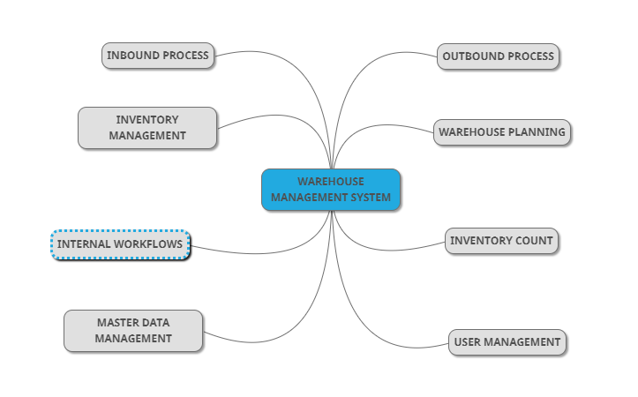

## Warehouse Planning & Workforce Management

* Define warehouses locations based on hierarchy (Country, Site, warehouse, chamber, area, etc.)
* Define items along with their attributes rules and put away zones, locations etc
* Define material categories & sub-categories & specification of attribute rules per category, sub-category or material
* Define suppliers, client, carriers, etc.
* Define device groups
* Assignment of locations, deliveries, issue requests, task request types, categories and sub-categories to mobile device groups.
* Assignment of users to mobile device groups
* Configuration of users, groups, roles and permissions
* Group and assign the teams for different tasks like Client’s Request, project request and reconciliation etc.
  + Senior WH Assistant
  + WH Assistants
  + Warehouse Porters
  + Drivers and Vehicle
  + Forklift Operator and Equipment
  + Office Assistant
* Assignment, recording of time and full lifecycle management of tasks.
* Filling out of daily checklists of Warehouse operations.
* Maintain forklift & vehicle details
* Upload of all third party contractors’ documents and job completion reports.

## Warehouse Inbound Process

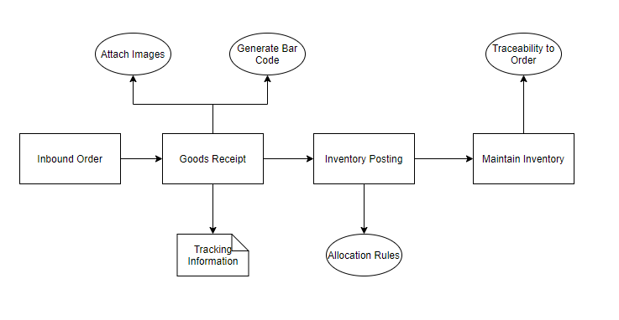

* Recording of Inbound Requests from clients.
* Perform Goods Receipt against Inbound Orders
  + Generate bar code for item and order information
  + Upload HD images to Goods receipt
* Inspection of received goods
* Receipt Validation against Order
* Inventory Posting
* Warehouse / storage allocation strategy based on item group/ customer etc.
* Storage Limits and inventory level management
* Order information management for tracking and reports
* Traceability of inventory
* Blind Receipts for services / cost items

## Inventory Management

* Traceability of all items to order / receipt
* Picking, reserving and shipping of items.
* Real-time inventory visibility.
* Provide storage location visibility down to the Bin, Pallet, and carton
* Utilization of Case ID, Pallet ID, and Rack ID to track all products
* Identification through barcode labels of the items.
* Relocation of items within the same warehouse or from other Warehouse.
* Track and monitor overall data entry and operation processes status in system
* Data reconciliation and correction.
* Tracking of loaned items.

## Inventory Count

* Full physical count of inventory
* Cycle count functionality
* Inventory count split into multi teams and reconciliation
* Consolidation of counting results
* Variance Analysis
* Final Inventory Report
* Inventory Correction

## Internal Warehouse Workflow

* Inbound Order, Good receipt and Inventory put away
* Outbound request, goods issue, Inventory pick and Pack order
* Inventory Corrections
* Inventory Disposal Process
* Transfer of inventory within warehouse
* Warehouse to warehouse transfer of inventory

## Warehouse Outbound Process

* Creation of Outbound Requests.
* Goods Issue against outbound requests.
* Identify & Locate inventory for picking task
* Approve any outbound shipment and attached documentation
* Facilitate the PPE and packing material request and consumption.
* Travel Log of vehicles.
* Update delivery details in Order transaction log
* Manage returns to warehouse with barcode traceability

## User & Role Management

Various Roles in the system are

* Warehouse Supervisor
* Warehouse Assistant/Senior Warehouse Assistant
* Porter
* Forklift Operator
* Driver
* Inventory Database Administrator
* Database Administrator /Supervisor
* Reports & Approvals User (Managers, Directors, Assistant )

## Mobile Application

* Porter
* Receive notification on new request (once warehouse supervisor assigns team for operation)
* Pack Order
* Search inventory item
* Delivery Note and customer confirmation
* Verification of issued inventory
* Warehouse Supervisor
* Receive new inbound client requests
* Assign operation team to respective order
* Dashboard
* Warehouse Assistant/Senior Warehouse Assistant
* Receive new requests (once Warehouse Supervisor assigns team for operation)
* Assign storage location for inventory
* Verify inventory of item (quantity, weight, dimensions, Condition and brand name (if any))
* Upload photograph of item received and photo edit
* Generate barcode label
* Maintain Inventory reports
* Locate item on system assigned location
* Checks physically items quantity. Package Details. Item Condition and designated Location comparing with inventory data sheet.
* Inventory transfer (intra & WH-WH)
* Dashboard
* Forklift Operator
* Receive new requests (once warehouse supervisor assigns team for operation)
* Locate item
* Confirm picking and put away
* Inventory transfer (intra & WH-WH)
* Dashboard
* Driver
* Receive new requests (once warehouse supervisor assigns team for operation)
* Confirmation on delivery note
* Dashboard
* Inventory database Administrator
* Receive new request
* Verify inventory request
* Assign item category and post on system
* Updates Item details in the system if any changes.
* Segregating item with Client comment.
* Prepare IDF (Item Disposal Form)
* Retrieves the item and location details from the system.
* Transfers and updates items to assigned warehouse
* Updates outbound inventory in the system
* Approves & verifies all inbound Inventory.
* Dashboard
* Database Supervisor
* Receive Outbound client Requests
* Approves and verifies inbound inventory
* Generates inventory data sheets rack-wise.
* Segregating item with Client comment.
* Preparing IDF (Item Disposal Form)
* Submit IDF to the client representative
* Assigning Warehouse as per Client.
* Dashboard

Generic Note:

* Warehouse workers will login to the system via Active Directory credentials.
* For other users, can login to system using the predefined username and password, and upon login they will be prompted to reset the password.
* The application will have web and mobile application (IOS and Android) to manage the WMS. The scope of the application against the user type shall be defined during the discovery phase.

## Warehouse Activities

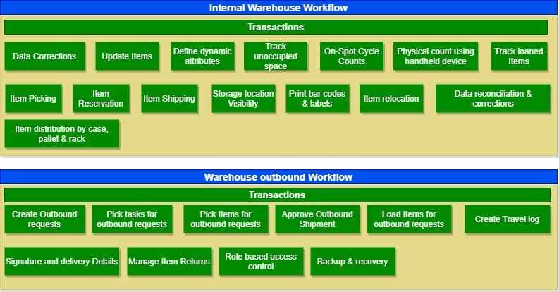

*Note:*

* *This feature mentioned above have been derived and concluded from the initial requirements shared in RFI which had very minimal information about features and functionalities. If Verbat finds during the requirement gathering/discovery phase that the actual requirements (features and functionalities) uncovered are different from what has been assumed, this might affect the estimates provided and Verbat shall exercise rights to renege on the contract. Clarifications/Changes in the scope during system study/ analysis may call in for additional effort.*
* *Documentation submitted after project initiation and system study supersedes any proposal or documentation submitted during initial requirement gathering / discussion / negotiation.*
* *Verbat shall provide a comprehensive plan for the entire project post the system study indicating the Cost & Timeline.*

## WAREHOUSE CONTROL SYSTEM

The Warehouse Control System (WCS) serves as a mediating IoT layer between the WMS and the material handling equipment operating on the warehouse floor. WMS will send a pick or put away list which is processed by the WCS. The WCS which is status aware of each machine then allocates the job to the appropriate machine (including route optimization and task interleaving features). The WCS instructions are sent to the Smart glass or VMT (vehicle mounted terminal) worn by each operator

**Efficiencies**

* Reduces empty trips and machine idling by a minimum of 30 %
* Measurable trip and machine utilization
* Task interleaving brings min of 15 % reduction in equipment trips
* Facilitates semi-autonomous and autonomous machine operation of warehouse equipment (if guidance system available on machine )
* Smart glass will replace handhelds / vehicle mounted terminals used for connectivity

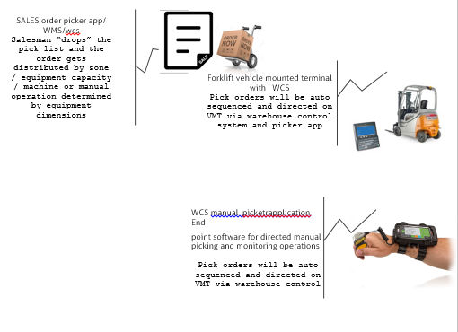

## Feature functionality requested by application handling scenario

|  |  |
| --- | --- |
| Scenario | Description |
| Assign task to warehouse team for inbound outbound service requests and projects’ requests etc. | WCS is a central task orchestrator software, that aggregates warehouse and inventory jobs, sequences , schedules and dispatches these tasks to appropriate end point i.e HHT on a picker , VMT on a forklift or dispatch unit on a delivery vehicle .  The WCS aggregates , schedules, sequences assigns to appropriate unit and finally monitors execution of the task and uploads task updates to the transaction processing system . |
| Device: use WMS on IPad, Laptop or other suitable devices recommended by the IT vendor. | The application is built on Node.js, the most lightweight and superfast application development platform, Node.js is hardware neutral, it runs on IOS, Android, Windows and Linux with no additional interfaces. Gives organization to pick and choose from any family or price point of devices |
| **W1. Warehouse Planning & Management**  *W1.1 Warehouse Space Management* | The WCS comes with a default spatial warehouse utilization map. To this you can add rules by zones , location stuffing % and replenishment rules which works in tandem or by exception to allow for Management by exception ( |
| *W1.2 Warehouse Workforce Management* | The WCS picker application is a central task assignment control and monitoring app and helps in managing warehouse personnel via rule based task assignments and management by exception rules |
| Warehouse Processes and workflows   * I1. Warehouse Inbound Workflow * *I1.1 Client Request for Client Location Pickup* * *I1.2 Unloading / Receiving* * *I1.3 Inventory Process* * *I1.4 Storage / Location function* * *I1.5 Inventory Posting to System* * T1. Internal Warehouse Workflow * *T1.1 Inventory Reconciliation Procedure* * *T1.2 Item Disposal Procedure* * *T1.3 Internal Warehouse Transfer* * O1. Warehouse Outbound Workflow * *O1.1 Client Request for Pickup from Warehouse* * *O1.2 Loading and Dispatching* * *O1.3 Inventory Posting to System*,   Performing item inventory inside the client’s location and other jobs as instructed by clients. | The WCS sits as an upper application layer on the transaction modules, it concerns itself with all transaction requests, scheduling and sequencing, and finally monitoring the execution of task and updating appropriate.  From past customer experiences , we have seen a minimum 20 % performance improvement by just implementing the following components:  1.WCS core scheduler / order aggregator and scheduler  2. WCS order picker on HHT and VMT  3. Dispatch and delivery planner app  For route planning and delivery sequencing , route optimization and Proof of Delivery (POD)and real time control room dashboard updated |
| Third party contractors’ documents: Uploading and archiving of third party contractors’ documents in WMS  including job completion reports. | Provide in the dispatch app portal intranet feature. This is for delivery tracking , document management and handling customer interactions via intranet portal /webservice |
| Delivery orders: when items are delivered from one client location to another or suppliers deliver items to warehouse for final delivery to client location or we pick up items from supplier’s location, taking fine quality photos from WMS hand-held device and directly deliver to client location. | Standard feature in the delivery and dispatch system |

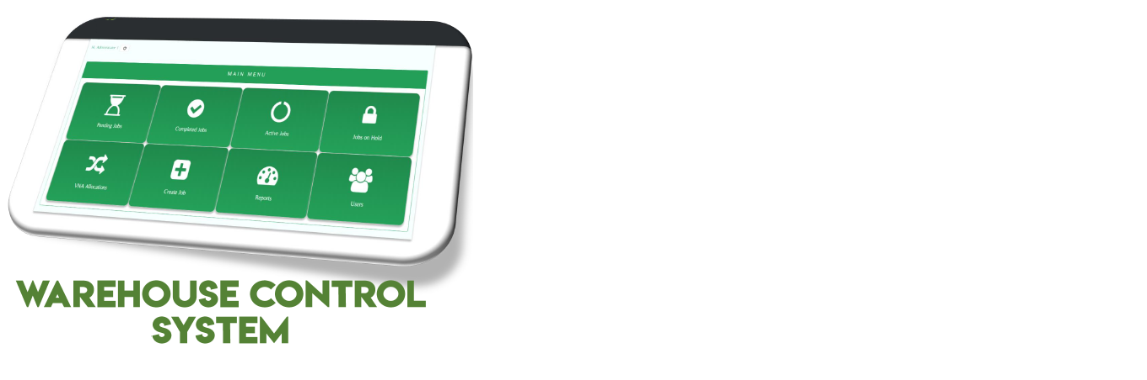

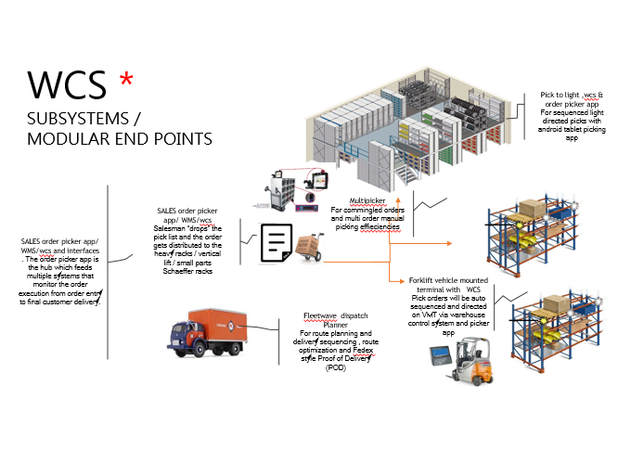

**Vuzix Smart Glasses**



**Vehicle mounted Terminal**

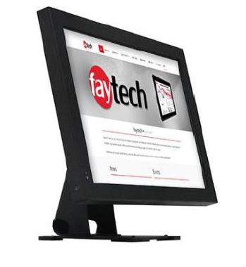

## NON-FUNCTIONAL REQUIREMENT (OTHERS)

|  |  |
| --- | --- |
| **Requirements** | **Details** |
| User Experience and  UI Design | * The application will be developed in English * The layout and graphical components will be created considering the usability factors |
| Performance | * Application will allow users to have smooth and quick access to the information or services required. |
| Security | * Web security standards will be followed ( as per Verbat Standards) |

## PROJECT ASSUMPTIONS

The project solution and technology is created from the initial understanding of the requirement shared with Verbat through RFI. The proposed solution is based on the following assumptions:

### OBJECTIVE

* The requirement is to develop a Warehouse Management System with the functionalities as defined in ‘Functional Requirements’ section

### DISCOVERY PHASE

* During the discovery phase, authorized personnel (project owners, system users, stakeholders) from the Client’s side are expected to be available for discussions and finalization of the requirements.
* Type of reports, formats, workflow if under the scope of the project, need to be specified/defined by the Client clearly.

### DESIGN

* Client to provide Verbat with the branding guidelines.
* Client shall provide the text and associated images for the proposed application. Text should be provided in digital format preferably in MS Word 2013 or above. Client shall provide licensed images and logos in specified size & format requested by Verbat.
* Verbat is free to use custom-made template for design, if required.
* The client will finalize the Business Requirement Document (BRD) document submitted post the discovery phase before the commencement of the design phase.

### DEVELOPMENT

* The development will be initiated post the completion of discovery phase and confirmation of prototype.
* The proposed application front end and backend will be in English.
* Development is contingent upon timely feedback from client.
* The client will finalize the functional requirements and UI/UX/Prototype before the commencement of the development of the project
* Requirements should be well defined, agreed and signed-off by the Client
* Report and work flow will be discussed in detail during discovery phase
* Security, Technical Architecture and Hosting Specifications will be discussed and finalized during discovery phase.
* Supporting OS- As mentioned under “Technical Configurations”
* Client will procure the mobile devices and shall share with Verbat for testing purposes.
* Client will provide all necessary support and access for Active Directory Integration.
* Client will procure templates, SSL certificates, SMS gateway and email gateway details (if applicable).
* Necessary API’s (if any) and documentations shall be provided by client.
* Data entry in the live application will be the responsibility of the client.
* Client will provide sample data to test the application
* Client shall provide clear directions on additional business process which may not be covered in this proposal. In such cases, the effort estimated provided in this proposal may be amended.
* The web site shall not be tested for IE browser.
* Verbat shall provide Functionality Testing
* All the infrastructure, services and support components need to be provided by the client during the execution of the project.
* Client will host and manage the application on infrastructure recommended by Verbat for managing database and application backup.
* All necessary plugins/licenses/tools needs to be procured/subscribed by the client
* The proposed application is a bespoke software and no licenses are applicable. However, the licenses required for the third-party software like SQL and any other third-party licenses will be out of Verbat Scope.
* Necessary software licenses will be procured by the client if hosted on client server (On premise). Any other hardware/licenses/plugins required to complete this project (if any) will be procured by the client.
* Application and data backups needs to be managed by the client
* Mobile Application elements or design cannot be modified once the app is deployed
* Does not support offline access or operations
* Internet connectivity is required for the functioning of the web & mobile application. The application requires a fast internet connection for real time communication.

## OUT OF SCOPE

With the ever evolving digital market, the requirement should be clear to both the parties involved, hence the importance of mentioning the out of scope details of the project. Following are considered to be out of scope while creating this proposal:

* Purchase of copyrighted images, fonts – if required by client
* Any language other than English
* Migration of existing data / Database migration
* Detailed Audit Trail
* Content writing / proof reading / Data Replication / Manual data entry
* Content or image procurement or uploading or editing
* Test Cases, Load Testing, Stress Testing, Performance Testing, Security Testing, End User Testing, Penetration Testing, Regression Testing
* BI tools integration or reports generation engine
* Application Analytics
* Voice commands
* Filling forms using voice
* 3D/360 preview of images
* Landscape mode and Offline accessibility of the Mobile application.
* Adding new features to the application other than mentioned in the functional requirements. Such requests will be handled via change management. For Change management details, please refer to section titled “Change Management” in the Proposal.
* Annual Maintenance Contract (Bug fixing, debugging, enhancements) – Please refer section titled “Maintenance and Support”, unless contracted for.
* Hosting Infrastructure and Maintenance (*web and email hosting including Exchange server set up)*
* Deployment in client server/ Physical deployment on-site / installation of the application in devices and physical connection, installation of system
* Integration with third-party, if any.
* Documentations and Deliverables other than mentioned under “Deliverables”.
* Backup solution and Disaster recovery, Data management, Data retention policies, failover and high availability.
* Hardware Integrations / procurement and purchase
* Procurement of SMS gateway / payment gateway / email gateway
* Integration of payment gateway
* SSL Purchase and installation, if any
* Relevant / related software libraries/Plugin/template purchases, if any
* Purchase of any tools/plugins/other resources/hardware required to perform any of the activities other than what is explicitly mentioned in this proposal

# TECHNICAL ARHITECTURE

## Minimum Viable Architecture (Default Implementation)

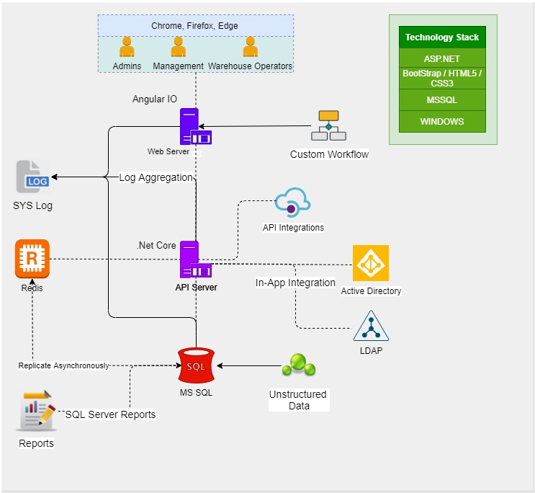

## Optional Scalable Architecture (Reference)

The minimum viable architecture can be upgraded to the scalable architecture

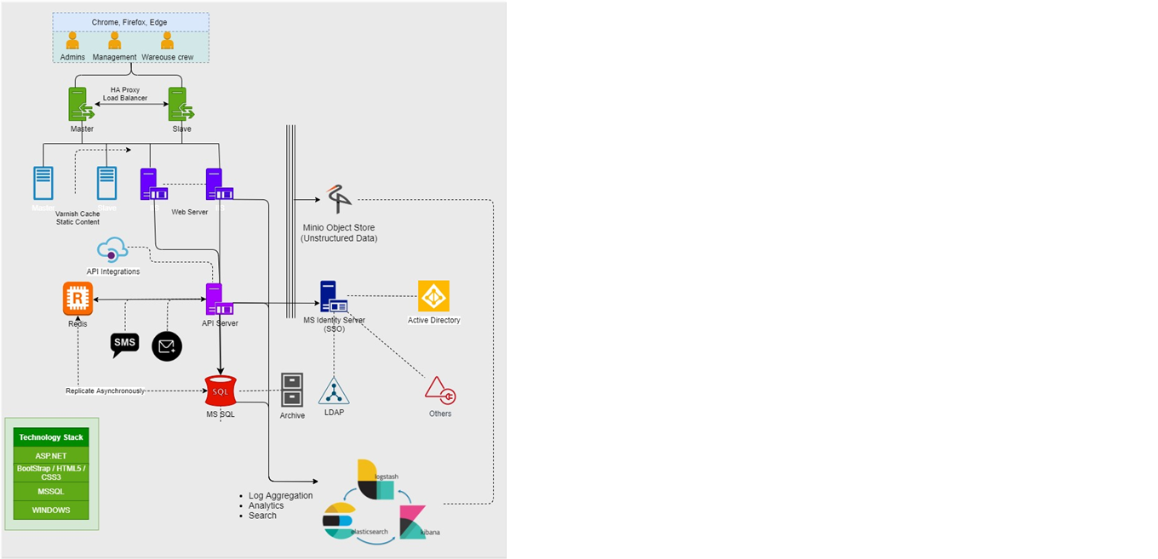

## Architecture Explanation

## Network Topology

## Release & Deployment Pipeline

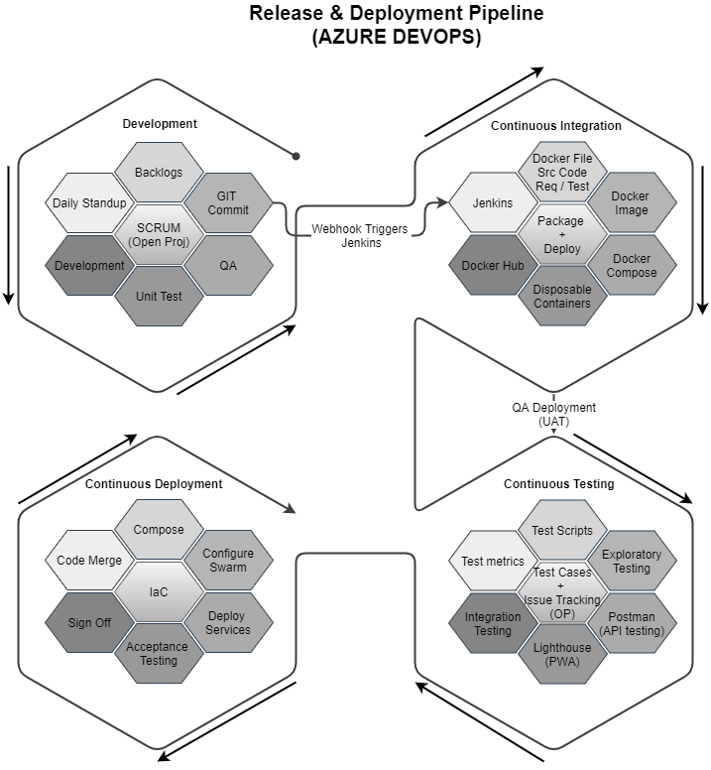

## Security Posture

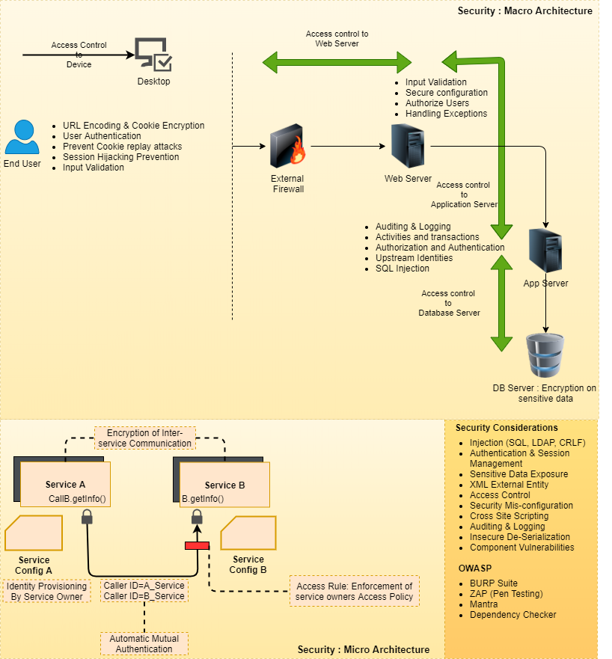

## Software Quality Assurance

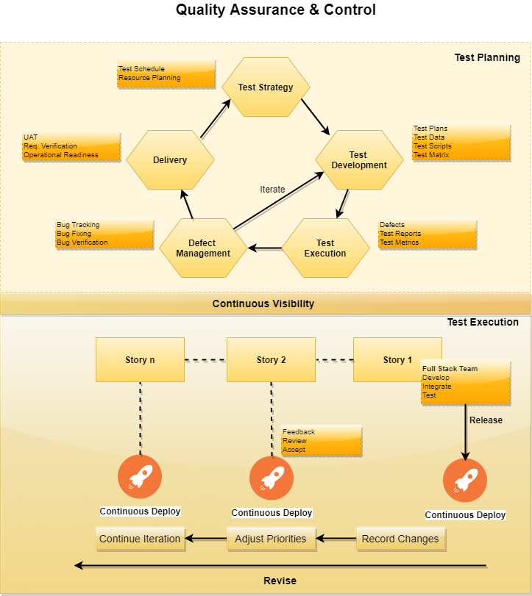

*\*The diagrams and pictorial representations depicted under section 4 are only for illustrative purposes and are not a part of the estimated effort (cost & timeline) of the project. The architecture and other processes for the proposed scope of work shall be discussed and confirmed during detailed system study.*

# PROJECT PLAN & PROJECT DELIVERY

## PROJECT MANAGEMENT

The Verbat development center strictly follows industry standards on quality. Our project management process is governed by the Verbat Quality Management system and is verified through internal audit programs.

Verbat will dedicate a project leader for the proposed implementation. Furthermore, Verbat proposes the client to identify one project manager (CSPM – Client-Side Project Manager) who will be driving all activities undertaken by the client, and will be the single point of contact for Verbat.

## ROLES & RESPONSIBILITIES

Verbat will assign its own dedicated Project Lead (*VPL – Verbat Project Lead*) for the client. The VPL will be responsible for planning and management of all activities related to the project. Furthermore, the VPL will work closely with CSPM, on all periodic status updates and will ensure high level visibility and comfort on the progress of the project.

*Note: Detailed CVs of project team shall be provided upon the awarding of the project.*

## COMMUNICATION MANAGEMENT PLAN

This Communications Management Plan sets the communications framework for this project. It will serve as a guide for communications throughout the life of the project and will be updated as communication requirements change. This plan identifies and defines the roles of team members as they pertain to communications. It also includes a communications matrix which maps the communication requirements of this project, and communication conduct for meetings and other forms of communication.

The Project Manager will take the lead role in ensuring effective communications on this project. The communications requirements are documented in the Communications Matrix below. The Communications Matrix will be used as the guide for what information to communicate, who is to do the communicating, when to communicate it, and to whom to communicate.

|  |  |  |  |  |  |  |
| --- | --- | --- | --- | --- | --- | --- |
| **#** | **Meeting** | **Format** | **Frequency** | **Owner** | **Distribution** | **Escalation** |
| 1 | Weekly Status Update | Email | Once a week | Verbat PM | All project team members and major stakeholders | Project Head |
| 2 | Action Items Follow-up | Conference call & Email | Once in 2 weeks | Verbat PM / technical team | Respective stakeholders | Project Head |
| 3 | Steering Committee update meeting | Formal meeting | Monthly | Verbat / Client PM | Steering Committee | Project Head |

**Communications Conduct:**

**Meetings:**

The Project Manager will initiate a meeting request at least 2 days prior to any scheduled meeting. It is imperative that all participants arrive to each meeting on time.

**Email:**

All email pertaining to the Project should be professional, free of errors, and provide brief communication. Email should be distributed to the correct project participants in accordance with the communication matrix. All attachments should be in one of the organization’s standard software suite programs and adhere to established company formats. If the email is to bring an issue forward then it should discuss what the issue is, provide a brief background on the issue, and provide a recommendation to correct the issue. The Project Manager should be included on any email pertaining to the Project.

**Informal Communications:**

While informal communication is a part of every project and is necessary for successful project completion, any issues, concerns, or updates that arise from informal discussion between team members must be communicated to the Project Manager so the appropriate action may be taken.

## SCOPE MANAGEMENT PLAN

Project Scope Management process are as follows:

1. Collect and Freeze Requirements – this first step is the process by which we define and document the requirements needed to meet all project objectives. Verbat will be collecting the requirements during the discovery phase after project initiation.
2. Control Scope – this is the process of monitoring/controlling the project/product scope as well as managing any changes in the scope baseline. It is the responsibility of the Project Manager to prevent scope creep and any deviation from the finalized scope will be subject to change management procedures. Refer section titled “Change Management” for change management plan.

## CHANGE MANAGEMENT PROCESS

Any addition which comes out of the project scope, upon and after the launch of the application will be considered as change management. Verbat recommends the following change management procedure for the same:

* Changes will be implemented only after raising a change request.
* Change requests will be studied and an impact analysis will be performed on the existing work flow.
* Upon assessment of the impact, effort estimation will be calculated and raised as an additional requirement.
* The change request will be initiated only after receiving a formal approval from the client for the additional changes raised.
* Changes which are out of scope will be charged at per man day rate. *(refer financial proposal)*

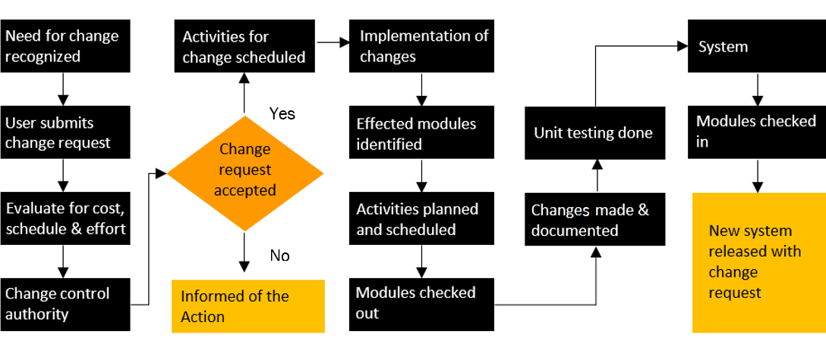

## QUALITY MANAGEMENT PLAN

The Verbat development center strictly follows industry standards on quality. Our project management process is governed by the Verbat Quality Management system and is verified through internal audit programs.

The Quality Assurance activities are involved in all the stages of our Software development Life Cycle where product defects are reported by Verbat QA team, tracked fixed and retested until the product reaches to the Quality Standards set by the QA center.

## DELIVERY ACTIVITY SUMMARY

|  |  |
| --- | --- |
| Activities | Description |
| **Discovery Phase** |  |
| Detailed requirement Analysis/Discovery Phase | Verbat team to conduct detailed study of requirement for the application development. Verbat will conduct workshops, meetings with the client. |
| Business Requirement Document (BRD) | Once the requirement analysis/discovery phase is completed, Verbat team will submit the BRD document for approval |
| **Development Phase** |  |
| UI/UX Design, Prototyping | Based on the BRD, Verbat UX/UI team will work on the UI/UX of the screens and submit for approval |
| DB Design | DB design for central and test DB. |
| Development | Actual system development starts based on the approval of UI/UX/prototype. This involves detailed design and software development of the Application. |
| Testing | Test Planning, test plan creations, internal, integration testing and user acceptance testing. |
| Deployment | Deploying the latest built in Verbat Test Server. |

## PROJECT IMPLEMENTATION PLAN

Verbat will be providing the solution in a stand-alone fixed bid approach which ensures minimum viable solution for quick wins with core focus on the long-term business objective and outcome. Once the implementation is over, Verbat will initiate the application maintenance process (once the maintenance contract is signed) which continues to extend after the implementation.

## DELIVERABLES

### IT Project Management Deliverables

* Project Plan
* Change Management Plan
* Minutes of meetings (MOM)
* Project change requests
* Project Closure document.

### Development Deliverables

* Business Requirement Specification Document (BRD)
* Technical Requirement Specification Document
* Solution Architecture Specification
* Prototype/UI/UX [ Technical Design Document]
* Test Plan and Text Execution Report
* SysAdmin Manual
* Fully developed & tested application
* Source code (if applicable)
* Deployment procedure

## ESTIMATED DELIVERY TIME

### DISCOVERY PHASE

The timeline estimated for discovery phase of the application will be as below:

* X working days for the discovery from the date of approval of project along with LPO and advance payment

| **Activity** |
| --- |
| Contract Signoff (T0) |
| Project Initiation & Initiating requirement gathering |
| Business Requirement Document(BRD) |
| BRD Approval (T1) |

### DEVELOPMENT TIMELINE

The timeline estimated for development of the application will be as below:

* X months from for the development of the application from the date of approval of BRD and prototype

Note: Actual timeline shall be shared post the discovery phase and based on the development option selected.

| **Activity** |
| --- |
| BRD Signoff (T0) |
| System UI/UX-Complete |
| System UI/UX-Approval (T1) |
| Development Phase-Complete |
| Perform QC (Unit Testing and Integration Testing) |
| System ready for UAT |
| UAT Acceptance on Test server (T2) |

*Note:*

* *The above-mentioned timeline is in UAE Working Days*
* *Discovery Phase*
  + *The initiation of the discovery phase is dependent on the confirmation of the project along with LPO, signed proposal and advance payment related to Discovery Phase.*
  + *During the discovery phase, authorized personnel from the Client’s side are expected to be available for discussions and finalization of the requirements.*
  + *Type of reports, formats, workflow if under the scope of the project, need to be specified/defined by the Client.*
* *Development Phase:*
  + *The initiation of the UI/UX development is dependent on the confirmation of the BRD*
  + *The above mentioned timeline for development is post the confirmation of Prototype.*
  + *Any ‘Change Request’ from client, post the initiation of development which will impact existing approved features will be considered as a separate phase.*
  + *Documentation submitted after project initiation and system study supersedes any proposal or documentation submitted during initial requirement gathering / discussion / negotiation*
  + *Project plan will be submitted post the confirmation of project with necessary payments*
  + *The above timeline is based on the initial understanding of the requirement grounded on the details shared by client via RFP. The estimated timeline may be revisited post the discovery phase. i.e If Verbat finds during the requirement gathering phase that the actual requirements uncovered are different form the original, this might affect the estimates provided and Verbat shall exercise rights to renege on the contract. Clarifications/Changes in the scope during system study/ analysis may call in for additional timeline.*
* *All approvals and queries regarding the client requirement and any queries which may hinder the project advancement at any stage should be answered by the client within 02 Business days from the time of initiation, failing which the time delay will get added to the actual effort and timeline which was estimated.*
* *Any delay in getting the approvals of deliverables from client will cause change in timelines and the revised timelines will be updated in weekly status reports shared with client after the project commencement*
* *On project confirmation, Verbat requires a lead time of minimum fourteen (14) days for resource mobilization*
* *The impact of location constraints due to Covid19 situation is unknown and has not been factored into the project. The timeline is based on the assumption that project owner/business and development team are accessible as needed with facilities for* *communication and collaboration*

## DEPLOYMENT DETAILS (AT CLIENT’S BEHEST)

* If deployment is at the client’s server, responsibility of deploying the application onto the production environment after conducting the necessary acceptance testing will lie with the client

*Note:*

* *If Verbat’s support is contracted for deployment on client server, remote server access with all required credentials to perform the deployment needs to be provided by the client. Verbat also requires full support and availability of the client IT Team who will prepare the necessary server environment to be ready for deployment as per the recommendations provided by Verbat. Deployment will call in for additional charges.*

## RELEASE PLANNING

* Client will be informed about the release date and time through email.
* Client performs the UAT

## RISK CONTINGENCY PLANNING

Verbat has identified various risk factors associated with this assignment and understands the impact of these risk factors on the project schedules. Here, we highlight our collective risks, analyze the impact of these risks on project execution and propose strategies to control and reduce impact.

| **Type of risk** | **IMPACT** | Risk Mitigation | Risk Handling |
| --- | --- | --- | --- |
| Scope Creep | **H** | Functions and features will be detailed in system requirement document and will go through client approval. Once this document is approved, all changes will go through the change management process for impact assessment. | Proper change management procedure will be implemented |
| Delay in client feedback | **H** | The plan is prepared with sufficient lead-time for reviews and approvals.  The client will advise us on all dates connected to the document review and approval. | The request for feedback will be escalated if not attended to at the right time so that the schedules are not affected. Deemed acceptance criterion is finalized up-front and will be followed |
| Non-availability of necessary software, frameworks, database instances and infrastructure at client’s hosting environment (If hosting support is provided by Verbat) | **M** | Client will be informed in advance on these requirements. | Possible impact to schedule |
| Manpower attrition | **L** | All efforts will be made to ensure that all initiatives are process dependent. To mitigate risk Verbat/Client will train a person to ensure all back-ups are in place. | A new person will be appointed as early as possible, provided the required project-specific training and mentoring is in place - to minimise impact of attrition on the project |

*H-High, M-Medium, L-Low, NA-Not Applicable*

## TRAINING & KNOWLEDGE TRANSFER

The Client will be provided with a one-time training (train the trainer) on how to use the application (maximum of 16 to 24 hours). Additional training requests will be charged at cost to the client. Client may be provided training via video conference.

All the documents mentioned under deliverables will be shared with the client. (Business Requirement Specification Document (BRD), Technical Requirement Specification Document, Solution Architecture Specification, SysAdmin Manual, Deployment Procedure, source code (if applicable)

Transfer Knowledge and Migration Plan can be provided during the time of such execution. Additional cost may be applicable.

# TECHNICAL SPECIFICATION

Following are the Hardware and Software Recommendations

## DEVELOPMENT TOOLS

* ASP.Net 4.5
* MS SQL
* HTML / CSS 3
* Visual Studio
* Web services, Ajax, JavaScript

## BROWSER COMPATABILITY

* Chrome version: 71
* Edge version: 39
* Safari Version: 12.0.1

## HARDWARE

The application is reliant on hardware interfaces to provide a seamless automated user experience.

* Computer with Windows 8 or 10 OS
* Compatible Browsers as specified in section 6.2

HOSTING ?

# ACCEPTANCE CRITERIA, WARRANTY & SUPPORT PLAN

## ACCEPTANCE CRITERIA

* UAT (User Acceptance Test) sign off should take place within 14 Days from the first release of the application and the acceptance confirmation needs to be mailed to Verbat failing which Verbat will consider the project as approved by the client.
* Any comments and reasons for rejection need to be documented and the same needs to be sent as an email from the official mail id of client to Verbat on or before 14 days from the first release.
* Timeframe for acceptance for any further release will be mutually agreed and finalized between client and Verbat depending on the UAT Comments.

## APPLICATION WARRANTY

* Verbat shall provide a bug ﬁx warranty for 30 days from the date of UAT acceptance of the project or 14 days from the date of delivery of the application for UAT acceptance (whichever is earlier), for correction of any errors in the developed application that may be attributed to Verbat
* However, this does not cover modifications by Client, or use of the application on an environment other than the proposed environment, or other circumstances outside Verbat’s reasonable control. In such a case Verbat reserves the right to charge for its services.
* All error corrections will be executed by Verbat offsite team. In the event of any need for on-site work, all expenses incurred for such trips (flights, accommodation, meals, transportation) will be payable to Verbat by Client.

*Note*: *Hardware warranty is not considered. This will depend on the manufactures.*

## APPLICATION MAINTENANCE & SUPPORT

* Maintenance contracts by default are supported as per the basic SLA terms.
* AMC with Basic SLA is charged at 30% of the total project value. Additional Effort/change management request will be added towards Total Value of the Project to determine the AMC value.
* Maintenance support is limited to providing application support for ensuring the consistency of the look-and-feel, bug fixes and user issues i.e. maintenance and support of the existing features of the application.
* Support does not in any way cover providing technical or other support to the end user(client customers & non key users, including third parties) or hardware/ server support or on-premise support or Data entry/ Data migration / Data uploading or Application deployment. The maintenance agreement does not include functionality changes or feature additions which will be handled as change requests and will be charged at AED X per man day. All IOT related development activities will be charged at AED X per man day
* AMC charges will cover Off-Site Support and Debugging. Support includes E-mail, telephone and video conference (if required). In the event, the application is hosted with the client or if it is a client server development, necessary remote desktop connectivity should be provided for carrying out maintenance activities.
* All maintenance support will be executed by Verbat offsite team. In the event of any need for on-site work, all expenses incurred for such trips (flights, accommodation, meals, transportation) will be payable to Verbat by Client.
* Gap in AMC - In case if the client does not opt an AMC for a year and want to renew it after that period, 50% of the AMC amount for the year for which AMC is not taken will also be payable if the client wishes to renew the AMC contract.

|  |  |  |  |  |
| --- | --- | --- | --- | --- |
| **SLA Type** | **Max Response Time** | | **Max Resolution Time** | **Target** |
| Basic | 1  working day | 3 working days | | Request / incident / problem tickets |

*Note:*

* *Time zone applicable as per UAE Time Zones (8.00 AM to 5.00 PM, Sunday to Thursday)*
* *Please note that the AMC support shall start only after all the necessary sign-offs (AMC Document) to this effect have been given.*
* *Any request by the client to use client preferred third party tools for issue tracking may call in for additional effort.*
* *It is not mandatory that the client should opt for an AMC. The client will still be supported on an ad-hoc basis on an agreed man-day rate.*
* *Hardware maintenance is not considered. This will depend on the manufactures.*
* *AMC Payment Terms: 100% to be paid as advance.*

AMC Option: Client can opt for time and material based Annual Maintenance, the details of which will be shared post the completion of project.

# TERMS AND CONDITIONS

## SOURCE CODE & INTELLECTUAL PROPERTY RIGHTS

* Upon completion of the Project and 100% completion of the payment, the client will have access to the source code except for proprietary codes, developer tools and third-party applications.
* The solution offered will be the intellectual property of the client and will be made available to the client on an “unlimited license” basis.
* No person or organization, other than Verbat or any person authorized by Verbat in writing, has any permission to modify/change the software solution to be eligible to get continued support from Verbat as per the support terms defined under this document.
* Verbat accepts no liability or damages of any kind arising out of use or non-use of the software delivered. The responsibility of testing of software lies with the client.

## GENERAL TERMS AND CONDITIONS

* Offer Valid for 30 calendar days from the date of submission of the Proposal.
* An average of 20 working days is assumed in a month.
* All the development activities will be carried out from our off-shore development center in India.
* All the documentations will be provided in English.
* Third party components may be used to develop this application.
* The scope of the project is to develop the application as mentioned in the technical proposal and will be finalized post the completion of the recommended discovery phase. If Verbat finds during the discovery phase that the actual requirements uncovered are different form the original, this might affect the estimates provided and Verbat shall exercise rights to renege on the contract. Clarifications/Changes in the scope during system study/ analysis may call in for additional effort and timeline. Any changes or additions will have to go through our change management process.
* This proposal is derived and concluded from either the RFQ /RFP/data shared via email / information transferred during an initial requirement analysis meeting / tele-conversation. Verbat reserves the right to change the terms of this proposal if the final terms (including the costing), features & functionalities and timelines are changed during the course of the project. Hence any fees quoted / timeline committed in this proposal may not be considered as final unless agreed upon and signed by both parties.
* Application will be best viewed in the environment mentioned in “Technical Configurations”
* All source codes and other project artifacts will adhere to the Verbat document templates and internal coding standards. Any additional request will be analyzed and charged accordingly.
* The documents delivered to the client include the ones mentioned under ‘Deliverables’ and these will adhere to Verbat’s internal document standards. Any additional request will be analyzed and charged accordingly.
* The security standards will adhere to Verbat’s security standards (OWASP). Any additional request will be analyzed and charged accordingly.
* Acceptance criteria shall be based on the clauses which were mutually discussed between Verbat and client at the Requirement Analysis phase. The same will be documented and approved by both parties through official emails.
* In the event that the Client requires any extension of the proposed acceptance schedule, the associated effort and cost of such extension will be mutually reviewed.
* If the project needs to be put on Hold / Stop, a minimum notice period of 1 week is required along with the duration of the holding period. Thereafter Verbat will make a final decision based on the request.
* If deployment is done in the client’s server, Verbat will not be held responsible for any performance issues arising due to hardware malfunctions.
* The Client is responsible for all data-backups in case the application is not hosted on the Verbat server.
* All source codes will only be delivered or uploaded on the production server after the due payments are made to Verbat.

## GENERAL ADMINISTRATIVE, TECHNICAL & FUNCTIONAL ASSUMPTIONS

* Detailed system study is required before the start of the project.
* During the requirement gathering phase, authorized personnel from the Client’s side are expected to be available for discussions and finalization of the HLD (High Level Design), before development commences.
* Type of reports, formats, workflow if under the scope of the project, need to be specified by the Client before the project sign off.
* Verbat assumes that all sign-offs from the Client will be provided within the agreed and specified timeframe.
* The client should provide the relevant information and data, well in advance of the execution of the related activity. Non- availability of this information or data may lead to an interruption of work, which may result in a delay in delivery as well as additional costs to the client.
* The Client should possess a server with the technical specifications recommended by Verbat for the proposed application.
* The Client will be provided with a one-time training (train the trainer) on how to use the application via a video conference (maximum of 4 hours). Additional training requests will be charged at cost to the client.

# ANNEXURE A: PROJECT REFERENCES

# ANNEXURE B: VERBAT PROFILE



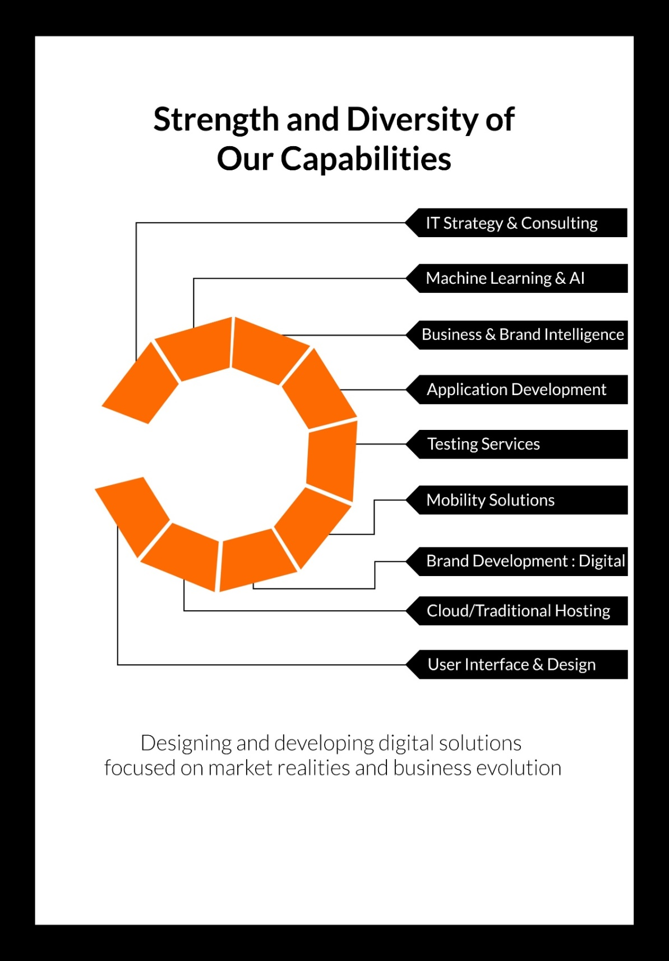

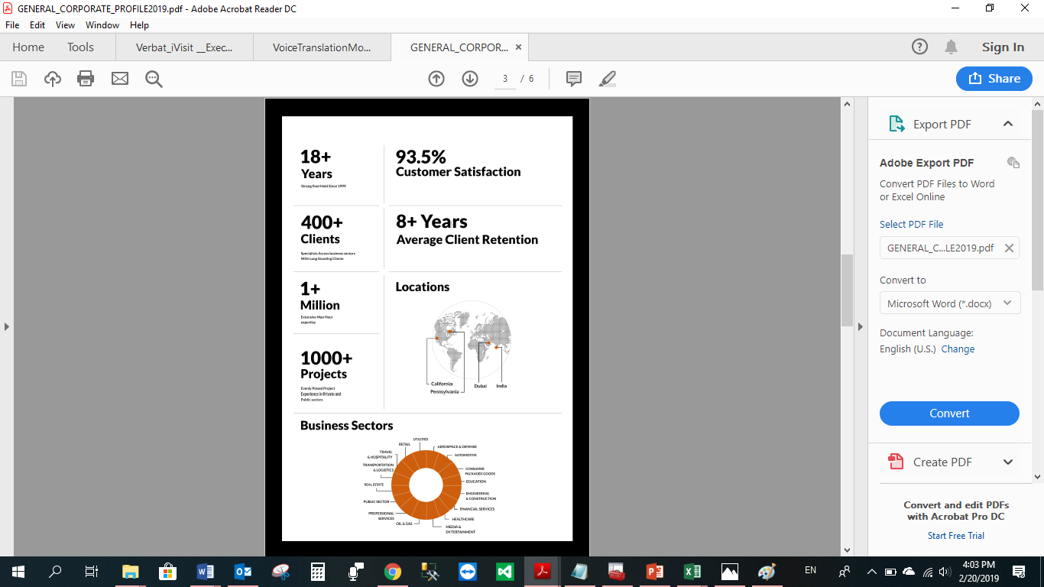

20 Years

Strong Foot holds since 1999

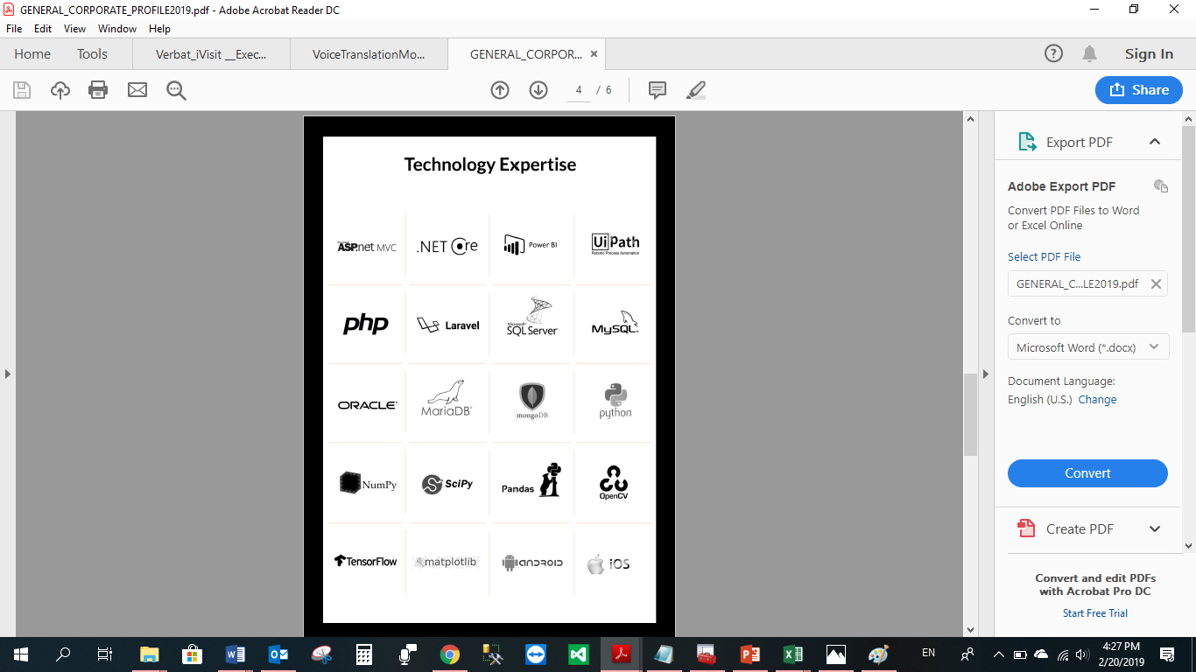

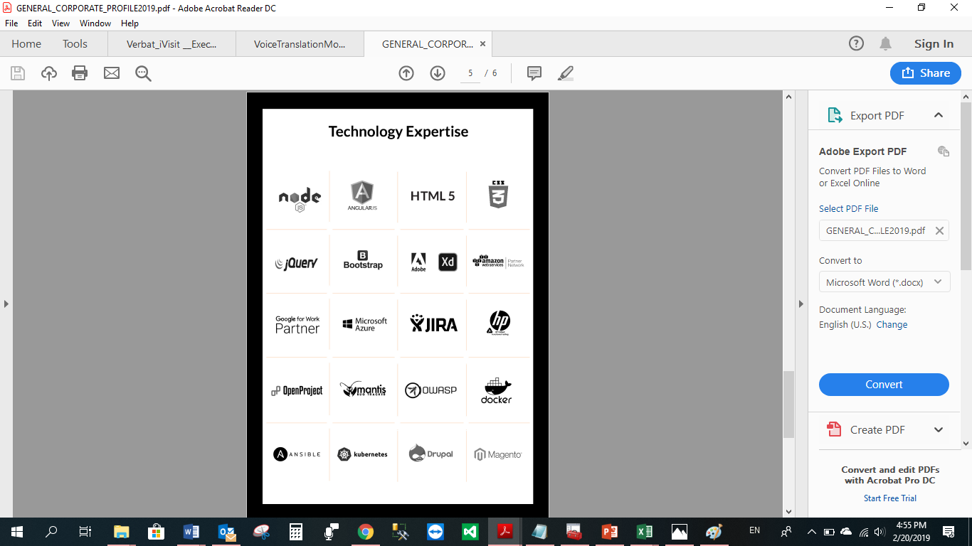

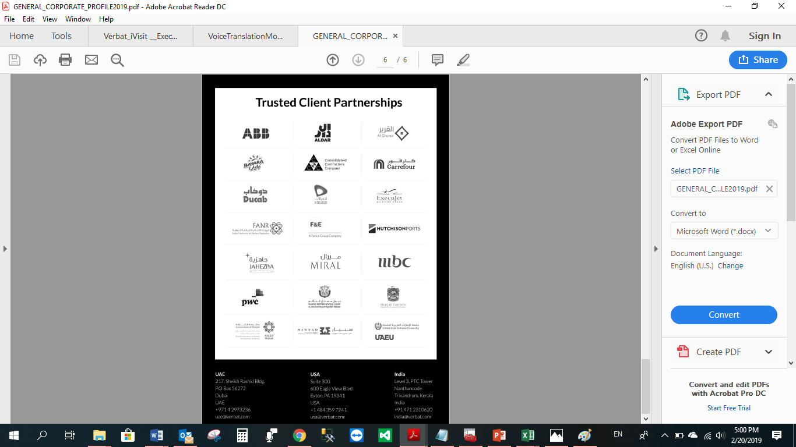

**WITH OUR**

**SINCERE THANKS.**

CONFIDENTIALITY NOTICE:

This Proposal is conﬁdential and contains proprietary information and intellectual property of Verbanet Technologies LLC. Neither this proposal nor any of the information contained herein may be reproduced or disclosed under any circumstances without the express written permission of Verbanet Technologies L.L.C (hereby known under its brand name of Verbat in the United Arab Emirates). 2020. All Rights Reserved.