roid

217, Sheikh Rashid Building

P.O Box 56272, Dubai

United Arab Emirates

Tel: +971 4 2973236 / 04 2974007

Email: uae@verbat.com

SOFTWARE REQUIREMENT SPECIFICATION

**TaxBreeze**

|  |  |
| --- | --- |
| **Prepared for:**  **PWC** | **Submission Date:**  17 Mar 2018  **Proposal ID:**  SRS/21082017/1343/2 |

\_\_\_\_\_\_\_\_\_\_\_\_\_\_\_\_\_\_\_\_\_\_\_\_\_\_\_\_\_\_\_\_\_\_\_\_\_\_\_\_\_\_\_\_\_\_\_\_\_\_\_\_\_\_\_\_\_\_\_\_\_\_\_\_\_\_\_\_\_\_\_\_\_\_\_\_\_\_\_\_\_\_\_\_\_\_\_\_\_\_\_\_\_\_\_\_\_\_\_\_\_\_\_\_\_\_\_\_\_\_\_\_\_\_\_\_\_\_\_\_\_\_\_\_\_\_\_\_\_\_\_\_\_\_\_\_\_\_\_  
Conﬁdentiality Notice: This Proposal is conﬁdential and contains proprietary information and intellectual property of Verbanet Technologies LLC. Neither this proposal nor any of the information contained herein may be reproduced or disclosed under any circumstances without the express written permission of Verbanet.

© 2018 by Verbanet Technologies LLC. All rights reserved. Confidential.

\_\_\_\_\_\_\_\_\_\_\_\_\_\_\_\_\_\_\_\_\_\_\_\_\_\_\_\_\_\_\_\_\_\_\_\_\_\_\_\_\_\_\_\_\_\_\_\_\_\_\_\_\_\_\_\_\_\_\_\_\_\_\_\_\_\_\_\_\_\_\_\_\_\_\_\_\_\_\_\_\_\_\_\_\_\_\_\_\_\_\_\_\_\_\_\_\_\_\_\_\_\_\_\_\_\_\_\_\_\_\_\_\_\_\_\_\_\_\_\_\_\_\_\_\_\_\_\_\_\_\_\_\_\_\_\_\_\_\_

Revision History

|  |  |
| --- | --- |
| ***Document Owner*** | Verbat Technologies LLC |
| ***Document Location*** | This document is only valid on the day it was printed and the electronic version is located at /PMO/SRS |
| ***Document Status*** | ***Approved*** |

|  |  |  |  |  |
| --- | --- | --- | --- | --- |
| **Revision #** | **Revision Date** | **Description of Change** | **Author** | **Comments** |
| 1.0 | 16 Mar 2017 | Initial Draft | Varsha E |  |
|  |  |  |  |  |
|  |  |  |  |  |
|  |  |  |  |  |
|  |  |  |  |  |

Document Approval

This document has been accepted and approved by the following:

|  |  |  |  |
| --- | --- | --- | --- |
| **Signature** | **Printed Name** | **Title** | **Date** |
|  |  |  |  |
|  |  |  |  |
|  |  |  |  |
|  |  |  |  |

**Table of Content**

[1 Introduction 6](#_Toc509031989)

[1.1 Overview of the Document 6](#_Toc509031990)

[1.2 Product Perspective 6](#_Toc509031991)

[2 General description 7](#_Toc509031992)

[2.1 Assumptions & Dependencies 7](#_Toc509031993)

[3 Functional requirement 8](#_Toc509031994)

[3.1 Website 8](#_Toc509031995)

[3.2 Application 9](#_Toc509031996)

[3.2.1 Site Registration (Via Social Media) 9](#_Toc509031997)

[3.2.2 Site Registration via Pan 9](#_Toc509031998)

[3.2.3 Registration email 9](#_Toc509031999)

[3.2.4 Terms and Conditions 9](#_Toc509032000)

[3.2.5 Eligibility 9](#_Toc509032001)

[3.2.6 Basic Information 10](#_Toc509032002)

[3.2.7 Plan Options 10](#_Toc509032003)

[3.2.8 Plan options display 11](#_Toc509032004)

[3.2.9 Returning Registered Users: Login 11](#_Toc509032005)

[3.2.10 Payment 11](#_Toc509032006)

[3.2.11 New PAN Card 12](#_Toc509032007)

[3.2.12 Download XML File 12](#_Toc509032008)

[3.2.13 Use upload XML file to prefill data 12](#_Toc509032009)

[3.2.14 Prefill with PAN data 13](#_Toc509032010)

[3.2.15 Tax Period 13](#_Toc509032011)

[3.2.16 BOP (Basis of Partnership) 13](#_Toc509032012)

[3.2.17 User Dashboard 13](#_Toc509032013)

[**3.2.17.1.1** **Tax summary** 13](#_Toc509032014)

[**3.2.17.1.2** **My tax returns (Current + History)** 13](#_Toc509032015)

[**3.2.17.2** **Tax return creation** 13](#_Toc509032016)

[**3.2.17.2.1** **Personal information** 14](#_Toc509032017)

[**3.2.17.2.2** **Address** 14](#_Toc509032018)

[**3.2.17.2.3** **Salary / Upload form 16** 14](#_Toc509032019)

[**3.2.17.2.4** **House property** 14](#_Toc509032020)

[3.2.17.2.5 Rental property 14](#_Toc509032021)

[3.2.17.2.6 Capital gain 15](#_Toc509032022)

[3.3 Requirement Specification 15](#_Toc509032023)

[3.2.1 Login 15](#_Toc509032024)

[3.2.2 Logout 16](#_Toc509032025)

[3.2.3 Forgot Password 16](#_Toc509032026)

[3.2.4 Change Passwords 17](#_Toc509032027)

[3.2.5 Admin 17](#_Toc509032028)

[**3.3.5.1** Admin Dashboard 17](#_Toc509032029)

[**3.3.5.2** TSD Manager Registration 17](#_Toc509032030)

[**3.3.5.3** TSD Staff Registration 19](#_Toc509032031)

[3.2.6 Applicant E-Permit Registration 19](#_Toc509032032)

[**3.3.6.1** Application Verification 21](#_Toc509032033)

[**3.3.6.2** Registration Review and Action 21](#_Toc509032034)

[**3.3.6.3** Vehicle Permit Request Details 22](#_Toc509032035)

[**3.3.6.4** Applicant Vehicle Details 22](#_Toc509032036)

[**3.3.6.5** Permit Application Details Review 23](#_Toc509032037)

[**3.3.6.6** Permit Application Details Summary 24](#_Toc509032038)

[**3.3.6.7** Permit Application Review and Action 24](#_Toc509032039)

[**3.3.6.8** Approve/Reject Permit Application 25](#_Toc509032040)

[3.3.6.8.1 Vehicle Inspection – Muroor 26](#_Toc509032041)

[**3.3.6.9** Resubmit Vehicle Details 27](#_Toc509032042)

[**3.3.6.10** Payment of Fees 27](#_Toc509032043)

[**3.3.6.11** Permit Issuance 28](#_Toc509032044)

[3.2.7 Applicant Dashboard 28](#_Toc509032045)

[3.2.8 TSD Staff Dashboard 29](#_Toc509032046)

[3.2.9 TSD Manager Dashboard 30](#_Toc509032047)

[4 Other Requirements 32](#_Toc509032048)

[4.1 User Interface 32](#_Toc509032049)

[4.2 Hardware Interface 32](#_Toc509032050)

[4.3 Technology for development/Hosting 32](#_Toc509032051)

[5 Non Functional requirement 33](#_Toc509032052)

[5.1 Documentations 33](#_Toc509032053)

[5.2 Security 33](#_Toc509032054)

[5.3 Data Storage 33](#_Toc509032055)

[5.4 User Inputs 34](#_Toc509032056)

[5.5 Usability 34](#_Toc509032057)

[6 Analysis Models 36](#_Toc509032058)

[6.1 Application Workflow 36](#_Toc509032059)

[6.2 Tour Operator Registration Workflow 36](#_Toc509032060)

[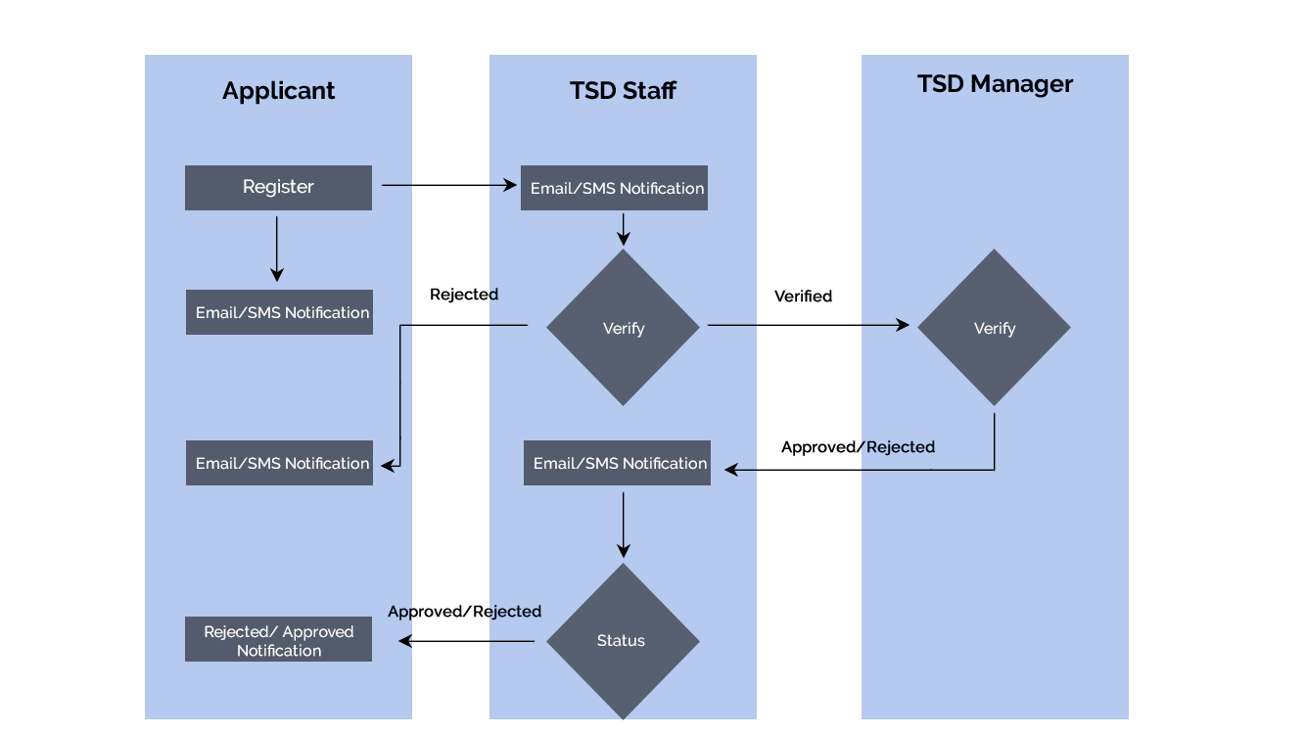 36](#_Toc509032061)

[6.3 New Permit Application Work Flow 36](#_Toc509032062)

# Introduction

This section gives a scope description and overview of everything included in this SRS document. In addition, the purpose of this document is described. The purpose of this document is to give a detailed description of the requirements for the “TaxBreeze”. The document will illustrate the purpose and complete declaration for the development of the system. This document is primarily intended to be proposed to a customer for approval, and a reference for the development team to develop the first version of the system.

## Overview of the Document

The remainder of this document includes five chapters. The second chapter provides an overview of the system functionality. The chapter further elaborates how the system manages the four user (Admin, TSD Manager, TSD Counter Staff and Tour Operators) types. The third chapter provides the requirements specification in detailed terms, and descriptions of the different system interfaces. Different specification techniques are used in order to specify the requirements more precisely for different audiences. The chapter has described the complete requirement specification put forward by the client. We have assessed them, and converted them to business logic. The business logic describes the functionality of each module/system. The fourth chapter provides the system architecture used to develop the system. The fifth chapter describes the nonfunctional requirement of the system users. The sixth chapter provides the data flow diagram.

## Product Perspective

The proposed system should be able to handle both ITR1 and ITR 2 returns as per Income Tax Authority of India. Also, the system should have a set of administrator kind of functionality that will control the functions and content of the web/app. The users should be able to register, submit personal and tax related information, track the status etc. by using the system.

TaxBreeze will aim to provide interactive compliance management system that will automate compliance responsibility of the taxpayer. TaxBreeze is in line with government process of improvising the infrastructure for providing fully online module for electronic return filing with online payment.

# General description

## Assumptions & Dependencies

One assumption of this application is that it will be using a compatible browser connected to Internet, which we have specified in section 4.1.

The upload and download of documents/ files will depend on the internet speed. We assume the internet speed for the users would be adequate for uploading/downloading files of large size. In case the speed is not adequate/stable, downloads/uploads may be interrupted.

The points mentioned below are out of the scope of this project.

* Purchase of images, fonts
* Adding new features to the application other than mentioned in the functional specification.
* Any language other than English and Arabic
* Manual data entry
* Hardware Integrations / procurement and purchase
* Database migration
* Content writing
* Physical deployment at client’s site
* Backup solution and Disaster recovery

# Functional requirement

The application being developed shall have the following components

* Web site with information on services provided, pricing etc.
* Tax filing portal where users can register or login so that they can complete their tax filing

The sections below shall describe these components in detail

## Website

The Website shall have the following pages. Verbat shall design these pages with appropriate layouts. PWC shall provide Verbat with additional information and guidance to finalize the layout of these pages as well as its content and graphics. The pages that shall be designed are

* Services page: Describes the services provided by PWC
* Pricing: A page that shall provide details on the plan options, its price and description
* Help Center: A page dedicated to provide insight and tips to Tax Breeze users
* Contact: Information page that shall provide email and phone numbers additionally it shall have a “Contact Us” form with the following fields
  + Email address
  + Subject
  + Description
* Site Header: The site header shall display the name of the logged-in user (if user had logged in)
* Chat (Plugin) – \**Client to provide the plugin*
* Terms & Conditions: Standard disclaimers for the site
* Legal
* Privacy Policy: Cookie, Session policies etc. along with information that details how PWC shall utilize the user information
* Site Provider: A page that shall display more information on PWC India with its registered address, mailing address Fax numbers, phone numbers and email
* Linking Policy: Page that shall describe the linking policies followed by PWC India

## Application

### Site Registration (Via Social Media)

* New Users shall register on the site using popular social media logins such as
  + Facebook
  + Twitter
  + Google
* The application shall use the API provided by these sites to authenticate the users
* Once the users are authenticated via social media, their username and email address shall be logged on the cloud app for future reference
* The users shall be prompted to create a password for their account by prompting the user to enter passwords twice

### Site Registration via Pan

* Users shall also choose to register using their PAN Numbers
* Users shall enter their password twice to validate their password

### Registration email

* After the user has registered via social media or PAN card, they shall receive an account verification email
* Users shall verify their email by clicking on the link in the verification email

### Terms and Conditions

* Users shall accept the terms and conditions of PWC to continue using the website for filing taxes

*TBD: does 3.2.4 come before 3.2.5 (Need to confirm)*

### Eligibility

* Before starting application applicant shall confirm eligibility as described in the image below

**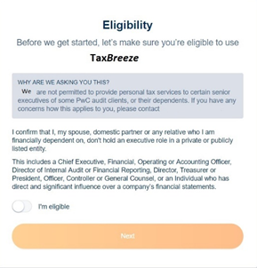**

* The application shall make a note of the eligibility status so that it can be provided to the PWC Middle Tier.

### Basic Information

Before the user is directed to select a plan, the user is directed to fill their basic information. This is because the user may be indecisive at the time and may require gentle reminders to return back to Tax Breeze to continue their registration

Basic information includes

* First name, last name, Phone, DOB and PAN # (if registered via social media)

### Plan Options

Once the user has acknowledged their eligibility, the user shall be provided with different options to select a package that best fits their use case. The pricing plans shall provide the following information

* Name of the package
* Price of the package
* Description of the package with benefits and brief use cases

### Plan options display

Plan options shall be displayed on aptly labelled tabs. Clicking on each tab shall display plan price and descriptions. A radio button placed on each tab shall be used to select the plan

TBD: Is this the best way or should we follow airtax as an example?

### Returning Registered Users: Login

Users who have not been converted to potential client may log back into the site using their social media login credentials or PAN numbers.

* In the former case once the user shall be authenticated via social media, they shall have a reference in the cloud database
* In the latter case, they shall be authenticated using their PAN # and password stored in the cloud database

### Payment

After the user has provided their basic information and selected the plan, they shall be directed to the payment gateway where they shall use their credit or debit card details to pay for the PWC service desired. The payment gateway shall be provided by PWC.

The Cloud database shall store the following

* Plan selected, Date paid, amount paid and status of payment

PWC SERVER INPUTS

If the payment process was a success this information will be posted to the PWC Middle Tier application in JSON format. The details of the message shall include

* Tax payer First and Last Name
* PAN #
* DOB
* Email & Phone
* Plan selected, payment date, Payment amount (optional)
* Payment Reference Number

PWC shall provide services to update this information as well as read this information.

PWC SERVER OUTPUT

PWC shall provide an internal reference number for the newly lodged taxpayer. The purpose of this reference number shall be to update the PWC Middle Tier with future updates to all other information related to the lodged taxpayer

### New PAN Card

Users who have registered on the site and who has already selected and paid for a plan, but without a PAN number shall be provided with the following option

* A link with clear instructions on how to apply for a new PAN card

Action Item: PWC to provide the necessary information

### Download XML File

New users without tax records in PWC, but has filed for taxes shall be redirected to the Income Tax site with information on how to download their XML file.

Action Item: PWC to provide the necessary information

PWC Services Required

* Upload XML file to PWC Middle Tier ()

### Use upload XML file to prefill data

Description

Inputs

Outputs

Pre-conditions

Post conditions

Sequence

Relationships

TBD (In Red)

Notes

Call to Actions (in Red)

Numbering

### Prefill with PAN data

### Tax Period

### BOP (Basis of Partnership)

Place holder: Needs to go towards the end

### User Dashboard

The applicant dashboard shall contain information on

#### Tax summary

Tax Summary information shall be provided by PWC to the tax payer after they have submitted all of the requested information by PWC. The tax summary information shall contain the following

* TBD: Information to be provided by PWC
* PWC ITR pdf file
* PWC tax calculation file

PWC Services required

* Tax Summary statement()
* ITR ()
* Tax Calculation document()

#### My tax returns (Current + History)

If the applicant had created Tax returns for multiple tax years, then all those records shall be listed on the dashboard, with proper status of those returns. Tax Records shall be available by year ( as a dropdown)

* Applicant shall search for tax records

#### Document Library

* A Document Library needs to be provided in the dashboard, from where the applicant shall be able to view the uploaded docs (list of docs uploaded for creating tax return pertaining to each Tax Year) and the final docs (the one prepared by the PwC pertaining to each Tax Year). The screen shall list all those documents and the user should be able to View/Download them.

**3.1.2.3.4 Tax savings**

* Applicant shall view the tax savings details in this tab

#### **Tax return creation**

Applicant shall clicks on “File a new return” to A Payment Gateway also needs to be integrated in the process on the basis of which the preparation of the return will be decided. It means that unless and until the payment is not done by the user, the return will not be considered for preparation by the PwC tax experts

##### **Personal information**

* Applicant personal information shall prefill in the form, applicant shall update and save the data

##### **Address**

* Applicant communication address shall prefill in the form, applicant shall update and save the data

##### **Salary / Upload form 16**

In this page applicant shall enter following details

* Upload form 16 document

It has

* Income from salary
* TDS for salary
* Income other than salary
* Interest income
* Other income
* Exempt income
* Agriculture income
* Dependent income
* PF withdrawal income and tax rate

##### **House property**

* House Address
* Interest paid on housing loan for Self occupied property
* Property Ownership
* Co-Owner Details

##### Rental property

* Your Property Address
* Income earned from Rental Property
* Interest paid on housing loan Rental property
* Unrealized Rent
* Property Ownership
* Co-Owner Details

##### Capital gain

## Requirement Specification

### Login

It allows only authorized users to access the application. After entering login details - email ID and password fields, user has to click ‘Sign In’ button. Once ID and password are validated, the user is given access to the application. If login fails, an error message will show as “Invalid email id or password”.

| **REQUIREMENT ID (RID)** | **DESCRIPTION** | [**PRIORITY LEVELS**](file:///C:\Users\Verbat\Desktop\pmp\requirements\Requirements_Gathering_Guidelines_and_Checklists_2.xls#'Document Conventions'!_Toc136410958)  (P1,P2,P3,P4) | [**EFFORT REQUIRED**](file:///C:\Users\Verbat\Desktop\pmp\requirements\Requirements_Gathering_Guidelines_and_Checklists_2.xls#'Document Conventions'!_Toc136410958)  (H,M,L) |
| --- | --- | --- | --- |
| 3.2.1.1 | * Email Id * Password * Sign In Button | P1 | H |
| 3.2.1.2 | * If access denied for three times, it shall redirects to Forgot password page | P1 | M |

### Logout

It allows only authorized users to logout from the application. After clicking logout user will be redirected to the login page.

| **REQUIREMENT ID (RID)** | **DESCRIPTION** | [**PRIORITY LEVELS**](file:///C:\Users\Verbat\Desktop\pmp\requirements\Requirements_Gathering_Guidelines_and_Checklists_2.xls#'Document Conventions'!_Toc136410958)  (P1,P2,p3,P4) | [**EFFORT REQUIRED**](file:///C:\Users\Verbat\Desktop\pmp\requirements\Requirements_Gathering_Guidelines_and_Checklists_2.xls#'Document Conventions'!_Toc136410958)  (H,M,L) |
| --- | --- | --- | --- |
| 3.2.2.1 | * Logout Button | P1 | L |

### Forgot Password

If the user forgets the password, it can be retrieved by clicking the ‘Forgot Password?’ link. A click on this link will ask the user to enter registered email ID. A password reset email will then be sent to the user in his registered email ID.

| **REQUIREMENT ID (RID)** | **DESCRIPTION** | [**PRIORITY LEVELS**](file:///C:\Users\Verbat\Desktop\pmp\requirements\Requirements_Gathering_Guidelines_and_Checklists_2.xls#'Document Conventions'!_Toc136410958)  (P1,P2,P3,P4) | [**EFFORT REQUIRED**](file:///C:\Users\Verbat\Desktop\pmp\requirements\Requirements_Gathering_Guidelines_and_Checklists_2.xls#'Document Conventions'!_Toc136410958)  (H,M,L) |
| --- | --- | --- | --- |
| 3.2.3.1 | * Email ID * Submit Button * Cancel Button | P1 | L |
| 3.2.3.2 | * On entering invalid email id, system throws an error message. | P1 | M |

### Change Passwords

The user can change their password by clicking ‘Change Password’ link. The user has to enter the current password, new valid password, confirm password and click ‘Change Password’ button. Both new password and confirm password should be same and valid. The system will verify both new and old passwords and will update the new password. If verification fails, then an error message will appear.

| **REQUIREMENT ID (RID)** | **DESCRIPTION** | [**PRIORITY LEVELS**](file:///C:\Users\Verbat\Desktop\pmp\requirements\Requirements_Gathering_Guidelines_and_Checklists_2.xls#'Document Conventions'!_Toc136410958)  (P1,P2,P3,P4) | [**EFFORT REQUIRED**](file:///C:\Users\Verbat\Desktop\pmp\requirements\Requirements_Gathering_Guidelines_and_Checklists_2.xls#'Document Conventions'!_Toc136410958)  (H,M,L) |
| --- | --- | --- | --- |
| 3.2.4.1 | * Current password * New password * Confirm password * Change Password Button * Clear Button | P1 | L |

### Admin

#### Admin Dashboard

Admin Dashboard shall provide the system with the following features. The admin can manage users by adding, editing and deleting their accounts and the admin can enter master data.

|  |  |  |  |
| --- | --- | --- | --- |
| **REQUIREMENT**  **ID (RID)** | **DESCRIPTION** | **PRIORITY**  **LEVELS**  (P1,P2,P3,P4) | **EFFORT**  **REQUIRED** (H,M,L) |
| 3.2.5.1.1 | * Manage users (add/edit/delete) | **P1** | **M** |
| 3.2.5.1.2 | * Manage Nationality(add/delete/edit) * Manage Request Status(add/delete/edit) * Manage Incomplete Comments (add/delete/edit) * Manage Action Taken(add/delete/edit) * Manage Permit Period(add/delete/edit) * Manage Vehicle Ownership(add/delete/edit) * Manage Vehicle Type(add/delete/edit) * Manage Place of issue(add/delete/edit) * Manage Permit Requirements (add/delete/edit) * Manage Permit Action Taken (add/delete/edit) | **P1** | **H** |

#### TSD Manager Registration

Admin register TSD Manager on the website. After successful registration, an auto generated SMS/Email notification will be received by the TSD Manager.

|  |  |  |  |
| --- | --- | --- | --- |
| **REQUIREMENT ID (RID)** | **DESCRIPTION** | **PRIORITY LEVELS**  (P1, P2, P3, P4) | **EFFORT**  **REQUIRED**  (H,M,L) |
| 3.2.5.2.1 | * Name * Email * Contact Number * Mobile Number * Designation * Role(drop down) | **P1** | **L** |
| 3.2.5.2.2 | * An auto generated SMS/Email notification will be received with username and password * Password will be system generated | **P1** | **M** |

#### TSD Staff Registration

Admin register TSD Staff on the website with the following information. After successful registration, an auto generated SMS/Email notification will be received by the TSD Staff.

|  |  |  |  |
| --- | --- | --- | --- |
| **REQUIREMENT ID (RID)** | **DESCRIPTION** | **PRIORITY LEVELS**  (P1, P2, P3, P4) | **EFFORT**  **REQUIRED**  (H,M,L) |
| 3.2.5.3.1 | * Name * Email * Contact Number * Mobile Number * Designation * Role(drop down) | **P1** | **L** |
| 3.2.5.3.2 | * An auto generated SMS/Email notification will be received with username and password * Password will be system generated | **P1** | **M** |

### Applicant E-Permit Registration

Applicant should register their details on the website after reading and confirming the Terms, Condition, Policy and Disclaimer. Only one tour operator representative is allowed to register in the website. After filling the form, applicant can either submit or close the details. If submitted, applicant will be notified with a Reference Number else will navigates to the login page.

|  |  |  |  |
| --- | --- | --- | --- |
| **REQUIREMENT ID (RID)** | **DESCRIPTION** | **PRIORITY LEVELS**  (P1, P2, P3, P4) | **EFFORT**  **REQUIRED**  (H,M,L) |
| 3.2.6.1 | * Once confirming terms and condition, by checking check box user will be redirecting to the registration page. | **P1** | **M** |
| 3.2.6.2 | Applicant registration details:   * Name (50 char)   *(Establishment name must be exactly as written in the Trade License)*   * Address(100 char)\* * P.O. Box(10 char) * Website(50 char) * Trade License Source (Emirate)\* * Trade License Number(15 char)\* * Trade License Validity\* * Company Profile (75 char)   Tour Operator Representative contact information:   * Username(11 char)\* * Password\* * Confirm Password\* * First Name(20 char)\* * Last name(20 char)\* * Middle name(20 char)\* * E-mail(acceptable format)\* * Nationality(drop-down)\* * Emirates ID(15 characters)\* * Mobile phone number(auto fill country code) 971 (00) (0000000)\* * Business phone (direct) number (auto fill country code) 971 (00) (0000000)\* * Upload document requirement   + Copy of valid tour Operator Trade License.   + Copy of Representative UAE Emirates ID Card.   + Copy of Representative Residence Visa.   + Copy of Representative Passport.   + No Objection Certificate(NOC) * Submit button * Close button   Application receipt notification:   * System generated Reference Number for the new record display onscreen as a notification receipt status.(50 char)\*   + Print   + Close * After receiving reference number, page redirects to login page * Notification shall send to the applicant and the TSD Staff. | **P1** | **L** |
| 3.2.6.3 | * If registration is rejected by TSD Staff then tour operator will get notification and can login to the account using the Username and Password to resubmit the application. |  |  |

#### Application Verification

TSD Staff will verify the application details. TSD staff can either review or reject the application. After reviewing, application will be available to the TSD manager for approval. If rejected by TSD manager, the application will be available for the TSD Staff with comments. Based on the rejection comments, TSD Staff can either send to TSD Manager for approval or reject the application. If registration is rejected by TSD Staff then tour operator will get notification and can login to the account using the Username and Password to resubmit the application. When approved, an auto-generated email/SMS notification will be send to the applicant informing that the account is activated and requires clicking on a link to login.

#### Registration Review and Action

TSD Staff can review registration and can take action after verification.

|  |  |  |  |
| --- | --- | --- | --- |
| **REQUIREMENT ID (RID)** | **DESCRIPTION** | **PRIORITY LEVELS**  (P1, P2, P3, P4) | **EFFORT**  **REQUIRED**  (H,M,L) |
| 3.2.6.2.1 | * New request   + Company name   + Registration Request Reference Number   + Registration Requirement(Complete/Incomplete)   + Requirements incomplete/Not Valid(drop-down list)   + Action Taken(drop-down list) * Active Request   + Company Name   + Registration Request Reference Number   + Number of vehicles with permit | **P1** | **L** |

#### Vehicle Permit Request Details

Applicant should first fill out the e-form of permit request before vehicle registration. Added permit details will be listed in a table. In that table applicant can view all the added vehicle details and can delete any vehicle from the list.

|  |  |  |  |
| --- | --- | --- | --- |
| **REQUIREMENT ID (RID)** | **DESCRIPTION** | **PRIORITY LEVELS**  (P1, P2, P3, P4) | **EFFORT REQUIRED**  (H,M,L) |
| 3.2.6.3.1 | * Applicant cannot add new vehicle permit details unless and until his registration is approved by TSD. |  |  |
| 3.2.6.3.2(Screen 1) | * Period time   + 6 months   + 1 year * Permit Start Date\* * Permit End Date(Auto generated)\* * Save button | **P1** | **L** |

#### Applicant Vehicle Details

Applicant should fill out e-form with complete information required for each vehicle request permit after login. After adding vehicle details, applicant can submit application for permit. After filling the form, applicant can either submit or close the details. If closed, navigates to the dashboard. For each vehicle separate application will be created.

|  |  |  |  |
| --- | --- | --- | --- |
| **REQUIREMENT ID (RID)** | **DESCRIPTION** | **PRIORITY LEVELS**  (P1, P2, P3, P4) | **EFFORT**  **REQUIRED**  (H,M,L) |
| 3.2.6.4.1 | * Vehicle Ownership: select 1-Owned 2- Rented\* * Plate number(7 char – alphanumeric)\* * Vehicle Type(drop-down i.e. 4x4,car)\* * Year Manufactured(4 char)\* * Place of issue(drop-down Emirates list)\* * Vehicle registration as Safari Tourism Vehicle Validity Period: From/To dd/mm/yyyy\* * Comprehensive Vehicle Insurance Validity period: From/To dd/mm/yyyy\* * Documents to be uploaded   + Copy of valid vehicle registration as Safari Tourism Vehicle(if Owned)\*   + Copy of rental contract for minimum of six months and shall not be less than the requested Permit duration(if Rented)\*   + Copy of valid Comprehensive Vehicle Insurance\*   (*vehicle insurance shall not be less than the requested permit*)   * + Checklist of required equipment for desert tour driving.\*   + Copy of valid Desert Driver License\* * Save button * Close button | **P1** | **L** |

#### Permit Application Details Review

Applicant can review or change application details. Each vehicle have separate permit application and separate review, approval/rejection and Payment.

|  |  |  |  |
| --- | --- | --- | --- |
| **REQUIREMENT ID (RID)** | **DESCRIPTION** | **PRIORITY LEVELS**  (P1, P2, P3, P4) | **EFFORT**  **REQUIRED**  (H,M,L) |
| 3.2.6.5.1 | * Review Permit Details & View Attachments * Review Vehicle Details & View Attachments * Change button * Submit button * Close button | **P1** | **L** |

#### Permit Application Details Summary

Applicant can view Permit details. User can close the permit details page. On closing it should navigates to the applicant (Tour Operator) dashboard.

|  |  |  |  |
| --- | --- | --- | --- |
| **REQUIREMENT ID (RID)** | **DESCRIPTION** | **PRIORITY LEVELS**  (P1, P2, P3, P4) | **EFFORT**  **REQUIRED**  (H,M,L) |
| 3.2.6.6.1 | * Permit Type: Desert tour vehicle permit * Permit application type: New * Name of Tour Operator: XYZ tours * Permit Validity Date: From 01/01/2017 To 31/12/2017 * Permit Jurisdiction: Sharjah * Authorize Representative Name: No Name * Authorize Representative Contact Number(Mobile):050 1234567 * Authorize Representative Contact Number(Landline):04 1234567 * Close button | **P1** | **L** |
| 3.2.6.6.2 | * List vehicle details with status |  |  |

#### Permit Application Review and Action

TSD Staff can review permit application/ check requirements and verify documents submitted and can take action.

|  |  |  |  |
| --- | --- | --- | --- |
| **REQUIREMENT ID (RID)** | **DESCRIPTION** | **PRIORITY LEVELS**  (P1, P2, P3, P4) | **EFFORT**  **REQUIRED**  (H,M,L) |
| 3.2.6.7.1 | * New request   + Company name   + Permit Request Reference Number(13 char)   + Permit Request Requirement(Complete/Incomplete)   + Permit Requirements incomplete/Not Valid(drop-down)   + Red flags(Comments)(50 char)   + Payment Received(15 char)   + Action Taken(drop-down)   + On clicking Details Button, new request details shall be shown.     - Show the data of the vehicle     - The current status of the application     - The action buttons based on the current status of the application * Active Request   + Company Name   + Permit Request Reference Number   + Number of vehicles with permit   + On clicking Details Button, new request details shall be shown.     - Show the data of the vehicle     - The current status of the application | **P1** | **L** |

#### Approve/Reject Permit Application

After reviewing vehicle permit application, TSD Staff can send the application for approval to TSD Manager or reject the application with comment (E.g. Incorrect or incomplete application) .The TSD Manager can either approve or reject application.

If rejected by TSD manager, the application will be available for the TSD Staff with comments. Based on the rejection comments, TSD Staff can send back again for approval to TSD Manager with their comments/action taken or send rejection with comments (reason) to the applicant. If not an ultimate rejection, the applicant can resubmit the application again and follow the same previous workflow steps.

If approved by TSD manager, an auto-generated email/SMS notification will be sent to the applicant of the result and informing as well to login to his account to download the Muroor test request and proceed for vehicle testing.

Test result shall be uploaded into the system by logging-in to his account. After uploading the Muroor test result, the TSD staff shall be notified to review the document, where the TSD staff can either approve or reject the result. In case rejected the applicant will be notified to login to the system and upload another test result.

In case the TSD counter staff approve the Muroor result, then the applicant shall be notified to make payment through their account in the system. On successful payment, an auto-generated email/SMS notification will be send to the applicant informing to collect the permit sticker within 24Hrs from the counter. Once the Permit is physically collected, the TSD staff shall mark the Permit as collected, and close the process to have an active vehicle.

|  |  |  |  |
| --- | --- | --- | --- |
| **REQUIREMENT ID (RID)** | **DESCRIPTION** | **PRIORITY LEVELS**  (P1, P2, P3, P4) | **EFFORT**  **REQUIRED**  (H,M,L) |
| 3.2.6.8.1 | * TSD Staff can recommend vehicle permit application approval to TSD Manager. * TSD Staff can recommend rejection of vehicle permit application to TSD Manager. * If permit application is approved by the TSD Manager, an auto-generated email/SMS is sent to the applicant to take muroor test OR to upload valid permit if vehicle testing has been taken before. | **P1** | **L** |

##### Vehicle Inspection – Muroor

Applicant should go for muroor testing if the vehicle does not have any valid desert tour vehicle issued by other Emirates. Applicant need to download a request for muroor vehicle testing by logging-in to his account and should upload as well the copy of the result in pdf format. Then the TSD Staff can review the result.

|  |  |  |  |
| --- | --- | --- | --- |
| **REQUIREMENT ID (RID)** | **DESCRIPTION** | **PRIORITY LEVELS**  (P1, P2, P3, P4) | **EFFORT**  **REQUIRED**  (H,M,L) |
| 3.2.6.8.1.1 | * Applicant can download muroor request for vehicle testing/inspection. * Upload Murror Test result (or) * Upload a copy of existing valid permit (in which case, muroor vehicle testing is not required anymore) * Submit Button | **P1** | **L** |

#### Resubmit Vehicle Details

Applicant can resubmit the vehicle details which is rejected by the TSD Staff. While resubmitting the application, applicant cannot change the plate number. Plate number is the unique identifier. Fields in the Resubmit form is same as in vehicle registration.

#### Payment of Fees

When approved, an auto-generated email/SMS notification will be send to the applicant informing to make payment through their portal.

|  |  |  |  |
| --- | --- | --- | --- |
| **REQUIREMENT ID (RID)** | **DESCRIPTION** | **PRIORITY LEVELS**  (P1, P2, P3, P4) | **EFFORT**  **REQUIRED**  (H,M,L) |
| 3.2.6.10.1 | * View fee details * Payment is possible through Tahseel * Read Payment instruction and pay | **P1** | **L** |

#### Permit Issuance

TSD Staff will give permit to the applicant on successful payment of corresponding fees. Applicant can collect the permit sticker within 24Hrs from the counter after getting an auto-generated email/SMS notification. TSD Staff can provide the permit sticker (which is already printed) by scanning the barcode. Sticker details will be saved in the database. While providing the sticker, TSD Staff should check the Emirates ID of the Representative as proof of identity for authorize collection.

Once the Permit is physically collected, the TSD staff shall mark the Permit as collected, and close the process to have an active vehicle permit.

|  |  |  |  |
| --- | --- | --- | --- |
| **REQUIREMENT ID (RID)** | **DESCRIPTION** | **PRIORITY LEVELS**  (P1, P2, P3, P4) | **EFFORT**  **REQUIRED**  (H,M,L) |
| 3.2.6.11.1 | * Check payment Status * Send permit notification issuance/collection date(50 char)   (email & SMS)   * Scan preprinted Permit sticker | **P1** | **M** |

### Applicant Dashboard

Applicant dashboard will list their profile details and the details of the added vehicles.

|  |  |  |  |
| --- | --- | --- | --- |
| **REQUIREMENT ID (RID)** | **DESCRIPTION** | **PRIORITY LEVELS**  (P1, P2, P3, P4) | **EFFORT**  **REQUIRED**  (H,M,L) |
| 3.2.7.1 | * View Profile Details * View Vehicle details | **P1** | **L** |

### TSD Staff Dashboard

TSD Staff can view the list of new and active applications from the dashboard. From the dashboard, TSD Staff can view new and rejected permit details. TSD Staff can escalate applications to the TSD Manager.

The TSD staff should have four main pages as follows (all pages must have filters and search to find any required tour operator or vehicle):

1. Active Tour Operators, once opening any tour operator, it shows its master data, and below two tabs:
   1. Active Vehicles: when clicked it should show the data of the vehicle.
   2. In Process vehicles: when clicked should show the data of the vehicle and the current status of the application, with the action buttons based on the current status of the application. (i.e. Review, Reject, comments, Request to get Murror test, Request to do the payment, Request to collect the sticker)
2. In Process Tour Operators: shows the in process tour operators registrations with the current status and the action buttons based on the current status (i.e. Review, Reject, comments.)
3. In process vehicles: When click any in process vehicle should show the data of the vehicle and the current status of the application, with the action buttons based on the current status of the application. (i.e. Review, Reject, comments, Request to get Murror test, Request to do the payment, Request to collect the sticker)
4. Reports:
   1. Active Tour operators with their basic data (registration date, license expiry date)
   2. In process Tour operators with their basic data and current status and the action required, date of registration submitted.
   3. Active Vehicles: with their basic data (permit expiry date, plate number)
   4. In process Vehicles: with their basic data and current status and the action required, date of application submitted
   5. Permits Expiry: show all vehicles sorted based on their permit expiry date.

| **REQUIREMENT ID (RID)** | **DESCRIPTION** | **PRIORITY LEVELS**  (P1, P2, P3, P4) | **EFFORT**  **REQUIRED**  (H,M,L) |
| --- | --- | --- | --- |
| 3.2.8.1 | * View Active applicant Details * View Vehicle details(Approved/Rejected) * View new Registration request * View Permit Request(New/Resubmitted) * Escalate applications to the TSD Manager | **P1** | **L** |

### TSD Manager Dashboard

Manager dashboard will provide the following details

The TSD Manager should have four main pages as follows (all pages must have filters and search to find any required tour operator or vehicle. It would be a search box which can be searched by Tour Operator, By Vehicle Permit, By Permit application Number)

1. Active Tour Operators, once opening any tour operator, it shows its master data, and below two tabs:
   1. Active Vehicles: when clicked it should show the data of the vehicle.
   2. In Process vehicles: when clicked should show the data of the vehicle and the current status of the application, with the action buttons based on the current status of the application. (i.e. Review, Reject, comments, Request to get Murror test, Request to do the payment, Request to collect the sticker.)
2. In Process Tour Operators: shows the in process tour operators registrations with the current status and the action buttons based on the current status (i.e. Review, Reject, comment).
3. In process vehicles: When click any in process vehicle should show the data of the vehicle and the current status of the application, with the action buttons based on the current status of the application. (i.e. Review, Reject, comments, Request to get Murror test, Request to do the payment, Request to collect the sticker)
4. Reports:
   1. Active Tour operators with their basic data (registration date, license expiry date)
   2. In process Tour operators with their basic data and current status and the action required, date of registration submitted
   3. Active Vehicles: with their basic data (permit expiry date, plate number)
   4. In process Vehicles: with their basic data and current status and the action required, date of application submitted
   5. Permits Expiry: show all vehicles sorted based on their permit expiry date.

|  |  |  |  |
| --- | --- | --- | --- |
| **REQUIREMENT ID (RID)** | **DESCRIPTION** | **PRIORITY LEVELS**  (P1, P2, P3, P4) | **EFFORT**  **REQUIRED**  (H,M,L) |
| 3.2.9.1 | * View Permits Issued (by Month and City) [Charts] * Quick facts | **P1** | **L** |

# 

# Other Requirements

This section contains all of the functional and quality requirements of the system. It gives a detailed description of the system and all its features.

## User Interface

The user interface will be responsive.

*Browser Compatibility*

The application developed will be compatible with the browsers listed below:

1. Internet Explorer 11
2. Mozilla Firefox 50 or above
3. Chrome 50 or above

## Hardware Interface

Since the application is web-based, it is not dependent on any designated hardware, and it does not have any direct hardware interfaces. However, we recommend the specification mentioned below for the best output.

* Computer with Microsoft Windows XP Professional SP3/Vista SP1/Windows 7 or 8 OS
* Processor: 2.6 GHZ Intel Pentium IV or equivalent
* Memory: 2GB
* Disk Space: 1 GB of free disk space

## Technology for development/Hosting

The application shall be developed using the set of tools/technology listed below.

* **UI/UX Designs**
  + Wire Frames – Gliffy (Tool by Google)/Pencil
  + UI Designs – Photoshop CS6
  + Simulation – Sublime Text 3
* **Development**
  + VISUAL STUDIO 2015
  + ASP.NET 4.5
  + Database Engine – MS SQL SERVER 2012
  + IIS 8

# Non Functional requirement

## Documentations

|  |  |
| --- | --- |
| **ITEM** | **RESPONSE/COMMENT** |
| Project documentation requirements | * Requirements document * Functional specification document |
| Training  Requirements | Training will be provided for installing (including application migration) and using the application for users if required |

## Security

Hardware and network security will be dependent on the selected cloud/hosting service provider’s infrastructure and credentials.

* The system shall use secure sockets in all transactions that include any confidential customer information.
* The system shall automatically log out all customers after a period of inactivity.
* The system shall confirm all transactions with the customer’s web browser or mobile apps.

## Data Storage

* The user interfaces shall never display a customer’s password. It shall always be echoed with special characters representing typed characters.
* The user interfaces shall never display a customer’s credit card number after retrieving from the database. It shall always be shown with just the last four digits of the credit card number.
* The system’s back-end servers shall never display a customer’s password. The customer’s password may be reset but never shown.
* The system’s back-end servers shall only be accessible to authenticated administrators.

|  |  |
| --- | --- |
| **ITEM** | **REQUIREMENT** |
| Handling Sensitive Data | Insensitive data such as company name, documents processed, relevant dates, noncompliance data. could be stored in the database as plain text  Passwords will be encrypted. |
| Security Threats  Prevention | The application will be hosted on a web server that implements SSL (HTTPS). Passwords will be encrypted. Protection against SQL injection will be implemented  Protection against Cross browser hacks and cross-site scripting (XSS) will be implemented. |
| Access Control | Access control for the application will be Role based. Individual users will be authenticated with passwords and authorized to access different parts of the site depending upon assigned roles. |
| HTTPS | Application will support both HTTP and HTTPS. |
| Changing Passwords | User will be allowed to change password by providing his original password and typing the new password 2 times. |
| Forgotten Passwords | Forgotten passwords can be reset by providing an email address attached to the account. A token-based link with expiry will be send to the email for reset of the password. |

## User Inputs

|  |  |
| --- | --- |
| **ITEM** | **REQUIREMENT** |
| Auto-Generated  IDs | Auto generated ID’s will be used within a database context. Passwords may be auto generated for the user. |
| Boundary Conditions | Birth year values should be checked for boundary conditions. |

## Usability

|  |  |
| --- | --- |
| **ITEM** | **REQUIREMENT** |
| Documentation | User manuals and other relevant documents will be provided. |
| Time Zones | The prototype application will have UAE Standard Time as its time zone. Time zones cannot be configured in the current version of the application. Where ever applicable system date and time will be used to represent logical/business/calendar dates. |
| User Interface | The application developed will be best viewed in the resolution 1280px by  768px. The application will be responsive and will be available for mobile |
|  | devices as well as on a desktop web browser |
| Tab Sequence | Forward and backward tab sequences will be maintained in the form. |
| Transactions | Transactions will be ACID (Atomic, Consistent, Isolated and Durable) where required. |

# Analysis Models

## Application Workflow

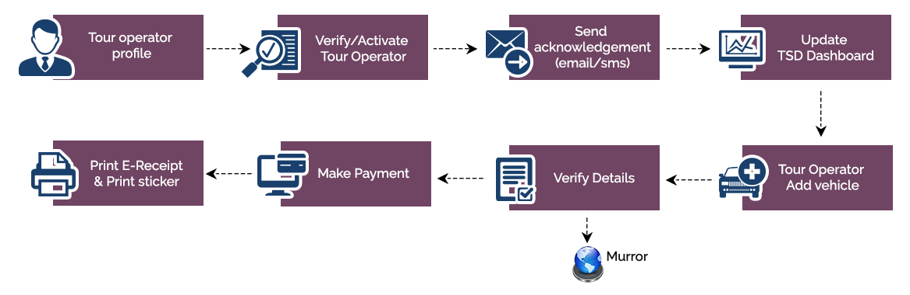

## Tour Operator Registration Workflow

## 

## New Permit Application Work Flow

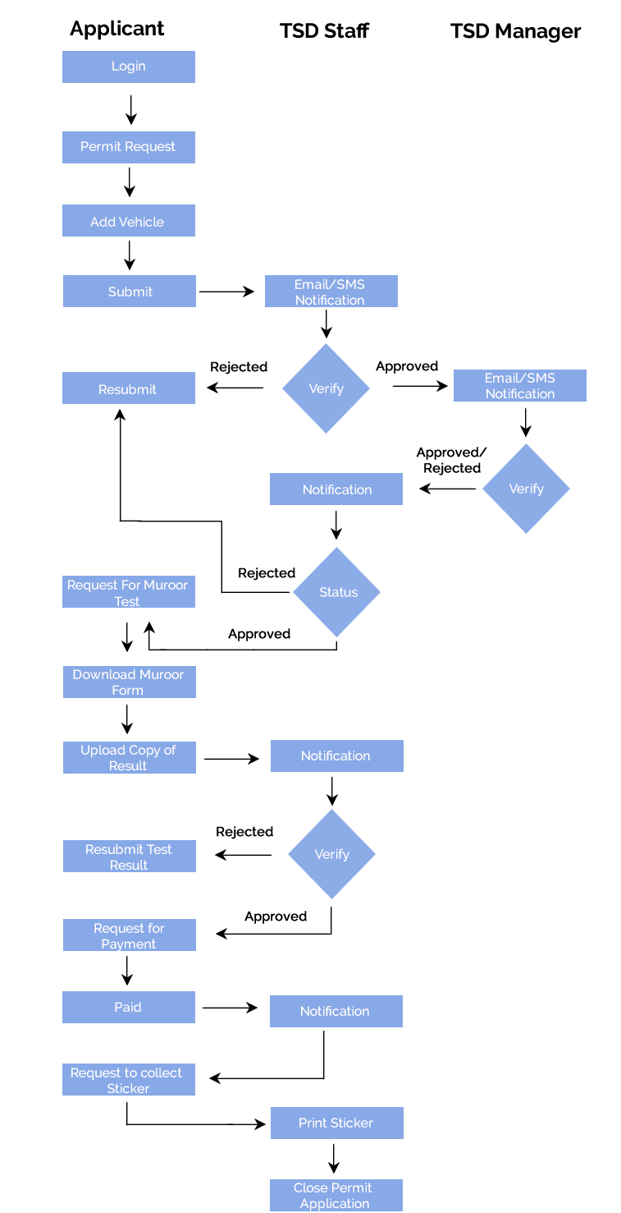

We look forward to hearing from you soon and hope that you will give us the privilege to work with you in meeting your business goals. Thank you.

Thank You



©   
1999 - 2017. All Rights Reserved   
Verbanet Technologies LLC  
www.verbat.com