roid

217, Sheikh Rashid Building

P.O Box 56272, Dubai

United Arab Emirates

Tel: +971 4 2973236 / 04 2974007

Email: uae@verbat.com

PROJECT   
PROPOSAL

**Retail Audit Application**

|  |  |
| --- | --- |
| **Prepared for:** | **Submission Date:**  19 Sept 2018  **Proposal ID:** AD/BP/19092018/1343/1 |

_______________________________________________________________________________________________________  
Conﬁdentiality Notice: This Proposal is conﬁdential and contains proprietary information and intellectual property of Verbanet Technologies LLC. Neither this proposal nor any of the information contained herein may be reproduced or disclosed under any circumstances without the express written permission of Verbanet.

© 2017 by Verbanet Technologies LLC. All rights reserved. Confidential.

_______________________________________________________________________________________________________

Project Contacts

|  |  |
| --- | --- |
| Client Information | |
| Project Name |  |
| Client Name | PowerRoot |
| Client Address |  |
| Contact Person |  |
| Contact Person Email |  |
| Contact Person Phone Number |  |
| Verbat Information | |
| Contact Person |  |
| Contact Person Phone Number | +971 42973236 |
| Contact Person E-Mail |  |
| Address | PO Box 56272, Dubai, United Arab Emirates |
| Physical Address | 217, Sheikh Rasheed Building, Hor Al Anz East |
| Project Information | |
| Proposed Technology/Methodology | PHP, MySQL, HTML 5, CSS 3, Code Igniter |
| Anticipate Start Date | NA |
| Proposal Valid For | 30 Calendar days from the submission of the proposal |

**Table of Content**

1 Executive Summary 5

1.1 Proposed Solution Model 5

1.2 Solution Objective 6

1.3 Advantages of Proposed Solution 8

1.4 Why Verbat 8

1.5 Key Differentiators 9

1.6 Technology & Services 10

2 Functional Specification 11

3 Nonfunctional Requirement (Others) 12

4 Assumptions 12

5 Out of Scope 13

6 Technology Solution 14

6.1 Proposed System Environment 14

6.2 Technical Configurations 15

6.2.1 Development Tools 15

6.2.2 Recommended Web Hosting Package 15

6.2.3 Browser Compatibility 15

6.2.4 Hardware Interface 15

7 Commercials 16

7.1 Web Application 16

7.2 Payment Terms 16

7.3 Mode of Payment 16

8 Delivery Management 17

8.1 Project Management 17

8.2 Roles and Responsibilities 17

8.3 Delivery Activity Summary 18

8.4 Project Implementation Plan 18

8.5 Deliverables 18

8.6 Estimated Delivery Time 19

8.7 Deployment Details (at Clients Behest) 19

8.8 Release Planning 19

8.9 Risk and Contingency Planning 19

9 Change Management 20

10 Miscellaneous 22

10.1 Acceptance Criteria 22

10.2 General Terms and Conditions 22

10.3 Assumptions and Dependencies 23

10.4 Source Code & Intellectual Property Rights 23

10.5 Maintenance & Support 24

10.6 Service Level Agreement 25

11 Our Clients 26

# Executive Summary

Power Root (Here after referred to as the client) started in 1999 in Johor Bahru, Malaysia wanted to share the vision of great instant coffee & tea. Power Root took their products inspired by the herbs of the rainforest, Eurycoma Longifolia Jack (Tongkat Ali) and Labisia Pumilia (Kacip Fatimah) to 48 countries around the world and in 2006, to the Middle East.

Power Root (hereafter referred to as “Client”) has requested Verbanet Technologies LLC., trading as Verbat Technologies (hereafter referred as” Verbat”) to develop an application to conduct audit against retailers to improve the marketing strategy of the product by reviewing the observations of the audit and hence to enhance the product-sales.

The business objective of the client is to evaluate and improve the sales strategy by Retail Auditing and there by optimizing their business.

Verbat is pleased to submit the proposal and values it as a great opportunity to have a long term & mutually beneficial association with the client. Verbat has gone through the requirement and presents a proposal for the requested system.

## Proposed Solution Model

**Stand-Alone Fixed Bid**

Verbat will be following a stand–alone fixed bid solution delivery model wherein the required solution would be devised and a suitable pricing would be offered.

## Solution Objective

After the initial analysis of the requirements provided by client, Verbat proposes to develop an android mobile application with the features and functionalities as described below:

The actors identified for the application are:

* Admin
* Auditors

The detailed functionalities of each actor is described below:

**Admin:** Admin uses the web application to review and monitor the audit observations. The features envisaged for the admin module are:

* Login:

Admin can login to the application with predefined username and password

* User Management:
  + Admin can manage (add / edit/ delete) the Auditors
* Master Management:
  + Products
  + Retailers
  + Add products to Retailers
  + Competitor
* Audit Schedule :

Admin can schedule auditor to periodic/recurring audits.

* + Select Auditor
  + Assign shops to Auditor
  + Specify the date and time
* Audit Analytics:

Admin can review the audit observations to conduct marketing analysis. The observations will be based on:

* + - Availability Summary
    - Price Positioning
    - Competitor Tracking
    - Planogram Compliance
    - Promotion Strategies
    - Store vise report Login
* Logout:

Admin can logout from the application.

**Auditor** : Auditor uses the android mobile application to conduct audit against retailers. Once the observations are collected, the same will be updated to the web application in real time.

* Login:
* Auditor can login to the application with predefined username and password created by the admin.
* Auditor Dashbaord:
* Auditor Dashbaord includes the below:
  + Trade Coverage
    - * Availability of the product
      * Price Positioning
      * Competitor Tracking
      * Planogram Compliance
      * Promotions and Sampling
      * Audit Findings and Recommendations
      * Audit Evidence
      * Survey Report
      * Call Audit
  + New Retailer
    - Auditors can add new retail shops which are not listed in the trade coverage using this feature.
* Logout:

Admin can logout from the application.

Note:

* *Audit findings and recommendations can be a text or audio recording.*

*Audit Evidences can be photos.*

Verbat’s Solution architects have conducted a thorough research on the requirements and have come to the conclusion that our proposed solution, which is detailed further in this document, will meet the requirements put forth by the client. And the proposed solution will be delivered in a phased approach as per Verbat’s stand-alone fixed bid solution model.

**Strong and Scalable platform:** The platform proposed will be strong and scalable enough to accommodate future enhancements.

**Accelerated solution:** The framework would act as a solution accelerator. It would provide the basic building blocks which could be reused in future for building new components and features.

**High performance:** The light weight framework used consumes fewer system resources thereby making the application perform faster.

**Security:** The application will be developed considering various aspects of security.

## Advantages of Proposed Solution



01

Agile development offering reliable, secure solution

02

Smooth transition and quicker completion of processes

03

User friendly interfaces enabling easy navigation between screens

## Why Verbat

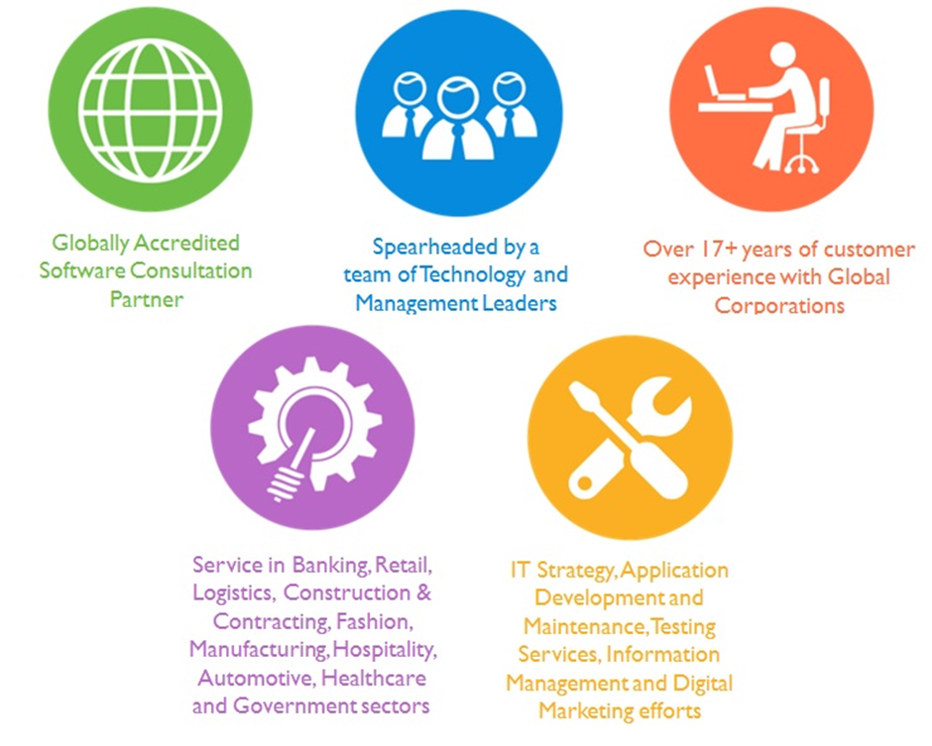

## Key Differentiators

Delivered digital transformation expertise to global customers for over a decade by following industry best practices to maximize ROI for client

Keen technology intelligence combined with aggressive market research to deliver solutions that achieve results with measurable value

Enable access to global consulting expertise with strong local market and business knowledge

Commercial Model that is customizable for your business needs

Services that are designed to optimize applications for improved performance and overall efficiency

1,000,000 plus man-hours of expertise in technology frameworks spanning Microsoft, Open Source, mobility platforms and other proprietary IT technology

Partners top technology vendors to bring in the latest and best services in integration, collaboration, and development

Commercial Model that is customizable for your business needs

Proven Methodologies & Processes

Investment in R & D

Strong Local Presence

Flexible commercial Models

Technology Associations

Software Development Experience

Offshore Development Centre

Quality Assurance & Testing

## Technology & Services

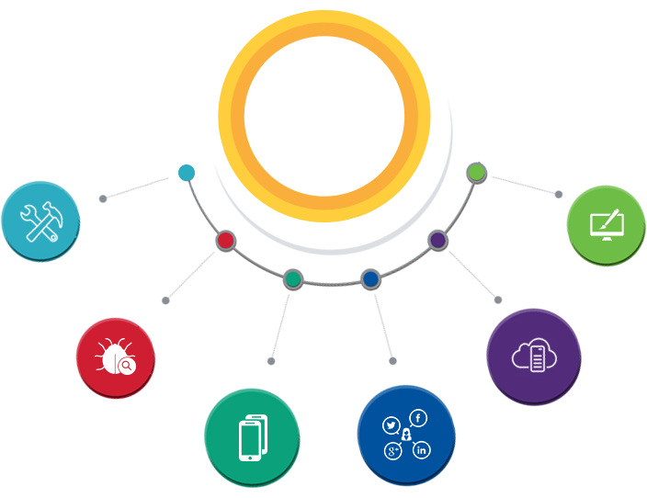

Technology  
&  
Services

Cloud/Traditional Hosting

User Interface & Design

Digital Marketing

Mobility Solutions

Testing Services

Application  
Development

# Functional Specification

|  |
| --- |
| Set up development environment and server - PHP CodeIgniter |
| Super Admin - |
| Dashboard |
| Manage Roles & Permissions |
| Manage Users |
| Master Management |
| Products |
| Retailers (sub items like route map, route master, contact etc..) |
| Country, Region |
| Shops |
| Users (Auditor) |
| Shops Products upload (No subcategories - direct SKU) |
| Create Shop Template |
| Audit Schedule |
| Audit Analytics |
| Reports (3) |
| Mobile API |

# Nonfunctional Requirement (Others)

|  |  |
| --- | --- |
| **Requirement** | **Details** |
| User Experience and  UI Design | * The application will be developed only in English and Arabic * The layout and graphical components will be created considering the usability factors |
| Performance | * Application will allow users to have smooth and quick access to the information or services they require. |
| Security | * The system will be protected against attempts of security breaching that may arise. * Web security standards will be followed. |

# Assumptions

The project solution is created from the initial understanding of the requirement. The proposed solution is based on the following assumptions for the application.

Objective:

* To develop an android retail audit application with features and functionalities are defined in the “Solution” section.

Design:

* Client to provide Verbat with the branding guidelines.
* Verbat is free to use custom made template for design, if required.
* Client shall provide licensed images and logos in specified size & format

Development:

* The proposed application front end and backend would be developed in English.
* System will be built with enough basic architecture to accommodate future additions / enhancements.
* Detailed system study is required before the start of the project.
* Admin can manage the users of the application.
* Requirements should be well defined, agreed and signed-off by the client.
* Verbat assumes that all sign-offs from Client will be provided within agreed and specified timeframe.
* Product details will accept the documents only in Excel format.
* Price Listing of the product will be its competitive price not the SRP.
* Auditors device should have an internet connectivity through out the audit session.
* Availability of the product in the Trade coverage list is restriced to the retail store.
* The client will finalize the functional requirements and prototype before the commencement of the development.
* Client will provide sample data to test the entire application.
* Testing of web application will be done in latest versions of Google Chrome, Mozilla, Edge and Safari web browsers.
* Client will procure templates, SSL certificates (if applicable)
* Client will host and manage the application on infrastructure (server / cloud) recommended by Verbat for managing database and application backup inclusive of images.
* Application and data backups are subject to the purchase of such services at an extra cost.
* During the requirement gathering phase, authorized personnel from the Client’s side is expected to be available for discussion and finalizing the HLD (High Level Design), before development commences.
* Internet connectivity is required for the functioning of the web application.

# Out of Scope

With the ever evolving digital market, the requirement should be clear to both the parties involved. Hence the following are considered to be out of scope while creating this proposal.

* Purchase of images, fonts and domain names
* Any language other than English
* Manual data entry
* Database migration
* Content writing
* Content or image procurement or uploading or editing.
* Audit Trail
* End user testing and load testing
* Adding new features to the application other than mentioned in the solution. Such requests will be handled via change management. For Change management details, please refer section titled “Change Management”.
* Annual Maintenance of the application (Bug fixing, debugging)- For AMC details, please refer section titled “Maintenance and Support”
* Hosting Infrastructure and Maintenance (web and email hosting), unless contracted for.
* Application Deployment on the server, unless contracted with Verbat.
* Backup solution and Disaster recovery unless contracted for.
* Physical deployment onsite / installation of the application in devices and Physical connection, installation of system.
* Integration with third-party, if any, other than mentioned in the functional requirements.
* Hardware Integrations / procurement and purchase
* Procurement of SMS gateway / payment gateway / email gateway
* Integration of SMS gateway / payment gateway
* SSL Purchase and installation, if any
* Plugin/template purchases, if any
* Relevant / related software libraries
* SRP or RRP of the product listing
* Auditor tracking.

# Technology Solution

## Proposed System Environment

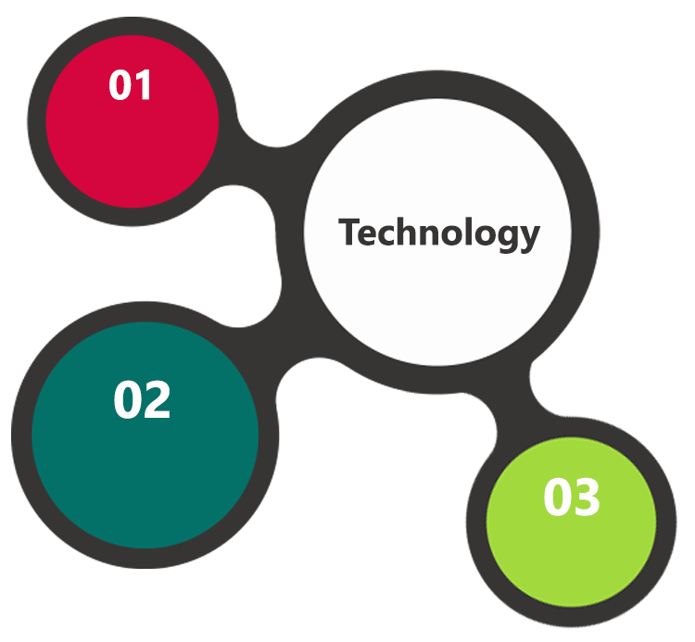

Apache, MySQL

PHP / Code Ignitor

HTML / CSS3

**MS SQL2012  
Windows 8/10  
Web Services**

## Technical Configurations

### Development Tools

* PHP, CodeIgnitor
* MySQL, Apache
* HTML / CSS 3
* Ajax, JavaScript, JQuery

### Recommended Web Hosting Package

* Medium CPU power – single to dual CPU
* Single Domain
* Windows Sever 2012R2 Data Center
* Disk Space: 5 GB
* Monthly Bandwidth: 10 GB
* Web site Server Software – IIS 8.0

### Browser Compatibility

* Chrome version: 56
* Firefox version: 51
* Edge version: 39

### Hardware Interface

**Desktop**

The application is reliant on hardware interfaces to provide a seamless automated user experience.

* Computer with Windows 8 or 10 OS
* Compatible Browsers as specified in section 7.2.3

# Commercials

## Web Application

|  |  |  |
| --- | --- | --- |
| **No** | **Description** | **Amount (USD)** |
| 01. |  | 00,000.00 |
| 02. |  | 00,000.00 |
|  |  |  |

*Note:*

* *The above cost does not include Application hosting, integration, Project Management or deployment*
* *For change management cost, please refer to section 10 titled Change Management*

## Payment Terms

* Payment terms
* Payment terms
* Payment terms

*Note: Payment should be made within 7 days from the date of the invoice*

## Mode of Payment

By Cheque / DD to Verbanet Technologies LLC

OR

Wire transfer to our bank account

Bank Name : Emirates NBD

Account Name : Verbanet Technologies LLC

Account Number : 1011492858201

IBAN Number : AE61 0260 0010 1149 2858 201

Swift Code : EBILAEAD

Bank Address : Mamzar Branch, Dubai

*Note: Bank charges incurred during wire transfer to be borne by the client. Any local taxes applicable to be borne by the client*

# Delivery Management

## Project Management

The Verbat development center strictly follows industry standards on quality. The project management is process governed by the Verbat Quality Management system and is put to verification through internal audit programs that happen from time to time.

Verbat will dedicate a project manager for the proposed implementation. Verbat proposes Client to identify one project manager who will be driving activities to be undertaken by Client to be the single point of contact for Verbat.

## Roles and Responsibilities

Verbat will assign a dedicated Project Manager/Project Lead to lead the project, who will be the first point contact for Client. He/she will be responsible for planning and managing the various activities within the project. He/she will work closely with Client Project Manager, to give periodic status updates and ensure high level of visibility and comfort on the progress of the project.

The Project Manager/Project Lead will lead the co-ordination between Verbat and Client, thus enabling smooth transitioning of Client requirements to the Verbat’s offshore delivery team, and provide visibility as well as comfort on the progress of the services to Client.

He/she will have periodic meetings with Verbat’s Senior Management, thus ensuring Verbat’s Management commitment and focus on Client initiatives.

## Delivery Activity Summary

|  |  |
| --- | --- |
| Activities | Description |
| Detailed requirement Analysis | Verbat team to conduct detailed study of requirement for the phase. If clarification is required, team will reach out to Client for more information and/or time for discussions. |
| DB Design | DB design for central and test DB. |
| Software Requirement Specification document (SRS) | Once the requirement analysis is completed, Verbat team will submit the SRS document for approval |
| UI/UX Design, Prototyping | Based on the SRS, Verbat UX/UI team will work on the UI/UX of the screens and submit a prototype for approval |
| Functional Specification Document (FS) | Once the Prototype. UI/UX is approved, Verbat shall submit an FS document for approval. |
| Development | Actual system development starts based on the FS. This involves detailed design and software development of Web Application. |
| Testing | Test Planning, test plan creations, internal, integration testing and user acceptance testing. |
| Deployment | Deploying the latest built in the Verbat Test Server. |

## Project Implementation Plan

Verbat will be providing the solution in a stand-alone fixed bid approach which ensures minimum viable solution for quick wins with core focus on the long-term business objective and outcome. Once the implementation is over, Verbat will initiate the application maintenance process (once the maintenance contract is signed) which continues to extend after the implementation.

## Deliverables

* Project Plan
* SRS
* Prototype of the application
* Test Cases
* User Manual
* Source Code
* Fully Developed & Tested Application

## Estimated Delivery Time

**5 UAE working days for prototype from the date of Approval of the project (LPO/Signed proposal) with advance payment: 45 working man days UAE Working days for the development of the application from the Date of Approval of the Prototype.**

## Deployment Details (at Clients Behest)

* Client can opt for hosting the application at Verbat’s Server.
* If deployment is at the client’s server, responsibility of deploying the application onto the production environment after conducting the necessary acceptance testing will lie with the client unless and until Verbat’s support is contracted for deployment.

***Note****: Hosting the application at Verbat’s server will call in for additional charges.*

## Release Planning

* Client will be informed about the release date and time through email.
* Client performs the UAT

## Risk and Contingency Planning

Verbat has identified various risk factors associated with this assignment and understands the impact of these risk factors on the project schedules. The objective of this section is to highlight for both Verbat and client, the risk factors, to analyze the impact of the risks on project execution, and to propose strategies to control and reduce the impact of the risk factor.

These various risks, which could arise during the project, are tabulated below along with mitigation implementation.

| Type of risk | Impact | Risk Mitigation | Risk Handling |
| --- | --- | --- | --- |
| Scope Creep | H | Functions and features will be detailed in system requirement documents and will go through client approval. Once this document is approved, any change to requirement will go through change management review for possible impact assessment. | Proper change management procedure will be implemented. |
| Delay in customer feedback | H | The plan is prepared with enough lead-time for customer reviews and approvals.  The customer is indicated with the dates when the document is expected after review and approval. | The request for feedback will be escalated if not attended at the right time so that the schedules are not affected. Deemed acceptance criterion is set up front and will be followed. |
| Non-availability of necessary software’s, frameworks, database instances and infrastructure at client’s hosting environment(If hosting support is provided by Verbat) | M | Client will be informed in advance on these requirements. | Possible impact to schedule. |
| Manpower attrition | L | All efforts would be made to ensure process dependence rather than being person dependent. As a risk mitigation plan Verbat will train backups. | A new person will be identified as early as possible, provided the required project-specific training and mentored by the senior members of the team to minimise impact of attrition on the project. |

*H-High, M-Medium, L-Low, NA-Not Applicable*

# Change Management

Any addition which comes out of the project scope, upon and after the launch of the tool will be considered as change management. Verbat recommends the following change management procedure for the same.

* Any change which comes out of the project scope, which was discussed, documented, and mutually approved by both the parties in the requirement stage, will be carried out only through raising a change request.
* Change request will be studied and an impact analysis on the existing work flow will be performed.
* On finalizing the impact, effort estimation for the change will be calculated and raised as additional requirement.
* Verbat will initiate the change request only after getting a formal approval from the client for the additional changes raised.
* Any change from the scope will be charged at **USD ----- per man day effort** and approval from the clients will be availed before commencing on any change management.

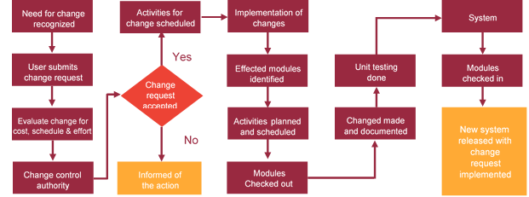

# Miscellaneous

## Acceptance Criteria

* UAT sign off should happen within 7 Days from the release of the application/ Phase and the acceptance confirmation needs to be mailed to Verbat failing which Verbat will consider the project as approved by the client.
* Any comments or reason for rejection need to be documented and the same needs to be sent as an email from the official mail id of client to Verbat.

## General Terms and Conditions

* An average of 20 working days are assumed in a month
* All the projects activities will be carried out from our off-shore development center in India
* The scope of the project is to develop the Application as detailed in the scope of the project and mentioned in this proposal. Any changes or additions will have to go through change management.
* This proposal and all technical/ functional specifications have been derived or concluded from the data shared via email / information's transferred during the initial requirement analysis meetings and conversations. Verbat reserves the right to amend the terms of this proposal, should the SOW terms, functional features and functionalities change during the course of the project
* Application will be best viewed only in the environment mentioned in the section 7.2.3
* All the documentation will be provided in English.
* Third party components may be used to develop this application.
* All Source Code and other project artefacts would adhere to the Verbat document templates and internal coding standards
* Acceptance criteria shall be based on the clauses which were mutually discussed between Verbat and client at the Requirement Analysis phase and the same will be documented and approved by both parties through official emails
* In case Client requires any extension of the proposed acceptance schedule, the associated effort and cost of such extension can be mutually reviewed.
* For any circumstances if project needs to be put on Hold / Stop it requires minimum request notice period of 1 week along with duration for which request will be addressed by management and final decision on the request will be based on that
* If deployment is done in client’s server, Verbat cannot be held responsible for any performance issues arising due to hardware malfunctions.
* Client is responsible for data backup in case the application is not hosted on Verbat server.
* Source code will only be delivered or uploaded on the Production Server once the due payments are made.

## Assumptions and Dependencies

* Detailed system study is required before the start of the project.
* During the requirement gathering phase, authorized personnel from the Client’s side is expected to be available for discussion and finalizing the HLD (High Level Design), before development commences.
* Type of reports and formats, if under the scope of the project, needs to be specified by Client before project sign off.
* Workflows if under the scope of the project, need to be specified/ confirmed by client before project signoff.
* All queries regarding the client requirement and any queries which may hinder the project advancement at any stage should be answered by the client within 24 hours from the time of initiation, failing which the time delay will get added to the actual effort which was estimated.
* Verbat assumes that all sign-offs from Client will be provided within agreed and specified timeframe.
* Client will provide all the necessary contents, both text and image, before starting the project in the format suggested by Verbat (if any).
* The client should provide the relevant information and data well in time for the execution of a related activity. Non- availability of this information or data may lead to an interruption of work which may result in a delay in delivery as well as additional costs to the client.
* Client should have/possess server with technical specifications as suggested by Verbat for the proposed application.

## Source Code & Intellectual Property Rights

* Upon completion of the Project and 100% completion of the payment, client will have access to the source code except for propriety codes, developer tools and third party application etc.
* The solution offered will be the intellectual property of the client and will be made available to the client on an “unlimited license” basis.
* Modifications by third party/person: No person or organization, other than Verbat or any person authorized by Verbat in writing, has any permission to modify/change the software Solution to be eligible to get continued support from Verbat as per the support terms defined under this document.
* Liabilities/Damages: Verbat accepts no liability or damages of any kind arising out of use or non-use of the software delivered. The responsibility of testing of software lies with Client.

## Maintenance & Support

* Maintenance contracts by default are supported as per the basic SLA terms.
* **AMC with Basic SLA is charged at 20 % of the total project value**. Additional Effort/change management request will be added towards Total Value of the Project to determine the AMC value.
* Maintenance support is limited to providing application support for ensuring the consistency of the look-and-feel, bug fixes and user issues i.e. maintenance and support of the existing features of the application.
* Support does not in any way cover providing technical or other support to the end users. The maintenance agreement does not include functionality changes or feature additions which are handled as change requests which will be charged AED 1200 per man day. AMC does not include server support, maintenance and application deployment.
* AMC charges will cover Off-Site Support and Debugging. Support includes E-mail, Telephone and Chat unless explicitly specified. In the event, the application is hosted with the client; necessary remote desktop connectivity should be provided for carrying out maintenance activity.
* Gap in AMC - In case if the client does not opt an AMC for a year and want to renew it after that period, 50% of the AMC amount for the year for which AMC is not taken will also be payable if the client wishes to renew the AMC contract.
* Note:
  + Please note that the AMC support shall start only after all the necessary sign-offs (AMC Document) to this effect have been given.
  + It is not mandatory that the client should opt for an AMC. The client will still be supported on an ad-hoc basis on an agreed man-day rate.
  + AMC Payment Terms: 100% to be paid as advance.

## Service Level Agreement

|  |  |  |  |  |
| --- | --- | --- | --- | --- |
| **Key** | **Max Response Time** | | **Max Resolution Time** | **Target** |
| Basic | 1  working day | 3 working days | | Request / incident / problem tickets |
| Advanced | 5 Business Hours | 12 Business Hours | | Request / incident / problem tickets |
| Priority | 3 Business Hours | 5 Business Hours | | Request / incident / problem tickets |

Note:-

* We provide Basic SLA as standard with AMC while Advanced and Priority SLAs attract additional charges.
* Time zone applicable as per India time zones (3:30 AM GMT to 12:30 PM GMT- Monday to Friday).

# Our Clients

**UAE University**

Education

Transportation

**Canada Cartage**

Construction

Services

Finance

We look forward to hearing from you soon and hope that you will give us the privilege to work with you in meeting your business goals. Thank you.

Thank You



©   
1999 - 2017. All Rights Reserved   
Verbanet Technologies LLC  
www.verbat.com