roid

217, Sheikh Rashid Building

P.O Box 56272, Dubai

United Arab Emirates

Tel: +971 4 2973236 / 04 2974007

Email: uae@verbat.com

PROJECT   
PROPOSAL

**Employee Smart App**

|  |  |
| --- | --- |
| **Prepared for:**  **_______** | **Submission Date:**  31 March 2018  **Proposal ID:** AD/BP/31032018/1343/1 |

___________________________________________________________________________________________________________________________________________  
Conﬁdentiality Notice: This Proposal is conﬁdential and contains proprietary information and intellectual property of Verbanet Technologies LLC. Neither this proposal nor any of the information contained herein may be reproduced or disclosed under any circumstances without the express written permission of Verbanet.

© 2017 by Verbanet Technologies LLC. All rights reserved. Confidential.

___________________________________________________________________________________________________________________________________________

Project Contacts

|  |  |
| --- | --- |
| Client Information | |
| Project Name | Employee Smart App |
| Client Name | Transguard |
| Client Address | -------------------------- |
| Contact Person |  |
| Contact Person Email |  |
| Contact Person Phone Number |  |
| Verbat Information | |
| Contact Person | Joyce Daniel |
| Contact Person Phone Number | +971 42973236 |
| Contact Person E-Mail | [joyce.daniel@verbat.com](mailto:joyce.daniel@verbat.com) |
| Address | PO Box 56272, Dubai, United Arab Emirates |
| Physical Address | 217, Sheikh Rasheed Building, Hor Al Anz East |
| Project Information | |
| Proposed Technology/Methodology | AngularJS, NodeJS, ExpressJS, MongoDB |
| Anticipate Start Date | NA |
| Proposal Valid For | 30 Calendar days from the submission of the proposal |

**Table of Content**

1 Scope of Work 7

1.1 Solution Objective 8

1.2 Response from Vendor 8

1.2.1 Employee App (IOS/Android) 8

1.2.2 Employee Web Portal 12

1.2.3 WFS Dashboard/Back End System 12

1.2.4 Others 14

1.2.5 Nice to Have 14

1.3 Advantages of Proposed Solution 16

1.4 Why Verbat 17

1.5 Key Differentiators 18

1.6 Technology & Services 19

2 Functional Specification 20

2.1 Site Design & Development 20

2.2 Admin Features 23

2.3 System Features 24

2.4 Mobile features 26

3 Connect.ae UX Tear Down 29

3.1 Who are the key users? 30

3.2 What is the user’s number one critical goal in using the site? 30

3.3 What is likely to make the user’s experience particularly positive? 30

3.4 What is the approximate information architecture for the site? 30

3.5 What style(s) of navigation is/are used? Do they answer the key questions (Where am I and how did I get here? Where should I go next and how do I get there?)? 31

3.6 What key interactions does the user have? Are they clear and usable? 31

3.7 What did the site of well to allow the user to accomplish his goal effectively, efficiently, and with good satisfaction? 32

4 User Characteristics 33

4.1 Customers 33

4.2 Advertisers 35

4.3 Connect.ae 36

5 High Level Solution 37

5.1 High Level System Architecture 37

5.2 Keyword search 39

5.3 System Workflow (High Level) 40

5.4 Data Architecture Overview 42

5.5 Application Architecture Overview 43

5.5.1 Agile Development Mode 45

5.5.2 Approval Hierarchy 46

5.5.3 Maps 46

5.6 System Architecture 46

6 Nonfunctional Requirement (Others) 48

7 Assumptions 48

8 Out of Scope 49

9 Technology Solution 50

9.1 Proposed System Environment 50

9.2 Technical Configurations 51

9.2.1 Development Tools 51

9.2.2 Recommended (minimum) Web Hosting Package 51

9.2.3 Browser Compatibility 51

9.2.4 Hardware Interface 51

9.2.5 Third Party Licensing 51

10 Commercials 53

10.1 Web Application 53

10.2 Payment Terms 53

10.3 Mode of Payment 53

11 Delivery Management 54

11.1 Project Management 54

11.2 Roles and Responsibilities 54

11.3 Delivery Activity Summary 55

11.4 Project Implementation Plan 55

11.5 Deliverables 55

11.6 Estimated Delivery Time 56

11.7 Deliverables 57

11.7.1 Phase 1 Web 57

11.7.2 Phase 1 & 2 Mobile (IOS & Android) 58

11.7.3 Phase 2 Web 58

11.7.4 Phase 3 59

11.8 Release Planning 59

11.9 Risk and Contingency Planning 59

12 Change Management 60

13 Miscellaneous 62

13.1 Acceptance Criteria 62

13.2 General Terms and Conditions 62

13.3 Assumptions and Dependencies 63

13.4 Source Code & Intellectual Property Rights 63

13.5 Maintenance & Support 64

13.6 Service Level Agreement 65

14 Our Clients 66

# Scope of Work

Transguard has witnessed a steady rise in the headcount of their employees and are finding it difficult to manage employee requests and to service employee needs.

HR has requested the need for an application with the following features

* Pay slip Requests
* Annual Leave Management
* Sick Leave Management
* Contact Information
* NOC Letter request
* Salary Transfer Letter Request
* Air Ticket Request
* Updating bank details
* Updating contact information
* Updating pass information
* General queries

While the current process in manual, management would like to introduce a digital platform for employees to raise requests and submit and receive information. The digital platform could take form as a mobile application (employee smart app) or cloud based interface through web browser. The solution should integrate with their Oracle ERP system where current employee information and HR data is stored. The solution would allow interaction between employee and BU to be clear, scalable, tracked and simple to use. There should also be a back end system which allows BU to manage requests through a dashboard, highlighting dates/times queries were requested and closed, similar to a HR Ticketing system.

**Stand-Alone Fixed Bid**

Verbat will be following a stand–alone fixed bid solution delivery model wherein the required solution would be devised and a suitable pricing would be offered.

## Solution Objective

The goals of the project are

* Implement a mobile based application (IOS or Android) for WFS Outsourced employees
* Allow users to access the same features through a mobile web browser
* Implement a back office dashboard in a web browser format or desktop application that tracks in real time all employee queries and requests
* Integrate solution with Oracle ERP & HR 360
* Install a control centre screen/CPU setup for the HR Administration team to view open queries and requests.
* Employee Access to view data, submit data, request documents, download pay slip, update contact information, submit leave information, view HR documentation
* Pilot test for TG HQ staff
* Ensure that line manager integration is available for leave approvals.

## Response from Vendor

|  |  |
| --- | --- |
| **Scale** | **Description** |
| **10** | S- Standard feature |
| **5** | C-Customisation required. |
| **0** | U-Unavailable |

### Employee App (IOS/Android)

**NOTE:** “S” refers to the features that are available within the application developed, however there may be external dependencies and they are implied in the comments column.

|  |  |  |  |  |
| --- | --- | --- | --- | --- |
| # | Requirement Description | Priority (H/M/L) | Vendor Response (S/U/C) | Vendor Comments |
| 1.1 | Employee login through TG ID and password. TG ID is generated in Oracle. Password reset system required with authentication. | H | S | Access to oracle API access to be provided by client |
| 1.2 | Mobile App Home page. To include Employee photo taken from HR360. | H | S | Access to oracle API access to be provided by client |
| 1.3 | Feature to upload photo if picture unavailable from HR 360 | L | S |  |
| 1.4 | Designation, Client name and TG ID no. to be displayed on home page | H | S | This information comes from the local DB instance (not ORACLE) |
| 1.5 | Home page to have links to the following pages:  -Personal Information  -HR Requests  -Payroll  -Leave Management  -Feedback  -Notifications  -Log Out | H | S |  |
| 1.6 | Under Personal Information page employee should have access to update contact information, such as phone no. email I.D, home address, and Emergency contacts. All features are currently available in Oracle | H | S | Access to Oracle via Oracle API required. Client shall provide vendor with the required access and API information |
| 1.7 | HR Requests page to have the following features.  -Request Salary Certificate   * Salary Certificate Language (English/Arabic/Both) * Generic or addressed to (please specify…)   -Request NOC for the following   * Liquor License * Embassy/Consulate (please specify country) * RTA(Application for Driving License), specify license type (private car, motorcycle,)   -Request Salary Transfer Letter   * Control function required if active salary transfer letter is issued. * Once Salary transfer Letter is issued a control measure is required if new request is made. Control should specify that clearance or non-liability letter required. Control requires Payroll Administrator authorization.   -Employment/Service Certificate Request  -NOC for new employer. | H | S | This information will be stored in the application developed |
| 1.8 | Under payroll page employee can access all pay slips since beginning of employment. Option to select pay slip by month. Once selected pay slip to open in pdf format. Employee to have option to save, print or email pay slip | H | S | Access to Oracle API shall be provided by the client |
| 1.9 | Under leave management the following features are required.   * Leave balance to be made visible * Line manager details to be visible * Annual leave request * Authorized Unpaid leave request * Sick Leave Request (Upload Sick Leave Certificate, with line manager approval) * Approval status * Start date, end date * Air ticket request * Air ticket destination as per oracle * Flight departure date * Flight return date * Date of application * Comments | H | S | Leave management shall be managed within the application as well as air ticket request information. The application shall not manage the booking of the air ticket or allied services related to travel. Information flow from Oracle shall be provided by client via API’s |
| 1.10 | Feedback page must allow employees to send a message through the app to the HR Administrator team.   * Pre-defined drop-down menu can categories request   -Categories to include   * Payroll * Leave * Visa * Medical Insurance * Place of Work * Contract * Others | H | S |  |
| 1.11 | Notification page should highlight any pending notifications with a red circle and the number of notifications pending.   * Notifications can include NOC Requests received through app * Communication from HR admin team in response to a feedback request * Can be a single page communication from HR Admin team notifying of any benefits/changes/updates | H | S | Notifications from Oracle (if any) shall be accessed via Oracle API provided by client |
| 1.12 | Log out feature to allow user to return to login page. | H | S |  |

### Employee Web Portal

|  |  |  |  |  |
| --- | --- | --- | --- | --- |
| Ser | Requirement Description | Priority (H/M/L) | Vendor Response (S/U/C) | Vendor Comments |
| 2.1 | Accessible through desktop web browser or mobile web browser | H | S |  |
| 2.2 | Can integrate login portal on Transguard Workforce Solutions web page | H | S |  |
| 2.3 | Same functionality as IOS/Android App | H | S |  |

### WFS Dashboard/Back End System

|  |  |  |  |  |
| --- | --- | --- | --- | --- |
| Ser | Requirement Description | Priority (H/M/L) | Vendor Response (S/U/C) | Vendor Comments |
| 3.1 | HR Administrator to access employee smart app dashboard on a web browser | H | S |  |
| 3.2 | HR Admin rights to be provided and managed by Super User | H | S |  |
| 3.3 | Once logged in HR Admin can review all ‘open requests’ received from employees with oldest request visible on top | H | S |  |
| 3.4 | Request lines to summarize the following:  employee photo, name, TG ID number, contract, date/time requested, type of request, contact number, email ID | H | S |  |
| 3.5 | Super User can assign request to each HR admin member | H | S |  |
| 3.6 | HR Admin member can select a request to action. Once selected request is moved to ‘Request in process’ list | H | S |  |
| 3.7 | HR Admin can upload document, i.e NOC letter against a single request. Uploaded documents can be several file types, pdf, jpeg | H | S |  |
| 3.8 | HR admin can select close request once completed. When the request is closed it will move to ‘Request close list’ | H | S |  |
| 3.9 | Dashboard to be divided into 3 segments.  Open Requests  Requests in Process (including requests from last week)  Requests closed (7 days) | H | S |  |
| 3.10 | Request type to have associated SLA turnaround time.  If 50% of the SLA Time has passed the request should display green.  If 75% of the SLA time has passed the request should display amber.  If 100% of the SLA time has passed the request should display red. | H | S |  |
| 3.11 | Reporting feature in the dashboard to analyze data.  Report by request type  Time taken from request start to close  HR Admin performance based on SLA  Total number of requests by date period  Report by contract | H | S |  |

### Others

|  |  |  |  |  |
| --- | --- | --- | --- | --- |
| # | Requirement Description | Priority (H/M/L) | Vendor Response (S/U/C) | Vendor Comments |
| 4.1 | Line Manager hierarchy to implement into Oracle  Employee to be assigned a line manager. | H | S |  |

### Nice to Have

|  |  |  |  |  |
| --- | --- | --- | --- | --- |
| # | Requirement Description | Priority (H/M/L) | Vendor Response (S/U/C) | Vendor Comments |
| 5.1 | Functionality to store employee document details such as:  Passport  Visa  Medical Insurance  Contract  Pass Information (JAFZA, DIFC, TECOM)  Employee to access documents as files (pdf, jpeg) available to email, save, print. | L | S |  |
| 5.2 | Implement Time & Attendance Module (Monthly) within the app.  Employee can confirm full monthly attendance  Leave requests automatically reflected in T&A.  Line Manager to approve leave requests and sick leave documents  Line manager to batch approve T&A  Line manager to be able to specify commission or incentive for each employee  Reporting for T&A  Linking to payroll GTN processing  Module to be considered within phase 2. | M | S | Not included in this proposal |

Verbat’s Solution architects have conducted a thorough research on the requirements and have come to the conclusion that our proposed solution, which is detailed further in this document, will meet the requirements put forth by the client. And the proposed solution will be delivered in a phased approach as per Verbat’s stand-alone fixed bid solution model.

**Strong and Scalable platform:** The platform proposed will be strong and scalable enough to accommodate future enhancements.

**Accelerated solution:** The framework would act as a solution accelerator. It would provide the basic building blocks which could be reused in future for building new components and features.

**High performance:** The light weight framework used consumes fewer system resources thereby making the application perform faster.

**Security:** The application will be developed considering various aspects of security.

## Advantages of Proposed Solution

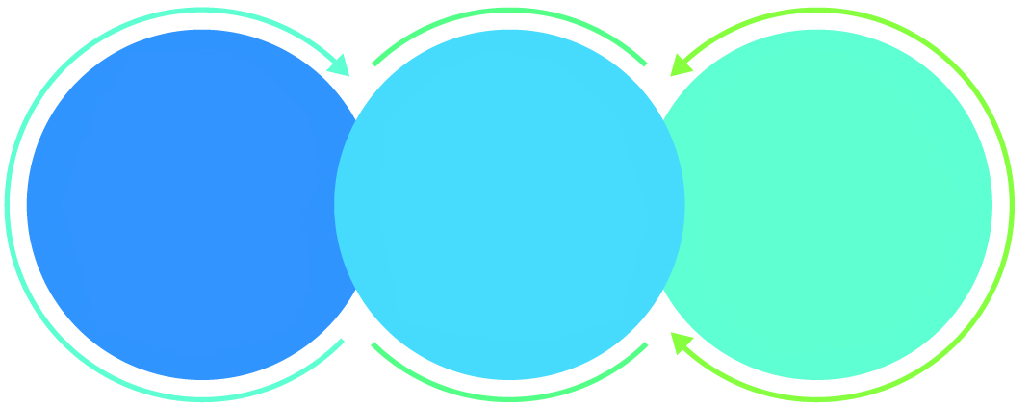

01

Agile development offering reliable, secure solution

02

Smooth transition and quicker completion of processes

03

User friendly interfaces enabling easy navigation between screens

## Why Verbat

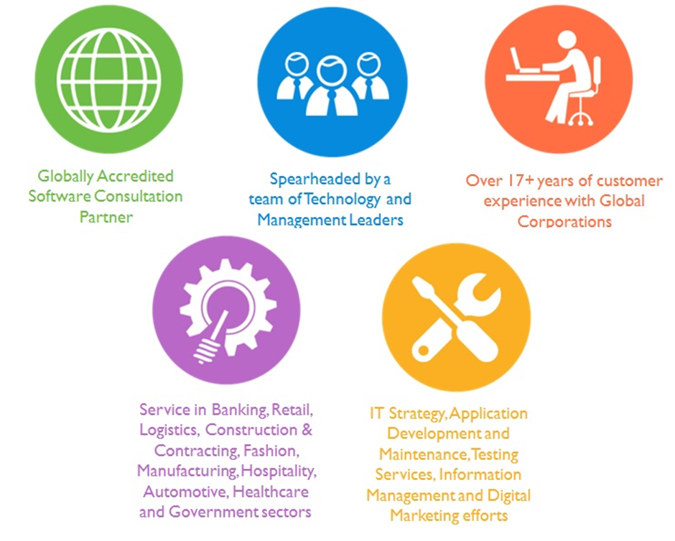

## Key Differentiators

Delivered digital transformation expertise to global customers for over a decade by following industry best practices to maximize ROI for client

Keen technology intelligence combined with aggressive market research to deliver solutions that achieve results with measurable value

Enable access to global consulting expertise with strong local market and business knowledge

Commercial Model that is customizable for your business needs

Services that are designed to optimize applications for improved performance and overall efficiency

1,000,000 plus man-hours of expertise in technology frameworks spanning Microsoft, Open Source, mobility platforms and other proprietary IT technology

Partners top technology vendors to bring in the latest and best services in integration, collaboration, and development

Commercial Model that is customizable for your business needs

Proven Methodologies & Processes

Investment in R & D

Strong Local Presence

Flexible commercial Models

Technology Associations

Software Development Experience

Offshore Development Centre

Quality Assurance & Testing

## Technology & Services

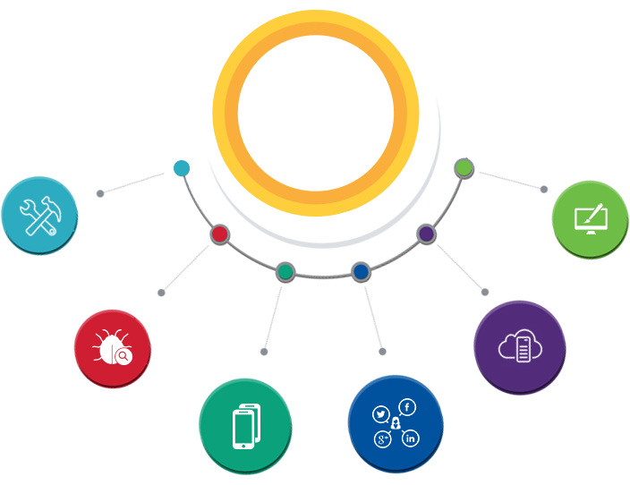

Technology  
&  
Services

Cloud/Traditional Hosting

User Interface & Design

Digital Marketing

Mobility Solutions

Testing Services

Application  
Development

# Functional Specification

## Mobile application (Android)

|  |
| --- |
| **UI Design** |
| Page Design |
| **Development** |
| Basic Setup |
| Splash Screen |
| Employee login through TG ID and password |
| Mobile App Home page |
| Employee photo taken from HR360 |
| Upload photo if picture unavailable from HR 360 |
| Log Out |
| Personal Information |
| HR Requests |
| Payroll |
| Leave Management |
| Feedback |
| Notifications |
| Personal Information edit page |
| Request Salary Certificate |
| Request NOC for the following |
| Request Salary Transfer Letter |
| Employment/Service Certificate Request |
| NOC for new employer |
| **Api Integration** |
| API Integration |

## Web Application

### Agile Development Mode

Verbat Practices distributed Agile development methodology, because we realize that communication between geographically distributed teams becomes cumbersome if the project is not supplemented by ancillary documents such as project plan, SRS, wireframes, prototypes etc. Based on past experience, our clients have appreciated the prospect of knowing upfront what is being built at a reasonably high level of detail, while still having the flexibility to mediate change in requirements or priorities.

While this is our general approach, Verbat can adapt and comply with development standards that are agreeable to the client.

# Nonfunctional Requirement (Others)

|  |  |
| --- | --- |
| **Requirement** | **Details** |
| User Experience and  UI Design | * The application will be developed only in English and Arabic * The layout and graphical components will be created considering the usability factors |
| Performance | * Application will allow users to have smooth and quick access to the information or services they require. |
| Security | * The system will be protected against attempts of security breaching that may arise. * Web security standards will be followed. |

# Assumptions

The project solution and technology is created from the initial understanding of the requirement shared with Verbat through mails and meetings. The proposed solution is based on the following assumptions:

* Client to provide Verbat with the branding guidelines.
* The proposed application will be bilingual (English & Arabic)
* Client will purchase the necessary templates needed for development
* Client shall provide licensed images and logos in specified size & format
* Requirements should be well defined, agreed and signed-off by the client
* Internet connectivity is required for the functioning of the web application.
* Testing will be done in latest versions of Google Chrome, Mozilla, Safari, & Edge web browsers only
* Development Contingent upon timely feedback from client
* Application shall support SDK version 19 (KitKat) and above
* Application designed for mobiles in portrait mode
* HR360 Android SDK and Documentation will be provide
* API access to Oracle ERP and HR 360 Application to be provided by client
* Login, Employee details, leave information etc. may require Oracle access
* Air ticket booking, cancellation, hotel accommodation etc. are not managed by the application being developed

# Out of Scope

Following are considered to be out of scope while creating this proposal.

* Purchase of images, fonts
* Adding new features to the application other than mentioned in the functional specification.
* Any language other than English & Arabic
* Manual data entry
* Hardware Integrations / procurement and purchase
* Database migration
* Content writing
* Content or image procurement or uploading or editing.
* Hosting Infrastructure and Maintenance
* Annual Maintenance of the application (Bug fixing, debugging) - For AMC details, please refer section titled “Maintenance and Support”
* Physical deployment at client’s site
* Backup solution and Disaster recovery
* Time and attendance module is not included within this proposal

# Technology Solution

## Proposed System Environment

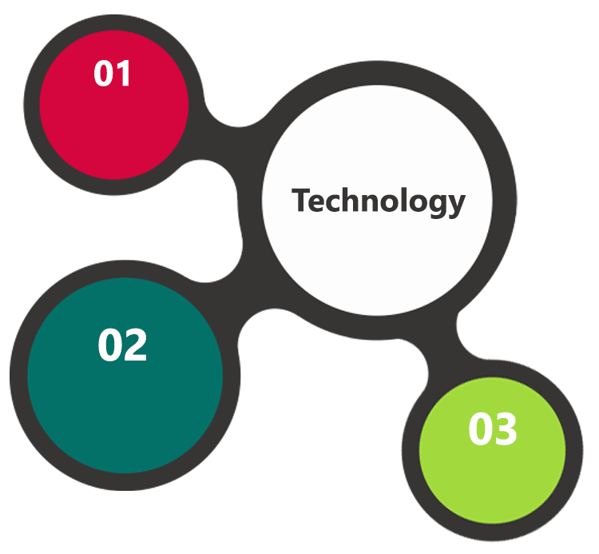

NodeJS, Express, MongoDB

Angular

HTML / CSS3/ Jquery

**MS SQL2012  
Windows 8/10  
Web Services**

## Technical Configurations

### Development Tools

* MVC, Angular
* NodeJS, Express JS, MongoDB
* HTML / CSS 3
* Ajax, JavaScript, JQuery

### Recommended (minimum) Web Hosting Package

* OctaCore CPU
* RAM: 32 GB
* MongoDB Enterprise Advanced
* Disk Space: 1 TB
* Monthly Bandwidth: 20 TB
* Web site Server Software – Apache

### Browser Compatibility

* Chrome version: 56
* Firefox version: 51
* Edge version: 39
* Safari version 10.1

### Hardware Interface

**Desktop**

The application is reliant on hardware interfaces to provide a seamless automated user experience.

* Computer with Windows 8 or 10 OS
* Compatible Browsers as specified in section 7.2.3

# Commercials

## Web Application

|  |  |  |
| --- | --- | --- |
| **No** | **Description** | **Amount (USD)** |
| 01. |  | 00,000.00 |
| 02. |  | 00,000.00 |
|  |  |  |

*Note:*

* *The above cost does not include Application hosting, integration, Project Management or deployment*
* *For change management cost, please refer to section 10 titled Change Management*

## Payment Terms

*Note: Payment should be made within 7 days from the date of the invoice*

## Mode of Payment

By Cheque / DD to Verbanet Technologies LLC

OR

Wire transfer to our bank account

Bank Name : Emirates NBD

Account Name : Verbanet Technologies LLC

Account Number : 1011492858201

IBAN Number : AE61 0260 0010 1149 2858 201

Swift Code : EBILAEAD

Bank Address : Mamzar Branch, Dubai

*Note: Bank charges incurred during wire transfer to be borne by the client. Any local taxes applicable to be borne by the client*

# Delivery Management

## Project Management

The Verbat development center strictly follows industry standards on quality. The project management is process governed by the Verbat Quality Management system and is put to verification through internal audit programs that happen from time to time.

Verbat will dedicate a project manager for the proposed implementation. Verbat proposes Client to identify one project manager who will be driving activities to be undertaken by Client to be the single point of contact for Verbat.

## Roles and Responsibilities

Verbat will assign a dedicated Project Manager/Project Lead to lead the project, who will be the first point contact for Client. He/she will be responsible for planning and managing the various activities within the project. He/she will work closely with Client Project Manager, to give periodic status updates and ensure high level of visibility and comfort on the progress of the project.

The Project Manager/Project Lead will lead the co-ordination between Verbat and Client, thus enabling smooth transitioning of Client requirements to the Verbat’s offshore delivery team, and provide visibility as well as comfort on the progress of the services to Client.

He/she will have periodic meetings with Verbat’s Senior Management, thus ensuring Verbat’s Management commitment and focus on Client initiatives.

## Delivery Activity Summary

|  |  |
| --- | --- |
| Activities | Description |
| Detailed requirement Analysis | Verbat team to conduct detailed study of requirement for the phase. If clarification is required, team will reach out to Client for more information and/or time for discussions. |
| DB Design | DB design for central and test DB. |
| Software Requirement Specification document (SRS) | Once the requirement analysis is completed, Verbat team will submit the SRS document for approval |
| UI/UX Design, Prototyping | Based on the SRS, Verbat UX/UI team will work on the UI/UX of the screens and submit a prototype for approval |
| Functional Specification Document (FS) | Once the Prototype. UI/UX is approved, Verbat shall submit an FS document for approval. |
| Development | Actual system development starts based on the FS. This involves detailed design and software development of Web Application. |
| Testing | Test Planning, test plan creations, internal, integration testing and user acceptance testing. |
| Deployment | Deploying the latest built in the Verbat Test Server. |

## Project Implementation Plan

Verbat will be providing the solution in a stand-alone fixed bid approach which ensures minimum viable solution for quick wins with core focus on the long-term business objective and outcome. Once the implementation is over, Verbat will initiate the application maintenance process (once the maintenance contract is signed) which continues to extend after the implementation.

## Deliverables

* Scope Document
* Project Plan
* Design templates
* Functional Specification Document
* Prototype of the application
* Test Plan Document
* User Manual
* Source Code
* Fully Developed & Tested Application

## Estimated Delivery Time

The effort estimated for delivering the application is as follows;

|  |  |  |
| --- | --- | --- |
| Phase | No of sprints | Total Man Days |
| System Study | 1.5 | 54 |
| Phase 1 | 3 | 510 |
| Phase 2 | 3 | 535 |
| Phase 3 | 2 | 119 |

|  |  |  |  |  |  |  |  |  |  |
| --- | --- | --- | --- | --- | --- | --- | --- | --- | --- |
|  | **Sys Study** | Phase 1 | | | Phase 2 | | | Phase 3 | |
| Resource | 1.5 Months | Sprint 1 | Sprint 2 | Sprint 3 | Sprint 4 | Sprint5 | Sprint 6 | Sprint 7 | **Sprint 8** |
| Project Manager | 4 | 7 | 10 | 5 | 11 | 10 | 5 | 3 | 3 |
| Business Analyst | 15 | 5 | 12 | 5 | 16 | 10 | 0 | 0 | 5 |
| UX | 25 | 10 | 15 | 3 | 25 | 15 | 2 | 1 | 1 |
| App Arch | 2 | 8 | 5 |  | 8 | 5 |  |  |  |
| DB Arch | 1 | 5 |  |  | 6 |  |  |  |  |
| Tech Lead | 3 | 15 | 10 | 5 | 18 | 10 | 5 | 0 | 0 |
| Sr. Dev |  |  | 25 | 20 |  | 20 | 20 | 0 | 0 |
| Developer |  |  | 80 | 80 |  | 80 | 80 | 10 | 10 |
| Android |  |  | 20 | 15 | 15 | 8 | 13 | 10 | 10 |
| IOS |  |  | 20 | 20 | 15 | 20 | 15 | 10 | 10 |
| QA Manager | 4 | 7 | 8 | 8 | 8 | 7 | 6 | 3 | 3 |
| QA |  | 5 | 20 | 62 |  | 20 | 62 | 20 | 20 |

* **20 UAE working man days per sprint**
* **Days for the development of the application from the Date of Approval of the Project: 6 working man months**

## Deliverables

Development will be split into 2 phases. Each phase split into 3 sprints each with a concise description of items that will be delivered for each sprint. The deliverables for each sprint will be dictated by the client.

The list below is a brief overview of the items that will be delivered mainly for referral purposes. The actual items delivered will be vary based on the decisions made at the time.

### Phase 1 Web

|  |  |
| --- | --- |
|  | Description |
| 1 | Home page and home page sections |
| 2 | Application framework |
| 3 | Application prototype and design |
| 4 | CMS integration for header and footer links including page content |
| 5 | Search results page |
| 6 | Business profile pages |
| 7 | Customer registration via social media with address details / login |
| 8 | Business registration and profile creation / login |
| 9 | Admin dashboard ( add customers, business, editors, publishers) |
| 10 | Publishing workflow |
| 11 | Search bar features |
| 12 | Implement search logic |
| 13 | Implement ad placement basic logic |
| 14 | Implement SEO |
| 15 | Basic map implementation with directions |
| 16 | Admin: Category management |
| 17 | Basic coupon management |
| 18 | Time bound advertisements |
| 19 | API development |
| 22 | Authentication, authorization, logging, auditing |

### Phase 1 & 2 Mobile (IOS & Android)

|  |  |
| --- | --- |
|  | Description |
| 1 | Login/ signup |
| 2 | Hamburger menu |
| 3 | Search bar with location enable |
| 4 | Search results |
| 5 | Profile page |
| 7 | Maps |
| 8 | Navigation with directions |
| 9 | Ad placement placeholders |
| 10 | Click to action |
| 11 | Newsletter subscription, service or product subscriptions |
| 12 | List view |
| 13 | Frequent searches |
| 14 | Reviews |
| 15 | Mobile app prototype & Design (Android & IOS) |
| 16 | In-App and Out-App notifications for coupons, discounts etc. |
| 17 | Vouchers with barcodes |

### Phase 2 Web

|  |  |
| --- | --- |
|  | Description |
| 1 | Site catalyst |
| 2 | Ad management server |
| 3 | Integration with Map (advanced features) |
| 4 | Integration with aggregation services |
| 5 | Integration with 3rd party services (booking, zomato etc) |
| 6 | Configuration of varnish and reports based on varnish |
| 7 | Redis configuration |
| 8 | Advertisement campaign management creation and set up |
| 9 | Bilingual web site |
| 10 | Fuzzy logic, word stemming, synonym recognition |
| 11 | Approval workflow advanced features |
| 12 | CRM related workflows |
| 13 | Archival and Cron jobs |
| 14 | Various reports for advertisers |
| 15 | Reports for connect.ae |
| 16 | Campaign management features for advertisers |
| 17 | API management |
| 18 | Syndicating search results as a service |
| 19 | Approval workflow for advertisers |

### Phase 3

Phase 3 will involve testing (functional, regression, load) of the product along with bug fixes (Android, IOS & Web).

## Release Planning

* Client will be informed about the release date and time through email.
* Client performs the UAT

## Risk and Contingency Planning

Verbat has identified various risk factors associated with this assignment and understands the impact of these risk factors on the project schedules. The objective of this section is to highlight for both Verbat and client, the risk factors, to analyze the impact of the risks on project execution, and to propose strategies to control and reduce the impact of the risk factor.

These various risks, which could arise during the project, are tabulated below along with mitigation implementation.

| Type of risk | Impact | Risk Mitigation | Risk Handling |
| --- | --- | --- | --- |
| Scope Creep | H | Functions and features will be detailed in system requirement documents and will go through client approval. Once this document is approved, any change to requirement will go through change management review for possible impact assessment. | Proper change management procedure will be implemented. |
| Delay in customer feedback | H | The plan is prepared with enough lead-time for customer reviews and approvals.  The customer is indicated with the dates when the document is expected after review and approval. | The request for feedback will be escalated if not attended at the right time so that the schedules are not affected. Deemed acceptance criterion is set up front and will be followed. |
| Non-availability of necessary software’s, frameworks, database instances and infrastructure at client’s hosting environment(If hosting support is provided by Verbat) | M | Client will be informed in advance on these requirements. | Possible impact to schedule. |
| Manpower attrition | L | All efforts would be made to ensure process dependence rather than being person dependent. As a risk mitigation plan Verbat will train backups. | A new person will be identified as early as possible, provided the required project-specific training and mentored by the senior members of the team to minimise impact of attrition on the project. |

*H-High, M-Medium, L-Low, NA-Not Applicable*

# Change Management

Any addition which comes out of the project scope, upon and after the launch of the tool will be considered as change management. Verbat recommends the following change management procedure for the same.

* Any change which comes out of the project scope, which was discussed, documented, and mutually approved by both the parties in the requirement stage, will be carried out only through raising a change request.
* Change request will be studied and an impact analysis on the existing work flow will be performed.
* On finalizing the impact, effort estimation for the change will be calculated and raised as additional requirement.
* Verbat will initiate the change request only after getting a formal approval from the client for the additional changes raised.
* Any change from the scope will be charged at **USD ----- per man day effort** and approval from the clients will be availed before commencing on any change management.

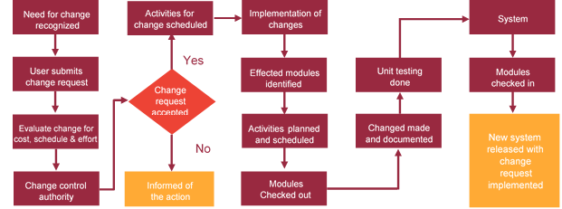

# Miscellaneous

## Acceptance Criteria

* UAT sign off should happen within 14 Days from the release of the application/ Phase and the acceptance confirmation needs to be mailed to Verbat failing which Verbat will consider the project as approved by the client.
* Any comments or reason for rejection need to be documented and the same needs to be sent as an email from the official mail id of client to Verbat.

## General Terms and Conditions

* All the projects activities will be carried out from our off-shore development center in India
* The scope of the project is to develop the Application as detailed in the scope of the project and mentioned in this proposal. Any changes or additions will have to go through change management.
* This proposal and all technical/ functional specifications have been derived or concluded from the data shared via email / information's transferred during the initial requirement analysis meetings and conversations. Verbat reserves the right to amend the terms of this proposal, should the SOW terms, functional features and functionalities change during the course of the project
* Application will be best viewed only in the environment mentioned in this document
* All the documentation will be provided in English.
* Third party components may be used to develop this application.
* All Source Code and other project artefacts would adhere to the Verbat document templates and internal coding standards
* Client shall provide the respective enterprise apple store and Google play store accounts for development and production
* Acceptance criteria shall be based on the clauses which were mutually discussed between Verbat and client at the Requirement Analysis phase and the same will be documented and approved by both parties through official emails
* In case Client requires any extension of the proposed acceptance schedule, the associated effort and cost of such extension can be mutually reviewed.
* For any circumstances if project needs to be put on Hold / Stop it requires minimum request notice period of 2 weeks along with duration for which request will be addressed by management and final decision on the request will be based on that
* If deployment is done in client’s server, Verbat cannot be held responsible for any performance issues arising due to hardware malfunctions.
* Source code will only be delivered or uploaded on the Production Server once the due payments are made.

## Assumptions and Dependencies

* Detailed system study is required before the start of the project.
* During the requirement gathering phase, authorized personnel from the Client’s side is expected to be available for discussion and finalizing the HLD (High Level Design), before development commences.
* Type of reports and formats, if under the scope of the project, needs to be specified by Client before project sign off.
* Workflows if under the scope of the project, need to be specified/ confirmed by client before project signoff.
* All queries regarding the client requirement and any queries which may hinder the project advancement at any stage should be answered by the client within 24 hours from the time of initiation, failing which the time delay will get added to the actual effort which was estimated.
* Verbat assumes that all sign-offs from Client will be provided within agreed and specified timeframe.
* Client will provide all the necessary contents, both text and image, before starting the project in the format suggested by Verbat (if any).
* The client should provide the relevant information and data well in time for the execution of a related activity. Non- availability of this information or data may lead to an interruption of work which may result in a delay in delivery as well as additional costs to the client.

## Source Code & Intellectual Property Rights

* Upon completion of the Project and 100% completion of the payment, client will have access to the source code except for propriety codes, developer tools and third party application etc.
* The solution offered will be the intellectual property of the client and will be made available to the client on an “unlimited license” basis.
* Modifications by third party/person: No person or organization, other than Verbat or any person authorized by Verbat in writing, has any permission to modify/change the software Solution to be eligible to get continued support from Verbat as per the support terms defined under this document.
* Liabilities/Damages: Verbat accepts no liability or damages of any kind arising out of use or non-use of the software delivered. The responsibility of testing of software lies with Client.

## Maintenance & Support

* Maintenance contracts by default are supported as per the basic SLA terms.
* **AMC with Basic SLA is charged at 20 % of the total project value**. Additional Effort/change management request will be added towards Total Value of the Project to determine the AMC value.
* Maintenance support is limited to providing application support for ensuring the consistency of the look-and-feel, bug fixes and user issues i.e. maintenance and support of the existing features of the application.
* Support does not in any way cover providing technical or other support to the end users. The maintenance agreement does not include functionality changes or feature additions which are handled as change requests which will be charged AED 1200 per man day. AMC does not include server support, maintenance and application deployment.
* AMC charges will cover Off-Site Support and Debugging. Support includes E-mail, Telephone and Chat unless explicitly specified. In the event, the application is hosted with the client; necessary remote desktop connectivity should be provided for carrying out maintenance activity.
* Gap in AMC - In case if the client does not opt an AMC for a year and want to renew it after that period, 50% of the AMC amount for the year for which AMC is not taken will also be payable if the client wishes to renew the AMC contract.
* Note:
  + Please note that the AMC support shall start only after all the necessary sign-offs (AMC Document) to this effect have been given.
  + It is not mandatory that the client should opt for an AMC. The client will still be supported on an ad-hoc basis on an agreed man-day rate.
  + AMC Payment Terms: 100% to be paid as advance.

## Service Level Agreement

|  |  |  |  |  |
| --- | --- | --- | --- | --- |
| **Key** | **Max Response Time** | | **Max Resolution Time** | **Target** |
| Basic | 1  working day | 3 working days | | Request / incident / problem tickets |
| Advanced | 5 Business Hours | 12 Business Hours | | Request / incident / problem tickets |
| Priority | 3 Business Hours | 5 Business Hours | | Request / incident / problem tickets |

Note:-

* We provide Basic SLA as standard with AMC while Advanced and Priority SLAs attract additional charges.
* Time zone applicable as per India time zones (3:30 AM GMT to 12:30 PM GMT- Monday to Friday).

# Our Clients

**UAE University**

Education

Transportation

**Canada Cartage**

Construction

Services

Finance

We look forward to hearing from you soon and hope that you will give us the privilege to work with you in meeting your business goals. Thank you.

Thank You



©   
1999 - 2017. All Rights Reserved   
Verbanet Technologies LLC  
www.verbat.com