roid

217, Sheikh Rashid Building

P.O Box 56272, Dubai

United Arab Emirates

Tel: +971 4 2973236 / 04 2974007

Email: uae@verbat.com

PROJECT   
PROPOSAL

**Derby**

|  |  |
| --- | --- |
| **Prepared for:**  **XXXXXXXXX Group**  **Ms../Mr. XXXXXX**  **XXXXX Position** | **Submission Date:**  18 Jun 2018  **Proposal ID:** AD/BP/18062018/1343/1 |

________________________________________________________________________________________________________________________________  
Conﬁdentiality Notice: This Proposal is conﬁdential and contains proprietary information and intellectual property of Verbanet Technologies LLC. Neither this proposal nor any of the information contained herein may be reproduced or disclosed under any circumstances without the express written permission of Verbanet.

© 2018 by Verbanet Technologies LLC. All rights reserved. Confidential.

________________________________________________________________________________________________________________________________

Project Contacts

|  |  |
| --- | --- |
| Client Information | |
| Project Name | Derby |
| Client Name |  |
| Client Address |  |
| Contact Person |  |
| Contact Person Email |  |
| Contact Person Phone Number |  |
| Verbat Information | |
| Contact Person | Ms. Darshana S |
| Contact Person Phone Number | +971 42973236 |
| Contact Person E-Mail | [darshana.s@verbat.com](mailto:darshana.s@verbat.com) |
| Address | PO Box 56272, Dubai, United Arab Emirates |
| Physical Address | 217, Sheikh Rasheed Building, Hor Al Anz East |
| Project Information | |
| Proposed Technology/Methodology | Asp.Net, MVC, MS SQL, CSS3, HTML5, JQuery |
| Anticipate Start Date | NA |
| Proposal Valid For | 30 Calendar days from the submission of the proposal |

**Table of Content**

1 Company Background 4

2 Scope of Work 5

2.1 Proposed Solution 5

2.2 Expected Project Goals 6

2.3 Stand-Alone Fixed Bid 6

2.4 Solution Objective 7

2.5 Advantages of Proposed Solution 8

2.6 Why Verbat 8

2.7 Key Differentiators 9

2.8 Verbat’s Technology & Services 10

3 Functional Specification 11

4 Nonfunctional Requirement (Others) 14

5 Assumptions 14

6 Out of Scope 15

7 Technology Solution 16

7.1 Proposed System Environment 16

7.2 Technical Configurations 17

7.2.1 Development Tools 17

7.2.2 Suggested Web Hosting Specification 17

7.2.3 Browser Compatibility 17

7.2.4 Hardware Interface 17

8 Commercials 18

8.1 Web Application 18

8.2 Mobile Application 18

8.3 Payment Terms 18

8.4 Mode of Payment 18

9 Delivery Management 19

9.1 Project Management 19

9.2 Roles and Responsibilities 19

9.3 Project Implementation Plan 20

9.4 Deliverables 20

9.5 Estimated Delivery Time 21

9.6 Release Planning 21

9.7 Risk and Contingency Planning 21

10 Change Management 23

11 Miscellaneous 24

11.1 Acceptance Criteria 24

11.2 General Terms and Conditions 24

11.3 Assumptions and Dependencies 25

11.4 Source Code & Intellectual Property Rights 25

11.5 Maintenance & Support 26

11.6 Service Level Agreement 27

12 Our Clients 28

# Company Background

The client has requested Verbat to redesign and develop their existing web based application composed in Classic ASP. Verbat intends to redesign and build from scratch a bleeding edge version of the existing application using the latest technologies. The application will leverage features of HTML5, CSS3 and ASP.NET MVC framework.

The main purpose of the application is to keep track of the all the Jobs received by the client. The jobs have the following features

* Jobs can be created in the system with unique job Id’s. The job register is a roster that contains all of the jobs entered into the system. The job description includes Job Title, Job ID(Unique), Associated Fees, Fee Collection Advance in Percentage, Associated invoices, Job Status, Estimated Value and Job Assignment(Option to assign job to employee)
* Jobs may be added, deleted or updated with an associated revision count for each update
* Each job may have multiple drawings (Structural or Architectural) associated with it called listings
* The job listings may be added individually or imported using a spread sheet. The job listings shall have attributes such as Drawing Number (Predefined naming convention), Title, Category, Status, Revision Status, Valuation, Weights. The Listings may be deleted and updated accordingly
* Multiple invoices (Recurrently) may be raised against a job based on job listing. The amount received against the invoices shall be registered against the job (and associated listings) so as to keep a running total of the amounts collected vs. the amount pending receipt. Invoices may be deleted.
* The application contains a list of employees. Employees may be added by the admin and assigned a login. Employees can login and view the jobs allocated to them.
* Employees can log the effort that they spend on each job / Drawing in hours. The effort expended by the employee may be compared to the estimate for each listing / job. Any variance that results in additional effort than the estimated effort will raise an alert as well as an indicator on the application dashboard with the ability to comment on the reason for the extra effort
* Time sheets may be generated based on the efforts expended by the employees. Employees may log sick days, casual leaves, Annual leaves etc.

# Scope of Work

The scope of this project is to develop a **Responsive** **Web Application** that will replace (and retire) the existing application based on Classic ASP. The application will make use of the latest technologies offered by the Microsoft technology stack. MSSQL server will serve as the backend database.

The features of the application are

**Admin Portal**

The Admin Portal can

* Add job / batch entry / invoice / delete job
* For batch entry, admin can copy paste the excel (tasks) in the text box provided in the application (Or import data via Excel)
* Admin shall maintain the master data related to categories, statuses etc.

**Employees**

Employees may

* View all the jobs assigned to them. (System will not manage auto assignment of the job). Jobs may be of 2 types – Structural or Architectural
* Work on either Structural part or Architectural part of the particular task at any one time
* Fill up the time sheet ( in hours ) for Structural part or Architectural part (time for both the parts has to be filled)
* Apply for leave (3 types of leaves – Annual / Casual / Sick)
* Change password
* Generate report from the timesheet (the report is a web page)

**Manager**

Managers can

* View report for total no of hours spent on a project
* Filter reports based on name of the employee or the project

**Good to Have**

* Fill up the timesheet such that an employee may add start time and end time for the part he has worked on related to the particular project.
* If the time taken for the task is more than what is estimated, then the alert should pop up and there should be a comment section where employee can add the reasons for extra time taken to complete the task.

## Expected Business Outcome

The business outcome expected from the Proposed System is to:

* Create a modern web application that integrates the latest technology
* Create an application that is much more user friendly and intuitive than the existing application
* Create a maintainable application with provisions to easily upgrade when new features are needed.

## Stand-Alone Fixed Bid

Verbat will be following a stand–alone fixed bid solution delivery model wherein the required solution would be devised and a suitable pricing would be offered.

## Solution Objective

Verbat proposes to build a **Responsive** **Web based Application**. Verbat’s Solution architects have conducted a thorough research on the requirements and have come to the conclusion that our proposed solution, which is detailed further in this document, will meet the requirements put forth by the client. And the proposed solution will be delivered in a phased approach as per Verbat’s stand-alone fixed bid solution model.

**Strong and Scalable platform:** The platform proposed will be strong and scalable enough to accommodate future enhancements.

**Accelerated solution:** The framework would act as a solution accelerator. It would provide the basic building blocks which could be reused in future for building new components and features.

**High performance:** The light weight framework used consumes fewer system resources thereby making the application perform faster.

**Security:** The application will be developed considering various aspects of security.

## Advantages of Proposed Solution

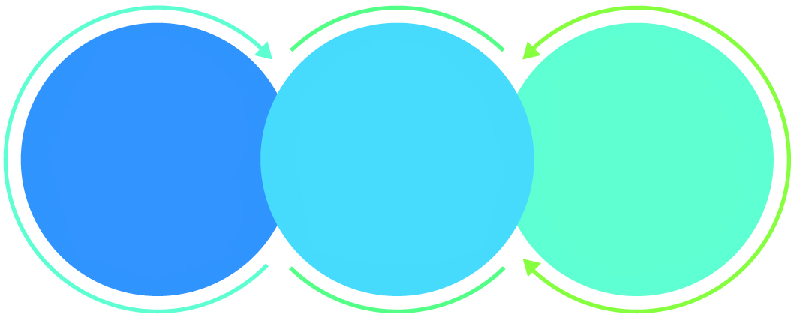

01

Agile development offering reliable, secure solution

02

Smooth transition and quicker completion of processes

03

User friendly interfaces enabling easy navigation between screens

## Why Verbat

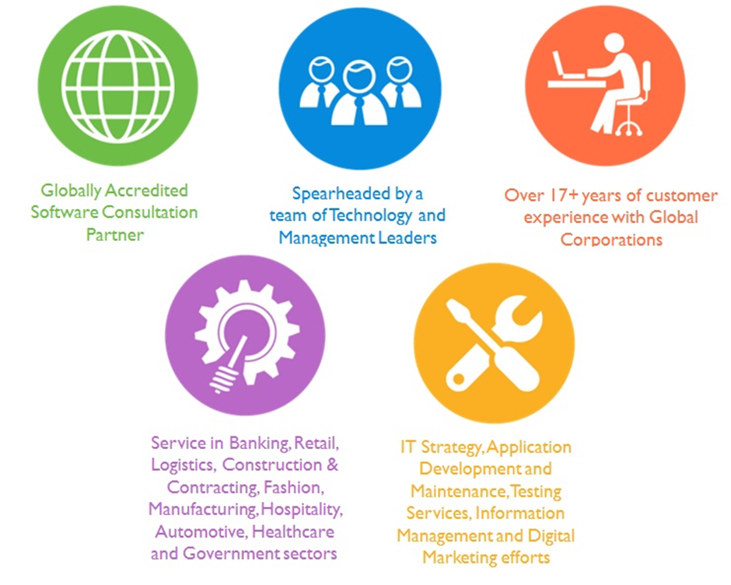

## Key Differentiators

Delivered digital transformation expertise to global customers for over a decade by following industry best practices to maximize ROI for client

Keen technology intelligence combined with aggressive market research to deliver solutions that achieve results with measurable value

Enable access to global consulting expertise with strong local market and business knowledge

Commercial Model that is customizable for your business needs

Services that are designed to optimize applications for improved performance and overall efficiency

1,000,000 plus man-hours of expertise in technology frameworks spanning Microsoft, Open Source, mobility platforms and other proprietary IT technology

Partners top technology vendors to bring in the latest and best services in integration, collaboration, and development

Commercial Model that is customizable for your business needs

Proven Methodologies & Processes

Investment in R & D

Strong Local Presence

Flexible commercial Models

Technology Associations

Software Development Experience

Offshore Development Centre

Quality Assurance & Testing

## Verbat’s Technology & Services



Technology  
&  
Services

Cloud/Traditional Hosting

User Interface & Design

Digital Marketing

Mobility Solutions

Testing Services

Application  
Development

# Functional Specification

|  |
| --- |
| **Derby Employee Dashboard** |
| Logged in User Details |
| Logout / Forgot / Reset Password |
| Jobs Assigned (Job Summary) |
| Timesheet Summary |
| Time Sheet Report Links |
| **Employee Assignments** |
| Timesheet Reports |
| Accept Jobs |
| Apply for leave (or Mark Leave hours) |
| **ADMIN** |
| Maintain Masters( Leave Type, Drawing Type, Category, Status, Sub Status, Payment Types) |
| Manage Jobs (Add / Delete / Update) |
| Add Listings (Copy Paste): (Add / Delete / Update) |
| View Jobs |
| View Job Lists |
| Manage Revisions (Jobs & Job Listings) |
| Create Invoices (Against Job & Job Listings) |
| Manage Invoices (Add / Delete) |
| Document Transmittal |
| **System features** |
| Authentication & authorization |
| Auditing & logging |
| Exception handling |
| **Extra Effort** |
| Alerts based on underestimated job efforts |
| Fill Time Sheets With Start and End Time |
| Explanation for alerts on the Dashboard |
| Add Listing (CSV upload) |
| SMS & Email |
| Reports |
| Export to CSV, PDF, DOC |

Figure Overall Workflow

# Nonfunctional Requirement (Others)

|  |  |
| --- | --- |
| **Requirement** | **Details** |
| User Experience and  UI Design | * The application will be developed only in English * The layout and graphical components will be created considering the usability factors |
| Performance | * Application will allow users to have smooth and quick access to the information or services they require. |
| Security | * The system will be protected against attempts of security breaching that may arise. * Web security standards will be followed. |

# Assumptions

The project solution and technology is created from the initial understanding of the requirement shared with Verbat through mails and meetings. The proposed solution is based on the following assumptions:

* Client to provide Verbat with the branding guidelines.
* The proposed application will be in English
* Client will purchase the necessary themes needed for development
* Client shall provide licensed images and logos in specified size & format
* Requirements should be well defined, agreed and signed-off by the client
* Internet connectivity is required for the functioning of the web application.
* Development Contingent upon timely feedback from client

# Out of Scope

Following are considered to be out of scope while creating this proposal.

* Purchase of images, fonts
* Adding new features to the application other than mentioned in the functional specification.
* Any language other than English
* Manual data entry
* Hardware Integrations / procurement and purchase
* Database migration
* Content writing
* Content or image procurement or uploading or editing.
* Annual Maintenance of the application (Bug fixing, debugging) - For AMC details, please refer section titled “Maintenance and Support”
* Physical deployment at client’s site
* Backup solution and Disaster recovery

# Technology Solution

## Proposed System Environment

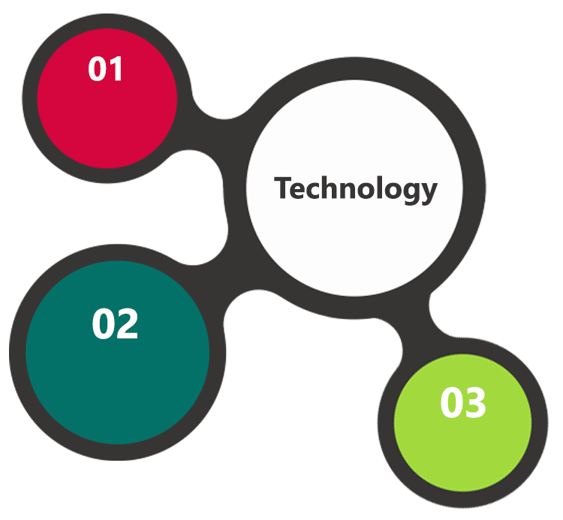

.NET, MVC, C#, ASP.NET

IIS / MS SQL

HTML / CSS3/ JQuery

**MS SQL2012  
Windows 8/10  
Web Services**

## Technical Configurations

### Development Tools

* ASP.Net / MVC / C#
* HTML / CSS3/ JQUERY
* IIS / MSSQL

### Suggested Web Hosting Specification

* Windows Dedicated server
* 8 Core CPU
* 16 GB RAM
* 1 TB HDD
* Windows OS, MS SQL Work Group Edition
* IIS 8.5, ASP.Net 4.5

### Browser Compatibility

* Chrome version: 56
* Firefox version: 51
* Edge version: 39
* Safari version 10.1

# Commercials

## Web Application

|  |  |  |
| --- | --- | --- |
| **No** | **Description** | **Amount (USD)** |
| 01. |  | 00,000.00 |
|  |  |  |

*Note:*

* *The above cost does not include Application hosting, integration, Project Management or deployment*
* *For change management cost, please refer to section 10 titled Change Management*

## Payment Terms

*Note: Payment should be made within 7 days from the date of the invoice*

## Mode of Payment

By Cheque / DD to Verbanet Technologies LLC

OR

Wire transfer to our bank account

Bank Name : Emirates NBD

Account Name : Verbanet Technologies LLC

Account Number : 1011492858201

IBAN Number : AE61 0260 0010 1149 2858 201

Swift Code : EBILAEAD

Bank Address : Mamzar Branch, Dubai

*Note: Bank charges incurred during wire transfer to be borne by the client. Any local taxes applicable to be borne by the client*

# Delivery Management

## Project Management

The Verbat development center strictly follows industry standards on quality. The project management is process governed by the Verbat Quality Management system and is put to verification through internal audit programs that happen from time to time.

Verbat will dedicate a project manager for the proposed implementation. Verbat proposes Client to identify one project manager who will be driving activities to be undertaken by Client to be the single point of contact for Verbat.

## Roles and Responsibilities

Verbat will assign a dedicated Project Manager/Project Lead to lead the project, who will be the first point contact for Client. He/she will be responsible for planning and managing the various activities within the project. He/she will work closely with Client Project Manager, to give periodic status updates and ensure high level of visibility and comfort on the progress of the project.

The Project Manager/Project Lead will lead the co-ordination between Verbat and Client, thus enabling smooth transitioning of Client requirements to the Verbat’s offshore delivery team, and provide visibility as well as comfort on the progress of the services to Client.

He/she will have periodic meetings with Verbat’s Senior Management, thus ensuring Verbat’s Management commitment and focus on Client initiatives.

Delivery Activity Summary

|  |  |
| --- | --- |
| Activities | Description |
| Detailed requirement Analysis | Verbat team to conduct detailed study of requirement for the phase. If clarification is required, team will reach out to Client for more information and/or time for discussions. |
| DB Design | DB design for central and test DB. |
| Software Requirement Specification document (SRS) | Once the requirement analysis is completed, Verbat team will submit the SRS document for approval |
| UI/UX Design, Prototyping | Based on the SRS, Verbat UX/UI team will work on the UI/UX of the screens and submit a prototype for approval |
| Functional Specification Document (FS) | Once the Prototype. UI/UX is approved, Verbat shall submit an FS document for approval. |
| Development | Actual system development starts based on the FS. This involves detailed design and software development of Web/Mobile Application. |
| Testing | Test Planning, test plan creations, internal, integration testing and user acceptance testing. |
| Deployment | Deploying the latest built in the Verbat Test Server. |

## Project Implementation Plan

Verbat will be providing the solution in a stand-alone fixed bid approach which ensures minimum viable solution for quick wins with core focus on the long-term business objective and outcome. Once the implementation is over, Verbat will initiate the application maintenance process (once the maintenance contract is signed) which continues to extend after the implementation.

## Deliverables

* Project Plan
* Design templates (Web & Mobile)
* Functional Specification Document
* Prototype of the application
* Test Plan Document
* User Manual
* Source Code
* Fully Developed & Tested Application (Web, iOS and Android Mobile App)

## Estimated Delivery Time

The effort estimated for delivering the application is as follows;

* Delivery of Prototype: 3 Working Man Days
* Days for the development of the application from the Date of Approval of the Prototype: 18 – 27 Working man days

## Release Planning

* Client will be informed about the release date and time through email.
* Client performs the UAT

## Risk and Contingency Planning

Verbat has identified various risk factors associated with this assignment and understands the impact of these risk factors on the project schedules. The objective of this section is to highlight for both Verbat and client, the risk factors, to analyze the impact of the risks on project execution, and to propose strategies to control and reduce the impact of the risk factor.

These various risks, which could arise during the project, are tabulated below along with mitigation implementation.

| Type of risk | Impact | Risk Mitigation | Risk Handling |
| --- | --- | --- | --- |
| Scope Creep | H | Functions and features will be detailed in system requirement documents and will go through client approval. Once this document is approved, any change to requirement will go through change management review for possible impact assessment. | Proper change management procedure will be implemented. |
| Delay in customer feedback | H | The plan is prepared with enough lead-time for customer reviews and approvals.  The customer is indicated with the dates when the document is expected after review and approval. | The request for feedback will be escalated if not attended at the right time so that the schedules are not affected. Deemed acceptance criterion is set up front and will be followed. |
| Non-availability of necessary software’s, frameworks, database instances and infrastructure at client’s hosting environment(If hosting support is provided by Verbat) | M | Client will be informed in advance on these requirements. | Possible impact to schedule. |
| Manpower attrition | L | All efforts would be made to ensure process dependence rather than being person dependent. As a risk mitigation plan Verbat will train backups. | A new person will be identified as early as possible, provided the required project-specific training and mentored by the senior members of the team to minimise impact of attrition on the project. |

*H-High, M-Medium, L-Low, NA-Not Applicable*

# Change Management

Any addition which comes out of the project scope, upon and after the launch of the tool will be considered as change management. Verbat recommends the following change management procedure for the same.

* Any change which comes out of the project scope, which was discussed, documented, and mutually approved by both the parties in the requirement stage, will be carried out only through raising a change request.
* Change request will be studied and an impact analysis on the existing work flow will be performed.
* On finalizing the impact, effort estimation for the change will be calculated and raised as additional requirement.
* Verbat will initiate the change request only after getting a formal approval from the client for the additional changes raised.
* Any change from the scope will be charged at **USD ----- per man day effort** and approval from the clients will be availed before commencing on any change management.

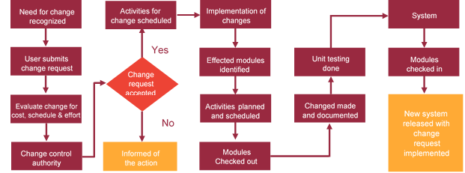

# Miscellaneous

## Acceptance Criteria

* UAT sign off should happen within 14 Days from the release of the application/ Phase and the acceptance confirmation needs to be mailed to Verbat failing which Verbat will consider the project as approved by the client.
* Any comments or reason for rejection need to be documented and the same needs to be sent as an email from the official mail id of client to Verbat.

## General Terms and Conditions

* All the projects activities will be carried out from our off-shore development center in India
* The scope of the project is to develop the Application as detailed in the scope of the project and mentioned in this proposal. Any changes or additions will have to go through change management.
* This proposal and all technical/ functional specifications have been derived or concluded from the data shared via email / information's transferred during the initial requirement analysis meetings and conversations. Verbat reserves the right to amend the terms of this proposal, should the SOW terms, functional features and functionalities change during the course of the project
* Application will be best viewed only in the environment mentioned in this document
* All the documentation will be provided in English.
* Third party components may be used to develop this application.
* All Source Code and other project artefacts would adhere to the Verbat document templates and internal coding standards
* Client shall provide the respective enterprise apple store and Google play store accounts for development and production
* Acceptance criteria shall be based on the clauses which were mutually discussed between Verbat and client at the Requirement Analysis phase and the same will be documented and approved by both parties through official emails
* In case Client requires any extension of the proposed acceptance schedule, the associated effort and cost of such extension can be mutually reviewed.
* For any circumstances if project needs to be put on Hold / Stop it requires minimum request notice period of 2 weeks along with duration for which request will be addressed by management and final decision on the request will be based on that
* If deployment is done in client’s server, Verbat cannot be held responsible for any performance issues arising due to hardware malfunctions.
* Source code will only be delivered or uploaded on the Production Server once the due payments are made.

## Assumptions and Dependencies

* Detailed system study is required before the start of the project.
* During the requirement gathering phase, authorized personnel from the Client’s side is expected to be available for discussion and finalizing the HLD (High Level Design), before development commences.
* Type of reports and formats, if under the scope of the project, needs to be specified by Client before project sign off.
* Workflows if under the scope of the project, need to be specified/ confirmed by client before project signoff.
* All queries regarding the client requirement and any queries which may hinder the project advancement at any stage should be answered by the client within 24 hours from the time of initiation, failing which the time delay will get added to the actual effort which was estimated.
* Verbat assumes that all sign-offs from Client will be provided within agreed and specified timeframe.
* Client will provide all the necessary contents, both text and image, before starting the project in the format suggested by Verbat (if any).
* The client should provide the relevant information and data well in time for the execution of a related activity. Non- availability of this information or data may lead to an interruption of work which may result in a delay in delivery as well as additional costs to the client.

## Source Code & Intellectual Property Rights

* Upon completion of the Project and 100% completion of the payment, client will have access to the source code except for propriety codes, developer tools and third party application etc.
* The solution offered will be the intellectual property of the client and will be made available to the client on an “unlimited license” basis.
* Modifications by third party/person: No person or organization, other than Verbat or any person authorized by Verbat in writing, has any permission to modify/change the software Solution to be eligible to get continued support from Verbat as per the support terms defined under this document.
* Liabilities/Damages: Verbat accepts no liability or damages of any kind arising out of use or non-use of the software delivered. The responsibility of testing of software lies with Client.

## Maintenance & Support

* Maintenance contracts by default are supported as per the basic SLA terms.
* **AMC with Basic SLA is charged at 20 % of the total project value**. Additional Effort/change management request will be added towards Total Value of the Project to determine the AMC value.
* Maintenance support is limited to providing application support for ensuring the consistency of the look-and-feel, bug fixes and user issues i.e. maintenance and support of the existing features of the application.
* Support does not in any way cover providing technical or other support to the end users. The maintenance agreement does not include functionality changes or feature additions which are handled as change requests which will be charged AED 1200 per man day. AMC does not include server support, maintenance and application deployment.
* AMC charges will cover Off-Site Support and Debugging. Support includes E-mail, Telephone and Chat unless explicitly specified. In the event, the application is hosted with the client; necessary remote desktop connectivity should be provided for carrying out maintenance activity.
* Gap in AMC - In case if the client does not opt an AMC for a year and want to renew it after that period, 50% of the AMC amount for the year for which AMC is not taken will also be payable if the client wishes to renew the AMC contract.
* Note:
  + Please note that the AMC support shall start only after all the necessary sign-offs (AMC Document) to this effect have been given.
  + It is not mandatory that the client should opt for an AMC. The client will still be supported on an ad-hoc basis on an agreed man-day rate.
  + AMC Payment Terms: 100% to be paid as advance.

## Service Level Agreement

|  |  |  |  |  |
| --- | --- | --- | --- | --- |
| **Key** | **Max Response Time** | | **Max Resolution Time** | **Target** |
| Basic | 1  working day | 3 working days | | Request / incident / problem tickets |
| Advanced | 5 Business Hours | 12 Business Hours | | Request / incident / problem tickets |
| Priority | 3 Business Hours | 5 Business Hours | | Request / incident / problem tickets |

Note:-

* We provide Basic SLA as standard with AMC while Advanced and Priority SLAs attract additional charges.
* Time zone applicable as per India time zones (3:30 AM GMT to 12:30 PM GMT- Monday to Friday).

# Our Clients

**UAE University**

Education

Transportation

**Canada Cartage**

Construction

Services

Finance

We look forward to hearing from you soon and hope that you will give us the privilege to work with you in meeting your business goals. Thank you.

Thank You



©   
1999 - 2018. All Rights Reserved   
Verbanet Technologies LLC  
www.verbat.com