

217, Sheikh Rashid Building

P.O Box 56272, Dubai

United Arab Emirates

Tel: +971 4 2973236 / 04 2974007

Email: uae@verbat.com

PROJECT   
PROPOSAL

**----------------------**

|  |  |
| --- | --- |
| **Prepared for:**  **-------------------------**  **------------** | **Submission Date:**  09 March 2017  **Proposal ID:** SW/12122016/1245/1 |

___________________________________________________________________________________________________________________________________________  
Conﬁdentiality Notice: This Proposal is conﬁdential and contains proprietary information and intellectual property of Verbanet Technologies LLC. Neither this proposal nor any of the information contained herein may be reproduced or disclosed under any circumstances without the express written permission of Verbanet.

© 2017 by Verbanet Technologies LLC. All rights reserved. Confidential.

___________________________________________________________________________________________________________________________________________

Project Contacts

|  |  |
| --- | --- |
| Client Information | |
| Project Name |  |
| Client Name |  |
| Client Address |  |
| Phone Number |  |
| Contact Person |  |
| Contact Person Email |  |
| Contact Person Phone Number |  |
| Contact Person Fax Number |  |
| Verbat Information | |
| Contact Person | Ms. Joyce Daniel |
| Contact Person Phone Number | 04 2973236 |
| Contact Person E-Mail | Joyce.daniel@verbat.com |
| Address | PO Box 56272, Dubai |
| Physical Address | Flat 217, Sheik Rasheed Building, Hor Al Anz East, Dubai |
| Project Information | |
| Proposed Technology/Methodology | - |
| Anticipate Start Date | NA |
| Proposal Valid For | 30 Calendar days from the submission of the proposal |

**Table of Content**

1 Executive Summary 6

1.1 Introduction 6

1.2 Overview 6

2 Solution Objective 6

2.1 DAM Admin 7

2.2 DAM Sites 7

3 Objectives 7

4 Scope of Work 8

4.1 Upload Asset Files 8

4.2 Edit Asset File 8

4.3 Collaborate, access and share 9

4.4 Cataloguing Made Easy 9

4.5 Other Core Features 10

4.5.1 Single Sign on (SSO) 10

4.5.2 Supports all well-Known file formats 10

4.5.3 SharePoint Integration 10

4.5.4 Dynamic filtering 10

4.5.5 Image and video editing 11

4.5.6 Privileges 11

4.5.7 Bulk editing of media 11

4.5.8 Statistics and Reporting 11

4.5.9 Preview of media files 12

4.5.10 Version management 12

4.5.11 Auto-tagging 12

4.5.12 Multilingual (Arabic is Mandatory) 12

4.5.13 Software UI in different languages 12

4.5.14 API/Developer access 13

4.5.15 Automatic thumbnail conversion 13

4.5.16 Scalability 13

4.5.17 Backup & Availability 13

4.6 Advantages of Proposed Solution 15

4.7 Why Verbat 15

4.8 Key Differentiators 16

4.9 Underlying Support Services 17

5 Functional Specification 18

6 High Level Architecture 20

7 Assumptions 21

8 Out of Scope 21

9 Technology Solution 22

9.1 Technical Configuration 23

9.1.1 COTS/Software components/others 23

9.1.2 Development Tools 23

9.1.3 Browser Compatibility for Web Admin 23

9.1.4 Hardware Interface 24

10 Delivery Management 24

10.1 Project Management 24

10.2 Roles and Responsibilities 24

10.3 Phase Delivery Activity summary 26

10.4 Project Implementation plan 26

10.5 Deliverables 27

10.6 Release Planning 27

10.7 Risk and Contingency planning 27

11 Change Management 29

12 Project Effort & Timeline 30

12.1 High Level Project Plan 30

12.2 Delivery Timeline 30

13 Commercial overview 30

14 Miscellaneous 32

14.1 Warranty 32

14.2 Acceptance Criteria 32

14.3 General Terms and Conditions 32

14.4 Assumptions and Dependencies 33

14.5 Source Code & Intellectual Property Rights 34

15 Our Clients 35

# Executive Summary

## Introduction

Client has raised the RFQ to manage Digital Asset Management System (DAMS) in the .net. This document provides a comprehensive custom/development plan and proposed solution.

## Overview

CLIENT would like to implement an On-Site Digital Asset Management System. Digital assets are any form of a digital file. Common digital assets include images, documents, photos, presentations and videos.

Digital asset management (DAM) offers an effective solution for enterprises to store, organize, find, retrieve and share digital files. Quick to deploy and easy-to-use, a centralized digital library provides peers, employees, clients, contractors and any other key stakeholders controlled access to digital assets — including images, photos, creative files, video, audio, presentations, documents and more.

Digital asset management software is primarily used by enterprise marketing and creative teams, so it is necessary for DAM software to accommodate a broad spectrum of creative files.

# Solution Objective

Verbat proposes a .net custom solution based approach for development of DAM system. The following key features are requested as per Functional Requirements.

Verbat would recommend the following high level functional architecture for Verbat. Due to the complexity of the requested system, Verbat have used the best possible technology to be most cost effective as well. The architecture is a combination of .net, scripting and other peripheral tools to deliver the system as requested in the RFP.

The application is mainly categorized based on the user group. There are two main categories are listed below.

## DAM Admin

The DAM Admin application is mainly meant for the administrators users who can configure the DAM application according their site preferences. This is highly configurable modules which controls the entire site application behaviour. Some of the main functionality includes in this is listed below.

* 1. Backup Manager
  2. Mail Manager
  3. Report Manager
  4. User Manager
  5. Web Client Configuration

## DAM Sites

DAM Sites application is meant for the users who can perform the activities like Upload, View, and Share, Download and Print on the digital assets.

# Objectives

* The DAM Sites user can login into the application and perform the below set of activities.
* The administrator can set the catalogs permission on which the DAM Sites user can do perform the above activities.
* The user can create a collection and share the media asset to the users, which can be later used to download and print in many options.

# Scope of Work

There three main core functions the system is meant to perform the first function is to upload the second is to edit for search ability and the third is to share and repurpose.

## Upload Asset Files

1. The first way is user can click open this asset folder and select one or always assets and hit OK.
2. The other way is user can scroll out of the same folder drag them on the upload.
3. Then it automatically extracts the related metadata associated with the uploaded file.

## Edit Asset File

1. When the user searches and select an asset to edit the application will automatically extracts the related metadata associated with this record now this is out of the box but this can be configured and customized to meet the specific needs.
2. We have the file format the height the width the resolution.
3. The user can create a container where he can group the assets, it’s not making a copy of this assets rather referencing this record or asset in multiple containers. So any time there’s a change make like a new version or there’s been some additional metadata has been updated it’s going to update that record anywhere in the system it lives.
4. The user can add Key words for improve search ability, author, star rating etc.
5. In the application we have other tabs like relation, history and comments.
6. **Relation Tab**

Usage – The user can create and find groups of files that coexist like a PowerPoint with multiple images and slides. The user can group those records with a master file and find with one click.

1. **Comments Tab**

From the comments tab, when the user can create a string of comments for people within the system asking them to do certain things or actions like look at a file make changes to file and reply back to me. The user can also make comments directly on the preview itself so to make a comment direct into preview and select a specific area I want someone to take a look at make changes.

1. **History Tab**

When the user checks out the selected picture and opens in Photoshop and changes this image and click to save the changes. And then check this record back and the user receive the notification. Now the user can view the edited record along with the original record under the history tab.

## Collaborate, access and share

Share any folder or collection with your group in a public space or within organization. With the commenting and discussion feature you can give appropriate feedback for each asset.

You can let users look at your assets with sharing a folder or collection. You can assign permissions to allow downloading of assets or enable the ordering option.

Three ways the user can share the files are listed below.

* 1. Create a collection for personal use only
  2. Share the collection within the application user
  3. Send a link to the collection to selected recipients

The user can enter the recipient email address and then if they are integrated in the active directory they will auto complete.

The user can input the details like.

1. Subject Field
2. Add Text
3. Set an Embargo Date – When the user wants this collection to go out.
4. Expiration Date

## Cataloguing Made Easy

The application can be integrated into your publishing workflow and captures, displays and writes metadata (XMP/ITPC/EXIF, etc.). This way you can add keywords and description that travel with your assets. It now also captures all metadata from different documents, videos and audio files.

To make information consistent across your media library it uses the XMP standard. XMP is a open standard that is being used by all major vendors.

## Other Core Features

### Single Sign on (SSO)

Drag assets directly from your desktop to the upload window. You can also select many assets in one go. This can also add files from your FTP server, by eMail or create a link to your existing file server.

### Supports all well-Known file formats

The application lets you manage and publish digital assets independently from any format. We support video, images, audio and many more file formats. Manage and access all your digital media assets in one location at any time.

Images, Videos and Audios can be individually converted to other formats. This allows you to deliver the correct content to the right device on the fly. Pass on direct URLs to your customers and/or generate a public webpage with a collection of assets.

### SharePoint Integration

Optional integration into SharePoint is available using the SharePoint Object API. Also, the application lets you access your digital library directly.

### Dynamic filtering

This application not only stores your digital assets but also search and find them again. The application searches the title or description of your documents along with full index search of the whole document. We even take it one step further and index available metadata within your assets.

### Image and video editing

The batch processing allows you to edit metadata of many assets in a single process. Furthermore, you can batch the encoding to many formats for a file in one step.

### Privileges

It makes it easy to define access control for each folder. The group permissions puts you in control who can access your sensitive information. Users only see the folders and collection that they should see. Offer tools for managing rights and permissions of media content for external use and embedding on internal or external websites

### Bulk editing of media

The batch processing allows you to edit metadata of many assets in a single process. Furthermore, you can batch the encoding to many formats for a file in one step.

### Statistics and Reporting

The main purpose of a DAM application is to bring simplicity to storing, managing and sharing digital assets, the most innovative solutions also provide insights and information that is valuable to your business and answer questions like:

* What edits were made to metadata and by whom?
* Who logged in last week and when?
* How many times are assets downloaded, viewed, shared and repurposed?

The reporting features enable organization groups to understand how their digital assets are being managed and how they’re performing.

### Preview of media files

Previews of media are handy because they can save you time as you don’t need to download a file to view it. Previews are especially important if you are working with extremely large files, such as videos and TIFF files that can take a few minutes to download.

### Version management

Optionally you can create a new asset of your original asset and upload it as a new version. You can specify how many versions you would like it to keep. A list of all the versions lets you revert to a selected version.

### Auto-tagging

The application automatically extracts file metadata and allows you to specify and enforce required metadata fields as assets are added. Creates its own custom keyword taxonomy or allow it to grow organically with your team. You can even add short and long descriptions and metadata in different languages.

* 1. **Encryption**

Security is even more important. External users should trust the content they put into the Digital Asset Management system. Likewise it should be protected by using protocols like HTTPS and other encryption methods.

### Multilingual (Arabic is Mandatory)

The digital asset management system must provide full multi-language support. There are different levels to multi-language support.

### Software UI in different languages

Most users prefer working with a graphical user interface localized in their native language.

* **Localized metadata description**

A Arabic user might not know the labels in the application is. Therefore, it must be possible to translate the name of metadata fields, too.

* **Metadata in multiple languages**

The final element in a truly multi-language solution is support for maintaining metadata in different languages.

### API/Developer access

Developers are free to use our API and integrate into their custom solutions for enhanced productivity.

### Automatic thumbnail conversion

When you add assets it can automatically create thumbnails, poster images and playable audio files of your original asset.

### Scalability

Given the exponential growth and demand for digital media, we know that the volume of content you have is only going to grow. We can also expect that the file sizes of your digital assets will increase due to continuing advances in camera resolutions and media production technology. And, the fact that anyone can create quality content with their smartphone today just means that the pace at which digital media is produced is just going to pick up.

This means that your DAM needs to be scalable to ensure your long-term success by allowing your digital library to grow and evolve as necessary. Our solution easily holds millions of assets in a single system with no maximum on capacity to accommodate your growing library of digital content.

### Backup & Availability

With this option you get our backup solution with your server. Adding an additional backup plan to your storage gives you the safety that your data is safe, since your data is stored at different locations. Historic backup services automatically backup up your data in historic snap shots at time intervals that you can choose. With this solution, you can choose to backup weekly, monthly, or quarterly.

Verbat’s Solution architects have conducted a thorough research on the requirements and have come to the conclusion that our proposed solution, which is detailed further in this document, will meet the requirements put forth by the client. And the proposed solution will be delivered in a phased approach as per Verbat‘s managed solution model.

**Strong and Scalable platform:** The platform proposed will be strong and scalable enough to accommodate future enhancements such as scheduling, auditing & logging, push notifications etc.

**Accelerated solution:** The framework would act as a solution accelerator. It would provide the basic building blocks which could be reused in future for building new components and features as part of enhancements

**High performance:** The light weight framework used consumes fewer system resources thereby making the application perform faster

* System shall be available 24/7
* System shall be performant without any lags or delays
* System should be accessible by up to 15 people at a time
* System Shall be able to store up to 10,000 soldier details at a time

**Security:** The application will be developed considering various aspects of security.

* Only authorized personnel shall have access to the system

## Advantages of Proposed Solution

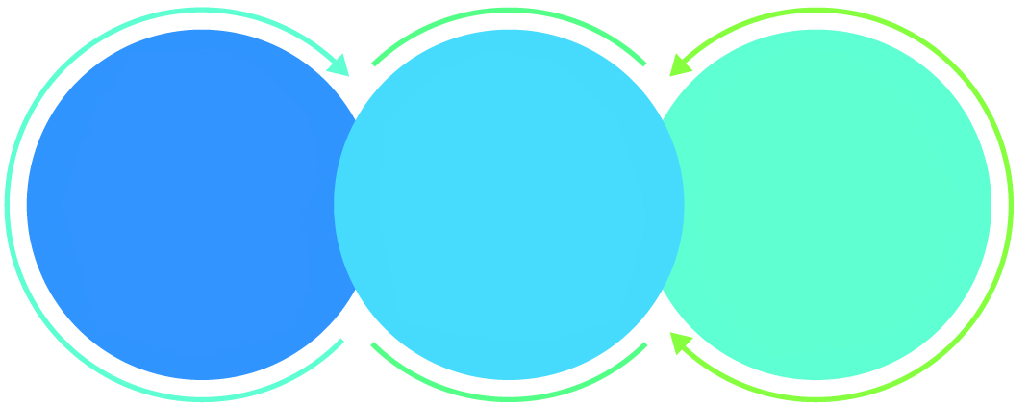

01

Agile development offering reliable, scalable and secure solution

02

Smooth transition and quicker completion of processes

03

User friendly interfaces enabling easy navigation between screens

## Why Verbat

Globally Accredited

Software Consultation Partner

Spearheaded by a   
team of Technology and   
Management Leaders



Over 16+ years of customer experience with Global   
Corporations

Service in Banking, Retail, Logistics, Construction & Contracting, Fashion, Manufacturing, Hospitality, Automotive, Healthcare and Government sectors

IT Strategy, Application Development and Maintenance, Testing Services, Information Management and Digital Marketing efforts



## Key Differentiators

Delivered digital transformation expertise to global customers for over a decade by following industry best practices to maximize ROI for client

Keen technology intelligence combined with aggressive market research to deliver solutions that achieve results with measurable value

Enable access to global consulting expertise with strong local market and business knowledge

Commercial Model that is customizable for your business needs

Reuse of code libraries for Rapid Application Development

1,000,000 plus man-hours of expertise in technology frameworks spanning Microsoft, Open Source, mobility platforms and other proprietary IT technology

Partners top technology vendors to bring in the latest and best services in integration, collaboration, and development

Commercial Model that is customizable for your business needs

Proven Methodologies & Processes

Investment in R & D

Strong Local Presence

Flexible commercial Models

Technology Associations

Code Repository

Software Development Experience

Offshore Development Centre

## Underlying Support Services

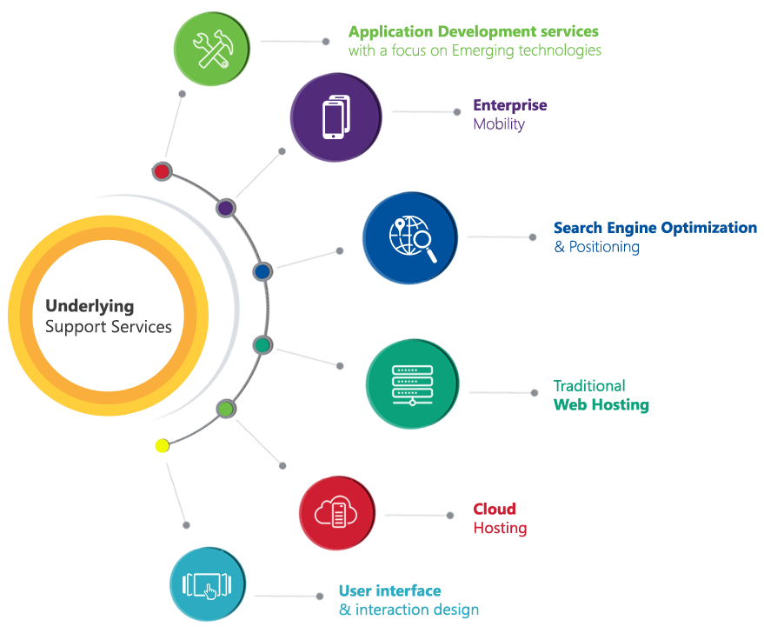

# Functional Specification

|  |
| --- |
| **Module** |
| **Initiation** |
| Business analysis |
| Project Management |
| Design and Prototype |
| **Development** |
| Application basic setup |
| **DAM Admin Modules** |
| Login, Forgot password |
| Backup Manager |
| Mail Manager |
| Report Manager |
| User Manager |
| Web Client Configuration |
| Dashboard |
| **DAM Sites Module** |
| Login, Forgot password |
| Dashboard |
| Information |
| Relation |
| History |
| Comments |
| **Actions** |
| Preview |
| Download |
| Share |
| Add to basket |
| Edit |
| Check In |
| Check Out |
| Delete |
| **DAM Clients** |
| Login, Forgot password |
| Dashboard |
| **Actions** |
| Download |
| Print |
| **General application features** |
| Simple search & advanced search |
| Send Feedback |
| Dashboard for staff, receptionist, admins (Fav, Viewed, History, Shared, recommended exercises, Exercise charts etc.) |
| Intranet Manual |
| **System features** |
| Single Sign on (SSO) |
| Supports all well-Known file formats |
| SharePoint Integration |
| Dynamic filtering |
| Image and video editing |
| Bulk editing of media |
| Statistics and Reporting |
| Preview of media files |
| Version management |
| Auto-tagging |
| Encryption |
| Multilingual |
| API/Developer access |
| Automatic thumbnail conversion |
| Create a Collection and Sharing |

# High Level Architecture

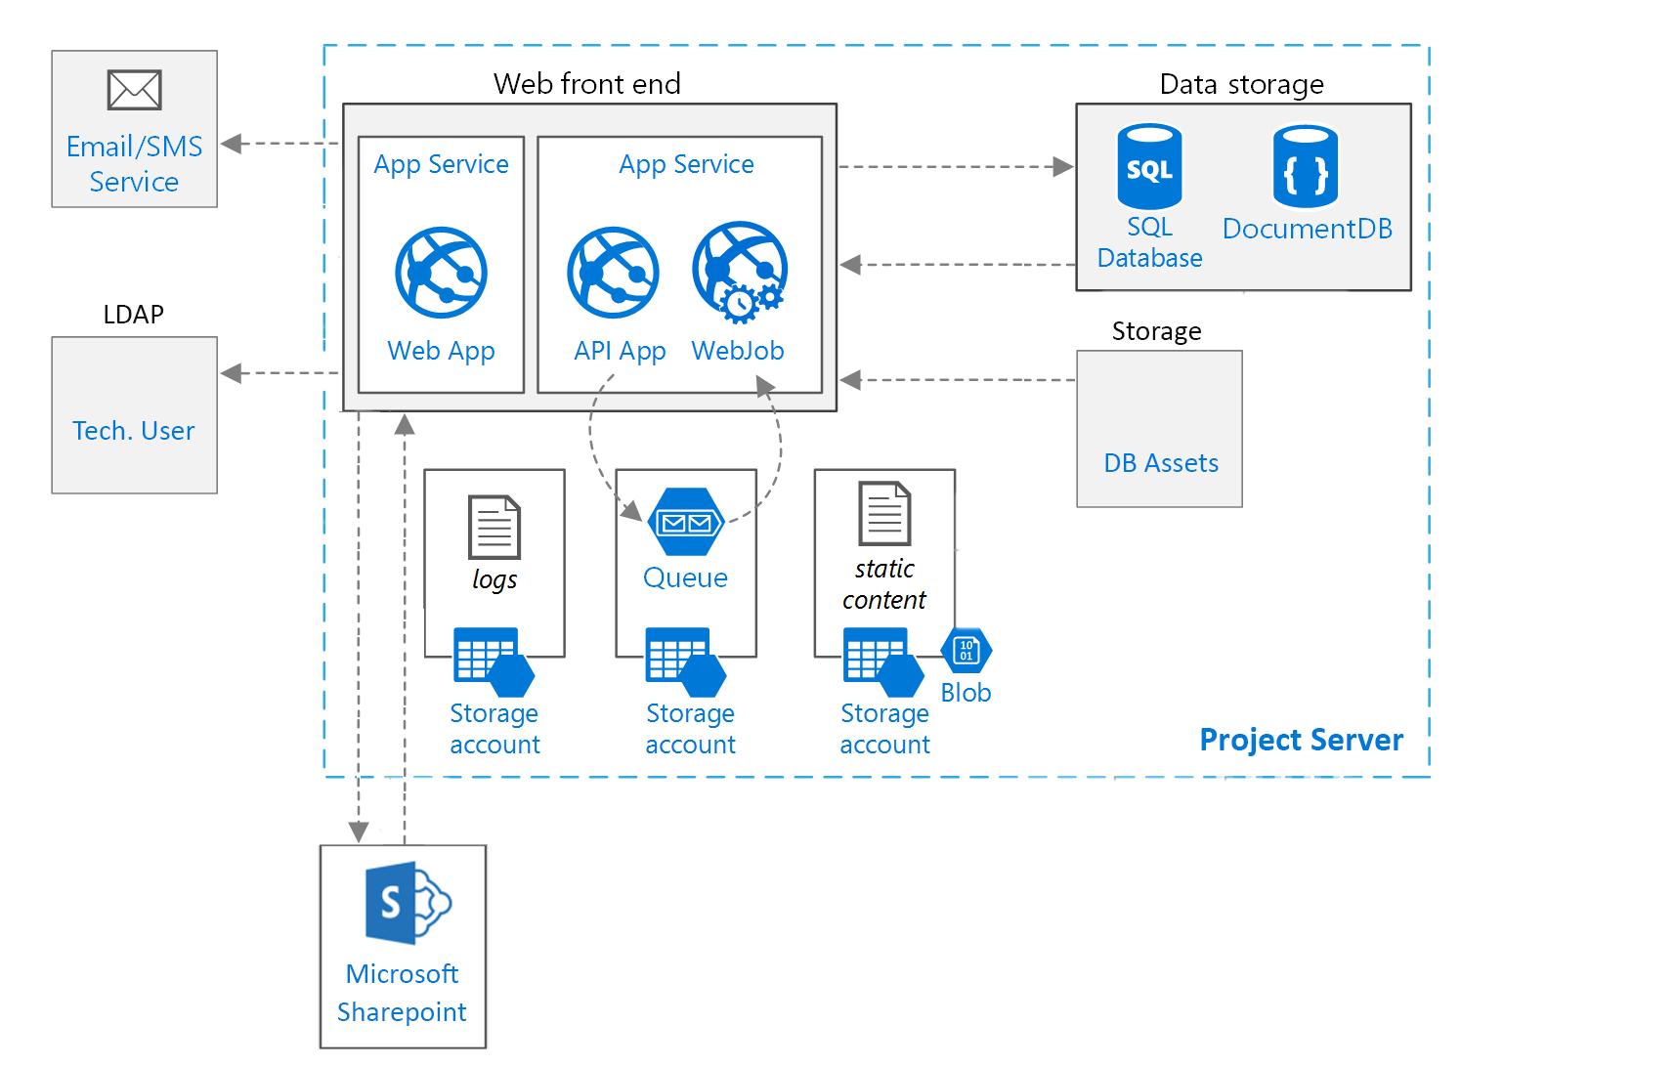

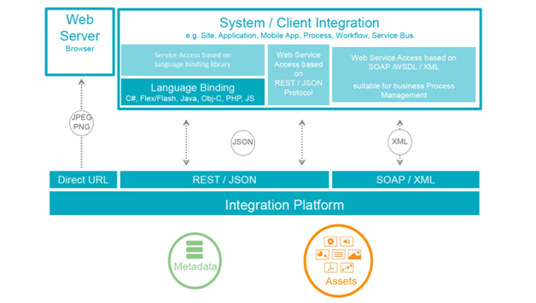

# Assumptions

The project solution and technology is created from the initial understanding of the requirement shared with Verbat through mails and meetings. The proposed solution is based on the following assumptions;

* Color theme shall be provided by the client
* The client shall provide the branding guidelines
* Client shall provide licensed images and logos in specified size & format
* Client shall approve the wireframes and prototype of the web application before development work starts
* The whole responsibility of data security is expected to own by Client.
* The performance of the server and its configuration must be taken care by Client.

# Out of Scope

With the ever evolving digital market, the requirement needs should be clear to both the parties involved, hence the importance of mentioning the out of scope details of the project. Following are considered to be out of scope while creating this proposal.

* Purchase of images, fonts
* Adding new features to the application other than mentioned in this proposal
* Any language other than English
* Manual data entry
* Database migration
* Content writing
* Hosting Infrastructure
* Annual Maintenance Contract ( Bug fixing, debugging, enhancements, develop new modules)
* Physical deployment at client’s site

# Technology Solution

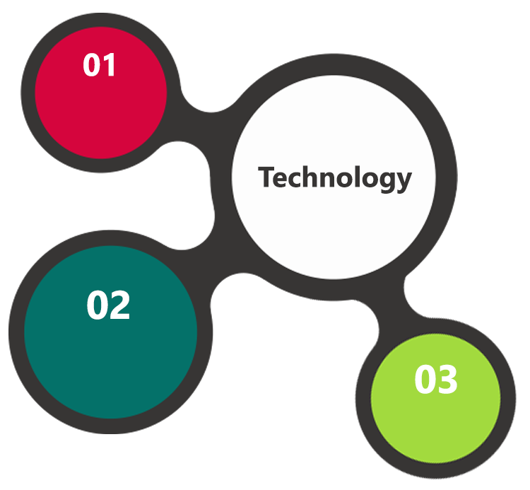

Sharepoint,

.Net, C#

MSSQL, IIS  
Web Services

AJAX  
JavaScript  
JSON

The application will be developed using open source technologies employing a mix of web services and a web interfaces to configure the application.

## Technical Configuration

### COTS/Software components/others

|  |  |  |  |  |
| --- | --- | --- | --- | --- |
|  |  |  |  |  |
|  | **Sl No.** | **Technology/COTS** | **Used for** |  |
|  | 1 | Microsoft .Net | Custom Development |  |
|  | 2 | Microsoft SharePoint Foundation | Base CRMS |  |
|  | 3 | Microsoft SharePoint Server | Deployment server |  |
|  | 4 | Microsoft Visual Studio | Development platform |  |
|  | 5 | Microsoft Team server | Continuous integration |  |
|  | 6 | Microsoft Word | Integration |  |
|  | 7 | Microsoft Excel | Integration |  |
|  | 8 | Microsoft Power pivot | Integration |  |
|  | 9 | Microsoft SQL Server | Database server |  |

### Development Tools

* We use Confluence (http://www.atlassian.com/software/confluence) as the knowledge base.
* We use Jira (http://www.atlassian.com/software/jira ) to know the heartbeat of every project.
* We use Github (http://github.com/) as our source code repository
* We use Hudson (http://hudson-ci.org/) as our Continuous Integration server
* We use agile development and extreme programming

### Browser Compatibility for Web Admin

* Chrome 56.0
* Firefox 51.0
* Internet Explorer 11

### Hardware Interface

The application is reliant on hardware interfaces to provide a seamless automated user experience.

* Computer with Windows 8 or 10 OS

### Recommended Server Configuration

|  |
| --- |
| Recommended configuration – one machine |
| **Processor:** 2 x Intel Xeon 2GHz 4 CPU core |
| **Memory:** 16 GB |
| **HDD:** 1TB |
| **Operating system:** Windows Server 2008/2008R2 x64 Standard Edition (Enterprise Edition is needed to use sql failover clusters) |
| **Web server:** IIS7.5 |
| **SQL server:** Microsoft SQL Server 2008/2008R2 x64 |

# Delivery Management

## Project Management

The Verbat development center strictly follows industry standards on quality. The project management is process governed by the Verbat Quality Management system and is put to verification through internal audit programs that happen from time to time.

Verbat will dedicate a project manager for the proposed implementation. Verbat proposes Client to identify one project manager who will be driving activities to be undertaken by Client to be the single point of contact for Verbat.

## Roles and Responsibilities

Verbat will assign a dedicated Project Manager/Project Lead to lead the project, who will be the first point contact for Client. He/she will be responsible for planning and managing the various activities within the project. He/she will work closely with Client Project Manager, to give periodic status updates and ensure high level of visibility and comfort on the progress of the project.

The Project Manager/Project Lead will lead the co-ordination between Verbat and Client, thus enabling smooth transitioning of Client requirements to the Verbat’s offshore delivery team, and provide visibility as well as comfort on the progress of the services to Client.

He/she will have periodic meetings with Verbat’s Senior Management, thus ensuring Verbat’s Management commitment and focus on Client initiatives.

*Note: detailed qualification and experience of the persons involved in the project will be shared be finalizing the project on request*

## Phase Delivery Activity summary

|  |  |
| --- | --- |
| Activities | Description |
| Detailed requirement Analysis | Verbat team to conduct detailed study of requirement for the phase. If clarification is required, team will reach out to Client for more information and/or time for discussions. |
| Software Requirement Specification document (SRS) | Once the requirement analysis is completed, Verbat team will submit the SRS document for approval |
| UI/UX Design, Prototyping | Based on the SRS, Verbat UX/UI team will work on the UI/UX of the screens and submit a prototype for approval |
| Functional Specification Document (FS) | Once the Prototype. UI/UX is approved, Verbat shall submit an FS document for approval. |
| Development | Actual system development starts based on the FS. This involves detailed design and software development of Web Admin, API |
| Testing | Test Planning, test plan creations, internal, integration testing and user acceptance testing. |
| Deployment | Deploying the latest built in the Verbat Test Server. |

## Project Implementation plan

Verbat will be providing the solution in a phased approach which ensures minimum viable solution for quick wins with core focus on the long term business objective and outcome. Once the implementation of phase 1 is over, Verbat will initiate the application maintenance process which continues to extend after the implementation of successive phases.

## Deliverables

* Software Requirement Specification Document (SRS)
* Wire Frames for Key Screens
* Functional Specification Document (FS)
* Fully Developed & Tested Application
* Test Cases
* Fully commented source code
* User Manual (English)
* Install shield executable

## Release Planning

* Client will be informed about the release date and time through email.
* Client performs the UAT

## Risk and Contingency planning

Verbat has identified various risk factors associated with this assignment and understands the impact of these risk factors on the project schedules. The objective of this section is to highlight for both Verbat and client, the risk factors, to analyze the impact of the risks on project execution, and to propose strategies to control and reduce the impact of the risk factors.

These various risks, which could arise during the project, are tabulated below along with mitigation implementation.

| Type of risk | Impact | Risk Mitigation | Risk Handling |
| --- | --- | --- | --- |
| Scope Creep | H | Functions and features will be detailed in system requirement documents and will go through client approval. Once this document is approved, any change to requirement will go through change management review for possible impact assessment. | Proper change management procedure will be implemented. |
| Delay in customer feedback | H | The plan is prepared with enough lead-time for customer reviews and approvals.  The customer is indicated with the dates when the document is expected after review and approval. | The request for feedback will be escalated if not attended at the right time so that the schedules are not affected. Deemed acceptance criterion is set up front and will be followed. |
| Non-availability of necessary software’s, frameworks, database instances and infrastructure at client’s hosting environment(If hosting support is provided by Verbat) | M | Client will be informed in advance on these requirements. | Possible impact to schedule. |
| Manpower attrition | L | All efforts would be made to ensure process dependence rather than being person dependent. As a risk mitigation plan Verbat will train backups. | A new person will be identified as early as possible, provided the required project-specific training and mentored by the senior members of the team to minimise impact of attrition on the project. |

*H-High, M-Medium, L-Low, NA-Not Applicable*

# Change Management

Any addition which comes out of the project scope, upon and after the launch of the tool will be considered as change management. Verbat recommends the following change management procedure for the same.

* Any change which comes out of the project scope, which was discussed, documented, and mutually approved by both the parties in the requirement stage, will be carried out only through raising a change request.
* Change request will be studied and an impact analysis on the existing work flow will be performed.
* On finalizing the impact, effort estimation for the change will be calculated and raised as additional requirement.
* Verbat will initiate the change request only after getting a formal approval from the client for the additional changes raised.
* Any change from the scope will be charged at **AED 1200 per man day effort** and approval from the clients will be availed before commencing on any change management.

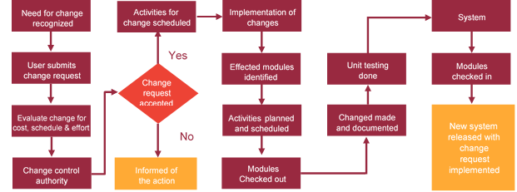

# Project Effort & Timeline

## High Level Project Plan

## Delivery Timeline

Working prototype development: 12 days

Delivery of the project after confirmation of working prototype: 90 days

# Commercial overview

|  |  |  |  |
| --- | --- | --- | --- |
| **Line Number** | **Quantity** | **Unit of Measure** | **Unit Price (in USD)** |
| **0001** | 1.000 | each | 45256 |
| **Product Catg.:** Digital Asset Management Software | | | |
| **Item Description:** Digital Asset Management Software licenses | | | |
| **Tendering Text:** Enter the price for one license as specified in Section Scope of Work. The price must includeonsite or remote vendor installation including the one year of maintenance and managed service support in addition to all other requirements listed in the Scope of Work. | | | |

|  |  |  |  |
| --- | --- | --- | --- |
| **Line Number** | **Quantity** | **Unit of Measure** | **Unit Price (in USD)** |
| **0002** | 3.000 | Years | 20160 |
| **Product Catg.:** Warranty Support | | | |
| **Item Description:** 3 years Warranty Support | | | |
| **Tendering Text:** Enter the price for the 3 year of warranty support as specified in Section Scope ofWork | | | |

All customer payments shall be made within 15 days from the date of customer raising the invoice by transferring the funds into the customer bank account detailed below.

* 30% advance along with signing of this agreement
* 25% Milestone-2
* 25% Milestone-3
* 20% on Go Live & before deploying the application to production server
* Yearly AMC payment needs to be paid upfront within 15 days from the starting of AMC period.

# Miscellaneous

## Warranty

Verbat shall provide a bug ﬁx warranty at no additional cost for 30 days from the date of acceptance of the project, for correction of any errors in the developed application that may be attributed to Verbat.

However, this does not cover modifications by Client, or use of the application on an environment other than the proposed environment, or other circumstances outside Verbat’s reasonable control. In such a case Verbat reserves the right to charge for its services.

All error corrections will be executed at Verbat India office. In the event of any need for on-site work, all expenses incurred for such trips will be payable to Verbat by Client.

## Acceptance Criteria

* UAT sign off should happen within 14 Days from the release of each module/ Phase and the acceptance confirmation needs to be mailed to Verbat failing which Verbat will consider the project as approved by the client.
* Any comments or reason for rejection need to be documented and the same needs to be sent as an email from the official mail id of client to Verbat.

## General Terms and Conditions

* Offer Valid for 30 calendar days from the date of submission of the Proposal
* An average of 20 working days are assumed in a month
* This proposal and all technical/ functional specifications have been derived or concluded from the data shared via email / information's transferred during the initial requirement analysis meetings and conversations. Verbat reserves the right to amend the terms of this proposal, should the SOW terms, functional features and functionalities change during the course of the project
* The applications will be built as per the specifications agreed mutually. Any changes will be executed through a deﬁned change management process between both parties
* All Source Code and other project artefacts would adhere to the Verbat document templates and internal coding standards
* Acceptance criteria shall be based on the clauses which were mutually discussed between Verbat and client at the Requirement Analysis phase and the same will be documented and approved by both parties through official emails
* Final deployment to production server pursuant to completion of all payments

## Assumptions and Dependencies

* During the requirement gathering phase, authorized personnel from the Client’s side is expected to be available for discussion and finalizing the HLD (High Level Design), before development commences.
* Type of reports and formats, if under the scope of the project, needs to be specified by Client before project sign off.
* Workflows need to be specified/ confirmed by client before project signoff.
* All queries regarding the client requirement and any queries which may hinder the project advancement at any stage should be answered by the client within 24 hours from the time of initiation, failing which the time delay will get added to the actual effort which was estimated.
* Verbat assumes that all sign-offs from Client will be provided within agreed and specified timeframe.
* Client will provide all the necessary contents, both text and image, before starting the project in the format suggested by Verbat (if any).
* The client should provide the relevant information and data well in time for the execution of a related activity. Non- availability of this information or data may lead to an interruption of work which may result in a delay in delivery as well as additional costs to the client.

## Source Code & Intellectual Property Rights

* Upon completion of the Project and 100% completion of the payment, client will have access to the source code except for propriety codes, developer tools and third party application / modules like Microsoft Dynamics Products, Share Point LMS etc.
* The solution offered will be the intellectual property of the client and will be made available to the client on an “unlimited license” basis.
* Modifications by third party/person: No person or organization, other than Verbat or any person authorized by Verbat in writing, has any permission to modify/change the software Solution to be eligible to get continued support from Verbat as per the support terms defined under this document.
* Liabilities/Damages: Verbat accepts no liability or damages of any kind arising out of use or non-use of the software delivered. The responsibility of testing of software lies with Client.

# Our Clients

**UAE University**

Education

Transportation

**Canada Cartage**

Construction

Services

Finance

We look forward to hearing from you soon and hope that you will give us the privilege to work with you in meeting your business goals. Thank you.

Thank You

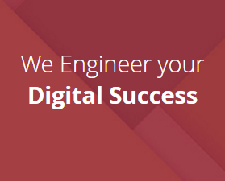

©   
1999 - 2017. All Rights Reserved   
Verbanet Technologies LLC  
www.verbat.com