**ENSCO DATA MANAGEMENT SYSTEM**

**Ministry of Human Resource and Emiratization**

Development of ENSCO Data Management System

Submitted By:

VERBANET TECHNOLOGIES L.L.C

**CONTENTS**

**1** **KEY DETAILS** 3

**2** **PROJECT SCOPE** 4

2.1 PROPOSED SOLUTION MODEL 4

2.2 FUNCTIONAL REQUIREMENTS 5

2.3 NON-FUNCTIONAL REQUIREMENT (OTHERS) 6

2.4 PROPOSED SYSTEM ENVIRONMENT 7

2.5 TECHNICAL CONFIGURATIONS 8

2.6 PROJECT DELIVERY 10

2.7 PROJECT ASSUMPTIONS 15

**3** **OUT OF SCOPE** 17

3.1 CHANGE MANAGEMENT 18

3.2 MAINTENANCE & SUPPORT 20

3.3 SERVICE LEVEL AGREEMENT (SLA) 20

**4** **TERMS & CONDITIONS** 22

4.1 ACCEPTANCE CRITERIA 22

4.2 WARRANTY 22

4.3 SOURCE CODE & INTELLECTUAL PROPERTY RIGHTS 22

4.4 GENERAL TERMS AND CONDITIONS 23

4.5 GENERAL ADMINISTRATIVE, TECHNICAL & FUNCTIONAL ASSUMPTIONS 24

**5** **FINANCIALS** 25

5.1 WEB APPLICATION DEVELOPMENT 25

5.2 WINDOWS DEDICATED HOSTING – OPTIONAL 26

**6** **ABOUT US** 28

# **KEY DETAILS**

**PROJECT NAME CLIENT**

ENSCO Data Management System Ministry of Human Resource & Emiratization

**CLIENT CONTACT CLIENT ADDRESS**

Mr. P.O.Box 123

ABC Street

Dubai

U.A.E

**PROPOSAL SUBMISSION PROPOSAL ID NO.**

01.08.19  AD/BP/25042018/1820/2

**PROPOSAL VALID UNTIL ANTICIPATED START DATE**

30.10.19 00.00.00

**PROPOSAL SUBMITTED BY PROPOSED TECHNOLOGY**

ASP.NET

Verbanet Technologies L.L.C

Dubai, U.A.E **APPLICATION TYPE**

+971 4 297 3236 Web Application

+971 50 765 2345

# **PROJECT SCOPE**

Ministry of Human Resource and Emiratization (hereafter referred to as “Client”) has approached Verbanet Technologies L.L.C., (hereafter referred under its trade / brand name as” Verbat”) to develop an accessible and informative ENSCO data management system that fulfill the aim of ENSCO in relation to transparency and understanding of occupation profiles

The ENSCO system shall provide a modern and central national platform for referencing, collecting, compiling, analyzing and communicating information about occupations on a national and international level. ENSCO wishes to provide a standardized framework for organizing the world of work in a manageable, understandable and coherent system.

The building of a competitive and resilient economy requires that all occupations be classified with associated tasks, skills and core abilities. The system shall follow the international ISCO-8 standards to manage information about the UAE labor market

The primary objectives of ENSCO are

* Create a multifunctional repository that is resilient to changes
* Develop an electronic management system that enables the stakeholders to choose a classified occupation before requesting work permit
* A system that can be integrated with other government repositories where skills and occupations are linked with each other
* A single source of truth for all occupations and skill levels
* Integration with all MOHRE core systems to support the decision making process in all classifications
* Multidimensional system that identifies occupations progression routes, core competencies, skills and qualifications

## PROPOSED SOLUTION MODEL

**STAND- ALONE FIXED BID**

Verbat will be following a stand–alone fixed bid solution delivery model wherein the required solution would be devised and a suitable pricing would be offered. Verbat’s solution architects have conducted a thorough research on the requirements and have come to the conclusion that our proposed solution, which is detailed further in this document, will meet the requirements put forth by the client.

**KEY STRENGTHS OF OUR SOLUTION**

* Strong and Scalable platform accommodating to future enhancements
* A framework which acts as a solution accelerator with building blocks that can be re-used in n future for building new components and features.
* Our light weight framework used consumes fewer system resources thereby making the application perform faster.
* All security aspects are considered

## FUNCTIONAL REQUIREMENTS

The main features and functionalities of the application to be developed are presented below:

### **MOHRE Staff Module**

* Login/logout
* Maintenance and management of ENSCO system
* Administration control of all data fields
* Make judgments on specific request from employers regarding new occupations or job titles

### **Employers and General Public Module**

* Employers
  + Login/logout
  + Fill online application
  + Submit request for new occupation or job titles
  + Review, search and print information of individual occupation profiles
* General Public
  + Login/Logout
  + Review, search and print information of occupation profiles
  + Choose classified occupation
  + Request work permit

### **General Requirements**

* Integration with MOHRE core systems and other related ministry systems
* Unified and comprehensive database
* Manage and govern the implementation of classified occupation, skills and qualifications automatically
* Multi-dimensional system to identify occupation progression routes, core competencies, skills and qualifications
* Integrated dynamic electronic management system
* Interactive search engine and decision making processes enabler
* Add, edit, cancel and suggest stakeholders or decision body to make clear decision body to make clear decisions or recommendations
* Date and classification related to labor market:
  + ISCO-08 Group classification
  + ENSCO occupations and job titles
  + ENSCO occupation profile attributes
  + ENSCO linkage with ISIC and ISCED
  + Source of core competencies, skills and qualifications
  + Established business sectors
  + Career pathways and progression
  + Up skilling and training
* Master Data Management system:
  + Technology
  + Software
  + Data governance and stewardship
  + Database

The project shall be completed in 4 Phases.

**Phase one** will consist of studying and understanding of the business requirements. During this phase Verbat shall also conduct a study of the existing systems being used at MOHRE. The outcome of which would be a formal document that describes the system that shall be built. The document would outline the process flows, data flow diagrams, entity diagrams etc. The document shall cover various technology options, risk factors, associated costs etc. Verbat shall try to make use of the existing technologies if needed.

**Phase Two** shall be the implementation and construction phase. Based on the understanding reached during the requirement gathering phase, the system shall be built to specifications

**Phase Three** is the pilot and testing phase. The system shall be tested for responsiveness as well as support for all major browser versions

**Phase Four** During this time, Verbat shall develop supporting documents that describe how to best make use of the system being built. Staff training shall also be provided during this phase

**Phase Five** All items that had been deferred for change management shall be considered during this phase. On-going support may also be considered during the phase. The terms of the agreement shall be determined at a future date

## Detailed Requirements

|  |  |
| --- | --- |
| **Project Initiation** | |
| Business Analysis | |
| Project Management (Projects schedule, communication management plan, project charter, Change management) | |
| Design (UI & UX prototypes with 3 design alternatives) : Responsive design | |
| QA ( functional testing, performance testing, usability testing) | |
| Documentation (Business requirements, Functional requirement specification, User guides) | |
| Staff Training (System admins, Staff) | |
| **Development** | |
| Home Page, About, Contact US, Privacy, T&C, Enquiry & Complaints | |
| Management of static content using CMS | |
| Bi-Lingual Site (Arabic & English) | |
| Social Network integration | |
| **Internal Staff** | |
| ISCO-8 Major Group Classification | |
| ISCO-8 Sub-Major Group Classification | |
| ISCO-8 Minor Group Classification | |
| ISCO-8 unit group classification | |
| Occupation profile & attributes | |
| Occupation progression (process flow and business logic) | |
| Established business sectors | |
| Career Pathways & Propagation | |
| upskilling and training recommendations | |
| Software and hardware technology competencies and classifications | |
| Data governance & stewardship | |
| Essential qualifications by industry (link between ENSCO, ISIC & ISCED) | |
| Verify companies | |
| Verify job categories | |
| Communication management | |
| Analytics & Reporting (Basic functionality) | |
| Login (Social networks, Smart Pass etc.) | |
| Dashboards (Audit trail, Major / Minor categories, site visitors, services usage) | |
| **System characteristics** | |
| Workflow to capture suggestions and decisions of the general body | |
| Document management | |
| Auditing & logging | |
| Authentication & authorization | |
| Exception management | |
| Email notifications and management | |
| CMS based pages for static content that can be updated by internal users | |
| FEDNET compatibility (code changes to adapt to the environment) | |
| **Intelligent Search** | |
| Elastic search (ELK stack) | |
| Faceted search | |
| **Employers & Public** | |
| Register companies | |
| Register employees | |
| Create / Update job classifications / categories | |
| Login (Social networks) (remember PW, Forgot PW) | |
| **Robotic Process Automation** | |
| Enter information into the App (internal staff) from emails or email attachments received * | |
| **QA** | |
| Functional Testing | |
| Deployment (including migration to FEDNET)** | |
| Estimate based on RFP provided. However it was difficult to gauge the depth of functional requirement. Hence actual estimate may vary depending upon the requirements uncovered during business study |
| Integration with other systems cannot be estimated without knowing the actual requirements |
| The reporting and analytics dashboard will contain essential functionality to cover basic reports and stats. Typically about 4 reports and 3 analytics dashboard data. Additional reports and dashboards would come under change management and estimation of effort |
| * Per independent process. Actual estimate may vary depending on the business process. If two processes are related, then the second process being designed might take a fraction of the original effort |
| ** Deployment without fednet will be 16 hours. Does not include migration of data from an existing system. Migration included for transferring data and apps from local instances (created bt vendor) to fednet instance |

## NON-FUNCTIONAL REQUIREMENT (OTHERS)

|  |  |
| --- | --- |
| **Requirements** | **Details** |
| User Experience and  UI Design | * The application will be developed only in English & Arabic * The layout and graphical components will be created considering the usability factors |
| Performance | * Application will allow users to have smooth and quick access to the information or services they require. |
| Security | * Web security standards will be followed. |

## INFRASTRUCTURE

|  |  |  |  |
| --- | --- | --- | --- |
| **Category** | **Requirement** | **Compliance** | **Notes** |
| Portability | The system shall allow easy transition from “on premise” solution to cloud based hosting i.e. FedNet. Transitions shall eliminate applications re-engineering and implementation of the application architectural changes | Compliant | Assumes that the client would use containers |
| Design | The system shall be fully virtualized, including primary, support and infrastructure services. Any exception components, platform compatibility shall be explicitly mentioned and shall be provided with rational | Compliant | Support IAAS |
| Design | The system shall eliminate any underlying dependency on the underlying OS features (e.g. windows clustering), hardcoded IP addressing or hardware | Compliant |  |
| Design | The system shall have flexibility to use be deployed on database technology of ministry’s choice | Compliant |  |
| Design | The system shall be compliant with design principles | Compliant |  |

## SCALABILITY

|  |  |  |  |
| --- | --- | --- | --- |
| **Category** | **Requirement** | **Compliance** | **Notes** |
| Design | The solution and its components shall fully support and shall be planned to explicitly configure for stateless architecture to enable on-demand scalability and elasticity | Compliant |  |

## SECURITY

|  |  |  |  |
| --- | --- | --- | --- |
| **Category** | **Requirement** | **Compliance** | **Notes** |
| Design | The solution design shall adhere to defense in depth principle | Compliant | See Architecture diagrams attached |
| Design | The solution shall have corresponding security architecture that describes corresponding security threats and identify all participating components of the solution that ensure security of the overall solution | Compliant | See Architecture diagrams attached |
| Design | Verbat shall mention any assumed or planned reliance of the solution on the third party security components | Compliant | UIPath Recommended as part of the solution |
| Access Control | The solution shall provide a fine grained access control capability that allows user permission hierarchy and levels to be setup | Compliant | This is by default assumed |
| Access Control | The solution shall provide a fine grained access control for data level access. The solution shall support defining of multiple classification levels and map the level against case attributes and fields. The solution shall restrict access to entire cases or partial case data depending on user hierarchy/role, access | Compliant | Access based on privileges and roles |
| Access Control | The solution shall give ability to apply role based access controls to allow for the proper designation of administrative and user roles | Compliant | Same as above |
| Access Control | The solution shall provide centralized management of access control or decentralized if needed in the future | Compliant |  |
| Access Control | The solution shall allow security administrator to reset password for subsequent change by user | Compliant |  |
| Access Control | The solution shall allow automated user password reset based on correct answers to predefined security questions | Compliant |  |
| Access Control | The solution shall allow a security administrator to suspend or deactivate a user id from further use as opposed to delete | Compliant | Soft delete the account |
| Access Control | The solution shall allow a security administrator to add or modify user security information using online screens with immediate profile update | Compliant |  |
| Access Control | The solution shall allow a security administrator to review and report on attempted violations by batch report or online | compliant | Audit reports shall be available |
| Access Control | The solution shall record who changed security profiles and when changes are made | Compliant |  |
| Authentication | The solution shall provide the ability to support configurable soft and hard multi factor authentication | Compliant |  |
| Authentication | The solution shall give ability to use MOHRE user ID | Compliant | We have already implemented SmartPass in other Gov related projects |
| Authentication | The solution shall enable implementation of a data privacy policy leveraging the fine grained access control for data level and the role based access controls capabilities in the system | Compliant |  |
| Compliance | The solution shall support industry standard TLS, SSL, SSH, HTTPS security encryption | Compliant | Client shall purchase the required certificates. Verbat can help with the procurement |
| Compliance | The solution shall be in compliance with all local and national security standards including all applicable NESA and ADSSSA standards | Partial | We can provide the necessary software related compliance. However we do not provide nor support hardware compliance |
| Audit | The solution shall have out of the box capability to record and trace all end-user and administrator sessions | Partial | We shall be engaged in developing a solution from the ground up. Therefore it would be premature to say that we provide out of the box functionality. However based on the requirements we can have this backed into the application being developed |

## SYSTEM MANAGEMENT

|  |  |  |  |
| --- | --- | --- | --- |
| **Category** | **Requirement** | **Compliance** | **Notes** |
| Backup and archiving | The solution shall adhere to UAE government data/records retention requirements | Partial | We can help you with setting up backup and archiving. Provided that you procure the necessary products |
| Deployment | The solution shall have out of the box capability to perform out of the box deployments of the customizations, configurations as part of the ongoing management | Compliant | We generally do container based deployments |
| Monitoring | The system shall support monitoring capability that allows user experience monitoring and transaction response time | Partial | This can be performed as part of the pilot project (UAT) |

## INTEGRATION

|  |  |  |  |
| --- | --- | --- | --- |
| **Category** | **Requirement** | **Compliance** | **Notes** |
| Design | The solution shall refer to other systems through the use of middleware | Compliant | Based on requirements |
| Design | All APIs shall be fully documented describing their usage, inputs, outputs, technology, protocols and negative/positive flow behavior | Compliant | We use swagger and postman to test and document our API’s |
| Design | The solution shall support synchronous and asynchronous interactions as required | Compliant | We recommend development in AngularIO, .net Core & RxJS |
| Design | The solution shall support the management and monitoring of all APIs to facilitate trouble shooting and tracing needs | Compliant | We recommend the use of one of many API monitoring services (Uptrends, Amazon cloud watch) |
| Design | The solution shall use industry standards to authenticate and authorize web services request | Compliant |  |

## CLOUD READINESS

|  |  |  |  |
| --- | --- | --- | --- |
| **Category** | **Requirement** | **Compliance** | **Notes** |
| Stateless | Application code shall not be planned directly for a specific technology. For example consist of any embedded IP addresses into the build/deployment packages, keep application from being affected by dynamic scaling. Application shall be as generic and stateless as possible. If you must use a singleton, enable a voting protocol so that the remaining nodes recreate a singleton if the singleton dies. Also keep a permanent backup of the singletons state in a shared repository such as a database | Compliant | We recommend a technology agnostic development environment. Our apps can be deployed on linux / windows. Please see our architecture diagrams to get a better picture |
| File System | Application shall not assume that the local file system is permanent. Limit use of local file system as a store for temporary information, put temporary information in a remote store such as an SQL or NoSQL database. Be aware that reading static information from a file system is fine. For example your application can read a configuration or properties file if each node has the same files in the same, or an equivalent, directory structure. This also includes log files | compliant | We generally do deployments based on Infrastructure as a Service. Therefore applications can be configured to be deployed on MSSQL or MariaDB as opposed to couchdb or another flavor of NoSQL |
| Stateless | Application shall not keep session state in application itself. If you can’t eliminate session state entirely, the best practice is to push it out to a highly available store that is external to application server, that is put it in a distributed caching store or in an external database | Compliant | Generally we do not recommend stick sessions |
| Infrastructure Dependencies | Reliance on OS – specific features shall be avoided. Application shall be more resilient in a cloud environment, they shall be agnostic to any infrastructure dependency. For example, clustering. A better approach is to consult an external service registry to resolve service end points or delegate the entire routing function to a service bus/middleware or a load balancer with a virtual name | Compliant | We recommend APIGEE |
| Infrastructure dependencies | Application shall not use infrastructure APIs from within. Avoid making assumptions about the infrastructure that your application runs on, it makes changing that infrastructure more challenging. Think about why application code is calling an infrastructure or API. Consider other options of obstructing this, using some other layer or relying on the middleware | Partial | Not sure what you mean |
| Integration protocols | Avoid obscure protocols and standardize on middleware. Moving to an HTTP based infrastructure based on such standards as REST makes it easier to port your system to an environment. It will also enable additional business opportunities that are provided by API management and middleware. Ministry has middleware setup that can be leveraged for integration purposed that supports REST API calls | Compliant | We tend to avoid SOAP |
| Infrastructure dependencies | Reliance on OS – specific features shall be avoided. Avoid the OS- specific dependencies as much as you can and rely instead on services that are provided by middleware infrastructure. Any OS specific features and dependencies shall be explained and presented as part of the solution | Compliant |  |
| Automated Deployment | Solution shall have capability to capture and provide application installation as a set of operating system level scripts. Vendor would be expected to roll out production environment zero touch and rely on bash, shell and other scripts to demonstrate this capability. Associated scripts shall be provided to the ministry. It is preferred that non-production environments follow the same approach | Compliant |  |

## Application Architecture

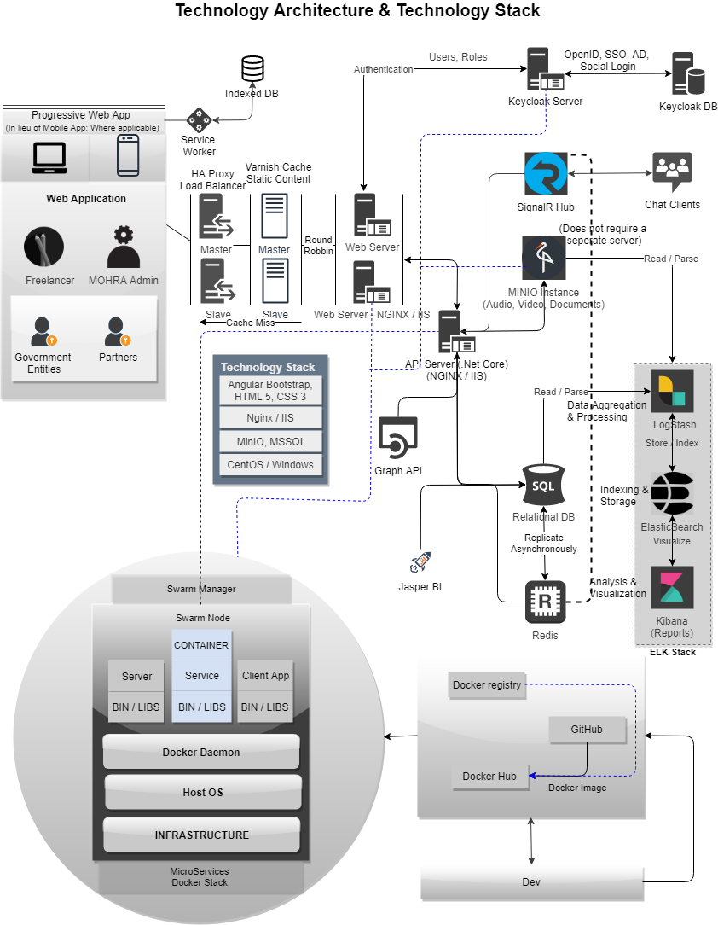

## Master Data Management High Level Overview

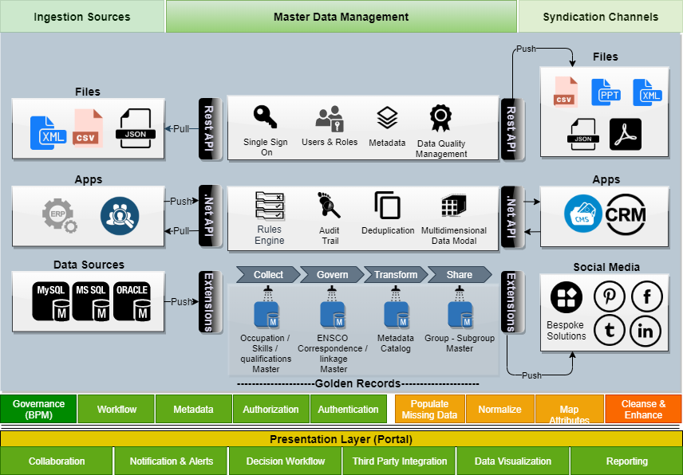

Based on our understanding of the requirements, MoHRE wishes to implement a national classification of occupations and its management. The system is based on the International Standard Classification of Occupations (ISCO-08). The system shall also reference market demands and trends for workforce planning.

The project envisions the building of a Master Data Management (MDM) system. The system shall be integrated with related ministry stakeholders. Occupation profiles, skills, salaries and qualifications etc. may be linked to these tertiary entities.

The ENSCO data warehouse shall comprise of information extracted from these entities through a combination of back end processes, ETL’s, secure file transfers etc. The data extracted must be sanitized and normalized. Business Leads would study the business processes as well as the sources of these data to get a better understanding of the domain objects.

* A short description of the steps involved include
* Identifying the data sources in the enterprise that needs to be consolidated
* Acquire the data from all the different sources and do data profiling
* Perform data modelling, create schemas, determine and create rules on the data from different sources
* Cleanse the data and determine hierarchies
* Integrate the data from different sources.
* Implement data workflow management and data sharing
* Leverage master data for business scalability and growth

This will enable the management of every aspect of the master records including hierarchy, structure, validations, versioning and enriching of master data with attributes, descriptions, translations, documentation, and other related data components.

By managing the master data in a central location (single source of truth), it allows for a single authoritative view of business information while reducing data silos, improving data reliability, reducing data redundancies, increasing operational efficiencies, and providing actionable insights.

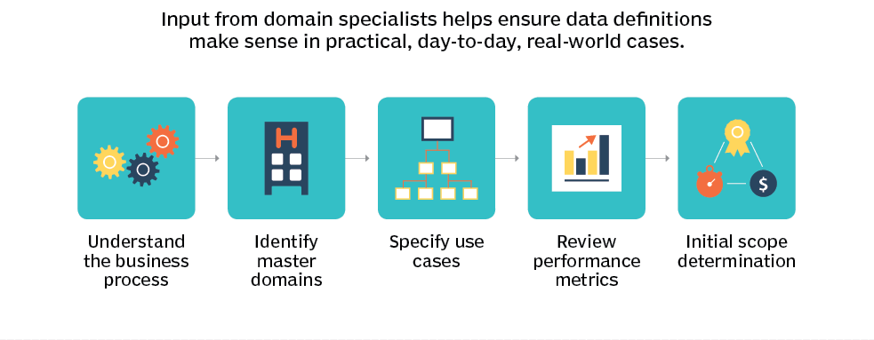

Verbat is proposing a bespoke solution for the creation and management of the MDM because we understand that majority of the data needs to be assembled based on the groups, subgroups, occupations etc. dictated by ISCO-08. Furthermore this information must also be collated against ISIC and ISCED. This will eventually result in the creation of master data that is golden.

This would form the basis for the creation of a data warehouse with facts, dimensions and measures. By integrating this data with various state departments and actors, information about employment, job requirements, salaries, attrition rates etc. can be discovered.

Workflows may be created that would guide citizens on how to achieve career growth, compare their earnings to the state average for their occupations etc.

While there are many out of the box solutions available, Most are priced in the $50K-$100k range. This solutions do not include the implementation cost. The sophisticated solutions have a learning curve that is non-trivial. It also incurs a maintenance cost related to managing the application.

## Network Topology

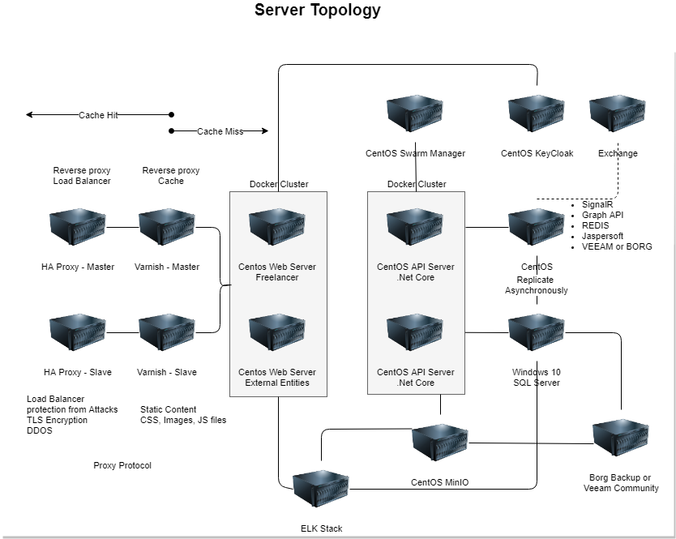

## Architecture Descriptions

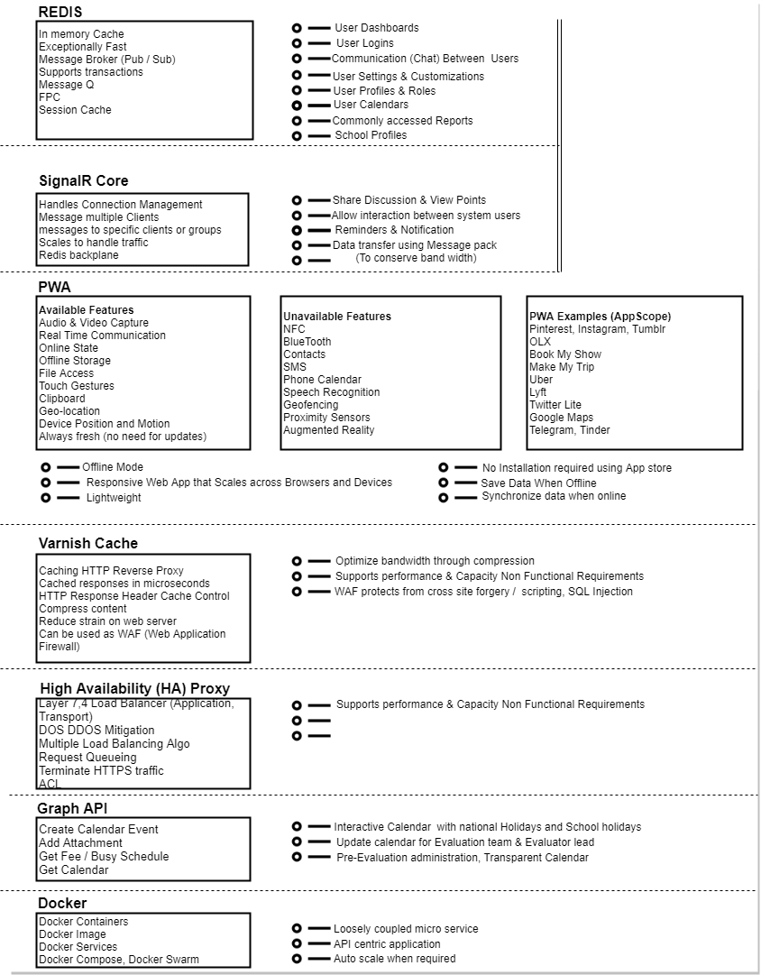

## Security Architecture

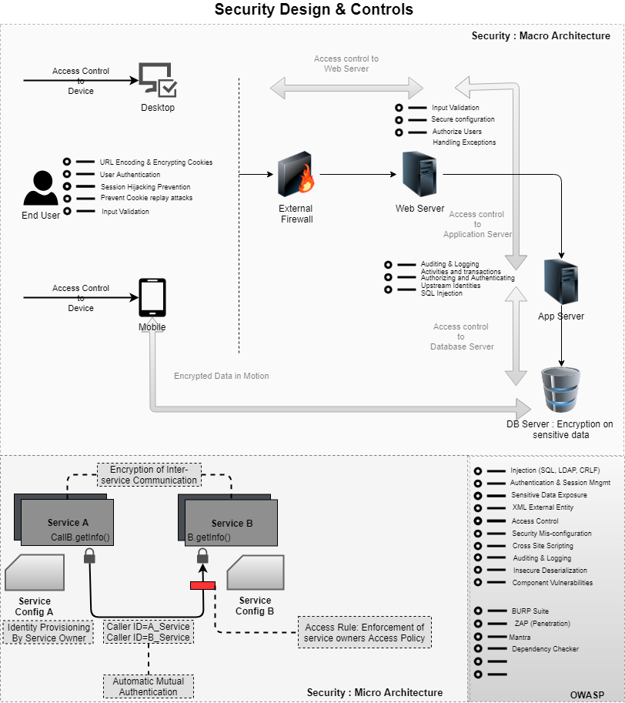

## Annex A

## ISCO 08 Compliance (Example)

**ISCO 08 Code**

**2511**

**Title EN**

**Systems analysts**

**Lead Statement**

Systems analysts conduct research, analyses and evaluate client information technology requirements, procedures or problems, and develop and implement proposals, recommendations, and plans to improve current or future information systems.

**Task statement**

Tasks include:

* Consulting with users to formulate and document requirements and with management to
* Ensure agreement on systems principles;
* Identifying and analyzing business processes, procedures and work practices;
* Identifying and evaluating inefficiencies and recommending optimal business practices, and
* System functionality and behavior;
* Taking responsibility for deploying functional solutions, such as creating, adopting and implementing system test plans;
* Developing functional specifications for use by systems developers;
* Expanding or modifying systems to improve work flow or serve new purposes;
* Coordinating and linking the computer systems within an organization to increase compatibility.

**Included occupations**

* Analyst, business (IT)
* Analyst, communications/computers
* Consultant, computer
* Consultant, information technology
* Consultant, systems
* Designer, systems
* Scientist, computer

**Excluded occupations**

**Notes**

**Comments**

Split group - includes IT business analysts

Sources: ONET 15-1051; ANZSCO 2611; CAN2512

**ISCO 88 Code(s)**

2131, part

## PROPOSED SYSTEM ENVIRONMENT

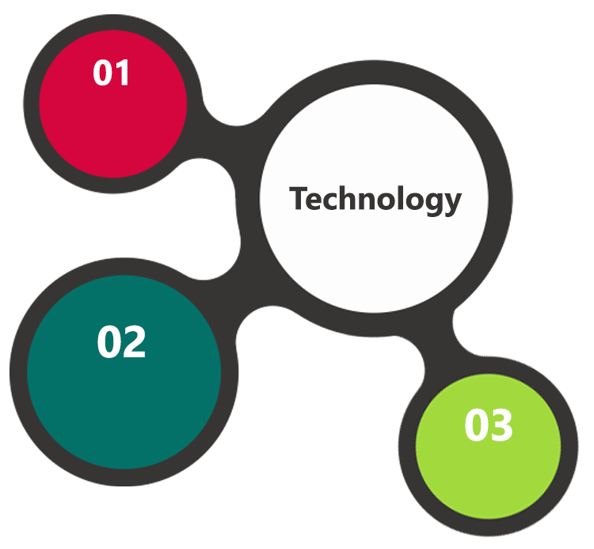

.Net Core, Angular IO

HTML5 / CSS3

Java Script

Windows / NGINX

IIS / Apache

MSSQL / Oracle

**MS SQL2012  
Windows 8/10  
Web Services**

## TECHNICAL CONFIGURATIONS

### **DEVELOPMENT TOOLS**

* ASP.Net 4.5
* MS SQL
* HTML / CSS 3
* Photoshop
* Web services, Ajax, JavaScript

### **RECOMMENDED WEB HOSTING PACKAGE- DEDICATED HOSTING**

* Operating System : Windows Server
* CPU : 2 core
* Domains: Unlimited
* Disk Space: 200 GB
* Monthly Bandwidth: 50 GB
* Web site Server Software – IIS 7.5 +
* ASP.NET 4.5

### **BROWSER**

* Chrome version: 56
* Firefox version: 51
* Edge version: 39

### **HARDWARE**

The application is reliant on hardware interfaces to provide a seamless automated user experience.

* Computer with Windows 8 or 10 OS
* Compatible Browsers as specified in section 6.2.3

### **TECHNICAL GUIDELINES**

The guidelines provide instructions and conditions that will be adhered to during the development of the application.

* The client will finalize the functional requirements and UI/UX before the commencement of the project
* The duration mentioned in the project time line is for development and testing and any delay or time taken by the review team to respond will not be Verbat’s responsibility
* Any clarification required from client needs to be addressed within 24 hrs.
* Verbat will inform the client if any of the client requirements /request deviates from it.

## PROJECT DELIVERY

### **PROJECT MANAGEMENT**

The Verbat development center strictly follows industry standards on quality. The project management is process governed by the Verbat Quality Management system and is put to verification through internal audit programs that happen from time to time. Verbat will dedicate a project manager for the proposed implementation. Verbat proposes Client to identify one project manager who will be driving activities to be undertaken by Client to be the single point of contact for Verbat.

### **ROLES & RESPONSIBILITIES**

Verbat will assign a dedicated Project Manager/Project Lead to lead the project, who will be the first point contact for Client. He/she will be responsible for planning and managing the various activities within the project. He/she will work closely with Client Project Manager, to give periodic status updates and ensure high level of visibility and comfort on the progress of the project. The Project Manager/Project Lead will lead the co-ordination between Verbat and Client, thus enabling smooth transitioning of Client requirements to the Verbat ’ offshore delivery team, and provide visibility as well as comfort on the progress of the services to Client.

He/she will have periodic meetings with Verbat ’ s Senior Management, thus ensuring Verbat ’ Management commitment and focus on Client initiatives.

### **DELIVERY ACTIVITY SUMMARY**

|  |  |
| --- | --- |
| Activities | Description |
| Detailed requirement Analysis | Verbat team to conduct detailed study of requirement for the phase. If clarification is required, team will reach out to Client for more information and/or time for discussions. |
| Project Schedule | With significant dates and milestones |
| DB Design | DB design for central and test DB. |
| Software Requirement Specification document (SRS) | Once the requirement analysis is completed, Verbat team will submit the SRS document for approval |
| UI/UX Design, Prototyping | Based on the SRS, Verbat UX/UI team will work on the UI/UX of the screens and submit for approval |
| Functional Specification Document (FS) | Once the UI/UX is approved, Verbat shall submit an FS document for approval. |
| Development | Actual system development starts based on the FS. This involves detailed design and software development of Web Application. |
| Testing | Test Planning, test plan creations, internal, integration testing and user acceptance testing. |
| Deployment | Deploying the latest built in the Verbat Test Server. |

### **PROJECT IMPLEMENTATION PLAN**

Verbat will be providing the solution in a stand-alone fixed bid approach which ensures minimum viable solution for quick wins with core focus on the long-term business objective and outcome. Once the implementation is over, Verbat will initiate the application maintenance process (once the maintenance contract is signed) which continues to extend after the implementation.

### **DELIVERABLES**

* Home Page
* Use case
* Project Plan
* Software Requirement Specification Document (SRS)
* UI/UX Design
* Prototype of the application
* Functional Specification
* Fully Developed & Tested Application
* Source Code

### **ESTIMATED DELIVERY TIME**

The effort estimated for delivering the application will be as below:

* UAE working days for the UI/UX from the date of approval of the SRS
* UAE working days for the development of the application from the Date of Approval of the FS.

| **Activity** |
| --- |
| Contract Signoff (T0) |
| Project Initiation & Initiating requirement gathering |
| Software Requirement Specification Document(SRS) |
| SRS Approval (T1) |
| System UI/UX-Complete |
| System UI/UX-Approval (T2) |
| Functional Specification (FS) |
| FS Approval (T3) |
| Development Phase-Complete |
| Perform QC (Unit Testing and Integration Testing) |
| System ready for UAT |
| UAT Acceptance on Verbat server (T4) |

* The above-mentioned timeline is in UAE Working Days
* The initiation of the UI/UX development is dependent on the confirmation of SRS. SRS will be submitted post the confirmation of the project along with LPO, signed proposal and advance payment
* The above mentioned timeline for development is post the confirmation of FS
* Documentation submitted after project initiation and system study supersedes any proposal or documentation submitted during initial requirement gathering / discussion / negotiation
* Project plan will be submitted post the confirmation of project with necessary payments
* Any delay in getting the approvals of deliverables from client will cause change in timelines and the revised timelines will be updated in weekly status reports shared with client after the project commencement
* All approvals and queries regarding the client requirement and any queries which may hinder the project advancement at any stage should be answered by the client within 24 hours from the time of initiation, failing which the time delay will get added to the actual effort and timeline which was estimated.
* On project confirmation, Verbat requires a lead time of minimum seven (07) days for resource mobilization.

### **DEPLOYMENT DETAILS (AT CLIENT’S BEHEST)**

* Client can opt for hosting the application at Verbat’ Server.
* If deployment is at the client’s server, responsibility of deploying the application onto the production environment after conducting the necessary acceptance testing will lie with the client unless and until Verbat ’ support is contracted for deployment.

### **RELEASE PLANNING**

* Client will be informed about the release date and time through email.
* Client performs the UAT

### **RISK CONTINGENCY PLANNING**

Verbat has identified various risk factors associated with this assignment and understands the impact of these risk factors on the project schedules. The objective of this section is to highlight for both Verbat and client, the risk factors, to analyze the impact of the risks on project execution, and to propose strategies to control and reduce the impact of the risk factor. These various risks, which could arise during the project, are tabulated below along with mitigation implementation.

| Type of risk | Impact | Risk Mitigation | Risk Handling |
| --- | --- | --- | --- |
| Scope Creep | H | Functions and features will be detailed in system requirement documents and will go through client approval. Once this document is approved, any change to requirement will go through change management review for possible impact assessment. | Proper change management procedure will be implemented. |
| Delay in customer feedback | H | The plan is prepared with enough lead-time for customer reviews and approvals.  The customer is indicated with the dates when the document is expected after review and approval. | The request for feedback will be escalated if not attended at the right time so that the schedules are not affected. Deemed acceptance criterion is set up front and will be followed. |
| Non-availability of necessary software’s, frameworks, database instances and infrastructure at client’s hosting environment(If hosting support is provided by Verbat ) | M | Client will be informed in advance on these requirements. | Possible impact to schedule. |
| Manpower attrition | L | All efforts would be made to ensure process dependence rather than being person dependent. As a risk mitigation plan Verbat will train backups. | A new person will be identified as early as possible, provided the required project-specific training and mentored by the senior members of the team to minimise impact of attrition on the project. |

*H-High, M-Medium, L-Low, NA-Not Applicable*

# PROJECT ASSUMPTIONS

The project solution and technology is created from the initial understanding of the requirement shared with Verbat through mails and meetings. The proposed solution is based on the following assumptions:

## OBJECTIVE

* The requirement is to develop a ENSCO Data Management System with the functionalities as defined in ‘Functional Requirements’ section

## DESIGN

* Client to provide Verbat with the branding guidelines.
* Color theme shall be provided by the client
* Client shall provide licensed images and logos in specified size & format
* Client shall provide the text and associated images for the proposed application. Text should be provided in digital format preferably in MS Word 2013 or above
* Verbat may use template based design for the application
* Verbat shall provide 3 layouts based on the requirements. Once the layouts are fixed, further changes (major) are subject to change management.

## DEVELOPMENT

* The proposed application front end and backend would be developed in English & Arabic
* Development Contingent upon timely feedback from client
* The client will finalize the functional requirements and UI/UX before the commencement of the development of the project
* Client shall approve the UI/UX for the web application before development work starts
* Verbat assumes client requires minimal reports and the reports considered in the scope are mentioned under the respective user modules.
* Final data needs to be entered by the client via the application
* Client will provide sample data to test the application
* Testing of web application will be done in latest versions of Google Chrome, Mozilla, Edge web browsers only
* Client will host and manage the application on infrastructure (server / cloud) recommended by Verbat for managing database and application backup inclusive of images
* Application and data backups are subject to the purchase of such services at an extra cost
* Internet connectivity is required for the functioning of the Web portal
* Does not support offline access or operations.
* Client shall provide clear directions on additional business process not covered in this proposal. In such cases, the effort estimated provided in this proposal may be amended.
* Client is responsible for procurement of UIPath and any other additional software recommended

# **OUT OF SCOPE**

With the ever evolving digital market, the requirement should be clear to both the parties involved, hence the importance of mentioning the out of scope details of the project. Following are considered to be out of scope while creating this proposal:

* Purchase of images, fonts
* Any language other than English & Arabic
* Migration of existing data / Database migration
* Content writing / proof reading / Data Replication / Manual data entry
* Content or image procurement or uploading or editing
* Audit Trail
* End user testing and load testing
* Developer account creation and Maintenance (Play Store)
* Adding new features to the application other than mentioned in the functional specifications. Such requests will be handled via change management. *For Change management details, please refer section titled “Change Management” in the Proposal*. (refer to section 4.1)
* Annual Maintenance Contract (Bug fixing, debugging, enhancements) – Please refer section titled “Maintenance and Support”, unless contracted for.(refer to section 4.2)
* Hosting Infrastructure and Maintenance (web and email hosting), unless contracted for.
* Application Deployment on the server and respective stores, unless contracted for.
* Backup solution and Disaster recovery unless contracted for.
* Physical deployment onsite / installation of the application in devices and Physical connection, installation of system.
* Integration with third-party, if any, other than mentioned in the functional specifications
* Hardware Integrations / procurement and purchase
* Procurement of SMS gateway / payment gateway / email gateway
* SSL Purchase and installation, if any
* Plugin/template purchases, if any
* OS other than mentioned in the Hardware Interface
* Relevant / related software libraries
* System shall not digitally verify the authenticity of documents uploaded
* Menu organization subject to detailed understanding of the requirement
* Verbat shall not perform hardware related maintenance tasks

## CHANGE MANAGEMENT

Any addition which comes out of the project scope, upon and after the launch of the application will be considered as change management. Verbat recommends the following change management procedure for the same.

* Any change which comes out of the project scope, which was discussed, documented, and mutually approved by both the parties in the requirement stage, will be carried out only through raising a change request.
* Change request will be studied and an impact analysis on the existing work flow will be performed.
* On finalizing the impact, effort estimation for the change will be calculated and raised as additional requirement.
* Verbat will initiate the change request only after getting a formal approval from the client for the additional changes raised.
* Any change from the scope will be charged at AED 1,200.00 per man day effort and approval from the clients will be availed before commencing on any change management.

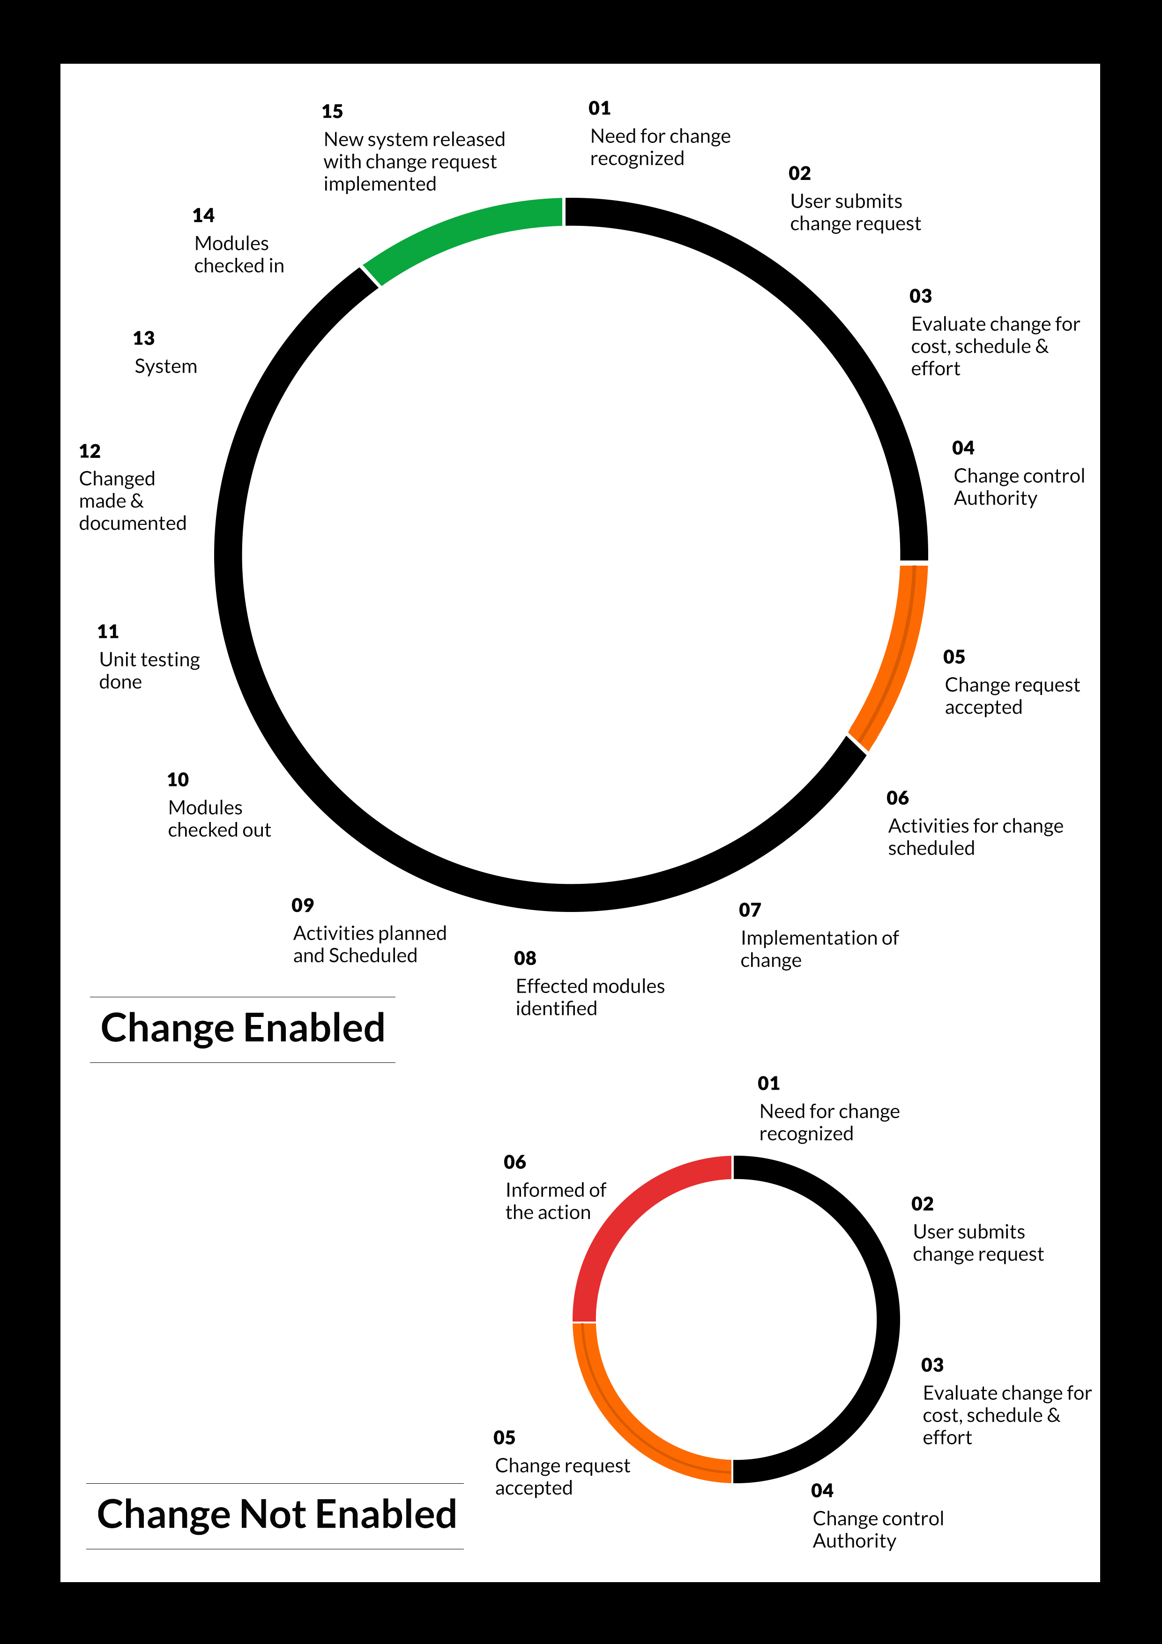

## MAINTENANCE & SUPPORT

* Maintenance contracts by default are supported as per the basic SLA terms.
* AMC with Basic SLA is charged at 25 % of the total project value. Additional Effort/change management request will be added towards Total Value of the Project to determine the AMC value.
* Maintenance support is limited to providing application support for ensuring the consistency of the look-and-feel, bug fixes and user issues i.e. maintenance and support of the existing features of the application.
* Support does not in any way cover providing technical or other support to the end users. The maintenance agreement does not include functionality changes or feature additions which are handled as change requests which will be charged AED 1,200.00 per man day. AMC does not include server support, maintenance and application deployment.
* AMC charges will cover Off-Site Support and Debugging. Support includes E-mail, Telephone and Chat unless explicitly specified. In the event, the application is hosted with the client; necessary remote desktop connectivity should beprovided for carrying out maintenance activity.
* Gap in AMC - In case if the client does not opt an AMC for a year and want to renew it after that period, 50% of the AMC amount for the year for which AMC is not taken will also be payable if the client wishes to renew the AMC contract.

*Note:*

* *Please note that the AMC support shall start only after all the necessary sign-offs (AMC Document) to this effect have been given.*
* *It is not mandatory that the client should opt for an AMC (replace with perhaps: It is mandatory that the client opts for an AMC). The client will still be supported on an ad-hoc basis on an agreed man-day rate.*
* *AMC Payment Terms: 100% to be paid as advance.*

## SERVICE LEVEL AGREEMENT (SLA)

|  |  |  |  |  |
| --- | --- | --- | --- | --- |
| **SLA Type** | **Max Response Time** | | **Max Resolution Time** | **Target** |
| Basic | 1  working day | 3 working days | | Request / incident / problem tickets |
| Advanced | 5 Business Hours | 12 Business Hours | | Request / incident / problem tickets |
| Priority | 3 Business Hours | 5 Business Hours | | Request / incident / problem tickets |

*Note:*

* *We provide Basic SLA as standard with AMC while Advanced and Priority SLAs attract additional charges.*
* *Time zone applicable (8:00 am to 5.00 pm, Sunday to Thursday)*

AMC Option:

Client can opt for time and material based Annual Maintenance, the details of which will be shared post the completion of project.

# **TERMS & CONDITIONS**

## ACCEPTANCE CRITERIA

* UAT (User Acceptance Test) sign off should happen within 07 Days from the first release of the application and the acceptance confirmation needs to be mailed to Verbat failing which Verbat will consider the project as approved by the client.
* Any comments or reason for rejection need to be documented and the same needs to be sent as an email from the official mail id of client to Verbat on or before 07 days from the first release.
* Timeframe for acceptance for any further release will be mutually agreed and finalized between client and Verbat depending on the UAT Comments

## WARRANTY

* Verbat shall provide a bug ﬁx warranty at no additional cost for 30 days from the date of acceptance of the project, for correction of any errors in the developed application that may be attributed to Verbat.
* However, this does not cover modifications by Client, or use of the application on an environment other than the proposed environment, or other circumstances outside Verbat’s reasonable control. In such a case Verbat reserves the right to charge for its services.
* All error corrections will be executed at Verbat India office. In the event of any need for on-site work, all expenses incurred for such trips will be payable to Verbat by Client.

## SOURCE CODE & INTELLECTUAL PROPERTY RIGHTS

* Upon completion of the Project and 100% completion of the payment, client will have access to the source code except for propriety codes, developer tools and third party applications etc.
* The solution offered will be the intellectual property of the client and will be made available to the client on an “unlimited license” basis.
* Modifications by third party/person: No person or organization, other than Verbat or any person authorized by Verbat in writing, has any permission to modify/change the software Solution to be eligible to get continued support from Verbat as per the support terms defined under this document.
* Liabilities/Damages: Verbat accepts no liability or damages of any kind arising out of use or non-use of the software delivered. The responsibility of testing of software lies with Client.

## GENERAL TERMS AND CONDITIONS

* Offer Valid for 30 calendar days from the date of submission of the Proposal.
* An average of 20 working days are assumed in a month.
* All the projects activities will be carried out from our off-shore development center in India
* All the documentation will be provided in English.
* Third party components may be used to develop this application.
* The scope of the project is to develop the Application as detailed in the scope of the project and mentioned in this proposal. Any changes or additions will have to go through change management.
* This proposal would have been derived or concluded from either the RFQ /RFP/data shared via email / information transferred during an initial requirement analysis meeting / tele-conversation. Verbat reserves the right to change the terms of this proposal as the final terms (including the costing), features & functionalities and timeline could change during the course of the project. Hence any fees quoted / timeline committed in this proposal may not be considered as final unless agreed and signed by both parties.
* Web Application will be best viewed only in the environment mentioned in the section Browser Compatibility
* All Source Codes and other project artefacts would adhere to the Verbat document templates and internal coding standards.
* The documents delivered to the client includes the ones mentioned under ‘Deliverables’ and these will adhere to Verbat’s internal document standards.
* Acceptance criteria shall be based on the clauses which were mutually discussed between Verbat and client at the Requirement Analysis phase and the same will be documented and approved by both parties through official emails
* In case Client requires any extension of the proposed acceptance schedule, the associated effort and cost of such extension can be mutually reviewed.
* For any circumstances if project needs to be put on Hold / Stop it requires minimum request notice period of 1 week along with duration for which request will be addressed by management and final decision on the request will be based on that
* If deployment is done in client’s server, Verbat cannot be held responsible for any performance issues arising due to hardware malfunctions.
* Client is responsible for data backup in case the application is not hosted on Verbat server.
* Source code will only be delivered or uploaded on the Production Server once the due payments are made.

## GENERAL ADMINISTRATIVE, TECHNICAL & FUNCTIONAL ASSUMPTIONS

* Detailed system study is required before the start of the project.
* During the requirement gathering phase, authorized personnel from the Client’s side is expected to be available for discussion and finalizing the HLD (High Level Design), before development commences.
* Type of reports and formats, if under the scope of the project, needs to be specified by Client before project sign off.
* Workflows if under the scope of the project, need to be specified/ confirmed by client before project signoff.
* Verbat assumes that all sign-offs from Client will be provided within agreed and specified timeframe.
* Client will provide all the necessary contents, both text and image, before starting the project in the format suggested by Verbat (if any).
* The client should provide the relevant information and data well in time for the execution of a related activity. Non- availability of this information or data may lead to an interruption of work which may result in a delay in delivery as well as additional costs to the client.
* Client should have/possess server with technical specifications as suggested by Verbat for the proposed application.
* Client will be provided with one time training (train the trainer) on how to use the application via video conference (maximum of 4 hours). Additional training requests will be charged.

# **FINANCIALS**

## WEB APPLICATION DEVELOPMENT

|  |  |  |
| --- | --- | --- |
| **No** | **Description** | **Amount (AED)** |
| 01. | Development of:   * Web Application |  |
|  | **Total Project Cost** |  |

*Note:*

* *The above cost is exclusive of VAT applicable in UAE*
* *The above cost is based on the initial understanding of the requirement grounded on the details shared by client. Any further changes in the scope or complexity if encountered during detailed system study/ analysis will call in for additional effort and time.*
* *The above cost does not include Application hosting, integration with any other third-party systems, deployment unless explicitly mentioned in this proposal.*
* *For feature additions, please refer section titled “Change Management “.*
* *LPO to be raised in the name of “Verbanet Technologies LLC” for project initiation*
* *Refer section 7.3 for ‘Mode of Payment’.*

### **PAYMENT TERMS**

* 30% () of total project value to be paid as advance along with the Purchase Order
* 40% () of total project value to be paid on confirmation of the UI/UX
* 30% () of the total project value to be paid on completion of Development and UAT on Verbat test server

*Note: Payment should be made within 7 days from the date of invoice.*

## WINDOWS DEDICATED HOSTING – OPTIONAL

ITEM NO. DECSRIPTION AMOUNT (AED)

1. Windows Dedicated Hosting

TOTAL PROJECT COST

*Note:*

* *The above cost is exclusive of VAT applicable in UAE*
* *Refer “Windows Dedicated Hosting Proposal” for detailed Server specifications.*
* *Refer section 7.3 for ‘Mode of Payment’.*
* *LPO to be raised in the name of “Verbanet Technologies LLC” for project initiation*

### **PAYMENT TERMS**

* 100% advance payment along with Purchase Order to initiate Server purchase

*Note:*

*Payment should be made within 7 days from the date of invoice.*

### **MODE OF PAYMENT**

By Cheque to Verbanet Technologies LLC

OR

Wire transfer to our bank account

Bank Name : Emirates NBD

Account Name : Verbanet Technologies LLC

Account Number : 1011492858201

IBAN Number : AE61 0260 0010 1149 2858 201

Swift Code : EBILAEAD

Bank Address : Mamzar Branch, Dubai

*Note:*

* *Bank charges incurred during wire transfer to be borne by the client.*
* *Any local taxes / VAT applicable to be borne by the client*
* *Client invoices will include VAT charges in addition to the application cost*

# **ABOUT US**

Education

Transportation

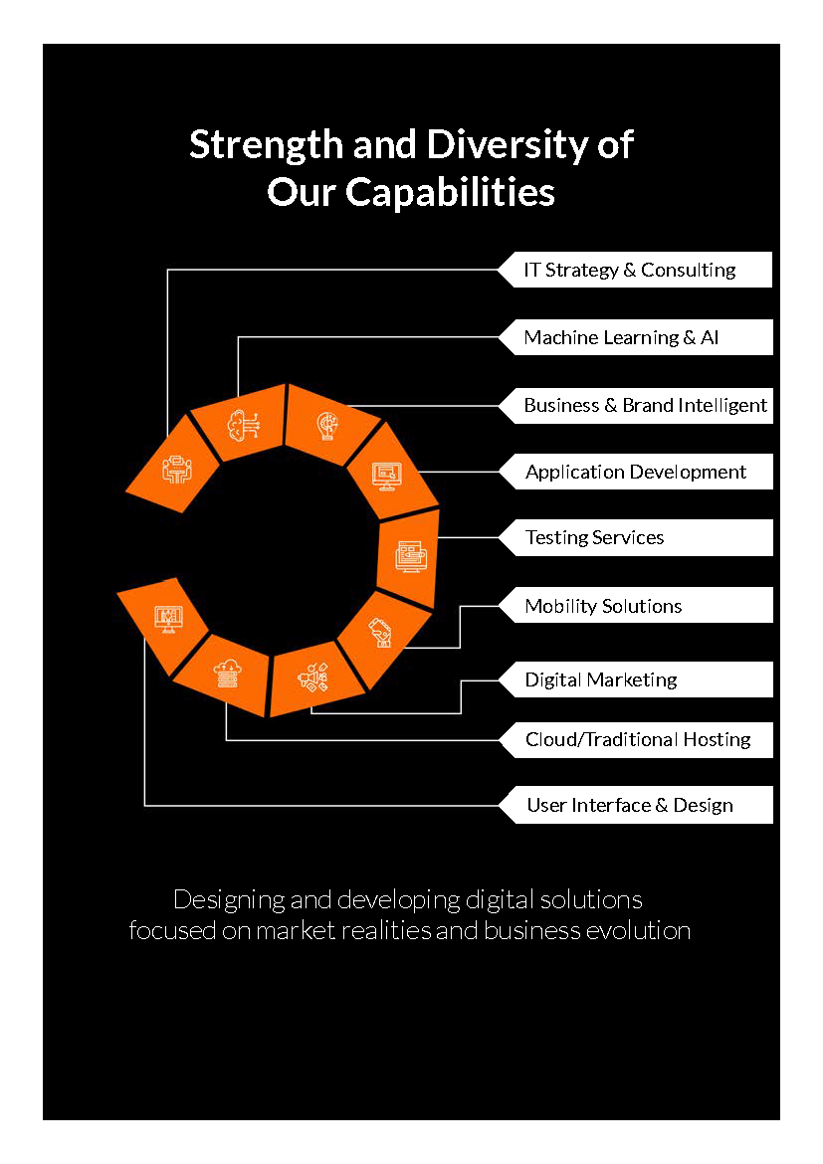

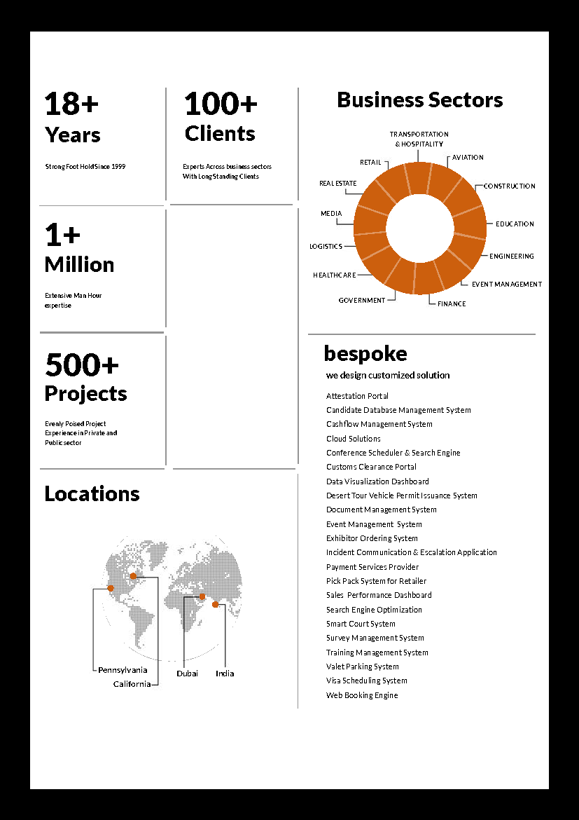

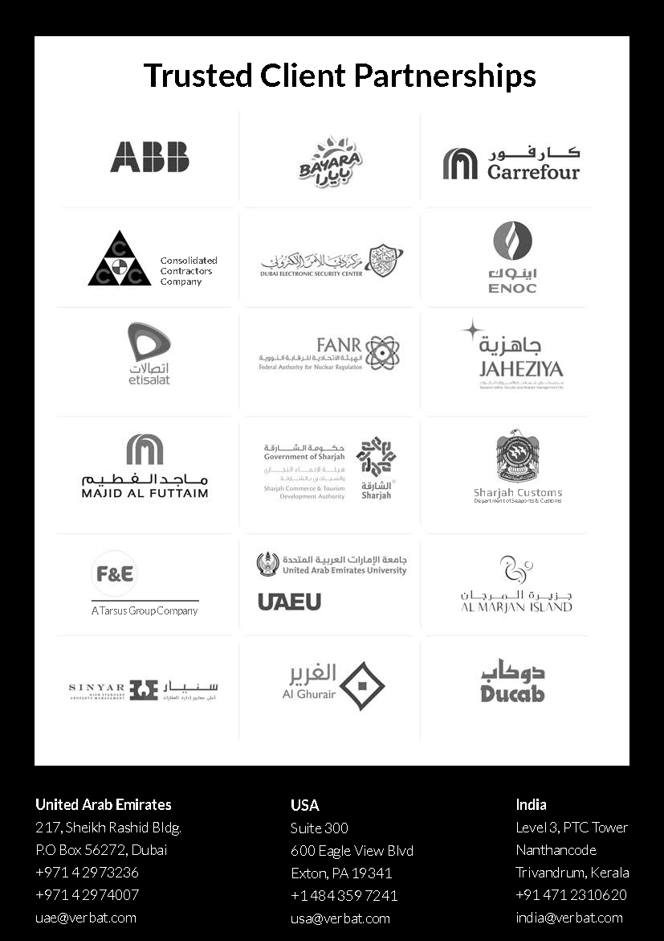

**Conﬁdentiality Notice:**

**This Proposal is conﬁdential and contains proprietary information and intellectual property of Verbanet Technologies LLC. Neither this proposal nor any of the information contained herein may be reproduced or disclosed under any circumstances without the express written permission of Verbanet Technologies L.L.C (hereby known under its brand name of Verbat in the United Arab Emirates). 2018. All rights Reserved**