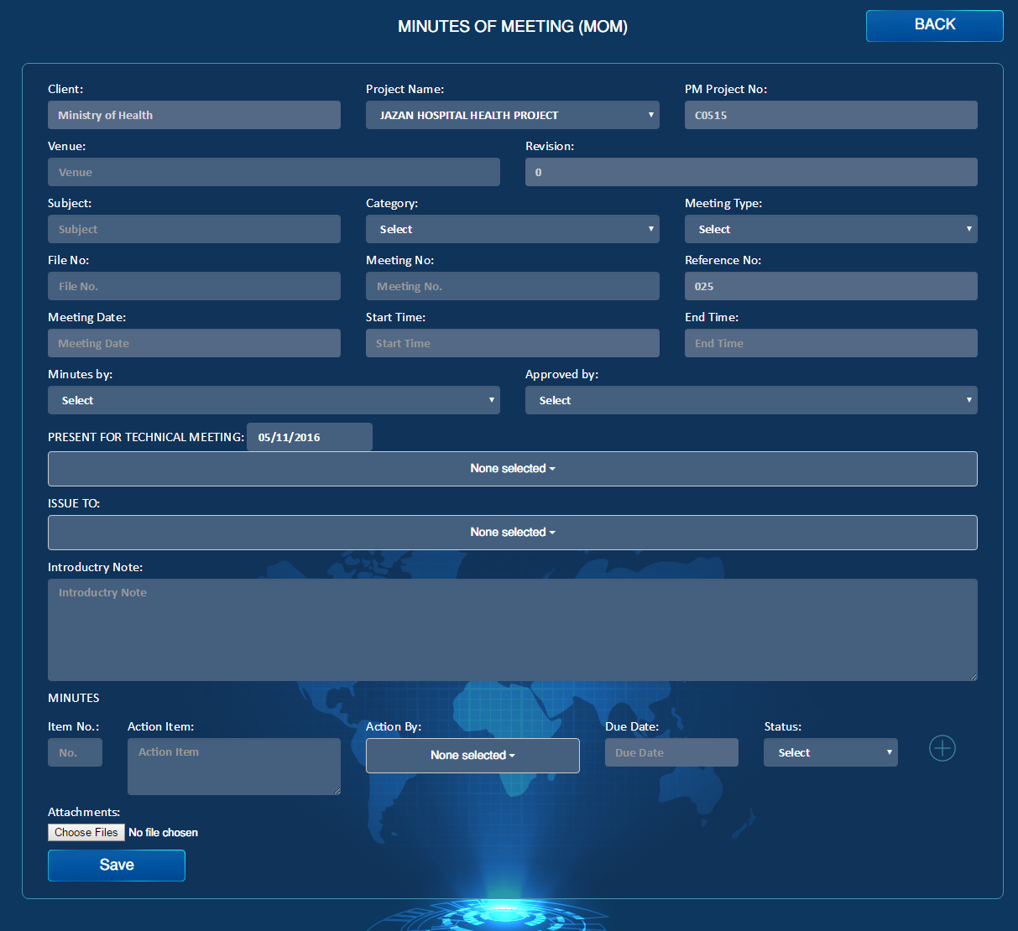

Create Next

Email

PDF

Submit

Draft

Open

Completed

For Information

Export to Concern

Transmittal Letter

Issued To

Attendees

**MOM**

1. Export to concerns should be in the View and edit pages

2. Notes should be in View, edit and add pages

3. Transmittal letter Button should be in the form.

4. Draft Option should be there only the creator can put in draft. Only the creator can the line items are in draft under their name. no other user creator’s draft line items.

5. Create Next should be there, so whatever is not closed will be pulled to the next meeting

6. PDF & Email

7. Rename present for technical meeting to attendees

8. Issue to – Issued to

9. Delete Category

10. Delete file No.

11. Status should be (Completed, Open, For Information)

12. Flag Legend should just include (Open & Closed)

13. For information & Completed Status will turn the flag to Green

14. If we have any item with open Status that means the flag should stay Red.

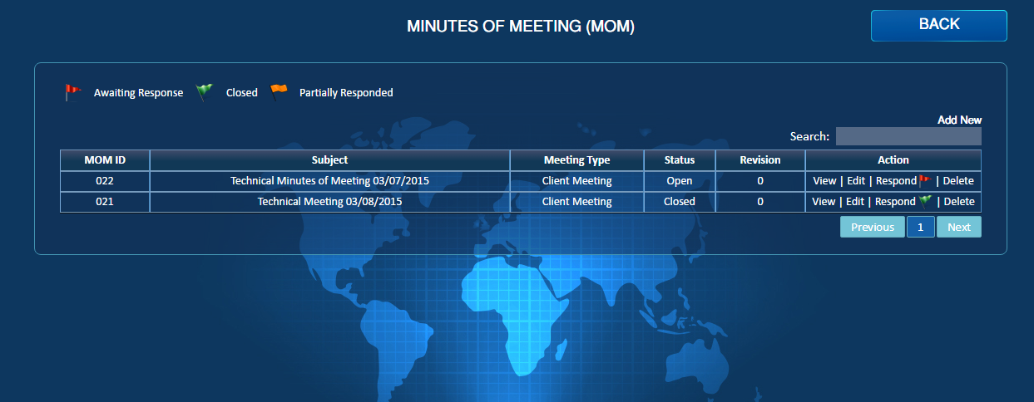

Open