**NCR (Non Complaince Report)**

1. Form:

* DIV/PACK Re-name it to Description.
* Links to Reports: (Engineering, Material, Procurement Register, Payments, Daily Report, Vendor Register, Inspection Request).
* Draft Option should be there in all stages of NCR submission Process.
* PDF & Email
* Create Inspection Request should be there in Step #4 and the status must be taken from the inspection Request

1. List:

* Ability to filter by Discipline.
* Show Links Button Should be there.
* Export to concerns Button.
* Print & PDF.
* Transmittal letter.
* Export & Import Options should be there.
* Assigned to me option must be there

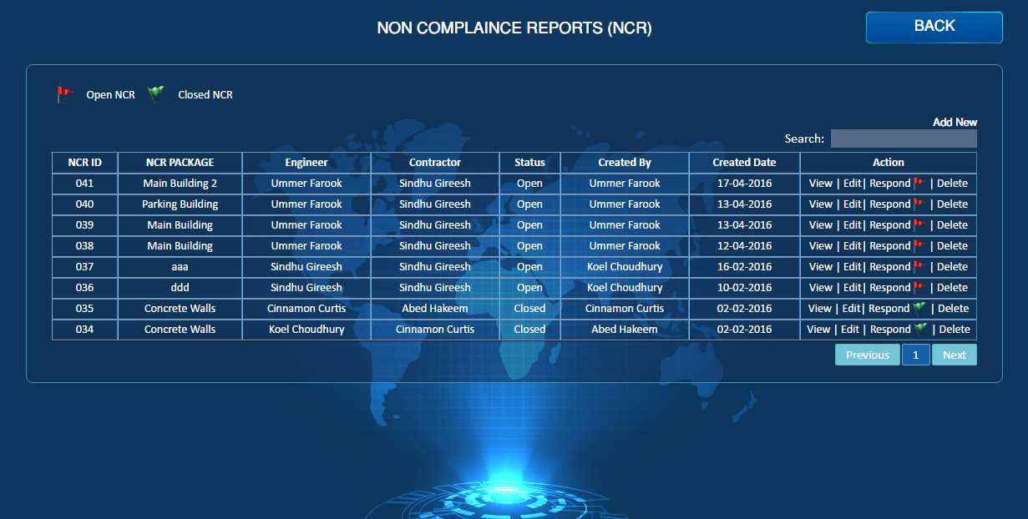

Export/Import

Assigned to me

Assigned to me

Transmittal Letter

Export to Concerns

Show Links

Discipline

mail

PDF

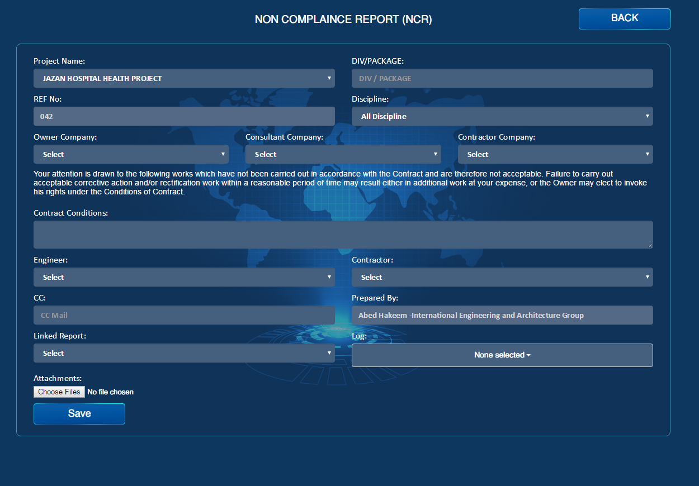

Inspection Request

PDF

mail

Submit

Draft

Description