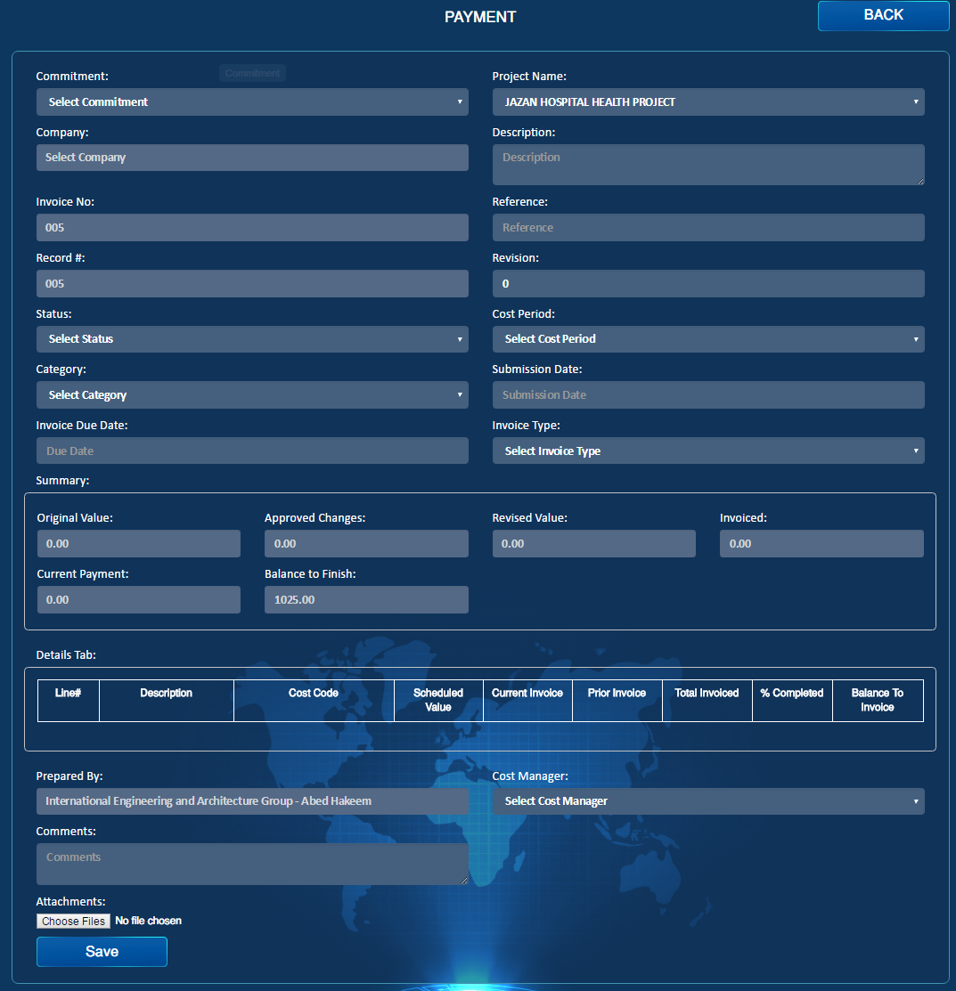

Contract

Reject

Import

Approve

Import

Submit

Import

Draft

Import

MR #

Import

PO#

Import

Payment No

PDF

Import

Email

Import

Transmittal Letter

Import

Create Payment Certificate

Import

1. Create Payment Certificate buttons should be there.
2. Category should include:
3. Contract
4. Subcontract
5. Purchase order
6. Consultations
7. PDF & Email.
8. Transmittal Letter
9. PO# & MR# should be filled in automatically if the type of contract was Purchase Order. Otherwise it will be empty.
10. Submit & Draft should be there
11. Approve & Reject will be choices for the responder who is the cost Manager.
12. Revision Concept should be the same as all reports, after the creator will edit the form then he has a tick box to if he wants to change the revision( so the process will be semi-Manual)

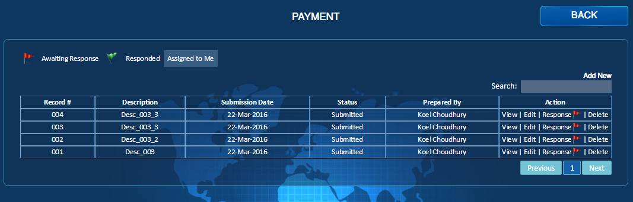

Category

Import

Show Links

Import

1. In the list page filter by Category is required
2. Show Links Tab should be there, the connected Reports are:

(NCR, SWI, Change Order)