**SELF-EMPLOYMENT APPLICATION**

**Ministry of Human Resource and Emiratization**

Development of Self-Employment application

Submitted By:

VERBANET TECHNOLOGIES L.L.C

**CONTENTS**

**1** **KEY DETAILS** 4

**2** **PROJECT SCOPE** 5

2.1 PROPOSED SOLUTION MODEL 6

2.2 Stakeholders 6

2.3 FUNCTIONAL REQUIREMENTS 7

3 APPLICATION ARCHITECTURE 13

3.1 Use Case Diagram 13

3.2 Information Architecture 14

3.3 Functional Architecture 15

3.4 Government Entities and Private Corporation Workflow 15

3.5 Freelancers Workflow 16

3.6 MOHRE Admin 16

3.7 Technology Architecture 17

3.8 Network Topology 18

3.9 Short description of the architectural components 19

3.10 Security Architecture 20

3.11 NON-FUNCTIONAL REQUIREMENT (OTHERS) 21

3.12 PROPOSED SYSTEM ENVIRONMENT 22

3.13 TECHNICAL CONFIGURATIONS 23

3.14 PROJECT DELIVERY 25

3.15 PROJECT ASSUMPTIONS 34

**4** **OUT OF SCOPE** 37

4.1 CHANGE MANAGEMENT 38

4.2 MAINTENANCE & SUPPORT 40

4.3 SERVICE LEVEL AGREEMENT (SLA) 40

**5** **TERMS & CONDITIONS** 42

5.1 ACCEPTANCE CRITERIA 42

5.2 WARRANTY 42

5.3 SOURCE CODE & INTELLECTUAL PROPERTY RIGHTS 42

5.4 GENERAL TERMS AND CONDITIONS 43

5.5 GENERAL ADMINISTRATIVE, TECHNICAL & FUNCTIONAL ASSUMPTIONS 44

**6** **FINANCIALS** 45

6.1 WEB AND MOBILE APPLICATION DEVELOPMENT 45

6.2 WINDOWS DEDICATED HOSTING – OPTIONAL 46

**7** **ABOUT US** 47

# **KEY DETAILS**

**PROJECT NAME CLIENT**

Self-Employment Application Ministry of Human Resource & Emiratization

**CLIENT CONTACT CLIENT ADDRESS**

Mr. P.O.Box 123

ABC Street

Dubai

U.A.E

**PROPOSAL SUBMISSION PROPOSAL ID NO.**

01.08.19  AD/BP/25042018/1820/2

**PROPOSAL VALID UNTIL ANTICIPATED START DATE**

30.10.19 00.00.00

**PROPOSAL SUBMITTED BY PROPOSED TECHNOLOGY**

ASP.NET

Verbanet Technologies L.L.C

Dubai, U.A.E **APPLICATION TYPE**

+971 4 297 3236 Web & Mobile Application

+971 50 765 2345

# **PROJECT SCOPE**

Ministry of Human Resource and Emiratization (hereafter referred to as “Client”) has approached Verbanet Technologies L.L.C., (hereafter referred under its trade / brand name as” Verbat”) to develop a Self-employment web and mobile application to be used by the clients, self-employment nationals and freelancers.

The scope of the project is to develop an

* An online community and platform of qualified freelancers and self-employed professionals who can apply for projects at Federal Government Institutions and private sector corporations
* Provide downloadable resources, career guidance, training links and tools to accelerate their career development and skills in collaboration with strategic partners
* A “One-Stop-Shop” platform that provides a suite of integrated services to enable interaction between freelancers, strategic partners and Government Institutions or private sector corporations. Services include
  + Registrations
  + Managing profiles, profile ratings
  + Store credentials, licenses, documents, certificates, permits etc.
  + Job classifications
  + Job postings
  + Courses
  + Execute contracts and conduct financial transactions
* Provide important statistical information on the jobs available, self-employment data etc.
* Share important information to alleviate the professional stature of the self-employed professionals
* Create links and help all parties to make a meaningful connection and help create mutually beneficial initiatives

## PROPOSED SOLUTION MODEL

**STAND- ALONE FIXED BID**

Verbat will be following a stand–alone fixed bid solution delivery model wherein the required solution would be devised and a suitable pricing would be offered. Verbat’s solution architects have conducted a thorough research on the requirements and have come to the conclusion that our proposed solution, which is detailed further in this document, will meet the requirements put forth by the client.

**KET STRENGTHS OF OUR SOLUTION**

* Strong and Scalable platform accommodating to future enhancements
* A framework which acts as a solution accelerator with building blocks that can be re-used in n future for building new components and features.
* Our light weight framework used consumes fewer system resources thereby making the application perform faster.
* All security aspects are considered

## Stakeholders

### **Backend/Administrator**

* Login/Logout
* Manage individual profiles
* Manage training, education and vendors
* Manage companies profile, content and update dashboards
* Control authorization and user rights matrix
* Deactivate individuals and establishment profiles
* Reports

### **Clients (Federal government institutions & Private sector entities)**

* Registration
* Login/Logout
* Seek freelancers for dedicated professional services
* Search-match functionality
* Conclude/terminate contract
* Sent offers
* Transactions to freelancer

### **Freelancers/Self-employed nationals**

* Registration
* Login/Logout
* Connect with clients
* Upload documents
* Accept/reject offers
* Conclude/terminate contract
* Receive permits and enter E-contract
* Receive payment
* Receive notifications

### **Strategic Government Partners**

* Registration
* Login/logout
* Provide career guidance, downloadable professional resources and tools
* Issue notifications on relevant coaching and training opportunities made available through MOHRE partners

## FUNCTIONAL REQUIREMENTS

The main features and functionalities of the application to be developed are presented below:

### **Individual**

* Administrator
  + Manage individual profiles, company profiles, training courses, update dashboards, education and vendors
  + Control authorization and user rights matrix
  + Deactivate individuals, establishment profiles
* Freelancer
  + Provide professional services
  + Connect and apply for projects at federal government institutions and private sector corporations
  + Searching and matching
  + Download professional resources, training links
  + Seek career guidance and tools to accelerate development and expand capabilities
  + Access all the available services, resources and tools through dashboard
* Clients (Federal government institutions & Private sector entities)
  + Simple and advanced functionalities to look for targeted candidates (freelancers) based on profiles and credentials/verification results
  + Responsive searching, application and suggested matching
  + Flexible and easily customizable search/matching criteria with a scoring evaluation for each match
  + Relevant events and training opportunities calendar
* Strategic government partners
  + Provide career guidance, downloadable professional resources and tools
  + Issue notifications on relevant coaching and training opportunities made available through MOHRE partners

### **Integration**

* Payment Integration
* Social media Integration
* Integration with MOHRE and government authentication systems
* Open API led integration
* Integration for data validation and exchange
  + Emirates ID authority to verify individual credential
  + Smart pass to execute SSO
  + Ministry of finance procurement systems
  + Economic Departments

### **Analytical Requirements**

* Platform usage Tracking Information
  + Registrations, application, profile views, time spent on application, resources downloaded, permits issued, offers sent, offers accepted, offers rejected, contracts concluded/terminates, monthly report on number of successful clients and freelancers
* Business Intelligent dashboard
  + Graphical components and corresponding dynamic BI reporting system
* Predefined dashboard
  + Show progress and statistics
* Freelance market best practice Information
  + Latest news and trends, self-employment statistics

### **General Requirements**

* Contracting transactions between freelancers and clients
* Rating mechanisms of freelancers
* Payment structures linked with government systems
* Permit applications and issuance
* Centralized content management system
* Audit logging
* Email notifications, sms, live chats, video conferencing
* Modern and seamless mechanism for assessing and verifying registered users
* Responsive and modern soft design
* Caching
* Bi-directional search
* End to end service monitoring and analytical solution for IT operation
* Description of each department and nature of work
* Relevant self-employment report/data to MOHRE
* Best practices and information on latest developments/tips
* Links of mutually beneficial initiatives and programs

### Detailed Functional Specifications

|  |
| --- |
| **Development** |
| Home Page, About, Contact US, Privacy, T&C, Enquiry & Complaints |
| Bilingual Site (Arabic & English) |
| **FREELANCERS** |
| Freelancer registration, Email validation, OTP |
| Login, Remember password, Forgot password, Social Login |
| Manage Profile - Upload documents, Images, professional & social URL, Description, Sex, DOB, Address, Tax identification number, Emirates ID, languages, references etc. |
| Identify areas of interests, Job categories etc. |
| Add bank details |
| Create cover letters (Tinymce) |
| Create Experience |
| Take assessments |
| Freelancer dashboard (Jobs applied, replies received, compose message - tiny MCE, Profile visits, recommended jobs, Recommended courses / assessments etc.) |
| Communication Hub (Chat / email / SMS ) |
| Search based on category and subcategory, date posted, by employer. Sort by date |
| Job Listing Page |
| job details page |
| Apply for job (With cover letter, references, Experience, certificates) |
| Accept Interview request |
| Execute contract |
| Make payment (If applicable) |
| Receive payment |
| Accept job |
| List / Search / download courses, videos, educational articles |
| Apply for course registration, make payment |
| **CMS** |
| Create Career guidance Videos (Description, category, subcategory, reference URL, tags, Bibliography) |
| Career guidance articles ( Tinymce editor - Rich text, Reference links, Abstract, description, category, subcategory, tags) |
| Training material / videos for federal Gov. employees |
| Site news |
| Other platform pages |
| Announcements & Notifications |
| **MOHRE Admin** |
| Login, Remember password, Forgot password, Social Login |
| Register federal / private / strategic partner entities |
| Verify or upload License, Certificate, Permit, proof of residence, business identification, registration |
| Configure Key Cloak |
| Entity type |
| Job Type: part time, long term etc |
| Job Classifications: Engineer, doctor, Plumber |
| job category |
| job subcategory |
| Spoken languages |
| Countries |
| States |
| Cities |
| Registration of Gov. Entity Users, manage User profiles, Authentication: SSO, OpenID, LDAP, Emirates ID |
| Create course, Articles |
| Manage user profiles (Deactivate, Edit) |
| Communication dashboard(Received emails, send emails, compose email- tinymce, customer support queries) |
| Platform Usage reports |
| Health Check reports |
| Business Intelligence dashboard |
| **System Integration** |
| Key cloak (Integration for SSO, Smart Pass) |
| Emirate ID integration |
| Payment g/w |
| Social media Integration |
| Federal government Integration |
| Minio to store documents, videos, images) |
| Redis Cache (Fast search results from DB) |
| Graph API ( Open Source integration with Calendar) |
| SignalR Hub (Low cost open source chat API) |
| ELK Stack ( Lightning fast indexing of documents, videos, images and visualization dashboards) |
| BORG or Veam community edition for Data backup |
| **Federal Government Entities & Private Companies** |
| Employee login (via SSO, OPENID, EMIRATESID or Smart Pass) |
| Update employee profile |
| Post Jobs (Job description, Category, Subcategory, Job type, Hire date, Job requirements: certifications, trade license, years of experience etc., Attach assessment questionnaire, Schedule) |
| Faceted search for freelancers |
| Create Assessment questionnaire |
| Respond to job applications |
| evaluate applications |
| Communication Dashboard(Received applications, interviews scheduled, received emails, send emails, compose email- tinymce) |
| Employee Admin Dashboard (Interviews Scheduled, Completed, contracts Signed, Employee performance) |
| Schedule interviews / Note interview results |
| Make / Receive payments |
| Offer employment / Execute contract |
| Rate freelancer |
| List, Search & Download training materials / View videos |
| **Federal Government Strategic Partners** |
| Employee login (via SSO, OPENID, EMIRATESID or Smart Pass) |
| Create Course (Course description, Course video, category, subcategory, length, venue, price) |
| Create informational articles, Career guidance advice) |
| Receive payment |
| Search freelancers and send offers |
| **PWA** |
| Web application that scales across devices / browsers. Offline access for most resources |
| **QA** |
| Functional Testing |
| Performance testing |
| Availability Testing |
| Penetration Testing |
| Accessibility and Usability testing |

# APPLICATION ARCHITECTURE

## Use Case Diagram

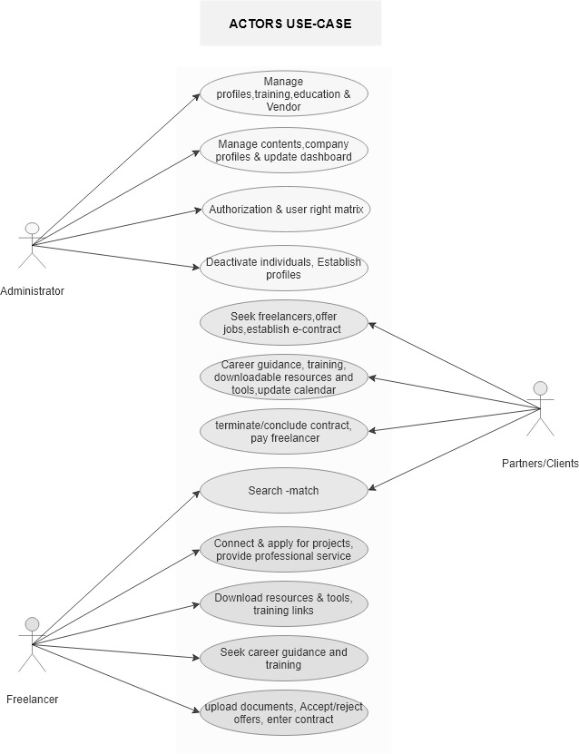

## Information Architecture

## Functional Architecture

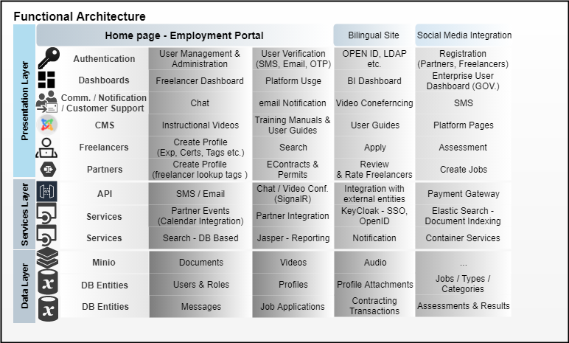

## Government Entities and Private Corporation Workflow

## Freelancers Workflow

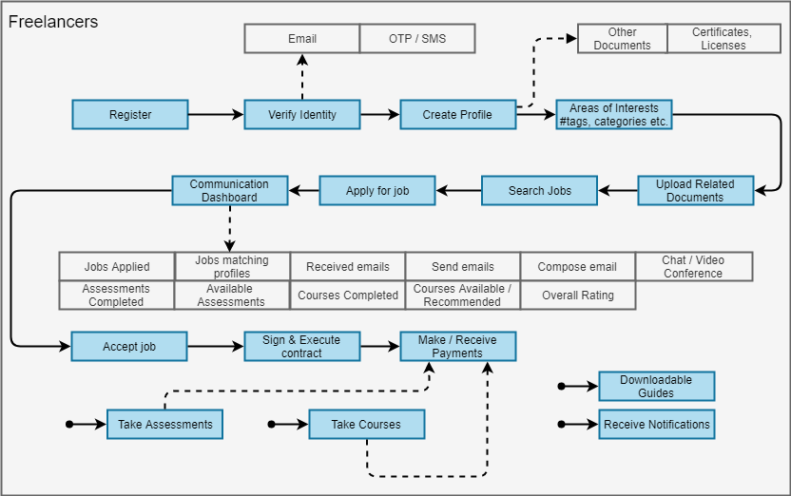

## MOHRE Admin

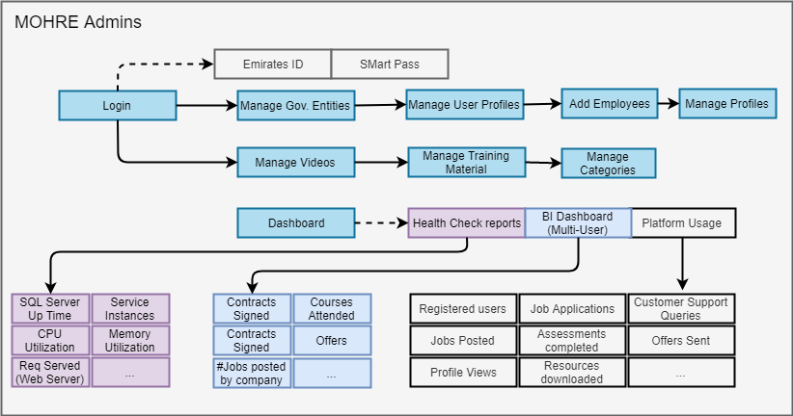

## Technology Architecture

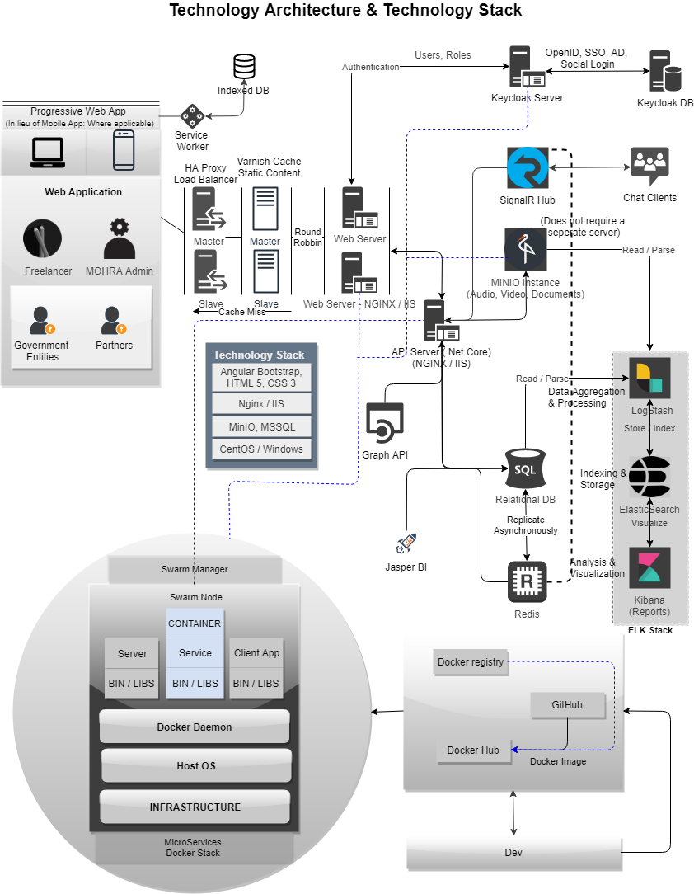

## Network Topology

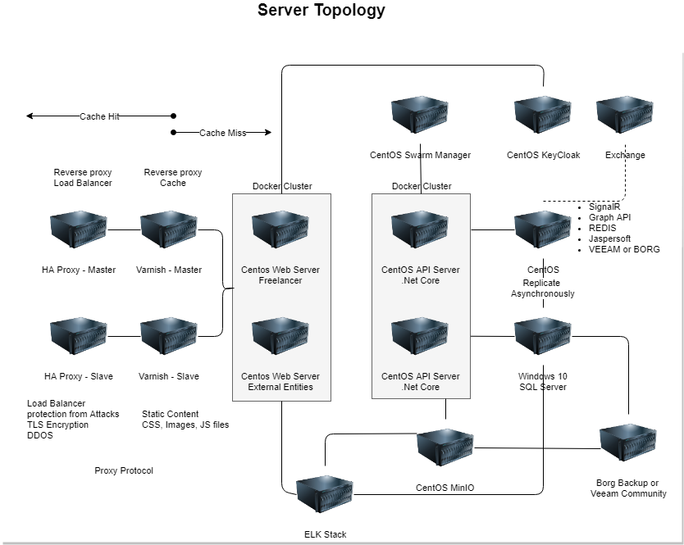

## Short description of the architectural components

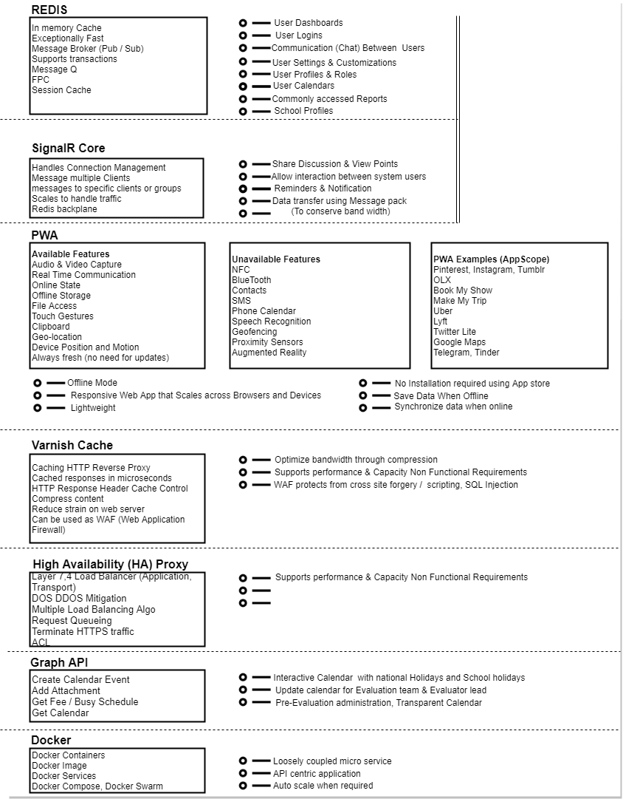

## Security Architecture

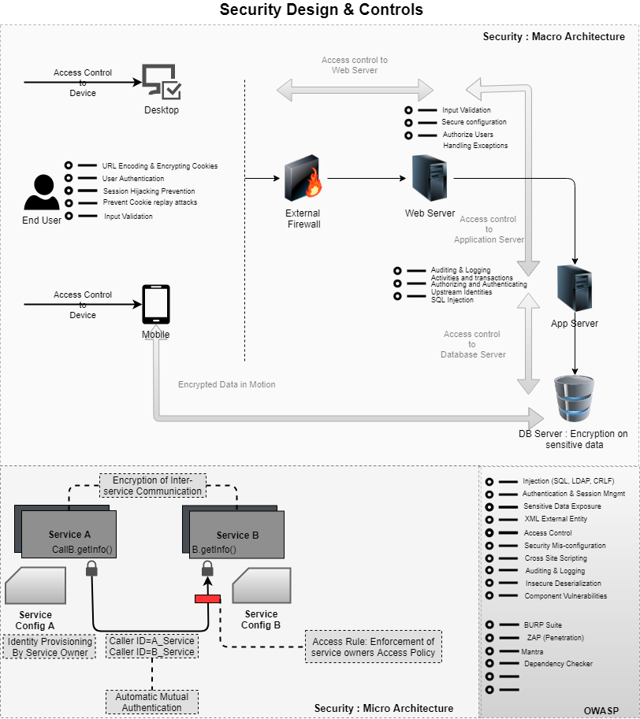

## NON-FUNCTIONAL REQUIREMENT (OTHERS)

|  |  |
| --- | --- |
| **Requirements** | **Details** |
| User Experience and  UI Design | * The application will be developed only in English & Arabic * The layout and graphical components will be created considering the usability factors |
| Performance | * Application will allow users to have smooth and quick access to the information or services they require. |
| Security | * Web security standards will be followed. |

## PROPOSED SYSTEM ENVIRONMENT

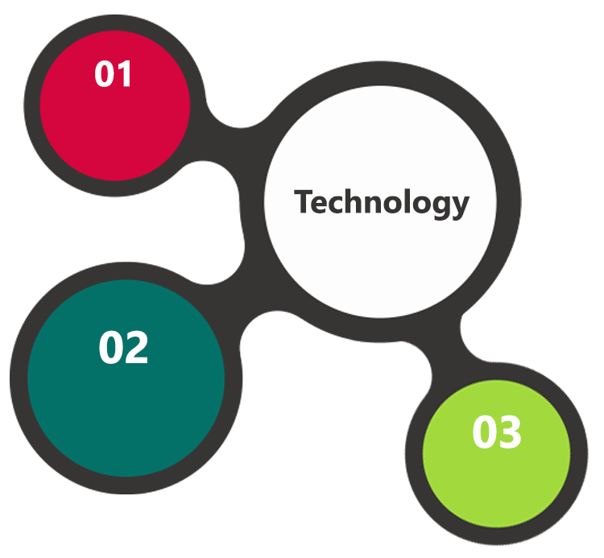

Angular, MVC, .net Core

HTML5 / CSS3

Java Script

Windows / CentOS

IIS

MS SQL

**MS SQL2012  
Windows 8/10  
Web Services**

## TECHNICAL CONFIGURATIONS

### **DEVELOPMENT TOOLS**

* ASP.Net 4.5
* MS SQL
* HTML / CSS 3
* Photoshop
* Web services, Ajax, JavaScript

### **RECOMMENDED WEB HOSTING PACKAGE- DEDICATED HOSTING**

* Operating System : Windows Server
* CPU : 2 core
* Domains: Unlimited
* Disk Space: 200 GB
* Monthly Bandwidth: 50 GB
* Web site Server Software – IIS 7.5 +
* ASP.NET 4.5

### **BROWSER**

* Chrome version: 56
* Firefox version: 51
* Edge version: 39

### **HARDWARE**

The application is reliant on hardware interfaces to provide a seamless automated user experience.

* Computer with Windows 8 or 10 OS
* Compatible Browsers as specified in section 6.2.3

### **TECHNICAL STANDARDS**

* Screen Resolutions

1080 x 1920, 720 x 1280, 750 x 1334, 640 x 1136

* Testing Devices
* Android
  + Moto G( Marshmallow)
  + Alcatel (nougat)
  + Google Pixel (pie)
  + Samsung Galaxy Tab(Lollipop)
* iOS
  + iPhone 5S
  + iPhone 6
  + iPad mini 2
* OS Version
  + KitKat and above
  + iOS 9.0+

### **TECHNICAL GUIDELINES**

The guidelines provide instructions and conditions that will be adhered to during the development of the mobile application.

* API will be used, as the case may be, in realizing the features and functionalities mentioned
* The client will finalize the functional requirements and UI/UX before the commencement of the project
* Verbat will be testing the app in the mentioned devices only. Testing on devices other than the ones mentioned under the “Technical Standards “ will have to be specified and provided by the client at the beginning of the development phase
* The client will have to provide the details of the testing devices they are using before the start of development phase
* Client should provide the relevant Developer's Account credentials before the development phase. In case Verbat needs to create the developer id additional charges will be incurred by the client
* The duration mentioned in the project time line is for development and testing and any delay or time taken by the review team to respond will not be Verbat’s responsibility
* Any clarification required from client needs to be addressed within 24 hrs.
* The apps will be developed / created within the guidelines of Android play store.
* Verbat will strictly follow the guidelines provided by the respective stores.
* Verbat will inform the client if any of the client requirements /request deviates from it.
* Customization of the features of the app will be susceptible to the limitation imposed by the respective platform/ store.
* Once development commences the test device/screen sizes will not be susceptible to change. Any change requested by the client will have to go through change management
* OS version support will be limited to the ones mentioned in the technical specifications. Further support will have to go through change management

## PROJECT DELIVERY

### **PROJECT MANAGEMENT**

The Verbat development center strictly follows industry standards on quality. The project management is process governed by the Verbat Quality Management system and is put to verification through internal audit programs that happen from time to time. Verbat will dedicate a project manager for the proposed implementation. Verbat proposes Client to identify one project manager who will be driving activities to be undertaken by Client to be the single point of contact for Verbat.

### **ROLES & RESPONSIBILITIES**

Verbat will assign a dedicated Project Manager/Project Lead to lead the project, who will be the first point contact for Client. He/she will be responsible for planning and managing the various activities within the project. He/she will work closely with Client Project Manager, to give periodic status updates and ensure high level of visibility and comfort on the progress of the project. The Project Manager/Project Lead will lead the co-ordination between Verbat and Client, thus enabling smooth transitioning of Client requirements to the Verbat ’ offshore delivery team, and provide visibility as well as comfort on the progress of the services to Client.

He/she will have periodic meetings with Verbat ’ s Senior Management, thus ensuring Verbat ’ Management commitment and focus on Client initiatives.

### **DELIVERY ACTIVITY SUMMARY**

|  |  |
| --- | --- |
| Activities | Description |
| Detailed requirement Analysis | Verbat team to conduct detailed study of requirement for the phase. If clarification is required, team will reach out to Client for more information and/or time for discussions. |
| DB Design | DB design for central and test DB. |
| Software Requirement Specification document (SRS) | Once the requirement analysis is completed, Verbat team will submit the SRS document for approval |
| UI/UX Design, Prototyping | Based on the SRS, Verbat UX/UI team will work on the UI/UX of the screens and submit for approval |
| Functional Specification Document (FS) | Once the UI/UX is approved, Verbat shall submit an FS document for approval. |
| Development | Actual system development starts based on the FS. This involves detailed design and software development of Web Application. |
| Testing | Test Planning, test plan creations, internal, integration testing and user acceptance testing. |
| Deployment | Deploying the latest built in the Verbat Test Server. |

### Quality Assurance

Verbat has experience in both scrum based development as well as traditional waterfall methods. From experience, we have combined the best of both worlds and take a hybrid approach in quality control. While just enough documentation is good enough for small projects, for larger projects adequate documentation provides the team with better foresight to plan better.

Our quality analyst gets engaged right from the inception of the project. This allows our team to catch bugs early on (including requirement bugs). Our QA team does not work in isolation, instead they are part of the development team. We encourage our QA team members to be opinionated and question established assumptions. As can be seen from the diagram, various documents are created as deliverables during the different phases of the project.

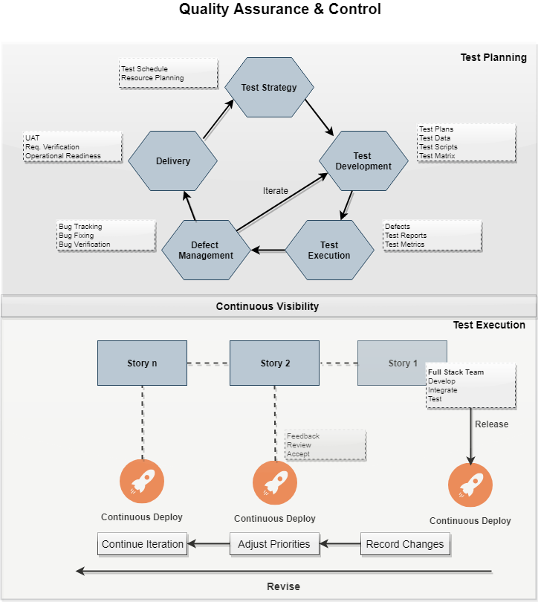

### Release and Deployment

During development Code is checked in regularly to GitHub. A trigger jumpstarts the Jenkins automation pipeline. A Docker image is created. The image is spun up to generate Docker containers. Parity checks are conducted to verify the stability of the container. Once done the image is checked into the Docker hub.

This code is then released into the QA environment where the application is tested. Depending on the maturity of the development, different types of tests are conducted, from functional to integration and performance testing. The final product is released to UAT. The product is released to UAT as an IAC (Infrastructure as code). The instance is spun up from scratch to ensure that it is ready for production.

### **PROJECT IMPLEMENTATION PLAN**

Verbat will be providing the solution in a stand-alone fixed bid approach which ensures minimum viable solution for quick wins with core focus on the long-term business objective and outcome. Once the implementation is over, Verbat will initiate the application maintenance process (once the maintenance contract is signed) which continues to extend after the implementation.

### **DELIVERABLES**

* Project Plan
* Software Requirement Specification Document (SRS)
* UI/UX Design
* Functional Specification
* Fully Developed & Tested Application
* Documentations related to System Architecture, Database schema & Database backup
* Source Code

### **ESTIMATED DELIVERY TIME**

The effort estimated for delivering the application will be as below:

* UAE working days for the UI/UX from the date of approval of the SRS
* UAE working days for the development of the application from the Date of Approval of the FS.

| **Activity** |
| --- |
| Contract Signoff (T0) |
| Project Initiation & Initiating requirement gathering |
| Software Requirement Specification Document(SRS) |
| SRS Approval (T1) |
| System UI/UX-Complete |
| System UI/UX-Approval (T2) |
| Functional Specification (FS) |
| FS Approval (T3) |
| Development Phase-Complete |
| Perform QC (Unit Testing and Integration Testing) |
| System ready for UAT |
| UAT Acceptance on Verbat server (T4) |

* The above-mentioned timeline is in UAE Working Days
* The initiation of the UI/UX development is dependent on the confirmation of SRS. SRS will be submitted post the confirmation of the project along with LPO, signed proposal and advance payment
* The above mentioned timeline for development is post the confirmation of FS
* Documentation submitted after project initiation and system study supersedes any proposal or documentation submitted during initial requirement gathering / discussion / negotiation
* Project plan will be submitted post the confirmation of project with necessary payments
* Any delay in getting the approvals of deliverables from client will cause change in timelines and the revised timelines will be updated in weekly status reports shared with client after the project commencement
* All approvals and queries regarding the client requirement and any queries which may hinder the project advancement at any stage should be answered by the client within 24 hours from the time of initiation, failing which the time delay will get added to the actual effort and timeline which was estimated.
* On project confirmation, Verbat requires a lead time of minimum seven (07) days for resource mobilization.

### **DEPLOYMENT DETAILS (AT CLIENT’S BEHEST)**

* Client can opt for hosting the application at Verbat’ Server.
* If deployment is at the client’s server, responsibility of deploying the application onto the production environment after conducting the necessary acceptance testing will lie with the client unless and until Verbat ’ support is contracted for deployment.

### **RELEASE PLANNING**

* Client will be informed about the release date and time through email.
* Client performs the UAT

### **RISK CONTINGENCY PLANNING**

Verbat has identified various risk factors associated with this assignment and understands the impact of these risk factors on the project schedules. The objective of this section is to highlight for both Verbat and client, the risk factors, to analyze the impact of the risks on project execution, and to propose strategies to control and reduce the impact of the risk factor. These various risks, which could arise during the project, are tabulated below along with mitigation implementation.

| Type of risk | Impact | Risk Mitigation | Risk Handling |
| --- | --- | --- | --- |
| Scope Creep | H | Functions and features will be detailed in system requirement documents and will go through client approval. Once this document is approved, any change to requirement will go through change management review for possible impact assessment. | Proper change management procedure will be implemented. |
| Delay in customer feedback | H | The plan is prepared with enough lead-time for customer reviews and approvals.  The customer is indicated with the dates when the document is expected after review and approval. | The request for feedback will be escalated if not attended at the right time so that the schedules are not affected. Deemed acceptance criterion is set up front and will be followed. |
| Non-availability of necessary software’s, frameworks, database instances and infrastructure at client’s hosting environment(If hosting support is provided by Verbat ) | M | Client will be informed in advance on these requirements. | Possible impact to schedule. |
| Manpower attrition | L | All efforts would be made to ensure process dependence rather than being person dependent. As a risk mitigation plan Verbat will train backups. | A new person will be identified as early as possible, provided the required project-specific training and mentored by the senior members of the team to minimise impact of attrition on the project. |

*H-High, M-Medium, L-Low, NA-Not Applicable*

## PROJECT ASSUMPTIONS

The project solution and technology is created from the initial understanding of the requirement shared with Verbat through mails and meetings. The proposed solution is based on the following assumptions:

### **OBJECTIVE**

* The requirement is to develop a Self-employment application with the functionalities as defined in ‘Functional Requirements’ section

### **DESIGN**

* Client to provide Verbat with the branding guidelines.
* Color theme shall be provided by the client
* Client shall provide licensed images and logos in specified size & format
* Client shall provide the text and associated images for the proposed application. Text should be provided in digital format preferably in MS Word 2013 or above
* Verbat may use template based design for the application
* The application designed for mobiles will be in portrait mode

### **DEVELOPMENT**

* The proposed application front end and backend would be developed in English & Arabic
* Development Contingent upon timely feedback from client
* The client will finalize the functional requirements and UI/UX before the commencement of the development of the project
* Client shall approve the UI/UX for the mobile and web application before development work starts
* Verbat assumes client requires minimal reports and the reports considered in the scope are mentioned under the respective user modules.
* The following items will be hardcoded / implemented in the application
* Final data needs to be entered by the client via the application
* Client will provide sample data to test the application
* Testing of web application will be done in latest versions of Google Chrome, Mozilla, Edge web browsers only
* Testing of the mobile app will be executed on devices mentioned under Technical Standards
* Client will procure templates, SSL certificates (if applicable)
* Client will host and manage the application on infrastructure (server / cloud) recommended by Verbat for managing database and application backup inclusive of images
* Application and data backups are subject to the purchase of such services at an extra cost
* Internet connectivity is required for the functioning of the Mobile App & Web portal
* Mobile Application elements or design cannot be modified once the app is deployed
* This estimate is only for portrait orientation on android mobile phones (Not Tabs)
* Client shall provide the developer account for Android Store.
* Does not support offline access or operations.
* The financial estimation is only for native application
* Client shall provide licensed copies or access to environments with UI Path (with appropriate plugins and extensions for OCR) , Cloudera, Tableau and data lake
* Templates for all certificates shall be provided by the client
* Payment gateway (e-Dirham) along with API’s and documentation shall be provided by the client
* Client shall provide clear directions on additional business process not covered in this proposal. In such cases, the effort estimated provided in this proposal may be amended.
* Curse creation is outside the scope of the platform
* Video Conferencing requires third party services. This is not included in the effort estimate.
* Client provides the hardware for backups. Verbat will configure the software provided by client. Configuration of Free Software packages (Veeam community edition or BORG backup) are considered for the effort estimation
* Career guidance videos shall not be created using the web application. They shall be created external to the application and uploaded to the portal
* Videos guides for Federal employees shall be uploaded to the portal. Creation of these videos are outside the scope of portal development
* Client shall provide repository for code checking (GitHub, bit bucket etc.)
* SMS messages shall be generated form the server and received by the mobile device. The mobile app (PWA) will be incapable of intercepting and using an SMS message.
* Client shall provide full API documentation for integrating external parties
* Data migration effort shall be done in phase and is not part of the effort estimation
* Additional nonfunctional requirements shall be determined after business analysis
* System integration testing for external API's is subject to documentation provided for external facing API's
* CMS shall be developed only for clearly defined requirements. Does not make use of prebuilt components like WordPress or Drupal
* Effort includes the development of PWA. Native application development not considered
* e-contracting mechanism shall be defined by the client
* Only push notifications are supported by the App (Web or mobile)
* User rights shall be managed by Key cloak for SSO and Emirates ID. (Separate URL)
* Vendor shall try it’s best to utilize equipment provided by the client. But there may be instances where additional equipment or software may need to be procured or provided by the client

# **OUT OF SCOPE**

With the ever evolving digital market, the requirement should be clear to both the parties involved, hence the importance of mentioning the out of scope details of the project. Following are considered to be out of scope while creating this proposal:

* Purchase of images, fonts
* Any language other than English & Arabic
* Migration of existing data / Database migration
* Content writing / proof reading / Data Replication / Manual data entry
* Content or image procurement or uploading or editing
* Audit Trail
* End user testing and load testing
* Developer account creation and Maintenance (Play Store)
* Adding new features to the application other than mentioned in the functional specifications. Such requests will be handled via change management. *For Change management details, please refer section titled “Change Management” in the Proposal*. (refer to section 4.1)
* Annual Maintenance Contract (Bug fixing, debugging, enhancements) – Please refer section titled “Maintenance and Support”, unless contracted for.(refer to section 4.2)
* Hosting Infrastructure and Maintenance (web and email hosting), unless contracted for.
* Application Deployment on the server and respective stores, unless contracted for.
* Backup solution and Disaster recovery unless contracted for.
* Physical deployment onsite / installation of the application in devices and Physical connection, installation of system.
* Integration with third-party, if any, other than mentioned in the functional specifications
* Hardware Integrations / procurement and purchase
* Procurement of SMS gateway / payment gateway / email gateway
* SSL Purchase and installation, if any
* Plugin/template purchases, if any
* OS other than mentioned in the Hardware Interface
* Relevant / related software libraries
* Mobile offline access or operations
* System shall not digitally verify the authenticity of documents uploaded

## CHANGE MANAGEMENT

Any addition which comes out of the project scope, upon and after the launch of the application will be considered as change management. Verbat recommends the following change management procedure for the same.

* Any change which comes out of the project scope, which was discussed, documented, and mutually approved by both the parties in the requirement stage, will be carried out only through raising a change request.
* Change request will be studied and an impact analysis on the existing work flow will be performed.
* On finalizing the impact, effort estimation for the change will be calculated and raised as additional requirement.
* Verbat will initiate the change request only after getting a formal approval from the client for the additional changes raised.
* Any change from the scope will be charged at AED 1,200.00 per man day effort and approval from the clients will be availed before commencing on any change management.

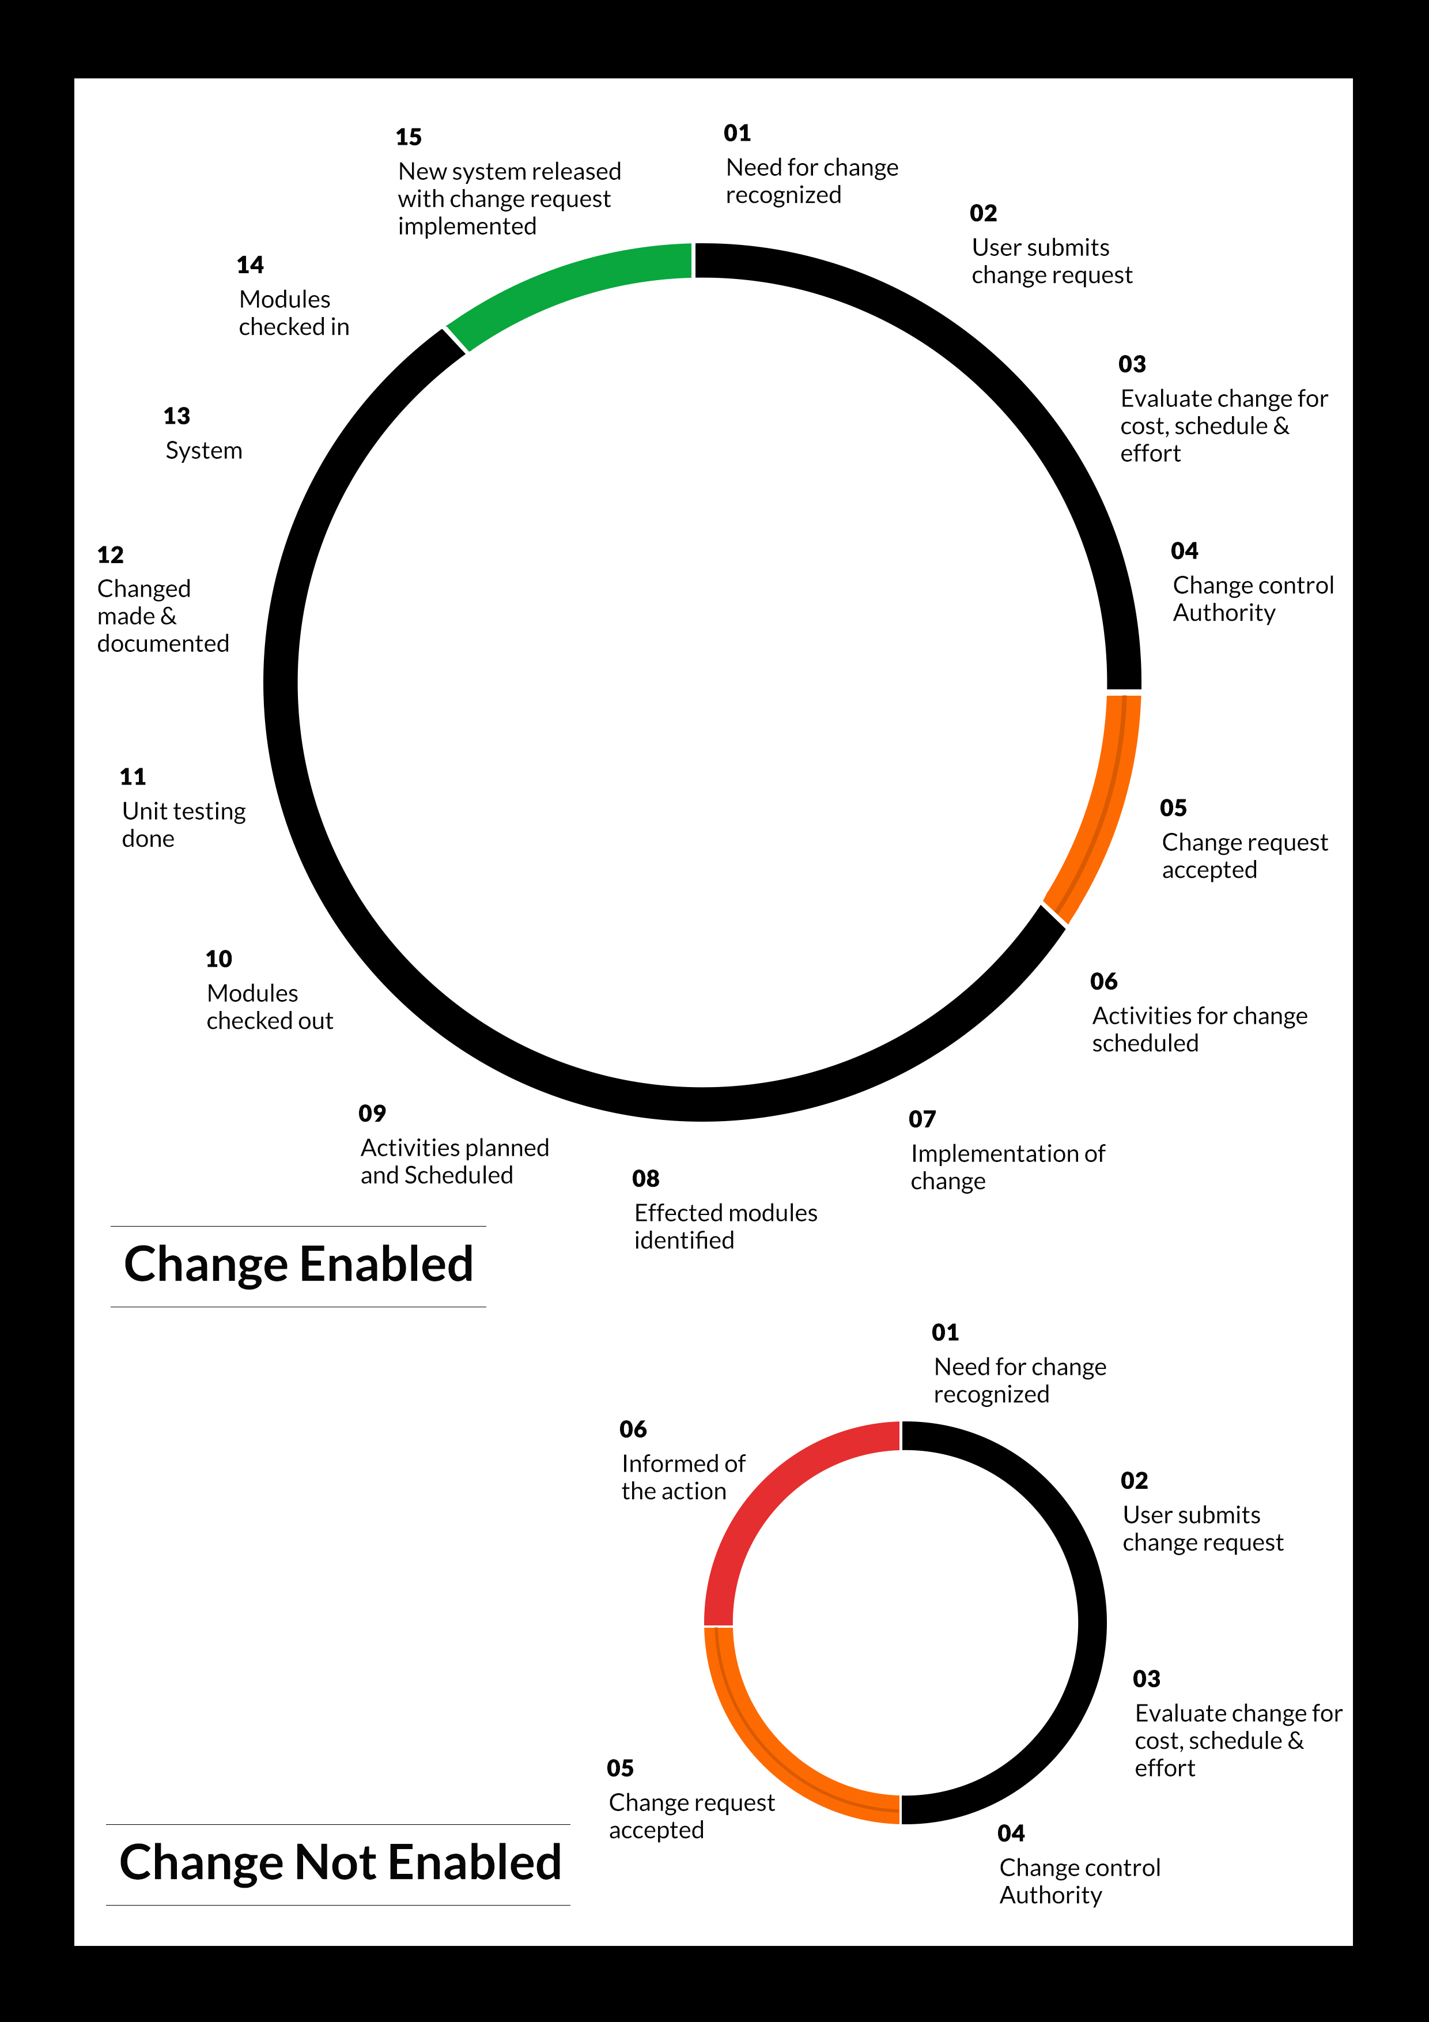

## MAINTENANCE & SUPPORT

* Maintenance contracts by default are supported as per the basic SLA terms.
* AMC with Basic SLA is charged at 25 % of the total project value. Additional Effort/change management request will be added towards Total Value of the Project to determine the AMC value.
* Maintenance support is limited to providing application support for ensuring the consistency of the look-and-feel, bug fixes and user issues i.e. maintenance and support of the existing features of the application.
* Support does not in any way cover providing technical or other support to the end users. The maintenance agreement does not include functionality changes or feature additions which are handled as change requests which will be charged AED 1,200.00 per man day. AMC does not include server support, maintenance and application deployment.
* AMC charges will cover Off-Site Support and Debugging. Support includes E-mail, Telephone and Chat unless explicitly specified. In the event, the application is hosted with the client; necessary remote desktop connectivity should beprovided for carrying out maintenance activity.
* Gap in AMC - In case if the client does not opt an AMC for a year and want to renew it after that period, 50% of the AMC amount for the year for which AMC is not taken will also be payable if the client wishes to renew the AMC contract.

*Note:*

* *Please note that the AMC support shall start only after all the necessary sign-offs (AMC Document) to this effect have been given.*
* *It is not mandatory that the client should opt for an AMC (replace with perhaps: It is mandatory that the client opts for an AMC). The client will still be supported on an ad-hoc basis on an agreed man-day rate.*
* *AMC Payment Terms: 100% to be paid as advance.*

## SERVICE LEVEL AGREEMENT (SLA)

|  |  |  |  |  |
| --- | --- | --- | --- | --- |
| **SLA Type** | **Max Response Time** | | **Max Resolution Time** | **Target** |
| Basic | 1  working day | 3 working days | | Request / incident / problem tickets |
| Advanced | 5 Business Hours | 12 Business Hours | | Request / incident / problem tickets |
| Priority | 3 Business Hours | 5 Business Hours | | Request / incident / problem tickets |

*Note:*

* *We provide Basic SLA as standard with AMC while Advanced and Priority SLAs attract additional charges.*
* *Time zone applicable (8:00 am to 5.00 pm, Sunday to Thursday)*

AMC Option:

Client can opt for time and material based Annual Maintenance, the details of which will be shared post the completion of project.

# **TERMS & CONDITIONS**

## ACCEPTANCE CRITERIA

* UAT (User Acceptance Test) sign off should happen within 07 Days from the first release of the application and the acceptance confirmation needs to be mailed to Verbat failing which Verbat will consider the project as approved by the client.
* Any comments or reason for rejection need to be documented and the same needs to be sent as an email from the official mail id of client to Verbat on or before 07 days from the first release.
* Timeframe for acceptance for any further release will be mutually agreed and finalized between client and Verbat depending on the UAT Comments

## WARRANTY

* Verbat shall provide a bug ﬁx warranty at no additional cost for 30 days from the date of acceptance of the project, for correction of any errors in the developed application that may be attributed to Verbat.
* However, this does not cover modifications by Client, or use of the application on an environment other than the proposed environment, or other circumstances outside Verbat’s reasonable control. In such a case Verbat reserves the right to charge for its services.
* All error corrections will be executed at Verbat India office. In the event of any need for on-site work, all expenses incurred for such trips will be payable to Verbat by Client.

## SOURCE CODE & INTELLECTUAL PROPERTY RIGHTS

* Upon completion of the Project and 100% completion of the payment, client will have access to the source code except for propriety codes, developer tools and third party applications etc.
* The solution offered will be the intellectual property of the client and will be made available to the client on an “unlimited license” basis.
* Modifications by third party/person: No person or organization, other than Verbat or any person authorized by Verbat in writing, has any permission to modify/change the software Solution to be eligible to get continued support from Verbat as per the support terms defined under this document.
* Liabilities/Damages: Verbat accepts no liability or damages of any kind arising out of use or non-use of the software delivered. The responsibility of testing of software lies with Client.

## GENERAL TERMS AND CONDITIONS

* Offer Valid for 30 calendar days from the date of submission of the Proposal.
* An average of 20 working days are assumed in a month.
* All the projects activities will be carried out from our off-shore development center in India
* All the documentation will be provided in English.
* Third party components may be used to develop this application.
* The scope of the project is to develop the Application as detailed in the scope of the project and mentioned in this proposal. Any changes or additions will have to go through change management.
* This proposal would have been derived or concluded from either the RFQ /RFP/data shared via email / information transferred during an initial requirement analysis meeting / tele-conversation. Verbat reserves the right to change the terms of this proposal as the final terms (including the costing), features & functionalities and timeline could change during the course of the project. Hence any fees quoted / timeline committed in this proposal may not be considered as final unless agreed and signed by both parties.
* Web Application will be best viewed only in the environment mentioned in the section Browser Compatibility
* Mobile app will be best viewed only in the environment mentioned in the section Hardware Interface
* All Source Codes and other project artefacts would adhere to the Verbat document templates and internal coding standards.
* The documents delivered to the client includes the ones mentioned under ‘Deliverables’ and these will adhere to Verbat’s internal document standards.
* Acceptance criteria shall be based on the clauses which were mutually discussed between Verbat and client at the Requirement Analysis phase and the same will be documented and approved by both parties through official emails
* In case Client requires any extension of the proposed acceptance schedule, the associated effort and cost of such extension can be mutually reviewed.
* For any circumstances if project needs to be put on Hold / Stop it requires minimum request notice period of 1 week along with duration for which request will be addressed by management and final decision on the request will be based on that
* If deployment is done in client’s server, Verbat cannot be held responsible for any performance issues arising due to hardware malfunctions.
* Client is responsible for data backup in case the application is not hosted on Verbat server.
* Source code will only be delivered or uploaded on the Production Server once the due payments are made.

## GENERAL ADMINISTRATIVE, TECHNICAL & FUNCTIONAL ASSUMPTIONS

* Detailed system study is required before the start of the project.
* During the requirement gathering phase, authorized personnel from the Client’s side is expected to be available for discussion and finalizing the HLD (High Level Design), before development commences.
* Type of reports and formats, if under the scope of the project, needs to be specified by Client before project sign off.
* Workflows if under the scope of the project, need to be specified/ confirmed by client before project signoff.
* Verbat assumes that all sign-offs from Client will be provided within agreed and specified timeframe.
* Client will provide all the necessary contents, both text and image, before starting the project in the format suggested by Verbat (if any).
* The client should provide the relevant information and data well in time for the execution of a related activity. Non- availability of this information or data may lead to an interruption of work which may result in a delay in delivery as well as additional costs to the client.
* Client should have/possess server with technical specifications as suggested by Verbat for the proposed application.
* Client will be provided with one time training (train the trainer) on how to use the application via video conference (maximum of 4 hours). Additional training requests will be charged.

# **FINANCIALS**

## WEB AND MOBILE APPLICATION DEVELOPMENT

|  |  |  |
| --- | --- | --- |
| **No** | **Description** | **Amount (AED)** |
| 01. | Development of:   * Web Application |  |
|  | **Total Project Cost** |  |

*Note:*

* *The above cost is exclusive of VAT applicable in UAE*
* *The above cost is based on the initial understanding of the requirement grounded on the details shared by client. Any further changes in the scope or complexity if encountered during detailed system study/ analysis will call in for additional effort and time.*
* *The above cost does not include Application hosting, integration with any other third-party systems, deployment unless explicitly mentioned in this proposal.*
* *For feature additions, please refer section titled “Change Management “.*
* *LPO to be raised in the name of “Verbanet Technologies LLC” for project initiation*
* *Refer section 7.3 for ‘Mode of Payment’.*

### **PAYMENT TERMS**

* 30% () of total project value to be paid as advance along with the Purchase Order
* 40% () of total project value to be paid on confirmation of the UI/UX
* 30% () of the total project value to be paid on completion of Development and UAT on Verbat test server

*Note:*

*Payment should be made within 7 days from the date of invoice.*

## WINDOWS DEDICATED HOSTING – OPTIONAL

ITEM NO. DECSRIPTION AMOUNT (AED)

1. Windows Dedicated Hosting

TOTAL PROJECT COST

*Note:*

* *The above cost is exclusive of VAT applicable in UAE*
* *Refer “Windows Dedicated Hosting Proposal” for detailed Server specifications.*
* *Refer section 7.3 for ‘Mode of Payment’.*
* *LPO to be raised in the name of “Verbanet Technologies LLC” for project initiation*

### **PAYMENT TERMS**

* 100% advance payment along with Purchase Order to initiate Server purchase

*Note:*

*Payment should be made within 7 days from the date of invoice.*

### **MODE OF PAYMENT**

By Cheque to Verbanet Technologies LLC

OR

Wire transfer to our bank account

Bank Name : Emirates NBD

Account Name : Verbanet Technologies LLC

Account Number : 1011492858201

IBAN Number : AE61 0260 0010 1149 2858 201

Swift Code : EBILAEAD

Bank Address : Mamzar Branch, Dubai

*Note:*

* *Bank charges incurred during wire transfer to be borne by the client.*
* *Any local taxes / VAT applicable to be borne by the client*
* *Client invoices will include VAT charges in addition to the application cost*

# **ABOUT US**

Education

Transportation

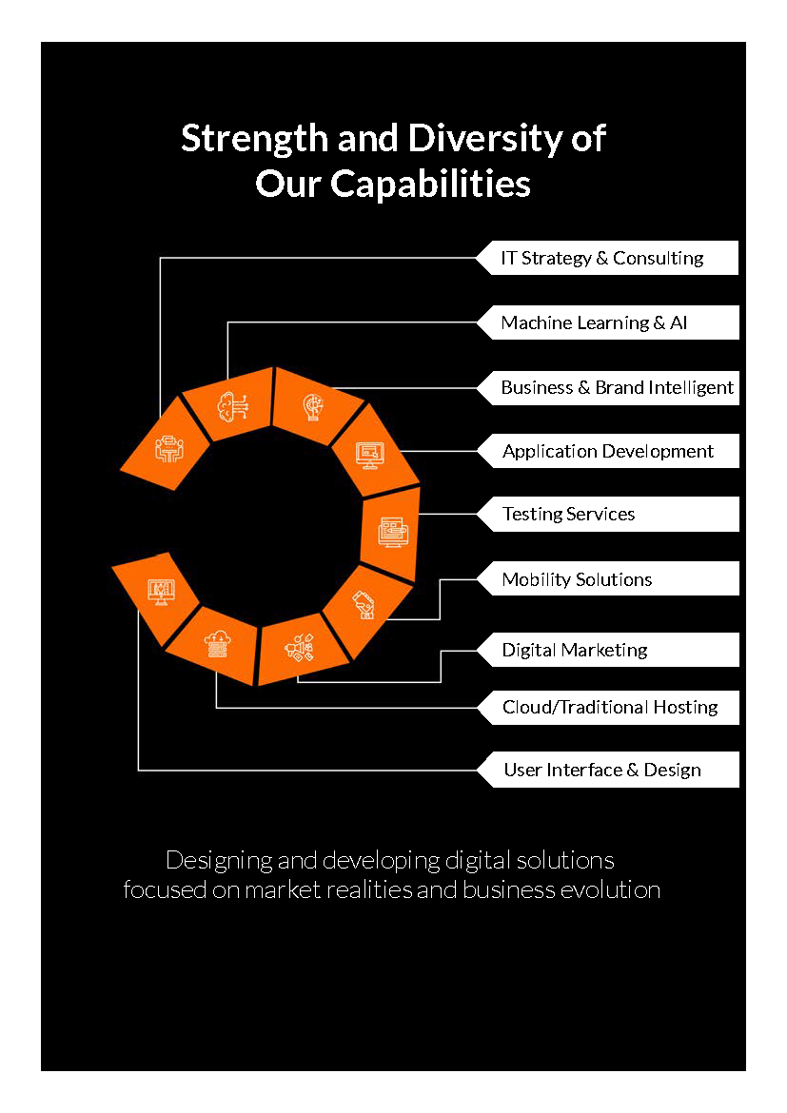

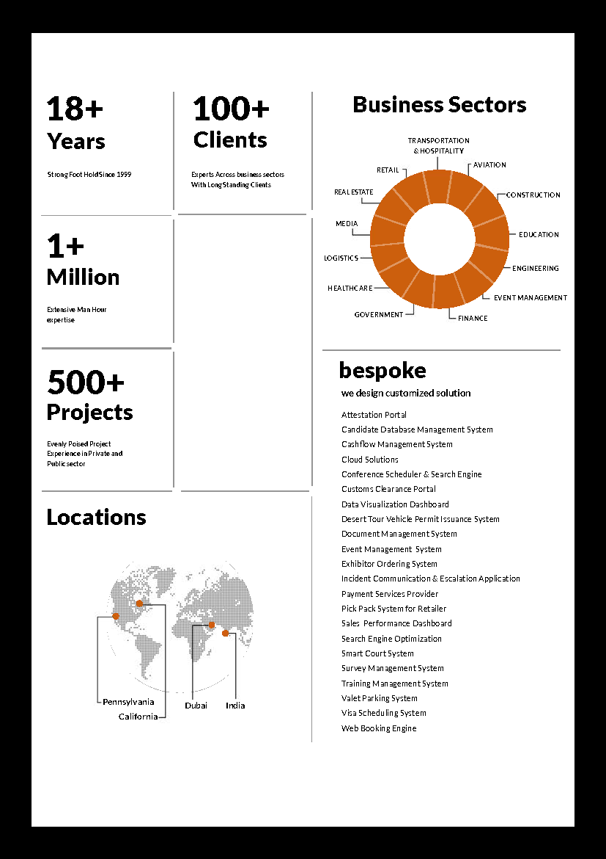

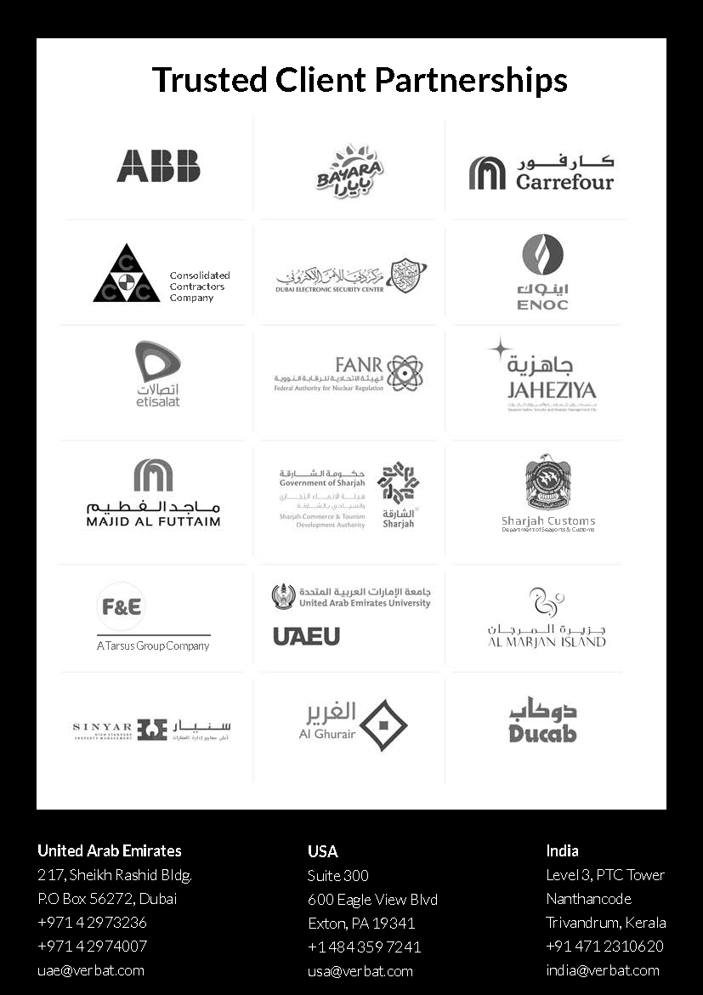

**Conﬁdentiality Notice:**

**This Proposal is conﬁdential and contains proprietary information and intellectual property of Verbanet Technologies LLC. Neither this proposal nor any of the information contained herein may be reproduced or disclosed under any circumstances without the express written permission of Verbanet Technologies L.L.C (hereby known under its brand name of Verbat in the United Arab Emirates). 2018. All rights Reserved**