

**SRS:**

**Intelli Planner**

**Carrefour**

**Submitted by**

Verbanet Technologies LLC  
04.03.19

Document ID: SRS/18022019/1872/3

Revision History

|  |  |
| --- | --- |
| ***Document Owner*** | Verbat Technologies LLC |
| ***Document Location*** | The electronic version is located at /AAU/SRS |
| ***Document Status*** | ***Submitted for review by Client*** |

|  |  |  |  |  |
| --- | --- | --- | --- | --- |
| **Revision #** | **Revision Date** | **Description of Change** | **Author** | **Comments** |
| 1.0 | 08 April 2019 | Initial draft | Prashant |  |
|  |  |  |  |  |
|  |  |  |  |  |
|  |  |  |  |  |
|  |  |  |  |  |

Document Approval

This document has been accepted and approved by the following:

|  |  |  |  |
| --- | --- | --- | --- |
| **Signature** | **Printed Name** | **Title** | **Date** |
|  |  |  |  |
|  |  |  |  |
|  |  |  |  |
|  |  |  |  |

**DIRECTORY**

[1 Introduction 1](#_Toc5699686)

[1.1 Overview of the Document 1](#_Toc5699687)

[1.2 Engagement Context 1](#_Toc5699688)

[1.3 Product Perspective 2](#_Toc5699689)

[2 Functional Requirements 3](#_Toc5699690)

[2.1 Requirement Summary 3](#_Toc5699691)

[2.1.1 F&V Order Support System 3](#_Toc5699692)

[2.1.2 Butchery Product Estimate System 4](#_Toc5699693)

[2.1.3 Bakery Product Estimate System 4](#_Toc5699694)

[2.1.4 Common Features 5](#_Toc5699695)

[2.2 Requirement Specification 5](#_Toc5699696)

[2.2.1 Login 5](#_Toc5699697)

[2.2.2 Logout 6](#_Toc5699698)

[2.2.3 Admin Dashboard 6](#_Toc5699699)

[2.2.4 F & V Dashboard 9](#_Toc5699700)

[2.2.5 Butchery Dashboard 12](#_Toc5699701)

[2.2.6 Bakery Dashboard 13](#_Toc5699702)

[2.2.7 General Features 14](#_Toc5699703)

[3 Technology Solution 15](#_Toc5699704)

[3.1 User Interface 15](#_Toc5699705)

[3.2 Hardware Interface 16](#_Toc5699706)

[3.3 Technology for Development/Hosting 16](#_Toc5699707)

[4 Assumptions, Dependencies & Out of Scope 16](#_Toc5699708)

[5 Non-Functional Requirements 17](#_Toc5699709)

[5.1 Documentations 17](#_Toc5699710)

[5.2 Security 17](#_Toc5699711)

[5.3 Data Storage 17](#_Toc5699712)

[5.4 Usability 18](#_Toc5699713)

[6 Analysis Models 19](#_Toc5699714)

[6.1 Application Workflow 19](#_Toc5699715)

[6.1.1 Fruits and Vegetables Workflow 19](#_Toc5699716)

[6.1.2 Butchery Workflow 20](#_Toc5699717)

[6.1.3 Bakery Workflow 20](#_Toc5699718)

# Introduction

This section gives a scope description and overview of everything included in this SRS document. In addition, the purpose of this document is described. The purpose of this document is to give a detailed description of the requirements for the “Intelli Planner System”. The document will illustrate the purpose and complete declaration for the development of the system. This document is primarily intended to be proposed to a customer for approval, and a reference for the development team to develop the first version of the system.

## Overview of the Document

The remainder of this document includes five chapters. The second chapter provides an overview of the system functionality. The chapter further elaborates how the system manages the various divisions within a retail store. The chapter has described the complete requirement specification put forward by the client. We have assessed them, and converted them to business logic. The business logic describes the functionality of each module/system. The third chapter provides the Technology solution and various system compatibilities. The fourth chapter mentions about the assumptions, dependencies and out of scope. The fifth chapter describes the nonfunctional requirement of the system users. The sixth chapter provides the work flow diagram.

## Engagement Context

Carrefour has contacted Verbat to develop an Inventory management system to replenish supplies in their hypermarket stores located in UAE. Carrefour has 28 stores in UAE. The system shall help managers to place orders based on historical sales volumes by taking into account holiday seasons, promotions and weekend sales. It does this by receiving various files on a daily basis from their GIMA and GICA warehouse management solutions. The full scope of the application includes management of the following divisions within each store

* Fruits and Vegetables (FNV)
* Butchery
* Bakery

The proposed application shall be developed using the .NET ecosystem. The application shall be developed as a Responsive user friendly Web Application that plays well with tablets and desktop browsers.

## Product Perspective

Primarily, the scope of the document pertains to the application features for the development of the initial phase of the Intelligent Planning System. The application shall be developed in three phases starting off with F&V, followed by the butcher and bakery applications.

The application will have the following core components:

* **F&V Modules:**

Closely interacts with the Distribution Center and Warehousing Applications to generate leads and help place orders.

* **Butchery Product Estimating Module**

Helps in estimating the produce required and selects the best cut of meat to support production

* **Bakery** **Product Estimation Module**

Helps determine the raw material needed to produce bakery products based on the active ingredients of their constitution

# Functional Requirements

## Requirement Summary

The application will have the following core components

### F&V Order Support System

The objective of the application is to build a system that will be used by F & V Store Team(Currently 28 stores in UAE) for ordering process based on the inputs received [Quotation file] from DC (Distribution Centre) team and the order support file generated by GIMA. Additional sales related information about the ‘sales’ and ‘promotions’ will also be available for the Section Manager to support the decision making process during the ordering stage.

**Main Actors**

* DC Team Member (uploads quotation to our system)
* Merchandise Manager ( review/edit quotation)
* F & V Section Manager

**Device**

* Tablet (Section Managers)

**Files Required from Carrefour**

* Quotation
* Order Support File
* Daily Sales File
* Promotion Files
* Jwolk File Sample
* Order creation API documentation

**Order Support File** is generated daily by GIMA and available in sftp folder to be fetched automatically to the system.

**Daily Sales File** is generated by GIMA and available in sftp folder to be fetched automatically to the system.

**Promotion File** is generated by GIMA and available in sftp folder to be fetched automatically to the system.

* Quotation’ file will be uploaded to the new proposed system by DC team
* The uploaded ‘quotation’ file can be reviewed/edited by Merchandise Manager (item list, quantity, purchased price, supplier code etc.)
* F & V Section Manager will be able to view the Average Sales data and Promotion Sales history of item in one year.
* F &V Section Manager has to place the order using the new system after confirming the Quantity, Selling Price and Margin.
* One year older data related to Promotions will get deleted.
* Once Section Manager has placed the order, it will communicate to GIMA. Now all the items which are available in DC will be marked as Active and other Suppliers are marked as Not Active/Blocked. If the items are not available in DC, then the Section Manager will be able to place order from other suppliers. i.e, In order to restrict the Section Manager from ordering from other suppliers when the item is available in DC using GIMA order interface, the proposed system can generate a file to be fetched by Carrefour team to update item/ supplier status in GIMA using Jwolk.
* Reports will be visible to F&V Section Manager where he can filter using different fields (like date, item, quantity etc.)

### Butchery Product Estimate System

The objective of the application is to ensure that the Butchery team uses the most relevant items for producing the final product. The application will give estimate/ guide to the Butchery Manager on the RAW MATERIALS (eg. Meat required to develop the product) to be used and the QTY of the items to be produced for a particular day.

**Main Actor:**

* Butchery Section Manager

**Device:**

* Tablet

**Required Files from Carrefour:**

* Sales file
* Mapping file
* Promotion file
* Hourly Sales data

Butchery Section Manager will be able to view the type of meat from which the order in selection can be produced at optimum cost.

Butchery Section Manager will be able to view the Sales data and Promotion Sales history of item in one year.

Butchery Section Manager will be able to view hourly sales by mid of the day.

Butchery Section Manager will be able to view the Average Sales data and Promotion Sales history of item in one year.

### Bakery Product Estimate System

**Main Actor:**

* Bakery Section Manager

**Device:**

* Tablet

**Required Files from Carrefour:**

* Promotion Files
* Daily Sales Files
* Hourly Sales Files
* Recipe file
* Packing details
* Waste Details

System will give an estimate to the Manager on the raw materials to be used and quantity of the item to be produced for a particular day based on the ‘Time Series Analytics Algorithm’.

**Baking Batches:**

* Morning (Before opening)
* Noon
* 3.00 PM
* 6.00 PM
* Night (9.00 PM)

With particular date range Bakery Manager can view the daily-hourly sales data.

Bakery Section Manager should be able to view the Sales and promotion data.

Bakery Manager will be able to enter the QTY of items to be produced (baked) in each baking batch, in order to identify the raw materials and recipes to be used.

Bakery Manger will be able to view the number of packs to be packed related to the item classification.

Bakery Manager will be able to view the Inventory related to Raw Materials and Wastage of the items.

### Common Features

* A Purge process will be available to delete the old data related to promotions. Sales data may retain.
* Reports with filters are available in new system.
* Reports can be downloaded as Excel.
* Top Selling and top wastage (only for Bakery Product Estimate System) Reports will be available to the Management.

## Requirement Specification

### Login

It allows only authorized users to access the application. After entering login details - email ID and password fields, user has to click ‘LOGIN’ button. Once ID and password are validated, the user is given access to the application. If login fails, an error message will show as “Invalid email id or password”.

| **REQUIREMENT ID (RID)** | **DESCRIPTION** | [**PRIORITY LEVELS**](file:///C:\Users\Verbat\Desktop\pmp\requirements\Requirements_Gathering_Guidelines_and_Checklists_2.xls#'Document Conventions'!_Toc136410958)  (P1,P2,P3,P4) | [**EFFORT REQUIRED**](file:///C:\Users\Verbat\Desktop\pmp\requirements\Requirements_Gathering_Guidelines_and_Checklists_2.xls#'Document Conventions'!_Toc136410958)  (H,M,L) |
| --- | --- | --- | --- |
| 2.2.1 | * Email Id * Password * LOGIN Button | P1 | H |

### Logout

It allows only authorized users to log out of the application. After clicking SIGN OUT, user will be redirected to the login page. The system provides auto logout/session time out has been idle for more than two hours.

| **REQUIREMENT ID (RID)** | **DESCRIPTION** | [**PRIORITY LEVELS**](file:///C:\Users\Verbat\Desktop\pmp\requirements\Requirements_Gathering_Guidelines_and_Checklists_2.xls#'Document Conventions'!_Toc136410958)  (P1,P2,P3,P4) | [**EFFORT REQUIRED**](file:///C:\Users\Verbat\Desktop\pmp\requirements\Requirements_Gathering_Guidelines_and_Checklists_2.xls#'Document Conventions'!_Toc136410958)  (H,M,L) |
| --- | --- | --- | --- |
| 2.2.2 | * Sign-out Button | P1 | L |

### Admin Dashboard

Admin can login to web application

The application shall provide the following features for the super admin

* Admin can view dashboard
* Admin can manage (add/edit/delete) Users
* Admin can manage (add/edit/delete) Roles
* Admin can manage (add/edit/delete) the Departments
* Admin can manage (add/edit/delete) Promotions
* Admin can manage (add/edit/delete) Recipes.
* Admin can manage (add/edit/delete) Holiday Calendar
* Look Up historical prices by department, holiday season, time of year, weekend etc.
* Manage stores
* Store wise reports
* File status: Verify that all files expected for the day have been received
* Manage Inventory stocked in store
* Bakery production Schedules

| **REQUIREMENT ID (RID)** | **DESCRIPTION** | [**PRIORITY LEVELS**](file:///C:\Users\Verbat\Desktop\pmp\requirements\Requirements_Gathering_Guidelines_and_Checklists_2.xls#'Document Conventions'!_Toc136410958)  (P1,P2,P3,P4) | [**EFFORT REQUIRED**](file:///C:\Users\Verbat\Desktop\pmp\requirements\Requirements_Gathering_Guidelines_and_Checklists_2.xls#'Document Conventions'!_Toc136410958)  (H,M,L) |
| --- | --- | --- | --- |
| 2.2.3.2 | * **Manage**  **Users** (Add/Edit/Delete) * User Name * First name * Department (Dropdown) * Last name * Password * Email   Filters   * User Name | **P1** | **H** |
| 2.2.3.3 | * **Manage**  **Role**  (Add/Edit/Delete) * Role Name * Role Type (Team Member, Section Manager, Merchandizing Manager)   Filters   * Role` | **P1** | **M** |
| 2.2.3.4 | * **Manage**  **Departments** (Add/Edit/Delete) * Department Name (Butchery, Bakery, F&V)   Filters   * Department (Dropdown) | **P1** | **M** |
| 2.2.3.5 | * **Manage**  **Promotions** (Add/Edit/Delete) * Promotion name * Promotion department * Promotion start date * Promotion end date * Promotion price * Promotion season (drop down) * Lookup historical price | **P1** | **M** |
| 2.2.3.6 | * **Manage**  **Recipes** (Add/Edit/Delete) * Recipe name * Recipe ingredient * Recipe ingredient quantity * Look up price per unit (extract from GICA or GIMA)   Filters   * Recipe name | **P1** | **M** |
| 2.2.3.7 | * **Manage Holiday Calendar ( Add/edit/delete)** * Holiday Name * Holiday Category (Christian, Islamic, Hindu, National holiday) * Holiday Start date * Holiday End date   Filters   * Holiday name * Category * Date (Start & End date) |  |  |
| 2.2.3.8 | * **Lookup Historical Prices** * Select Division / Department * Select Dates (Start-End) * Auto detect holiday, holiday category, weekend, national holiday * Lookup historical prices * Return result options: average, instances, by year, by season) | **P1** | **M** |
| 2.2.3.9 | * **Manage**  **Store** (Add/Edit/Delete) * Store Name * Store address * Store departments / divisions * Store manager * Store division managers * Store sales by day, month year (integration with external system)   Filters   * Name (Dropdown) * Location City ( Dropdown) | **P1** | **M** |
| 2.2.3.10 | * **Storewide reports** * Sales report by store (filter by city, region or store) * Recommended promotions reports * Historical sales report * Bakery wastage reports * Meat sales report * Fruits and Vegetables sales report * Items to be re-ordered | **P1** | **M** |
| 2.2.3.11 | * **File Status: Verify file receipt for** * Quotation File * Order Support * Daily Sales * Promotions * Mapping File * Hourly Sales * Packing Details * Waste Details   **File verification shall be supported for all stores and per division** | **P1** | **H** |
| 2.2.3.12 | * **Inventory of items in each division** * Item name * Category (Pulses, grain, oil, meat etc.) * Sub category (wheat, leg of lamb etc.) * Tags * Item quantity * SKU * PLU * Minimum qty. required * Max qty. required | **P1** | **H** |
| 2.2.3.13 | * **Bakery schedule management** |  |  |

### F & V Dashboard

The F &V dashboard provides the following features

* Import files (order support, daily sales, promotions) from SFTP
* Normalize and fit data to target DB (Our Database)
* Upload Quotation file
* Edit quotation file
* Generate summary information for Avg. sales, promotion Sales History etc. for all items (Fruits and Vegetables only) sold in store
* Generate summary information for a time series (hourly, daily, monthly, yearly, date ranges, time ranges etc.)
* Check inventory in DC
* Block Suppliers when inventory is available is DC (Active / Blocked)
* Place orders in DC
* View supplier Rates and quantity available when item not present in DC
* Recommend supplier based on past history (or some other criterion)
* Reports exportable to word, pdf or excel
* Order creation API calls to GIMA, GICA
* Responsive and bilingual Mobile tablet app
* Manage local Item inventory (Price, quantity, margin, promotion, sold, unsold, daily inventory requirements, throw away etc.)
* Consolidate daily transactions and push to source (GICA , GIMA)

| **REQUIREMENT ID (RID)** | **DESCRIPTION** | **PRIORITY LEVELS**  (P1, P2, P3, P4) | **EFFORT**  **REQUIRED**  (H,M,L) |
| --- | --- | --- | --- |
| 2.2.4.1 | * Order Support, Daily sales & promotions files are dropped into an SFTP folder by GIMA. * A back end system shall retrieve the files from the SFTP location * Scrub & sanitize the data * Load the data into the target application being built | **P1** | **H** |
| 2.2.4.2 | * Upload Quotation file by DC Team * An interface to upload the quotation file. | **P1** | **M** |
| 2.2.4.3 | * Update the quotation file * Merchandising manager updates the quotation file | **P1** | **M** |
| 2.2.4.4 | * Generate historical summary information for all items (Fruits and Vegetables only) sold in store * Average sales per item * Promotional sales and prices per item * Holiday Season sales per item * Daily sales per item * Time series reports for all of the above | **P1** | **M** |
| 2.2.4.5 | * Generate daily requirement report * Items that need to be reordered (out of stock) * Cross reference historical information to predict items required | **P1** | **M** |
| 2.2.4.6 | * Place orders * Block distributors when item is available in DC * Show distributors when item is not available in DC * Recommend distributor based on order history, location, price etc. | **P1** | **M** |
| 2.2.4.7 | * Export option for all generated reports * Excel * PDF * CSV * Word (optional) | **P1** | **M** |
| 2.2.4.8 | * Place Order to DC via API * API to GIMA * API to GICA | **P1** | **H** |
|  | * Manage Local Inventory (F&V Manager) * Price * Quantity * Margin * Promotion * Sold * Unsold * Throw away * Etc. * Cross ref with item table | **P1** | **H** |

### Butchery Dashboard

The Butchery dashboard is available for the section manager related to butchery and it shall have the following features

* File Imports from Carrefour (sales, mappings, promotions, Hourly sales)
* Scrub, Normalize and fit data to target (Our database)
* Define products (meat cuts, types-chicken, fish, lamb, cow; portion sizes)
* Identify availability and daily requirements (estimates)
* Generate summary information
* Predictions based on past information (daily, promotions, holidays etc.)
* Identify cheapest meat cut for minced meat (to get optimum cost)
* Manage waste
* Push EOD data to GICA
* Generate multi-format reports with multiple filters and orderings
* API integration with source and target systems
* Update source systems (GICA, GIMA) with daily sales and inventory data

|  |  |  |  |
| --- | --- | --- | --- |
| **REQUIREMENT ID (RID)** | **DESCRIPTION** | **PRIORITY LEVELS**  (P1, P2, P3, P4) | **EFFORT**  **REQUIRED**  (H,M,L) |
| 2.2.5.1 | * Import files as described in section 2.2.4.1 | **P1** | **M** |
| 2.2.5.2 | * Manage Local Inventory (Butchery Manager) * Meat type * Meat cut * Portion size * Recommended price | **P1** | **M** |
| 2.2.5.3 | * Generate daily requirements | **P1** | **H** |
| 2.2.5.4 | * See historical data * Holiday sales * Promotional sales * This day that year * Previous months * Forecasted sales | **P1** | **H** |
| 2.2.5.5 | * Identify cheapest meat cuts for minced meat to optimize production cost | **P1** | **H** |
| 2.2.5.6 | * Record waste | **P1** | **L** |
| 2.2.5.7 | * Push end-of –day sales to GICA via API | **P1** | **M** |
| 2.2.5.8 | * Generate multi-format reports with filters and orderings. See 2.2.4.4 | **P1** | **M** |
| 2.2.5.9 | * Export reports to excel, PDF & CSV | **P1** | **M** |
| 2.2.5.10 | * Dashboard displays summary information on * Daily sales forecast * Daily requirements * Status of the File imports * Running total of sales, remaining items |  |  |

### Bakery Dashboard

The Bakery dashboard is available for the section manager related to bakery and it shall have the following features

* File Imports from Carrefour (promotions, daily sales, hourly sales, recipe packing details, waste details)
* Scrub, normalize and fit data to target
* Generate Historical data (Time series)
* Estimate daily requirements based on historical data
* Create recipe with ingredient quantity
* Baking batches
* Generate raw material quantity of items based on order
* Manage package information (packed, unpacked)
* Manage waste

Update source systems (GICA, GIMA) with daily sales and inventory data

|  |  |  |  |
| --- | --- | --- | --- |
| **REQUIREMENT ID (RID)** | **DESCRIPTION** | **PRIORITY LEVELS**  (P1, P2, P3, P4) | **EFFORT**  **REQUIRED**  (H,M,L) |
| 2.2.6.1 | * Import files as described in section 2.2.4.1 | **P1** | **M** |
| 2.2.6.2 | * Generate historical data | **P1** | **M** |
| 2.2.6.3 | * Estimate daily requirements based on historical data | **P1** | **M** |
| 2.2.6.4 | * Calculate quantity of ingredients and prices based on recipe information of each bakery product | **P1** | **M** |
| 2.2.6.5 | * Determine baking batches and plan (requirement unclear) | **P1** | **H** |
| 2.2.6.6 | * Manage packing information (requirement unclear) | **P1** | **H** |
| 2.2.6.7 | * Manage waste and record it | **P1** | **L** |
| 2.2.6.8 | * Update GICA and GIMA with EOD stats | **P1** | **M** |
| 2.2.6.9 | * Dashboard that reflects that reflect daily statistics. Similar to 2.2.5.10 |  |  |

### General Features

General features include functionality that is inherent to all developing activities. Examples are

* Auditing and logging
* Authentication & Authorization
* Exception Handling
* Purge process to delete old promotions
* Top Selling and top wastage

|  |  |  |  |
| --- | --- | --- | --- |
| **REQUIREMENT ID (RID)** | **DESCRIPTION** | **PRIORITY LEVELS**  (P1, P2, P3, P4) | **EFFORT**  **REQUIRED**  (H,M,L) |
| 2.2.7.1 | * Application shall log user activities in the DB | P1 | M |
| 2.2.7.2 | * Users shall be authenticated and redirected to the functionality that has been designed for them based on their roles | P1 | M |
| 2.2.7.3 | * All exceptions shall be logged in log files and an shall be handled in a user friendly manner | P1 | L |
| 2.2.7.4 | * Historical information older than an year related to promotions shall be purged from the database | P1 | L |
| 2.2.7.5 | * In general all dashboards shall display top selling and top items that are being wasted | P1 | L |

# Technology Solution

This section contains all of the functional and quality requirements of the system. It gives a detailed description of the system and all its features.

## User Interface

The user interface will be responsive.

*Browser Compatibility*

The application developed will be compatible with the browsers listed below:

1. Internet Explorer 11
2. Mozilla Firefox 50 or above
3. Chrome 50 or above

## Hardware Interface

Since the application is web-based, it is not dependent on any designated hardware, and it does not have any direct hardware interfaces. However, we recommend the specification mentioned below for the best output.

* Operating System: Linux / CentOS
* Core: 2
* Memory: 4GB
* Disk Space: 500 GB of free disk space

## Technology for Development/Hosting

The application shall be developed using the set of tools/technology listed below.

* **UI/UX Designs**
  + Wire Frames – Gliffy (Tool by Google)/Pencil
  + UI Designs – Photoshop CS6
  + Simulation – Sublime Text 3
* **Development**
  + .Net 4.5, MVC, ASP.NET
  + C#, HTML 5 , CSS3
  + MSSQL, Entity framework
  + IIS

# Assumptions, Dependencies & Out of Scope

Assumptions and Dependencies are as below:

* The application front end and backend would be developed in English (ARABIC???).
* The application will be using a compatible browser connected to Internet, details of which is specified under section 3.1.
* The upload and download of documents/ files will depend on the internet speed. We assume the internet speed for the users would be adequate for uploading/downloading files of large size if any. In case the speed is not adequate/stable, downloads/uploads may be interrupted.
* The roles (user types) will be predefined in the system
* Internet connectivity is required for the functioning of the Web portal.

The points mentioned below are out of the scope of this project:

* Purchase of images, fonts and domain names
* Any language other than English
* Migration of existing data / Database migration
* Content writing / proof reading / Data Replication / Manual data entry
* Content or image procurement or uploading or editing.
* Adding new features to the application other than mentioned in the solution. Such requests will be handled via change management. For Change management details, please refer section titled “Change Management” in the proposal.
* Annual Maintenance of the application (Bug fixing, debugging)-
* Hosting Infrastructure and Maintenance (web and email hosting), unless contracted for.
* Application Deployment on the server, unless contracted with Verbat.
* Backup solution and Disaster recovery unless contracted for.
* Physical deployment onsite / installation of the application in devices and Physical connection, installation of system.
* Integration with third-party, if any, other than mentioned in the functional requirements.
* Hardware Integrations / procurement and purchase
* SSL Purchase and installation, if any
* Plugin/template purchases, if any
* OS other than mentioned in the Hardware Interface
* Relevant / related software libraries

# Non-Functional Requirements

## Documentations

|  |  |
| --- | --- |
| **ITEM** | **RESPONSE/COMMENT** |
| Project documentation requirements | * Requirements document |

## Security

Hardware and network security will be dependent on the selected cloud/hosting service provider’s infrastructure and credentials.

* The system shall automatically log out all customers after a period of inactivity.

## Data Storage

* The user interfaces shall never display a customer’s password. It shall always be echoed with special characters representing typed characters.
* The system’s back-end servers shall never display a customer’s password. The customer’s password may be reset but never shown.
* The system’s back-end servers shall only be accessible to authenticated administrators.

|  |  |
| --- | --- |
| **ITEM** | **REQUIREMENT** |
| Handling Sensitive Data | Insensitive data such as company name, documents processed, relevant dates, noncompliance data. could be stored in the database as plain text  Passwords will be encrypted. |
| Security Threats  Prevention | Passwords will be encrypted. Protection against SQL injection will be implemented  Protection against Cross browser hacks and cross-site scripting (XSS) will be implemented. |
| Access Control | Access control for the application will be Role based. Individual users will be authenticated with passwords and authorized to access different parts of the site depending upon assigned roles. |

## Usability

|  |  |
| --- | --- |
| **ITEM** | **REQUIREMENT** |
| Auto-Generated  IDs | Auto generated ID’s will be used within a database context. |

# Analysis Models

## Application Workflow

### Fruits and Vegetables Workflow

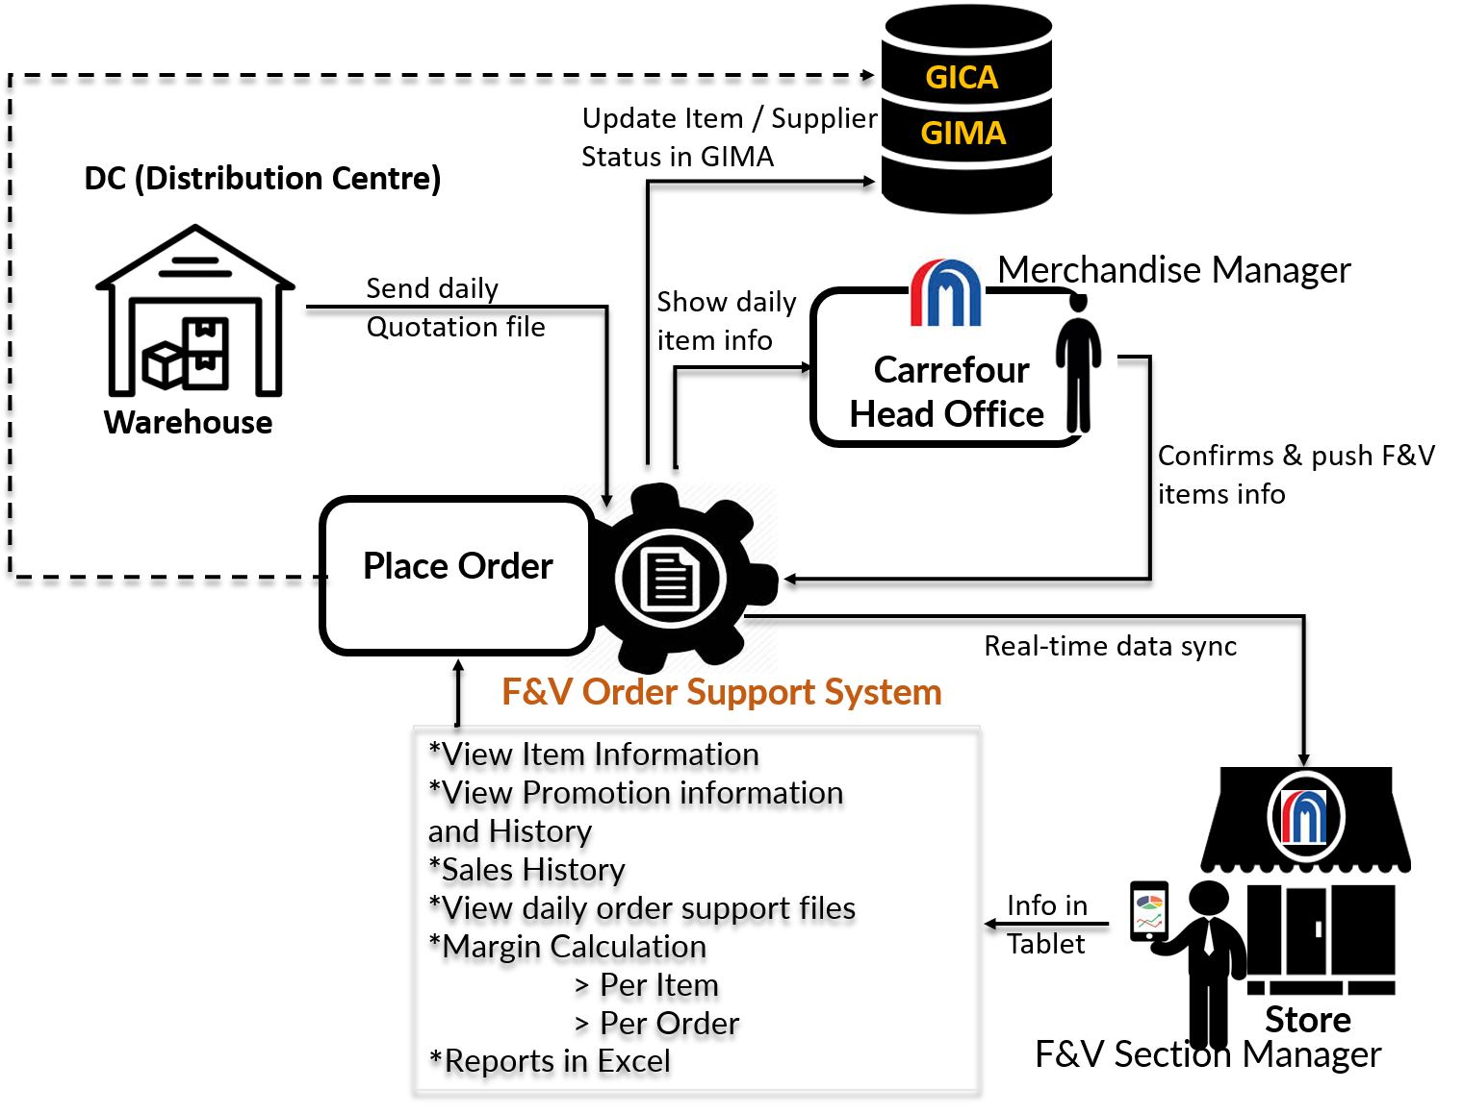

### Butchery Workflow

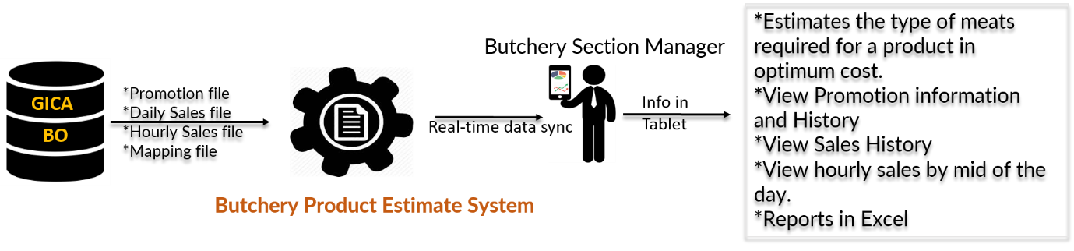

### Bakery Workflow

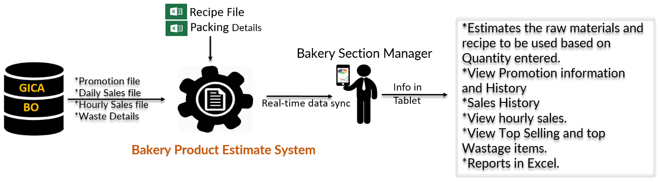

**WITH OUR**

**SINCERE THANKS.**

Conﬁdentiality Notice:

This document is conﬁdential and contains proprietary information and intellectual property of Verbanet Technologies LLC. Neither this proposal nor any of the information contained herein may be reproduced or disclosed under any circumstances without the express written permission of Verbanet Technologies L.L.C (hereby known under its brand name of Verbat in the United Arab Emirates). 2019. All rights Reserved