**COUNTRY BY COUNTRY REPORTING SYSTEM**

**Ministry of Finance**

Country By Country Reporting System

Submitted By:

VERBANET TECHNOLOGIES L.L.C

**CONTENTS**

**0 KEY DETAILS** 4

**1** **EXECUTIVE SUMMARY** 5

**2** **COMPANY PROFILE** 6

2.1 COMPANY INFORMATION 6

2.2 FINANCIAL INFORMATION 6

2.3 REFERENCES 7

**3** **PARTNERS & SUBCONTRACTORS** 8

**4** **CONFLICT OF INTEREST** 10

**5** **SOLUTION ROAD MAP** 11

5.1 PROPOSED SOLUTION MODEL 11

**6** **PROPOSED ORGANISATION STRUCTURE & KEY PERSON CVs** 12

**7** **PROJECT IMPLEMENTATION APPROACH & PROJECT PLAN** 13

7.1 PROJECT DELIVERY 13

**8** **KEY PROJECT ASSUMPTIONS & RISKS** 18

8.1 PROJECT ASSUMPTIONS 18

8.2 RISK CONTINGENCY PLANNING 19

**9** **PROPOSED SLAs** 21

9.1 MAINTENANCE & SUPPORT 21

9.2 SERVICE LEVEL AGREEMENT (SLA) 22

**10** **LIST OF IT COMPONENTS** 23

10.1 IT ASSET INVENTORY 23

10.2 LIST OF TOOLS 23

10.3 HIGH LEVEL FUNCTIONAL ARCHITECTURE 23

10.4 HIGH LEVEL APPLICATION ARCHITECTURE 23

10.5 HIGH LEVEL DATA ARCHITECTURE 23

10.6 HIGH LEVEL NETWORK ARCHITECTURE 23

**11** **CORE APPLICATION DETAILS** 24

11.1 KEY MODULES 24

11.2 APPLICATION FEATURES 25

11.3 TECHNOLOGY DETAILS 25

**12** **FUNCTIONAL REQUIREMENTS** 27

12.1 REGISTRATION 27

12.2 NOTIFICATION 28

12.3 CBCR FILING 28

12.4 DATA AGGREGATION 29

12.5 CONVERSION 30

12.6 INFORMATION EXCHANGE 30

12.7 GENERAL DESCRIPTION 31

12.8 OTHER REQUIRMENTS 31

**13** **NON-FUNCTIONAL REQUIREMENT (OTHERS)** 34

13.1 PROPOSED SYSTEM ENVIRONMENT 37

**14** **OUT OF SCOPE** 39

14.1 CHANGE MANAGEMENT 40

**15** **TERMS & CONDITIONS** 42

15.1 ACCEPTANCE CRITERIA 42

15.2 WARRANTY 42

15.3 SOURCE CODE & INTELLECTUAL PROPERTY RIGHTS 42

15.4 GENERAL TERMS AND CONDITIONS 43

15.5 GENERAL ADMINISTRATIVE, TECHNICAL & FUNCTIONAL ASSUMPTIONS 44

**16** **FINANCIALS** 46

16.1 WEB APPLICATION DEVELOPMENT 46

16.2 WINDOWS DEDICATED HOSTING – OPTIONAL 47

**17** **ABOUT US** 48

# **0 KEY DETAILS**

**PROJECT NAME CLIENT**

Country By Country Reporting System Ministry of Finance

**CLIENT CONTACT CLIENT ADDRESS**

Mr. P.O.Box 123

ABC Street

Dubai

U.A.E

**PROPOSAL SUBMISSION PROPOSAL ID NO.**

20.12.19  AD/BP/20122019/1820/2

**PROPOSAL VALID UNTIL ANTICIPATED START DATE**

30.12.19 00.00.00

**PROPOSAL SUBMITTED BY PROPOSED TECHNOLOGY**

Verbanet Technologies L.L.C ASP.NET Dubai, U.A.E **APPLICATION TYPE**

+971 4 297 3236 Web Application

+971 50 765 2345

# **EXECUTIVE SUMMARY**

# **COMPANY PROFILE**

## COMPANY INFORMATION

|  |  |
| --- | --- |
| Name of the Organization |  |
| Address(street, zip code, town/ city, country) |  |
| Website Address |  |
| Establishment Year |  |
| Contact Person |  |
| Contact Person Number |  |
| Contact Person E-mail |  |
| Company Trade License number within the UAE, Subcontractor License |  |
| Annual turnover (Revenue) for the past 5 years |  |
| Total No. of employee |  |
| No. of Employees - CbCR software development and support |  |
| No. of English speaking staff |  |
| No. of Arabic speaking staff |  |
| No. of available local skills (within UAE) |  |
| No. of staff having CbCR system experience |  |
| SI Partners in the UAE |  |

## FINANCIAL INFORMATION

|  |  |  |  |  |  |
| --- | --- | --- | --- | --- | --- |
| **Information** | **Year 1** | **Year 2** | **Year 3** | **Year 4** | **Year 5** |
| Annual Turnover (Revenue) |  |  |  |  |  |
| Annual Turnover from tax Products |  |  |  |  |  |

## REFERENCES

|  |  |  |
| --- | --- | --- |
| **No** | **Information** | **Answer/Remarks** |
| 1 | Client Name |  |
| 2 | Client Contact and phone number |  |
| 3 | Country |  |
| 4 | Year of Implementation |  |
| 5 | Duration of Implementation |  |
| 6 | Duration of Contract |  |
| 7 | Was the contract renewed? |  |
| 8 | Delivery Model |  |
| 9 | Implementation Challenges |  |
| 10 | Number of target Users |  |
| 11 | Number of notifications filed |  |
| 12 | Number of CBCR reports generated |  |
| 13 | Outcomes |  |
| 14 | Methodology |  |
| 15 | Did the solution include FATCA or CRS capabilities |  |
| 16 | Additional Information |  |

# **PARTNERS & SUBCONTRACTORS**

Partner/Subcontractor Name:

Project Name:

**Partner/ Subcontractor Information**

|  |  |
| --- | --- |
| Name of the Organization |  |
| Address(street, zip code, town/ city, country) |  |
| Website Address |  |
| Establishment Year |  |
| Contact Person |  |
| Contact Person Number |  |
| Contact Person E-mail |  |
| Company Trade License number within the UAE, Subcontractor License |  |
| Annual turnover (Revenue) for the past 5 years |  |
| Total No. of employee |  |
| No. of Employees - CbCR software development and support |  |
| No. of English speaking staff |  |
| No. of Arabic speaking staff |  |
| No. of available local skills (within UAE) |  |
| No. of staff having CbCR system experience |  |
| SI Partners in the UAE |  |

**Financial Information**

|  |  |  |  |  |  |
| --- | --- | --- | --- | --- | --- |
| **Information** | **Year 1** | **Year 2** | **Year 3** | **Year 4** | **Year 5** |
| Annual Turnover (Revenue) |  |  |  |  |  |
| Annual Turnover from tax Products |  |  |  |  |  |

**References**

|  |  |  |
| --- | --- | --- |
| **No** | **Information** | **Answer/Remarks** |
| 1 | Client Name |  |
| 2 | Client Contact and phone number |  |
| 3 | Country |  |
| 4 | Year of Implementation |  |
| 5 | Duration of Implementation |  |
| 6 | Duration of Contract |  |
| 7 | Was the contract renewed? |  |
| 8 | Delivery Model |  |
| 9 | Implementation Challenges |  |
| 10 | Number of target Users |  |
| 11 | Number of notifications filed |  |
| 12 | Number of CBCR reports generated |  |
| 13 | Outcomes |  |
| 14 | Methodology |  |
| 15 | Did the solution include FATCA or CRS capabilities |  |
| 16 | Additional Information |  |

**RACI Matrix**

|  |  |  |  |  |  |
| --- | --- | --- | --- | --- | --- |
| **Task** | **Project Executive (Name)** | **Project Manager (Name)** | **Business Analyst (Name)** | **Technical Architect (Name)** | **Application Developers**  **(Name)** |
|  |  |  |  |  |  |
|  |  |  |  |  |  |
|  |  |  |  |  |  |
|  |  |  |  |  |  |

R-responsible/works on

A-accountable

C-consulted

I-Informed

# **CONFLICT OF INTEREST**

# **SOLUTION ROAD MAP**

## PROPOSED SOLUTION MODEL

**STAND- ALONE FIXED BID**

Verbat will be following a stand–alone fixed bid solution delivery model wherein the required solution would be devised and a suitable pricing would be offered. Verbat’s solution architects have conducted a thorough research on the requirements and have come to the conclusion that our proposed solution, which is detailed further in this document, will meet the requirements put forth by the client.

**KEY STRENGTHS OF OUR SOLUTION**

* Strong and Scalable platform accommodating to future enhancements
* A framework which acts as a solution accelerator with building blocks that can be re-used in n future for building new components and features.
* Our light weight framework used consumes fewer system resources thereby making the application perform faster.
* All security aspects are considered

# **PROPOSED ORGANISATION STRUCTURE & KEY PERSON CVs**

**Organogram**

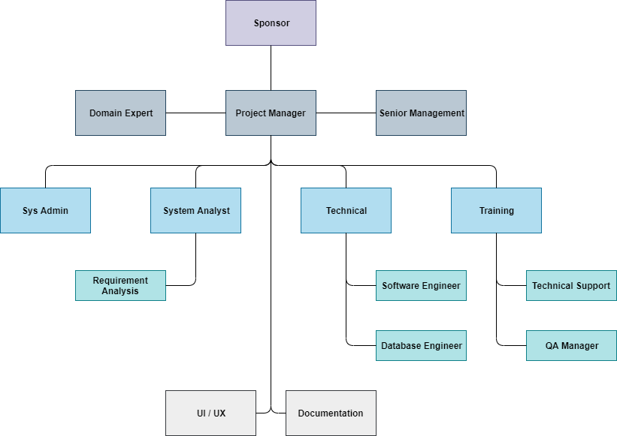

**Staffing Plan**





# **PROJECT IMPLEMENTATION APPROACH & PROJECT PLAN**

## PROJECT DELIVERY

### **PROJECT MANAGEMENT**

The Verbat development center strictly follows industry standards on quality. The project management is process governed by the Verbat Quality Management system and is put to verification through internal audit programs that happen from time to time. Verbat will dedicate a project manager for the proposed implementation. Verbat proposes Client to identify one project manager who will be driving activities to be undertaken by Client to be the single point of contact for Verbat.

### **ROLES & RESPONSIBILITIES**

Verbat will assign a dedicated Project Manager/Project Lead to lead the project, who will be the first point contact for Client. He/she will be responsible for planning and managing the various activities within the project. He/she will work closely with Client Project Manager, to give periodic status updates and ensure high level of visibility and comfort on the progress of the project. The Project Manager/Project Lead will lead the co-ordination between Verbat and Client, thus enabling smooth transitioning of Client requirements to the Verbat ’ offshore delivery team, and provide visibility as well as comfort on the progress of the services to Client.

He/she will have periodic meetings with Verbat ’ s Senior Management, thus ensuring Verbat ’ Management commitment and focus on Client initiatives.

### **DELIVERY ACTIVITY SUMMARY**

|  |  |
| --- | --- |
| Activities | Description |
| Detailed requirement Analysis | Verbat team to conduct detailed study of requirement for the phase. If clarification is required, team will reach out to Client for more information and/or time for discussions. |
| DB Design | DB design for central and test DB. |
| Software Requirement Specification document (SRS) | Once the requirement analysis is completed, Verbat team will submit the SRS document for approval |
| UI/UX Design, Prototyping | Based on the SRS, Verbat UX/UI team will work on the UI/UX of the screens and submit for approval |
| Functional Specification Document (FS) | Once the UI/UX is approved, Verbat shall submit an FS document for approval. |
| Development | Actual system development starts based on the FS. This involves detailed design and software development of Web Application. |
| Testing | Test Planning, test plan creations, internal, integration testing and user acceptance testing. |
| Deployment | Deploying the latest built in the Verbat Test Server. |

### **PROJECT IMPLEMENTATION PLAN**

Verbat will be providing the solution in a stand-alone fixed bid approach which ensures minimum viable solution for quick wins with core focus on the long-term business objective and outcome. Once the implementation is over, Verbat will initiate the application maintenance process (once the maintenance contract is signed) which continues to extend after the implementation.

### **DELIVERABLES**

* Home Page
* Software Requirement Specification Document (SRS)
* UI/UX Design
* Prototype of the application
* Functional Specification
* Fully Developed & Tested Application
* Source Code

|  |  |
| --- | --- |
| **Work Products** | **Key Deliverables** |
| Project Management | * Project Charter * Project Plan * Project Status Report * Steering Committee Report * Risk, Actions, Issues and Decisions Log |
| Requirements | * Business Requirements Document * Business Process Models * Use Cases * Requirements Traceability Matrix |
| Analysis & Design | * As-Is Architecture for Interim CbCR notification solution * Data Conversion Approach * Logical Data Model (SI) * Physical Data Model (SI) * Solution Specification |
| Development | * Code Management Approach * User Story or equivalent requirement model * Visual Design * Wireframes * User Interface Information Architecture * Post Implementation Documentation |
| Testing | * Test Approach * Test Cases and Scenarios * Test Completion Criteria * Test Completion Report |
| Migration | * Migration Plan and Approach |
| Training | * End-User Training Strategy * End-User Training Plan |
| Deployment | * Deployment Strategy * Deployment Plan * Post Implementation Criteria * Go-Live Criteria * System Operations Manual * System Architecture * System Deployment Manual * User Acceptance Test Results |
| Support | * Support Model * Support Plan |

### **ESTIMATED DELIVERY TIME**

The effort estimated for delivering the application will be as below:

* UAE working days for the UI/UX from the date of approval of the SRS
* UAE working days for the development of the application from the Date of Approval of the FS.

| **Activity** |
| --- |
| Contract Signoff (T0) |
| Project Initiation & Initiating requirement gathering |
| Software Requirement Specification Document(SRS) |
| SRS Approval (T1) |
| System UI/UX-Complete |
| System UI/UX-Approval (T2) |
| Functional Specification (FS) |
| FS Approval (T3) |
| Development Phase-Complete |
| Perform QC (Unit Testing and Integration Testing) |
| System ready for UAT |
| UAT Acceptance on Verbat server (T4) |

* The above-mentioned timeline is in UAE Working Days
* The initiation of the UI/UX development is dependent on the confirmation of SRS. SRS will be submitted post the confirmation of the project along with LPO, signed proposal and advance payment
* The above mentioned timeline for development is post the confirmation of FS
* Documentation submitted after project initiation and system study supersedes any proposal or documentation submitted during initial requirement gathering / discussion / negotiation
* Project plan will be submitted post the confirmation of project with necessary payments
* Any delay in getting the approvals of deliverables from client will cause change in timelines and the revised timelines will be updated in weekly status reports shared with client after the project commencement
* All approvals and queries regarding the client requirement and any queries which may hinder the project advancement at any stage should be answered by the client within 24 hours from the time of initiation, failing which the time delay will get added to the actual effort and timeline which was estimated.
* On project confirmation, Verbat requires a lead time of minimum seven (07) days for resource mobilization.

### **DEPLOYMENT DETAILS (AT CLIENT’S BEHEST)**

* Client can opt for hosting the application at Verbat’ Server.
* If deployment is at the client’s server, responsibility of deploying the application onto the production environment after conducting the necessary acceptance testing will lie with the client unless and until Verbat ’ support is contracted for deployment.

### **RELEASE PLANNING**

* Client will be informed about the release date and time through email.
* Client performs the UAT

# **KEY PROJECT ASSUMPTIONS & RISKS**

## PROJECT ASSUMPTIONS

The project solution and technology is created from the initial understanding of the requirement shared with Verbat through mails and meetings. The proposed solution is based on the following assumptions:

### **OBJECTIVE**

* The requirement is to develop an Integrated Higher Education Platform with the functionalities as defined in ‘Functional Requirements’ section

### **DESIGN**

* Client to provide Verbat with the branding guidelines.
* Color theme shall be provided by the client
* Client shall provide licensed images and logos in specified size & format
* Client shall provide the text and associated images for the proposed application. Text should be provided in digital format preferably in MS Word 2013 or above
* Verbat may use template based design for the application

### **DEVELOPMENT**

* The proposed application front end and backend would be developed in English only
* Development Contingent upon timely feedback from client
* The client will finalize the functional requirements and UI/UX before the commencement of the development of the project
* Client shall approve the UI/UX for the web application before development work starts
* Final data needs to be entered by the client via the application
* Client will provide sample data to test the application
* Testing of web application will be done in latest versions of Google Chrome, Mozilla, Edge web browsers only
* Client will procure templates, SSL certificates (if applicable)
* Client will host and manage the application on infrastructure (server / cloud) recommended by Verbat for managing database and application backup inclusive of images
* Application and data backups are subject to the purchase of such services at an extra cost
* Internet connectivity is required for the functioning of the Web portal
* Does not support offline access or operations

## RISK CONTINGENCY PLANNING

Verbat has identified various risk factors associated with this assignment and understands the impact of these risk factors on the project schedules. The objective of this section is to highlight for both Verbat and client, the risk factors, to analyze the impact of the risks on project execution, and to propose strategies to control and reduce the impact of the risk factor. These various risks, which could arise during the project, are tabulated below along with mitigation implementation.

| Type of risk | Impact | Risk Mitigation | Risk Handling |
| --- | --- | --- | --- |
| Scope Creep | H | Functions and features will be detailed in system requirement documents and will go through client approval. Once this document is approved, any change to requirement will go through change management review for possible impact assessment. | Proper change management procedure will be implemented. |
| Delay in customer feedback | H | The plan is prepared with enough lead-time for customer reviews and approvals.  The customer is indicated with the dates when the document is expected after review and approval. | The request for feedback will be escalated if not attended at the right time so that the schedules are not affected. Deemed acceptance criterion is set up front and will be followed. |
| Non-availability of necessary software’s, frameworks, database instances and infrastructure at client’s hosting environment(If hosting support is provided by Verbat ) | M | Client will be informed in advance on these requirements. | Possible impact to schedule. |
| Manpower attrition | L | All efforts would be made to ensure process dependence rather than being person dependent. As a risk mitigation plan Verbat will train backups. | A new person will be identified as early as possible, provided the required project-specific training and mentored by the senior members of the team to minimise impact of attrition on the project. |

*H-High, M-Medium, L-Low, NA-Not Applicable*

# **PROPOSED SLAs**

## MAINTENANCE & SUPPORT

* Maintenance contracts by default are supported as per the basic SLA terms.
* AMC with Basic SLA is charged at 25 % of the total project value. Additional Effort/change management request will be added towards Total Value of the Project to determine the AMC value.
* Maintenance support is limited to providing application support for ensuring the consistency of the look-and-feel, bug fixes and user issues i.e. maintenance and support of the existing features of the application.
* Support does not in any way cover providing technical or other support to the end users. The maintenance agreement does not include functionality changes or feature additions which are handled as change requests which will be charged AED 1,200.00 per man day. AMC does not include server support, maintenance and application deployment.
* AMC charges will cover Off-Site Support and Debugging. Support includes E-mail, Telephone and Chat unless explicitly specified. In the event, the application is hosted with the client; necessary remote desktop connectivity should beprovided for carrying out maintenance activity.
* Gap in AMC - In case if the client does not opt an AMC for a year and want to renew it after that period, 50% of the AMC amount for the year for which AMC is not taken will also be payable if the client wishes to renew the AMC contract.

*Note:*

* *Please note that the AMC support shall start only after all the necessary sign-offs (AMC Document) to this effect have been given.*
* *It is not mandatory that the client should opt for an AMC (replace with perhaps: It is mandatory that the client opts for an AMC). The client will still be supported on an ad-hoc basis on an agreed man-day rate.*
* *AMC Payment Terms: 100% to be paid as advance.*

## SERVICE LEVEL AGREEMENT (SLA)

|  |  |  |  |  |
| --- | --- | --- | --- | --- |
| **SLA Type** | **Max Response Time** | | **Max Resolution Time** | **Target** |
| Basic | 1  working day | 3 working days | | Request / incident / problem tickets |
| Advanced | 5 Business Hours | 12 Business Hours | | Request / incident / problem tickets |
| Priority | 3 Business Hours | 5 Business Hours | | Request / incident / problem tickets |

*Note:*

* *We provide Basic SLA as standard with AMC while Advanced and Priority SLAs attract additional charges.*
* *Time zone applicable (8:00 am to 5.00 pm, Sunday to Thursday)*

AMC Option:

Client can opt for time and material based Annual Maintenance, the details of which will be shared post the completion of project.

# **HIGH LEVEL OVERVIEW**

## HIGH LEVEL APPLICATION ARCHITECTURE

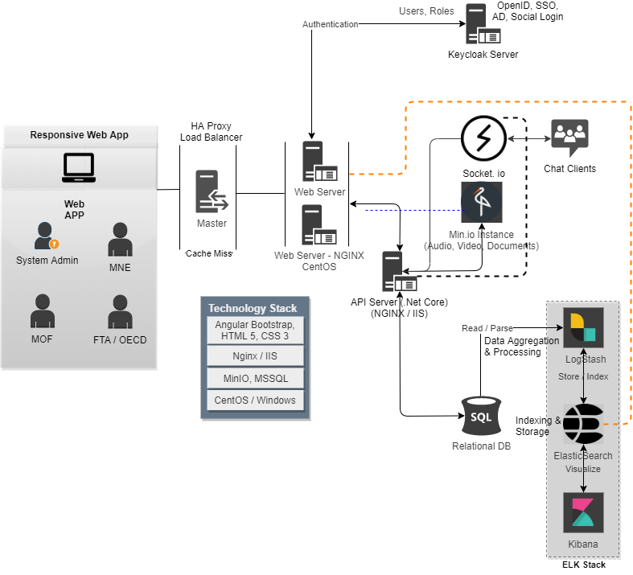

## HIGH LEVEL APPLICATION WORKFLOW

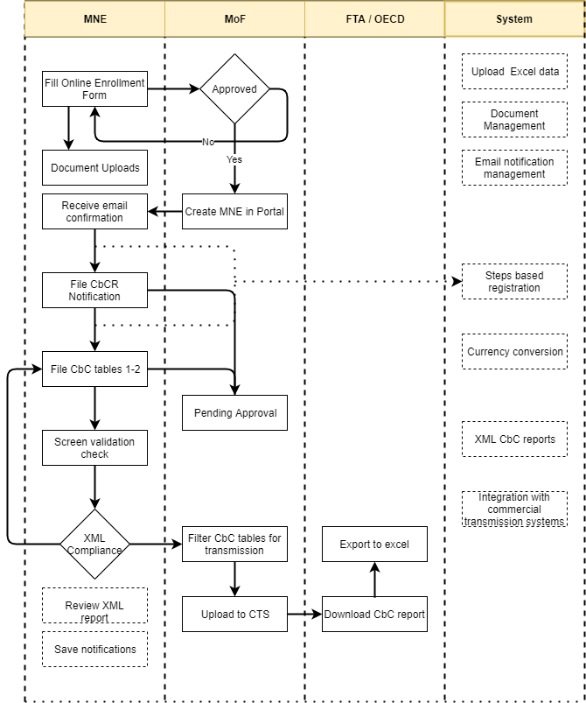

## HIGH LEVEL NETWORK ARCHITECTURE

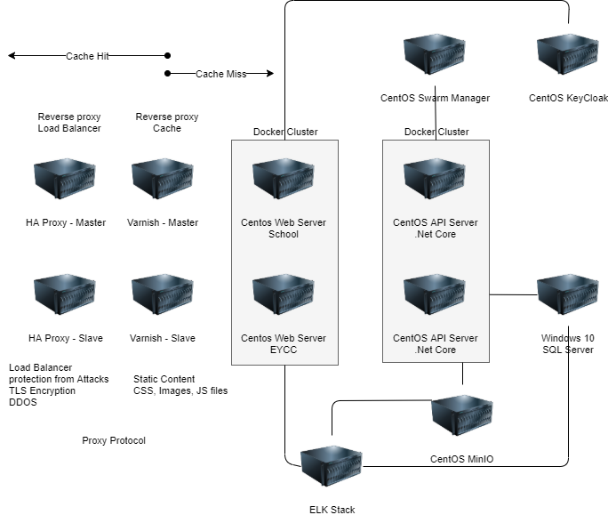

## QA PROCESS FLOW

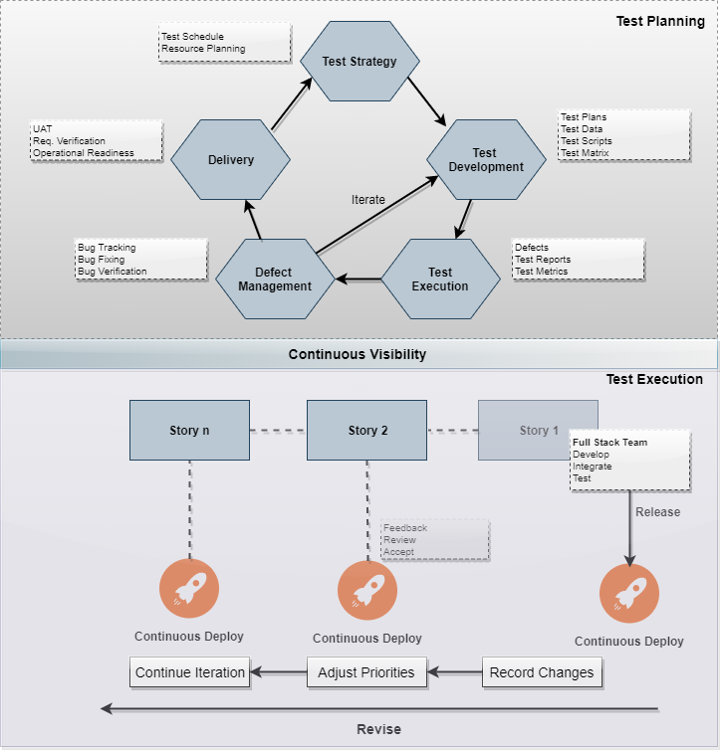

## RELEASE AND DEPLOYMENT PIPELINE

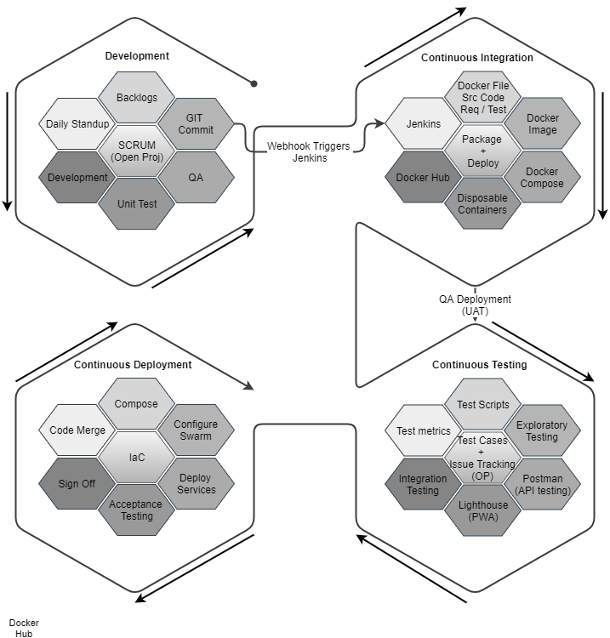

## SECURITY ARCHITECTURE

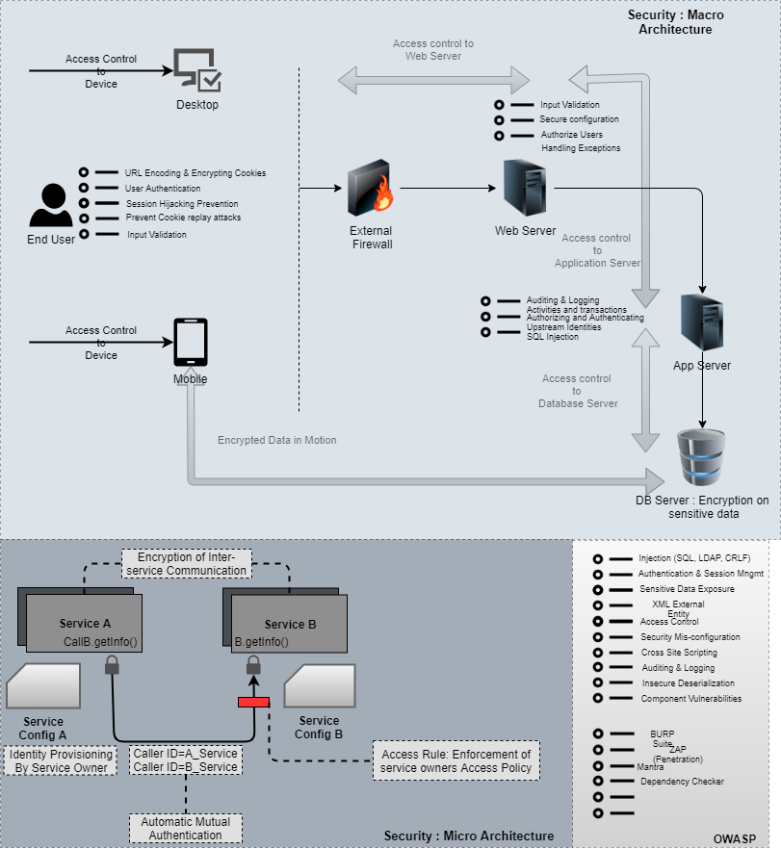

# **CORE APPLICATION DETAILS**

## KEY MODULES

|  |  |
| --- | --- |
| **MODULES** | **DESCRIPTION** |
| MOF | * Reject/Approve submitted form * Store information in CbCR notification data set * View notification filings & do filtering/Search * Review and approve justification document * Export tables to excel |
| System | * Online registration, Steps based registration, cancel registration, edit information * Sign-up, verify with message, upload documents, interface with Federal Tax Authority * Screen Validation(Presence check, Character check, Data type check, Format check, Logic check, Duplication check) * Save progress of registration * Obtain information, Store information on save * Send auto-generated Confirmation mail * Validate customer VAT * Freeze edit after submission of notification * Automatic currency conversion * Generate XML CbC reports * Generate OECD compliant and country-specify XML formats * Integrate with OECD’s commercial transmission system * Exchange CbCR information with other jurisdictions * Compare CbC reports and filed notification of the companies * Accept manually entered CbCR data/uploaded excel data |
| User/Company | * File CbCR notification * Save notification request * Upload document to justify need for change * Access and review XML report * Import CbC report for viewing/editing |

## APPLICATION FEATURES

## TECHNOLOGY DETAILS

### **DEVELOPMENT TOOLS**

* ASP.Net 4.5
* MS SQL
* HTML5 / CSS 3
* Angular
* Web services, Ajax, JavaScript

### **RECOMMENDED WEB HOSTING PACKAGE- DEDICATED HOSTING**

* Operating System : Windows Server
* CPU : 4 core
* Domains: Unlimited
* Disk Space: 200 GB
* Monthly Bandwidth: 50 GB
* Web site Server Software – IIS 7.5 +
* ASP.NET 4.5

### **BROWSER**

* Chrome version: 56
* Firefox version: 51
* Internet Explorer:11
* Safari:13

### **HARDWARE**

The application is reliant on hardware interfaces to provide a seamless automated user experience.

* Computer with Windows 8 or 10 OS
* Compatible Browsers as specified in section 6.2

# **FUNCTIONAL REQUIREMENTS**

The main features and functionalities of the application to be developed are presented below:

## REGISTRATION

* Self-register and subsequently submit filings.
* MoF shall approve or reject a submitted enrolment form.
* The System shall provide facility to perform online registration, change of registration information and deregistration.
* The system shall allow companies to sign-up to the online CbCR services by providing specified information such as Company Name, Company Trade License, Representative, Email, Mobile No.
* The system shall provide the facility to upload documents such as:

- Company Trade License/Incorporation Certificate

- Passport Details of (Partners / Representatives)

* The system shall verify the sign-up by sending a verification message to the provided email.
* The system shall verify the sign-up by providing an interface to the the Federal Tax Authority, that the trade license provided belongs to the company name provided, is registered and not expired.
* The system shall be able to provide a steps based registration upon login made up of different forms asking for information with instructions displayed in-line, such as via a wizard.
* On screen data validation :

1. Presence check (i.e. all of the mandatory information);

2. Allowed character check (e.g. a numerical field contains only one decimal point);

3. Data type check (e.g. a numerical field does not contain alpha characters);

4. Format check (e.g. checks that dates are entered in the correct format);

5. Logic check (e.g. checks that a date entered is within certain parameters); and a

6. Duplication check (i.e. checks that an identical Registration application has not been previously submitted)."

* Option to the companies to Save Progress on the Registration Process and come back to continue the process any time later.
* The system shall obtain the below information during the registration process:

- Status of business (Sole Proprietors / Partnerships / Corporates / etc.)

- Certificate Number / Trade License

- Trading Name (If any)

- Business Contact Details

- Business Activities

- Ask about other business involvements

- Other details

* By Pressing submit, the system shall store the application information and assign a MoF agent to review and verify the application based on a queuing algorithm.

## NOTIFICATION

* The solution shall allow the company to file a CbCR Notification over a web portal.
* The notification function at the end of the form that will send all the information entered to MoF to be stored in the CbCR notification data set.
* MoF users shall view the notification filings and do filtering/searching as marked.
* An auto-generated confirmation email shall be sent to the company filing the notification once the notification has been submitted. The email shall contain the filed data for recordkeeping.
* Validate customer VAT against an external validation service to prevent invalid notification submissions.
* The CbCR notification shall have at a minimum the fields mentioned in the "Notification" tab of the worksheet.
* Companies shall save their notification request in case they decide to fill it later.
* Companies shall edit their information before submitting the notification.
* Companies shall not be able to change any information in the notification after it has been submitted.
* In case change is required in the notification information after submission, the company shall upload a document to justify the need for change.
* MoF shall review the justification document and approve it before the company can edit/resubmit the information.

## CBCR FILING

* The solution shall allow the export of Tables 1, 2, 3 data to Excel for further analysis.
* The solution shall perform automatic currency conversion i.e. upload local amounts and automatically convert to the reporting entity’s functional currency.
* Table 1 shall include at a minimum the fields described in the "Table 1" tab of the worksheet and shall be aligned to the latest OECD schema.
* Table 2 shall include at a minimum the fields described in the "Table 2" tab of the worksheet and shall be aligned to the latest OECD schema.
* Table 3 shall allow companies to provide additional information to clarify the content of the CbCR and shall be aligned to the latest OECD schema.
* Jurisdictions shall be identified using standard two-digit ISO country codes.
* The solution shall allow the upload of Table 1, Table 2 and Table 3 data into the tool by uploading an Excel file.
* Visualization of Table 3 tagging: Table 3 additional information shall easily be tagged to certain Table 1 and Table 2 fields (jurisdiction, financial fields, entity info) using an Excel-like note system;
* The solution shall have analytics, key performance indicators (KPI), and graphs for data from tables 1 and 2 that show the user which jurisdictions need extra attention or clarification to be supplied in Table 3.
* The solution shall be able to compare the companies that filed the notification and the companies that submitted the CbC report to allow for follow up for notifications without matching filings.
* The solution shall accept manually entered CbCR data or uploaded Excel data.
* The solution shall allow the creation of a correction report for an existing CbCR, compare changes to the original report, and generate the correction report in valid CbC XML.
* The solution shall not allow a company to file the CbC report if the notification was not filed.

## DATA AGGREGATION

* The solution shall allow the creation of various versions of the CbC report to compare data year over year or between different data sources.
* The solution shall be able to get data insights to predict risk areas, support value creation, and validate CbC, Master File, and Local file reporting.
* The solution shall be able to perform data collection, calculation and consolidation.
* The solution shall have built-in CbCR data validation and error flagging at multiple steps.
* The solution shall perform sanity checks on the data.
* The solution shall support Microsoft SQL Server as the backend database management system or other databases.
* The solution shall have a risk analysis feature by automatic calculation and visualization of tax ratios.
* The solution shall be able to determine when penalties are imposed on entities based on configurable rules defined by MoF.
* The solution shall automatically allocate tax structures and jurisdictional rules while maintaining quality control for precise CbC reporting.

## CONVERSION

* The solution shall automatically generate valid XML CbC reports.
* A company user can access and review actual XML report.
* The solution shall generate OECD compliant and country-specific XML formats.
* The solution shall allow a user to import a CbC report that was received in XML from another source for viewing and/or editing.
* An electronic template using extensible mark-up language (an XML schema) shall be available to facilitate the electronic preparation, filing and exchange of CbCR.

## INFORMATION EXCHANGE

* The solution may have FATCA capabilities (a plus to have).
* The solution may have CSR capabilities (a plus to have).
* The solution shall provide up-to-date and customized global BEPS research information such as local legislative rules, timings and CbC, Master File and Local File data requirements.
* The solution shall easily be able to exchange CbCR information with other jurisdictions.
* The solution shall integrate with OECD's Commercial Transmission System.

## GENERAL DESCRIPTION

|  |  |
| --- | --- |
| **PROCESS** | **DESCRIPTION** |
| Registration | The process by which Multi-National Entities “MNE” sign-up and create an account to be able to file their CbCR notification and report. |
| Filing CbCR notification | The process by which MNEs file their CbCR notification which is a year before submitting the report. |
| Filing CbCR report | The process by which MNEs submit their CbCR filing with information in the required CbCR tables. |
| CbCR aggregation and validation | The process by which the system aggregates the CbCR data and validates its compliance. |
| Reporting | The process by which MoF can generate reports to meet its business requirements |
| Conversion to XML | The process by which the report is converted to XML for data exchange |
| Information exchange | The process by which MoF submits the CbCR report to international authorities / regulators. |

## OTHER REQUIRMENTS

|  |  |  |  |
| --- | --- | --- | --- |
| **S.No** | **Field Name** | **Data Type** | **Description** |
| 1 | Group Name | Alphanumeric | Name of the group that is generally used |
| 2 | Name of the Group’s Ultimate Parent Entity “UPE” | Alphanumeric | Name of the Group UPE |
| 3 | Group UPE Jurisdiction | Enumerated | This is a full list of country jurisdictions to select from. |
| 4 | Group UPE Address | Alphanumeric | The address / city where the Group UPE resides |
| 5.1 | Group UPE Identification Type | Enumerated | The type of ID that the Group UPE uses and that could be:  1. Tax ID No.  2. VAT ID No.  3. Trade License No.  4. None |
| 5.2 | * Group UPE Tax Number * Group UPE VAT number * Group UPE Trade License Number * None | * Numeric * Numeric * Alphanumeric * Text | A company should fill in the field based on the drop down option they selected in field |
| 6 | Reporting Entity Type | Enumerated | The company filing CbCR on behalf of the UPE |
| 7 | Reporting Entity Name | Alphanumeric | The name of the reporting entity |
| 8 | Reporting Entity Jurisdiction | Enumerated | This is a full list of country jurisdictions to select from. |
| 9 | Reporting Entity Address | Alphanumeric | The address / city where the reporting entity resides |
| 10.1 | Reporting Parent Entity Identification Type | Enumerated | The type of ID that the UPE uses and that could be:  - Tax ID No.  - VAT ID No.  - Trade License No.  - None |
| 10.2 | *  Entity Tax Identification Number * Entity VAT number * Entity Trade License Number * None | * Numeric * Alphanumeric * Numeric * Text | A company should fill in the field based on the drop down option they selected in field |
| 11 | Reporting period | Date | The period for where the CbCR will be filed |
| 12.1 | Constituent Entity Name | Alphanumeric | The name of the constituent entity |
| 12.2 | Constituent Parent Entity Identification Type | Enumerated | The type of ID that the UPE uses and that could be:   * Tax ID No. * VAT ID No. * Trade License No. * None |
| 12.3 | -Entity Tax Identification Number  - Entity VAT number  - Entity Trade License Number  - None | * Numeric * Alphanumeric * Numeric * Text | A company should fill in the field based on the drop down option they selected in field |
| 13 | Name of UAE entity filing | Alphanumeric | The name of the entity filing the CbC report in the UAE. |
| 14.1 | UAE Entity Filing CbCR Identification Type | Enumerated | The type of ID that the UPE uses and that could be:  - Tax ID No.  - VAT ID No.  - Trade License No.  - None |
| 14.2 | Entity Tax Identification Number   * Entity VAT number * Entity Trade License Number * None | * Numeric * Alphanumeric * Numeric * Text | A company should fill in the field based on the drop down option they selected in field |
| 15 | Name of contact person | Character | Name of the contact person from the Entity |
| 16 | Email address | Alphanumeric | Email of the contact person from the Entity |
| 17 | Phone Number | Number | Phone number of the contact person from the Entity |

# **NON-FUNCTIONAL REQUIREMENT (OTHERS)**

|  |  |
| --- | --- |
| **Requirements** | **Details** |
| User Experience and  UI Design | * The application will be developed only in English * The layout and graphical components will be created considering the usability factors |
| Performance | * Application will allow users to have smooth and quick access to the information or services they require. * The solution shall be scalable to handle heavy usage and peak periods e.g. Expected number of CbCR notifications: 2,000 notifications and filings per calendar year. * The system shall allow upload of files (maximum size 5 MB) to be received electronically. * The solution must be accessible over the internet. * The solution shall be accessible to MoF users both onsite and remotely. * Verbat shall conduct performance and load tests on the solution. |
| Security | * Web security standards will be followed. * Any test or development data that are required on non-production environments shall be masked by the copy scripts. * The solution login mechanism shall support UAE Pass or Smart Pass external login mechanisms. * The solution shall use secure connections (HTTPS) in all its communications. * The solution shall securely store a log of all staff actions and filings. * The solution shall allow only certain MoF users to be able to view the filed forms. * Verbat is ISO 27001:2013 certified. * All Personally Identifiable Information included in submissions, for example during the notification filing, should ensure data protection and privacy of personal information according to NESA & ISO 27000:2013. * The vendor shall provide evidence that sufficient testing has been applied to guard against the presence of malicious contents within application. * The vendor shall provide evidence that sufficient testing has been applied to guard against the presence of known vulnerabilities. |
| Flexibility | * The solution shall be flexible to add modules to address specific local nuances e.g. changes in the notification template, changes in CbCR fields, etc. * The solution hosted on the MoF website shall comply with all guidelines standards as set forth by MoF Strategy and Government Communications department. |
| Infrastructure | * The solution shall be available to end users over the internet through the MoF website. * The solution shall be hosted entirely on premise on designated MoF Data Centers. * The solution shall perform daily backups to avoid data loss. * The solution shall be highly available and fault tolerant. * The solution shall store CbCR notifications up to a period of at least 5 years. * The solution shall be configured and implemented with high availability. * Verbat shall include all the necessary server (virtual and physical) requirements for storage devices and associated infrastructure to run all environments. * Verbat shall include requirements for all supporting systems such as Operating Systems, Application Servers, Databases and monitoring tools across all environments. * The solution shall provide as minimum environments: development, testing, and production. * The solution shall be compatible with VMware vSphere containerization |
| Migration | * This includes the migration of the existing CbCR notifications to the target system. |
| Integration | * The solution shall integrate with the external entities required for CbCR such as the Commercial Transmission System “CTS” which is operated by the OECD. * The solution shall easily be able to exchange CbCR information with other jurisdictions via XML. * The solution shall be able to integrate its functions via a documented API. |
| Usability | * The solution shall be easy to use by the end users including MNEs and MoF staff. * The solution shall use descriptive error messages to inform users where errors have occurred and how to correct them. * The system shall have the minimal number of screens the user needs to navigate through for completing an action. Screens shall allow the user to complete the work without excessive scrolling. The system shall be able to define read only fields at runtime. * The system shall ensure that all reports are printable in pdf and MS excel. |
| Audit Trails | * The system shall be capable of generating audit trails which include details such as who inserted, changed, or deleted the data, the prior value, the new value, the type of change (insert, delete, or update), the date and time of the change as well as a reference to the record being changed ( a snapshot before and after the change). * The system shall not allow any modifications to the audit trail. * The system shall have the capability to display the audit trail for an action. * The system shall ensure that audit trail records are maintained for at least as long as the retention of the underlying records. * The system shall allow logging and reviewing of all system administrator actions. * The system shall record the attempts to change the master data. * The system shall be able to control access to audit logs. |

## PROPOSED SYSTEM ENVIRONMENT

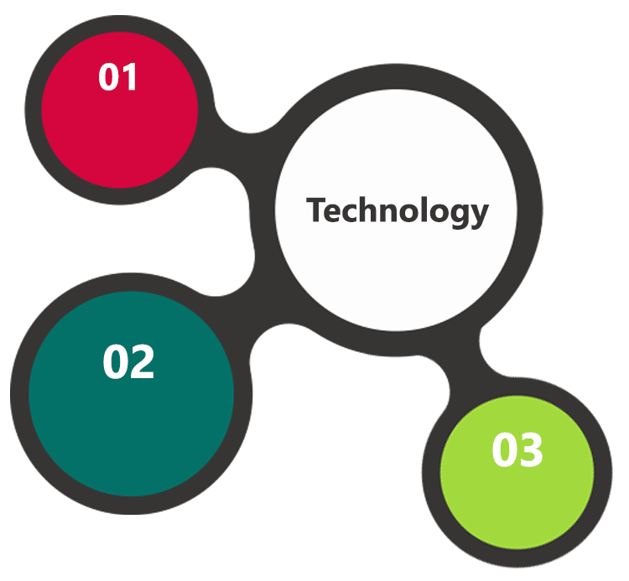

.Net Core, MVC

Angular

HTML5 / CSS3

Java Script

Windows

IIS

MS SQL

**MS SQL2012  
Windows 8/10  
Web Services**

# **OUT OF SCOPE**

With the ever evolving digital market, the requirement should be clear to both the parties involved, hence the importance of mentioning the out of scope details of the project. Following are considered to be out of scope while creating this proposal:

* Purchase of images, fonts
* Any language other than English
* Migration of existing data / Database migration
* Content writing / proof reading / Data Replication / Manual data entry
* Content or image procurement or uploading or editing
* End user testing and load testing
* Developer account creation and Maintenance (Play Store)
* Adding new features to the application other than mentioned in the functional specifications. Such requests will be handled via change management. *For Change management details, please refer section titled “Change Management” in the*
* Annual Maintenance Contract (Bug fixing, debugging, enhancements) – Please refer section titled “Maintenance and Support”, unless contracted for.(refer to section 4.2)
* Hosting Infrastructure and Maintenance (web and email hosting), unless contracted for.
* Application Deployment on the server and respective stores, unless contracted for.
* Backup solution and Disaster recovery unless contracted for.
* Physical deployment onsite / installation of the application in devices and Physical connection, installation of system.
* Integration with third-party, if any, other than mentioned in the functional specifications
* Hardware Integrations / procurement and purchase
* Procurement of SMS gateway / payment gateway / email gateway
* SSL Purchase and installation, if any
* Plugin/template purchases, if any
* OS other than mentioned in the Hardware Interface
* Relevant / related software libraries

## CHANGE MANAGEMENT

Any addition which comes out of the project scope, upon and after the launch of the application will be considered as change management. Verbat recommends the following change management procedure for the same.

* Any change which comes out of the project scope, which was discussed, documented, and mutually approved by both the parties in the requirement stage, will be carried out only through raising a change request.
* Change request will be studied and an impact analysis on the existing work flow will be performed.
* On finalizing the impact, effort estimation for the change will be calculated and raised as additional requirement.
* Verbat will initiate the change request only after getting a formal approval from the client for the additional changes raised.
* Any change from the scope will be charged at AED 1,200.00 per man day effort and approval from the clients will be availed before commencing on any change management.

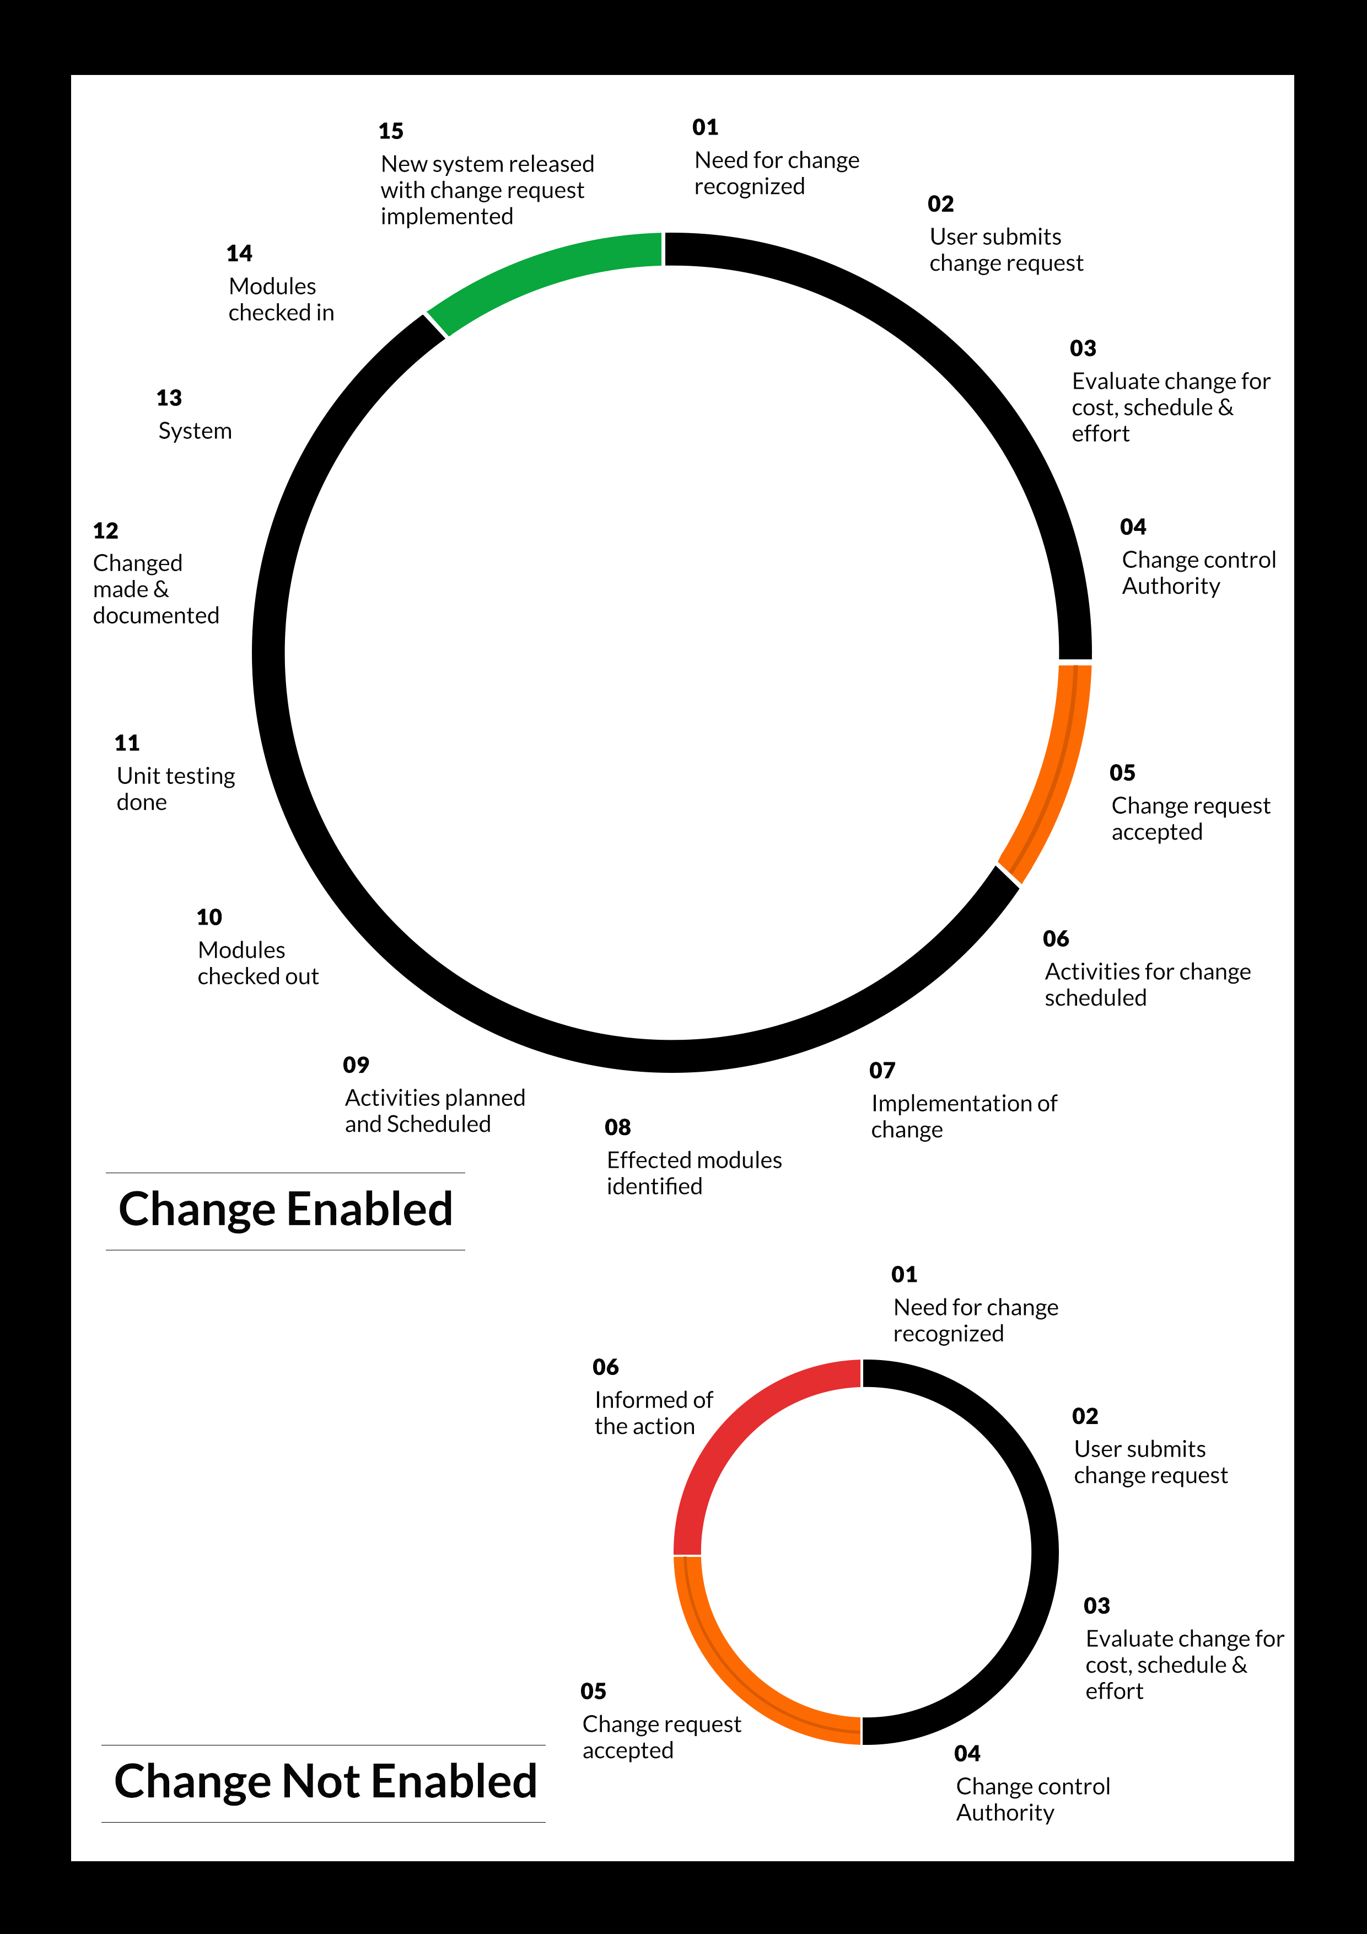

# **TERMS & CONDITIONS**

## ACCEPTANCE CRITERIA

* UAT (User Acceptance Test) sign off should happen within 07 Days from the first release of the application and the acceptance confirmation needs to be mailed to Verbat failing which Verbat will consider the project as approved by the client.
* Any comments or reason for rejection need to be documented and the same needs to be sent as an email from the official mail id of client to Verbat on or before 07 days from the first release.
* Timeframe for acceptance for any further release will be mutually agreed and finalized between client and Verbat depending on the UAT Comments

## WARRANTY

* Verbat shall provide a bug ﬁx warranty at no additional cost for 30 days from the date of acceptance of the project, for correction of any errors in the developed application that may be attributed to Verbat.
* However, this does not cover modifications by Client, or use of the application on an environment other than the proposed environment, or other circumstances outside Verbat’s reasonable control. In such a case Verbat reserves the right to charge for its services.
* All error corrections will be executed at Verbat India office. In the event of any need for on-site work, all expenses incurred for such trips will be payable to Verbat by Client.

## SOURCE CODE & INTELLECTUAL PROPERTY RIGHTS

* Upon completion of the Project and 100% completion of the payment, client will have access to the source code except for propriety codes, developer tools and third party applications etc.
* The solution offered will be the intellectual property of the client and will be made available to the client on an “unlimited license” basis.
* Modifications by third party/person: No person or organization, other than Verbat or any person authorized by Verbat in writing, has any permission to modify/change the software Solution to be eligible to get continued support from Verbat as per the support terms defined under this document.
* Liabilities/Damages: Verbat accepts no liability or damages of any kind arising out of use or non-use of the software delivered. The responsibility of testing of software lies with Client.

## GENERAL TERMS AND CONDITIONS

* Offer Valid for 120 calendar days from the date of submission of the Proposal.
* An average of 20 working days are assumed in a month.
* All the projects activities will be carried out from our off-shore development center in India
* All the documentation will be provided in English.
* Third party components may be used to develop this application.
* The scope of the project is to develop the Application as detailed in the scope of the project and mentioned in this proposal. Any changes or additions will have to go through change management.
* This proposal would have been derived or concluded from either the RFQ /RFP/data shared via email / information transferred during an initial requirement analysis meeting / tele-conversation. Verbat reserves the right to change the terms of this proposal as the final terms (including the costing), features & functionalities and timeline could change during the course of the project. Hence any fees quoted / timeline committed in this proposal may not be considered as final unless agreed and signed by both parties.
* Web Application will be best viewed only in the environment mentioned in the section Browser Compatibility
* All Source Codes and other project artefacts would adhere to the Verbat document templates and internal coding standards.
* The documents delivered to the client includes the ones mentioned under ‘Deliverables’ and these will adhere to Verbat’s internal document standards.
* Acceptance criteria shall be based on the clauses which were mutually discussed between Verbat and client at the Requirement Analysis phase and the same will be documented and approved by both parties through official emails
* In case Client requires any extension of the proposed acceptance schedule, the associated effort and cost of such extension can be mutually reviewed.
* For any circumstances if project needs to be put on Hold / Stop it requires minimum request notice period of 1 week along with duration for which request will be addressed by management and final decision on the request will be based on that
* If deployment is done in client’s server, Verbat cannot be held responsible for any performance issues arising due to hardware malfunctions.
* Client is responsible for data backup in case the application is not hosted on Verbat server.
* Source code will only be delivered or uploaded on the Production Server once the due payments are made.

## GENERAL ADMINISTRATIVE, TECHNICAL & FUNCTIONAL ASSUMPTIONS

* Detailed system study is required before the start of the project.
* During the requirement gathering phase, authorized personnel from the Client’s side is expected to be available for discussion and finalizing the HLD (High Level Design), before development commences.
* Type of reports and formats, if under the scope of the project, needs to be specified by Client before project sign off.
* Workflows if under the scope of the project, need to be specified/ confirmed by client before project signoff.
* Verbat assumes that all sign-offs from Client will be provided within agreed and specified timeframe.
* Client will provide all the necessary contents, both text and image, before starting the project in the format suggested by Verbat (if any).
* The client should provide the relevant information and data well in time for the execution of a related activity. Non- availability of this information or data may lead to an interruption of work which may result in a delay in delivery as well as additional costs to the client.
* Client should have/possess server with technical specifications as suggested by Verbat for the proposed application.
* Client will be provided with one time training (train the trainer) on how to use the application via video conference (maximum of 4 hours). Additional training requests will be charged.

# **FINANCIALS**

## WEB APPLICATION DEVELOPMENT

|  |  |  |
| --- | --- | --- |
| **No** | **Description** | **Amount (AED)** |
| 01. | Development of:   * Web Application |  |
|  | **Total Project Cost** |  |

*Note:*

* *The above cost is exclusive of VAT applicable in UAE*
* *The above cost is based on the initial understanding of the requirement grounded on the details shared by client. Any further changes in the scope or complexity if encountered during detailed system study/ analysis will call in for additional effort and time.*
* *The above cost does not include Application hosting, integration with any other third-party systems, deployment unless explicitly mentioned in this proposal.*
* *For feature additions, please refer section titled “Change Management “.*
* *LPO to be raised in the name of “Verbanet Technologies LLC” for project initiation*
* *Refer section 7.3 for ‘Mode of Payment’.*

### **PAYMENT TERMS**

* 30% () of total project value to be paid as advance along with the Purchase Order
* 40% () of total project value to be paid on confirmation of the UI/UX
* 30% () of the total project value to be paid on completion of Development and UAT on Verbat test server

*Note:*

*Payment should be made within 7 days from the date of invoice.*

## WINDOWS DEDICATED HOSTING – OPTIONAL

ITEM NO. DECSRIPTION AMOUNT (AED)

1. Windows Dedicated Hosting

TOTAL PROJECT COST

*Note:*

* *The above cost is exclusive of VAT applicable in UAE*
* *Refer “Windows Dedicated Hosting Proposal” for detailed Server specifications.*
* *Refer section 7.3 for ‘Mode of Payment’.*
* *LPO to be raised in the name of “Verbanet Technologies LLC” for project initiation*

### **PAYMENT TERMS**

* 100% advance payment along with Purchase Order to initiate Server purchase

*Note:*

*Payment should be made within 7 days from the date of invoice.*

### **MODE OF PAYMENT**

By Cheque to Verbanet Technologies LLC

OR

Wire transfer to our bank account

Bank Name : Emirates NBD

Account Name : Verbanet Technologies LLC

Account Number : 1011492858201

IBAN Number : AE61 0260 0010 1149 2858 201

Swift Code : EBILAEAD

Bank Address : Mamzar Branch, Dubai

*Note:*

* *Bank charges incurred during wire transfer to be borne by the client.*
* *Any local taxes / VAT applicable to be borne by the client*
* *Client invoices will include VAT charges in addition to the application cost*

# **ABOUT US**

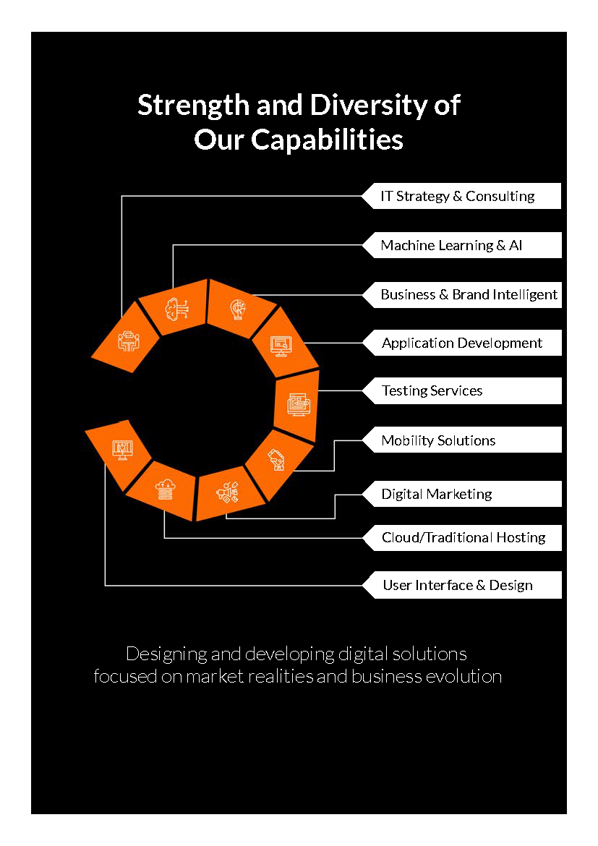

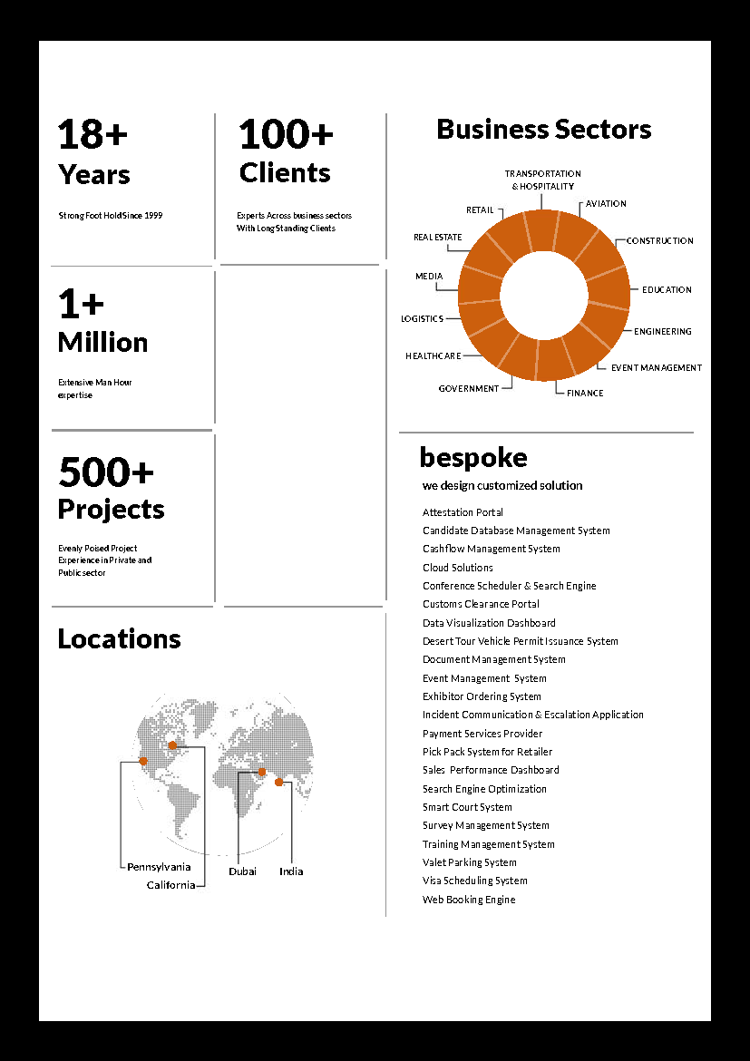

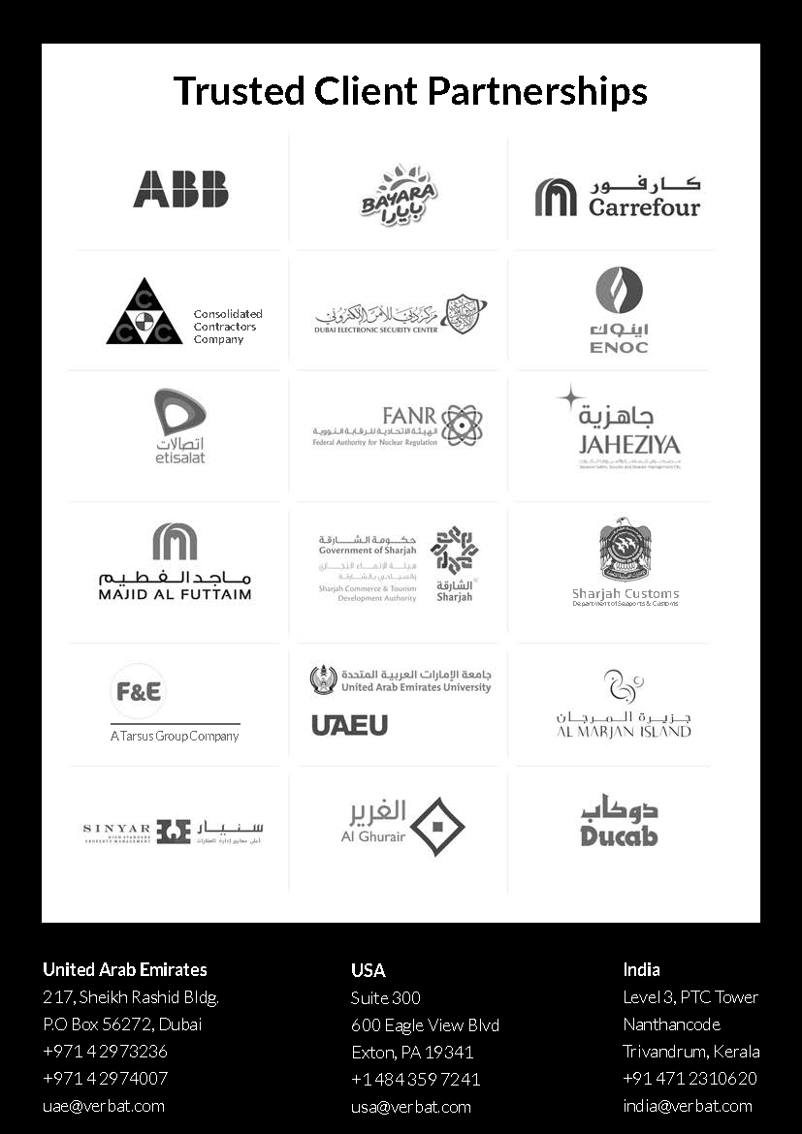

**Conﬁdentiality Notice:**

**This Proposal is conﬁdential and contains proprietary information and intellectual property of Verbanet Technologies LLC. Neither this proposal nor any of the information contained herein may be reproduced or disclosed under any circumstances without the express written permission of Verbanet Technologies L.L.C (hereby known under its brand name of Verbat in the United Arab Emirates). 2018. All rights Reserved**