Verbat Technologies

Floor 3, PTC Towers

YMR Jn., Nanthancode

Trivandrum.

Tel: +91 471 6003295

Email: Prashant.thomas@Verbat.com

PROJECT   
PROPOSAL

**Club Manager-2 Application Development**

|  |  |
| --- | --- |
| **Prepared for:**  Ashwin**. A ECS**  Mob: 956-718-0163  Email: ashwin.a@ecstvm.in | **Submission Date:**  30st Aug 2017  **Proposal ID:** WA/VT/30082017/1 |

___________________________________________________________________________________________________________________________________________  
Conﬁdentiality Notice: This Proposal is conﬁdential and contains proprietary information and intellectual property of Verbat. Neither this proposal nor any of the information contained herein may be reproduced or disclosed under any circumstances without the express written permission of Verbat.

© 2017 by Verbat Technologies (India) Pvt. Ltd. All rights reserved. Confidential.

___________________________________________________________________________________________________________________________________________

Project Contacts

|  |  |
| --- | --- |
| Client Information | |
| Project Name | Club Management Application |
| Client Name | ECS |
| Client Address | Vasudha, Thenmala Rd, Kawdiar, TVPM |
| Phone Number | 91-471-2439349 |
| Contact Person | Ashwin.A |
| Contact Person Email | ashwin.a@ecstvm.in |
| Contact Person Phone Number | 956-718-0163 |
| Verbat Information | |
| Contact Person | Prashant Thomas |
| Contact Person Phone Number | +91 471-6003295 |
| Contact Person E-Mail | Prashant.thomas@verbat.com |
| Address | Verbat Technologies  Floor 3, PTC Towers  YMR Jn., Nanthancode  Trivandrum. |
| Project Information | |
| Proposed Technology/Methodology | Web Based Application Development |
| Anticipate Start Date | NA |
| Proposal Valid For | 15 Calendar days from the submission of the proposal |

**Table of Content**

1 Introduction 4

1.1 Project Overview 4

1.1.1 Member Management 4

1.1.2 Master Data Management 5

1.1.3 Property Setup 7

1.1.4 Prototypes 7

2 Technology Solution 9

2.1.1 Web Hosting 9

2.1.2 Browser Compatibility for Web Admin 10

3 Assumptions 11

4 Out of Scope 11

5 Project Effort & Timeline 12

5.1 Effort 12

6 Commercial 13

7 Payment Terms 14

8 Miscellaneous 15

8.1 Acceptance Criteria 15

8.2 General Terms and Conditions 15

8.3 Dependencies 16

# Introduction

**Verbat is pleased to submit this proposal for developing a partial web application and prototype of the Club Manager-2.**

The application will have the following functional modules

1. Master Data Management
2. Member management
3. Property (Club) Setup

Verbat will also develop working (Basic) prototypes of the following modules

1. Reservations & Bookings
2. Accounting
3. Member Billing

## Project Overview

Verbat is a team of Digital Technology experts including consultants, web developers, graphic designers, programmers, marketing and SEO experts. Our specialty is creating modern, interactive, responsive, Custom Applications. **The project is to design and develop a Responsive Web Application with the following features**

### Member Management

|  |
| --- |
| **Member Attributes** |
| Membership |
| Membership type (Family, individual, corporate) |
| membership Expiry date |
| Basic information (name, address, DOB, Mob, Off, email, citizenship etc.) |
| Membership tier (Platinum, silver, gold etc.) |
| Allergies |
| Seniority level (calculated based on formula) |
| VIP Status (Politician, high net worth, Frequent guest) |
| membership renewal date |
| Family (names, ages, sex, family status etc.) |
| membership status |
| DOJ |
| **Reservations and Bookings** |
| Room type preference (size and features wise) |
| Concierge service requirements |
| Bed type preference |
| Reservation history |
| Booking history |
| **Accounting** |
| Dues Status |
| Payment due date |
| Pending Dues |
| Payment period (Annual, quarterly, monthly etc.) |
| Life time credit acquired |
| Member credit limit |
| Credit available |
| View Discounts available |
| Points received |
| Points Availed |
| **Member Functions** |
| Update various personal attributes |
| Membership payment |
| Room Reservation (Select Room: room type, beds, adults, children etc.) |
| Apply for discounts |
| Restaurant reservations( seat preference, Food preference, drinking preference, Guest size, pre order ) |
| Add referrals |
| **Management Functions** |
| Revoke Membership |
| Upgrade/Downgrade Member Tier |
| Add Work Order (KOT) |
| Search Members |
| Update member attributes |

### Master Data Management

|  |
| --- |
| **Membership** |
| Membership Tier (platinum, Gold, Silver, Bronze, Guest) |
| Food preference (Veg, Non Veg, Jain, Vegan) |
| Dining areas ( names of restaurants) |
| Payment Cycles ( Yearly, Quarterly, Monthly) |
| Membership Types (Family, Individual, corporate) |
| Corporate membership Type (Access levels & privileges) |
| Allergies |
| Religion (Hindu, Christian, Muslim, Jew etc.) |
| VIP Status (Politician: Active, inactive; High Net worth, artist, Frequent guest etc.) |
| Drinking Preferences (Fresh juice, vodka, whisky etc. or Alcoholic /nonalcoholic) |
| Dues collection preference (manual, Automated/recurring) |
| Currencies |
| Identity Type (Aadhar, PAN, DL, Passport, Visa) |
| Payment Methods( Bank, credit, debit) |
| **Bookings And reservations** |
| Room types |
| Room features |
| Concierge services |
| Bed types |
| Other Unique club features |
| Club features |
| Feature charges |
| Reservation and bookings |
| Reservation settings (On hold, Confirmed etc.) |
| Room Tariffs |
| Room discounts (corporate vs. Individual/family) |
| Room Amenities |
| Applicable taxes |
| Room status(Dirty/clean/Work Order) |
| Seasons & Seasonal rates |
| Transportation requirements(tickets, taxi standby, on call, Tour assistance) |
| Pickup requirements(airport/bus/train) |
| Reservation type (enquiry, hold, reserve etc.) |
| Room Revenue types (Late checkout, cancellation, no show, room rate) |
| **Accounting** |
| Taxes |
| Arbitrary charges |
| Payment processing |
| KOT Types (Bar, Restaurant, Shops, concierge, room service, Internet café, Gym) |
| POS |
| Holiday list |

### Property Setup

|  |
| --- |
| **property setup** |
| Description |
| facilities & attractions |
| checking policy |
| hotel policy |
| travel directions |
| cancellation policy |
| things to-do |
| parking details |
| children & extra guest policy |
| hotel description |
| booking conditions |
| important landmarks |
| Booking details displayed on confirmation (start-end dates, no of nights, names, no of rooms, rate plan, price etc.) |
| Images |
| Amenities( room wise based on room type) |
| bulk amenities (hotel wide) |
| **Manage Rooms** |
| room types, bed types |
| rate types |
| Rate plan (queen, king, king with breakfast etc.) |
| Images |
| reservation type |
| Manage house keepers |

### Prototypes

|  |
| --- |
| **Reservation & Bookings** |
| Guest information (Name, Address, Country) |
| Stay Information (Room type, room, no, services: room, room + breakfast etc.) |
| Additional details( Arrival, departure, nights, adult + child count, reservation Type) |
| Contact Info(email, Phone, Mobile, fax) |
| Others( Identity type, identity, nationality, gender, VIP status) |
| Allergies |
| Billing Information( rates: contract, normal, manual; bill to: company, group owner, guest; tax exempt ID; Payment mode: Cash, credit, debit) |
| Room features (bed types, A/C, Tub, Concierge services, room types etc.) |
| back office functions ( Reservation list, arrival list, departure list, release reservation, hold reservation, pending reservations, cancelled reservations, room status: FD remarks, House keeper remarks house keeper assigned, unsettled folios) |
| Room tariffs |
| KOT: Arbitrary Charges( Voucher no, Tax, description) |
| Payments(Type, amount, voucher no, comment) |
| Voucher details( Voucher .no, prepared by, type, payment method , date) |
| Charges( Type, amount, voucher no, comment) |
| Work Orders(order no, description, room #,category(maintenance, repair, clean),block from-to, priority, assign to, status (assigned, completed, pending), deadline) |
| Reservation report(No show, Released reservations, checked in), guest list |
| **Accounting** |
| Numbering formats (GL Ref No, Sales invoice, AR transaction no, sales order no, vendor invoice, AP transaction no, sales quotation no, RFQ no, part no, employees no, customer no, vendor no) |
| Year end |
| Admin Users |
| Chart of accounts |
| Departments |
| Types of business |
| Create Users |
| User Permissions( create a/c, AP All, AP vouchers, AP create invoice voucher, AP Transaction create Voucher, AR all, AR create Invoice, AR transaction create voucher, assembly stock, assets admin) |
| Definition of parts |
| Definition of part groups |
| Definition of assemblies ( for menu) |
| Part information |
| Vendor information |
| Customer information |
| Definition of services |
| Tax account definitions |
| Accounts receivable |
| Invoices |
| Payments |
| Vouchers |
| Raise invoices |
| Billing Statement |
| **Member Billing** |
| Create KOT |
| Edit KOT |
| Cancel KOT |
| KOT audit trail |
| KOT Pre execution mode |
| KOT Confirmed |
| POS receipt |

# Technology Solution

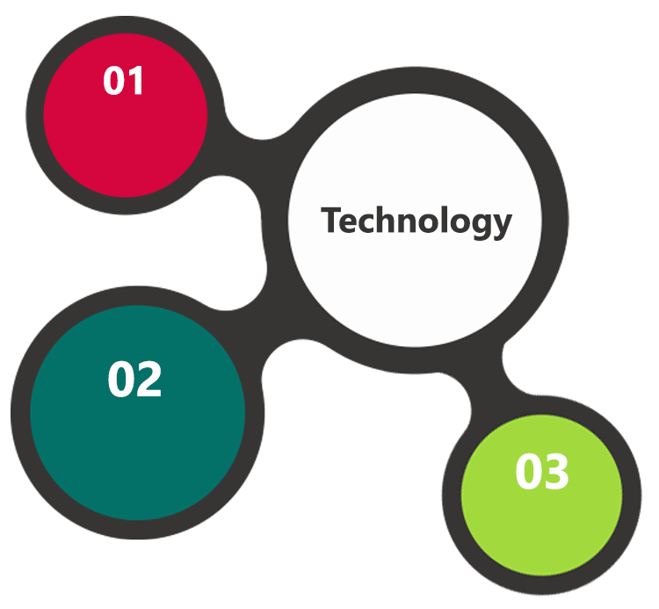

C#, MVC, .Net 4.5

ASP.Net  
IIS  
MSSQL DB

HTML 5  
JavaScript  
CSS 3

### Web Hosting

We have tie up with a renowned data center in India and can

* Guarantee 99.9% uptime.
* Have strong security features
* Provide detailed visitor statistics
* Respond quickly to support requests.

### Browser Compatibility for Web Admin

* Chrome version: 56
* Firefox version: 51

# Assumptions

The proposed solution is based on the following assumptions to be read along with the General Terms & Conditions mentioned in this document

* Branding of the application shall be provided by the client
* Client shall provide licensed images and logos in specified size & format
* Client shall provide further clarifications on product scope
* Client shall provide the required business domain support
* Client shall provide required screen shots of the existing “Club Manager” application
* The application shall be developed based on a theme selected by the client and customization shall be limited to what can be accommodated by the theme
* Client shall provide the hosting infrastructure required as suggested by Verbat and shall provide the required support needed for deployment
* Verbat shall deploy the application on the hosting infrastructure provided by client

# Out of Scope

Following are considered to be out of scope while creating this proposal.

* Purchase of images, fonts
* Procuring Payment gateway service
* Any language other than English
* Integration with any other systems
* Web hosting
* Disaster recovery for web hosting
* Annual Maintenance Contract

# Project Effort & Timeline

## Effort

The effort estimated for delivering the design and the prototype of the partial web application is **08 days** and the fully developed partial Web application is **52 days.** In total, **60 Indian working days.**

The effort estimated for developing the prototyping of other modules is **31** Indian working days

*The partially developed web application and prototyped modules shall be delivered together.*

# Commercial

**Responsive Web Application Development**

|  |  |
| --- | --- |
| **Description** | **Cost (INR)** |
| Design and Develop Partial web application | 5,53,350.00 |
| Prototyping of modules | 1,71,650.00 |
| Total (Rupees Seven Lakh Twenty Five Thousand Only)* | 7,25,000.00 |

*- Excluding taxes. Taxes are applicable as per GST. Client shall provide their GST Number for availing the credits.

# Payment Terms

* 20% of total project value to be paid as advance along with the purchase order
* 30% of total project value to be paid on confirmation of the Design & prototype of the partial web application
* 20% of the total project value on completion of the remaining prototyping modules
* 25% of the total project value to be paid on completion of development of partial web application and UAT Confirmation
* 5% of the total project value to be paid before going Live

# Change Management

Any addition which comes out of the project scope, upon and after the launch of the tool will be considered as change management. Verbat recommends the following change management procedure for the same.

* Any change which comes out of the project scope, which was discussed, documented, and mutually approved by both the parties in the requirement stage, will be carried out only through raising a change request.
* Change request will be studied and an impact analysis on the existing work flow will be performed.
* On finalizing the impact, effort estimation for the change will be calculated and raised as additional requirement.
* Verbat will initiate the change request only after getting a formal approval from the client for the additional changes raised.
* Any change from the scope will be charged at **INR 6,000 per man day effort** and approval from the clients will be availed before commencing on any change management.

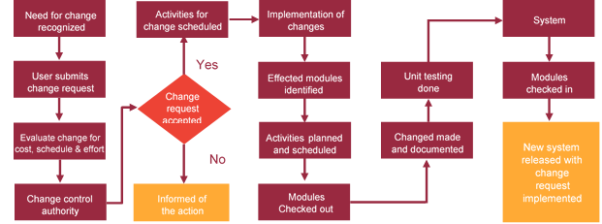

# Miscellaneous

## Acceptance Criteria

* UAT sign off should happen within 7 Days from the release and the acceptance confirmation needs to be mailed to Verbat failing which Verbat will consider the project as approved by the client.
* Any comments or reason for rejection need to be documented and the same needs to be sent as an email from the official mail id of client to Verbat.

## General Terms and Conditions

* Offer Valid for 15 calendar days from the date of submission of the Proposal
* An average of 20 working days are assumed in a month
* Verbat reserves the right to amend the terms of this proposal, should the SOW terms, functional features and functionalities change during the course of the project
* **The web application shall be built on the agreed use-case, wireframe. Any customization to the confirmed and purchased theme shall be executed through a defined change management process between both parties**
* All Source Code and other project artefacts would adhere to the Verbat document templates and internal coding standards
* Acceptance criteria shall be based on the clauses which were mutually discussed between Verbat and client at the Requirement Analysis phase and the same will be documented and approved by both parties through official emails
* Final deployment to production server pursuant to completion of all payments
* Verbat shall provide a bug ﬁx warranty at no additional cost for 30 days from the date of acceptance of the project, for correction of any errors in the developed application that may be attributed to Verbat
* If deployment is at the client’s server, responsibility of deploying the delivered built or any other interim releases onto the production environment after conducting the necessary acceptance testing will lie with Verbat unless otherwise agreed. However any support services shall be contracted separately for deployment.
* Verbat shall not be held responsible for any non-performance of the application if in case the Web application is hosted on the clients environment

## Dependencies

* During the requirement gathering phase, authorized personnel from the Client’s side is expected to be available for discussion and finalizing the HLD (High Level Design), before development commences
* All queries regarding the client requirement and any queries which may hinder the project advancement at any stage should be answered by the client within 24 hours from the time of initiation, failing which the time delay will get added to the actual effort which was estimated
* Verbat assumes that all sign-offs from Client will be provided within agreed and specified timeframe.
* Client will provide all the necessary contents, both text and image, before starting the project in the format suggested by Verbat
* The client should provide the relevant information and data well in time for the execution of a related activity. Non- availability of this information or data may lead to an interruption of work which may result in a delay in delivery as well as additional costs to the client

**Sharjah Customs**

**UAE University**

Transportation

**Canada Cartage**

Construction

Services

We look forward to hearing from you soon and hope that you will give us the privilege to work with you in meeting your business goals. Thank you.

©   
2017. All Rights Reserved   
Verbat Technologies   
www.verbat.com