

217, Sheikh Rashid Building

P.O Box 56272, Dubai

United Arab Emirates

Tel: +971 4 2973236

Email: uae@verbat.com

PROJECT   
PROPOSAL

**Learning Management Solution for Tutors**

|  |  |
| --- | --- |
| **Prepared for:**  Alaa Al Yaseen | **Submission Date:**  11 May 2017  **Proposal ID:** AD/BP/07052017/1345/2 |

___________________________________________________________________________________________________________________________________________  
Conﬁdentiality Notice: This Proposal is conﬁdential and contains proprietary information and intellectual property of Verbanet Technologies LLC. Neither this proposal nor any of the information contained herein may be reproduced or disclosed under any circumstances without the express written permission of Verbanet.

© 2017 by Verbanet Technologies LLC. All rights reserved. Confidential.

___________________________________________________________________________________________________________________________________________

Project Contacts

|  |  |
| --- | --- |
| Client Information | |
| Project Name | Learning Management Solution |
| Client Name | Alaa Al Yaseen |
| Contact Person Email | aalyaseen13@gmail.com |
| Contact Person Phone Number | +971 561773794 |
| Verbat Information | |
| Contact Person | Joyce Daniel |
| Contact Person Phone Number | +971 42973236 |
| Contact Person E-Mail | joyce.daniel@verbat.com |
| Address | PO Box 56272, Dubai, United Arab Emirates |
| Physical Address | 217, Sheikh Rasheed Building, Hor Al Anz East |
| Project Information | |
| Proposed Technology/Methodology | PHP / MySql / Android / iOS / HTML5 / Zoom API |
| Anticipate Start Date | NA |
| Proposal Valid For | 30 Calendar days from the submission of the proposal |

**Table of Content**

1 Executive Summary 5

1.1 Proposed Solution Model 5

1.2 Solution Objective 6

1.3 Advantages of Proposed Solution 7

1.4 Why Verbat 7

1.5 Key Differentiators 8

1.6 Technology & Services 9

2 Functional Specification 10

3 Application Workflow 14

4 High Level Solution 17

4.1 Video Conferencing using Zoom 17

4.2 High Level Hardware Architecture 19

4.3 High Level Software Architecture (Stack) 21

5 Non Functional Requirements 22

6 Assumptions 22

7 Out of Scope 23

8 Technology Solution 25

8.1 Proposed System Environment 25

8.2 Technical Configurations 26

8.2.1 Development Tools 26

8.2.2 Recommended Web Hosting Package 26

8.2.3 Browser Compatibility 26

8.2.4 Hardware Interface 27

9 Commercials 28

9.1 Web Application 28

9.2 Payment Terms 29

9.3 Mode of Payment 29

10 Delivery Management 30

10.1 Project Management 30

10.2 Roles and Responsibilities 30

10.3 Delivery Activity Summary 30

10.4 Project Implementation Plan 31

10.5 Deliverables 31

10.6 Estimated Delivery Time 32

10.7 Deployment Details (at Clients Behest) 33

10.8 Release Planning 33

10.9 Risk and Contingency Planning 33

11 Change Management 35

12 Miscellaneous 36

12.1 Warranty 36

12.2 Acceptance Criteria 36

12.3 General Terms and Conditions 36

12.4 Assumptions and Dependencies 37

12.5 Source Code & Intellectual Property Rights 38

12.6 Maintenance & Support 39

12.7 Service Level Agreement 40

13 Our Clients 41

# Executive Summary

The client has approached Verbat Technologies to develop a cutting edge, state of the art web / mobile based Learning Management Application, “Tutor App” that is highly scalable and performant.

Verbat has considered various options to suggest a suitable solution for the client based on the following implied requirements

* Bearing in mind that a major component of the application are meetings scheduled between Students and their Tutors in a collaborative environment, meeting bandwidth requirements is a cornerstone for the application to be developed.
* Managing workflows between the different user roles
* File management related to course assignments and submissions.
* Ubiquitous access to the application, be it on the web, smart phones or tablets

Mobile and Web Application Development is an area where Verbat has in-depth knowledge and expertise. We bring proven methodologies and processes, global expertise in application development, and a legacy of best practices and ready-to-fit frameworks to expedite the development cycle and reduce the total cost of ownership.

Verbat is pleased to have received the request to submit the proposal and values it as a great opportunity to have a long term & mutually beneficial association with the client. Verbat has gone through the requirement and presents a proposal for the requested system.

## Proposed Solution Model

**Stand-Alone Fixed Bid**

Verbat will be following a stand–alone fixed bid solution delivery model wherein the required solution would be devised and a suitable pricing would be offered.

## Solution Objective

Verbat intends to build a learning management solution (LMS) that will address the concerns outlined before as well as meet all the stated requirements of the client (details covered in functional requirements section.) Briefly it shall cover

* **User registration (Super Admin), Admin, Teacher, Student)**
* **Teacher-Student interaction workflow**
* **Online payments (for student)**
* **Teacher-Student meetings via the cloud**

Verbat’s Solution architects have conducted a thorough research on the requirements and have come to the conclusion that our proposed solution, which is detailed further in this document, will meet the requirements put forth by the client. And the proposed solution will be delivered in a phased approach as per Verbats stand-alone fixed bid solution model.

**Strong and Scalable platform:** The platform proposed will be strong and scalable enough to accommodate future enhancements.

**Accelerated solution:** The framework would act as a solution accelerator. It would provide the basic building blocks which could be reused in future for building new components and features.

**High performance:** The light weight framework used consumes fewer system resources thereby making the application perform faster.

**Security:** The application will be developed considering various aspects of security.

## Advantages of Proposed Solution

## Why Verbat

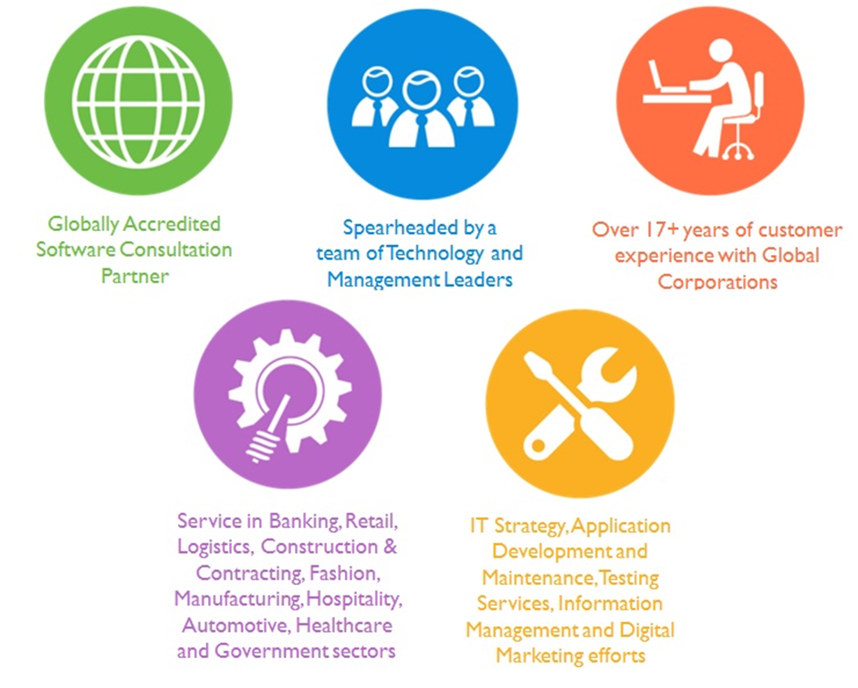

## Key Differentiators

Quality Assurance & Testing

## Technology & Services



Application  
Development

Testing Services

Mobility Solutions

Digital Marketing

Cloud/Traditional Hosting

User Interface & Design

Technology  
&  
Services

# Functional Specification

The main modules of the application are:

* **User Registration**
* **Student Workflow**
* **Teacher Workflow**
* **Admin Workflow**
* **Parent Workflow**
* **System Features**
* **Reports & Analytics**

Detailed features are listed below. Additional requirements have been extrapolated based on the workflows provided by the client.

|  |
| --- |
| **Registration** |
| Student / Parent profile |
| instructor profile |
| Admin profile |
| **Student Workflow** |
| Student Quick Guide (~6 screens) |
| Dashboard (My courses, My grades, Favorite instructors, Messages, Preferences, edit profile, Calendar and course schedule) |
| Class Selection (Request for class) |
| instructor Selection (request for instructor) |
| instructor ratings (Comments and stars) |
| Submit request |
| Request Timeout |
| Request escalation (to admin and then SuperAdmin) |
| Make payment online via payment processor |
| Create calendar entry and reminders |
| Send specific information to instructor |
| Attend class online (Record class) |
| Request clarification or post questions to instructor |
| Rate instructor & add instructor as favorite |
| Access assignment ( Attachments) |
| Submit assignment (upload assignments, take quiz etc.) |
| Assignment history with grades |
| Receive Course certificates |
| Request New Group Classes |
| Search For Group Classes |
| Join Group Classes |
| Update Group Class Calendar |
| **Instructor Workflow** |
| instructors Quick Guide (~6 screens) |
| Dashboard (My Students, Messages, Preferences, edit profile, Calendar and course schedule, Rating) |
| CV builder |
| Billing information |
| References |
| Specialization |
| Set availability and calendar |
| Upload Course content |
| Links to external sites for reference material |
| Accept Student request |
| Cancel Request |
| Update calendar & create reminders |
| Conduct classes (one on One) |
| Answer student questions or doubts |
| Upload assignments or create quizzes |
| Review assignments and assign grade |
| Receive payment |
| **Admin (principal) Workflow** |
| Admin Quick guide (~6 screens) |
| Upload CV |
| Add references |
| Add billing information |
| Access and manage student, instructor calendars. |
| Reassign instructors |
| Reschedule instructor and student classes |
| Approve Review |
| resolve instructor student issues |
| Add Teacher to Group Classes |
| Cancel Group Classes |
| Set Minimum strength for group classes |
| **Super Admin** |
| Manage students |
| Manage instructors |
| Manage Admins (principals) |
| Manage Courses |
| re-associate instructors to courses |
| Dashboard (Active Students, Active instructors, Active courses, edit profile, Messages-pending reviews, Latest ratings) |
| Post site wide messages or to individuals |
| Blacklist instructors |
| Quiz management* |
| **Parent Workflow** |
| Register Student |
| Review grades |
| View student course schedule |
| View Messages from Admin, SuperAdmin, Instructor |
| View student calendar |
| **System Features** |
| Authentication and authorization |
| Logging and auditing with notifications |
| Payment processing |
| File management |
| Roles and permissions |
| Password salting |
| Email authentication and management |
| SMS authentication (mobile devices) |
| Password policy |
| Cron Jobs for scheduling |
| Export or email reports |
| Suggest Private class for group classes with less than 2 members |
| Send reminders to members in group classes |
| Raise Request for private classes that have not been approved by teachers |
| **Reports and Analytics** |
| Student demographics |
| Inactive users |
| Student Activity Summary (Most Active Students) |
| Student grades Compared to Course Average (Compared to Course Average) |
| Revenue Generation |
| Demographic report |
| Revenue by student |
| Revenue by instructors |
| Login statistics (by students and instructors) |
| Available courses and student enrollment |
| Available courses and staffing |
| File utilization by student and instructor |
| Activity stats summary (logins, total course time spent) |
| Past due assignments |
| Course utilization report |
| Incomplete student teacher sessions |
| Student-teacher reassignments |
| Teacher review |
| **Mobile API Development** |

# Application Workflow

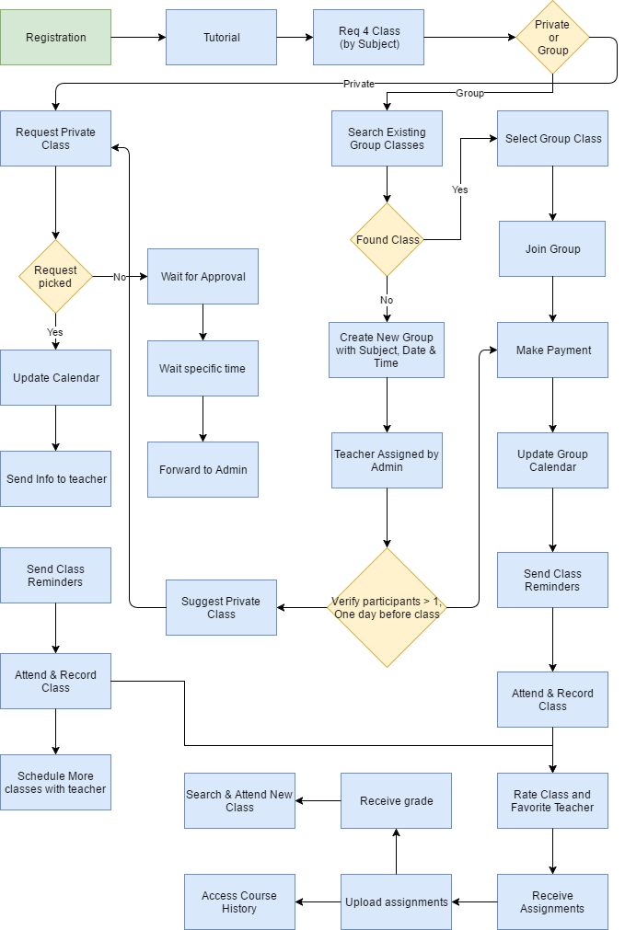

Figure 1 Student or Parent Workflow

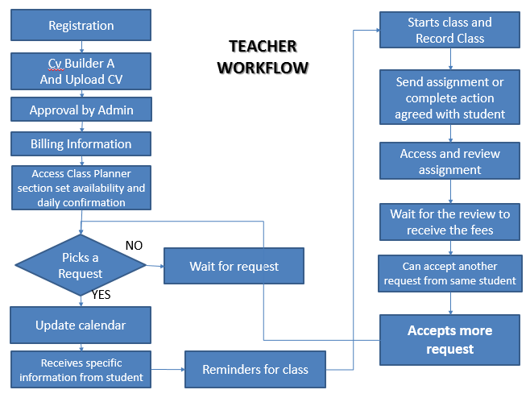

Figure 2 Teacher Workflow

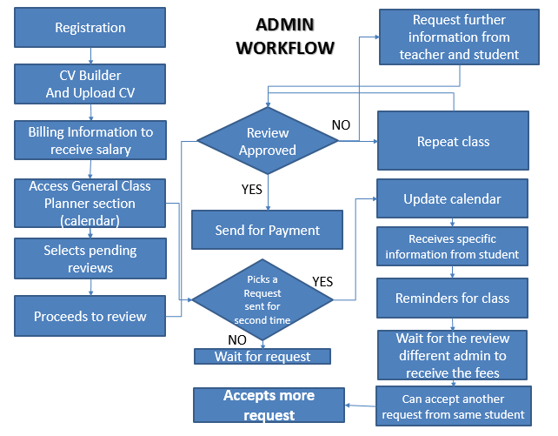

Figure 3 Admin Workflow

# High Level Solution

## Video Conferencing using Zoom

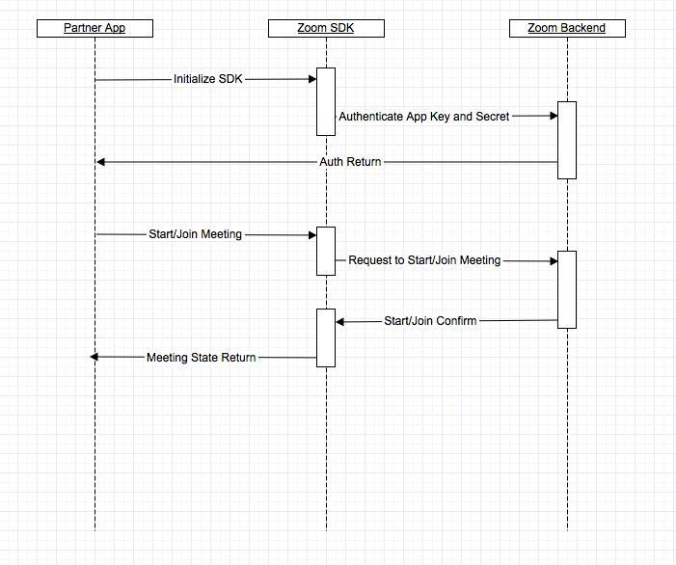

Figure 4 Solution Integration with Zoom

Verbat proposes the use of Zoom to conduct online instructor-student classes or sessions. Zoom is a full-featured web conferencing tool that allows instructors to host an entire class meeting online with a webcam, screen-sharing and annotation, voice and text chat. Students may use various devices to participate in a Zoom meeting including MAC/PC computers and iOS/ Android devices.

Zoom plugins and their SDK has tight integration with mobile and web apps. Zoom meetings can be integrated into the custom application being developed to do the following online instructional activities:

* Deliver and record a lecture online with presentation slides
* Display any software or webpage on your computer to share with students
* Moderate an online class discussion with webcam video/audio or chat
* Invite remote guest speakers to your online class meeting
* Meet individually with students online to provide instructional support or guidance
* Moderate online group presentations and debates
* Check in with group to view progress of group projects

Zoom being a “Cloud-based” video conferencing application, the most one would need for "smooth video conferencing' is 2Mbs. Moreover, the burden of managing costly hardware or software infrastructure is not a concern since Zoom will manage issues related to bandwidth. Zoom is also affordable, cheap and can be scaled up or down depending upon the clients requirements.

|  |  |
| --- | --- |
| **Zoom Bandwidth requirements (Per Teacher – Student Pair)** | |
| Session in HQ Video | 600 KBPS |
| Session using VOIP Audio | 80 KBPS |
| Total Bandwidth | ~800 KBPS |
| ZOOM API Charges | Starting $100 for 4000 Minutes (Discounts for larger packages) |

## High Level Hardware Architecture

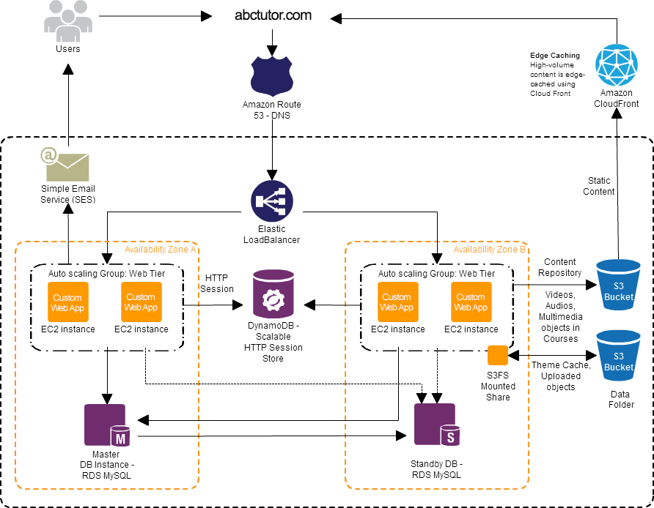

Figure 5 Scalable Architecture

The diagram above depicts a scalable architecture that can withstand the need for high availability and scalability. The architecture considered takes into account the potential prospect for a busy site experiencing high traffic and bandwidth requirements. However this architecture is not needed on day one as it can be scaled upwards incrementally based on an emerging need for higher computational, memory and bandwidth requirements.

This architecture assumes the use of Amazon Web Services and the main components of the architecture are described below

Amazon **Elastic Compute Cloud (EC2)** forms a central part of Amazon.com's cloud-computing platform, Amazon Web Services (AWS), by allowing users to rent virtual computers on which to run their own computer applications, thus being able to manage costs based on needs.

Amazon **RDS** **MySql** makes it easy to set up, operate, and scale MySQL deployments in the cloud. With Amazon RDS, you can deploy scalable MySQL deployments in minutes with cost-efficient and resizable hardware capacity.

**Pricing:** Pay for what you use. No minimum Fee. Multiple pricing options from structured to pay as you go.

**Amazon DynamoDB** is a fast and flexible NoSQL database service for all applications that need consistent, single-digit millisecond latency at any scale. It is a fully managed cloud database and supports both document and key-value store models.

Tomcat applications often store session-state data in memory. However, this approach doesn't scale well because once the application grows beyond a single web server, the session state must be shared among servers. A common solution is to set up a dedicated session-state server with MySQL. However, this approach also has drawbacks: you must administer another server, the session-state server is a single pointer of failure, and the MySQL server itself can cause performance problems.

DynamoDB avoids these drawbacks by providing an effective solution for sharing session state across web servers.

**Pricing:** AWS customers can get started with Amazon DynamoDB for free. DynamoDB customers get 25 GB of free storage, as well as up to 25 write capacity units and 25 read capacity units of ongoing throughput capacity (enough throughput to handle up to 200 million requests per month) and 2.5 million read requests from DynamoDB Streams for free.

**Elastic Load Balancers** automatically distributes incoming application traffic across multiple Amazon EC2 instances. It enables you to achieve fault tolerance in your applications, seamlessly providing the required amount of load balancing capacity needed to route application traffic. Among other things, the term elastic also applies to the ability for customers to use only what is needed and thus avoid high usage charges.

**Pricing:** Cost ranges from $0.025 per Elastic Load Balancer-hour (or partial hour) or $0.008 per GB of data processed by an Elastic Load Balancer.

Amazon **Simple Storage Service (S3) Bucket** is cloud storage for the internet to store photos, videos and documents. Amazon **S3 (Simple Storage Service)** is a web service offered by Amazon Web Services. Amazon S3 provides storage through web services interfaces (REST, SOAP, and Bit Torrent).

**Pricing:** As part of the AWS Free Usage Tier, you can get started with Amazon S3 for free. Upon sign-up, new AWS customers receive 5 GB of Amazon S3 standard storage, 20,000 Get Requests, 2,000 Put Requests, and 15GB of data transfer out each month for one year.

For even higher demands in speed and performance Verbat suggest memcached or couchDb, which is an in-memory database. Amazon S3 is a file based database hence it is sub optimal for very high performing sites. Memcached and CouchDB are open source and can be freely used, however there is additional cost for configuring the DB.

## High Level Software Architecture (Stack)

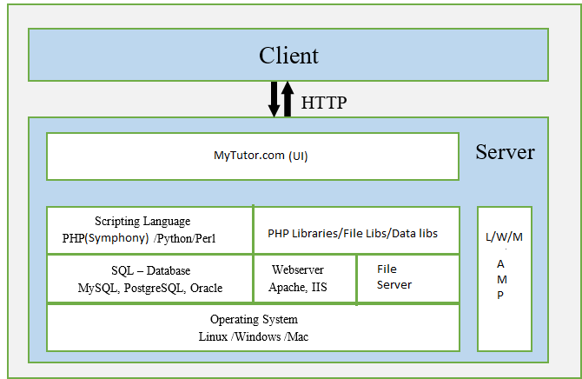

Figure 6 High Level Software Architecture

The application is built on a three layered architecture (MVC). The technology stack is not fixed and will be flexible to adapt to the client’s needs. Verbat suggest PHP over any standard application frameworks like Laravel or CodeIgnitor with an apache webserver hosted on a UNIX platform.

# Non Functional Requirements

|  |  |
| --- | --- |
| **Requirement** | **Details** |
| User Experience and  UI Design | * The application will be developed only in English (If Arabic is required we can accommodate the same on the website. Note that internationalization is not supported in Zoom) * The layout and graphical components will be created considering the usability factors |
| Performance | * Application will allow users to have smooth and quick access to the information or services they require. |
| Security | * The system will be protected against attempts of security breaching that may arise. * Web security standards will be followed. |

# Assumptions

The project solution and technology is created from the initial understanding of the requirement shared with Verbat through mails and meetings. The proposed solution is based on the following assumptions:

* Client to provide Verbat with the branding guidelines.
* The proposed application front end and backend would be developed in English.
* Client will purchase the necessary templates needed for development
* Client shall provide licensed images and logos in specified size & format
* Super Admin can manage all the users within the application.
* Requirements should be well defined, agreed and signed-off by the client
* Internet connectivity is required for the functioning of the web/mobile application.
* Recording will not be a filtered column for the class history report for student, Teacher & Admin. (As per slide 2,3 & 4 related to the class history)
* Tutorial for Admin, Teachers & Students will be static content
* Request (teacher) workflow escalation period is hardcoded in DB
* "Wait for the review different admin to receive the fees" in the admin workflow - Need clarification
* Assuming open source technology (Linux, Apache, PHP, MySql, HTML5, CSS )
* Customer will procure templates, SSL certificates & Payment processor
* UI development effort is 2-4 hrs. per screen
* Reporting and analytics for mobile devices will be imported from the web, if needed
* Both mobile and tablet will have similar design
* Estimated with default Android and IOS design, Custom design will take more effort
* Testing will be done in 2 major types of Android and IOS Mobiles
* Testing will be done in 2 major types of Android and IOS Tablets
* Testing will be done in latest versions of Google Chrome, Mozilla Firefox & IE web browsers only
* Verbat will capture billing information for tutors and admins, but will not process the salary payment for tutors or admins
* Payments & charges related to video/audio conferencing providers will be made by the client
* Payment gateway details will be provided by client before the start of the project
* Zoom Interface does not support Arabic
* Client will provide sample data to test the entire application

# Out of Scope

With the ever evolving digital market, the requirement needs should be clear to both the parties involved, hence the importance of mentioning the out of scope details of the project. Following are considered to be out of scope while creating this proposal.

* Purchase of images, fonts
* Adding new features to the application other than mentioned in the functional specification.
* Any language other than English & Arabic
* Manual data entry
* Hardware Integrations / procurement and purchase
* Database migration
* Content writing
* Content or image procurement or uploading or editing.
* Hosting Infrastructure and Maintenance
* Annual Maintenance of the application (Bug fixing, debugging) - For AMC details, please refer section titled “Maintenance and Support”
* Physical deployment at client’s site
* Backup solution and Disaster recovery
* Documentation and project planning are not considered for the effort estimate. From an Agile perspective, we provide only the documentation that is absolutely required by the client.
* Deployment of the mobile application into respective stores (play store & app store) will be the responsibility of the customer.

# Technology Solution

## Proposed System Environment

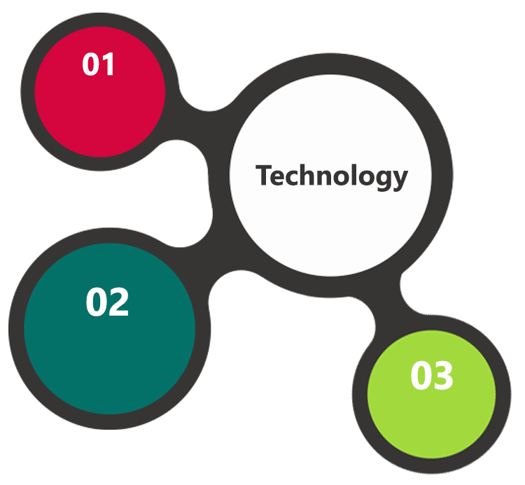

PHP, Code Igniter

Linux OS  
Apache  
My SQL

HTML / CSS3

**MS SQL2012  
Windows 8/10  
Web Services**

## Technical Configurations

### Development Tools

* PHP, Code Igniter
* My SQL
* HTML / CSS 3
* Web services, Ajax, JavaScript

### Recommended Web Hosting Package

* Medium CPU power – single to dual CPU
* Single Domain
* Windows/Linux OS
* Disk Space: 5 GB
* Monthly Bandwidth: 10 GB
* Control panels e.g. cPanel-v_11.42
* Web site Server Software – Apache
* PHP 5 Framework

Clients can also host using Amazon Web Services.

### Browser Compatibility

* Chrome version: 56
* Firefox version: 51
* Edge version: 39

### Hardware Interface

**Desktop**

The application is reliant on hardware interfaces to provide a seamless automated user experience.

* Computer with Windows 8 or 10 OS
* Compatible Browsers as specified in section 7.2.3

**IOS System Requirements**

iPhone 4+

iPad 4 +

OS 7 +

4G/LTE

40 MB Free Space

**Android Device Specifications**

1 GB Ram

ARM processor

Android 4+ and above

high-speed Wi-Fi and 4G LTE networks

40 MB Free Space

# Commercials

## Web Application

|  |  |  |
| --- | --- | --- |
| **No** | **Description** | **Amount (USD)** |
| 01. | Development of Learning Management Solution | .00 |
| 02. | Maintenance from month 7 to 24 ( a dedicated PHP resource of one (01) FTE (Full Time Equivalent) above 3 years’ experience) |  |
|  |  |  |

*Note:*

* *The above cost does not include Application hosting, integration, Project Management or deployment.*
* *For change management cost, please refer to section 10 titled Change Management.*
* *Manhours per month is 160 and Man days per month is 20.*
* *Any additional hours above 160 will be charged @ per man hour.*

## Payment Terms

* Development and Maintenance of Learning Management Solution

## Mode of Payment

Wire transfer to our bank account

Bank Name : Emirates NBD

Account Name : Verbanet Technologies LLC

Account Number : 1011492858201

IBAN Number : AE61 0260 0010 1149 2858 201

Swift Code : EBILAEAD

Bank Address : Mamzar Branch, Dubai

*Note: Bank charges incurred during wire transfer to be borne by the client. Any local taxes applicable to be borne by the client*

OR

By Cheque / DD to Verbanet Technologies LLC

# Delivery Management

## Project Management

The Verbat development center strictly follows industry standards on quality. The project management is process governed by the Verbat Quality Management system and is put to verification through internal audit programs that happen from time to time.

Verbat will dedicate a project manager for the proposed implementation. Verbat proposes Client to identify one project manager who will be driving activities to be undertaken by Client to be the single point of contact for Verbat.

## Roles and Responsibilities

Verbat will assign a dedicated Project Manager/Project Lead to lead the project, who will be the first point contact for Client. He/she will be responsible for planning and managing the various activities within the project. He/she will work closely with Client Project Manager, to give periodic status updates and ensure high level of visibility and comfort on the progress of the project.

The Project Manager/Project Lead will lead the co-ordination between Verbat and Client, thus enabling smooth transitioning of Client requirements to the Verbat’s offshore delivery team, and provide visibility as well as comfort on the progress of the services to Client.

He/she will have periodic meetings with Verbat’s Senior Management, thus ensuring Verbat’s Management commitment and focus on Client initiatives.

## Delivery Activity Summary

|  |  |
| --- | --- |
| Activities | Description |
| Detailed requirement Analysis | Verbat team to conduct detailed study of requirement for the phase. If clarification is required, team will reach out to Client for more information and/or time for discussions. |
| DB Design | DB design for central and test DB. |
| Software Requirement Specification document (SRS) | Once the requirement analysis is completed, Verbat team will submit the SRS document for approval |
| UI/UX Design, Prototyping | Based on the SRS, Verbat UX/UI team will work on the UI/UX of the screens and submit a prototype for approval |
| Functional Specification Document (FS) | Once the Prototype. UI/UX is approved, Verbat shall submit an FS document for approval. |
| Development | Actual system development starts based on the FS. This involves detailed design and software development of Web Application. |
| Testing | Test Planning, test plan creations, internal, integration testing and user acceptance testing. |
| Deployment | Deploying the latest built in the Verbat Test Server. |

## Project Implementation Plan

Verbat will be providing the solution in a stand-alone fixed bid approach which ensures minimum viable solution for quick wins with core focus on the long-term business objective and outcome. Once the implementation is over, Verbat will initiate the application maintenance process (once the maintenance contract is signed) which continues to extend after the implementation.

## Deliverables

* Software Requirement Specification Document (SRS)
* Prototype of the application
* Functional Specification Document (FS)
* Fully Developed & Tested Application

## Estimated Delivery Time

The effort estimated for delivering the application as specified in section 2 will be as below:

|  |  |  |  |  |
| --- | --- | --- | --- | --- |
| **Resource/Skill** | **June**  **(man hours )** | **July**  **(man hours )** | **Aug**  **(man hours )** | **Sept**  **(man hours )** |
| Project Manager | 42 | 42 | 42 | 42 |
| Architect | 80 |  |  |  |
| Business Analyst | 80 | 15 | 15 | 30 |
| User Experience | 120 | 20 | 20 |  |
| Team Lead Web | 120 | 100 | 80 | 120 |
| Web Developer | 124 | 160 | 160 | 160 |
| Team Lead Android | 120 | 86 | 80 | 120 |
| Android Developer | 168 | 180 | 180 | 168 |
| Team Lead iOS | 120 | 100 | 80 | 120 |
| iOS Developer | 168 | 180 | 180 | 168 |
| Test Lead | 80 | 50 | 80 | 100 |
| QA | 70 | 150 | 150 | 150 |
| **Total Effort(man hours)** | | | | 4620 |

|  |
| --- |
| **Other Expenses to consider**   * Templates and themes for development * Payment Processor Cost * Templates for reporting & analytics (Ex. HiCharts) * Cloud storage for documents and videos * Bandwidth Charges * API Charges for using Zoom * Amazon Cloud Hosting and related charges |

**Twenty Two (22) UAE working days for prototype from the date of Approval of the project (LPO/Signed proposal) with advance payment: and Sixty Five (65) UAE Working days for the development of the application from the Date of Approval of the Prototype**

| **Activity** | **Deliverables** | **Timeline** |
| --- | --- | --- |
| Project Initiation | SRS, Functional Specification,  Working Prototype | June |
| Development  (3 parallel Streams) |  | June thru September |
| Deployment in Verbat test server | Tested Web, Tablet & Mobile  Applications in iOS & Android | Mid to End September |

## Deployment Details (at Clients Behest)

* Client can opt for hosting the application at Verbat’s Server.
* If deployment is at the client’s server, responsibility of deploying the application onto the production environment after conducting the necessary acceptance testing will lie with the client unless and until Verbat’s support is contracted for deployment.

***Note****: Hosting the application at Verbat’s server will call in for additional charges.*

## Release Planning

* Client will be informed about the release date and time through email.
* Client performs the UAT

## Risk and Contingency Planning

Verbat has identified various risk factors associated with this assignment and understands the impact of these risk factors on the project schedules. The objective of this section is to highlight for both Verbat and client, the risk factors, to analyze the impact of the risks on project execution, and to propose strategies to control and reduce the impact of the risk factor.

These various risks, which could arise during the project, are tabulated below along with mitigation implementation.

| Type of risk | Impact | Risk Mitigation | Risk Handling |
| --- | --- | --- | --- |
| Scope Creep | H | Functions and features will be detailed in system requirement documents and will go through client approval. Once this document is approved, any change to requirement will go through change management review for possible impact assessment. | Proper change management procedure will be implemented. |
| Delay in customer feedback | H | The plan is prepared with enough lead-time for customer reviews and approvals.  The customer is indicated with the dates when the document is expected after review and approval. | The request for feedback will be escalated if not attended at the right time so that the schedules are not affected. Deemed acceptance criterion is set up front and will be followed. |
| Non-availability of necessary software’s, frameworks, database instances and infrastructure at client’s hosting environment(If hosting support is provided by Verbat) | M | Client will be informed in advance on these requirements. | Possible impact to schedule. |
| Manpower attrition | L | All efforts would be made to ensure process dependence rather than being person dependent. As a risk mitigation plan Verbat will train backups. | A new person will be identified as early as possible, provided the required project-specific training and mentored by the senior members of the team to minimise impact of attrition on the project. |

*H-High, M-Medium, L-Low, NA-Not Applicable*

# Change Management

Any addition which comes out of the project scope, upon and after the launch of the tool will be considered as change management. Verbat recommends the following change management procedure for the same.

* Any change which comes out of the project scope, which was discussed, documented, and mutually approved by both the parties in the requirement stage, will be carried out only through raising a change request.
* Change request will be studied and an impact analysis on the existing work flow will be performed.
* On finalizing the impact, effort estimation for the change will be calculated and raised as additional requirement.
* Verbat will initiate the change request only after getting a formal approval from the client for the additional changes raised.
* Any change from the scope will be charged at **per man day effort** and approval from the clients will be availed before commencing on any change management.

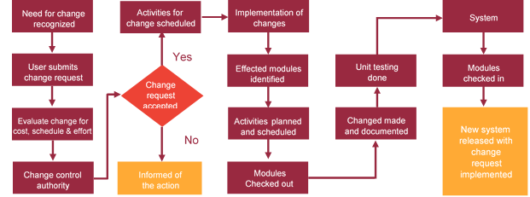

# Miscellaneous

## Warranty

* Verbat shall provide a bug ﬁx warranty at no additional cost for 30 days from the date of acceptance of the project/UAT, for correction of any errors in the developed application that may be attributed to Verbat.
* However, this does not cover modifications by Client, or use of the application on an environment other than the proposed environment, or other circumstances outside Verbat’s reasonable control. In such a case Verbat reserves the right to charge for its services.
* All error corrections will be executed at Verbat India office. In the event of any need for on-site work, all expenses incurred for such trips will be payable to Verbat by Client.

## Acceptance Criteria

* UAT sign off should happen on Verbat test server within 7 Days from the release of the application/ Phase and the acceptance confirmation needs to be mailed to Verbat failing which Verbat will consider the project as approved by the client.
* Any comments or reason for rejection need to be documented and the same needs to be sent as an email from the official mail id of client to Verbat.

## General Terms and Conditions

* An average of 20 working days are assumed in a month
* All the projects activities will be carried out from our off-shore development center in India
* The scope of the project is to develop the Application as detailed in the scope of the project and mentioned in this proposal. Any changes or additions will have to go through change management.
* This proposal and all technical/ functional specifications have been derived or concluded from the data shared via email / information's transferred during the initial requirement analysis meetings and conversations. Verbat reserves the right to amend the terms of this proposal, should the SOW terms, functional features and functionalities change during the course of the project
* Application will be best viewed only in the environment mentioned in the section 7.2.3
* All the documentation will be provided in English.
* Third party components may be used to develop this application.
* All Source Code and other project artefacts would adhere to the Verbat document templates and internal coding standards
* Acceptance criteria shall be based on the clauses which were mutually discussed between Verbat and client at the Requirement Analysis phase and the same will be documented and approved by both parties through official emails
* In case Client requires any extension of the proposed acceptance schedule, the associated effort and cost of such extension can be mutually reviewed.
* For any circumstances if project needs to be put on Hold / Stop it requires minimum request notice period of 1 week along with duration for which request will be addressed by management and final decision on the request will be based on that
* If deployment is done in client’s server, Verbat cannot be held responsible for any performance issues arising due to hardware malfunctions.
* Client is responsible for data backup in case the application is not hosted on Verbat server.
* Source code will only be delivered or uploaded on the Production Server once the due payments are made.

## Assumptions and Dependencies

* Detailed system study is required before the start of the project.
* During the requirement gathering phase, authorized personnel from the Client’s side is expected to be available for discussion and finalizing the HLD (High Level Design), before development commences.
* Type of reports and formats, if under the scope of the project, needs to be specified by Client before project sign off.
* Workflows if under the scope of the project, need to be specified/ confirmed by client before project signoff.
* All queries regarding the client requirement and any queries which may hinder the project advancement at any stage should be answered by the client within 24 hours from the time of initiation, failing which the time delay will get added to the actual effort which was estimated.
* Verbat assumes that all sign-offs from Client will be provided within agreed and specified timeframe.
* Client will provide all the necessary contents, both text and image, before starting the project in the format suggested by Verbat (if any).
* The client should provide the relevant information and data well in time for the execution of a related activity. Non- availability of this information or data may lead to an interruption of work which may result in a delay in delivery as well as additional costs to the client.
* Client should have/possess server with technical specifications as suggested by Verbat for the proposed application.

## Source Code & Intellectual Property Rights

* Upon completion of the Project and 100% completion of the payment, client will have access to the source code except for propriety codes, developer tools and third party application etc.
* The solution offered will be the intellectual property of the client and will be made available to the client on an “unlimited license” basis.
* Modifications by third party/person: No person or organization, other than Verbat or any person authorized by Verbat in writing, has any permission to modify/change the software Solution to be eligible to get continued support from Verbat as per the support terms defined under this document.
* Liabilities/Damages: Verbat accepts no liability or damages of any kind arising out of use or non-use of the software delivered. The responsibility of testing of software lies with Client.

## Maintenance & Support

* Maintenance contracts by default are supported as per the basic SLA terms.
* Additional Effort/change management request will be added towards Total Value of the Project to determine the AMC value.
* Maintenance support is limited to providing application support for ensuring the consistency of the look-and-feel, bug fixes and user issues i.e. maintenance and support of the existing features of the application.
* Support does not in any way cover providing technical or other support to the end users. The maintenance agreement does not include functionality changes or feature additions which are handled as change requests which will be charged USD per man day. AMC does not include server support, maintenance and application deployment.
* AMC charges will cover Off-Site Support and Debugging. Support includes E-mail, Telephone and Chat unless explicitly specified. In the event, the application is hosted with the client; necessary remote desktop connectivity should be provided for carrying out maintenance activity.
* Gap in AMC - In case if the client does not opt an AMC for a year and want to renew it after that period, 50% of the AMC amount for the year for which AMC is not taken will also be payable if the client wishes to renew the AMC contract.
* Note:
  + Please note that the AMC support shall start only after all the necessary sign-offs (AMC Document) to this effect have been given.
  + It is not mandatory that the client should opt for an AMC. The client will still be supported on an ad-hoc basis on an agreed man-day rate.
  + AMC Payment Terms: 100% to be paid as advance.
* As part of AMC, Verbat will provide a dedicated resource from Month 7 to Month 24 @ USD /Month (160 manhour per man month)

## Service Level Agreement

|  |  |  |  |  |
| --- | --- | --- | --- | --- |
| **Key** | **Max Response Time** | | **Max Resolution Time** | **Target** |
| Basic | 1  working day | 3 working days | | Request / incident / problem tickets |
| Advanced | 5 Business Hours | 12 Business Hours | | Request / incident / problem tickets |
| Priority | 3 Business Hours | 5 Business Hours | | Request / incident / problem tickets |

Note:-

* We provide Basic SLA as standard with AMC while Advanced and Priority SLAs attract additional charges.
* Time zone applicable as per India time zones (3:30 AM GMT to 12:30 PM GMT- Monday to Friday).

# Our Clients

1. **UAE University**
2. Education
3. Transportation
4. **Canada Cartage**
5. Construction
6. Services
7. Finance

We look forward to hearing from you soon and hope that you will give us the privilege to work with you in meeting your business goals. Thank you.



01

Agile development offering reliable, secure solution

02

Smooth transition and quicker completion of processes

03

User friendly interfaces enabling easy navigation between screens

Delivered digital transformation expertise to global customers for over a decade by following industry best practices to maximize ROI for client

Keen technology intelligence combined with aggressive market research to deliver solutions that achieve results with measurable value

Enable access to global consulting expertise with strong local market and business knowledge

Commercial Model that is customizable for your business needs

Services that are designed to optimize applications for improved performance and overall efficiency

1,000,000 plus man-hours of expertise in technology frameworks spanning Microsoft, Open Source, mobility platforms and other proprietary IT technology

Partners top technology vendors to bring in the latest and best services in integration, collaboration, and development

Commercial Model that is customizable for your business needs



Proven Methodologies & Processes

Investment in R & D

Strong Local Presence

Flexible commercial Models

Technology Associations

Software Development Experience

Offshore Development Centre

Thank You



©   
1999 - 2017. All Rights Reserved   
Verbanet Technologies LLC  
www.verbat.com