[**Slaughterhouse Accreditation Outside UAE**](https://www.moccae.gov.ae/en/our-services/licensing/newislamicabattoire.aspx)

Through this service, slaughterhouses outside UAE are approved for slaughtering animals and poultry after ensuring their applying with food safety systems and legislations based on the risk analysis approved by UAE. This includes meat shredding and storage facilities in order to allow the export of animal meat and poultry meat slaughtered to UAE (valid for one year starting from the issuing date)

Steps

Make e-payment

Review of application and complete procedures

Carry out evaluation visit with coordination of competent authority

Issue the accreditation

Required documents

* Certificate of registration / license of the slaughterhouse issued by the relevant veterinary and / or food control authorities in the country of origin
* Valid Certificate of application of food safety management system & quality management system issued by nationally accredited institution in the country of origin
* Certificate of registration / license/ accreditation/ recognition of the Certification body of food safety management system & quality management system Certificates by the relevant authorities in the country of origin or in the UAE (only)

[**Transfer Fishing Boat Ownership**](https://www.moccae.gov.ae/en/our-services/licensing/selling-of-fishing-boat-license-transfer-wra-3.aspx)

Through this service local fisher can sell and transfer the ownership of his/her fishing boat (license and boat body) which is registered with the ministry to another person who meets the requirements for enrollment in the general registry at the Ministry. A boat license and a captain card will be issued valid for 2 years from the date of transferring the fishing boat ownership

Steps

Fill out e-form

Review of application and complete procedures

Issue license, captain card, deletion certificate, fishing boat sales contract

Required Documents

* Copy of emirates ID card
* Copy of the full family book (compare it with the original)
* Passport copy
* Personal photo
* Certificate of Good Conduct and behavior
* Fishing license issued by the competent local authority
* Medical fitness certificate to operate and sail a fishing boat
* Salary certificate / pension or a certificate from the competent court stating that the applicant is unemployed and does not receive a pension
* Technical inspection report issued by the CICPA
* Delisting certificate of a Maritime Transport issued by Coast Guard

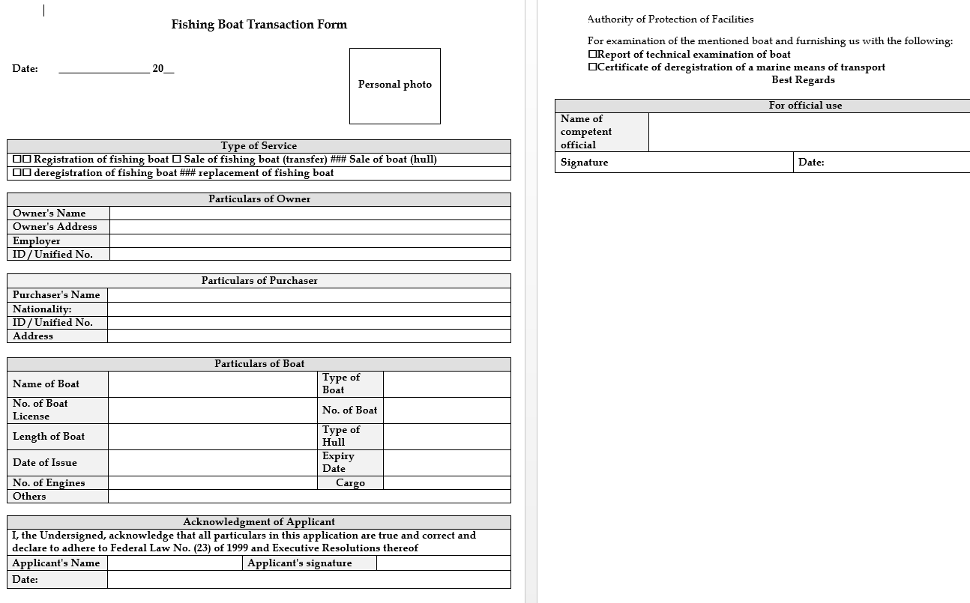

[**Transfer Fishing Boat's Ownership to Heirs**](https://www.moccae.gov.ae/en/our-services/licensing/transferring-of-fishing-boat-into-heirs-name.aspx)

Through this service the agent of the fisher’s heirs can modify the information of the boat owner in the general registry of the Ministry and transfer the ownership to the heirs. A boat license will be issued valid for 2 years from the date of transferring the fishing boat's ownership to heirs.

Steps

Fill out e-form

Review of application and complete procedures

Issue lf boat license

**Required Documents**

* Notification of inheritance
* An agent appointment certificate issued by the Sharia Court
* Copy of the family book to be compared with the original (for hires)
* Technical inspection report issued by CICPA

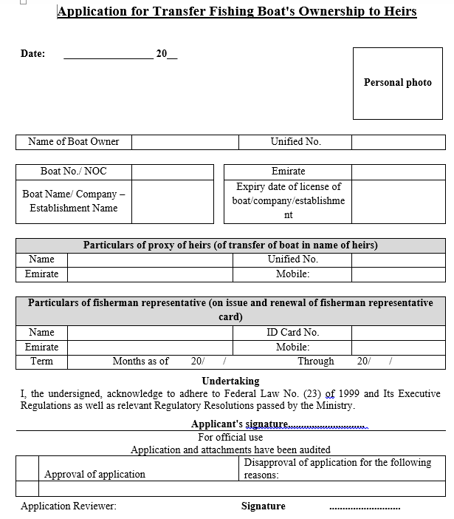

[**Veterinary Extension Request**](https://www.moccae.gov.ae/en/our-services/licensing/animal-vaccination.aspx)

Through this service, veterinary services are provided to livestock breeders which include (treatments, vaccination, veterinary guidelines, animal numbering)

Steps

Fill e-form

Visit field

Close request by documenting the service in electronic system

Required documents

-

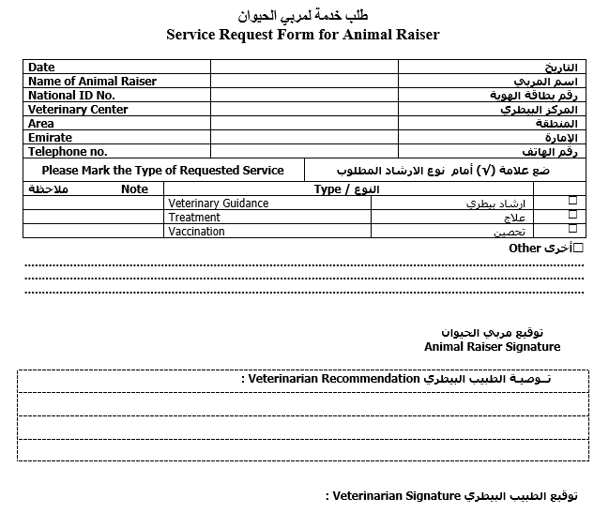

[**Vice-Captain Card Issuance**](https://www.moccae.gov.ae/en/our-services/licensing/issuing-of-license-for-captain-or-who-is-acting-on-behalf-of-him.aspx)

Through this service the fisher can appoint a local vice-captain to operate his/her boat and work on it on his/her behalf. A vice-captain card will be issued valid for 2 years from the date of issuance

Steps

Fill e-form

Review application and complete the procedure electronically

Issuance of vice-captain card

Required documents

* Copy of Emirates ID card OR passport for holders of a valid UAE passports only
* Copy of passport
* Personal photo
* Certificate of Good Conduct and Behavior
* Valid boat sailing license from the FTA
* Medical fitness certificate to operate and sail a fishing boat
* Certificate to prove the relationship between the vice-captain and the fishing boat owner (in the case of the first-to fourth-degree kinship only (to be issued by the Court. Alternatively, the relationship of kinship may be established on the basis of the data provided by their identity documents
* Certificate approved by a specialized medical committee to prove the inability of the owner to manage and operate the fishing boat (in case of medical inability only)
* Copy of the full family book of the heirs (in the case of minor heirs only)

