

**PROPOSAL: MOCCE**

**Ministry of Climate Change and Environment**

**Submitted by**

Verbanet Technologies LLC  
27/03/2020

**DIRECTORY.**

**1** **KEY DETAILS** 5

**2** **STRATERGIC OBJECTIVES** 6

**3** **PROJECT SCOPE** 6

3.1 USER CHARACTERISTICS 7

3.1.1 Business Users 7

3.1.2 Individual Users 7

3.1.3 Admin user 8

3.1.4 Content Managers 8

3.2 PROPOSED SOLUTION MODEL 8

3.3 FUNCTIONAL REQUIREMENTS 9

3.4 The seven factors that influence user experience 10

4 DETAILED REQUIRMENT SPECIFICATIONS 12

5 APPLICATION ARCHITECHURE 16

5.1 Information Architecture 16

5.2 Technical Architecture 19

5.2.1 Performance boost considerations 20

5.3 Hardware Architecture 23

5.4 Security Architecture 24

5.5 Quality Assurance 25

5.6 Release and Deployment Process 26

5.7 Verbat’s Website Redesign and Enhancement Strategy 27

6 Usability Issues with MOCCAE 28

6.1 Images do not always load 28

6.2 Inconsistent Call to Action 28

6.3 Incorrect use of Icons 29

6.4 Error messages could be more helpful 29

6.5 Information Overload 30

6.6 Mandatory fields are not very obvious 30

6.7 The services page provides too many options 30

6.8 The sign language interpreter is hardly functional 31

6.9 Page loaded with blank dropdowns 31

6.10 Webpage loads, but the content is un-curated 32

6.11 Chat bot repeats itself 32

6.12 YouTube videos that do not load 33

6.13 Verbat Guarantee 34

6.14 NON-FUNCTIONAL REQUIREMENTS (OTHERS) 37

6.15 Design Phases 38

6.16 TECHNICAL CONFIGURATIONS 40

6.16.1 DEVELOPMENT ENVIRONMENT 40

6.16.2 RECOMMENDED WED HOSTING PACKAGE - DEDICATED 40

6.16.3 BROWSER 41

6.16.4 HARDWARE DEVICES 41

6.16.5 TECHNICAL STANDARDS 42

6.16.6 TECHNICAL GUIDELINES 42

6.17 PROJECT DELIVERY 44

6.17.1 Agile Methodology 44

6.17.2 PROJECT MANAGEMENT 46

6.17.3 ROLES & RESPONSIBILITIES 47

6.17.4 DELIVERY ACTIVITY SUMMARY 48

6.17.5 PROJECT IMPLEMENTATION PLAN 49

6.17.6 DELIVERABLES 49

6.17.7 ESTIMATED DELIVERY TIME 50

6.17.8 DEPLOYMENT DETAILS 52

6.17.9 RELEASE PLANNING 52

6.17.10 RISK CONTINGENCY PLANNING 52

6.18 PROJECT ASSUMPTIONS 54

6.18.1 OBJECTIVES 54

6.18.2 DESIGN 54

6.18.3 DEVELOPMENT 54

**7** **OUT OF SCOPE** 55

**8** **CHANGE MANAGEMENT** 57

8.1 MAINTENANCE & SUPPORT 58

**9** **TERMS AND CONDITIONS** 59

9.1 ACCEPTANCE CRITERIA 59

9.2 WARRANTY 59

9.3 SOURCE CODE & INTELLECTUAL PROPERTY RIGHTS 60

9.4 GENERAL TERMS AND CONDITIONS 60

9.5 GENERAL ADMINISTRATIVE, TECHNICAL & FUNCTIONAL ASSUMPTIONS 62

**10** **FINANCIALS** 63

10.1 Curriculum Management Application 63

10.2 PAYMENT TERMS 63

10.2.1 MODE OF PAYMENT 64

# **KEY DETAILS**

**PROJECT NAME CLIENT**

Website Redesign MoCCaE

**CLIENT CONTACT PROPOSAL ID NO.**

Blah Blah AD/BP/23032020/2609/1

Blah@verbat.com

+91 8086517455

**PROPOSAL SUBMISSION ANTICIPATED START DATE**

27/03/2020  TBD

**PROPOSAL VALID UNTIL PROPOSED TECHNOLOGY**

27/03/2020 .Net, MSSQL, CSS3, HTML5

**PROPOSAL SUBMITTED BY APPLICATION TYPE**

Responsive Web Application

Verbanet Technologies L.L.C

Dubai, U.A.E

+971 4 297 3236

Mohi.karim@verbat.com

# **STRATERGIC OBJECTIVES**

Ministry of Climate Change and Environment – MOCCAE (here after referred to as the client) has floated an RFP towards the redesign and enhancement of their existing websites. The 2 sites under consideration are

* www.beeatna.ae
* www.moccae.gov.ae

The purpose of redesign is to

* Provide better and smoother services to its customers
* Increase customer satisfaction
* Decrease time spend or clicks needed to find information
* Enhance the portal performance

# **PROJECT SCOPE**

Verbanet Technologies L.L.C., (hereafter referred under its trade / brand name as” Verbat”) in partnership with MOCCAE (the Client) shall develop a brand new site that will replace the existing sites hosted by the client. The system shall be a Bi-lingual (Arabic & English) Responsive Web Application. The application being developed shall have the following features

* Customers shall reach the targeted information within 3 clicks
* Improve the performance of the site (Site loading, searching)
* Enhance integration with e-services
* 3 new designs to choose from and develop the site using the chosen design
* Designs to be provided for both English and Arabic
* Conduct workshops with stakeholders and develop site based on their feedbacks
* Responsive website with content that renders similarly in most popular browsers
* Replace descriptive text with intuitive and visually appealing graphics, icons and images
* Design should comply with W3C, TRA and UN standards
* The web site shall have accessibility features for the disabled
* Shall support dynamic rendering of up to 3 color schemes
* Support changes in font size
* Support Google Languages
* Supports the creation of content using the existing or modified CMS
* Home page to be focused on services

## USER CHARACTERISTICS

### Business Users

The main classes of business users are

* Agricultural companies
* Animal companies
* Environmental companies
* Fishery companies
* Veterinary companies

Users can obtain the following services from the site

* Licenses
* Permits
* CITES
* Certificates

### Individual Users

* Individual users are of the following types
* Animal Breeders
* Farm Owners
* Pet animal avocation
* Endangered animal species avocation
* Fisher
* Falconry avocation
* Horse avocation

These users can obtain the following services from the site

* Licenses
* Permits
* CITES
* Certificates
* Can perform generic user functions indicated above
* Can view course and program proposals that have been cancelled, withdrawn, rejected, or approved

### Admin user

* Managers users and roles
* Manages tags, categories and metadata
* Manages site content
* Manages Templates

### Content Managers

* Creates unique content for the site using the CMS provided
* Uploads Audio, Images, Videos
* Creates News alerts
* Creates Blog content
* Creates Polls and Surveys
* Updates static content

## PROPOSED SOLUTION MODEL

Verbat will be following a stand–alone fixed bid solution delivery model. Verbat’s solution architects have conducted a thorough research on the requirements and have come to the conclusion that our proposed solution, which is detailed further in this document, will meet the requirements put forth by the client.

**Key Strengths of Our Solution**

* Strong and Scalable platform accommodating to future enhancements.
* A framework which acts as a solution accelerator with building blocks that can be re-used in the future for building new components and features.
* Our light weight framework consumes fewer system resources thereby making the application perform faster.

## FUNCTIONAL REQUIREMENTS

* Enhance the performance of the web site (Significant improvement in page load times)
* Improve the search feature
* New Page for MOCCAE Projects and use current CMS shall be used to update its content
* New web page to list the issues establishment licenses information and integration with e-service
* New web page for Fiftieth Plan and use current CMS to be used to update its content
* New web page for Seminars and use current CMS to be used to update its content
* New web page to display registered fertilizers and integration with e-services
* New web page for Irina and use current CMS to update its content
* Enhance integration with services metadata
* Enhance integration with slaughterhouse e-service
* Enhance integration with Registered Fertilizers e-service
* Enhance integration with issued establishment’s e-service
* Integrations with other entities if necessary

## The seven factors that influence user experience

Verbat uses a 7 prong approach to nail User Experience (UX). All too often UX is confused with usability which describes to some extent how easy a product is to use and it is true that UX as a discipline began with usability – however, UX has grown to accommodate more than usability and it is important to pay attention to all facets of the user experience in order to deliver successful products to market.

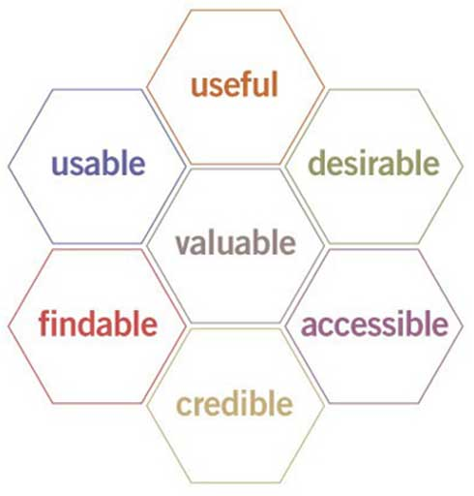

 In order for there to be a meaningful and valuable user experience, information must be:

* **Useful**: Content should be original and fulfill a need
* **Usable**: Site must be easy to use
* **Desirable**: Image, identity, brand, and other design elements are used to evoke emotion and appreciation
* **Findable**: Content needs to be navigable and locatable onsite and offsite
* **Accessible**: Content needs to be accessible to people with disabilities
* **Credible**: Users must trust and believe what you tell them

Verbat understands that government is the largest single producer, collector, consumer and disseminator of information. With such a strong presence in the daily life of its citizens, the government, as well as their agencies, develop their own web sites from which they render a number of services. Just like any other web site, these sites operate in an environment that includes their own internal goals and those of their customers.

Governments are publicly accountable. Thus, their web sites and those of their agencies need to justifyReturn On Investment (ROI). If these sites do not meet the visitors’ needs, then the number of complaints from unsatisfied citizens will proportionally increase with traffic. Due to the fact that governments must adopt citizen-centric approaches, such disservice has larger repercussions.

MOCCAE is a hub to a whole host of services (>100), it is critical that the public utilizes these service via the online portal. Verbat understands that by developing a site that adheres to the seven tenets of User Experience, It can save the Government a huge amount of money. This is because the Government could reduce the labor required to manage and maintain field offices and Customer Service centers along with costs incurred in maintaining these facilities.

# DETAILED REQUIRMENT SPECIFICATIONS

|  |
| --- |
| **BEEATNA.AE (Static pages)** |
| UAE Environment |
| Definition of climate change |
| National efforts to address climate change |
| Biodiversity and environment |
| National Biodiversity Strategy |
| Air quality |
| Wastes and chemicals |
| Food safety |
| Agriculture development and health |
| Animal development and health |
| Marine environment and fisheries sustainability |
| Ecotourism |
| Environmental authorities |
| Environmental-Authorities-in-UAE |
| Environmental reports |
| Events |
| Seniar |
| terms and conditions |
| Privacy policy |
| Contact Us |
| Social media links |
| Bilingual |
| Google Translate plugin |
| **MOCCAE.gov.ae** |
| **CMS for Dynamic Content** |
| Services content pages |
| About the ministry Pages |
| Add new legislations |
| Knowledge with |
| Related legislations |
| Strategies |
| Initiatives & projects |
| Conventions |
| Reports and studies |
| Bulletins / guides |
| Terminology |
| Knowledge -> Biosecurity |
| Manage Terminology |
| Blog |
| Polls |
| surveys |
| Video library |
| Photo Gallery |
| News |
| Publications |
| Logos |
| Activities and Events |
| Audio Gallery |
| Archive |
| Initiatives |
| Open Data |
| Government Links |
| Manage appointments |
| Happiness center |
| Post careers |
| English / Arabic |
| **Static Content & Page Templates** |
| Knowledge -> Biosecurity |
| Social media |
| E-Participation (8 Pages) |
| GIS MAP |
| Request Data |
| Submit Data |
| Register |
| Login |
| Search Advanced Search |
| Contact |
| Sitemap |
| Accessibility Settings |
| Personalize |
| Social media |
| RSS Feeds |
| Remarks and suggestions |
| Share |
| Chat-bot |
| Chat |
| Print page |
| Font settings |
| Home page |
| About the ministry |
| Legislation |
| Our services |
| Knowledge |
| E-Participation |
| Media center |
| Open Data |
| Book Appointments |
| Electronic refunds |
| Eservice user manual |
| View appointment |
| Subscribe to news letter |
| Call US |
| Copyright notice |
| Privacy |
| terms & conditions |
| Disclaimer |
| Visitor count |
| FAQ |
| contact Us |
| Careers |
| Search Legislations |
| Terminology |
| newsletter |
| **Administration** |
| User Management |
| Authentication and Authorization |
| Logging and Auditing |
| Tags & Category Management |

# APPLICATION ARCHITECHURE

## Information Architecture

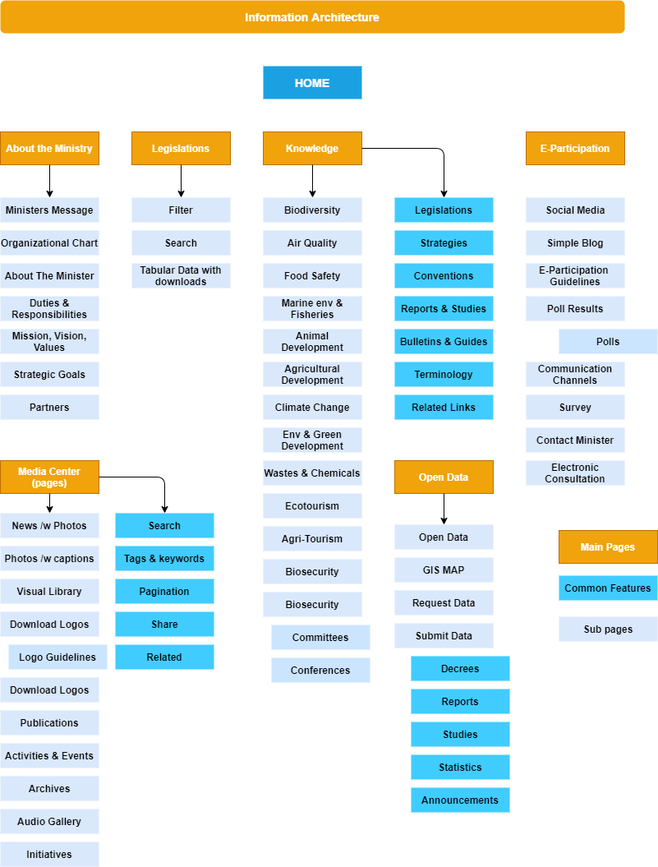

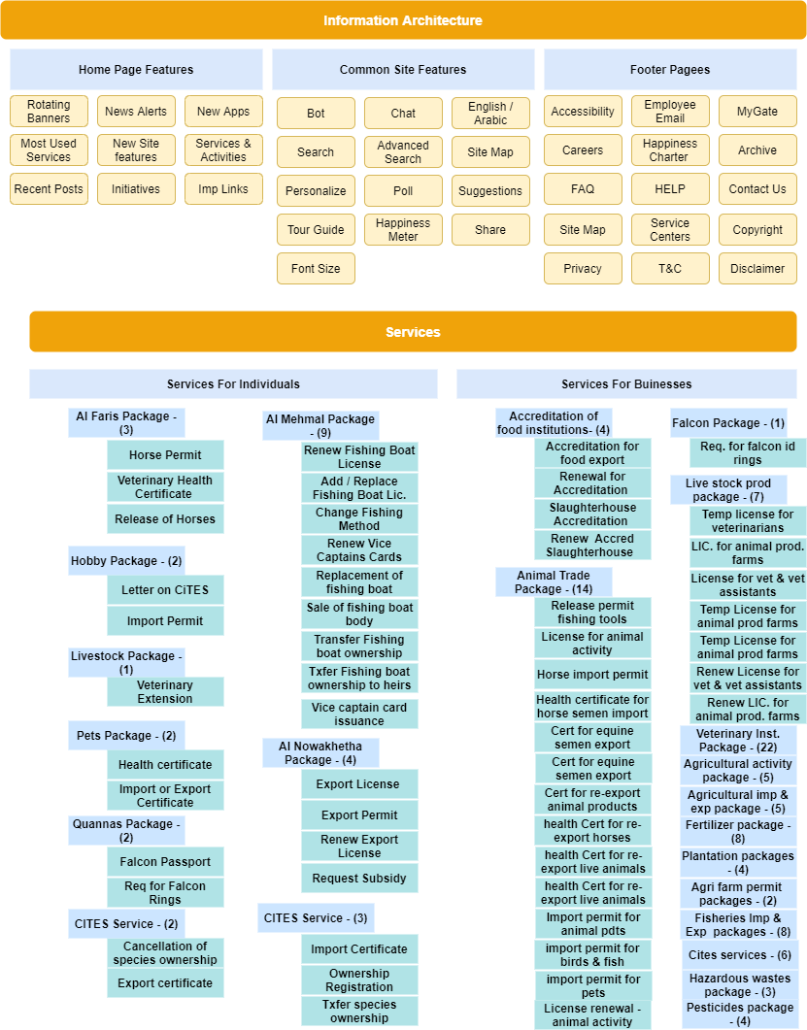

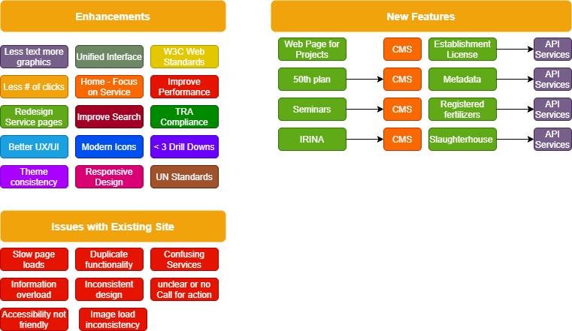

## Technical Architecture

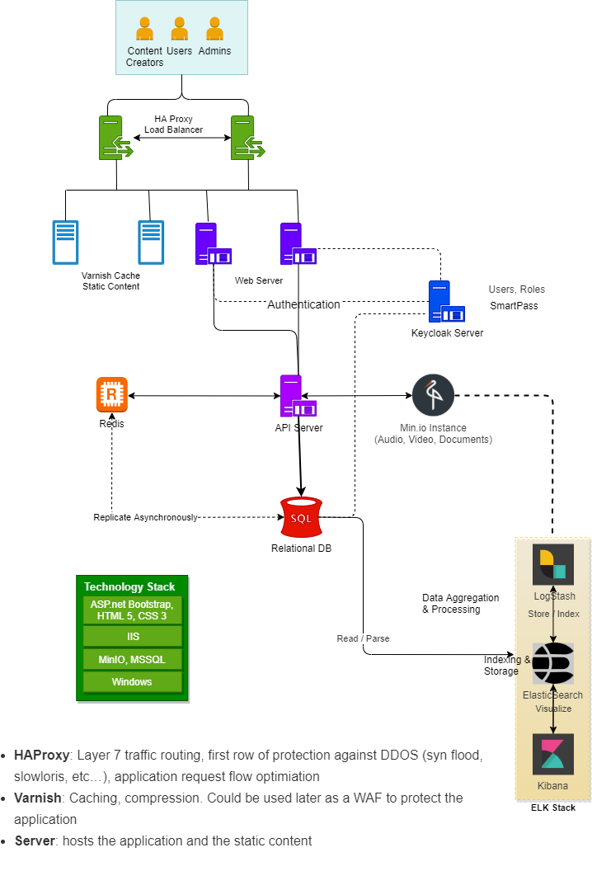

### Performance boost considerations

**Varnish and HA Proxy Layer**

**HAProxy**: Layer 7 traffic routing, first row of protection against DDOS (syn flood, slowloris, etc…), application request flow optimization

**Varnish:** Caching, compression. Could be used later as a WAF to protect the application

**Server:** hosts the application and the static content

**Traffic Flow**

Basically, the client will send all the requests to HAProxy, then HAProxy, based on URL or file extension will take a routing decision:

* If the request looks to be for a (pseudo) static object, then forward it to Varnish  
  If Varnish misses the object, it will use HAProxy to get the content from the server.
* Send all the other requests to the App Server. If configured properly, there should be only dynamic traffic here.

Varnish is not used as the default option in the flow, so as to avoid caching dynamic content as it could lead to somebody’s personal information sent to everybody…  
Furthermore, in case of massive misses or purposely built request to bypass the caches, it will prevent Varnish from hammering the App Servers as HAProxy protects them with a tight traffic regulation between Varnish and App Servers.

**Static Traffic flow**

* The client sends its request to HAProxy which sees that it is asking for a static content
* HAProxy forward the request to Varnish. If Varnish has the object in Cache (a HIT), it forwards it directly to HAProxy.
* If Varnish doesn’t have the object in cache or if the cache has expired, then Varnish forwards the request to HAProxy
* HAProxy randomly chooses a server. The response goes back to the client through Varnish.

In case of a MISS, HAProxy prevents Varnish to flood the servers. Furthermore, since Varnish sees only static content, its HIT rate is over 98%… So the overhead is very low and the protection is improved.

**Dynamic Traffic**

* The client sends its request to HAProxy
* HAProxy chooses a server based on cookie persistence or Load-Balancing Algorithm if there is no cookie.

The server processes the request and send the response back to HAPRoxy which forwards it to the client

**ElasticSearch**

Elasticsearch is a search engine based on the Lucene library. It provides a distributed, multitenant-capable full-text search engine with an HTTP web interface and schema-free JSON documents. Elasticsearch can be used to search all kinds of documents. It provides scalable search, has near real-time search, and supports multitenancy. Elasticsearch is distributed, which means that indices can be divided into shards and each shard can have zero or more replicas. Each node hosts one or more shards, and acts as a coordinator to delegate operations to the correct shard(s). Rebalancing and routing are done automatically. Related data is often stored in the same index, which consists of one or more primary shards, and zero or more replica shards. Once an index has been created, the number of primary shards cannot be changed.

**MinIO**

**MinIO** is a cloud storage server compatible with Amazon S3, released under Apache License v2. As an object store, MinIO can store unstructured data such as photos, videos, log files, backups and container images. The maximum size of an object is 5TB.

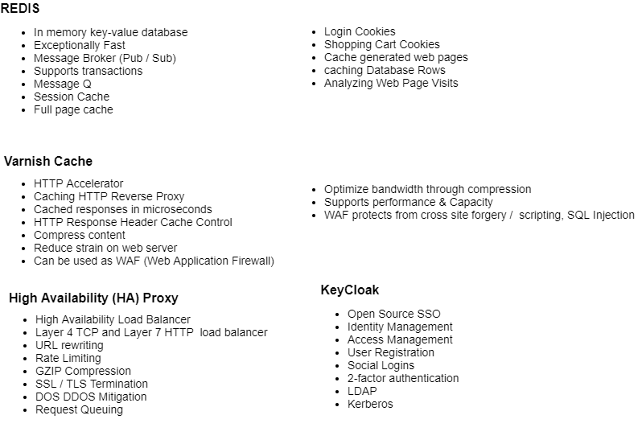

## Hardware Architecture

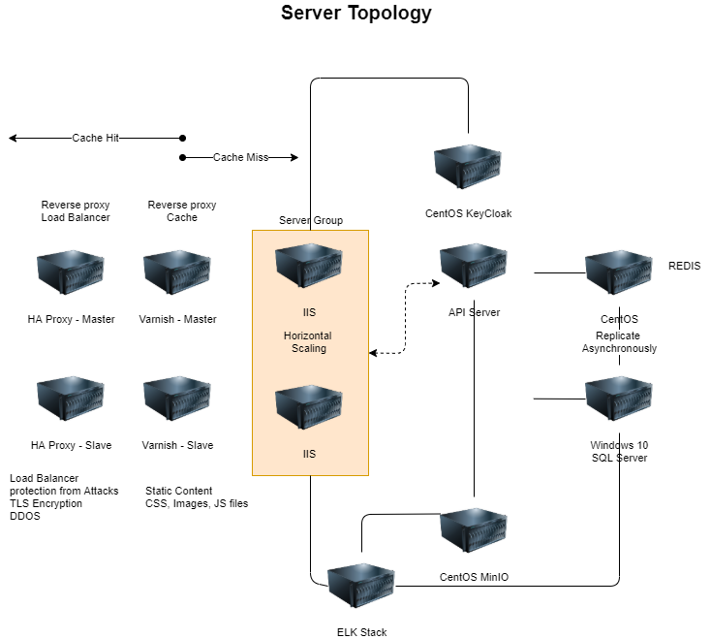

## Security Architecture

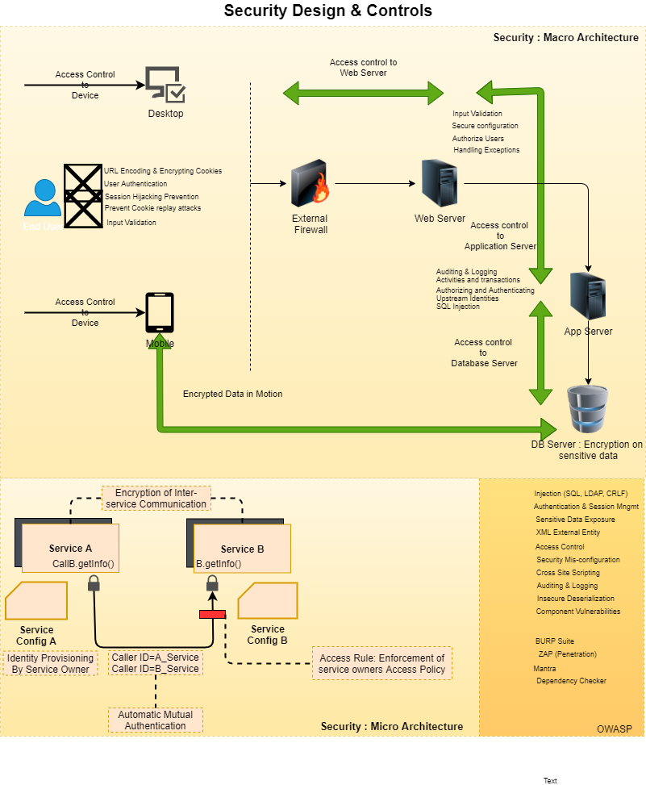

## Quality Assurance

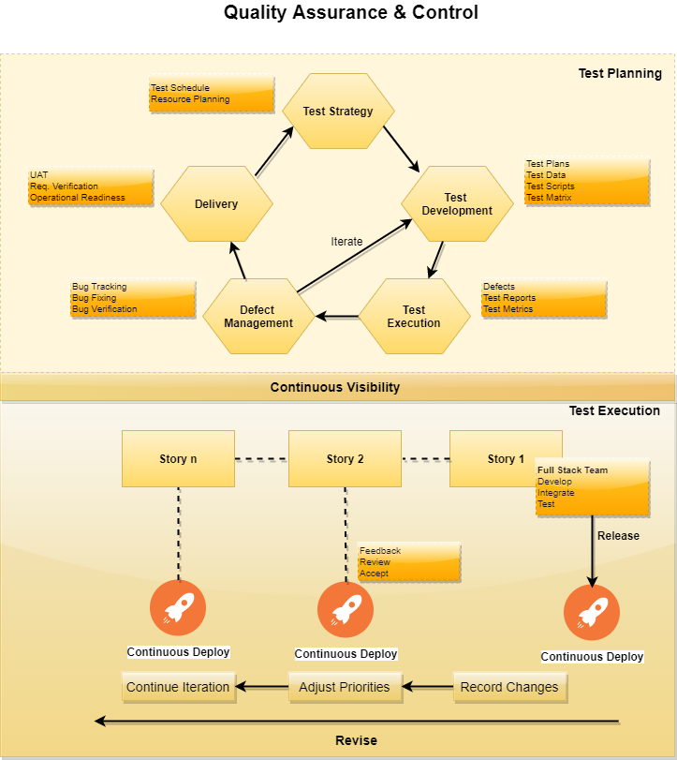

## Release and Deployment Process

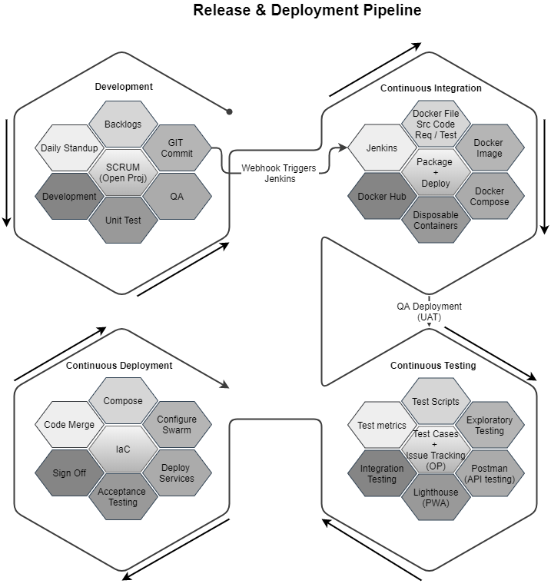

## Verbat’s Website Redesign and Enhancement Strategy

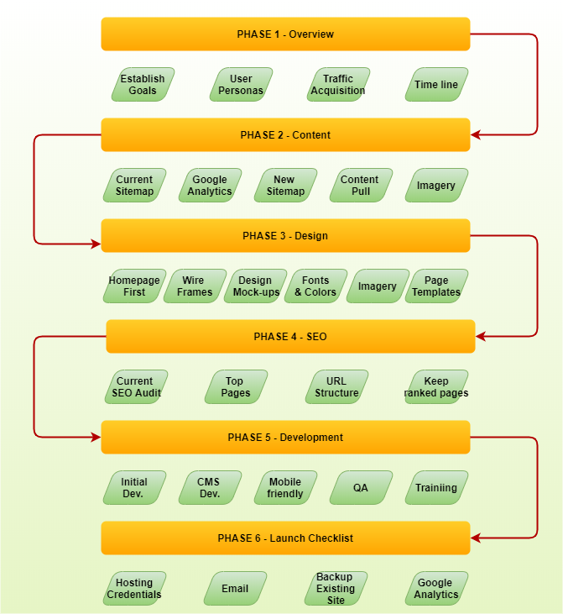

# Usability Issues with MOCCAE

Listed below are a few usability issues that were noticed at a first glance

## Images do not always load

## Inconsistent Call to Action

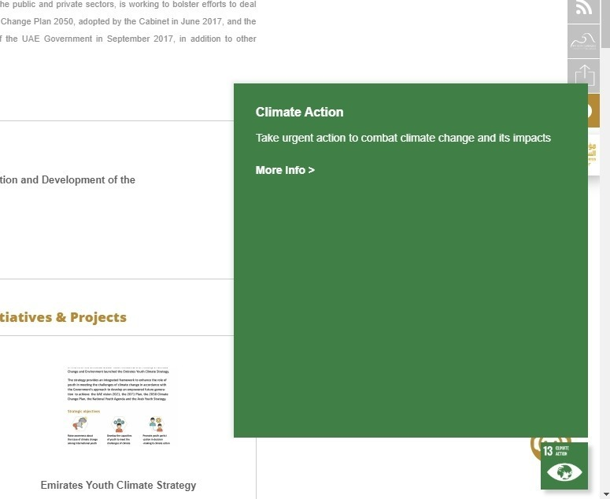

## Incorrect use of Icons

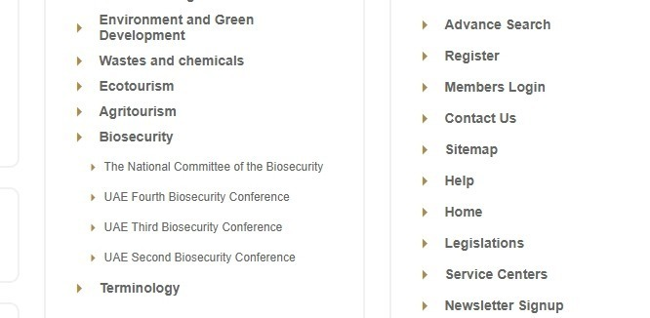

## Error messages could be more helpful

Mandatory fields are not very prominent and obvious

## Information Overload

There is too much information of the same type. Also it is comingled with information that has no relevance. This is confusing and misleading.

## Mandatory fields are not very obvious



## The services page provides too many options

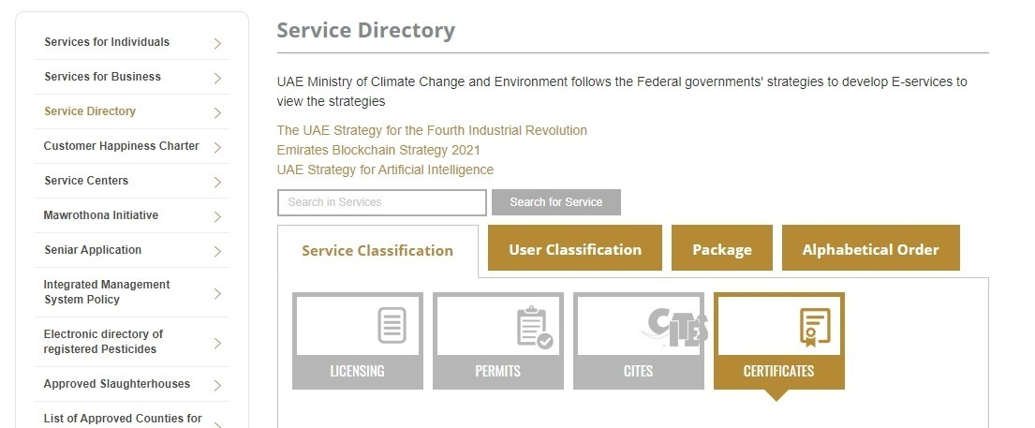

## The sign language interpreter is hardly functional

Does it make sense to have a functionality that is inconsistent and lags constantly?

## Page loaded with blank dropdowns

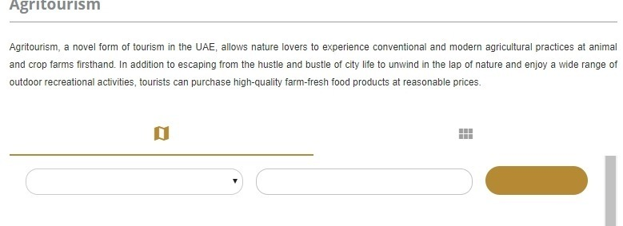

This behavior is consistent with slow page loads and unusable UI

## Webpage loads, but the content is un-curated

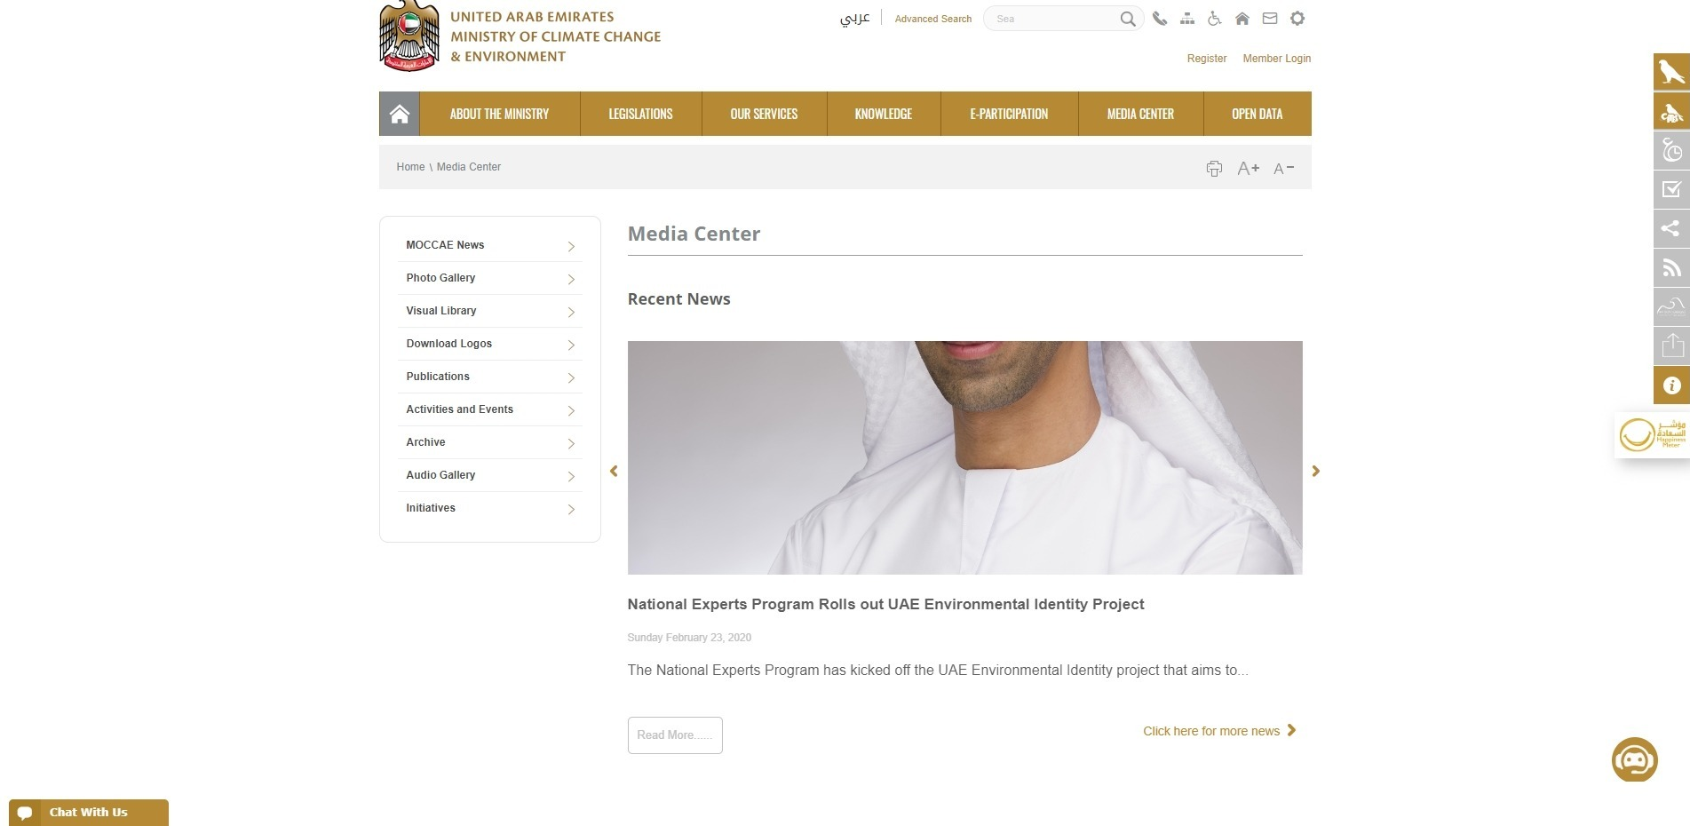

It appears that the content has either been not curated or the image is not scaling to the container that it is bound in

## Chat bot repeats itself

## YouTube videos that do not load

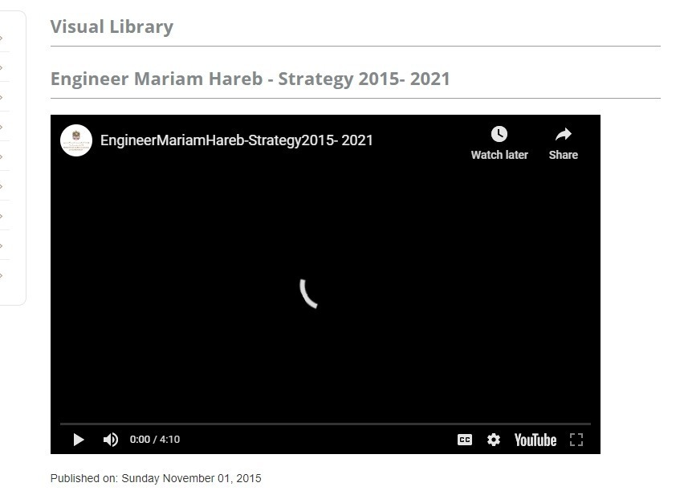

## Verbat Guarantee

|  |  |  |
| --- | --- | --- |
| Specification | Current | Future |
|  | | |
| Home page load | ~ 15 - 38 Sec | << ~3.5 Sec |
| Other pages | ~ 4 - 8 Sec | << ~2 Sec |
| Search drop down results | ~ 4 - 5 Sec | << ~ 2 Sec |
| Search results page | ~ 4 - 5 Sec | << ~ 2 Sec |
| Browser Compatibility | Compatibility with major browsers (Opera, Chrome, Edge, Firefox) | Compatibility with major browsers (Opera, Chrome, Edge, Firefox) |
| Device Compatibility | Mostly compatible. Tested using responsivetesttool.com | Compatible with iPhone 6+, Samsung S5, S3, S8, Google pixel, Samsung Note 7+, LG Nexus 4+, HTC One, One plus 3 +, MI 3, Blackberry leap |
| UI / UX compatibility | Unevaluated | See Below for sample Checklists |

**Responsiveness**

**Features**

**Fluid layout**

Content must be visible and accessible on any device size: Grids and column help to ratio the content appropriately

**Breakpoints**

Identify when to change the structure and how it will look: Focus on ultra-wide, desktop, tablet and mobile

**Typography**

The size of the text on each device size: Scale headings (a H1 should not be the same size on desktop and mobile)

**Change in selection area**

The area for a user to select an element e.g. text field or button: Mobile devices can afford larger space to select a button or text field as desktop devices typically have a mouse in use with finer accuracy and reach

**Scalability**

Minimizing content and adding to it at the right screen size: Keep content and visuals simple and minimal as possible on mobile, with a top down view. Desktop and tablet can be more abstract and grander in visuals as more is visible at one time

**Vector files for images (optional)**

An SVG allows any visual to be at 100% resolution at any size. One file fits all device sizes in being perfect in quality.

**Typography**

Text dictates several characteristics: tone, style, focus and structure. How you execute your typography is just as critical as your color palette, illustrations and overall design of the product.

**Features**

**Font Combinations**

How well do they work well together: A clear matrix for font choices helps consistency - one font for only headings, another font for only body text for example. The lower the saturation, the more accessible a color will be

**Line alignment and length**

The direction of how the text sits and how long it runs for. 50–60 character per line on desktop is a common guide, 30-40 on mobile

**Scale and variation**

How each text style differs in size: Headings should be noticeably larger and stronger than your body text. Create a variety of headings and consider their use cases. Establish the minimum size the fonts are readable.

**Contrast and style**

Visibility and look of text: Check text colors across accessibility tests. Incorporate color palette established for other elements and components

**Spacing**

The distance between different types of text

**Switch to light mode**

Some products may be just one or the other, but if you offer both then allow the user to make a seamless switch between the two.

**Dark Mode**

The ability to make the switch over a screen easier on the eyes at night has been increasingly demanded as a necessity in a product. For a designer, dark mode is larger than just flicking a switch and inverting some colors. The accessibility options completely change and your shades for structure and layout need to be re-evaluated - just for starters.

**Features**

**Adaptable color palette**

What your product looks like visually with a dark setting: A grey for your darkest color is more flexible in shadows and contrast than black. The lower the saturation, the more accessible a color will be. Ensure dark palette for backgrounds must allow white to be accessible

**Brand integrity**

Maintain your visual tone and style: Invert monotone visuals. Incorporate colors from your brand that are also present in light mode

**Elevation**

A way to structure elements to establish hierarchy: Use lightness over shadows to give focus to certain containers or elements

## NON-FUNCTIONAL REQUIREMENTS (OTHERS)

|  |  |
| --- | --- |
| **Requirements** | **Details** |
| User Experience and  UI Design | * The application will be developed in English and Arabic * The layout and graphical components will be created considering the usability factors |
| Performance | * Application will allow users to have smooth and quick access to the information or services they require. |
| Security | * Web security standards shall be followed. |
| Scalability | * Website shall be designed with the ability to add new services without impacting usability |
| Usability | * Website shall be user centric and its design shall be strongly influenced by user journeys. The designs and wireframes developed shall be technically executable |
| Accessibility compliance | * WCAG 2.0 compliance * TRA compliant * UN standards compliant |

## Design Phases

|  |  |  |  |
| --- | --- | --- | --- |
| Phase | Task | Activity | Deliverables |
| Discovery & Planning | Stakeholders Workshop | * Stakeholders workshop using Go To meetings * Understand and analyze wish list from stakeholders and put them into perspective * Brainstorm ideas, identify challenges, expected KPI’s and benchmarks | Vision document (Feedback, pain points, analysis & design) |
| Research (Customer Insights) | * Perform user interviews based on user segments identified in the research phase * Benchmark based on competition; perform high level audit of website and services * Create personas based on analytics and research * High level review of google analytics | * User testing protocol and report * Strategy document with consolidated outputs from all activities |
| Persona development & User Journey | * Build personas to convey user experience challenges * Define structure based on user tasks & pain points | User journeys and task flow document |
| Structure & Prototyping | Information Architecture | * Create site hierarchy based on user journeys and tasks. * Guidelines for sitemaps   + Discovery of content based on users mind map   + Current trend in user navigation   + Relevance of content based on users mental map model | Site architecture and Site map |
| Wireframe and FSD | * Create new navigation * Create wireframes * Review with client’s team * Obtain approvals | Wireframes and FSD |
| Prototyping and Testing | * Create click through prototypes * Prototype with User journeys * Elements to be tested: Navigation, Terminology & labels, Structure, User expectation | 3 prototypes  Test document  Test results  Analysis |
| Content | * Create content based on templates * Client to deliver and approve content | Content Matrix : English & Arabic |
| Visual Design and UI Guide | * Agree on visual designs in conformant with the clients guidelines * Create visual designs based on approved wireframes * Receive approval from client | Visual design and style guides |
| Eye tracking testing & Usability testing | * Prototype to cover user journeys * Elements to be tested: 1st impressions, design elements, Legibility & readability, Colors and typography * Design Iteration | Test guide document  Analysis report |
| Implementation Phase | Implement requirements | * Implement new design * Enhance performance * Implement new pages * Implement integration | Deploy on staging |
| QA | * Provide reports on different types of testing | Test cases  Test results  Defect reports  Performance testing report on internet browsers  Compatibility test report |
| UAT Sign-off | * UAT testing * Maintaining Sessions | UAT Test cases  UAT Signoff document |
| Go Live | * Prepare for deployment * Announce Go-Live | Training Session  Go Live approval document  Training Material |
| Closure Phase | PIR | * Fix all issues reported after Go-Live | Issue List with status  Sign-off document and project closure  All technical documents  Latest source code  Knowledge Transfer |

## TECHNICAL CONFIGURATIONS

### DEVELOPMENT ENVIRONMENT

* ASP.net or .Net core
* MySQL or MSSQL
* HTML 5 / CSS 3
* MinIO, Redis, Elastic Search, KeyCloak (All Open Source)

### RECOMMENDED WED HOSTING PACKAGE - DEDICATED

* Operating System: Windows Server
* CPU: 2 cores
* Domains: Unlimited
* Disk Space: 200 GB
* Monthly Bandwidth: 50 GB
* IIS
* .Net SDK, ASP.net

### BROWSER

The application developed shall be compatible with the browsers listed below:

* Internet Explorer 11
* Mozilla Firefox 50 or above
* Chrome 50 or above

### HARDWARE DEVICES

#### Mobile device with the following specs

* The device should support LTE / Wi-Fi 802.11 a/b/g/n/ac
* The device should have 3 GB RAM and above memory

#### Web Server

We recommend the specification mentioned below for the best output:

* Microsoft Windows Server 2016 with IIS 7.5 +
* Processor: 4.20 GHz Intel Core i7-7700 or equivalent
* Memory: 16GB
* Disk Space: 1 TB of free disk space

### TECHNICAL STANDARDS

* Testing Devices

Google Pixel     Android 7

Motorola Moto G Turbo Edition -   Android 6

* OS Version

Android: Android KitKat and above

IOS: IOS 9+

### TECHNICAL GUIDELINES

These guidelines provide instructions and conditions that will be adhered to during the development of the mobile application.

* API will be used, as the case may be, in realizing the features and functionalities mentioned.
* The client will finalize the functional requirements and UI/UX before the commencement of the project.
* Verbat will be testing the app in the mentioned devices only. Testing on devices other than the ones mentioned under the “Technical Standards “will have to be specified and provided by the client at the beginning of the development phase.
* The client will have to provide the details of the testing devices they are using before the start of development phase.
* Client should provide the relevant Developer's Account credentials before the development phase. In case Verbat needs to create the developer id, additional charges will be incurred by the client.
* The duration mentioned in the project timeline is for the development and testing; any delay or time taken by the review team to respond will not be Verbat’s responsibility.
* Any clarification required from client needs to be addressed within 02 business days.
* The apps will be developed / created within the guidelines of respective play store.
* Verbat will strictly follow the guidelines provided by the respective stores.
* Verbat will inform the client if any of the client requirements / request deviate from it.
* Customization of the features of the app will be susceptible to the limitation imposed by the respective platform/ store.
* Once development commences, the test device/screen sizes will not be susceptible to change. Any change requested by the client will have to go through change management.
* OS version support will be limited to the ones mentioned in the technical specifications. Further support will have to go through change management.

## PROJECT DELIVERY

### Agile Methodology

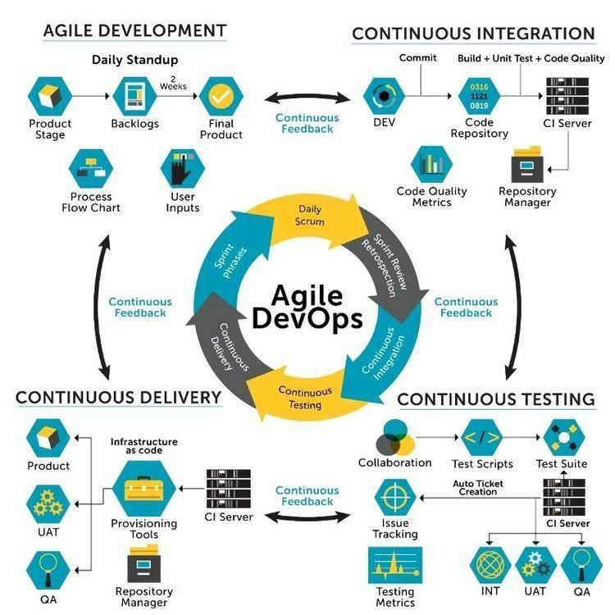

Verbat’s philosophy has been to deliver products that allowed clients to be intimately involved with the development activity. As early as 2005 Verbat had adopted the agile development practices into its pipeline for software development. This allowed clients to closely observe the product being developed. It created a tight feedback loop that allowed us, along with our clients to better understand the requirements and build a right sized and proportional product.

With the advent of next generation applications and tools that support a wide range of activities related to development, deployment and integration; the feedback loops became tighter and coupled, while at the same time it allowed us to create applications that were decoupled. Thus giving us the capability to have greater flexibility in development and deployment.

While development broke down the barrier between developers and management, Devops broke the barrier between software developers and operations teams. Our development and operations teams work under a single silo. While our Scrum teams are cross functional, in our quest to adopt better integration with operations, we have realized that Devops is not just a set of tools and processes, but a mindset and culture. We have fostered a culture collaboration and communication. Our scrum teams and Devops teams share a symbiotic relationship and they work united towards a common goal.

As a company, we have adopted the following tenets in our Devops philosophy

**Speed:** i.e. Move at a high velocity so as to innovate faster for customers and adapt to changing markets better, and grow more efficient at driving business results.

**Rapid Delivery:** Increase the frequency and pace of releases so we can innovate and improve products faster and thus respond to customers’ needs and build competitive advantage.

**Reliability:** Ensure the quality of application updates and infrastructure changes so we can reliably deliver at a more rapid pace while maintaining a positive experience for end users.

**Scale:** Operate and manage infrastructure and development processes at scale.

**Improved Collaboration:** Build more effective teams under a DevOps cultural model, which emphasizes values such as ownership and accountability. Developers and operations teams collaborate closely, share many responsibilities, and combine their workflows.

**Security:** Move quickly while retaining control and preserving compliance. We adopt a DevOps model without sacrificing security by using automated compliance policies, fine-grained controls, and configuration management techniques.

Please see below an illustration of our technology stack. The tools of the trade that allow us to practice an Agile and Devops centric framework

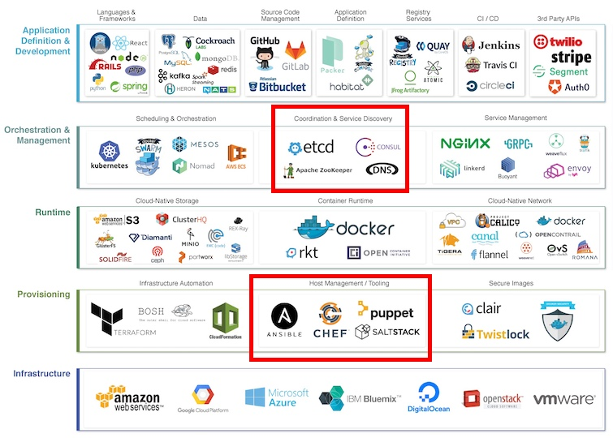

### PROJECT MANAGEMENT

The Verbat development center strictly follows industry standards on quality. Our project management process is governed by the Verbat Quality Management system and is verified through internal audit programs.

Verbat will dedicate a project leader for the proposed implementation. Furthermore, Verbat proposes the client to identify one project manager (*CSPM – Client-Side Project Manager)* who will be driving all activities undertaken by the client, and will be the single point of contact for Verbat.

### ROLES & RESPONSIBILITIES

Verbat will assign its own dedicated Project Lead (*VPL – Verbat Project Lead*) for the client. The VPL will be responsible for planning and management of all activities related to the project. Furthermore, the VPL will work closely with CSPM, on all periodic status updates and will ensure high level visibility and comfort on the progress of the project.

### DELIVERY ACTIVITY SUMMARY

|  |  |
| --- | --- |
| Activities | Description |
| Proof of Concept | Working Model of the project with two languages. |
| Detailed Requirement Analysis | Verbat team to conduct detailed study of requirement for the phase. If clarification is required, the team will reach out to Client for more information and/or time for discussions. |
| DB Design | DB design for central and test DB. |
| Software Requirement Specification document (SRS), | Once the requirement analysis is completed, Verbat team will submit the SRS document for approval |
| UI/UX Design, Prototyping | Based on the SRS, Verbat UX/UI team will work on the UI/UX of the screens and submit prototype for approval |
| Functional Specification Document (FS) With solution architecture | Once the UI/UX is approved, Verbat shall submit an FS document for approval. |
| Development | Actual system development starts based on the FS. This involves detailed design and software development of Web Application. |
| Testing | Test Planning, test plan creations, internal, integration testing and user acceptance testing. |
| Deployment | Deploying the latest build in the Verbat Test Server |

### PROJECT IMPLEMENTATION PLAN

Verbat will be providing the solution in a stand-alone fixed bid approach which ensures minimum viable solution for quick wins with core focus on the long-term business objective and outcome. Once the implementation is over, Verbat will initiate the application maintenance process (*once the maintenance contract is signed*) which continues to extend after the implementation.

### DELIVERABLES

* Proof of Concept
* Project schedule
* Requirement Traceability Matrix
* Communication management plan
* Software Requirement Specification Document (SRS)
* Prototype Design
* Functional Specification Document (FS) with final architecture
* Fully Developed & Tested Application
* Latest source Code
* Technical documentation
* User manuals

### ESTIMATED DELIVERY TIME

The timeline estimated for delivering the application will be as below:

* Working days to complete the proof of concept on completion of resource mobilization.
* Working days to complete the SRS & prototype of Language Translation Application.
* Working days to complete the development.

| **Activity** |
| --- |
| Contract Signoff (T0) |
| Proof of Concept-Allocate Resource |
| Proof of Concept-Complete |
| Proof of Concept- Approval (T1) |
| Detailed Requirement Gathering |
| Software Requirement Specification Document (SRS) |
| SRS Approval (T2) |
| System UI/UX Prototype-Complete |
| System UI/UX Prototype-Approval (T3) |
| Functional Specification (FS) |
| FS Approval (T4) |
| Development Phase-Complete |
| Perform QC (Unit Testing and Integration Testing) |
| System ready for UAT |
| UAT Acceptance on Verbat production server (T5) |

*Note:*

* *The above-mentioned timeline is in Working Days.*
* *Upon project confirmation, Verbat requires a lead time of minimum () working days for resource mobilization for proof of concept.*
* *Resource mobilization will be initiated post the confirmation of the project along with LPO, signed*

*proposal and advance payment.*

* *The initiation of the UI/UX/Prototype development is dependent on the confirmation of SRS.*
* *The above-mentioned timeline for development is post-confirmation of FS.*
* *Documentation submitted after project initiation and system study supersedes any proposal or documentation submitted during initial requirement gathering / discussion / negotiation.*
* *Project plan will be submitted post the confirmation of project with necessary payments.*
* *Any delay in getting the approvals of deliverables from client will cause change in timelines and the revised timelines will be updated in weekly status reports shared with client after the project commencement.*
* *All approvals and queries regarding the client requirement and any queries which may hinder the project advancement at any stage should be answered by the client within () business days from the time of initiation, failing which, the time delay will get added to the actual effort and timeline estimated.*

### DEPLOYMENT DETAILS

* Cloud server for hosting the application will be the responsibility of the client.
* Verbat will deploy the application on client’s cloud server after the client conducts the necessary acceptance testing.

*Note:*

* *Hosting the application at Verbat’s production server (hosting charges) will call in for additional charges. In the event, client wants to procure SSL, the same can be provided by Verbat at additional cost.*
* *Only deployment of the application will be the responsibility of Verbat, any additional installation will be charged separately.*

### RELEASE PLANNING

* Client will be informed about the release date and time through email.
* Client performs the UAT

### RISK CONTINGENCY PLANNING

Verbat has identified various risk factors associated with this assignment and understands the impact of these risk factors on the project schedules. The objective of this section is to highlight for both Verbat and client, the risk factors, to analyze the impact of the risks on project execution, and to propose strategies to control and reduce the impact of the risk factors. These various risks, which could arise during the project, are tabulated below along with mitigation implementation.

| **Type of risk** | **IMPACT** | Risk Mitigation | Risk Handling |
| --- | --- | --- | --- |
| Scope Creep | **H** | Functions and features will be detailed in system requirement document and will go through client approval. Once this document is approved, all changes will go through the change management process for impact assessment. | Proper change management procedure will be implemented |
| Delay in client feedback | **H** | The plan is prepared with sufficient lead-time for reviews and approvals.  The client will advise us on all dates connected to the document review and approval. | The request for feedback will be escalated if not attended to at the right time so that the schedules are not affected. Deemed acceptance criterion is finalized up-front and will be followed |
| Non-availability of necessary software, frameworks, database instances and infrastructure at client’s hosting environment (If hosting support is provided by Verbat) | **M** | Client will be informed in advance on these requirements. | Possible impact to schedule |
| Manpower attrition | **L** | All efforts will be made to ensure that all initiatives are process dependent. To mitigate risk Verbat/Client will train a person to ensure all back-ups are in place. | A new person will be appointed as early as possible, provided the required project-specific training and mentoring is in place - to minimise impact of attrition on the project |

*H-High, M-Medium, L-Low, NA-Not Applicable*

## PROJECT ASSUMPTIONS

The project solution and technology are created from the initial understanding of the requirement shared with Verbat through mails and meetings. The proposed solution is based on the following assumptions:

### OBJECTIVES

* The requirement is to develop 2 web sites for the client. The project involves development of such sites with a focus on usability and accessibility. The ultimate aim of the site is to maximize user experience.

### DESIGN

* Client to provide Verbat with the branding guidelines.
* Color theme shall be provided by the client.
* Client shall provide licensed images and logos in specified size & format.
* Client shall provide the text and associated images for the proposed application. Text should be provided in digital format preferably in MS Word 2013 or above
* Verbat is free to use custom-made template for design, if required.
* The application designed for mobiles will be in portrait mode

### DEVELOPMENT

1

Client shall procure the following services - Google Translation Services. (If required)

* Additional charges may be incurred for archiving and encryption services (depending on the requirements).
* Peers making use of translation services are likely to experience a latency which is directly proportional to the bandwidth of their network connection.
* The application requires a fast internet connection for real time communication.

# **OUT OF SCOPE**

With the ever-evolving digital market, the requirement should be clear to both the parties involved, hence the importance of mentioning the out of scope details of the project. Following are considered to be out of scope while creating this proposal:

* Purchase of images, fonts
* Any language other than English
* Migration of existing data / Database migration
* Content writing / proof reading / Data Replication / Manual data entry
* Content or image procurement or uploading or editing
* Native iOS App Development / Android App development
* Developer account creation and Maintenance (*IOS and Android Store*)
* Adding new features to the application other than mentioned in the functional specifications. Such requests will be handled via change management. For Change management details, please refer to section titled “Change Management” in the Proposal. (*refer page no: 33*)
* Annual Maintenance Contract (*Bug fixing, debugging, enhancements*) – Please refer to section titled “Maintenance and Support”, unless contracted for. (*refer page no: 34*)
* Hosting Infrastructure and Maintenance (*web and email hosting*), unless contracted for.
* Backup solution and Disaster recovery unless contracted for.
* Physical deployment on-site / installation of the application in devices and physical connection, installation of system.
* Integration with third-party, if any, other than mentioned in the functional specifications
* Hardware Integrations / procurement and purchase
* Procurement of SMS gateway / payment gateway / email gateway
* Integration of SMS gateway / payment gateway
* SSL Purchase and installation, if any
* Plugin/template purchases, if any
* API purchases
* OS other than mentioned in the Hardware Interface
* Relevant / related software libraries
* Mobile offline access or operations
* Verbat shall develop no more than 3 e-services. Additional e-services are out of scope until agreed upon otherwise.
* It is assumed that these services are part of the main domain.
* Verbat does not own a Usability lab and hence shall not be providing such services
* Verbat shall not be responsible for the management of the eservices sub domain. Any development related to it is out of scope
* The client shall be responsible for delivering the Arabic content on time. Client is expected to notify Verbat on time with regards to corrections related to grammar or typos.
* The web site shall not be tested for IE 11 or its predecessors.
* Browsers covered for testing are Chrome, Edge, Firefox and Opera

# **CHANGE MANAGEMENT**

Any addition which comes out of the project scope, upon and after the launch of the website will be considered as change management. Verbat recommends the following change management procedures for the same:

* Changes will be implemented only after raising a change request.
* Change requests will be studied and an impact analysis will be performed on the existing work flow.
* Upon assessment of the impact, effort estimation will be calculated and raised as an additional requirement.
* The change request will be initiated only after receiving a formal approval from the client for the additional changes raised.
* Changes which are out of scope will be charged @ per man day rate.

Activities for change scheduled

Modules checked in

Unit testing done

Change request accepted

Informed of the Action

Implementation of changes

Modules checked out

Activities planned and scheduled

Effected modules identified

New system released with change request

Changes made & documented

System

Need for change recognized

User submits change request

Evaluate for cost, schedule & effort

Change control authority

yes

No

## MAINTENANCE & SUPPORT

* Maintenance contracts by default are supported as per the basic SLA terms.
* AMC with Basic SLA is charged at % of the total project value. Additional Effort/change management request will be added towards Total Value of the Project to determine the AMC value.
* Maintenance support is limited to providing application support for ensuring the consistency of the look-and-feel, bug fixes and user issues i.e. maintenance and support of the existing features of the application.
* Support does not in any way cover providing technical or other support to the end users or hardware support. The maintenance agreement does not include functionality changes or feature additions which are handled as change requests which will be charged per man day rate. AMC does not include server support, maintenance and application deployment.
* AMC charges will cover Off-Site Support and Debugging. Support includes E-mail, telephone and video conference (if required). In the event, the application is hosted with the client or if it is a client server development; necessary remote desktop connectivity should be provided for carrying out maintenance activities.
* All maintenance support will be executed by Verbat off-site team. In the event of any need for on-site work, all expenses incurred for such trips (flights, accommodation, meals transportation) will be payable to Verbat by client.
* Gap in AMC - In case if the client does not opt an AMC for a year and wants to renew it after that period, % of the AMC amount for the year for which AMC is not taken will also be payable if the client wishes to renew the AMC contract.

|  |  |  |  |  |
| --- | --- | --- | --- | --- |
| **SLA Type** | **Max Response Time** | | **Max Resolution Time** | **Target** |
| Basic | 1 working day | 3 working days | | Request / incident / problem tickets |

*Note:*

* *Time zone applicable as per India Time Zones (3:30 GMT to 12:30 GMT, Monday to Friday)*
* *Please note that the AMC support shall start only after all the necessary sign-offs (AMC Document) to this effect have been given.*
* *It is not mandatory that the client should opt for an AMC. The client will still be supported on an ad-hoc basis on an agreed man-day rate.*
* *AMC Payment Terms: 100% to be paid as advance.*

AMC Option: Client can opt for time and material based Annual Maintenance, the details of which will be shared post the completion of project.

# **TERMS AND CONDITIONS**

## ACCEPTANCE CRITERIA

* UAT (User Acceptance Test) sign off should take place within Days from the first release of the application and the acceptance confirmation needs to be mailed to Verbat failing which Verbat will consider the project as approved by the client.
* Any comments and reasons for rejection need to be documented and the same needs to be sent as an email from the official e-mail id of client to Verbat on or before days from the first release.
* Timeframe for acceptance for any further release will be mutually agreed and finalized between client and Verbat depending on the UAT Comments

## WARRANTY

* Verbat shall provide a bug ﬁx warranty at no additional cost for 30 days from the date of acceptance of the project, for correction of any errors in the developed application that may be attributed to Verbat.
* However, this does not cover modifications by Client, or use of the application on an environment other than the proposed environment, or other circumstances outside Verbat’s reasonable control. In such cases Verbat reserves the right to charge for its services.
* All error corrections will be executed by Verbat offsite team. In the event of any need for on-site work, all expenses incurred for such trips (flights, accommodation, meals, transportation) will be payable to Verbat by Client.

## SOURCE CODE & INTELLECTUAL PROPERTY RIGHTS

* Upon completion of the Project and 100% completion of the payment, the client will have access to the source code except for proprietary codes, developer tools and third-party applications etc.
* The solution offered will be the intellectual property of the client and will be made available to the client on an “unlimited license” basis.
* No person or organization, other than Verbat or any person authorized by Verbat in writing, has permission to modify/change the software solution to be eligible to get continued support from Verbat as per the support terms defined under this document.
* Verbat accepts no liability or damages of any kind arising out of use or non-use of the software delivered. The responsibility of testing of software lies with the client.

## GENERAL TERMS AND CONDITIONS

* Offer Valid for 30 calendar days from the date of submission of the Proposal.
* An average of 20 working days are assumed in a month.
* All the development activities will be carried out from our off-shore development center in India.
* All the documentations will be provided in English.
* Third party components may be used to develop this application.
* The scope of the project is to develop the application as detailed in the scope of the project and mentioned in this proposal. Any changes or additions will have to go through our change management process.
* This proposal is derived and concluded from either the RFQ /RFP/data shared via email / information transferred during an initial requirement analysis meeting / tele-conversation. Verbat reserves the right to change the terms of this proposal if the final terms (including the costing), features & functionalities and timelines are changed during the course of the project. Hence any fees quoted / timeline committed in this proposal may not be considered as final unless agreed upon and signed by both parties.
* Web Application will be best viewed only in the environment mentioned in the section Browser Compatibility.
* Mobile app will be best viewed only in the environment mentioned in the section Hardware Interface.
* All source codes and other project artifacts will adhere to the Verbat document templates and internal coding standards.
* The documents delivered to the client include the ones mentioned under ‘Deliverables’ and these will adhere to Verbat’s internal document standards.
* Acceptance criteria shall be based on the clauses which were mutually discussed between Verbat and client at the Requirement Analysis phase. The same will be documented and approved by both parties through official emails.
* In the event that the Client requires any extension of the proposed acceptance schedule, the associated effort and cost of such extension will be mutually reviewed.
* If the project needs to be put on Hold / Stopped, a minimum notice period of 1 week is required along with the duration of the holding period. Thereafter Verbat will make a final decision based on the request.
* If deployment is done in the client’s server, Verbat will not be held responsible for any performance issues arising due to hardware malfunctions.
* The Client is responsible for all data-backups in case the application is not hosted on the Verbat server.
* All source codes will only be delivered or uploaded on the production server after the due payments are made to Verbat.

## GENERAL ADMINISTRATIVE, TECHNICAL & FUNCTIONAL ASSUMPTIONS

* Detailed system study is required before the start of the project.
* During the requirement gathering phase, authorized personnel from the Client’s side are expected to be available for discussions and finalization of the HLD (High Level Design), before the development commences.
* Type of reports, formats if under the scope of the project, need to be specified by the Client before the project sign off.
* Workflows if under the scope of the project, need to be specified/ confirmed by client before project signoff.
* Verbat assumes that all sign-offs from the Client will be provided within the agreed and specified timeframe.
* Client will provide all the necessary contents, both text and imagery, before starting the project in the format suggested by Verbat (if any).
* The client should provide the relevant information and data, well in advance of the execution of the related activity. Non- availability of this information or data may lead to an interruption of work, which may result in a delay in delivery as well as additional costs to the client.
* The Client should possess a server with the technical specifications recommended by Verbat for the proposed application.
* The Client will be provided with a one-time training (train the trainer) on how to use the application via a video conference (maximum of 4 hours). Additional training requests will be charged at cost to the client.
* Cost of all third-party components to be borne by the client.
* Application will support in three languages which are supported by Google Text to Speech API.

# **FINANCIALS**

## Curriculum Management Application

|  |  |  |
| --- | --- | --- |
| Sl. | Description | Amount (USD) |
| 01. |  | XXXX USD |

*Note:*

* *The above cost is exclusive of VAT applicable in UAE*
* *The above cost includes the cost of third-party service of non-translated calls.*
* *The above cost does not include third-party API purchases.*
* *The above estimate is based on the initial understanding of the requirement grounded on the details shared by client via meetings and tele-conversations. If Verbat finds during the requirement gathering phase that the actual requirements uncovered are different form the original, this might affect the estimates provided and Verbat shall exercise rights to renege on the contract. Clarifications/Changes in the scope during system study/ analysis may call in for additional effort and timeline.*
* *For feature additions, please refer section titled “Change Management “.*
* *LPO to be raised in the name of “Verbanet Technologies LLC” for project initiation*

## PAYMENT TERMS

* % of the proof of concept as advance.
* % of proof of concept on delivery of POC
* % of Language Translation Application as advance.
* % of Language Translation Application on completion of:
* SRS
* Prototype
* % on completion of development in UAT release of the Web Application on Verbat server/Mobile build.
* % of Language Translation Application to be paid on UAT Signoff.

*Note:*

* *Payment should be made within 7 days from the date of invoice.*

### MODE OF PAYMENT

Wire transfer to our bank account

|  |  |  |
| --- | --- | --- |
| Particulars | **Option 01** | **Option 02** |
| Bank Name | Commercial Bank of Dubai | Emirates NBD |
| Account Name | Verbanet Technologies LLC | Verbanet Technologies LLC |
| Account Number | 1000305555 | 1011492858201 |
| Swift Code | CBDUAEAD | EBILAEAD |
| IBAN Number | AE840230000001000305555 | AE61 0260 0010 1149 2858 201 |
| Bank Address | Al Qusais Branch, P.O Box 2668, Al Qusais | Mamzar Branch, Dubai |

*Note:*

* *Bank charges incurred during wire transfer to be borne by the client.*
* *Any local taxes / VAT applicable to be borne by the client.*
* *Client invoices will include VAT charges in addition to the application cost.*

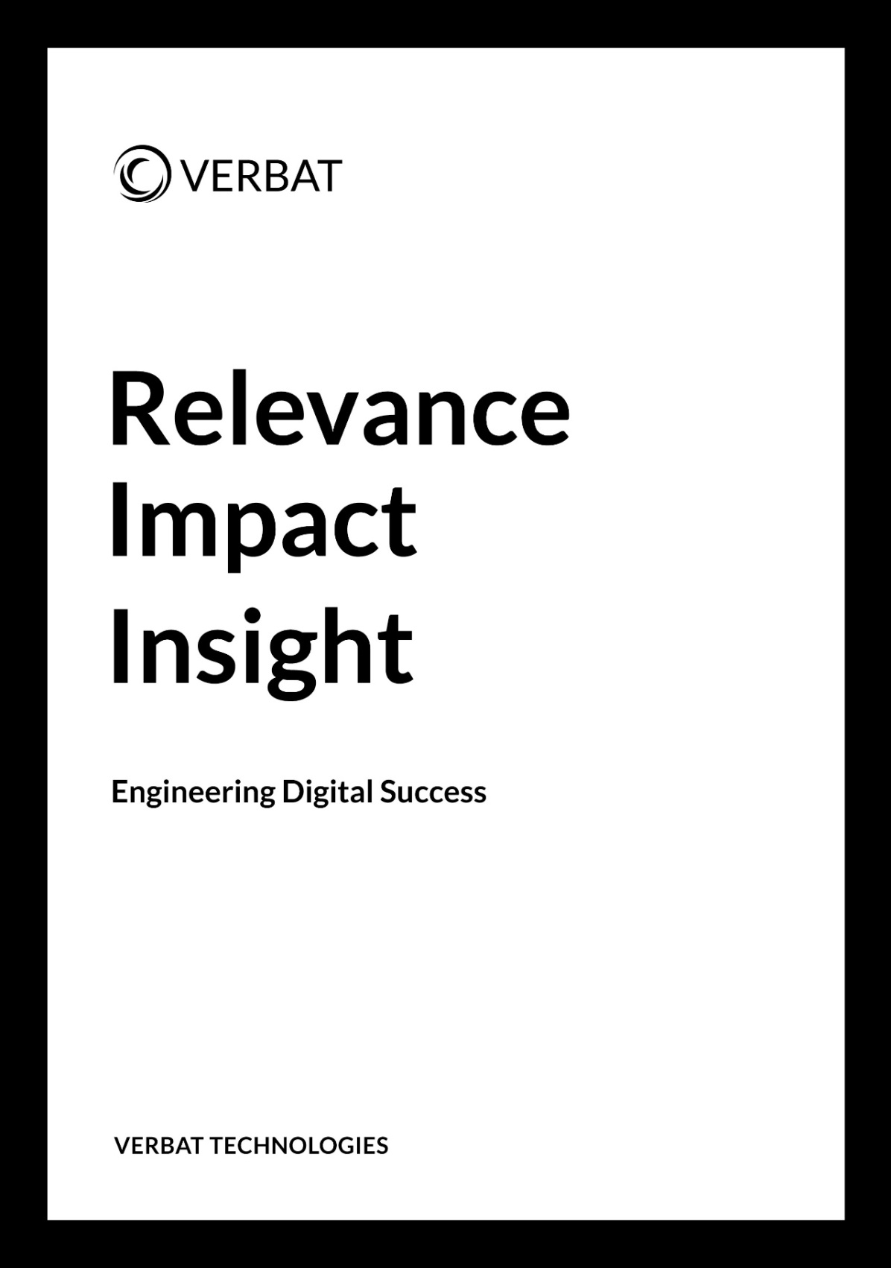

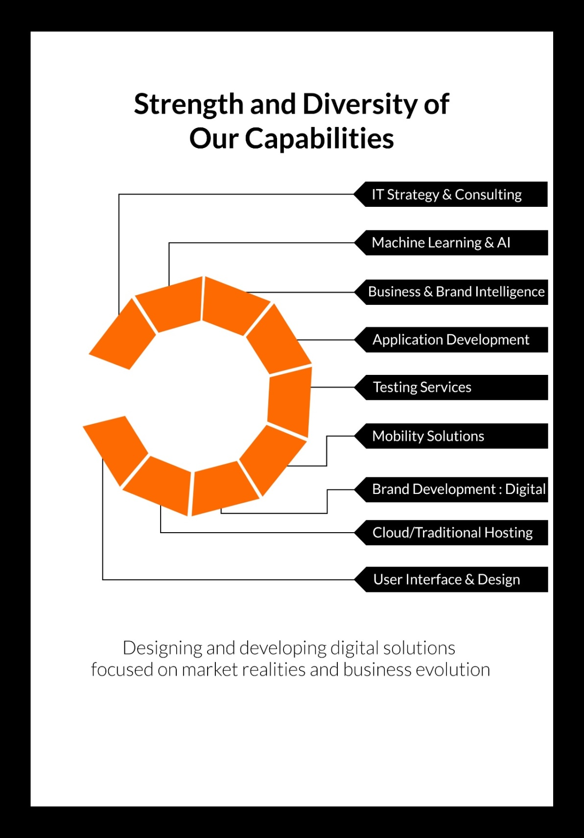

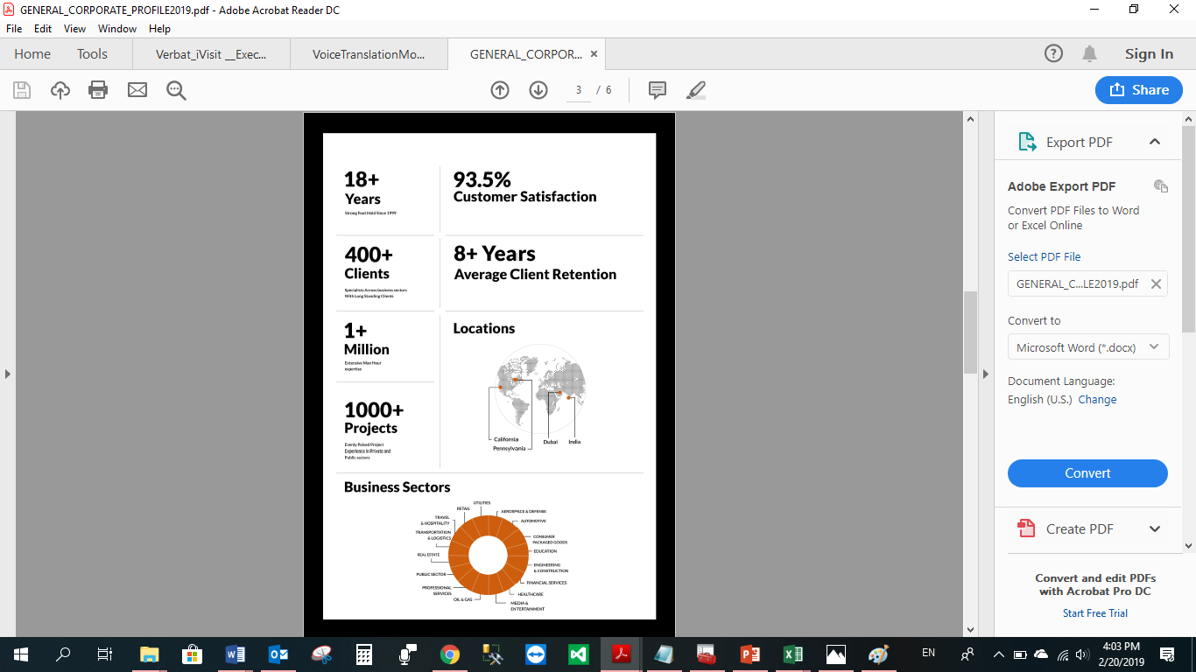

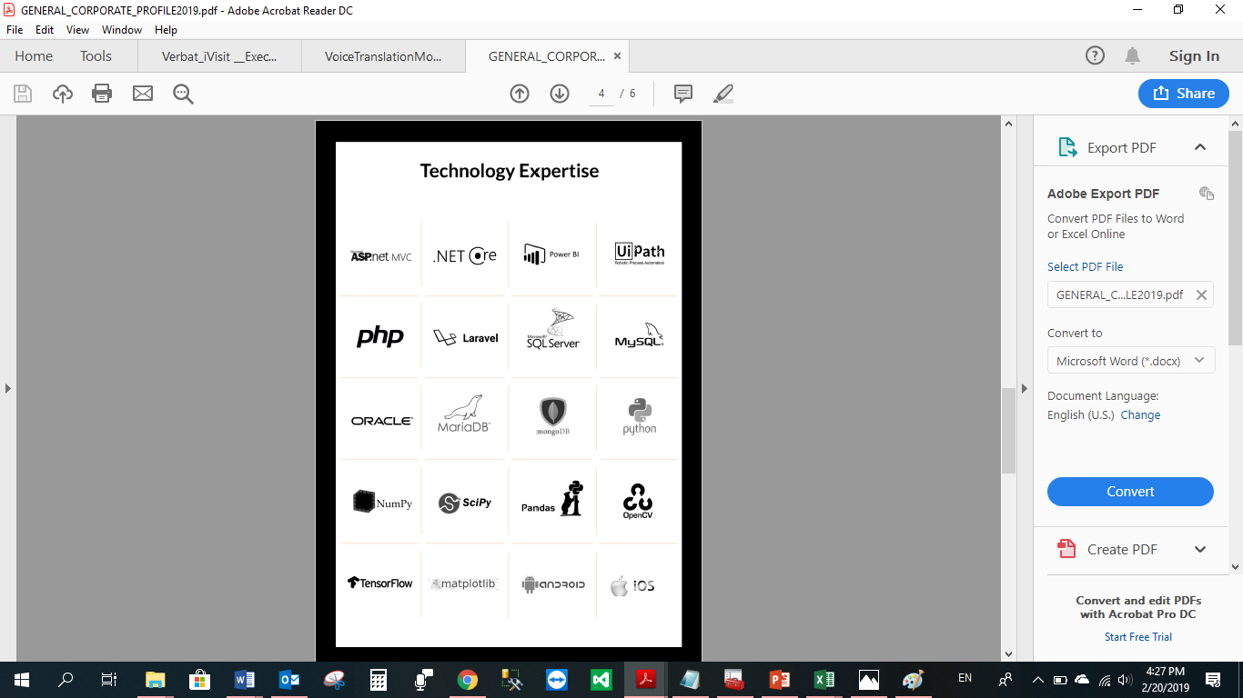

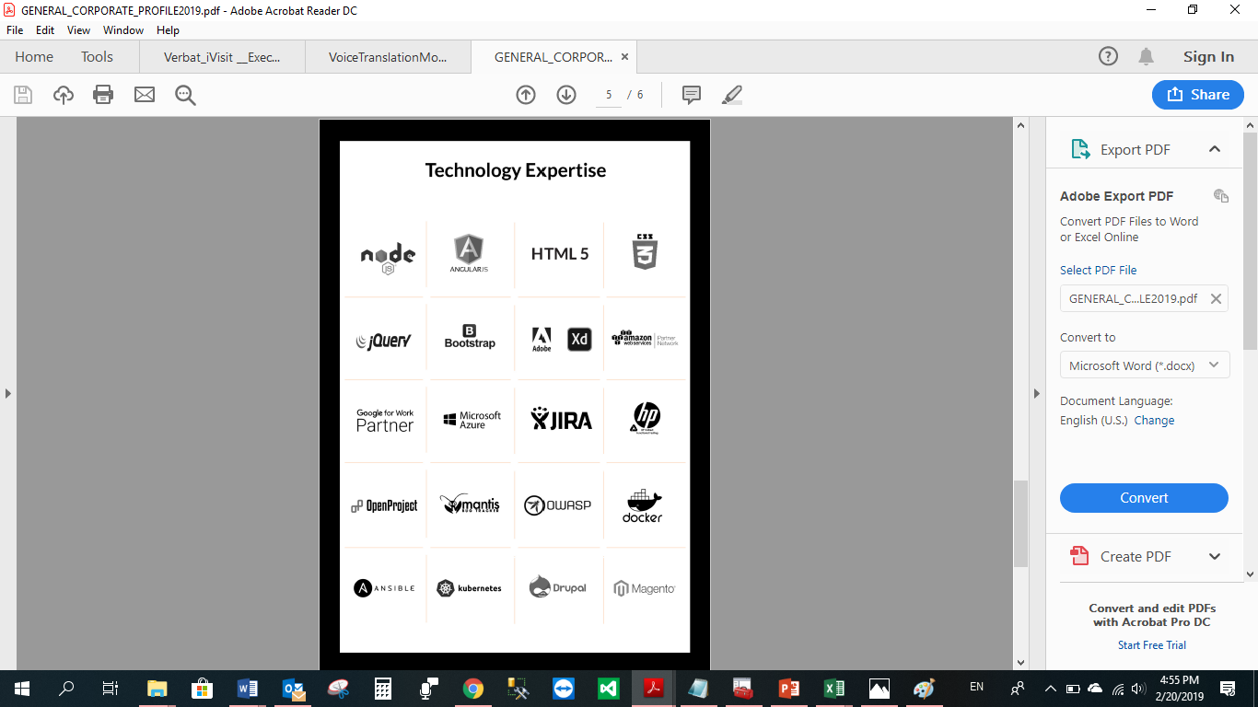

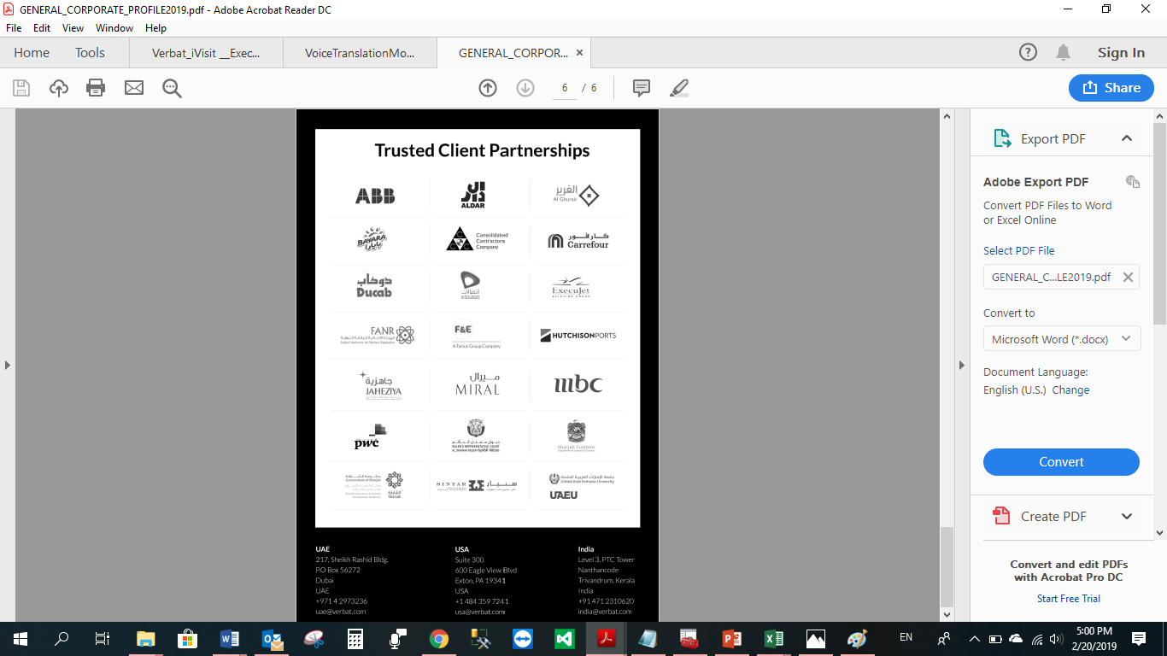

**WITH OUR**

**SINCERE THANKS.**

CONFIDENTIALITY NOTICE:

This Proposal is conﬁdential and contains proprietary information and intellectual property of Verbanet Technologies LLC. Neither this proposal nor any of the information contained herein may be reproduced or disclosed under any circumstances without the express written permission of Verbanet Technologies L.L.C (hereby known under its brand name of Verbat in the United Arab Emirates). 2019. All Rights Reserved.