**CHATBOT**

**Technical Proposal**

Ministry of Education

Submitted By:

VERBANET TECHNOLOGIES L.L.C

**CONTENTS**

**1** **KEY DETAILS** 3

**2** **PROJECT SCOPE** 4

2.1 PROPOSED SOLUTION MODEL 4

2.2 GENERAL DELIVERABLES AND FEATURES 4

2.3 FUNCTIONAL DELIVERABLES AND FEATURES 8

2.4 NON-FUNCTIONAL REQUIREMENTS 27

2.5 PLATFORM AND TECHNOLOGY 36

2.6 SYSTEM ARCHITECTURAL CHARACTERISTICS 39

2.7 SOFTWARE DEVELOPMENT PRACTICES 39

2.8 PROPOSED SYSTEM ENVIRONMENT 40

2.9 TECHNICAL CONFIGURATIONS 42

2.10 PROJECT DELIVERY 43

2.11 PROJECT ASSUMPTIONS 50

**3** **OUT OF SCOPE** 52

3.1 CHANGE MANAGEMENT 53

3.2 MAINTENANCE & SUPPORT 55

3.3 SERVICE LEVEL AGREEMENT (SLA) 55

**4** **TERMS & CONDITIONS** 57

4.1 ACCEPTANCE CRITERIA 57

4.2 WARRANTY 57

4.3 SOURCE CODE & INTELLECTUAL PROPERTY RIGHTS 57

4.4 GENERAL TERMS AND CONDITIONS 58

4.5 GENERAL ADMINISTRATIVE, TECHNICAL & FUNCTIONAL ASSUMPTIONS 59

**5** **FINANCIALS** 61

5.1 WEB APPLICATION DEVELOPMENT 61

5.2 WINDOWS DEDICATED HOSTING – OPTIONAL 62

**6** **CLIENT REFERENCES** 63

**7** **ABOUT US** 66

# **KEY DETAILS**

**PROJECT NAME CLIENT**

Chatbot Ministry of Education

**CLIENT CONTACT CLIENT ADDRESS**

Mr. P.O.Box 123

ABC Street

Dubai

U.A.E

**PROPOSAL SUBMISSION PROPOSAL ID NO.**

13.03.2020  AD/BP/13032020/1820/2

**PROPOSAL VALID UNTIL ANTICIPATED START DATE**

13.04.2020 00.00.00

**PROPOSAL SUBMITTED BY PROPOSED TECHNOLOGY**

Verbanet Technologies L.L.C PHP 7 / Phython Dubai, U.A.E **APPLICATION TYPE**

+971 4 297 3236 Web Application

+971 50 765 2345

# **PROJECT SCOPE**

Ministry of Education (hereafter referred to as “Client”) has approached Verbanet Technologies L.L.C., (hereafter referred under its trade/brand name as” Verbat”) to develop a chatbot system

## PROPOSED SOLUTION MODEL

**STAND- ALONE FIXED BID**

Verbat will be following a stand–alone fixed bid solution delivery model wherein the required solution would be devised and a suitable pricing would be offered. Verbat’s solution architects have conducted a thorough research on the requirements and have come to the conclusion that our proposed solution, which is detailed further in this document, will meet the requirements put forth by the client.

**KEY STRENGTHS OF OUR SOLUTION**

* Strong and Scalable platform accommodating to future enhancements
* A framework which acts as a solution accelerator with building blocks that can be re-used in n future for building new components and features.
* Our light weight framework used consumes fewer system resources thereby making the application perform faster.
* All security aspects are considered

## GENERAL DELIVERABLES AND FEATURES

|  |  |  |  |
| --- | --- | --- | --- |
| ID | Requirement | Compliance (Yes/No) | Remarks |
| CH-G-01 | All documentation that requested to this project which will be submitted by the vendor becomes the property of the MoE, also shall follow MoE standards and it will go through MoE approval process and reviewed by MoE team, Vendor must follow MoE notes and correct any required item/items, vendor must show their proficiency in all provided documents that follow best practices  P.S. Vendor should review the documents before sending them to the Ministry in a proper way and rely on the accuracy | Yes |  |
| CH-G-02 | Vendor must study\analyze, and provide the full journey map of MoE customers that makes the customers achieve a certain goal using the communication with MoE CHATBOT | yes |  |
| CH-G-03 | Vendor must study the current situation and provide it in a form of As-Is processes, which include all related touchpoints between MoE and its customers at its different channels, like; Call Center, Happiness Center, website, social media communication, and others. to find the best solution of the current customer's pain points | Yes |  |
| CH-G-04 | Vendor must provide tools, software, and utilities for the chatbot solution on production, development, and test environments with any needed interface | Yes |  |
| CH-G-05 | Vendor must design and build the solution with redundancy options, to ensure the system will not be affected by the failure of any component, software, or server in the production environment | yes |  |
| CH-G-06 | Vendor must provide all resources, tools, and software for an end to end setup, development, deployment, configuring, customizing, training, and support and maintenance of the Platform | Yes |  |
| CH-G-07 | The bidder must consider the variety of system that works to serve MoE customer and must provide a full overview of the opportunities that can reduce time, cost, efforts and may result in an increase the happiness of the customers | yes |  |
| CH-G-08 | The bidder shall provide all licenses and tools that may need to implement CHATBOT solution in addition to all libraries, and 3rd party tools, that needed to make the solution work as required | Yes |  |
| CH-G-09 | The bidder must provide all documentation for the Business and technical views and the architecture document and design of the solution | yes |  |
| CH-G-10 | The bidder must provide the best practice approach for process design, configuration, deployment, etc. in line with MOE standards and its practices | yes |  |
| CH-G-11 | The bidder team must cover all project tasks as per the agreed plan, such as:  • Project Manager  • Business Analysis team  • Quality team  • Development team  • Solution Architect  • Security Team | yes |  |
| CH-G-12 | The bidder must provide patches, updates, and upgrades during the warranty | yes |  |
| CH-G-13 | The bidder must provide details of hardware configuration and sizing to meet requirements | yes |  |
| CH-G-14 | The proposed solution shall have the ability to deal and integrate with different tools, databases, platforms, and systems used by MOE | yes |  |
| CH-G-15 | Vendors may be required to undertake to build a Pilot or PoC | yes |  |
| CH-G-16 | The bidder should provide training for MOE team in different roles from the technical side, business side and how these teams can deal with both areas | yes |  |
| CH-G-17 | Vendor to provide documentation and user manual for the product, tools, and utilities. The documentation for the processes should also be provided. | yes |  |
| CH-G-18 | Have a central data of all contact persons in all MOE systems | yes |  |
| CH-G-19 | Store all connected channels for each contact, for example to know each contact number if it is activated on WhatsApp or Telegram or linked to any proper and known messaging service. | yes | Cannot integrate the WhatsApp channel. Channel integrations will be detailed under assumptions |
| CH-G-20 | When a message sent to a contact number, the system should identify the least cost channel to send the message through it, if the service provides message delivery reports, it should be captured as well | yes |  |
| CH-G-21 | The system should provide APIs to be used by other | Yes |  |
| CH-G-22 | The system should be able to read contact persons information from different systems in the ministry through APIs | yes |  |
| CH-G-23 | The system should identify the important notifications and send it through the most reliable service which is the regular SMS, the importance can be identified by end user and/or by some configuration in the system based on some factors like message category and message source, for example, if the message sent by some system in MOE it will be treated as important, but if the message sent by end user in a school it will be treated as low priority. Also we may identify some users in schools to send important messages that goes through regular SMS like students absence or any other critical information that parent must read | yes |  |

## FUNCTIONAL DELIVERABLES AND FEATURES

|  |  |  |  |
| --- | --- | --- | --- |
| ID | Requirement | Compliance (Yes/No) | Remarks |
| CH-F-01 | Messaging Solution:  The proposed solution shall consider being used as one of the main MESSAGING / NOTIFICATION channels, like sending customer updates on their requests to replace the SMS notification, this:  - The solution to find which channel the customer own and he prefer to send the notification, also trusted enough assuring to deliver the notification to the client, and in  the last step if customer did not have option rather than SMS, the solution will use it as last option  -The messages or notification that comes from any system can use this solution to send the notification to the customer  -The messaging solution shall be ready to integrate with other system and services  This feature shall not require any previous communication between CHATBOT and customer | yes |  |
| CH-F-02 | The bidder to cover the following channels:  - MoE Portal and MOE Mobile app  - MoE WhatsApp channel  - IVR (call center)  - OmniChannel | Yes | WhatsApp channel subjected to approval from WhatsApp |
| CH-F-03 | The bidder must provide the solution that has the capabilities to integrate with different platforms and can be configured and scalable in an easy way, and this at least include, but not limited to:  - IVR  - WhatsApp  - Portal  - OmniChannel | yes | WhatsApp channel subjected to approval from WhatsApp |
| CH-F-04 | The bidder must cover the following services:  - Systems notification  - Inquiry Services in MOE systems  - Complain Service  - Suggestion Service  - “Request status” Service | yes |  |
| CH-F-05 | The performance takes the highest priority, but also CHATBOT personality is an important part that needs to be considered, CHATBOT solution shall be ready to answer the question, opening chat, and closing it smoothly without bothering customers, also it should attract them to use this channel again, this include at least:   * The greeting or opening of the conversation, * Answer unrelated questions, * Avoid repetitive responses, * Finish the chat responses, and * Answer “about CHATBOT” questions like (name, Age, do what, etc.) | yes |  |
| CH-F-06 | The proposed solution should support cognitive automation features with the artificial intelligence (AI), to recognize and deal with:  - Text Chatting  - Voice Chatting  - NLP  This shall include Text-to-Speech, Speech-to-Text, and translation from English to Arabic and vice-versa | yes | Some Arabic dialects may be excluded for text to speech and speech to text |
| CH-F-07 | The proposed solution should be more natural in conversation by the applying natural language processing and understanding, AI capabilities, Machine Learning, adding into consideration the rule-based flows where the CHATBOT try to provide the customer with service within MoE list of services | yes |  |
| CH-F-08 | The proposed solution shall have the capability to minimize the user input in the chatbox to be at the minimum level, this means the interaction with chatbot shall be smart, accurate and can recognize the user personal information, details, old conversations, all user requests, and his behavior, and build and update the continuous information bank of user preferences and needs in order to give him the fittest and appropriate answers and response | yes |  |
| CH-F-09 | The proposed solution shall have the capabilities to communicate with MOE systems in order to recognize the customer and can then suggest the most appropriate service or answer as per the customer needs | yes | API or Web Service need to provided to MOE Systems |
| CH-F-10 | The proposed solution shall depend on many factors that assure the customer needs will be defined and answers  Identify the needs of the user by his intent, in respect to the way he asked, entities that used, in the utterances, phrase, and statements | yes |  |
| CH-F-11 | The proposed solution shall be meaningful in terms of data communication and conversation content (CHATBOT answers and responses) with the customer more than simple question-answer flow | yes |  |
| CH-F-12 | The proposed solution must support multi-lingual in Arabic, English, and (Urdu), Plus other languages if needed as per the study of MOE services | yes |  |
| CH-F-13 | The proposed solution shall have the ability to allow users have the flexibility to go back in conversation or jump number of steps backward or forward in an easy way without requesting him to do multiple actions or clicks for completing the task | yes | LImited support in SMS & WhatsApp   No Buttons , Quick Replies, supported for WhatsApp & SMS |
| CH-F-14 | The proposed solution shall allow the user to be flexible to change the conversation flow in terms of adding a different question or different data or in case need to fix misunderstandings in the conversation and the interactions | yes |  |
| CH-F-15 | The proposed solution shall handle interruption from the user while CHATBOT perform an action | yes |  |
| CH-F-16 | The proposed solution shall work with multiple concurrent customer requests simultaneously at the same without affecting each other in terms of communication speed, results, recognition, and performance | yes |  |
| CH-F-17 | The proposed solution shall have the ability to transfer/ take over the conversations between bot agent and human agent at any specific action on the conversation (automatic at certain conditions, or manually by human agent) this may include a workspace that mange it including all active chat by different categories and filters, like but not limited to:  - Time  - User details  - User preference  - Chat type  - Subject  - Agent type  - Etc. | yes |  |
| CH-F-18 | The proposed solution shall deal with all customer inquiries, this meaning the CHATBOT shall cover all chat behavior and the solution shall deal with exception cases or unrelated questions and each exception need to be resolved with its related behavior or actions, those activities may include redirect user to human agent or taking another decision, or/and response with a proper messages  The unknown questions and exceptions shall be highlighted and saved in administration screens, administrators to answer and configure it in order to learn the CHATBOT with such questions and exceptions | yes |  |
| CH-F-19 | The proposed solution shall generate customer information from MoE different sources of information’s, this data shall lead the CHATBOT engine to prepare the fittest answers and respond to the customers, even in case the conversation will move to human agent the CHATBOT shall produce this information in proper view and send it to concerned employee; this view shall include customer personal information, customer pending requests, customer needs from that chat, and the chat details, like but not limited to; chat time, chat duration, number of chat that user enter, chat channel, user intent, etc. | yes |  |
| CH-F-20 | The proposed solution should provide the ability to links the chatting users who logged from different channels to the concerned account  e.g. this means if the user x used WhatsApp channel to communicate, then use MOE portal chat channel and so on; then the system shall link all channels to the same user x account in the backend, this shall provide the chatbot solution with all capabilities to train him about the customer and let the chatbot train and follow-up with customer regardless the channel that used  User accounts links shall be smoothly happened without affect user chat box with many questions to confirm links, and shall be smart enough, and accurate in this feature  All links and customer profiles shall be managed by admin/admins user in his workspace, which may include editing the links by removing it in a specific account/accounts, and other management/monitor facilities | yes |  |
| CH-F-21 | The proposed solution should provide the customer with feedback in different types, format, and resources, like but not limited to:  - Text, like service user, etc.  - Images, like service catalog images, etc.  - Files, like user manuals, etc.  - Video, like service customer journey, etc.  - Links, like links to services, or MOE site links, Maps and location, like customer happiness centers map location  - Voice, like telling the customer where to find customer happiness center  - Quick replies (icons, links, pictures, etc.)  - Buttons  - Card (e.g. about a service)  The configuration and managing all of these features shall be considered by the vendor to be provided | yes | Quick Replies, Cards, BUttons are not supported in WhatsApp & SMS |
| CH-F-22 | The proposed solution shall read/analyze and recognized user responses regardless of the input type, like but not limited to:  - Text Chatting  - Voice Chatting  - User selection for any of the quick replies (icons, links, Images, Buttons, Card, etc.) | yes |  |
| CH-F-23 | The proposed solution shall have its own dialog management controls and the ability to find and recall old conversations, memorize it and find the best way to follow the dialog for each specific customer | Yes |  |
| CH-F-24 | The proposed solution shall have the ability to save and archive conversation with the customer and build a relationship with each customer for different purposes, like but not limited to:  - Know customer behavior and needs for the next communication,  - Ease the next communication results and feedback and make more as human conversation, like asking the user about the last request status! Or his last chat, etc  - Keep records of each communication in case it needed to be audited or reviewed,  - The employee may use it to find key needs or for review it,  - it should be used to enhance next time communications for this customer, and  - for others by train the CHATBOT incrementally | yes |  |
| CH-F-25 | The proposed solution shall work from the beginning of launching the CHATBOT this meaning the CHATBOT shall be trained before starting the communication with MOE customers to understand specific knowledge and terms regarding the ministry of education, and pre-configured to resolve common customer needs and services of MoE, which need to feed the CHATBOT with services, information, FAQ, configurations, etc. | yes | Training contents and FAQ needs to be provided by MOE |
| CH-F-26 | The proposed solution shall have the ability to import data that help to train the CHATBOT with the different file format  And system users shall have the ability to import or export the questions, answers, and other system settings and configurations | yes |  |
| CH-F-27 | The proposed solution shall have quick replies and greetings messages and its configuration module, these messages shall be used wherever needed in start conversation or at the end each conversation, and it can be used in unrelated questions from customers  The starting of the conversation shall be differ between first time communication, or if its the second time communication, like (Hi, how can I help you) or (welcome back, how can I help you)  For greeting it can be in different way and responded to user depending on the user environment factors, like time (e.g. good morning or good evening)  All can be managed and edited at any time | yes |  |
| CH-F-28 | The proposed solution shall have the ability to collect and gather the user feedback on the conversation, this also can be configured in terms of following at least: can  - When it be used  - Type of survey/questions  - The content that will be used (it's dropdown, selection, happiness meter, other types) | yes |  |
| CH-F-29 | The proposed solution must collect, store events and audit any action of human agents or bot agent perform any operation within the proposed solution, including at a minimum:  1. Successful and unsuccessful attempts to access,  2. Modify, or delete data (include audit data, system configuration files, and file or users' formal access permission),  3. Successful and unsuccessful actions on the systems,  4. Type of activity happened,  5. Activity time,  6. Where the activity happened,  7. The source,  8. The result of the activity, and  9. The identity of any individuals or subjects associated with the activity  The proposed solution must secure the credentials of authentication information | yes |  |
| CH-F-30 | The proposed solution shall have the ability to marks and flag changes that happened on any configuration, settings, system files, and other components of the system with its details, this will be used in system auditing | yes |  |
| CH-F-31 | Vendor to provide Management Console (Control Panel) to manage and monitor all system component, system users, human agents, bot agents, and Processes with activity monitoring | yes |  |
| CH-F-32 | The proposed solution shall have at least the following administrative modules and features with its configuration capabilities to each of them, that allows the system to work and administrators to manage it:  - User and agents management, and Mange chat switching between bot agents and a human agents, and vice-versa  - Customer management and account links  - Channels management  - Contextual Intent, Keywords, and Entity management for each system  - Dialog management (Vendor to build the dialog that will be used as per requirements), and manage business process logic and design  - Manage knowledge base, FAQ, and Training  - Unknown and Exceptions module (also vendor to make the system answers and work in all cases with respect to user needs)  - Alert and notification management  - Resources management input and output (text, voice, cards, etc.)  - Manage clients/contacts source of information  - Manage systems connection and integration (enable, or disable the connection to a specific system)  - Dashboard Reports management  - Mange audit-trail  - Manage system configurations  With the ability to import/export the configuration files in a different format  In case; vendor implement any other feature from the third party he should consider it in the above list and all features that added but not included in this point shall be added in the administration module | yes |  |
| CH-F-33 | The proposed solution shall have reporting capabilities:  - Dashboard with different filters, and different views  - Statistical and detailed reports with different filters like time, date, channel, user preferences and their details, user behavior, etc.  - Export capability with different types/formats, like; excel, word, pdf, etc.  - Switch between different reports views and charts  - Allow user to select the data required in the report view and output, and may include Message Metrics, User Metrics, etc.  - Monitoring the solution behavior and the impacted results in many parts that may include but not limited to:   * Customers engagement * Customers happiness * Does the human agent get fewer requests * Does other chatting channels get fewer requests than before * Solution performance * Chat performance * Etc. | yes |  |
| CH-F-34 | The proposed solution shall be less in customization when its developed and it should easy for implementation, the solution shall be scalable in terms of updates, upgrades, integration with new systems, and have the capabilities to reduce the efforts required to add any new update | yes |  |
| CH-F-35 | The proposed solution shall have the capability to alert and notify users, this module cares about the communication between CHATBOT system and different types of users, in some cases may need to notify an employee about urgent customer requirements, which need employee attention, etc. | yes |  |
| CH-F-36 | The proposed solution shall have the ability to provide system administrators with all system errors, failed attempts communication, and misunderstanding cases, and this may require to use alert module and report module to provide the administrators with that results, in different words the solution shall have the quality controls that notify system administrators in case any actions required to improve the solution or enhance it | yes |  |
| CH-F-37 | The proposed solution shall have its built-in knowledge and data that make it run, also the solution shall have the ability to be used at early stages parallel with updating/developing remaining parts | yes |  |
| CH-F-38 | The proposed solution shall have the ability to configure/add intents, and entity/slots, in addition to configure keywords, and synonyms which express user need in different ways with same value. | yes |  |
| CH-F-39 | The system should provide capability to manage thousands of requests per second, we have almost 650 schools that will use the system, so the system should not delay any scheduled message more than 10 minutes. | yes |  |
| CH-F-40 | The system should priorities important message to be sent instantly without any delay | yes |  |
| CH-F-41 | The system should support SMS gateways using protocol SMPP to send regular messages. | yes |  |
| CH-F-42 | The system should provide ability to add more channels by the time, for example if the MOE decided to release a new application that pushes notifications to end users, then it should be one of the channels in the system. | yes |  |
| CH-F-43 | The system should provide users hierarchy to manage users access and quotas, for example limiting the number of important messages per user, restricting messages language and size, like if a user sending a regular SMS containing both Arabic and English, then it will be better from the cost perspectives to be sent in two different messages. | yes |  |
| CH-F-44 | The system should provide statistical reports on different levels of the users, for example number of sent messages per user or per school or per emirate. This depends on the defined users’ attributes and hierarchy. | yes |  |
| CH-F-45 | The system should be integrated with MOE Active Directory for authentication. | yes |  |
| CH-F-46 | The system should be available 24X7 with high availability architecture | yes |  |

## NON-FUNCTIONAL REQUIREMENTS

### **TRAINING REQUIREMENTS**

|  |  |  |  |
| --- | --- | --- | --- |
| ID | Requirement | Compliance (Yes/No) | Remarks |
| CH-T-01 | Handouts, and User Manuals to be provided to all participants to whom the Training would be provided by the Bidder | yes |  |
| CH-T-02 | Provide training plan and details for various user types (administrator, end-user) for which training will be provided, the mode and duration of the training, numbers of users for whom training will be provided, Describing the knowledge transfer plan | yes |  |
| CH-T-03 | Provide training on the implemented solution and its different aspects for MOE team | yes |  |
| CH-T-04 | Provide the training on system functionalities & features for MOE team | yes |  |
| CH-T-05 | Provide training and knowledge transfer to deal with implemented processes and services for MOE business department team and how to work in line with the new solution | yes |  |
| CH-T-06 | Provide training and certificate for MOE Technical team | yes |  |
| CH-T-07 | Trainers provided by the vendors must be certified | yes |  |

### **HELP AND USER GUIDE REQUIREMENTS**

|  |  |  |  |
| --- | --- | --- | --- |
| ID | Requirement | Compliance (Yes/No) | Remarks |
| CH-H-01 | Bilingual User Manual in Arabic and English and shall be clear for the end-user and the other stakeholders regardless of their backgrounds especially technical background, also provide other advance help for the technical team with detailed step by step use and functions | Yes |  |
| CH-H-02 | Provide the user guide in a different format and each type of users shall have in the different user guide and others that include all guides and helps | yes |  |
| CH-H-03 | Provide the user guide in a professional way that makes easy to learn and know the document content | yes |  |

### **INTEGRATION REQUIREMENTS**

|  |  |  |  |
| --- | --- | --- | --- |
| ID | Requirement | Compliance (Yes/No) | Remarks |
| CH-I-01 | Does the bot platform provide the ability to execute tasks by integrating and consuming APIs provided by various systems of record? | no | Inherently no, but can be developed |
| CH-I-02 | Does the platform support REST & ODATA APIs? | YES | JSON Based API Supported |
| CH-I-03 | Does the platform support Web Services/ SOAP APIs? | yes |  |
| CH-I-04 | Does the platform support other integration protocols? Please explain. | Yes | REST API to integrate with any 3rd party Apps |
| CH-I-05 | Does the platform have out-of-the-box adapters to support various message delivery channels? | yes | Depends on the channel |
| CH-I-06 | Does the bots platform expose APIs that can be invoked using another application? | Yes |  |

### **SUPPORT AND MAINTENANCE REQUIREMENTS**

|  |  |  |  |
| --- | --- | --- | --- |
| ID | Requirement | Compliance (Yes/No) | Remarks |
| CH-M-01 | The system should support the Omnichannel strategy of MOE | YES |  |
| CH-M-02 | The system should have a framework for integrations | Yes |  |
| CH-M-03 | What kind of support we will receive during and after implementation | yes | 30 days |

### **FLEXIBILITY AND SCALABILITY REQUIREMENTS**

|  |  |  |  |
| --- | --- | --- | --- |
| ID | Requirement | Compliance (Yes/No) | Remarks |
| CH-FS-01 | Can the bots be targeted towards end consumers (B2C)? | yes |  |
| CH-FS-02 | Can the bots be targeted towards employees (B2E)? | yes |  |
| CH-FS-03 | Can the bots be targeted towards business users (B2B)? | yes |  |
| CH-FS-04 | Will the bot allow end users to authenticate and authorize using their own personal credentials? | yes | Not natively. Functionality has to be developed |
| CH-FS-05 | Can the bot perform action tasks for the users?  (Action tasks are user-initiated interactions with the bot that usually update back-end systems or perform transactions.) | yes |  |
| CH-FS-06 | Can the bot alert the user of specific events that maybe of relevance to the user?  (Alert tasks allow a bot to initiate a conversation with the user by bringing relevant & personalized information to the users from systems of record.) | yes |  |
| CH-FS-07 | Can users personalize the bot alerts?  (Personalization can be in the form of individual filters and scheduling options that each user can specify per their preferences.) | Yes |  |
| CH-FS-08 | Can the user also request reports or information that the bot can fetch for the user? | yes | Report links ,may be provided to the user |
| CH-FS-09 | Can the report requests be on demand and scheduled for periodic retrievals? | yes | Additional functionality |
| CH-FS-10 | Does the bot enable you to respond to questions from users?  (The question and answer (FAQs) content can be either within a content management system (accessed via APIs) or stored within the platform.) | yes |  |
| CH-FS-11 | Does the platform provide the ability to make the alerts actionable?  (Users should have the ability to take quick actions when alerts and notifications are delivered to the user.) | Yes |  |
| CH-FS-12 | Does the platform provide the ability to send proactive, contextually relevant smart alerts to users? | yes | Provided the users provide their contacts |
| CH-FS-13 | Can enterprises execute workflows by mapping actions to actions? | Yes |  |
| CH-FS-14 | Can users automate and suggest subsequent actions? | no |  |
| CH-FS-15 | Can bots be instantiated within a team context? | Yes | Channels which allows group communication like WhatsApp , Skype |
| CH-FS-16 | Do the bots support input in natural language so that users can utter sentences in natural language to the bot?  (This is generally an unstructured input provided by the user.) | yes |  |
| CH-FS-17 | Is there a feature that enables creating bot families? (Parent and child bots with bot feature inheritance) | Yes |  |
| CH-FS-18 | Is there a way the configuration can be transferred between bots? | Yes |  |
| CH-FS-19 | Do the bots provide a forms-based UI in addition to natural language based input?  (Forms would need to be dynamically generated based on bot configuration when the user requests it. This feature also be used in combination with natural language input depending on use cases.) | yes | Can be developed |
| CH-FS-20 | Can the bot transfer a conversation to a human? | Yes |  |
| CH-FS-21 | Does the bot detect/analyze sentiment based on user utterances? | yes |  |
| CH-FS-22 | Does the platform allow for invoking intents or present custom responses based on a defined list of platform or channel-specific events? | yes |  |
| CH-FS-23 | Can the bot follow up an FAQ task with further dialog with the user and invoke another dialog task? | yes |  |
| CH-FS-24 | Can the bot allow customers visualize conversation flows and user journey? | yes |  |
| CH-FS-25 | Does the solution provide bot summary including training provided, channels, events, variables and extensions configured in the bot and help navigate to the corresponding module from a single screen? | no | Unsure about the requirement |
| CH-FS-26 | Does the solution provide search function and key board short-cuts to invoke commonly used tasks? | Yes |  |
| CH-FS-27 | Is live webchat available with your solution? | yes |  |
| CH-FS-28 | Can the bot generate auto-dialogues given a human-to-human dialogue history? | Yes |  |
| CH-FS-29 | Is there a capability to present relevant information using widgets to enhance user engagement with the bot? | Yes | Full Support in Website Chabot  LImited support in  FB Messenger Skype Telegram  No Supports In  WhatsApp SMS |

### **PERFORMANCE REQUIREMENTS**

|  |  |  |  |
| --- | --- | --- | --- |
| ID | Requirement | Compliance (Yes/No) | Remarks |
| CH-P-01 | Can interpret commands accurately | yes | In an ideal world |
| CH-P-02 | Can execute requested tasks | yes |  |
| CH-P-03 | Can maintain a discussion | yes |  |
| CH-P-04 | Can activate a new topic | yes | Change topic |
| CH-P-05 | Number of services available in the chatbot | yes | This depends on the requirement and context of the conversation. Any number of services can be integrated |
| CH-P-06 | Offers dependable information | Yes |  |
| CH-P-07 | Offers rating capability | Yes | At the end of the conversation |
| CH-P-08 | Shows breadth of knowledge | yes | Depends. This is usually predefined. No bot is capable of a breadth of knowledge that is comprehensive |
| CH-P-09 | Gracefully handles unexpected input | yes | Depends of the definition of unexpected input. |
| CH-P-10 | Offers transparency | No | Transparency on what? |
| CH-P-11 | Protects and respects privacy | yes |  |
| CH-P-12 | Is safe from intrusion/breach | yes |  |
| CH-P-13 | Is easy to use | yes |  |
| CH-P-14 | Supports canned responses vs. free text | yes | Usually it’s canned responses. |
| CH-P-15 | Is always available | yes |  |
| CH-P-16 | Is accessible via multiple platforms | yes | SSO, Single Sign On |

### **SECURITY AND PRIVACY REQUIREMENTS**

|  |  |  |  |
| --- | --- | --- | --- |
| ID | Requirement | Compliance (Yes/No) | Remarks |
| CH-S-01 | Does the bot allow enforcement of authentication and authorization rules as specified by the enterprise systems?  (Enterprise systems may have specific user access privilege rules and other security configuration such as session timeouts that would need to be enforced and emulated by the bots platform.) | Yes | Authentication can be done using Mobile Number or OTP  If both not available then sign can  A Sign-in Button can show to the user for limited channels which opens a secure webpage to authenticate |
| CH-S-02 | Does the bot platform support standard authentication models (Basic HTTP Auth, Oauth, API key, etc.) to authenticate the user? Please explain. | No | Refer above Answer CH-S-01 |
| CH-S-03 | Are bot messages encrypted while at rest within the database? | yes | This is a dependency of the database. |
| CH-S-04 | Are bot messages encrypted in transit? | yes | If it is over TLS |
| CH-S-05 | Is there an option to redact and secure sensitive user information, such as PCI, PII, PHI ? | no |  |
| CH-S-06 | Can enterprises audit the bot conversations with users? | yes | Redacts on secure sensitive information requirment |

### **USABILITY REQUIREMENTS**

|  |  |  |  |
| --- | --- | --- | --- |
| ID | Requirement | Compliance (Yes/No) | Remarks |
| CH-U-01 | Talk to people, systems & things | Yes | Converses with people and connects to other systems using api services based on context |
| CH-U-02 | Language emotions | yes | Depends on context |
| CH-U-03 | Learn from interactions | Yes |  |
| CH-U-04 | Work across multiple channels | yes |  |
| CH-U-05 | Interact when needed (scheduled/on-demand) | Yes | On-demand not scheduled |
| CH-U-06 | Remember context | yes |  |
| CH-U-07 | Use natural language (voice & text) | yes | Voice may not always be accurate |
| CH-U-08 | Via conversational user interfaces | No | No sure |
| CH-U-09 | Visual and Intuitive Dialog Builder | yes |  |
| CH-U-10 | Can Visual NLP Training models | Yes |  |
| CH-U-11 | No/Low code development -simple bot builder tools usable by business users versus IT. | Yes | simple drag and drop bot builder |
| CH-U-12 | Knowledge extraction and ingestion from multiple sources and formats. | yes | Multiple sources, but limited formats |
| CH-U-13 | Creating tasks using GUI based dialog builder | yes |  |

## PLATFORM AND TECHNOLOGY

|  |  |  |  |
| --- | --- | --- | --- |
| ID | Requirement | Compliance (Yes/No) | Remarks |
| CH-PT-01 | Does the platform have a tool to build bots in a comprehensive, step-by-step manner? | Yes |  |
| CH-PT-02 | Does the platform enable any developer to build a bot for custom requirements? | Yes | Must know the framework |
| CH-PT-03 | Does the platform provide out-of-the-box bots that can be used? | No | Out of the box bots for general conversation available |
| CH-PT-04 | Can enterprise customize and extend the out-of-the-box bots that are provided by the vendor? | Yes |  |
| CH-PT-05 | Does your solution offer Livechat capability out of the box? | Yes | secure widget (i frame) based integration possible |
| CH-PT-06 | Does the platform have omni-channel support? | Yes |  |
| CH-PT-07 | Does the platform provide multiple ways of following up the IVR session? (Call termination/initiate new task/jump to specific nodes in current task)? | No | IVR can be developed as separate project |
| CH-PT-08 | Is it possible to create instance-specific VXML properties while working with the IVR channel? | No | Can be developed |
| CH-PT-09 | Cisco WebEx Teams | No | Can be integrated |
| CH-PT-10 | Does the platform allow the developer to take advantage of channel specific responses? | Yes |  |
| CH-PT-11 | Does the platform provide its own messaging application & platform where bots can be instantiated? | Yes |  |
| CH-PT-12 | Does the platform allow multiple users in a group chat? | Yes |  |
| CH-PT-13 | Does the solution have a NLP engine support standard functions such as Language Parsing, Grammatical Correction/ Normalization, POS tagging and logging and tracing for all utterances? | Yes | limited support in Arabic and Urdu |
| CH-PT-14 | Does the NLP engine support user prompting and dialog management to start and end a conversation with a user? | Yes |  |
| CH-PT-15 | Does the platform have intent recognition? | Yes |  |
| CH-PT-16 | Does the platform use machine learning algorithms to train and tune the NLP accuracy? | Yes |  |
| CH-PT-17 | Does the platform handle tasks based on domain-specific ontologies? | Yes |  |
| CH-PT-18 | Does the platform have an inbuilt methodology to handle domain-specific knowledge tasks such as FAQ? | Yes |  |
| CH-PT-19 | Does the platform support knowledge extraction from PDF documents, CSV files or URLs? | Yes | CSV & JSON Only |
| CH-PT-20 | Can enterprises only use NLP engine from the platform and develop their own custom logic to handle the task execution? | No |  |
| CH-PT-21 | Does the platform have speech or voice recognition capabilities? | Yes | Limited support in Arabic & Urdu |
| CH-PT-22 | Is it possible to control/modify ML engine parameters via NLP thresholds? | Yes |  |
| CH-PT-23 | Is it possible to prioritize intents over entities or vice versa in a user utterance? | Yes |  |

## SYSTEM ARCHITECTURAL CHARACTERISTICS

|  |  |  |  |
| --- | --- | --- | --- |
| ID | Requirement | Compliance (Yes/No) | Remarks |
| CH-SA-01 | Is the bots platform available for hosting inside a cloud infrastructure? | yes |  |
| CH-SA-02 | Does the platform offer its own cloud connector to securely connect and access on-premise services from the cloud tenant? | Yes | Via API & Webhooks |
| CH-SA-03 | Does the platform let you host and deploy the bot in an auto-scaling infrastructure environment? | yes |  |
| CH-SA-04 | Is the platform available for on-premise deployment? | Yes |  |
| CH-SA-05 | Does the bots platform also support a hybrid deployment architecture? | Yes |  |

## SOFTWARE DEVELOPMENT PRACTICES

|  |  |  |  |
| --- | --- | --- | --- |
| ID | Requirement | Compliance (Yes/No) | Remarks |
| CH-SD-01 | Does the platform provide a developer tool which allows them to build new bots or extend existing bots? | yes | The chatbot framework will provide this |
| CH-SD-02 | Are developers able to easily "configure" a task which consumes an API from a back-end system of record? | yes | Depends on the capability of the developer. We provide a standard framework. Anyone who understands the framework shall be able to configure tasks |
| CH-SD-03 | Are developers able to configure the response provided by the bot once the API calls are made?  (Developers should be able to simply configure the responses as well as develop custom code logic to manipulate the API response before presenting to the user.) | yes | As above |
| CH-SD-04 | Can developers test and run the bot to functionally test the bot? | yes |  |
| CH-SD-05 | Is there an option to de-couple bot content from bot definitions to minimize coding effort? | yes |  |
| CH-SD-06 | Can developers follow a complete software developer lifecycle for bot development? | yes |  |
| CH-SD-07 | Can developers share bot and task development with other developers within the company? | yes |  |
| CH-SD-08 | Can the developer convert business processes into conversational flows? Is there a storyboarding mechanism? | yes |  |

## PROPOSED SYSTEM ENVIRONMENT

**MS SQL2012  
Windows 8/10  
Web Services**

HTML5 / CSS3

Java Script

ASP.NET

Windows

IIS

MS SQL

## TECHNICAL CONFIGURATIONS

### **DEVELOPMENT TOOLS**

* PHP 7 / Python / Node JS
* MS SQL & Mongo DB
* HTML5 / CSS 3 / Bootstrap 4
* Web services, Ajax, JavaScript

### **RECOMMENDED INFRASTRUCTURE**

* Operating System : Linux
* CPU : 16 core
* RAM : 32 GB
* Domains: Unlimited
* Disk Space: 1 TB SSD

Need dedicated server of above configuration for each node listed below

1. Webserver
2. Channels Server
3. Database Server
4. NLP & Bot Engine Server

### **BROWSER**

* Chrome version: 70
* Firefox version: 51
* Safari:13

### **HARDWARE**

The application is reliant on hardware interfaces to provide a seamless automated user experience.

* Computer with Windows 8 or 10 OS / Linux / MacOS
* Compatible Browsers as specified in section 6.2.3

## PROJECT DELIVERY

### **PROJECT MANAGEMENT**

The Verbat development center strictly follows industry standards on quality. The project management is process governed by the Verbat Quality Management system and is put to verification through internal audit programs that happen from time to time. Verbat will dedicate a project manager for the proposed implementation. Verbat proposes Client to identify one project manager who will be driving activities to be undertaken by Client to be the single point of contact for Verbat.

### **ROLES & RESPONSIBILITIES**

Verbat will assign a dedicated Project Manager/Project Lead to lead the project, who will be the first point contact for Client. He/she will be responsible for planning and managing the various activities within the project. He/she will work closely with Client Project Manager, to give periodic status updates and ensure high level of visibility and comfort on the progress of the project. The Project Manager/Project Lead will lead the co-ordination between Verbat and Client, thus enabling smooth transitioning of Client requirements to the Verbat ’ offshore delivery team, and provide visibility as well as comfort on the progress of the services to Client.

He/she will have periodic meetings with Verbat ’ s Senior Management, thus ensuring Verbat ’ Management commitment and focus on Client initiatives.

### **PROJECT IMPLEMENTATION PLAN**

Verbat will be providing the solution in a stand-alone fixed bid approach which ensures minimum viable solution for quick wins with core focus on the long-term business objective and outcome. Once the implementation is over, Verbat will initiate the application maintenance process (once the maintenance contract is signed) which continues to extend after the implementation.

### **DELIVERABLES**

**ANALYSIS / REQUIREMENTS**

* BRD “Business Requirement Document”
* SRS “System Requirement Specifications”
* As-Is process details and map
* To-Be process details and map
* Business Exception Handling Document
* System Architecture / Integration Design
* System Design Document

**PLANNING**

* Project Charter
* Project Plan
* Risk mitigation Plan
* Change Management Plan
* MOM
* Proposed Team Structure

**INTEGRATION**

* Integration documents
* Integration Test Plan
* Completed Integration Test Plan (eservices, e-payments)
* Integration Test Results Review/Signoff

**FUNCTIONAL TEST**

* Completed Requirements Validation Plan
* UAT process document
* Test Cases Document
* Functional Test Results Review/Signoff

**RELEASE**

* Software Release Documentation
* User Manual
* Technical Manuals
* Administrative Manuals
* Deployment Guide and Installation Scripts
* Released Software
* Source Code
* SDD “System Design Document” & DDD “DB Design Document”
* SAD “Solution Architecture Design Doc”
* System high level Architecture / Integration Design
* Implementation guide
* Technical Support commitment
* Deliverables signoffs

**Training:**

* Training Plan
* Training material
* Training certificates
* Training Signoffs

### **DELIVERY ACTIVITY SUMMARY**

|  |  |
| --- | --- |
| Activities | Description |
| Detailed requirement Analysis | Verbat team to conduct detailed study of requirement for the phase. If clarification is required, team will reach out to Client for more information and/or time for discussions. |
| DB Design | DB design for central and test DB. |
| Software Requirement Specification document (SRS) | Once the requirement analysis is completed, Verbat team will submit the SRS document for approval |
| UI/UX Design, Prototyping | Based on the SRS, Verbat UX/UI team will work on the UI/UX of the screens and submit for approval |
| Functional Specification Document (FS) | Once the UI/UX is approved, Verbat shall submit an FS document for approval. |
| Development | Actual system development starts based on the FS. This involves detailed design and software development of Web Application. |
| Testing | Test Planning, test plan creations, internal, integration testing and user acceptance testing. |
| Deployment | Deploying the latest built in the Verbat Test Server. |

### **ESTIMATED DELIVERY TIME**

The effort estimated for delivering the application will be as below:

* 00 UAE working days for the UI/UX from the date of approval of the SRS
* 00 UAE working days for the development of the application from the Date of Approval of the FS.

|  |
| --- |
| **Activity** |
| Contract Signoff (T0) |
| Project Initiation & Initiating requirement gathering |
| Software Requirement Specification Document(SRS) |
| SRS Approval (T1) |
| System UI/UX-Complete |
| System UI/UX-Approval (T2) |
| Functional Specification (FS) |
| FS Approval (T3) |
| Development Phase-Complete |
| Perform QC (Unit Testing and Integration Testing) |
| System ready for UAT |
| UAT Acceptance on Verbat server (T4) |

* The above-mentioned timeline is in UAE Working Days
* The initiation of the UI/UX development is dependent on the confirmation of SRS. SRS will be submitted post the confirmation of the project along with LPO, signed proposal and advance payment
* The above mentioned timeline for development is post the confirmation of FS
* Documentation submitted after project initiation and system study supersedes any proposal or documentation submitted during initial requirement gathering / discussion / negotiation
* Project plan will be submitted post the confirmation of project with necessary payments
* Any delay in getting the approvals of deliverables from client will cause change in timelines and the revised timelines will be updated in weekly status reports shared with client after the project commencement
* All approvals and queries regarding the client requirement and any queries which may hinder the project advancement at any stage should be answered by the client within 24 hours from the time of initiation, failing which the time delay will get added to the actual effort and timeline which was estimated.
* On project confirmation, Verbat requires a lead time of minimum seven (07) days for resource mobilization.

### **DEPLOYMENT DETAILS (AT CLIENT’S BEHEST)**

* Client can opt for hosting the application at Verbat’ Server.
* If deployment is at the client’s server, responsibility of deploying the application onto the production environment after conducting the necessary acceptance testing will lie with the client unless and until Verbat ’ support is contracted for deployment.

### **RELEASE PLANNING**

* Client will be informed about the release date and time through email.
* Client performs the UAT

### **RISK CONTINGENCY PLANNING**

Verbat has identified various risk factors associated with this assignment and understands the impact of these risk factors on the project schedules. The objective of this section is to highlight for both Verbat and client, the risk factors, to analyze the impact of the risks on project execution, and to propose strategies to control and reduce the impact of the risk factor. These various risks, which could arise during the project, are tabulated below along with mitigation implementation.

|  |  |  |  |
| --- | --- | --- | --- |
| Type of risk | Impact | Risk Mitigation | Risk Handling |
| Scope Creep | H | Functions and features will be detailed in system requirement documents and will go through client approval. Once this document is approved, any change to requirement will go through change management review for possible impact assessment. | Proper change management procedure will be implemented. |
| Delay in customer feedback | H | The plan is prepared with enough lead-time for customer reviews and approvals.  The customer is indicated with the dates when the document is expected after review and approval. | The request for feedback will be escalated if not attended at the right time so that the schedules are not affected. Deemed acceptance criterion is set up front and will be followed. |
| Non-availability of necessary software’s, frameworks, database instances and infrastructure at client’s hosting environment(If hosting support is provided by Verbat ) | M | Client will be informed in advance on these requirements. | Possible impact to schedule. |
| Manpower attrition | L | All efforts would be made to ensure process dependence rather than being person dependent. As a risk mitigation plan Verbat will train backups. | A new person will be identified as early as possible, provided the required project-specific training and mentored by the senior members of the team to minimise impact of attrition on the project. |

*H-High, M-Medium, L-Low, NA-Not Applicable*

## PROJECT ASSUMPTIONS

The project solution and technology is created from the initial understanding of the requirement shared with Verbat through mails and meetings. The proposed solution is based on the following assumptions:

### **OBJECTIVE**

* The requirement is to develop Chatbot with the functionalities as defined in ‘Functional Requirements’ section

### **DESIGN**

* Client to provide Verbat with the branding guidelines.
* Color theme shall be provided by the client
* Client shall provide licensed images and logos in specified size & format
* Client shall provide the text and associated images for the proposed application. Text should be provided in digital format preferably in MS Word 2013 or above
* Verbat may use template based design for the application

### **DEVELOPMENT**

* The proposed application front end and backend would be developed in English, Urdu & Arabic
* Development Contingent upon timely feedback from client
* The client will finalize the functional requirements and UI/UX before the commencement of the development of the project
* Client shall approve the UI/UX for the web application before development work starts
* Final data needs to be entered by the client via the application
* Client will provide sample data to test the application
* Testing of web application will be done in latest versions of Google Chrome, Mozilla, Safari, IE web browsers only
* Client will procure templates, SSL certificates (if applicable)
* Client will host and manage the application on infrastructure (server / cloud) recommended by Verbat for managing database and application backup inclusive of images
* Application and data backups are subject to the purchase of such services at an extra cost
* Internet connectivity is required for the functioning of the Web portal
* Effort would change after a detailed system study
* The application shall be ease of use with advanced UX
* The system design shall be responsive and work with all screen sizes including mobile devices and tablets.

# **OUT OF SCOPE**

With the ever evolving digital market, the requirement should be clear to both the parties involved, hence the importance of mentioning the out of scope details of the project. Following are considered to be out of scope while creating this proposal:

* Purchase of images, fonts
* Any language other than English, Urdu & Arabic
* Migration of existing data / Database migration
* Content writing / proof reading / Data Replication / Manual data entry
* Content or image procurement or uploading or editing
* Audit Trail
* End user testing and load testing
* Developer account creation and Maintenance (Play Store)
* Adding new features to the application other than mentioned in the functional specifications. Such requests will be handled via change management. *For Change management details, please refer section titled “Change Management” in the*
* Annual Maintenance Contract (Bug fixing, debugging, enhancements) – Please refer section titled “Maintenance and Support”, unless contracted for.(refer to section 4.2)
* Hosting Infrastructure and Maintenance (web and email hosting), unless contracted for.
* Application Deployment on the server and respective stores, unless contracted for.
* Backup solution and Disaster recovery unless contracted for.
* Physical deployment onsite / installation of the application in devices and Physical connection, installation of system.
* Integration with third-party, if any, other than mentioned in the functional specifications
* Hardware Integrations / procurement and purchase
* Procurement of SMS gateway / payment gateway / email gateway
* SSL Purchase and installation, if any
* Plugin/template purchases, if any
* OS other than mentioned in the Hardware Interface
* Relevant / related software libraries

## CHANGE MANAGEMENT

Any addition which comes out of the project scope, upon and after the launch of the application will be considered as change management. Verbat recommends the following change management procedure for the same.

* Any change which comes out of the project scope, which was discussed, documented, and mutually approved by both the parties in the requirement stage, will be carried out only through raising a change request.
* Change request will be studied and an impact analysis on the existing work flow will be performed.
* On finalizing the impact, effort estimation for the change will be calculated and raised as additional requirement.
* Verbat will initiate the change request only after getting a formal approval from the client for the additional changes raised.
* Any change from the scope will be charged at AED 1,200.00 per man day effort and approval from the clients will be availed before commencing on any change management.

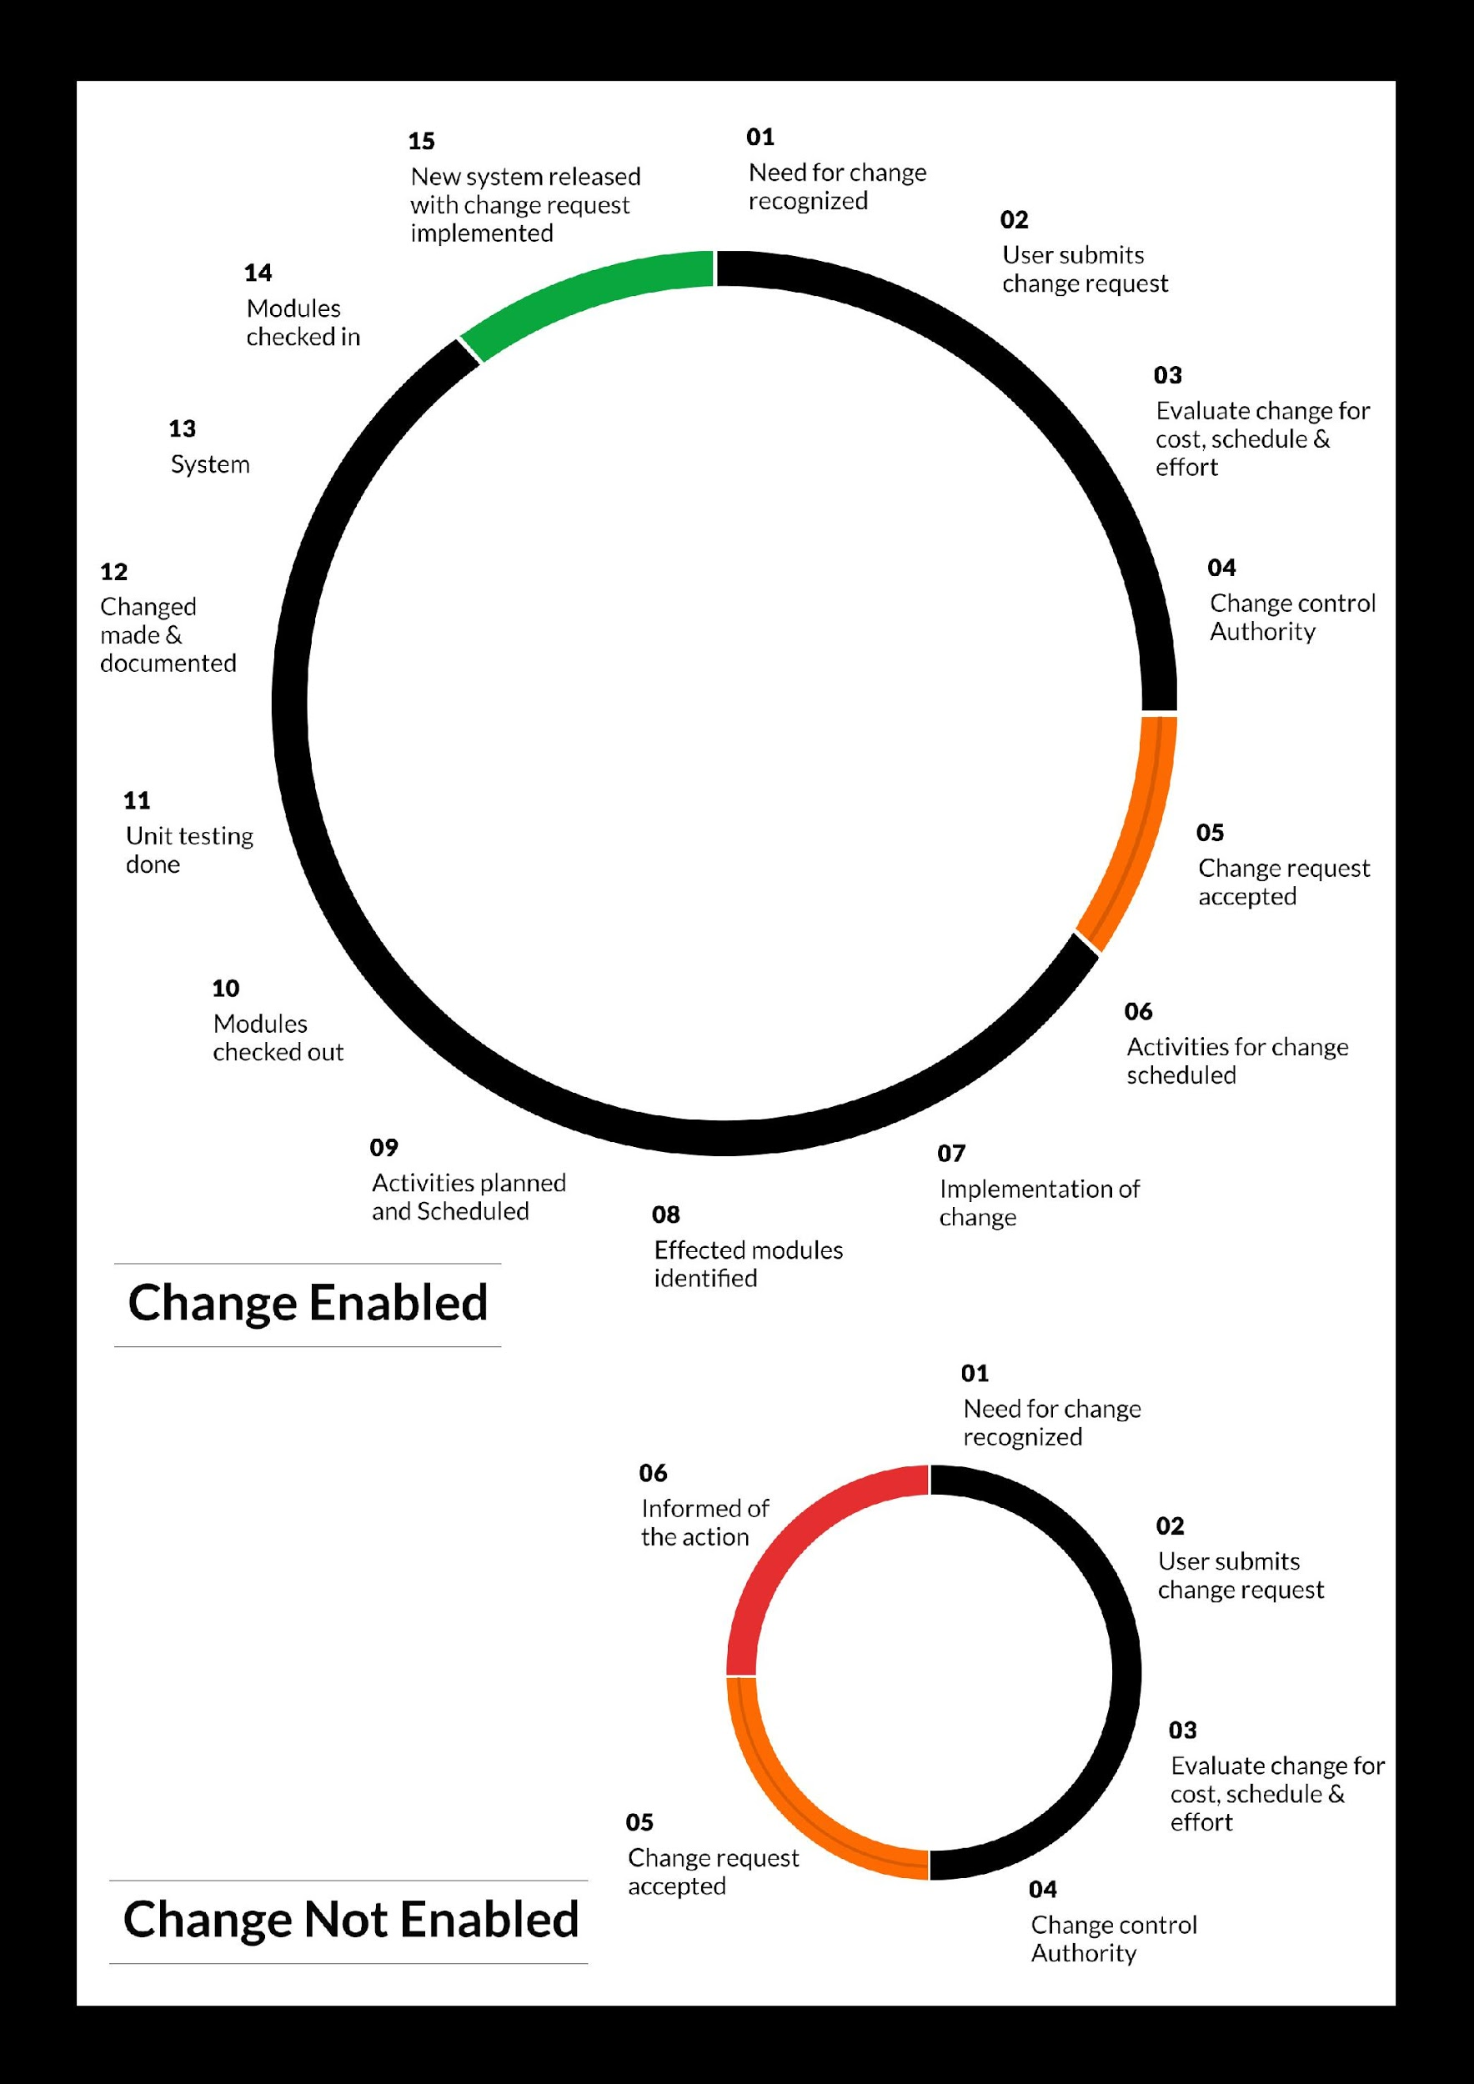

## MAINTENANCE & SUPPORT

* Maintenance contracts by default are supported as per the basic SLA terms.
* AMC with Basic SLA is charged at 25 % of the total project value. Additional Effort/change management request will be added towards Total Value of the Project to determine the AMC value.
* Maintenance support is limited to providing application support for ensuring the consistency of the look-and-feel, bug fixes and user issues i.e. maintenance and support of the existing features of the application.
* Support does not in any way cover providing technical or other support to the end users. The maintenance agreement does not include functionality changes or feature additions which are handled as change requests which will be charged AED 1,200.00 per man day. AMC does not include server support, maintenance and application deployment.
* AMC charges will cover Off-Site Support and Debugging. Support includes E-mail, Telephone and Chat unless explicitly specified. In the event, the application is hosted with the client; necessary remote desktop connectivity should beprovided for carrying out maintenance activity.
* Gap in AMC - In case if the client does not opt an AMC for a year and want to renew it after that period, 50% of the AMC amount for the year for which AMC is not taken will also be payable if the client wishes to renew the AMC contract.

*Note:*

* *Please note that the AMC support shall start only after all the necessary sign-offs (AMC Document) to this effect have been given.*
* *It is not mandatory that the client should opt for an AMC (replace with perhaps: It is mandatory that the client opts for an AMC). The client will still be supported on an ad-hoc basis on an agreed man-day rate.*
* *AMC Payment Terms: 100% to be paid as advance.*

## SERVICE LEVEL AGREEMENT (SLA)

|  |  |  |  |  |
| --- | --- | --- | --- | --- |
| **SLA Type** | **Max Response Time** | | **Max Resolution Time** | **Target** |
| Basic | 1  working day | 3 working days | | Request / incident / problem tickets |
| Advanced | 5 Business Hours | 12 Business Hours | | Request / incident / problem tickets |
| Priority | 3 Business Hours | 5 Business Hours | | Request / incident / problem tickets |

*Note:*

* *We provide Basic SLA as standard with AMC while Advanced and Priority SLAs attract additional charges.*
* *Time zone applicable (8:00 am to 5.00 pm, Sunday to Thursday)*

AMC Option:

Client can opt for time and material based Annual Maintenance, the details of which will be shared post the completion of project.

# **TERMS & CONDITIONS**

## ACCEPTANCE CRITERIA

* UAT (User Acceptance Test) sign off should happen within 07 Days from the first release of the application and the acceptance confirmation needs to be mailed to Verbat failing which Verbat will consider the project as approved by the client.
* Any comments or reason for rejection need to be documented and the same needs to be sent as an email from the official mail id of client to Verbat on or before 07 days from the first release.
* Timeframe for acceptance for any further release will be mutually agreed and finalized between client and Verbat depending on the UAT Comments

## WARRANTY

* Verbat shall provide a bug ﬁx warranty at no additional cost for 30 days from the date of acceptance of the project, for correction of any errors in the developed application that may be attributed to Verbat.
* However, this does not cover modifications by Client, or use of the application on an environment other than the proposed environment, or other circumstances outside Verbat’s reasonable control. In such a case Verbat reserves the right to charge for its services.
* All error corrections will be executed at Verbat India office. In the event of any need for on-site work, all expenses incurred for such trips will be payable to Verbat by Client.

## SOURCE CODE & INTELLECTUAL PROPERTY RIGHTS

* Upon completion of the Project and 100% completion of the payment, client will have access to the source code except for propriety codes, developer tools and third party applications etc.
* The solution offered will be the intellectual property of the client and will be made available to the client on an “unlimited license” basis.
* Modifications by third party/person: No person or organization, other than Verbat or any person authorized by Verbat in writing, has any permission to modify/change the software Solution to be eligible to get continued support from Verbat as per the support terms defined under this document.
* Liabilities/Damages: Verbat accepts no liability or damages of any kind arising out of use or non-use of the software delivered. The responsibility of testing of software lies with Client.

## GENERAL TERMS AND CONDITIONS

* Offer Valid for 30 calendar days from the date of submission of the Proposal.
* An average of 20 working days are assumed in a month.
* All the projects activities will be carried out from our off-shore development center in India
* All the documentation will be provided in English.
* Third party components may be used to develop this application.
* The scope of the project is to develop the Application as detailed in the scope of the project and mentioned in this proposal. Any changes or additions will have to go through change management.
* This proposal would have been derived or concluded from either the RFQ /RFP/data shared via email / information transferred during an initial requirement analysis meeting / tele-conversation. Verbat reserves the right to change the terms of this proposal as the final terms (including the costing), features & functionalities and timeline could change during the course of the project. Hence any fees quoted / timeline committed in this proposal may not be considered as final unless agreed and signed by both parties.
* Web Application will be best viewed only in the environment mentioned in the section Browser Compatibility
* All Source Codes and other project artefacts would adhere to the Verbat document templates and internal coding standards.
* The documents delivered to the client includes the ones mentioned under ‘Deliverables’ and these will adhere to Verbat’s internal document standards.
* Acceptance criteria shall be based on the clauses which were mutually discussed between Verbat and client at the Requirement Analysis phase and the same will be documented and approved by both parties through official emails
* In case Client requires any extension of the proposed acceptance schedule, the associated effort and cost of such extension can be mutually reviewed.
* For any circumstances if project needs to be put on Hold / Stop it requires minimum request notice period of 1 week along with duration for which request will be addressed by management and final decision on the request will be based on that
* If deployment is done in client’s server, Verbat cannot be held responsible for any performance issues arising due to hardware malfunctions.
* Client is responsible for data backup in case the application is not hosted on Verbat server.
* Source code will only be delivered or uploaded on the Production Server once the due payments are made.

## GENERAL ADMINISTRATIVE, TECHNICAL & FUNCTIONAL ASSUMPTIONS

* Detailed system study is required before the start of the project.
* During the requirement gathering phase, authorized personnel from the Client’s side is expected to be available for discussion and finalizing the HLD (High Level Design), before development commences.
* Type of reports and formats, if under the scope of the project, needs to be specified by Client before project sign off.
* Workflows if under the scope of the project, need to be specified/ confirmed by client before project signoff.
* Verbat assumes that all sign-offs from Client will be provided within agreed and specified timeframe.
* Client will provide all the necessary contents, both text and image, before starting the project in the format suggested by Verbat (if any).
* The client should provide the relevant information and data well in time for the execution of a related activity. Non- availability of this information or data may lead to an interruption of work which may result in a delay in delivery as well as additional costs to the client.
* Client should have/possess server with technical specifications as suggested by Verbat for the proposed application.
* Client will be provided with one time training (train the trainer) on how to use the application via video conference (maximum of 4 hours). Additional training requests will be charged.

# **FINANCIALS**

## WEB APPLICATION DEVELOPMENT

|  |  |  |
| --- | --- | --- |
| **No** | **Description** | **Amount (AED)** |
| 01. | Development of:   * Web Application |  |
|  | **Total Project Cost** |  |

*Note:*

* *The above cost is exclusive of VAT applicable in UAE*
* *The above cost is based on the initial understanding of the requirement grounded on the details shared by client. Any further changes in the scope or complexity if encountered during detailed system study/ analysis will call in for additional effort and time.*
* *The above cost does not include Application hosting, integration with any other third-party systems, deployment unless explicitly mentioned in this proposal.*
* *For feature additions, please refer section titled “Change Management “.*
* *LPO to be raised in the name of “Verbanet Technologies LLC” for project initiation*
* *Refer section 7.3 for ‘Mode of Payment’.*

### **PAYMENT TERMS**

* 30% () of total project value to be paid as advance along with the Purchase Order
* 40% () of total project value to be paid on confirmation of the UI/UX
* 30% () of the total project value to be paid on completion of Development and UAT on Verbat test server

*Note:*

*Payment should be made within 7 days from the date of invoice.*

## WINDOWS DEDICATED HOSTING – OPTIONAL

ITEM NO. DECSRIPTION AMOUNT (AED)

1. Windows Dedicated Hosting

TOTAL PROJECT COST

*Note:*

* *The above cost is exclusive of VAT applicable in UAE*
* *Refer “Windows Dedicated Hosting Proposal” for detailed Server specifications.*
* *Refer section 7.3 for ‘Mode of Payment’.*
* *LPO to be raised in the name of “Verbanet Technologies LLC” for project initiation*

### **PAYMENT TERMS**

* 100% advance payment along with Purchase Order to initiate Server purchase

*Note:*

*Payment should be made within 7 days from the date of invoice.*

### **MODE OF PAYMENT**

By Cheque to Verbanet Technologies LLC

OR

Wire transfer to our bank account

Bank Name : Emirates NBD

Account Name : Verbanet Technologies LLC

Account Number : 1011492858201

IBAN Number : AE61 0260 0010 1149 2858 201

Swift Code : EBILAEAD

Bank Address : Mamzar Branch, Dubai

*Note:*

* *Bank charges incurred during wire transfer to be borne by the client.*
* *Any local taxes / VAT applicable to be borne by the client*
* *Client invoices will include VAT charges in addition to the application cost*

# **CLIENT REFERENCES**

Education

Transportation

**Client Name – Ministry of Education (MOE)**

Project Name: Open Educational Resource Platform (OERP)

Location: Dubai, U.A.E

Ministry of Education has requested Verbat to develop a UAE- Open educational resource platform (OERP). The aim of this platform is to provide a centralized online platform where UAE and others can view, share and contribute their contents. Furthermore, this portal will allow UAE-MOE to track and monitor the progress through a dashboard. All information related to OER such as issue date, source, current state, future state, release dates along with best practices shall be captured.

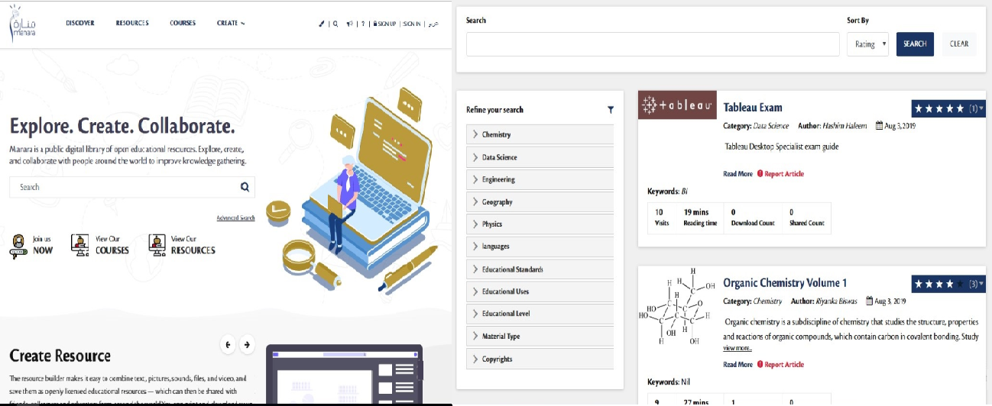

**Client Name – Sharjah Commerce and Tourism Development Authority (Government of Sharjah)**

Project Name: Permit Issuance and Inspection System

Contract Type: Fixed Bid

Location: Sharjah, U.A.E

Established in 1996, the Sharjah Commerce and Tourism Development Authority (SCTDA) is tasked with promoting commercial and tourism activities in the emirate of Sharjah. Sharjah intends to provide a sustainable tourism product with a unique and distinct tourism experience in the desert areas of the emirate. This is geared towards attracting the interest of various tourism companies, specifically tour operators, to focus on Sharjah when organizing desert trips and desert adventures activities within these areas. Consequently, this would be beneficial to the tourism sector and will contribute further to Sharjah’s economy. Hence, the Sharjah government has decided to organize desert tourism activities through this project; the issuance of permits to all tour vehicles entering the desert areas of Sharjah for desert safari activities owned or operated by tour operators along with the day to day inspection tasks carried by inspectors who can issue fines and attach evidences for further actions.

Sharjah Tourism resource deployment model comprises of Offsite resource (Verbat Resource) and Onsite Project Manager (from client’s side)

**Client Name – MBC**

Project Name: Security Inspection System

Contract Type: Fixed Bid

Location: Dubai, U.A.E

Smart Security System facilitates a sophisticated and structured approach to execute the daily security checklist to be used by the security patrol users. In addition to the ability of recording concern/issues as well to be viewed at any time as reports.  The application includes different users like Super Admin, Branch Admin, Inspector, Resolver and Viewer. The Inspector user reports patrol issues and concern issues using android mobile application. Branch admin assign the patrol issues to the resolver. Viewer will be able to see the issues and concerns related to the particular branch.

**Client Name – Carrefour Hybrid Project**

Project Name: Software Quality Assurance Managed Services

Contract Type: Time & Material

Resource Deployment Model: Hybrid (Onsite + Offsite)

Founded in 1992, Majid Al Futtaim is the leading shopping mall, retail and leisure pioneer across the Middle East and North Africa (MENA).

A remarkable business success story, Majid Al Futtaim started from one man’s vision to transform the face of shopping, entertainment and leisure to ‘create great moments for everyone, every day’. It has since grown into one of the United Arab Emirates’ most respected and successful businesses spanning 13 international markets, employing over 27,000 people, and achieving the highest credit rating (BBB) among privately-held corporates in the Middle East.

Carrefour testing team comprised of 20 resources inclusive of Onsite Project Manager, Onsite Test lead and Offsite Test Engineers

**Client Name – Ministry of Foreign Affairs**

Project Name: VISA Scheduling System

Contract Type: Fixed Bid

Location: Dubai, U.A.E

A web based application for the visa applicants and respected sponsors to schedule appointment for the security verifications. The system allows online payment facility. The application features include option for the sponsor to schedule appointments, option for the super admin to manage country and sites, manage other admin users and set e-mail/SMS notifications

# **ABOUT US**

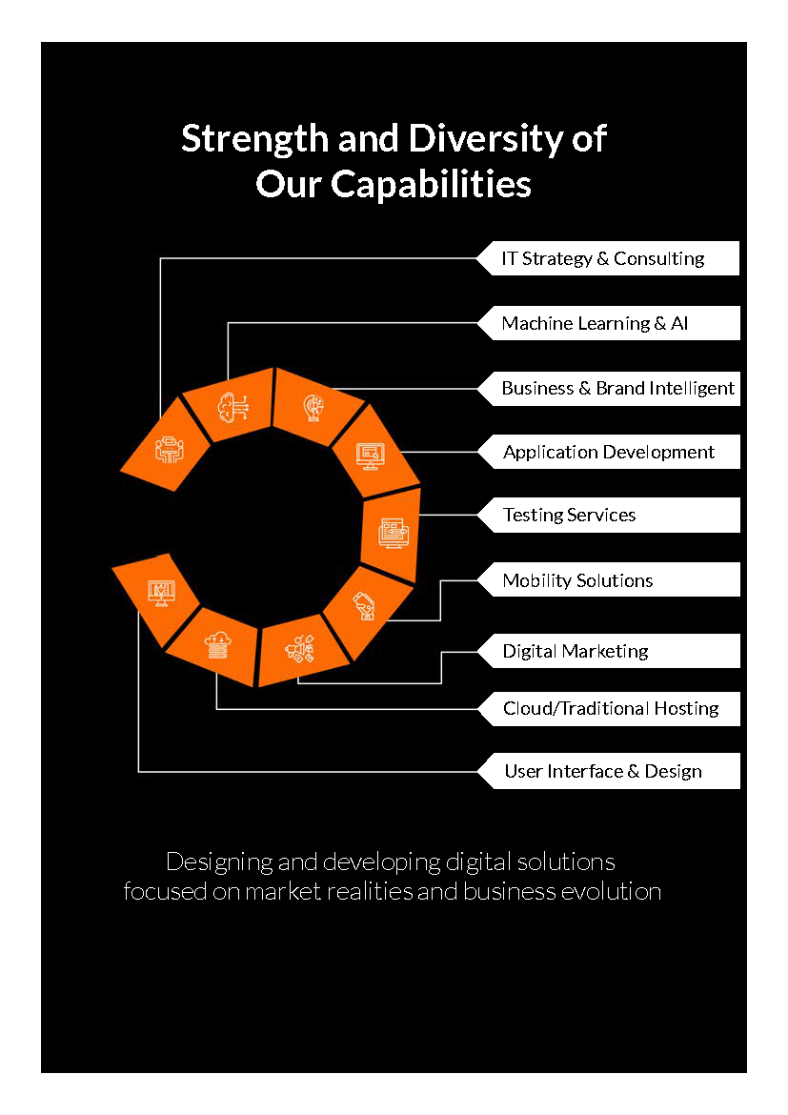

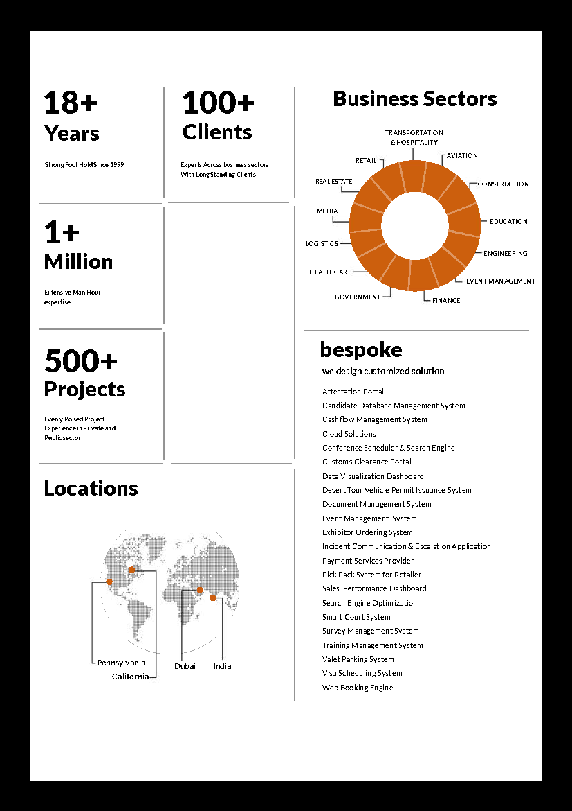

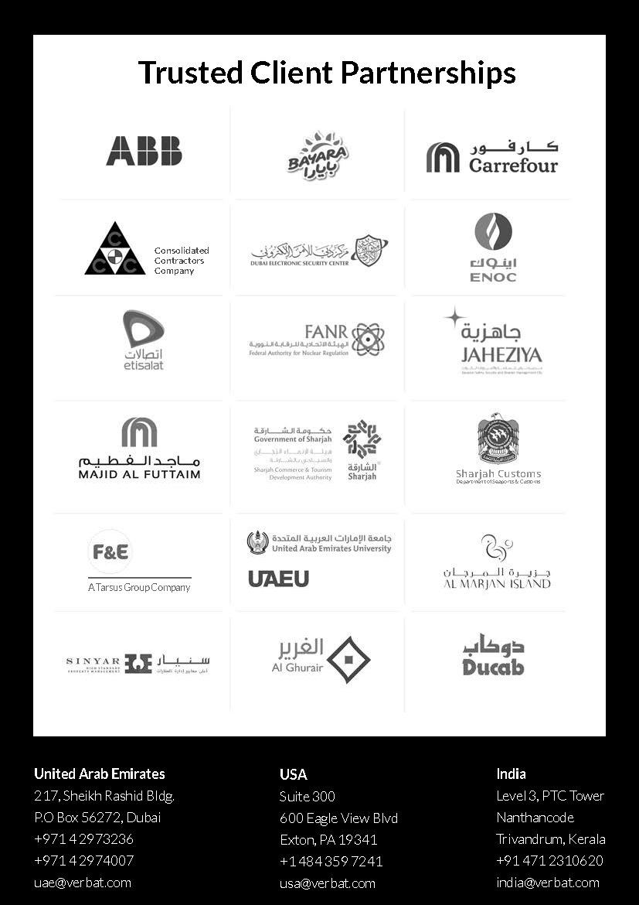

**Software ScreenShots**

**High Level Chabot Architecture**

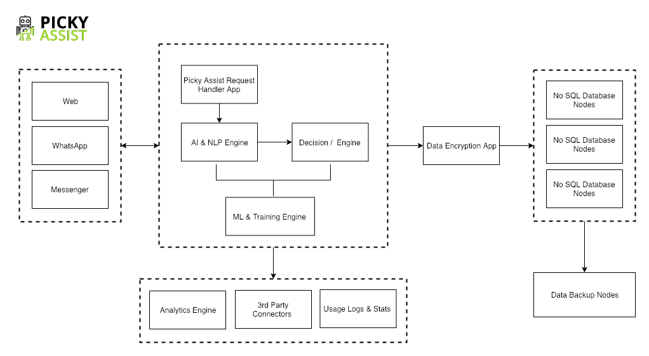

**Live Chat**

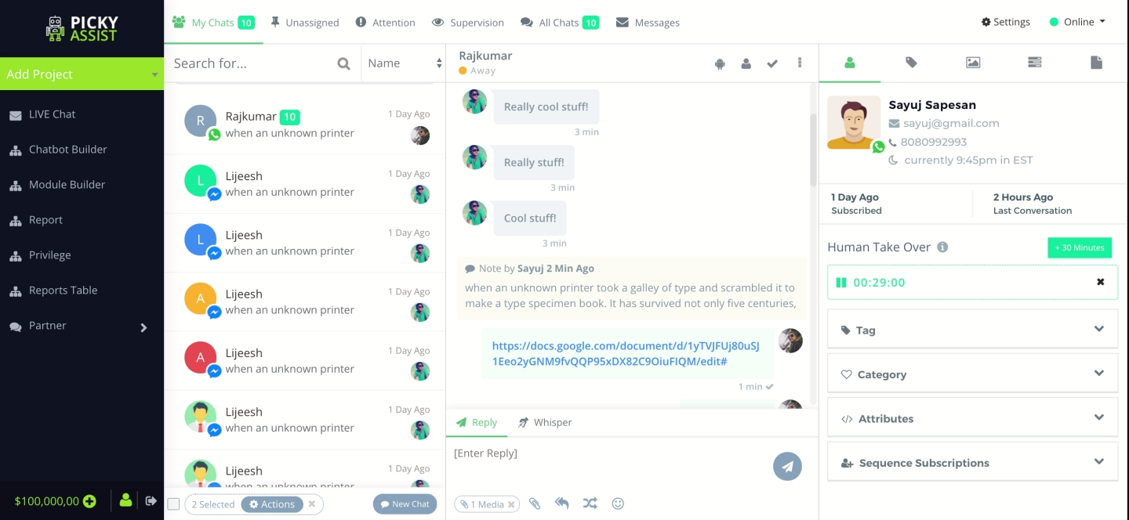

**Drag & Drop Bot Builder**

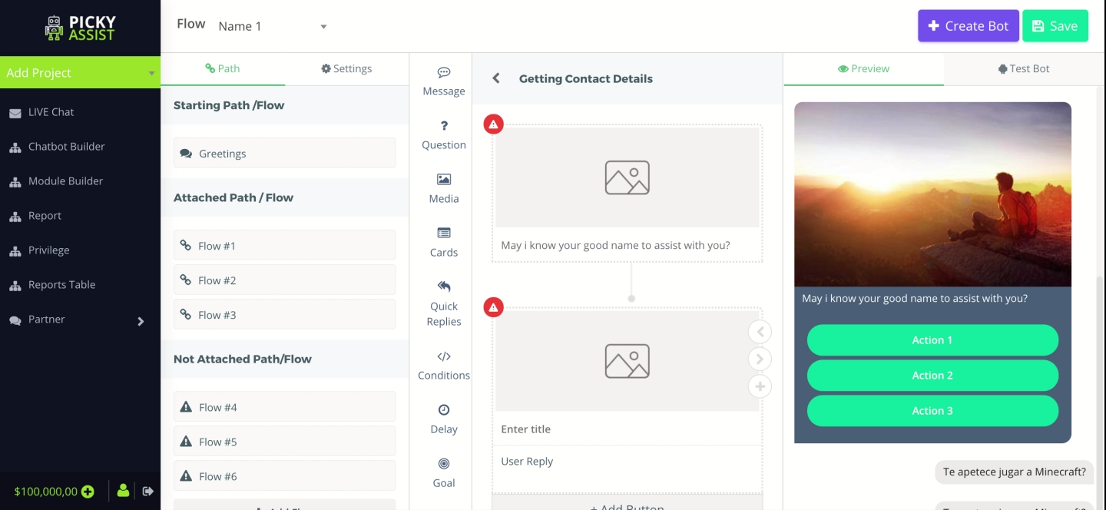

**AI Training Dashboard**

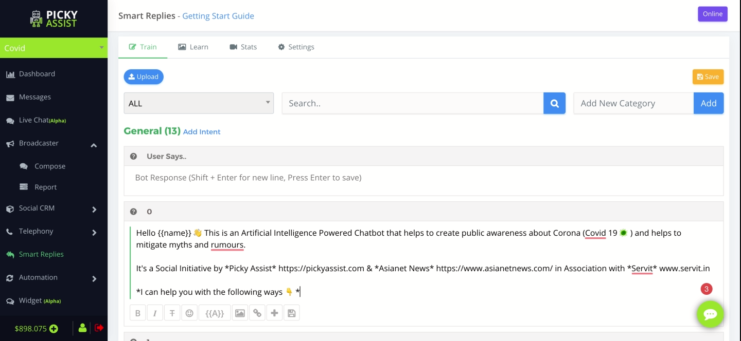

**Intent & Entity Management**

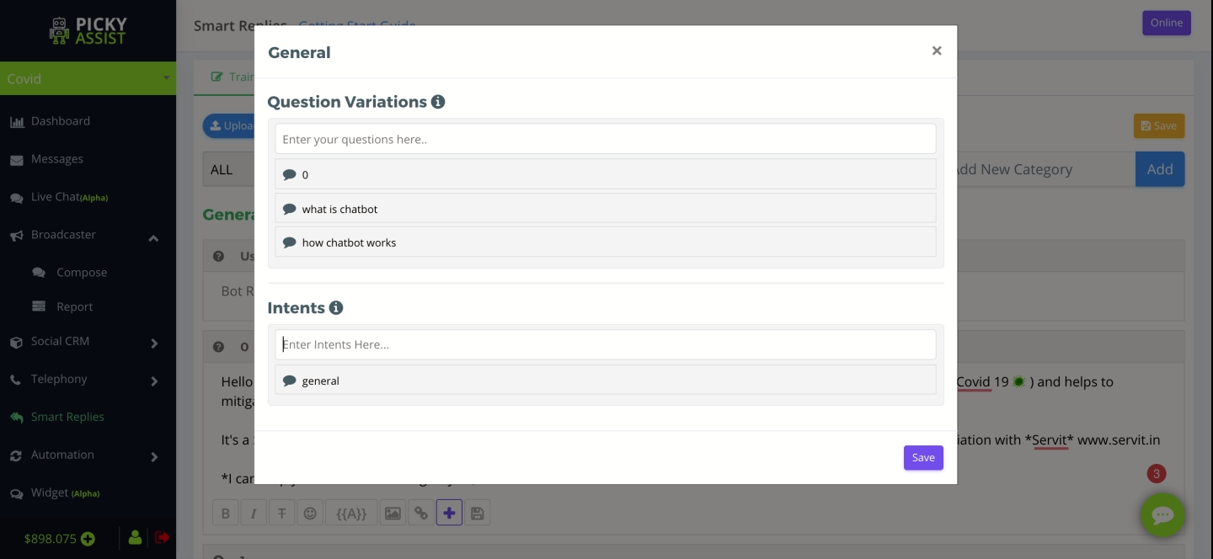

**Broadcaster**

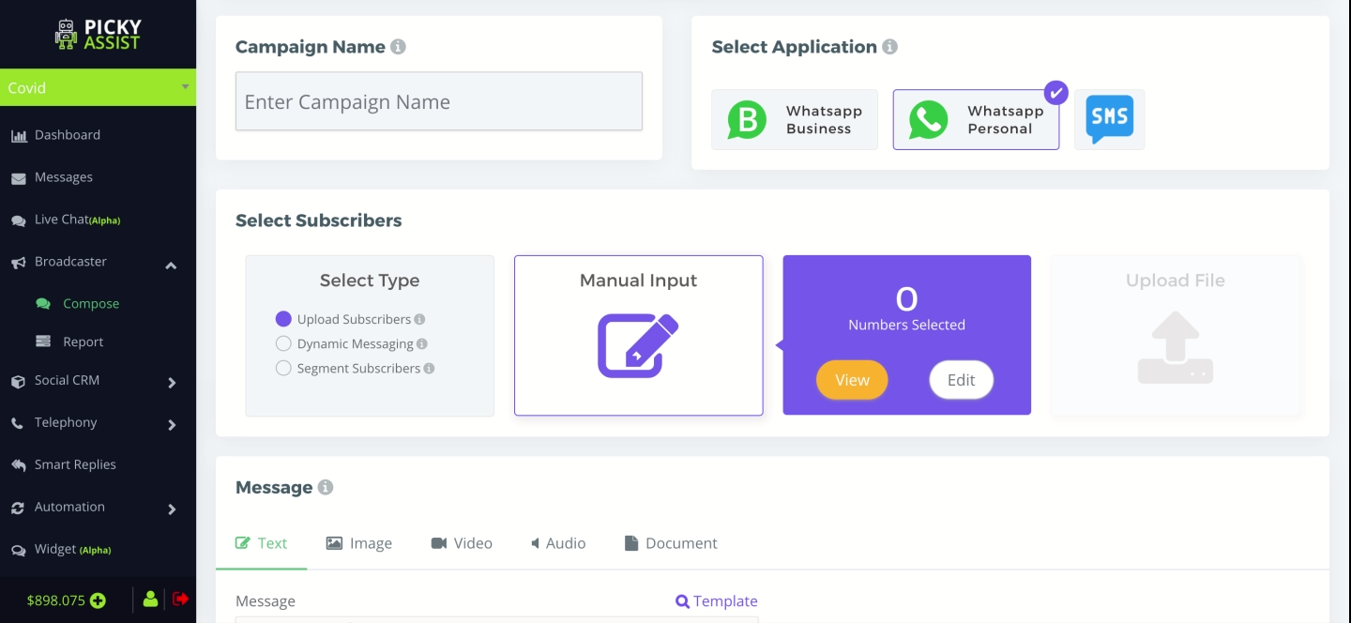

**User Segmentation**

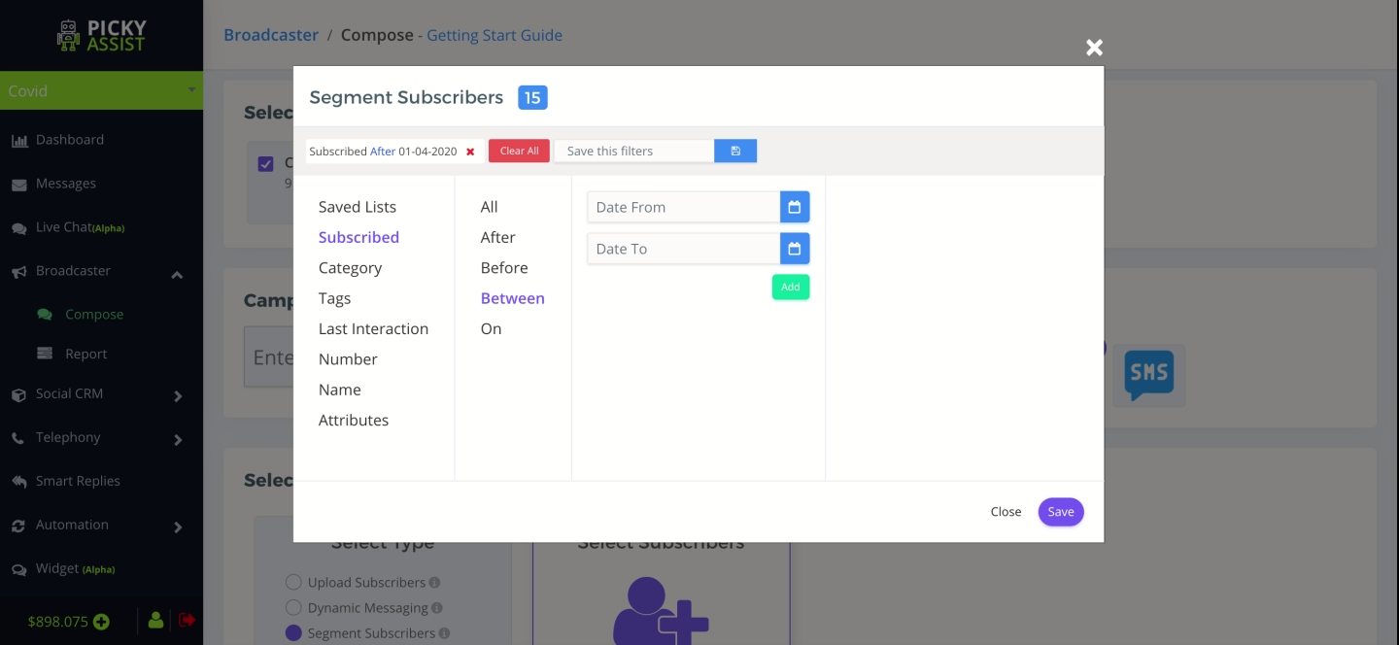

**Channel & Role Management**

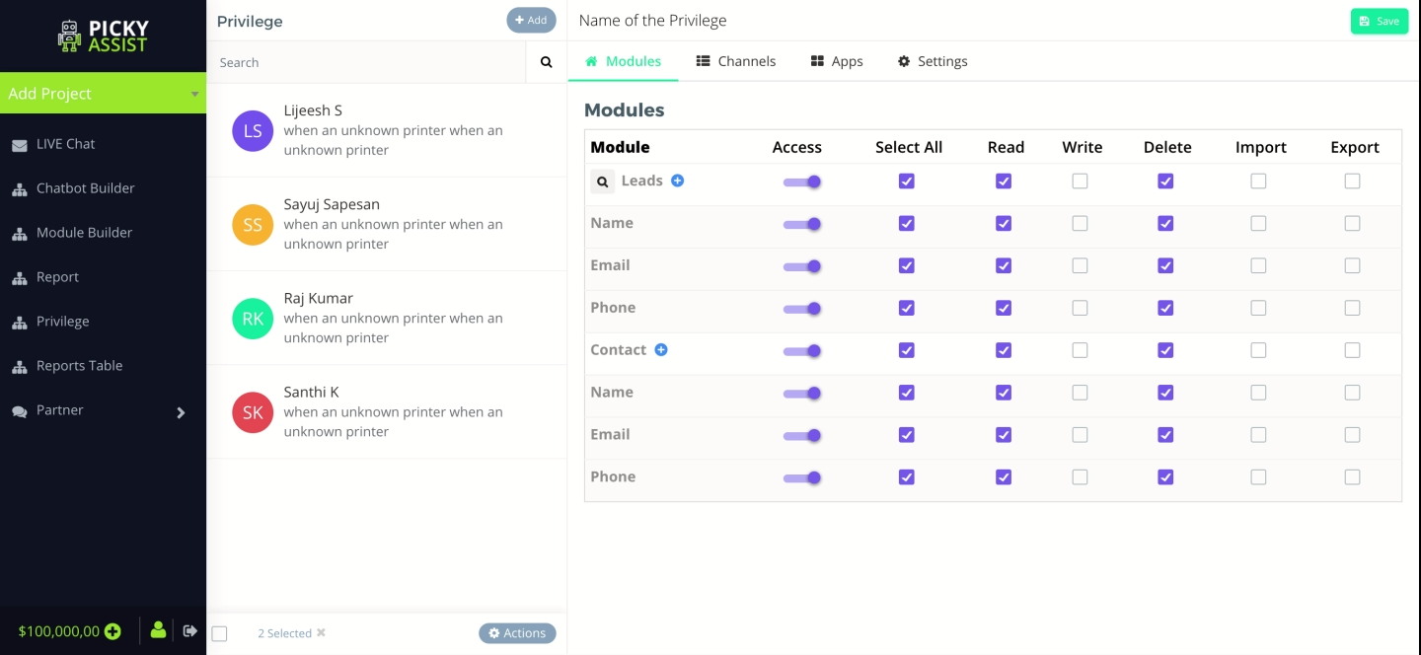

**Bot Subscribers**

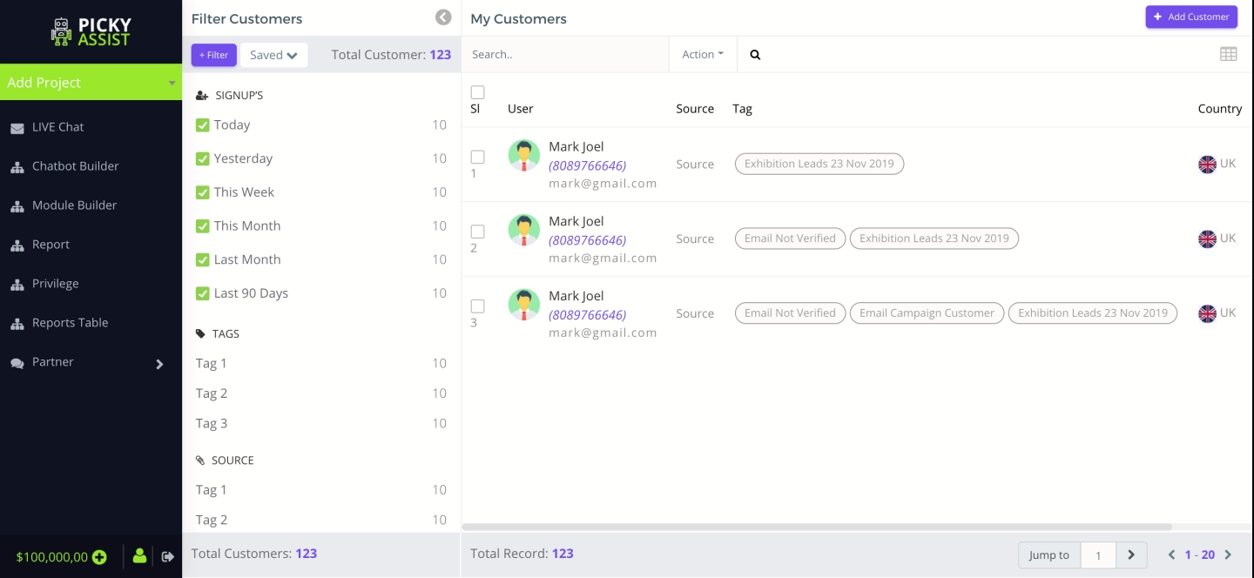

**Report View**

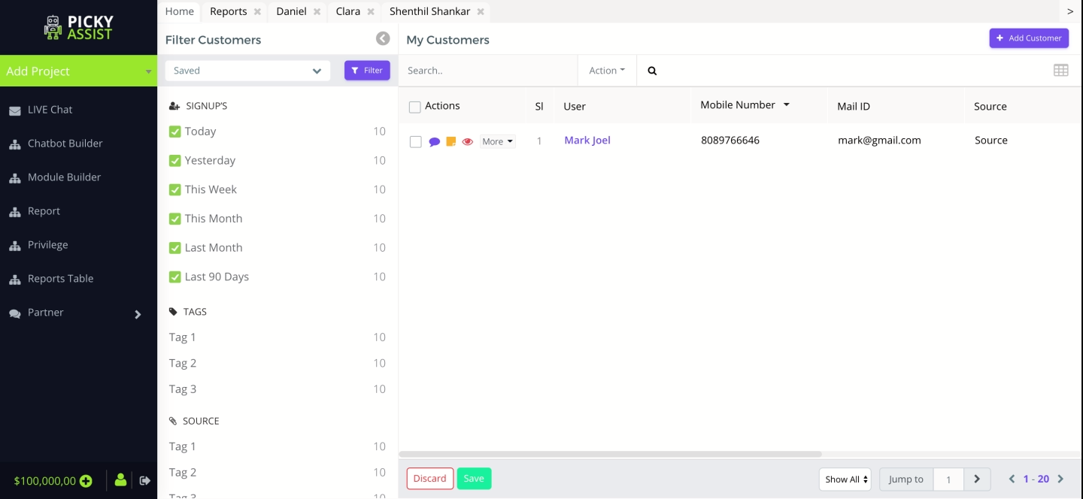

**Dashboard**

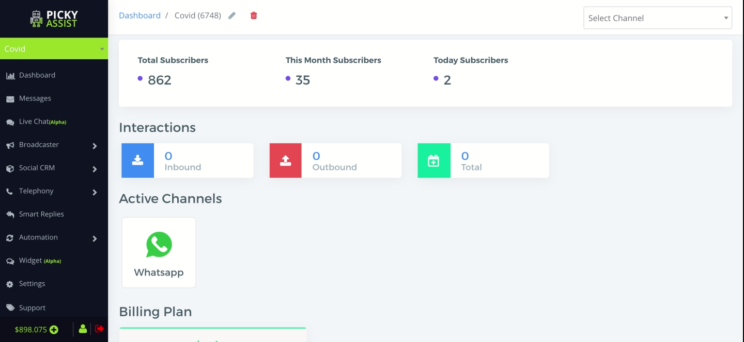

**Widget Customisation**

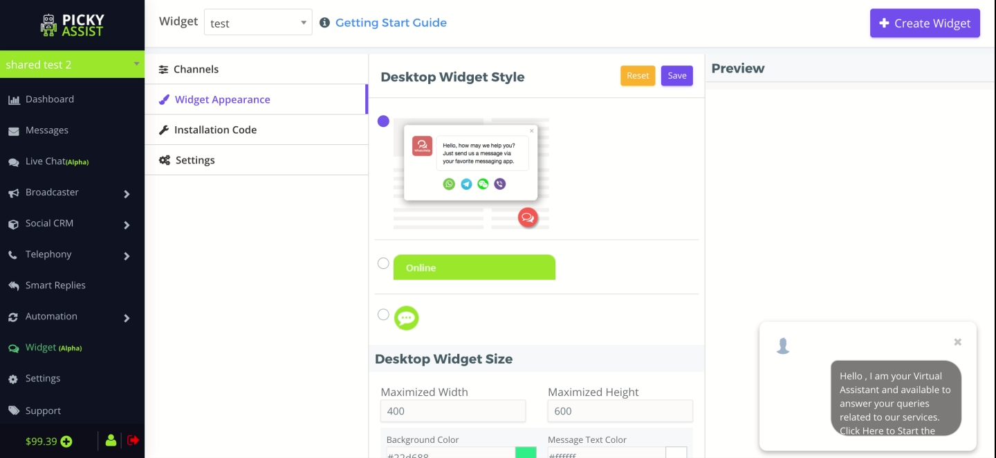

**Support Tickets**

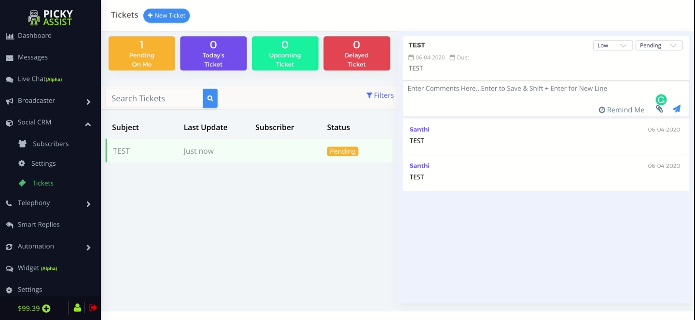

**Conﬁdentiality Notice:**

**This Proposal is conﬁdential and contains proprietary information and intellectual property of Verbanet Technologies LLC. Neither this proposal nor any of the information contained herein may be reproduced or disclosed under any circumstances without the express written permission of Verbanet Technologies L.L.C (hereby known under its brand name of Verbat in the United Arab Emirates). 2018. All rights Reserved**