**TECHNICAL PROPOSAL**

**Program Management & Asset Tracking Application**

Tatweer

Submitted By:

VERBANET TECHNOLOGIES L.L.C

**CONTENTS**

**1** **KEY DETAILS** 3

**2** **PROJECT SCOPE** 4

2.1 PROPOSED SOLUTION MODEL 4

2.2 FUNCTIONAL REQUIREMENTS 4

2.3 NON-FUNCTIONAL REQUIREMENT (OTHERS) 8

2.4 PROPOSED SYSTEM ENVIRONMENT 9

2.5 TECHNICAL CONFIGURATIONS 10

2.6 PROJECT DELIVERY 12

2.7 PROJECT ASSUMPTIONS 17

**3** **OUT OF SCOPE** 19

3.1 CHANGE MANAGEMENT 20

3.2 MAINTENANCE & SUPPORT 22

3.3 SERVICE LEVEL AGREEMENT (SLA) 22

**4** **TERMS & CONDITIONS** 24

4.1 ACCEPTANCE CRITERIA 24

4.2 WARRANTY 24

4.3 SOURCE CODE & INTELLECTUAL PROPERTY RIGHTS 24

4.4 GENERAL TERMS AND CONDITIONS 25

4.5 GENERAL ADMINISTRATIVE, TECHNICAL & FUNCTIONAL ASSUMPTIONS 26

**5** **FINANCIALS** 28

5.1 WEB AND MOBILE APPLICATION DEVELOPMENT 28

5.2 WINDOWS DEDICATED HOSTING – OPTIONAL 29

**6** **CLIENT REFERENCES** 30

**7** **ABOUT US** 34

# **KEY DETAILS**

**PROJECT NAME CLIENT**

Program Management and Asset Tracking Tatweer

**CLIENT CONTACT CLIENT ADDRESS**

Mr. P.O.Box 123

ABC Street

Dubai

U.A.E

**PROPOSAL SUBMISSION PROPOSAL ID NO.**

30.06.2020  AD/BP/25042018/1820/2

**PROPOSAL VALID UNTIL ANTICIPATED START DATE**

31.07.2020 00.00.00

**PROPOSAL SUBMITTED BY PROPOSED TECHNOLOGY**

Verbanet Technologies L.L.C ASP.NET Dubai, U.A.E **APPLICATION TYPE**

+971 4 297 3236 Mobile Application

+971 50 765 2345

# **PROJECT SCOPE**

Tatweer (hereafter referred to as “Client”) has approached Verbanet Technologies L.L.C., (hereafter referred under its trade/brand name as” Verbat”) to develop a program management and asset tracking software

## PROPOSED SOLUTION MODEL

**STAND- ALONE FIXED BID**

Verbat will be following a stand–alone fixed bid solution delivery model wherein the required solution would be devised and a suitable pricing would be offered. Verbat’s solution architects have conducted a thorough research on the requirements and have come to the conclusion that our proposed solution, which is detailed further in this document, will meet the requirements put forth by the client.

**KEY STRENGTHS OF OUR SOLUTION**

* Strong and Scalable platform accommodating to future enhancements
* A framework which acts as a solution accelerator with building blocks that can be re-used in n future for building new components and features.
* Our light weight framework used consumes fewer system resources thereby making the application perform faster.
* All security aspects are considered

## FUNCTIONAL REQUIREMENTS

The main features and functionalities of the application to be developed are presented below:

### **BACK OFFICE**

* Dashboard/Report
* Analyze data
* Analyze installations
* Analyze Project Progress
* Monitor, and visualize asset health
* Navigate to assets by spatial data
* Review Key Performance indicators
* Review status
* Track failures
* Assign crew to various tasks
* Manage installation and progress
* Manage asset details and inventory
* Integration with inventory system.
* Create maintenance log for every asset
* Track crew daily progress
* specify user roles for each user of the mobile application
* Straightforward KPI and performance evaluation
* Dashboard(s) for supervisors for quick and easy access to monitor program status, installations, progress, failures and exceptions
* Dashboard shall provide:
* Comparing the actual vs planned of project data.
* Easily track progress at the sectors, main streets and highways level, within each zone, and even down to a single sector.
* Compare and filter crew progress
* KPIs and statistics by day, week and months.
* Inventory statistics.

**Program Scheduling**

* Plan and feed in the complete program(no. of asset installation, staff required, and schedule of the installation/replacement of equipment)
* Track the progress of crews and project against program and notify and suggest the corrective actions when required
* Drilldown details to the zones, sectors and streets as well using the application’s GIS based features

**Live monitoring**

* Monitor (Real-time) the installation of inventory, health of assets and performance and activities of the crew and alerts stakeholders to take corrective actions in real-time.

**System**

* Full visibility and control of assets
* Monitor the asset installation, maintenance, events, and inspections, set schedules, maintenance and monitoring of the implementation and O&M staff KPIs.
* Data encryption and two-factor authentication
* System automatically informs personnel when it is time for installation in specific area, inspection and preventive maintenance.
* linking all information relating to the asset in one place
* Check-in and check-out while transfer
* Supervisor can assign technician to the ticket or maintenance request can come through integration with Maintenance System
* Email, SMS push notification with various data feeds like new task assignments or coming-up scheduled maintenance, assignments, the status of generated tickets, etc.

**Preventive maintenance scheduling**

* Plan maintenance activities and manage schedules of assets preventive maintenance and create checklists in schedules to maintain periodic tasks.
* Gather data surrounding preventive maintenance activities to report on or optimize those activities and set maintenance KPIs to work

### **MOBILE APPLICATION**

**Asset Installation**

* End-to-end asset installation and post installation processes
* Filter tasks based on date/zones/main streets or priority
* Upload the installation evidence (photos, videos or other documents) for each asset after installation
* Note: Installation process shall be updated to back office

**Post Installation Testing**

* Periodic inspection or testing the assets after installation and uploading the details with evidence
* Add data such as photos/capture photos, annotations, geographic coordinate, attribute, Signatures, Audio/Video.
* GPS functionality to identify exact locations
* Drop a pin to generate an address with coordinates

**Asset Movement**

* Transfer assets to another location/site or to the person employed in another department. Transfer asset back to the inventory
* Capture images, videos or files related to the assets while transferring them.

**Mobile User**

* Evaluate his own performance based on assigned vs actual performed activities.
* Upload data directly from mobile application, with failure reports, meter readings and installed assets evidence as photos/videos, and documents
* Compare the performance of several assets of the same type and identifying the performance gaps and plan accordingly
* Pull information from asset inventory, asset management and maintenance of assets (one place).
* Scanning of barcodes and QR codes of assets
* track and search archived records and access to installation history, asset, maintenance, and repairs

**Maintenance/Ticketing**

* Raise maintenance tickets or queries
* Check all tickets by their status like open, assigned, pending, or closed from a single dashboard.

## Detailed Requirements (Web)

|  |
| --- |
| **Master Data** |
| Asset Master |
| Asset Groups |
| Asset Locations |
| Inventory Master |
| Part Master with maintenance option |
| Drivers |
| Vehicles |
| Crew |
| Asset - Parts Linker |
| Suppliers |
| Job Locations |
| Inspection check list templates for assets |
| Scan Barcodes |
| **Asset Management** |
| **Asset Transactions** |
| Purchase Return |
| Asset Requisition |
| Material Issue |
| Material Return |
| Location Transfer Out |
| Location Transfer In |
| Adjustment |
| **Documents** |
| Goods Receipt |
| Purchase Return to Supplier |
| Material Issue |
| Material Return |
| Location Transfer Out |
| Location Transfer In |
| **Reports (Export to PDF & Excel)** |
| Stock Movement by location |
| Stock unconfirmed |
| Daily Store Movement |
| Inventory transfer Out |
| Inventory Transfer In |
| Stock Ledger |
| Delivery by Vehicle & Driver |
| Issued Items in a period |
| All Assets |
| **Utilities** |
| Import Assets |
| Import Parts |
| Import Suppliers |
| Import Inventory |
|  |
| **Program Management** |
| Create Job |
| Create Tasks in Job |
| Create Sub Tasks |
| Schedule Tasks |
| Assign Crew to tasks |
| Assign Location to tasks |
| Link Assets to Tasks |
| Progress update by Sub tasks, Tasks and Job (manual) |
| Update tickets automatically(If needed) |
| Capture Evidence & Signoff job completion |
| Trigger Maintenance jobs for task completions |
| Trigger Inspection Activities |
| **Asset Maintenance & Inspections** |
| Create Inspection Schedules (Linked to Maintenance job Triggers) |
| Prepopulate Schedule with Location, Parts, manufacturer recommended maintenance window & check lists |
| Create tasks for schedule |
| Create schedule check list from template or create new |
| Assign Crew to tasks |
| Update Tasks |
| Requisition Assets for damages found |
| Create Tickets for damages |
| **Ticketing** |
| Update ticket status |
| Assign Ticket owner |
| Create Job for ticket (Linked to program management) |
| Resolve Ticket |
| **Dashboards** |
| Interactive Map View with job locations |
| Tasks Completed |
| Crew deployed |
| Parts Deployed |
| Overall completion status |
| Impediments found |
| Near real-time view of crew movement (assuming the crew carries a mobile device with app installed) |
| Installation Schedules |
| Inspection Schedules |
| Maintenance Schedules |
| Installation status by job |
| Inspection status by job |
| Maintenance status by job |
| Ticketing status |
| Crew deployments |
| Impediments by Job |
| Other KPIs (6 hrs. per KPI) |
| Asset returns / surplus / defects |
| Assets linked to jobs |
| Actual vs Planned scheduled by job |
| **System Integrations** |
| Single Sign On |
| Multi Factor Authentication |
| AMS integration |
| MMIS Integration |
| SMS Gateway integration |
| Document management |
| Data Archival |
| Map integration |
|  |
|  |
| Redis Integration |
| **Security** |
| Protection against injection attacks (SQL, CRLF) |
| URL encoding, Input validation |
| Cookie Encryption, Cookie replay attacks |
| Session hijacking prevention |
| Cross site scripting and session management |
| **System Features** |
| Authentication, Authorization, Roles |
| Exception Handling and Error logging |
| Auditing & Logging |
| Search Engine |
| Notification management |
| Reporting Engine |
| Workflow management |
| **Mobile API** |
| Mobile API |

## Detailed Requirements (Mobile)

|  |
| --- |
| **Crew** |
| Today’s Schedule |
| Job Assigned |
| Task and task details in job |
| Item checklist |
| Accept Task |
| Update task |
| Capture evidence (upload images, video, documents, audio) |
| Navigate to job |
| Update GPS location |
| Create impediments |
| Create Schedule delays |
| Create notes |
| Update Job Status |
| Report issues |
| **Supervisor** |
| View Active Job Locations |
| Track crew assigned to jobs |
| Track Job status / task Status |
| Track crew location |
| Track impediments |
| Scan Barcodes |
| Update GPS location |
| Navigate to Job location |
| Create Schedule delays caused by impediments |
| Upload multimedia to document job status and progress |
| link to asset management |
| link to maintenance management |
| View Inspection Schedules & Status |
| View inspection Check list |
| Update inspection results and upload evidence (images, video, audio, text) |
| View Tickets, Ticket details & Status |
| Create & Update tickets |
| Update Job Status & task status |
| Report Crew |
| **Common Features** |
| Login / logout |
| Update preferences |
| Update account details |

## Functional Architecture

## Minimum Viable Architecture (Default Implementation)

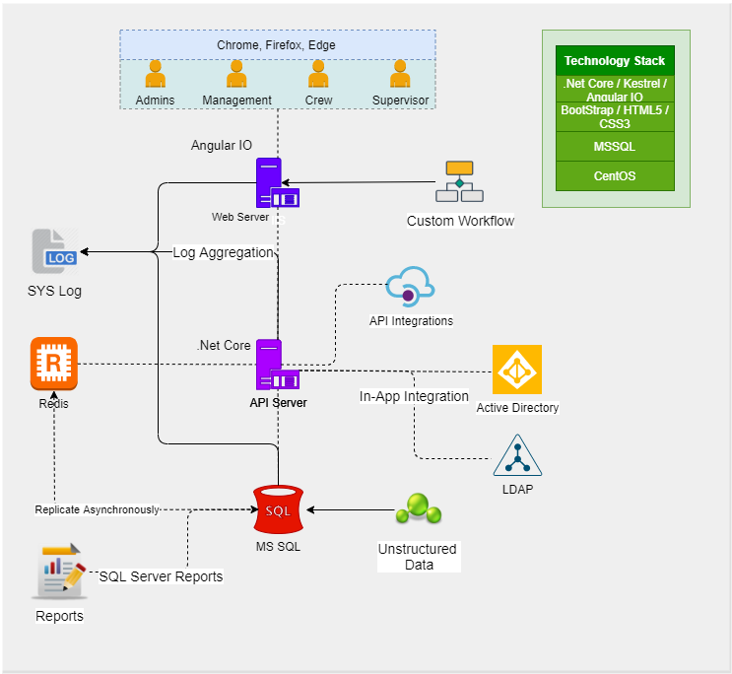

## Scalable Architecture (Reference)

## Architecture Components

## Network Topology (Based on Scalable Architecture)

## Release & Deployment

## QA Lifecycle

## Security Posture & Threat Modelling

# NON-FUNCTIONAL REQUIREMENT (OTHERS)

|  |  |
| --- | --- |
| **Requirements** | **Details** |
| User Experience and  UI Design | * The application will be developed only in English * The layout and graphical components will be created considering the usability factors |
| Performance | * Application will allow users to have smooth and quick access to the information or services they require. |
| Security | * Web security standards will be followed. |

# PROPOSED SYSTEM ENVIRONMENT

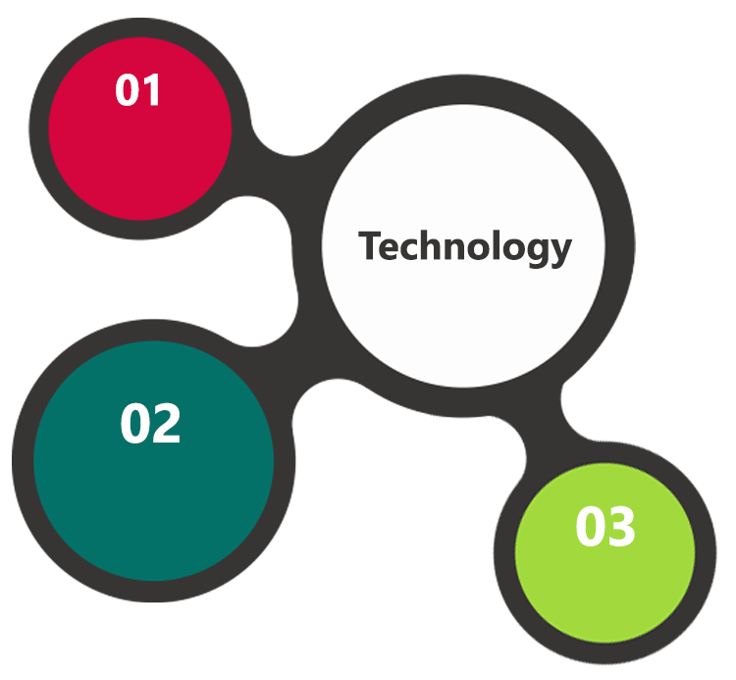

.Net Core, MVC

Angular

HTML5 / CSS3

Java Script

Windows

IIS

MS SQL

**MS SQL2012  
Windows 8/10  
Web Services**

# TECHNICAL CONFIGURATIONS

### **DEVELOPMENT TOOLS**

* .Net Core
* MS SQL
* HTML5 / CSS 3
* Angular
* Web services, Ajax, JavaScript

### **RECOMMENDED WEB HOSTING PACKAGE- DEDICATED HOSTING**

* Operating System : Windows Server
* CPU : 4 core
* Domains: Unlimited
* Disk Space: 200 GB
* Monthly Bandwidth: 50 GB
* Web site Server Software – IIS 7.5 +
* ASP.NET 4.5

### **BROWSER**

* Chrome version: 56
* Firefox version: 51
* Internet Explorer:11
* Safari:13

### **HARDWARE**

The application is reliant on hardware interfaces to provide a seamless automated user experience.

* Computer with Windows 8 or 10 OS
* Compatible Browsers as specified in section 6.2.3

### **TECHNICAL STANDARDS**

* Screen Resolutions

1080 x 1920, 720 x 1280, 750 x 1334, 640 x 1136

* Testing Devices
  + Android
    - Moto G( Marshmallow)
    - Alcatel (nougat)
    - Google Pixel (pie)
  + iOS
    - iPhone 5S and above
  + OS Version
    - KitKat and above
    - iOS 9.0+

### **TECHNICAL GUIDELINES**

The guidelines provide instructions and conditions that will be adhered to during the development of the mobile application.

* API will be used, as the case may be, in realizing the features and functionalities mentioned
* The client will finalize the functional requirements and UI/UX before the commencement of any development activities
* Verbat will be testing the app in the mentioned devices only. Testing on devices other than the ones mentioned under the “Technical Standards “ will have to be specified and provided by the client at the beginning of the development phase
* The client will have to provide the details of the testing devices they are using before the start of development phase.
* Client should provide the relevant Developer's Account credentials before the development phase. In case Verbat needs to create the developer id additional charges will be incurred by the client
* The apps will be developed / created within the guidelines of Android and IOS. Verbat will strictly follow the guidelines provided by the respective store. Verbat will inform the client if any of the client requirements/ request deviates from it.
* Customization of the features of the app will be susceptible to the limitation imposed by the respective platform/ store.
* OS version support will be limited to the ones mentioned under ‘Technical Configuration’, further support will have to go through change management.

# PROJECT DELIVERY

### **PROJECT MANAGEMENT**

The Verbat development center strictly follows industry standards on quality. The project management is process governed by the Verbat Quality Management system and is put to verification through internal audit programs that happen from time to time. Verbat will dedicate a project manager for the proposed implementation. Verbat proposes Client to identify one project manager who will be driving activities to be undertaken by Client to be the single point of contact for Verbat.

### **ROLES & RESPONSIBILITIES**

Verbat will assign a dedicated Project Manager/Project Lead to lead the project, who will be the first point contact for Client. He/she will be responsible for planning and managing the various activities within the project. He/she will work closely with Client Project Manager, to give periodic status updates and ensure high level of visibility and comfort on the progress of the project. The Project Manager/Project Lead will lead the co-ordination between Verbat and Client, thus enabling smooth transitioning of Client requirements to the Verbat ’ offshore delivery team, and provide visibility as well as comfort on the progress of the services to Client.

He/she will have periodic meetings with Verbat ’ s Senior Management, thus ensuring Verbat ’ Management commitment and focus on Client initiatives.

### **PROJECT IMPLEMENTATION PLAN**

Verbat will be providing the solution in a stand-alone fixed bid approach which ensures minimum viable solution for quick wins with core focus on the long-term business objective and outcome. Once the implementation is over, Verbat will initiate the application maintenance process (once the maintenance contract is signed) which continues to extend after the implementation.

### **DELIVERABLES**

* Project Plan
* Software Requirement Specification Document (SRS)
* UI/UX Design
* Functional Specification
* Testing plan and deliverables (testing scenarios and scripts)
* Source Code
* Fully Developed & Tested Application

### **DELIVERY ACTIVITY SUMMARY**

|  |  |
| --- | --- |
| Activities | Description |
| Detailed requirement Analysis | Verbat team to conduct detailed study of requirement for the phase. If clarification is required, team will reach out to Client for more information and/or time for discussions. |
| DB Design | DB design for central and test DB. |
| Software Requirement Specification document (SRS) | Once the requirement analysis is completed, Verbat team will submit the SRS document for approval |
| UI/UX Design, Prototyping | Based on the SRS, Verbat UX/UI team will work on the UI/UX of the screens and submit for approval |
| Functional Specification Document (FS) | Once the UI/UX is approved, Verbat shall submit an FS document for approval. |
| Development | Actual system development starts based on the FS. This involves detailed design and software development of Web Application. |
| Testing | Test Planning, test plan creations, internal, integration testing and user acceptance testing. |
| Deployment | Deploying the latest built in the Verbat Test Server. |

### **ESTIMATED DELIVERY TIME**

The effort estimated for delivering the application will be as below:

* 00 UAE working days for the UI/UX from the date of approval of the SRS
* 00 UAE working days for the development of the application from the Date of Approval of the FS.

| **Activity** |
| --- |
| Contract Signoff (T0) |
| Project Initiation & Initiating requirement gathering |
| Software Requirement Specification Document(SRS) |
| SRS Approval (T1) |
| System UI/UX-Complete |
| System UI/UX-Approval (T2) |
| Functional Specification (FS) |
| FS Approval (T3) |
| Development Phase-Complete |
| Perform QC (Unit Testing and Integration Testing) |
| System ready for UAT |
| UAT Acceptance on Verbat server (T4) |

* The above-mentioned timeline is in UAE Working Days
* The initiation of the UI/UX development is dependent on the confirmation of SRS. SRS will be submitted post the confirmation of the project along with LPO, signed proposal and advance payment
* The above mentioned timeline for development is post the confirmation of FS
* Documentation submitted after project initiation and system study supersedes any proposal or documentation submitted during initial requirement gathering / discussion / negotiation
* Project plan will be submitted post the confirmation of project with necessary payments
* Any delay in getting the approvals of deliverables from client will cause change in timelines and the revised timelines will be updated in weekly status reports shared with client after the project commencement
* All approvals and queries regarding the client requirement and any queries which may hinder the project advancement at any stage should be answered by the client within 24 hours from the time of initiation, failing which the time delay will get added to the actual effort and timeline which was estimated.
* On project confirmation, Verbat requires a lead time of minimum seven (07) days for resource mobilization.

### **DEPLOYMENT DETAILS (AT CLIENT’S BEHEST)**

* Client can opt for hosting the application at Verbat’ Server.
* If deployment is at the client’s server, responsibility of deploying the application onto the production environment after conducting the necessary acceptance testing will lie with the client unless and until Verbat ’ support is contracted for deployment.

### **RELEASE PLANNING**

* Client will be informed about the release date and time through email.
* Client performs the UAT

### **RISK CONTINGENCY PLANNING**

Verbat has identified various risk factors associated with this assignment and understands the impact of these risk factors on the project schedules. The objective of this section is to highlight for both Verbat and client, the risk factors, to analyze the impact of the risks on project execution, and to propose strategies to control and reduce the impact of the risk factor. These various risks, which could arise during the project, are tabulated below along with mitigation implementation.

| Type of risk | Impact | Risk Mitigation | Risk Handling |
| --- | --- | --- | --- |
| Scope Creep | H | Functions and features will be detailed in system requirement documents and will go through client approval. Once this document is approved, any change to requirement will go through change management review for possible impact assessment. | Proper change management procedure will be implemented. |
| Delay in customer feedback | H | The plan is prepared with enough lead-time for customer reviews and approvals.  The customer is indicated with the dates when the document is expected after review and approval. | The request for feedback will be escalated if not attended at the right time so that the schedules are not affected. Deemed acceptance criterion is set up front and will be followed. |
| Non-availability of necessary software’s, frameworks, database instances and infrastructure at client’s hosting environment(If hosting support is provided by Verbat ) | M | Client will be informed in advance on these requirements. | Possible impact to schedule. |
| Manpower attrition | L | All efforts would be made to ensure process dependence rather than being person dependent. As a risk mitigation plan Verbat will train backups. | A new person will be identified as early as possible, provided the required project-specific training and mentored by the senior members of the team to minimise impact of attrition on the project. |

*H-High, M-Medium, L-Low, NA-Not Applicable*

# PROJECT ASSUMPTIONS

The project solution and technology is created from the initial understanding of the requirement shared with Verbat through mails and meetings. The proposed solution is based on the following assumptions:

### **OBJECTIVE**

* The requirement is to develop Program management and asset tracking application with the functionalities as defined in ‘Functional Requirements’ section

### **DESIGN**

* Client to provide Verbat with the branding guidelines.
* Color theme shall be provided by the client
* Client shall provide licensed images and logos in specified size & format
* Client shall provide the text and associated images for the proposed application. Text should be provided in digital format preferably in MS Word 2013 or above
* Verbat may use template based design for the application

### **DEVELOPMENT**

* The proposed application front end and backend would be developed in English
* Development Contingent upon timely feedback from client
* The client will finalize the functional requirements and UI/UX before the commencement of the development of the project
* Client shall approve the UI/UX for the web application before development work starts
* Final data needs to be entered by the client via the application
* Client will provide sample data to test the application
* Testing of web application will be done in latest versions of Google Chrome, Mozilla, Edge web browsers only
* Client will procure templates, SSL certificates (if applicable)
* Client will host and manage the application on infrastructure (server / cloud) recommended by Verbat for managing database and application backup inclusive of images
* Application and data backups are subject to the purchase of such services at an extra cost
* Internet connectivity is required for the functioning of the application
* Effort may change after a detailed system study
* Client shall provide detailed and documented API endpoints for integration
* Implementation of navigation subject to the capability of the Navigation libraries / APIs provided by the client
* Client may need to purchase Tableau licenses for the development of interactive dashboards
* Sophisticated workflow development may require the purchase of the premium version of Microsoft Workflow Engine.

# **OUT OF SCOPE**

With the ever evolving digital market, the requirement should be clear to both the parties involved, hence the importance of mentioning the out of scope details of the project. Following are considered to be out of scope while creating this proposal:

* Purchase of images, fonts
* Any language other than English
* Migration of existing data / Database migration
* Content writing / proof reading / Data Replication / Manual data entry
* Content or image procurement or uploading or editing
* Audit Trail
* End user testing and load testing
* Developer account creation and Maintenance (Play Store)
* Adding new features to the application other than mentioned in the functional specifications. Such requests will be handled via change management. *For Change management details, please refer section titled “Change Management” in the*
* Annual Maintenance Contract (Bug fixing, debugging, enhancements) – Please refer section titled “Maintenance and Support”, unless contracted for.(refer to section 4.2)
* Hosting Infrastructure and Maintenance (web and email hosting), unless contracted for.
* Application Deployment on the server and respective stores, unless contracted for.
* Backup solution and Disaster recovery unless contracted for.
* Physical deployment onsite / installation of the application in devices and Physical connection, installation of system.
* Integration with third-party, if any, other than mentioned in the functional specifications
* Hardware Integrations / procurement and purchase
* SSL Purchase and installation, if any
* Plugin/template purchases, if any
* OS other than mentioned in the Hardware Interface
* Relevant / related software libraries
* Voice commands

## CHANGE MANAGEMENT

Any addition which comes out of the project scope, upon and after the launch of the application will be considered as change management. Verbat recommends the following change management procedure for the same.

* Any change which comes out of the project scope, which was discussed, documented, and mutually approved by both the parties in the requirement stage, will be carried out only through raising a change request.
* Change request will be studied and an impact analysis on the existing work flow will be performed.
* On finalizing the impact, effort estimation for the change will be calculated and raised as additional requirement.
* Verbat will initiate the change request only after getting a formal approval from the client for the additional changes raised.
* Any change from the scope will be charged at AED 1,200.00 per man day effort and approval from the clients will be availed before commencing on any change management.

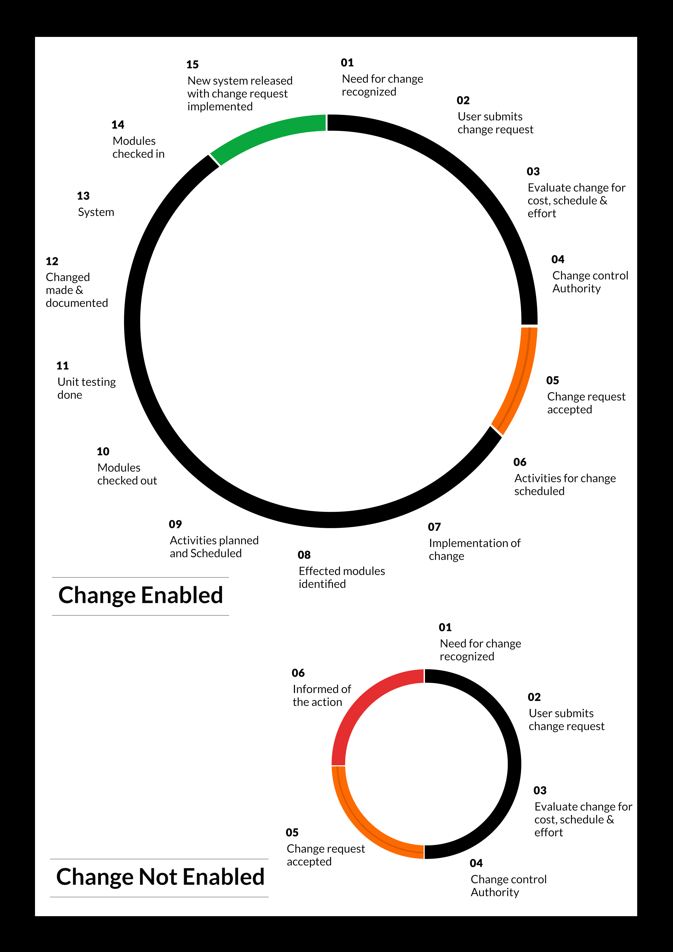

## MAINTENANCE & SUPPORT

* Maintenance contracts by default are supported as per the basic SLA terms.
* AMC with Basic SLA is charged at 25 % of the total project value. Additional Effort/change management request will be added towards Total Value of the Project to determine the AMC value.
* Maintenance support is limited to providing application support for ensuring the consistency of the look-and-feel, bug fixes and user issues i.e. maintenance and support of the existing features of the application.
* Support does not in any way cover providing technical or other support to the end users. The maintenance agreement does not include functionality changes or feature additions which are handled as change requests which will be charged AED 1,200.00 per man day. AMC does not include server support, maintenance and application deployment.
* AMC charges will cover Off-Site Support and Debugging. Support includes E-mail, Telephone and Chat unless explicitly specified. In the event, the application is hosted with the client; necessary remote desktop connectivity should beprovided for carrying out maintenance activity.
* Gap in AMC - In case if the client does not opt an AMC for a year and want to renew it after that period, 50% of the AMC amount for the year for which AMC is not taken will also be payable if the client wishes to renew the AMC contract.

*Note:*

* *Please note that the AMC support shall start only after all the necessary sign-offs (AMC Document) to this effect have been given.*
* *It is not mandatory that the client should opt for an AMC (replace with perhaps: It is mandatory that the client opts for an AMC). The client will still be supported on an ad-hoc basis on an agreed man-day rate.*
* *AMC Payment Terms: 100% to be paid as advance.*

## SERVICE LEVEL AGREEMENT (SLA)

|  |  |  |  |  |
| --- | --- | --- | --- | --- |
| **SLA Type** | **Max Response Time** | | **Max Resolution Time** | **Target** |
| Basic | 1  working day | 3 working days | | Request / incident / problem tickets |
| Advanced | 5 Business Hours | 12 Business Hours | | Request / incident / problem tickets |
| Priority | 3 Business Hours | 5 Business Hours | | Request / incident / problem tickets |

*Note:*

* *We provide Basic SLA as standard with AMC while Advanced and Priority SLAs attract additional charges.*
* *Time zone applicable (8:00 am to 5.00 pm, Sunday to Thursday)*

AMC Option:

Client can opt for time and material based Annual Maintenance, the details of which will be shared post the completion of project.

# **TERMS & CONDITIONS**

## ACCEPTANCE CRITERIA

* UAT (User Acceptance Test) sign off should happen within 07 Days from the first release of the application and the acceptance confirmation needs to be mailed to Verbat failing which Verbat will consider the project as approved by the client.
* Any comments or reason for rejection need to be documented and the same needs to be sent as an email from the official mail id of client to Verbat on or before 07 days from the first release.
* Timeframe for acceptance for any further release will be mutually agreed and finalized between client and Verbat depending on the UAT Comments

## WARRANTY

* Verbat shall provide a bug ﬁx warranty at no additional cost for 30 days from the date of acceptance of the project, for correction of any errors in the developed application that may be attributed to Verbat.
* However, this does not cover modifications by Client, or use of the application on an environment other than the proposed environment, or other circumstances outside Verbat’s reasonable control. In such a case Verbat reserves the right to charge for its services.
* All error corrections will be executed at Verbat India office. In the event of any need for on-site work, all expenses incurred for such trips will be payable to Verbat by Client.

## SOURCE CODE & INTELLECTUAL PROPERTY RIGHTS

* Upon completion of the Project and 100% completion of the payment, client will have access to the source code except for propriety codes, developer tools and third party applications etc.
* The solution offered will be the intellectual property of the client and will be made available to the client on an “unlimited license” basis.
* Modifications by third party/person: No person or organization, other than Verbat or any person authorized by Verbat in writing, has any permission to modify/change the software Solution to be eligible to get continued support from Verbat as per the support terms defined under this document.
* Liabilities/Damages: Verbat accepts no liability or damages of any kind arising out of use or non-use of the software delivered. The responsibility of testing of software lies with Client.

## GENERAL TERMS AND CONDITIONS

* Offer Valid for 30 calendar days from the date of submission of the Proposal.
* An average of 20 working days are assumed in a month.
* All the projects activities will be carried out from our off-shore development center in India
* All the documentation will be provided in English.
* Third party components may be used to develop this application.
* The scope of the project is to develop the Application as detailed in the scope of the project and mentioned in this proposal. Any changes or additions will have to go through change management.
* This proposal would have been derived or concluded from either the RFQ /RFP/data shared via email / information transferred during an initial requirement analysis meeting / tele-conversation. Verbat reserves the right to change the terms of this proposal as the final terms (including the costing), features & functionalities and timeline could change during the course of the project. Hence any fees quoted / timeline committed in this proposal may not be considered as final unless agreed and signed by both parties.
* Web Application will be best viewed only in the environment mentioned in the section Browser Compatibility
* All Source Codes and other project artefacts would adhere to the Verbat document templates and internal coding standards.
* The documents delivered to the client includes the ones mentioned under ‘Deliverables’ and these will adhere to Verbat’s internal document standards.
* Acceptance criteria shall be based on the clauses which were mutually discussed between Verbat and client at the Requirement Analysis phase and the same will be documented and approved by both parties through official emails
* In case Client requires any extension of the proposed acceptance schedule, the associated effort and cost of such extension can be mutually reviewed.
* For any circumstances if project needs to be put on Hold / Stop it requires minimum request notice period of 1 week along with duration for which request will be addressed by management and final decision on the request will be based on that
* If deployment is done in client’s server, Verbat cannot be held responsible for any performance issues arising due to hardware malfunctions.
* Client is responsible for data backup in case the application is not hosted on Verbat server.
* Source code will only be delivered or uploaded on the Production Server once the due payments are made.

## GENERAL ADMINISTRATIVE, TECHNICAL & FUNCTIONAL ASSUMPTIONS

* Detailed system study is required before the start of the project.
* During the requirement gathering phase, authorized personnel from the Client’s side is expected to be available for discussion and finalizing the HLD (High Level Design), before development commences.
* Type of reports and formats, if under the scope of the project, needs to be specified by Client before project sign off.
* Workflows if under the scope of the project, need to be specified/ confirmed by client before project signoff.
* Verbat assumes that all sign-offs from Client will be provided within agreed and specified timeframe.
* Client will provide all the necessary contents, both text and image, before starting the project in the format suggested by Verbat (if any).
* The client should provide the relevant information and data well in time for the execution of a related activity. Non- availability of this information or data may lead to an interruption of work which may result in a delay in delivery as well as additional costs to the client.
* Client should have/possess server with technical specifications as suggested by Verbat for the proposed application.
* Client will be provided with one time training (train the trainer) on how to use the application via video conference (maximum of 4 hours). Additional training requests will be charged.

# **FINANCIALS**

## WEB AND MOBILE APPLICATION DEVELOPMENT

|  |  |  |
| --- | --- | --- |
| **No** | **Description** | **Amount (AED)** |
| 01. | Development of:   * Web Application |  |
|  | **Total Project Cost** |  |

*Note:*

* *The above cost is exclusive of VAT applicable in UAE*
* *The above cost is based on the initial understanding of the requirement grounded on the details shared by client. Any further changes in the scope or complexity if encountered during detailed system study/ analysis will call in for additional effort and time.*
* *The above cost does not include Application hosting, integration with any other third-party systems, deployment unless explicitly mentioned in this proposal.*
* *For feature additions, please refer section titled “Change Management “.*
* *LPO to be raised in the name of “Verbanet Technologies LLC” for project initiation*
* *Refer section 7.3 for ‘Mode of Payment’.*

### **PAYMENT TERMS**

* 30% () of total project value to be paid as advance along with the Purchase Order
* 40% () of total project value to be paid on confirmation of the UI/UX
* 30% () of the total project value to be paid on completion of Development and UAT on Verbat test server

*Note:*

*Payment should be made within 7 days from the date of invoice.*

## WINDOWS DEDICATED HOSTING – OPTIONAL

ITEM NO. DECSRIPTION AMOUNT (AED)

1. Windows Dedicated Hosting

TOTAL PROJECT COST

*Note:*

* *The above cost is exclusive of VAT applicable in UAE*
* *Refer “Windows Dedicated Hosting Proposal” for detailed Server specifications.*
* *Refer section 7.3 for ‘Mode of Payment’.*
* *LPO to be raised in the name of “Verbanet Technologies LLC” for project initiation*

### **PAYMENT TERMS**

* 100% advance payment along with Purchase Order to initiate Server purchase

*Note:*

*Payment should be made within 7 days from the date of invoice.*

### **MODE OF PAYMENT**

By Cheque to Verbanet Technologies LLC

OR

Wire transfer to our bank account

Bank Name : Emirates NBD

Account Name : Verbanet Technologies LLC

Account Number : 1011492858201

IBAN Number : AE61 0260 0010 1149 2858 201

Swift Code : EBILAEAD

Bank Address : Mamzar Branch, Dubai

*Note:*

* *Bank charges incurred during wire transfer to be borne by the client.*
* *Any local taxes / VAT applicable to be borne by the client*
* *Client invoices will include VAT charges in addition to the application cost*

# **CLIENT REFERENCES**

Education

Transportation

**Client Name – Ministry of Education (MOE)**

Organization Name:

Nature of work performed:

Contact person Name:

Telephone Number:

E-mail address:

Project Name: Open Educational Resource Platform (OERP)

Location: Dubai, U.A.E

Ministry of Education has requested Verbat to develop a UAE- Open educational resource platform (OERP). The aim of this platform is to provide a centralized online platform where UAE and others can view, share and contribute their contents. Furthermore, this portal will allow UAE-MOE to track and monitor the progress through a dashboard. All information related to OER such as issue date, source, current state, future state, release dates along with best practices shall be captured.

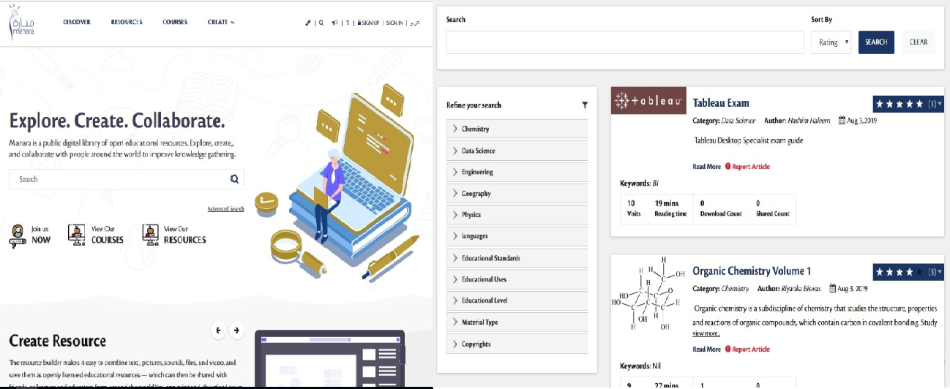

**Client Name – Sharjah Commerce and Tourism Development Authority (Government of Sharjah)**

Organization Name:

Nature of work performed:

Contact person Name:

Telephone Number:

E-mail address:

Project Name: Permit Issuance and Inspection System

Contract Type: Fixed Bid

Location: Sharjah, U.A.E

Established in 1996, the Sharjah Commerce and Tourism Development Authority (SCTDA) is tasked with promoting commercial and tourism activities in the emirate of Sharjah. Sharjah intends to provide a sustainable tourism product with a unique and distinct tourism experience in the desert areas of the emirate. This is geared towards attracting the interest of various tourism companies, specifically tour operators, to focus on Sharjah when organizing desert trips and desert adventures activities within these areas. Consequently, this would be beneficial to the tourism sector and will contribute further to Sharjah’s economy. Hence, the Sharjah government has decided to organize desert tourism activities through this project; the issuance of permits to all tour vehicles entering the desert areas of Sharjah for desert safari activities owned or operated by tour operators along with the day to day inspection tasks carried by inspectors who can issue fines and attach evidences for further actions.

Sharjah Tourism resource deployment model comprises of Offsite resource (Verbat Resource) and Onsite Project Manager (from client’s side)

**Client Name – MBC**

Organization Name:

Nature of work performed:

Contact person Name:

Telephone Number:

E-mail address:

Project Name: Security Inspection System

Contract Type: Fixed Bid

Location: Dubai, U.A.E

Smart Security System facilitates a sophisticated and structured approach to execute the daily security checklist to be used by the security patrol users. In addition to the ability of recording concern/issues as well to be viewed at any time as reports.  The application includes different users like Super Admin, Branch Admin, Inspector, Resolver and Viewer. The Inspector user reports patrol issues and concern issues using android mobile application. Branch admin assign the patrol issues to the resolver. Viewer will be able to see the issues and concerns related to the particular branch.

**Client Name – Carrefour Hybrid Project**

Organization Name:

Nature of work performed:

Contact person Name:

Telephone Number:

E-mail address:

Project Name: Software Quality Assurance Managed Services

Contract Type: Time & Material

Resource Deployment Model: Hybrid (Onsite + Offsite)

Founded in 1992, Majid Al Futtaim is the leading shopping mall, retail and leisure pioneer across the Middle East and North Africa (MENA).

A remarkable business success story, Majid Al Futtaim started from one man’s vision to transform the face of shopping, entertainment and leisure to ‘create great moments for everyone, every day’. It has since grown into one of the United Arab Emirates’ most respected and successful businesses spanning 13 international markets, employing over 27,000 people, and achieving the highest credit rating (BBB) among privately-held corporates in the Middle East.

Carrefour testing team comprised of 20 resources inclusive of Onsite Project Manager, Onsite Test lead and Offsite Test Engineers

**Client Name – Ministry of Foreign Affairs**

Organization Name:

Nature of work performed:

Contact person Name:

Telephone Number:

E-mail address:

Project Name: VISA Scheduling System

Contract Type: Fixed Bid

Location: Dubai, U.A.E

A web based application for the visa applicants and respected sponsors to schedule appointment for the security verifications. The system allows online payment facility. The application features include option for the sponsor to schedule appointments, option for the super admin to manage country and sites, manage other admin users and set e-mail/SMS notifications

# **ABOUT US**

|  |  |  |  |  |
| --- | --- | --- | --- | --- |
| Verbat Technologies | | 2017 | 2018 | 2019 |
| Number of Employees | UAE |  |  |  |
| Middle East |  |  |  |
| Globally |  |  |  |
| Number of relevant jobs | UAE |  |  |  |
| Middle East |  |  |  |
| Globally |  |  |  |
| Company Revenues | UAE |  |  |  |
| Middle East |  |  |  |
| Globally |  |  |  |
| Relevant Project Revenues | UAE |  |  |  |
| Middle East |  |  |  |
| Globally |  |  |  |

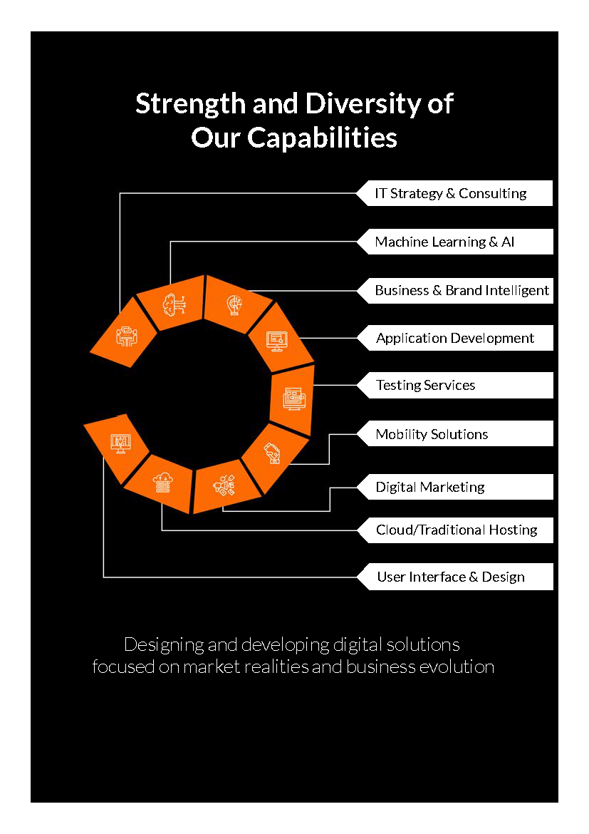

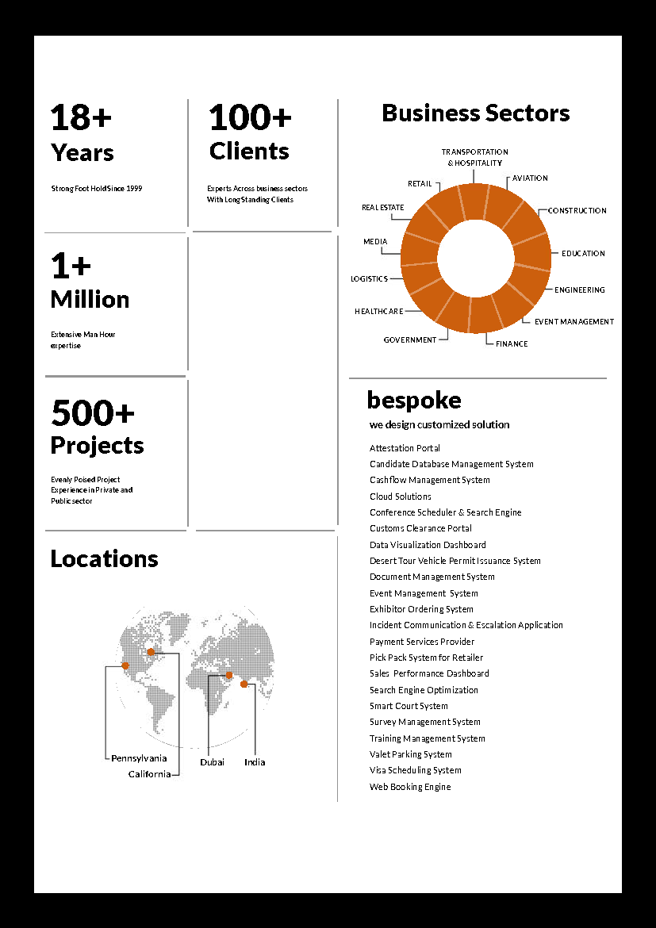



**Conﬁdentiality Notice:**

**This Proposal is conﬁdential and contains proprietary information and intellectual property of Verbanet Technologies LLC. Neither this proposal nor any of the information contained herein may be reproduced or disclosed under any circumstances without the express written permission of Verbanet Technologies L.L.C (hereby known under its brand name of Verbat in the United Arab Emirates). 2018. All rights Reserved**