

**Concept:**

**Distributed Digital Signage**

**Verbat Technologies**

**Submitted by**

Prashant Thomas

Verbat Technologies  
07.09.19

**DIRECTORY**

1 KEY DETAILS 4

2 INTRODUCTION 5

3 DISTRIBUTED DIGITAL SIGNAGE 6

4 GENERIC SYSTEM ARCHITECTURE 7

5 A BETTER SOLUTION… 8

6 OTHER FACTORS TO CONSIDER 10

7 USER CHARACTERISTICS 11

7.1 SYSTEM ADMINS 11

7.2 DEALERS 11

7.3 CUSTOMERS 12

7.4 SYSTEM 12

8 PROPOSED SOLUTION 13

9 PRICING STRUCTURE 15

10 TECHNOLOGY STACK 16

11 MAIN FEATURES OF THE SOLUTION 17

12 STANDARD LAYOUTS FOR DIGITAL DISPLAY 18

13 TECHNOLOGY ARCHITECTURE 20

14 SERVER TOPOLOGY 21

15 ERD DIAGRAM (Minimal Set) 22

16 COMPETITION ANALYSIS 23

17 RECOMMENDED HOSTING PAC 24

18 RECCOMENDED BROWSERS 24

19 HARDWARE DEVICES 24

19.1 Mobile device with the following specs 24

20 PRODUCT NAME SUGGESTIONS 25

21 RECCOMENDED WEB SERVER 26

# KEY DETAILS

**PROJECT NAME CLIENT**

Distributed Digital Signage System Srikanth Sir

**CLIENT CONTACT PROPOSAL ID NO.**

VB/SK/07092019

**CONCEPT SUBMISSION ANTICIPATED START DATE**

12.03.19  TBD

**PROPOSED TECHNOLOGY**

Java Script, Angular

CSS3, HTML5

PWA / Electron

**CONCEPT SUBMITTED BY APPLICATION TYPE**

Prashant Thomas Web Application

Verbanet Technologies L.L.C

Dubai, U.A.E

+971 4 297 3236

# INTRODUCTION

In the digital age, information is key. The speed and efficiency at which information is dispersed can enhance communication between individuals and communities. This is witnessed by Apps like WhatsApp and Skype. However, this fails when a call to action is required to create brand awareness or worse still when emergency relief operations require structured directions. In the past, the government employed mass media outlets like landlines or televisions to broadcast emergency information to citizens. Consider other scenarios; information about general elections, information, and activities related to local festivals, cautioning commuters to follow the local traffic laws, Directions and procedures to complete various activities in government offices. While these are challenges, in our mad frenzy to disseminate information, we've forayed into a wide variety of activities that contribute towards environmental pollution. Some examples are; Noise pollution in the form of insanely loud high wattage speakers, air & water pollution followed by deforestation through the indiscriminate use of paper for advertisements and propaganda.

It’s time to relegate such outdated practices and embrace an environment-friendly approach that addresses these shortcomings. One approach is to develop a Distributed Digital Signage System that is cheap, affordable and reliable. This is possible because of the emergence of cheap digital displays, single-board computers like Raspberry (computer on a chip), the availability of cheap wireless-broadband and the increased sophistication & wide adoption of numerous open standards in the World Wide Web. While many companies have taken advantage of these factors to float Distributed Digital Signage Systems, they lack the nimbleness to scale the disparity between micro, small and medium to large enterprises.

# DISTRIBUTED DIGITAL SIGNAGE

Digital signage is a widely-used terminology for digital displays with a centrally managed multimedia content that is used for conveying advertising, informational, entertainment, and commerce messages to a target audience. Digital signage was initially a standalone display situated in a specific location with an attached computing device that enabled the playing of multimedia content. This content could be changed/updated as needed by an operator who would physically access the display, manually remove the old content, and install the new content. Advances in network technology is now enabling digital signage to be physically distributed and pervasive making its deployment and management relatively easier; for example, now replacing content can be done remotely through a network. These network-attached digital signage systems are commonly referred to as distributed digital signage systems.

In general, a distributed digital signage system consists of four major components: hardware, software, network, and content. The hardware component, in general, comprises of a digital display (e.g. monitor or LCD television) and a computing device connected to the display that stores and plays the multimedia content. The computing device also has a communication port for sending and receiving data through the network. The software component for a digital signage system comprises of a content management system (CMS), remotely situated in some server, that holds all content to be displayed; a multimedia player in the digital signage unit for visualizing the content; and a local content manager also in the digital signage unit that periodically checks the CMS for any new content, retrieve it, and replace the displayed content with the newly retrieved content. The network component for a digital signage system usually employs the existing network infrastructure of the current organization or institution. Lastly, the content component for a digital signage system is typically a combination of audio, image, and/or video elements. The contents range from advertising and marketing messages to public information for communities, governments, and public institutions. How these elements are packaged and structured are usually proprietary and developed specifically for the system. Moreover, this package and structure are closely tied to the CMS and multimedia player that is being used by the system.

Distributed Digital Signage Systems are more prevalent in developed countries; insufficient work has been done to adapt and implement these systems in developing countries. Verbat intends to change that by developing a system that shall allow for the rapid sourcing of local components, spare parts, and expertise. This can be achieved by using open hardware devices and open-source software that is widely familiar to local skilled workers.

# GENERIC SYSTEM ARCHITECTURE

The architecture for the proposed system consists of three nodes: a server, an access point, and a digital signage unit. The deployment diagram for the architecture is depicted in Fig. 1. The server can be a single machine or a collection of machines in a server farm. Content may be uploaded, stored, and managed in the server by a content administrator. The digital signage unit is placed in an area that is visible to its target audience and consists of a display to show the intended content and a single board computer to locally store the content and to control the display. The display is any COTS monitor or television, which can be purchased in any consumer electronics store, that has a connector (preferably, an HDMI connector but not mandatory) that is supported by the single-board computer, for the computer to be able to control the display. The single-board computer can be any open hardware device (e.g. Raspberry Pi) but must have a built-in Wi-Fi module so that it can connect to the access point to access the Internet and communicate with the server to retrieve any needed content. Lastly, the access point can also be any COTS Wi-Fi access point that supports the 802.11x standard.

In this architecture, all content will be in HTML5 format. HTML5 based technologies are sufficiently mature to enable the creation of very sophisticated content and visualization, especially when combined with CSS3 and JavaScript (ES6). Moreover, by using HTML there is no need to create a proprietary editor for the content or to retrain content creators. As an added feature, by adopting the Progressive Web App (PWA) approach, the content can automatically adjust to different screen sizes without the need to create different versions for different screen sizes. From the software perspective, as with other distributed digital signage systems, this architecture consists of two major components; An App resides in the digital signage unit and a server-side App resides in the server. The server shall run a CMS to manage all content in the system. The function of this CMS is not only to distribute, manage, and store all relevant content but also to inform the digital signage units of any new content so that the content can be retrieved by the unit. Because the content is in HTML, any popular browser that has plugin support to play media will can be employed.

The architecture description of the system referenced above will suffice for most use cases. It is cheap and reliable. However, for a more robust system where the signage devices need to be managed remotely or when information needs to be dispersed intelligently depending on context (e.g. emergency relief versus advertisements in malls; situations where there is a need to control the dispersion of media to specific devices; when each display device has distinct content), a slightly more complex system may be required. The remainder of the document discusses these scenarios in detail. Please note that this alternate architecture does not deviate too far from the core principles that have already been discussed.

# A BETTER SOLUTION…

While the initial focus had been on the development of a cheap and reliable information dispersion system, the system can be easily expanded to accommodate a variety of commercial use cases. As an example consider the following scenarios:

A. In transportation centers — airports, train stations, subways, digital signs keep travelers on schedule while also displaying revenue-producing advertising.

B. In schools and on college campuses, digital signs are the new channel for communicating with students, replacing printed calendars and bulletin boards; they also play a role in the all-important emergency alerting system.

C. In high-volume, quick-service restaurants, digital signs help streamline the ordering process and offer customers a way to interact via their smartphones.

D. In hotels and resorts, digital signage is an easy and flexible way to provide guests with information about services and activities on and off the property—information that drives greater use of these services and delivers on the bottom line.

It is clear from these examples, digital signage offers significant advantages over conventional signage and posters, which have to be designed and printed well in advance. With digital signage, one can adapt messaging on the fly. Different content can appear on different screens at different times and different places. One can also have live feeds from TV, the Web, databases and more. While this dynamic flexibility is a huge advantage, if you think of digital signs simply as a replacement for posters and billboards, you are making a mistake. Digital signage is so pervasive; it is looked upon as a new medium, often referred to as the “fifth screen” (after film, TV, the PC, and the mobile device). In fact, many organizations that have digital signs have chosen to accept third-party advertising on them, creating another revenue stream.

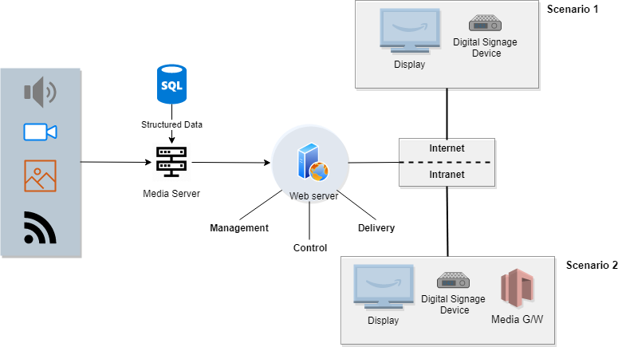

Figure 1: Shows an implementation that can accommodate both standalone as well as distributed digital signage

The diagram above depicts the deployment of a digital signage device either as part of a private network or as a part of a larger cloud-based network. In both cases, the device is capable of administered over the internet. The difference is that the content for the former is managed locally.

# OTHER FACTORS TO CONSIDER

The biggest factor driving the growth of digital signage is the value it provides. Digital signage works — helping increase sales, support brands deliver needed information, etc. That’s why organizations in a wide range of industries—including retail, hospitality, quick service restaurants, financial services, higher education and more are increasingly giving digital signage a critical role in marketing and customer service.

**Four Areas of Value**

While the value that digital signage delivers will differ from organization to organization, it typically can be broken down into these four areas:

* Higher Revenues
* More sales overall
* More sales of higher margin products
* More sales per customer visit
* Ability to run more promotions than previously
* More effective inventory management via dynamic promotions/price flexibility
* Lower Costs
* Reduced costs of printing, distribution, installation, removal, etc., of printed materials
* Increased speed of messaging and compliance or real-time campaign management
* Improved customer service delivered more cost-effectively
* Reduced shoplifting and stock shrinkage through deterrent messages
* Increased virtual display of products when there is not enough room or budget to have them physically in the store
* Enhanced Customer Experience
* Increasing the opportunities for intelligent digital engagement and interaction
* Reducing the perceived waiting time at check out and in waiting areas
* Aligning with community and demographic interests with relevant information
* Inexpensively refreshing the environment — particularly for frequent visitors
* Increased Customer Engagement
* Learn more about customer interactions via audience measurement
* Promote online and mobile programs
* Promote loyalty programs, gift cards, gift registry and website
* Promote special events
* Provide reasons for a future visit

# USER CHARACTERISTICS

## SYSTEM ADMINS

* Shall manage other users
* Shall register digital signage devices
* Shall install the device
* Shall remotely administer the device
* Shall administer the Content Management System (CMS)

## DEALERS

Dealers lease devices from multiple locations. They may club similar devices into zones or categories based on a variety of factors. Leasing of display devices at various locations is outside the scope of this application. At a minimum they shall be able to perform the following actions

* Register themselves
* Register device locations
* Create schedules
* Set prices based on schedules such as weekends, weekdays & rush
* Create Volume discounts
* Create zones for a related set of locations

## CUSTOMERS

Customers are the users of the systems. They can

* Register themselves
* Lease time for displaying infotainment
* Shall upload content that needs to be displayed
* Shall be able to make payments to dealers

## SYSTEM

The system performs some actions on behalf of other users in order to enhance the productivity and agility of the application. Examples are

* The system shall make recommendations to the customer so that they can avail better prices
* System shall create the schedule for displaying advertisements for every device plugged into the delivery network
* System shall maintain a run book that can provide proof of work
* Shall notify the customer in case of schedule clashes

# PROPOSED SOLUTION

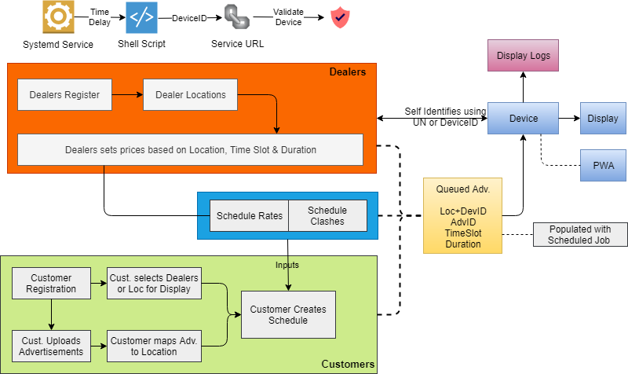

Figure 3: Implementation details for a Distributed Digital Signage

Figure 1 is an illustration of the proposed solution. The figure shows an implementation that consists of

1. Standalone Digital Signage System
2. Distributed Digital Signage System

In (i) the digital signage device hosts a desktop based application created using the Electron framework. The Electron framework lets you write cross-platform desktop applications using JavaScript, HTML and CSS. It is based on [Node.js](https://nodejs.org/). Electron lets you access native components. Because it is a desktop application, media can be stored directly on the device. Hence the device can forgo the need of a network connection. This would be ideal for standalone installations in small facilities like restaurants, grocery shops, gas stations etc. If there is a network connection available, the device (which is a mini computer) can also be administered remotely through a VPN.

The Distributed Implementation (ii) makes use of a Progressive Web App. A progressive web app (PWA) is a website that looks and behaves as if it is a native desktop app. PWAs are built to take advantage of native device features, without requiring the end-user to visit an app store, make a purchase and download software locally. Once installed the PWA is available on the desktop. PWA’s are capable of downloading the scheduled content in advance and store it offline so that it can be recalled and played later. PWA’s can be updated remotely through push notifications.

The disadvantage of PWA’s is that it cannot access the native features of the device. Therefore it is difficult to keep track of the device. Tracking the device requires knowledge of the device ID which is only accessible to desktop applications. But it is possible to circumvent this difficulty by leveraging the capabilities of the device itself. One way of doing this is described below

**Device Validation (PWA Only)**

1. A Systemd Service created in the device. The service calls a remote API with the device ID as one of its parameters. Since the device has already been registered this call will positively identify the device.

2. At the display location, Admin registers the device using the PWA with its Device ID. PWA stores the DeviceiD in IndexedDB. This should ideally be done before the device is delivered to the client so that the client would have a seamless zero-configuration setup experience.

3. App is launched at startup in full-screen mode. Keyboard and mouse gets locked shortly after

4. Systemd service polls the API Service with the device ID and marks the device status at known intervals

5. PWA requests from registered devices are compared to the last known active interval. If the status is stale then the requests will be rejected.

In general, all devices must be registered with their Device ID, before they are issued to the customer or dealer. In the case of standalone installations, the electron desktop application shall be installed on the device prior to the customer handoff. When the device starts up, the electron application is launched in full-screen mode. Shortly afterward the mouse and keyboard ports are disabled by default. This is so that the device cannot be tampered with in any way post-install. An administrator can unlock the device locally or access the device remotely if configured for remote access. PWA devices will also follow the same protocol.

**Scheduling of Advertisements**

Every night, at a predefined time, a batch job is initiated to populate the run book (basically a table). The run book contains advertisements targeted for a specific device with details about the advertisement, size, and orientation of displays, etc. The digital device polls this table with its DeviceID to retrieve the ads that are targeted for it.

# PRICING STRUCTURE

Most of the competition has setup a monthly / device pricing structure. Since we are introducing the concept of dealers. In turn we are introducing the concept of prices being based on demand. This means that the dealers will have flexibility to vary prices depending on season, time and location. This is very much similar to the business model employed by AirBnB and Booking.com.

We have two options

1. Just as a country regulates its interest rates, we will have to set up some baseline price rates to accommodate for our expenses related to infrastructure and management. This base line price is meant to regulate the framework so that all dealers have equal opportunity and it also guarantees us a commission that will effectively keep us floating
2. We do not regulate but simple receive a commission for every sale that happens in the framework. But this has the potential to cripple us if the dealers decided to setup aggressive or low prices so as to drive the competition out of business

# TECHNOLOGY STACK

PWA: Angular, Ionic

Desktop: Electron

Database: MY SQL, MongoDB

API Service: Python or .Net Core

# MAIN FEATURES OF THE SOLUTION

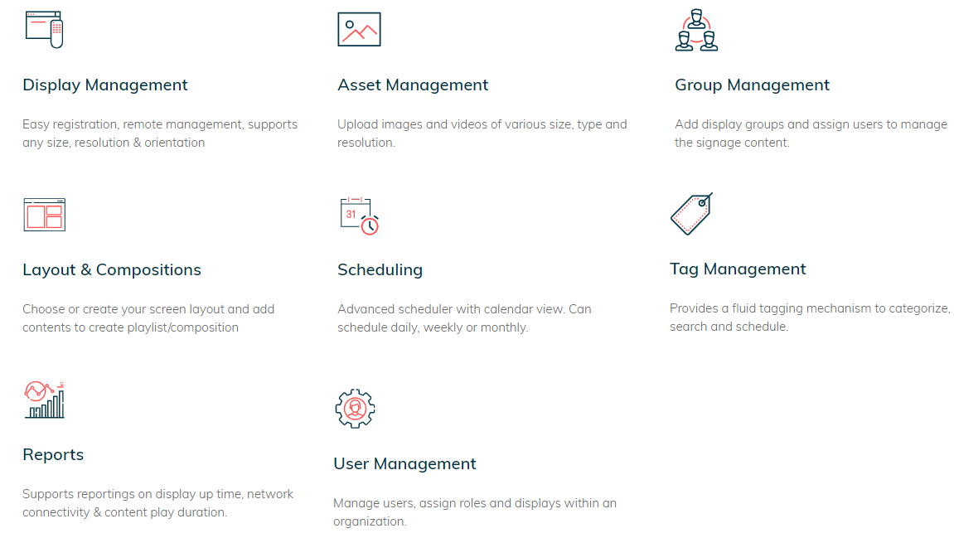

Figure 4 Features at a glance

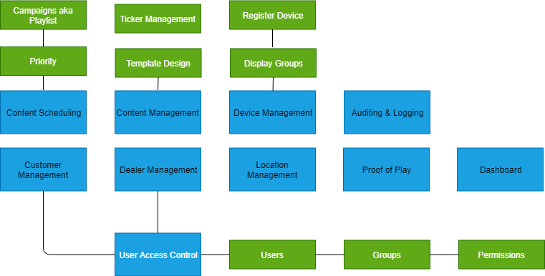

Figure 5 feature Details

# STANDARD LAYOUTS FOR DIGITAL DISPLAY

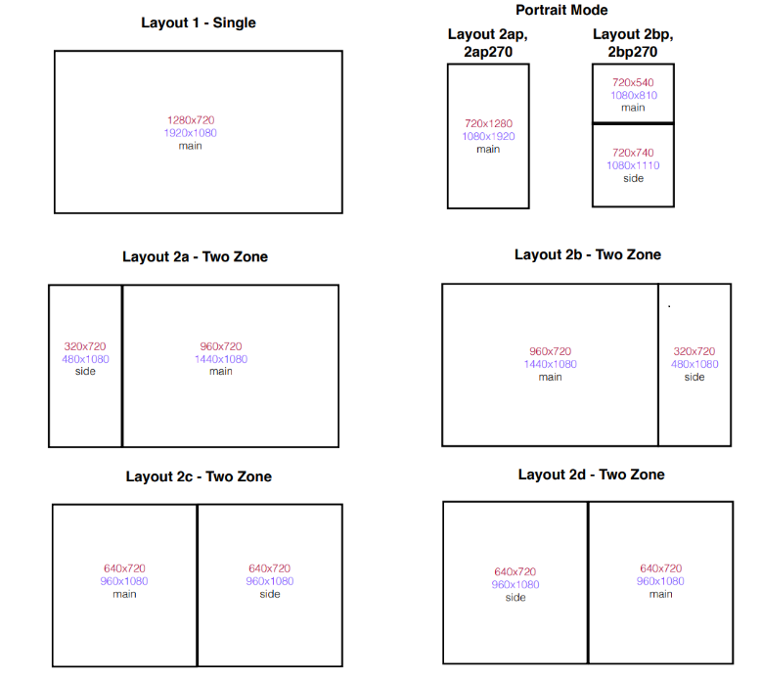

Figure 6 Suggested templates for display system-1

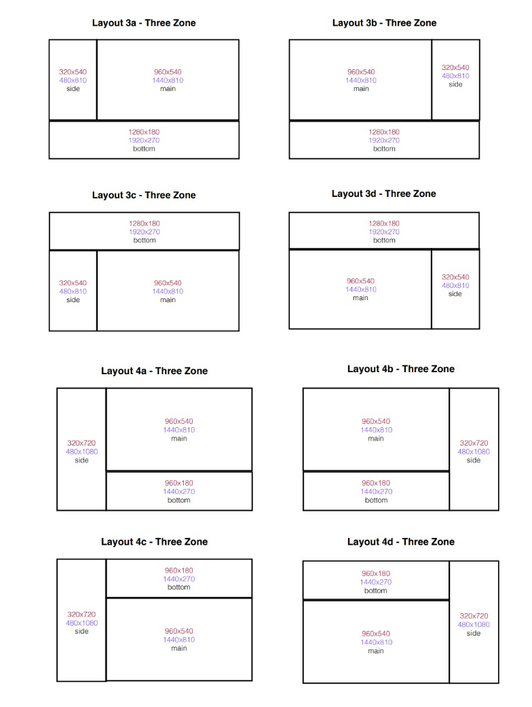

Figure 7 Suggested templates for display system-2

# TECHNOLOGY ARCHITECTURE

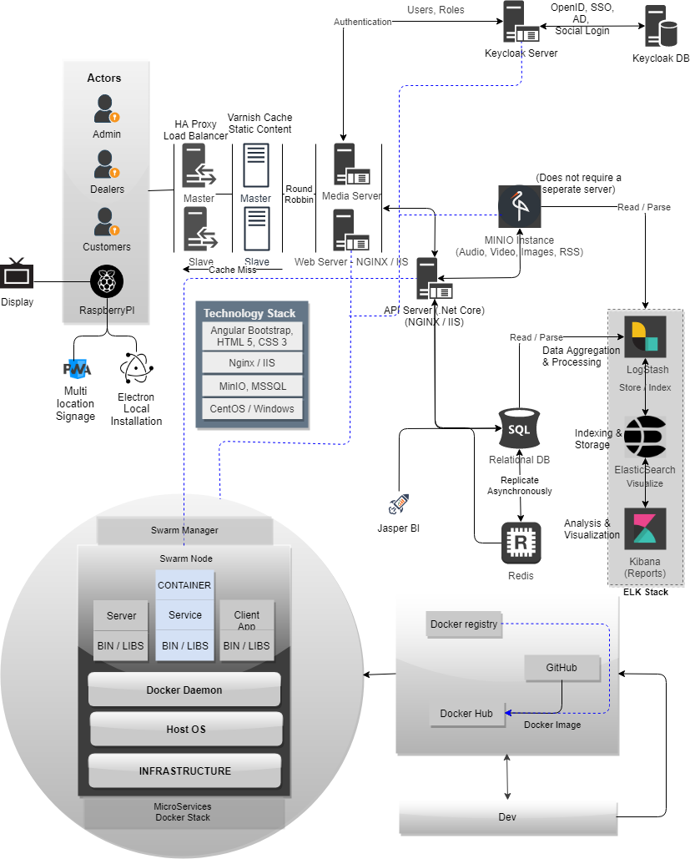

Figure 8 on day one only a web server with a SQL server is required. However as we scale out, the architecture depicted would serve as a guideline.

# SERVER TOPOLOGY

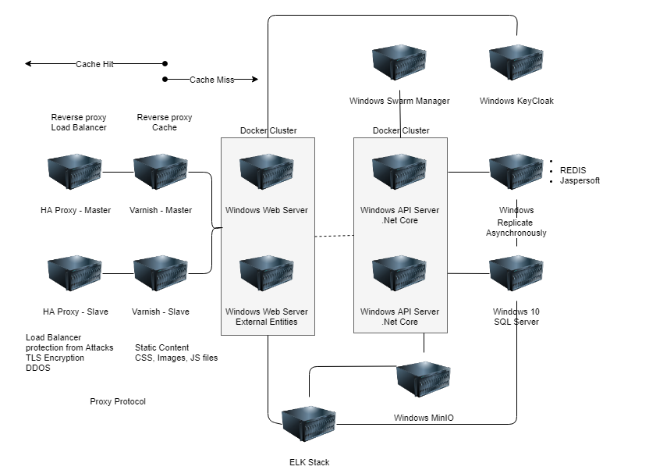

Figure 9 Server Stack: Again on day a minimal approach is suggested.

# ERD DIAGRAM (Minimal Set)

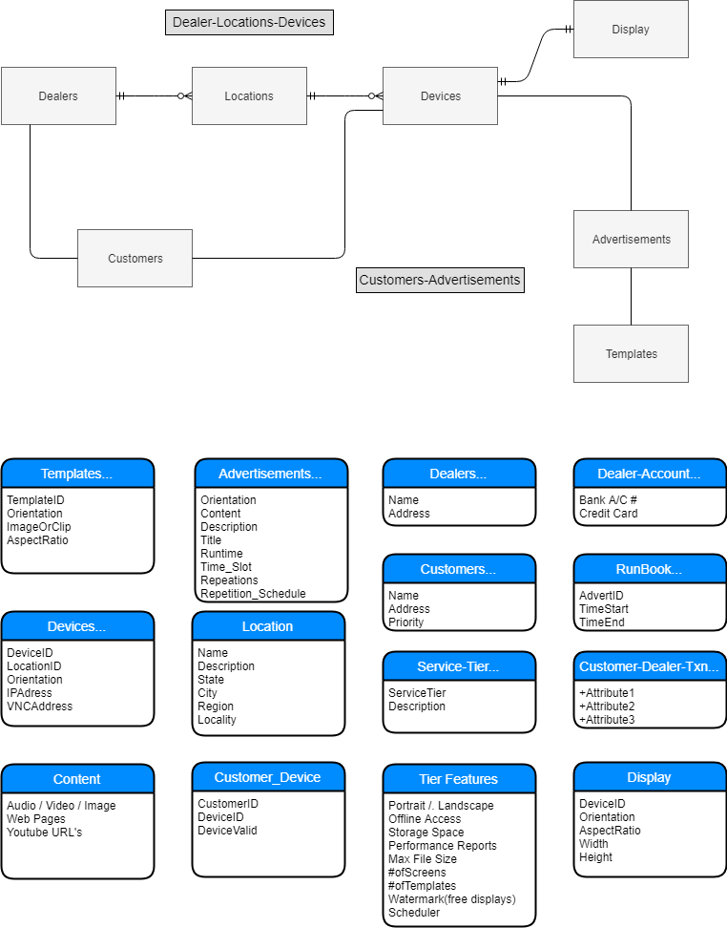

# COMPETITION ANALYSIS

There are the various players in the market. Listed below are some of the cheapest and most popular players.

1. [Yodeck](https://www.yodeck.com/) : Yodeck enables you to create and **schedule** your monitors effortlessly **from the web**, using your computer, tablet or smartphone. The concept is identical to the solution proposed by Verbat. However, they are a US-based company. Their pricing structure is term based ranging from $8-14 /month/screen with varying degrees of functionality offered between the tiers.
2. [Novisign](https://www.novisign.com/) : Novisign is an Israeli based company. It’s Digital Signage Software is sold as Software as a Service (SaaS) that enables the easy management of dynamic digital signage campaigns, from the cloud to IP-based digital signs anywhere in the world. From any PC, you can broadcast targeted messages to any number of signs, at an unlimited number of locations in real-time. Their pricing structure $20 /device/month
3. [Pickcel](https://www.pickcel.com/) : Pickcel is a Karnataka based Digital Signage solution provider and the most popular provider in India. They have proprietary players but they also support industry standard players such as Amazon Fire TV stick, Android media player, Android screen, Chrome box. They have deployed their apps on Android and IOS play stores. Their apps are also available on most smart TV play stores as well as the Raspberry PI box (You buy the device and register it with the Pickcel cloud solution. Then install the software on Ubuntu OS). They have a reseller program as well. Prices are at ₹ 900 /device/month for up to 50 displays.

# RECOMMENDED HOSTING PAC

* Operating System: NGINX
* CPU: 4 cores
* Domains: Unlimited
* Disk Space: 200 GB
* Monthly Bandwidth: 50 GB
* Apache Tomcat
* Hosting will be on cloud according to the band-width.

# RECCOMENDED BROWSERS

The application developed shall be compatible with the browsers listed below:

* Internet Explorer 11
* Mozilla Firefox 50 or above
* Chrome 50 or above

# HARDWARE DEVICES

## Mobile device with the following specs

* The device should support LTE / Wi-Fi 802.11 a/b/g/n/ac
* The device should have at least 500 MB Memory
* Device should have at least 8GB of disk space

# Product Development Cost

The product shall be developed in two phases. Phase 1 shall utilize a Raspberry Pi 4 board. Phase 2 shall utilize a Raspberry Pi Zero board. The objective of phase one is to develop a Proof of Concept (POC) while Phase 2 will concentrate on developing the POC into a marketable product. Pi Zero is cheaper and less powerful than the Pi 4. However it’s good enough to implement the desired product functionality without any lags or undesired side effects

## Pi 4 Implementation

|  |  |  |
| --- | --- | --- |
| Item | Description | Cost |
| Raspberry Pi 4 | Computer on a board | 3200 |
| Casing Box | Box to house the board | 240 |
| HDMI Cable | Cable to connect the comp to the HDMI screen | 550 |
| Micro SD card | Permanent storage to load OS and Application developed | 400 |
| Power Adapter | To power the unit | 425 |
| Cost | | 4459 |

## Raspberry Pi Zero

|  |  |  |
| --- | --- | --- |
| Item | Description | Cost |
| Raspberry Pi Zero with case | Computer on a board | 2300 |
| HDMI Cable | Cable to connect the comp to the HDMI screen | 550 |
| Micro SD card | Permanent storage to load OS and Application developed | 400 |
| Power Adapter | To power the unit | 425 |
| Cost | | 3675 |

The costs reflected above are based on the procurement of individual components. However if this items were to be procured in bulk, the prices could potentially be reduced by a factor of two.

# PRODUCT NAME SUGGESTIONS

* Neu Dizign :  New Digital Signage
* NeuDigit
* NeuDigitage
* Candy Signs
* Wally, Wallify, Walled
* WallPaperDesigns
* DivineSigns
* Diggs, Diggon
* PyWall, WallPie
* Impression, Impress
* Magnify
* Cloud Signal
* SignatureSigns
* Signify
* 69miles, 69shades, 69dezigns
* SignPost, Guidepost
* VrBad
* WallPost, ViewPost
* UniqueSigns, Usign, udezign
* Rocketwall, Rocketsigns
* Mediaman
* DigiSign
* 5thscreen, FifthScreen (alternate name for digital signage- according to Intel), Screen5

Other exciting names are more than welcome ☺… (my 5 cents)

# RECCOMENDED WEB SERVER

The recommend specification for a web server:

* Microsoft Windows Server 2016 with IIS 7.5 +
* Processor: 4.20 GHz Intel Core i7-7700 or equivalent
* Memory: 16GB
* Disk Space: 1 TB of free disk space



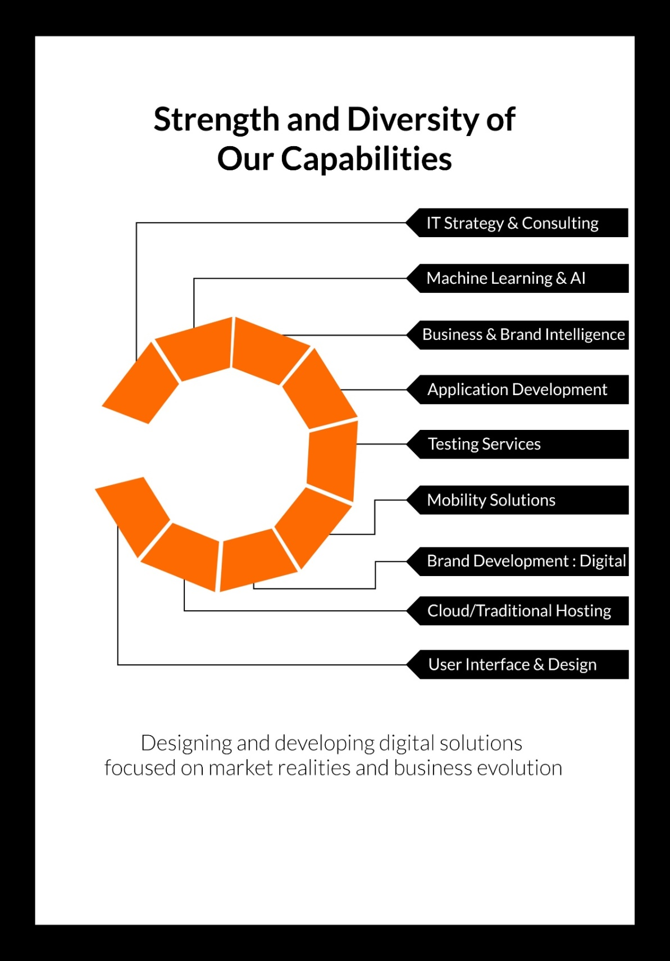

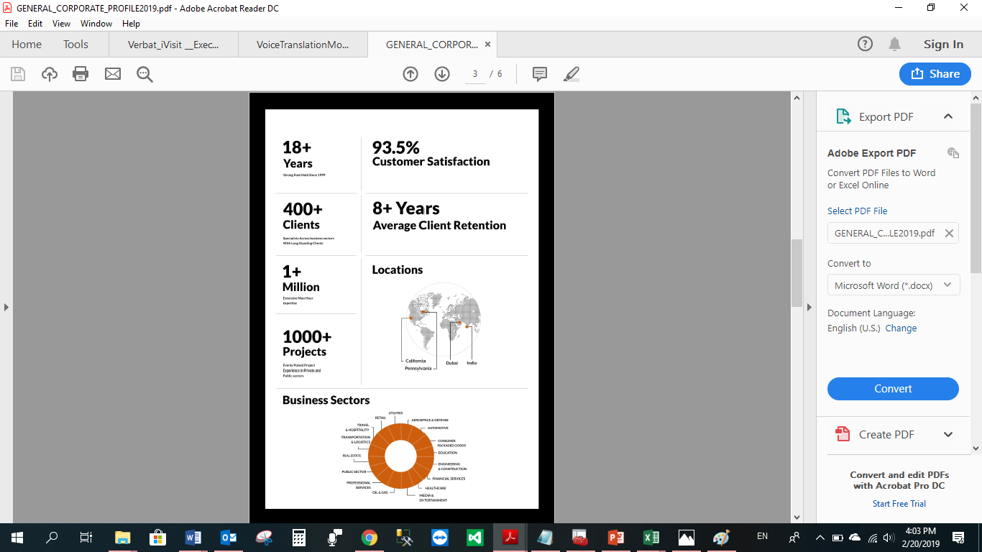

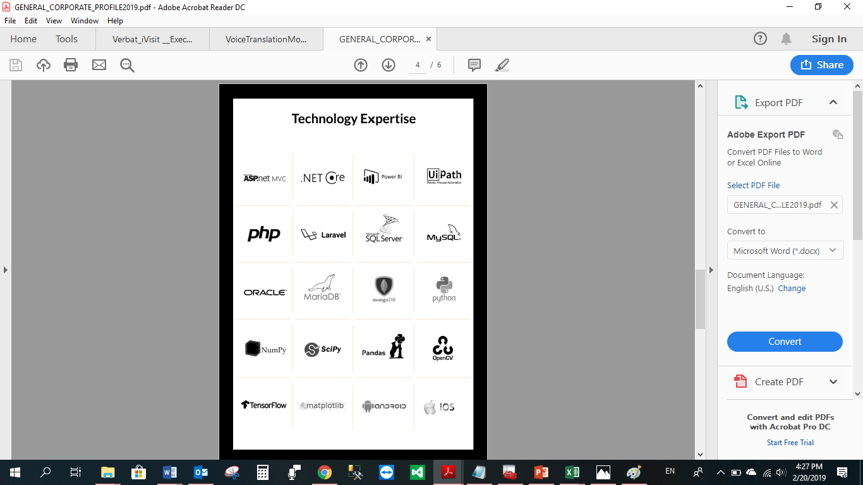

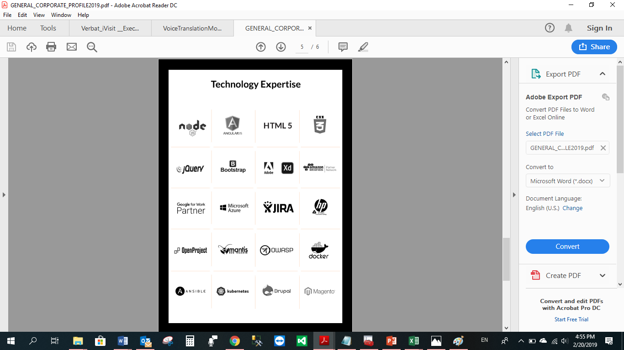

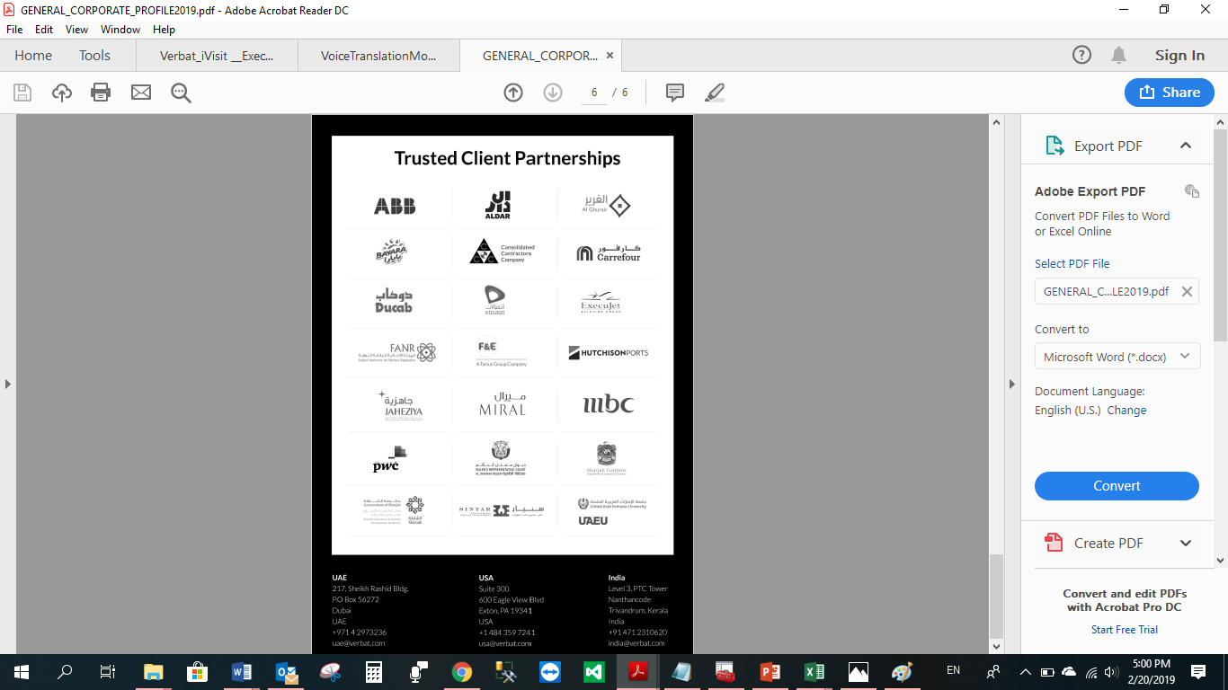

**WITH OUR**

**SINCERE THANKS.**

**CONFIDENTIALITY NOTICE:**

The proposed concept is conﬁdential and contains proprietary information and intellectual property of Verbanet Technologies LLC. Neither this proposed concept nor any of the information contained herein may be reproduced or disclosed under any circumstances without the express written permission of Verbanet Technologies L.L.C (hereby known under its brand name of Verbat in the United Arab Emirates). 2019. All Rights Reserved.