

**PROJECT SOLUTION:**

**ONLINE TRADING MANAGEMENT PORTAL**

**KERCHANSHE TRADING P.L.C**

**Submitted by**

Merin Mariam Stephen

25.03.19

**DIRECTORY.**

**1 KEY DETAILS. 3**

**2 FUNCTIONAL REQUIREMNTS 4**

**2.1 DETAILED APPLICATION FEATURE LIST 4**

2.1.1 Guest Module 5

2.1.2 Registered Customer Module 8

2.1.3 CRM User Module 12

2.1.4 Admin User Module 23

# **KEY DETAILS**.

**PROJECT NAME CLIENT**

Online Trading Management KERCHANSHE TRADING P.L.C

**CLIENT CONTACT CLIENT ADDRESS**

Sintayehu Gochel Bayene Building

Marketing Manager Near Bisrate Gebriel Church

[sintayehugochel@yahoo.com](mailto:sintayehugochel@yahoo.com) Nifas Silk Lafto Subcity Wereda 3

House No 702

+251 91 164 9583 Addis Ababa

Ethiopia

**PROJECT SOLUTION SUBMISSION DOCUMENT ID NO.**

25.03.19AD/PS/25032019/2705/1

**PROJECT SOLUTION VALID UNTIL ANTICIPATED START DATE**

24.04.19 TBA

**PROPOSAL SUBMITTED BY PROPOSED TECHNOLOGY**

Merin Mariam Stephen ASP.NET / PHP

Verbanet Technologies L.L.C

Dubai, U.A.E  **APPLICATION TYPE**

+971 4 297 3236Application Development

+971 55 8181345

cd.03@verbat.com

# FUNCTIONAL REQUIREMNTS

KERCHANSHE TRADING P.L.C (hereafter referred to as “Client”) has approached Verbanet Technologies L.L.C., (hereafter referred under its trade / brand name as” Verbat”) to develop an Online Trading Management Portal.

This proposed application is a Global web portal, which allows customers/prospective customers to view different coffee types offered by the client, their prices and place orders. The application allows the client to manage orders.

## **DETAILED APPLICATION FEATURE LIST**

The proposed application will be used by the following users:

**Front End Users:**

* Guest: Guest are users who places an order/enquiry for the first time.
* Registered Customers: Customers who have a signed agreement/contract with the client.

*(i. e. Guests who signs a contract with the client is a registered customer)*

**Back End Users:**

* CRM (Customer Relationship Manager): Customer Relationship manager is the person who manages the customers and their orders.
* Admin: Admin manages the entire application and the users.

The detailed functionalities of each the user is described below:

### **Guest Module**

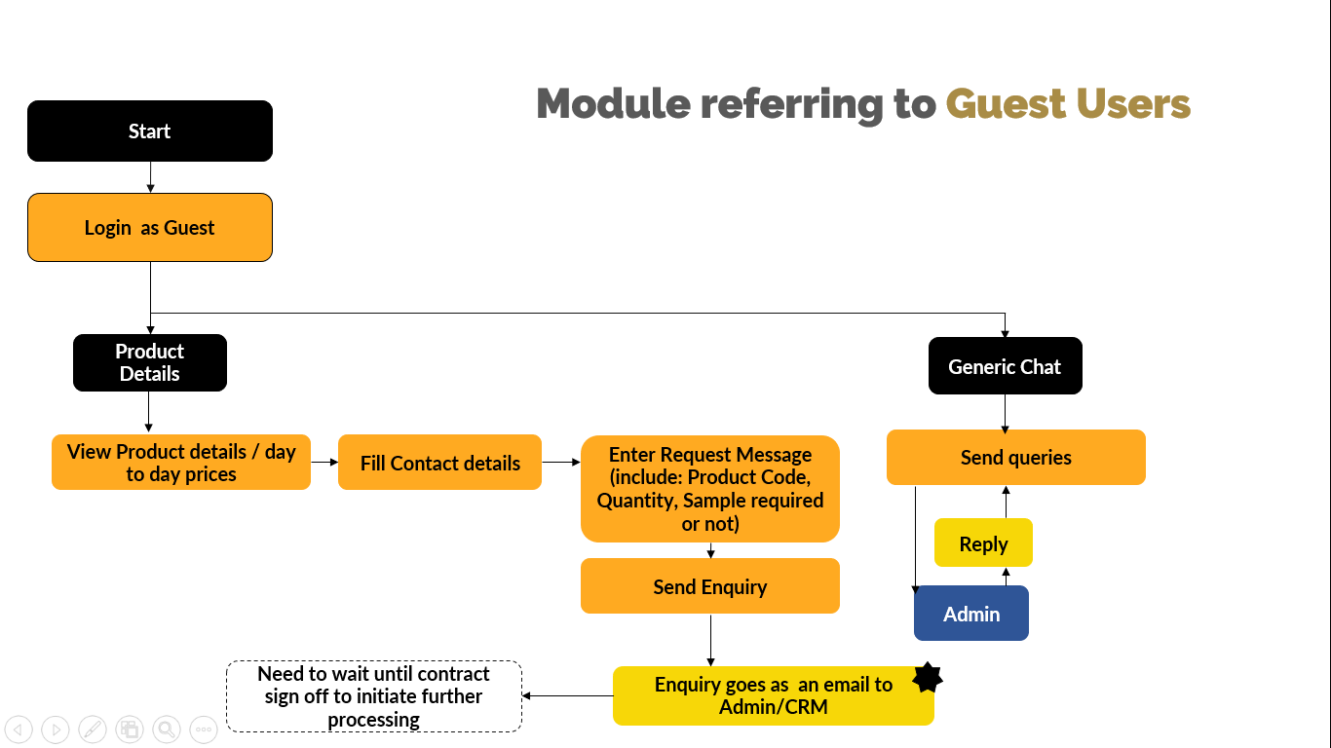

**Workflow No :1**

#### **Login**

Guest user can login to the system by simply clicking the button “Sign In as Guest”.

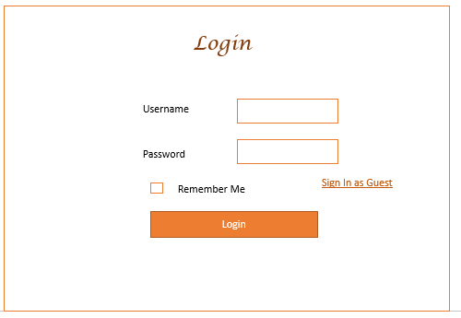

***Figure No :1***

#### **Product Details**

The guest user can view all the products with its details inclusive of price. The details will be displayed in the form of a list. The details include the following *(Shown in Figure No: 2.a)*:

* Serial No
* Product code
* Coffee Name
* Origin
* Sourcing Area/Site
* Grade
* Quantity
* Unit price (USD)

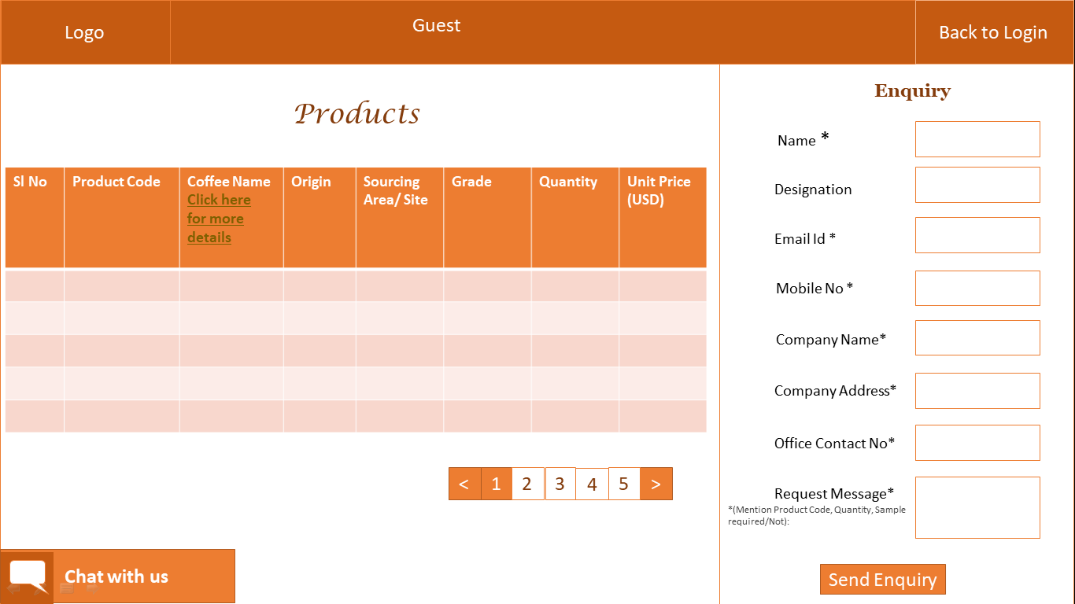

***Figure No: 2.a***

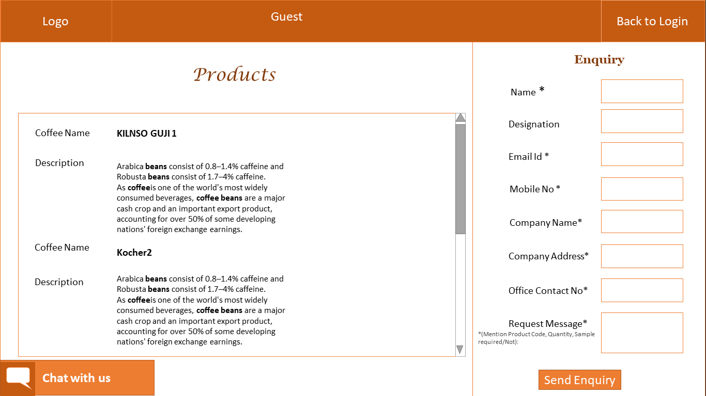

***Figure No: 2.b***

On clicking, “Click Here for more details” link in the Coffee Name column Header, it will display all coffee details as shown in *Figure No: 2.b*

#### **Send Enquiry**

After viewing the Products details (*Figure No: 2*), in same page itself the guest user has the provision to send an order request as an enquiry. To send an enquiry, the guest needs to enter the following details in the application:

* Customer Name
* Designation [Optional]
* Email Address
* Mobile No
* Company Name
* Company Address
* Office Contact No
* Request Message, where the guest needs to specify the product code, quantity and sample requirement *(if any).*

On clicking “Send Enquiry” button, the order request will be sent as an email to the admin/CRM.

#### **Generic Chat**

In this section, the guest user can initiate a chat with the admin, where he will be able to clarify his doubts regarding the coffee beans or methods for ordering. This Generic chat (*Chat with us*) is available on the same page of “Product Details” (*Figure No: 2*).

### **Registered Customer Module**

Registered customer is a customer who has a signed agreement/ contract with the client *(i. e. Guests who signs a contract with the client is a registered customer).* He has the functionality to manage his profile details by editing and uploading the documents(contract/other). He also has provision to view the product details and send enquiries similar to “Guest” users (Refer:2.1.1.2 & 2.1.1.3).

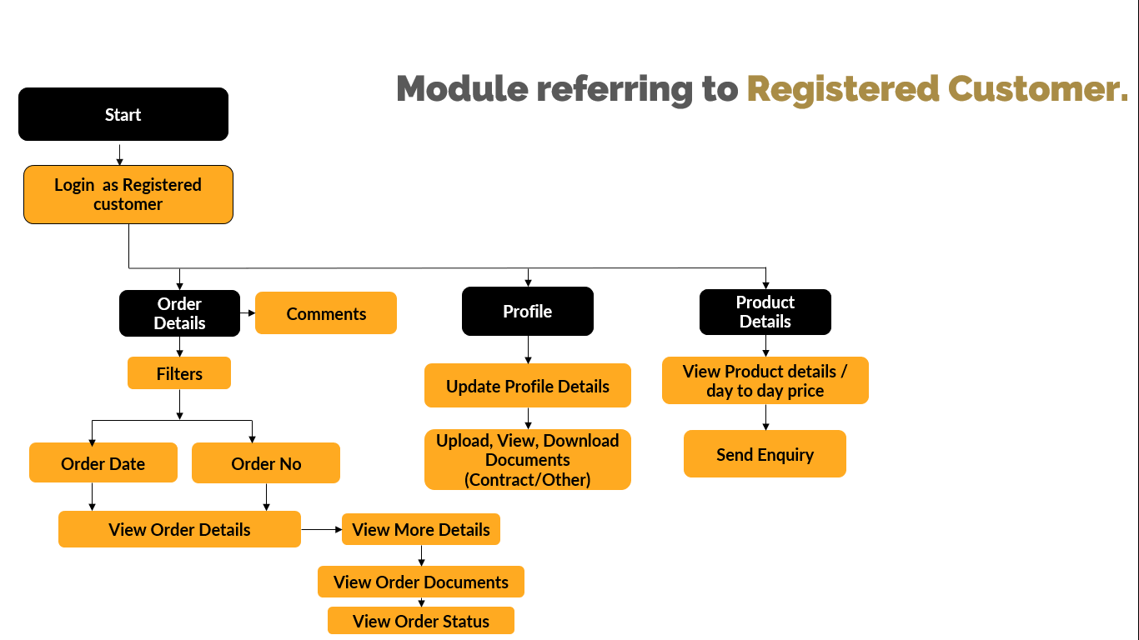

**Workflow No :2**

#### **Login**

Once the registration has been completed by admin/CRM, the registered customer will receive an email, which includes a link to the application where he can set his username, password and login. Once the username and password are set, the registered customer can use the same credentials for future login.

#### **Order Details**

The registered customer can view their orders, which include the following details:

* Order No
* Order Title
* Order Date

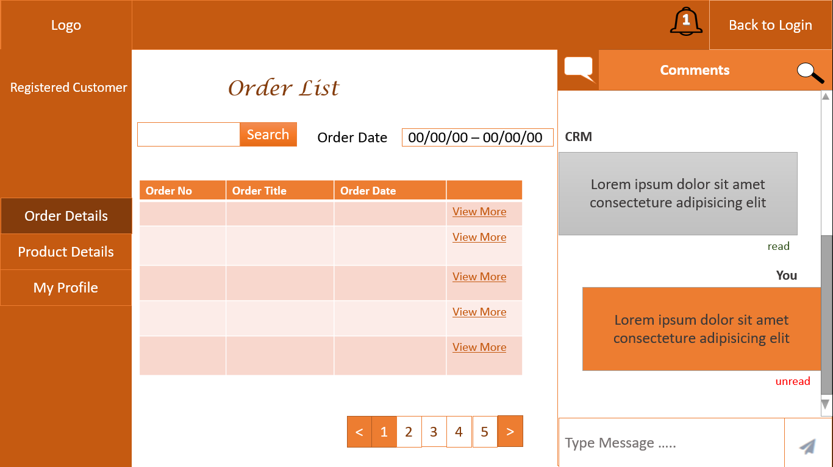

***Figure No :3***

* To view more details of the order, the registered customer needs to click “View more” button (*Figure No: 3*).
* On clicking, the registered customer will be able to view Order No, Order Title, Order Date, Order details/Description, Order Status and Added documents (*Figure No:4*).
* This user has an option:
* To filter the order based on Order No. and Order Date (*Date Range*). (*Figure No:3*)
* To view and download the documents uploaded by the CRM user via the order management module. (*Refer Section No. 2.1.3.3 for details*)
* To initiate chat with the admin/CRM user as well as view activity details. (*Refer Section No.2.1.3.5 for details*)
* To view and manage their profile updated by the admin/CRM as well as upload/download documents. (*Refer Section No. 2.1.3.2 for details*)

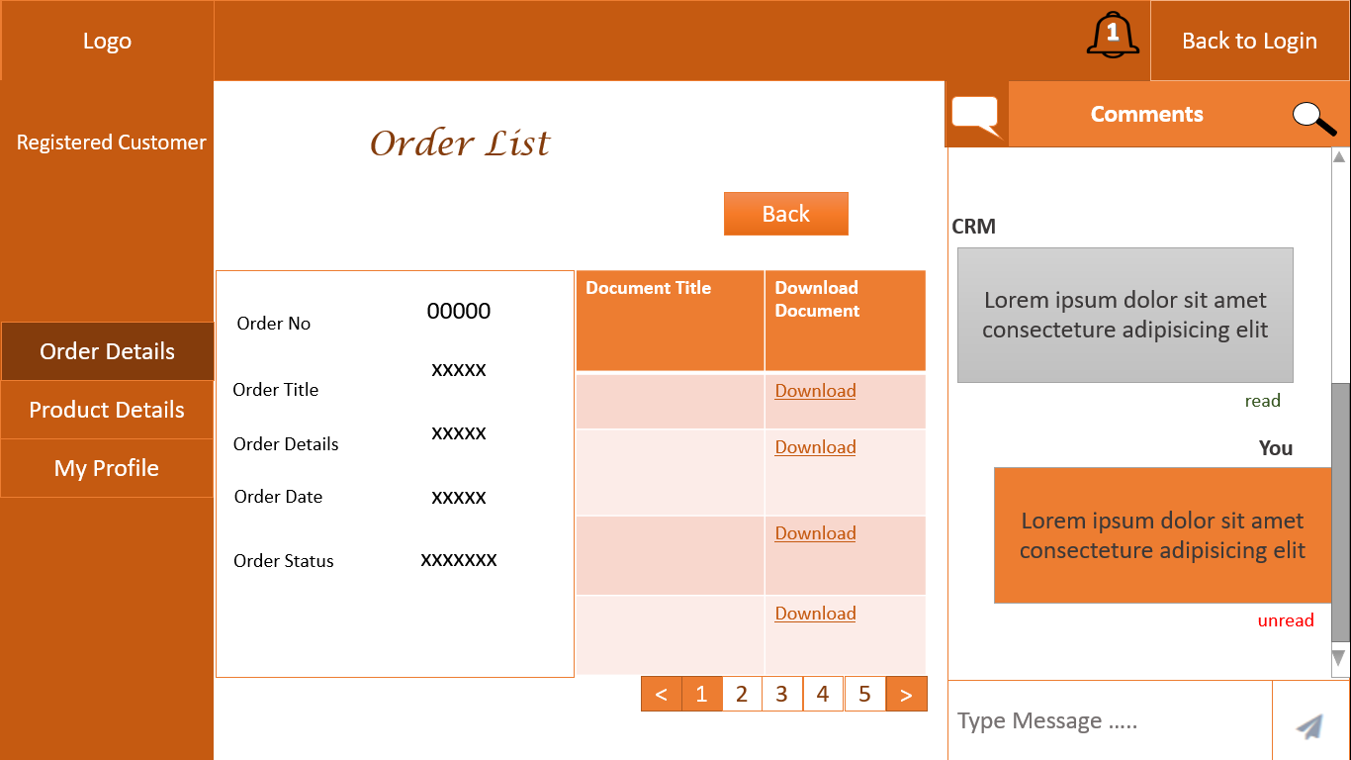

***Figure No :4***

### **CRM User Module**

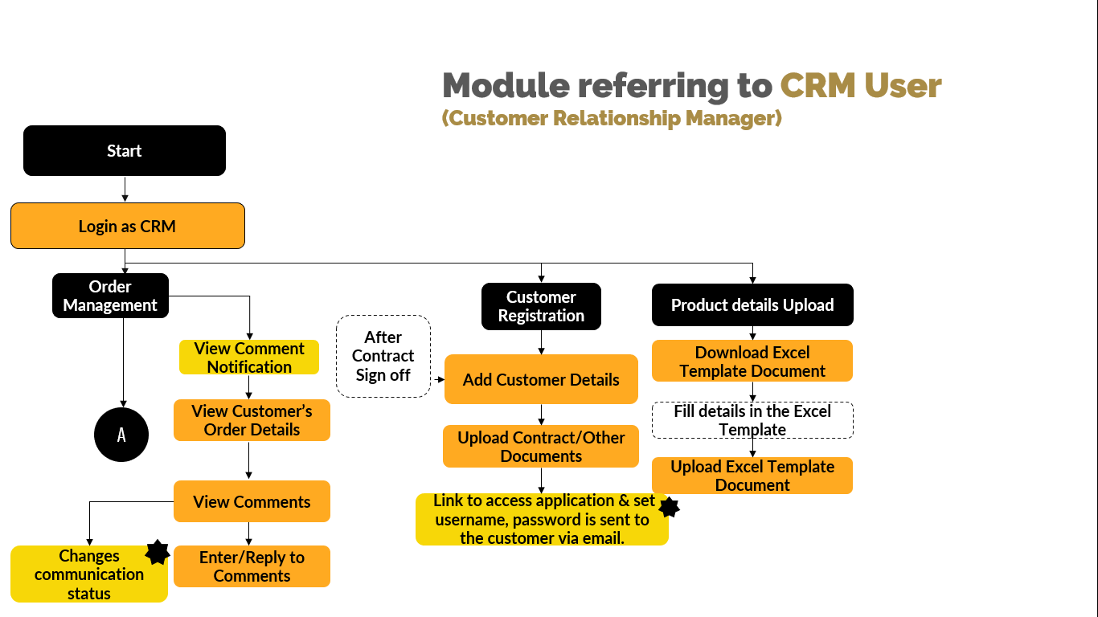

**Workflow No :3.1**

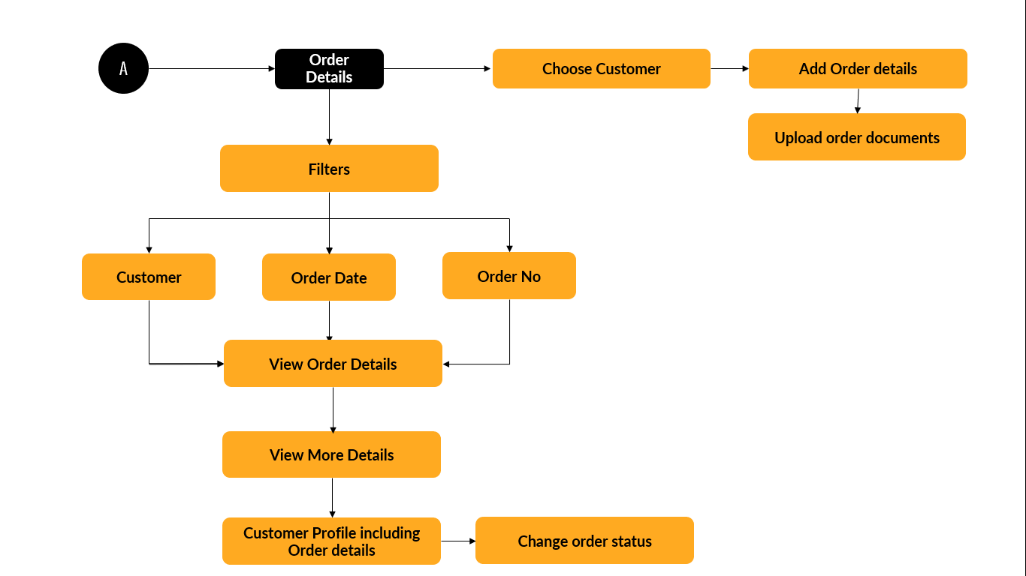

**Workflow No: 3.2**

#### **Login**

CRM User can login to the application by using the login credentials *(username and password*). *(Figure No:1)*

#### **Customer Management**

CRM user has the authority to register the “Guest Customer” to the application when the “Guest Customer” signs the contract with the client, thus they become a “Registered Customer”. The CRM user can edit/delete the customer details.

Landing Page:

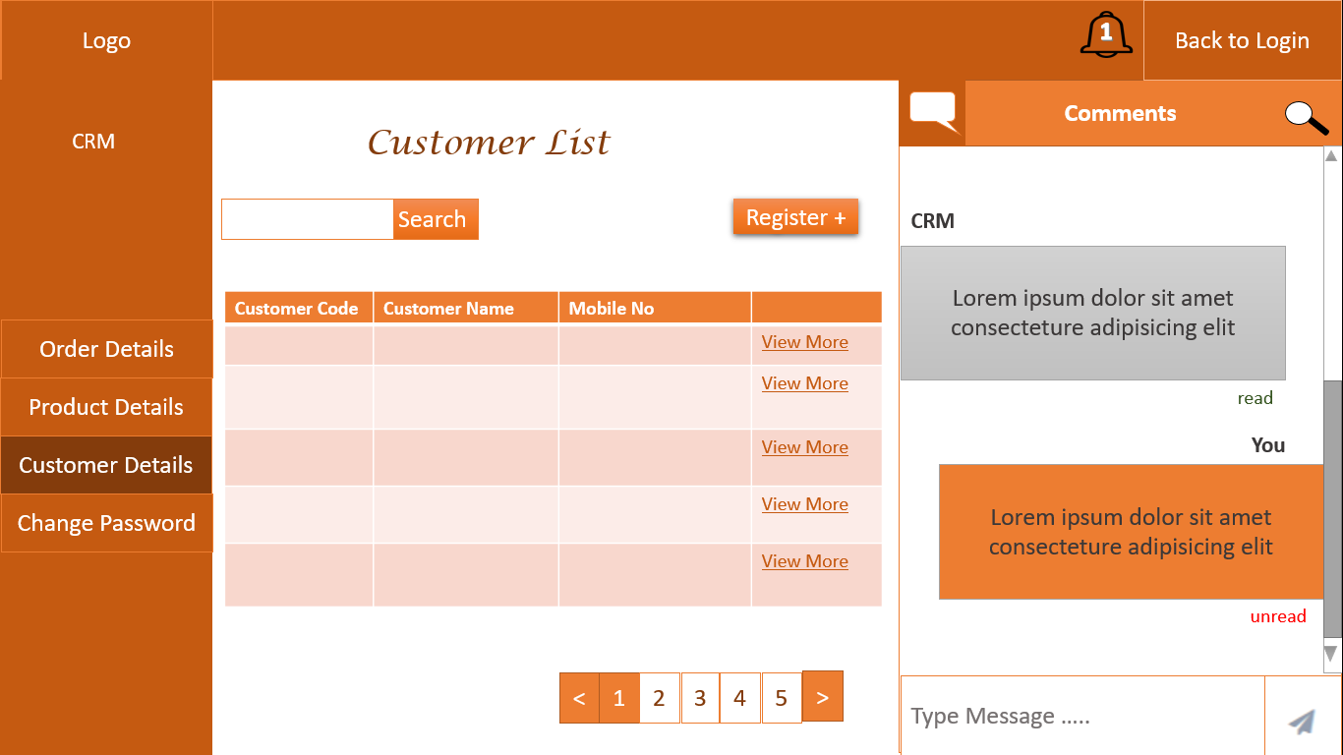

***Figure No: 5***

To register a customer, the CRM user needs to click on “Register” button and enter the following details (*Figure No:5*):

* Customer Code
* Customer Name
* Designation [optional]
* Email Address
* Company Name
* Company Address
* Office Contact No
* Mobile No

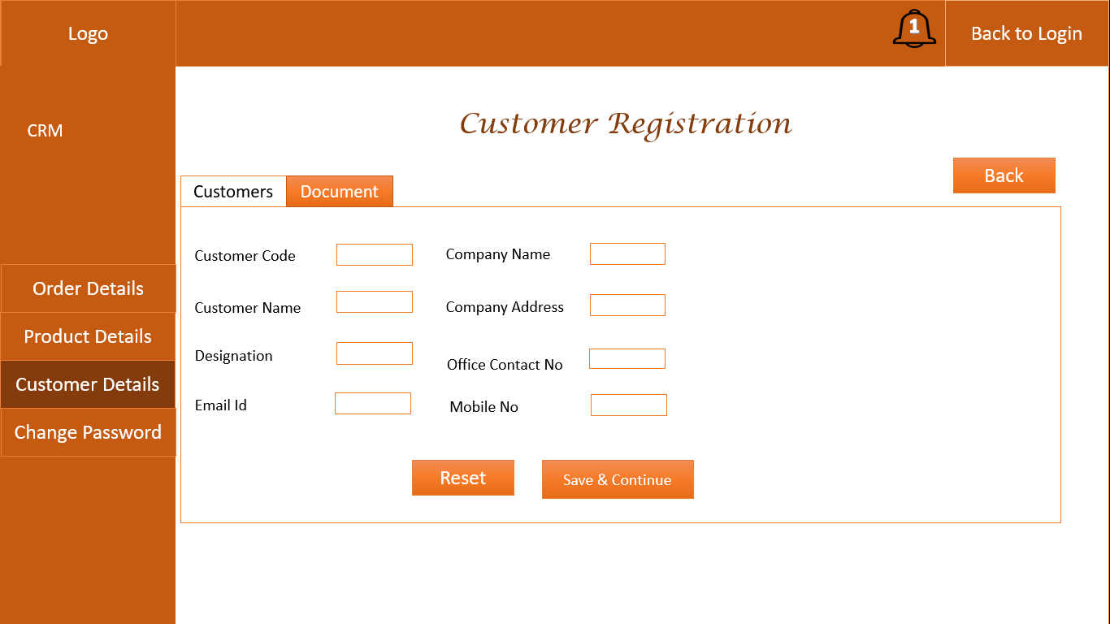

**Figure No:6**

* On clicking the “Save & Continue” button, the customer will be added to the application as a Registered Customer and the screen to upload documents will be displayed (*Figure No:7*).
* Upload Document (Contract/Other): The CRM user will be able to upload documents (Contract/ Other) related to that customer while registering the customer or later. To upload documents, select document type, enter document title/name, upload document file (word, pdf, excel).

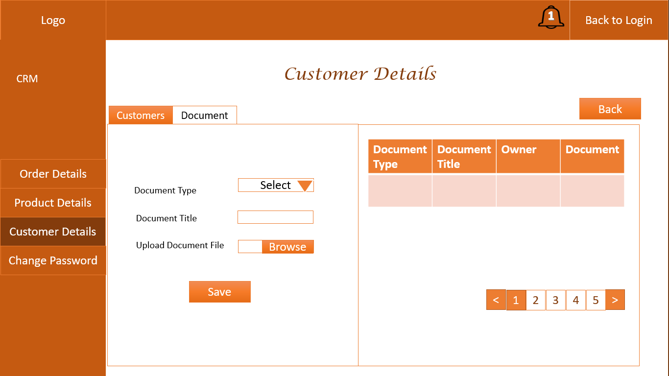

***Figure No :7***

* On completion of registration:
* the registered customer will receive an email which includes link to login to the application where he can set his username and password.
* The Registered Customers details will be displayed on the customer details page as shown in Figure No: 5.

*Note:*

*Uploaded documents can be viewed and downloaded by the respective registered user/customer, Admin and other CRM users. Then they will be able to view the document owner details (person who uploaded the document).*

#### **Order Management**

CRM user has the provision to manage the customer’s order by entering new orders against the customers, updating the order status and cancelling the orders.

Landing Page:

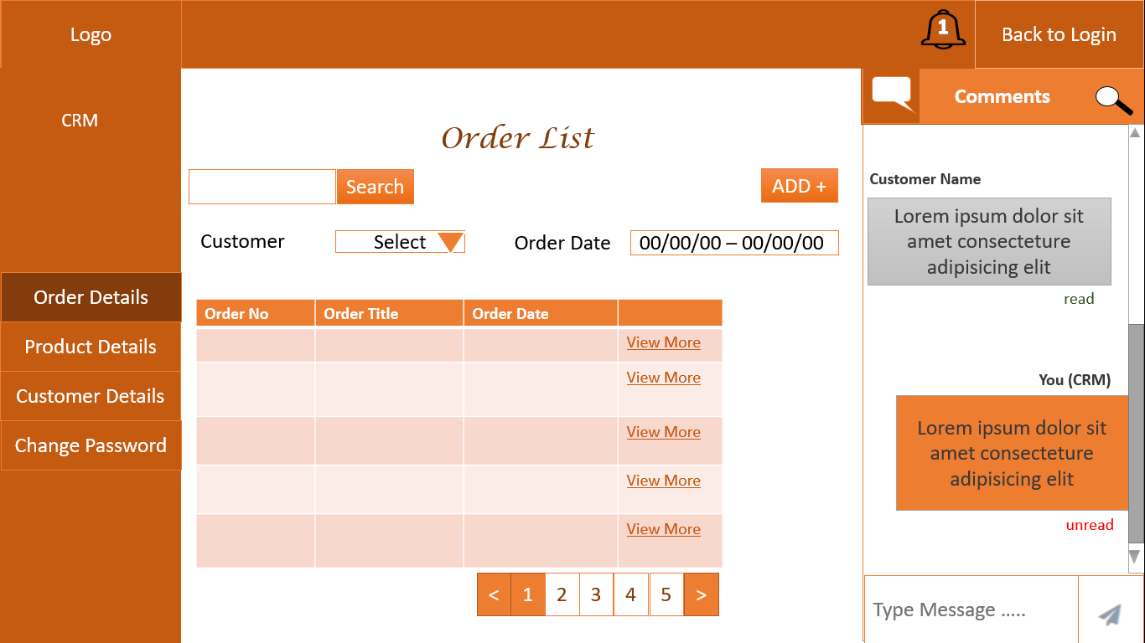

***Figure No :8***

To add an order, the CRM user needs to click on “ADD” button and enter the following details (*Figure No:8*):

* Order Title
* Order Details/Description
* Order Date
* Order Status (e.g.: Order placed, Shipped, delivered).

*Note:*

*Order No. will be generated by the system.*

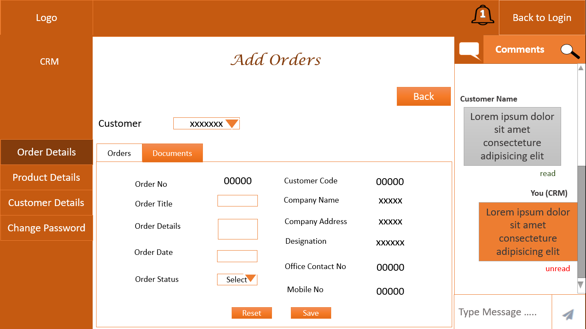

***Figure No :9***

* On clicking the “Save” button, the order will be added to the application and the screen to upload order documents will be displayed (*Figure No:10*).
* Upload Document: The CRM user will be able to upload order documents related to that order while adding its details or later. To upload documents, CRM user needs to enter Document Title/name, enter Description and then upload document file (word, pdf, excel).

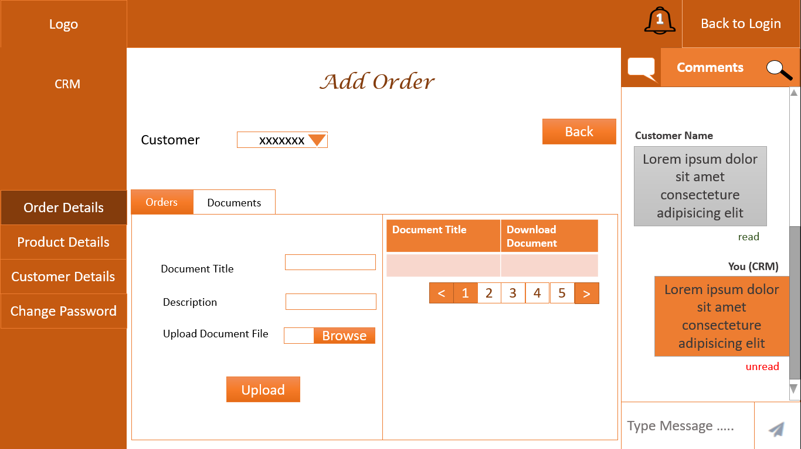

***Figure No :10***

* On completion of entering order details, the details will be displayed in the order list page as shown in Figure No: 8.
* The Order list includes:
* Order No
* Order Title
* Order Date
* To view more details of the order, the CRM user needs to click “View more” button *(Figure No: 8)*.
* On clicking, the CRM user will be able to view Order No, Order Title, Order Date, Order details/Description, Order Status, related customer details and Added documents *(Figure No:11, 12).*

*Note:*

*Uploaded documents can be viewed and downloaded by the respective registered user/customer, Admin and other CRM users.*

* This user has an option:
* To filter the order based on Order No., Order Date (*Date Range*) and Customer Name. (*Figure No:8*)
* To view and download the documents uploaded by the admin/CRM users.
* To initiate chat with the “Registered Customer “.

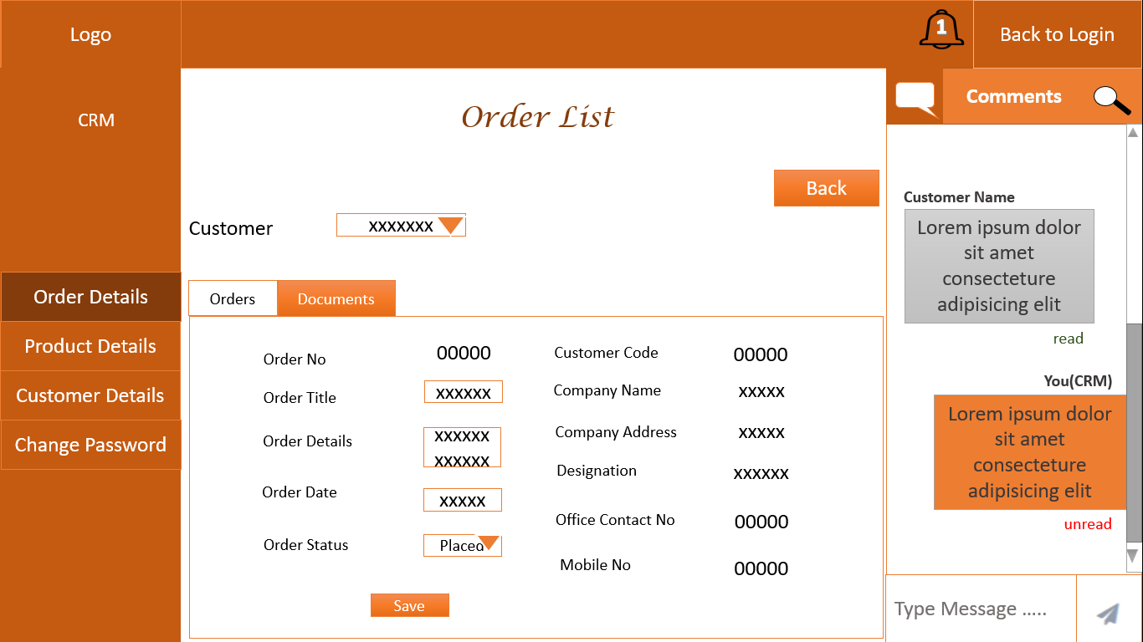

***Figure No :11***

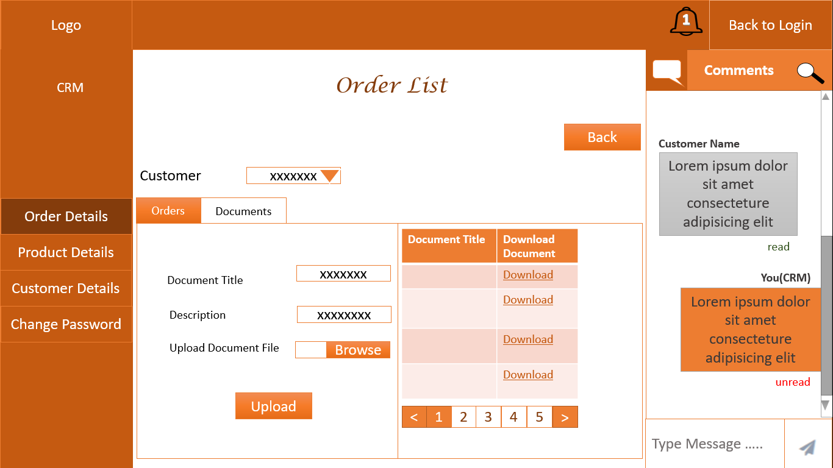

***Figure No :12***

#### **Product Details Upload**

The CRM user has the provision to upload excel document consisting of day to day stock and price of the products into the application.

First the CRM user needs to download the excel template by clicking “Download Excel Template” button as shown in the “Product List” page *(Figure No:13)* and fill the details, which are mentioned in *(Figure No:14)*. After filling the details, upload this document back into the application. These product details are viewed by the customers on a daily basis.

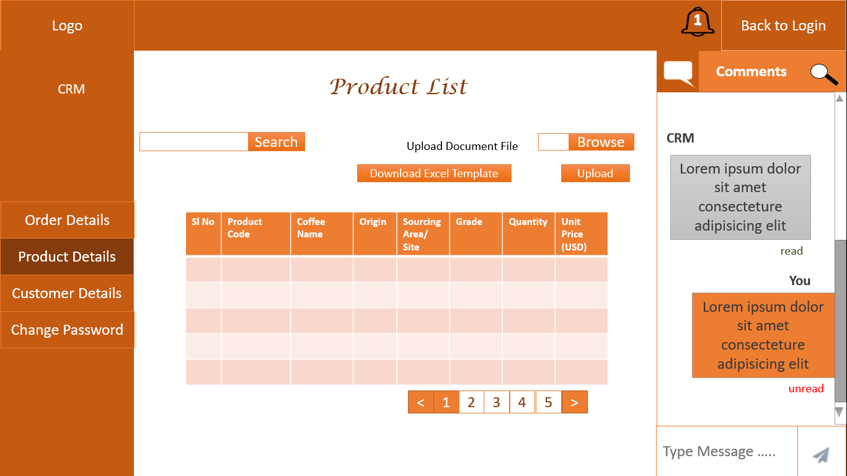

***Figure No:13***

**The figure given below is an example of a filled excel template that needs to be uploaded in the application**

|  |  |  |  |  |  |  |  |
| --- | --- | --- | --- | --- | --- | --- | --- |
| KERCHANSHE PRODUCT DETAILS | | | | | | | |
| Sl no | Product code | Coffee Name | Origin | Sourcing Area / Site | Grade | Quantity | (USD) Unit price |
| 1 | PRC001 | Arabica | Guji | Adola | Grade 1 | 2204.62 | 2.832 |
| 2 | PRC002 | Java | Sidamo | AnaSora | Grade 2 | 1500.62 | 2.009 |
| 3 | PRC003 | Blue Mountain | Sidamo | Hambella | Grade 2 | 2500.45 | 2.532 |
| 4 | PRC004 | Ethiopian Harar | Guji | Andola | Grade 3 | 2204.62 | 3.003 |
| 5 | PRC005 | Bourbon | Sidamo | Hambella | Grade 1 | 2204.62 | 2.832 |

***Figure No :14***

#### **Comment Box**

CRM users can communicate with the Registered Customers by sending comments or messages to them.

CRM user will receive a notification in the application like shown in Figure No 15-a, when the registered customers inputs any comment in the comment box *(Figure No 15-b).*

On receiving notification, the CRM user can click the notification and view the comment in the comment box along with the customer’s order details page. Once the CRM user views the comment, the status of the comment will automatically change to “read” and the notification will disappear from the notification icon on the top bar.

 

***FigNo:15-a FigNo:15-b***

***Figure No :15***

*Note:*

* *There are only two predefined status for communication – “read” and “unread”.*
* *When the CRM user performs any activity related to the Registered customer, that particular customer will receive activity details as comments in his “comment box”.*

### **Admin User Module**

Admin Module has all the features of the CRM user along with an additional functionality which is CRM User Management. Refer: 2.1.3.1 to 2.1.3.5 for details of the available features.

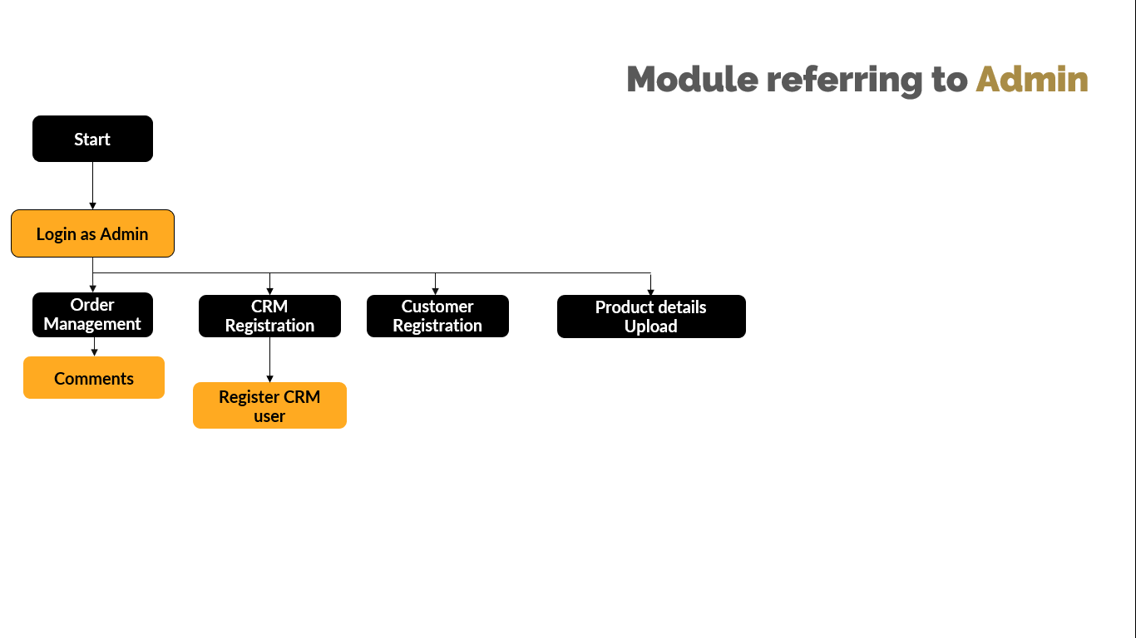

**Workflow No :4**

#### **Login**

Admin can login to the application by using the login credentials *(username and password).*

#### **CRM User Management**

Admin has the authority to create CRM users by providing the following etails *(Figure No:16)*:

* CRM Code
* CRM Name
* Password
* Confirm Password
* Activate /Deactivate

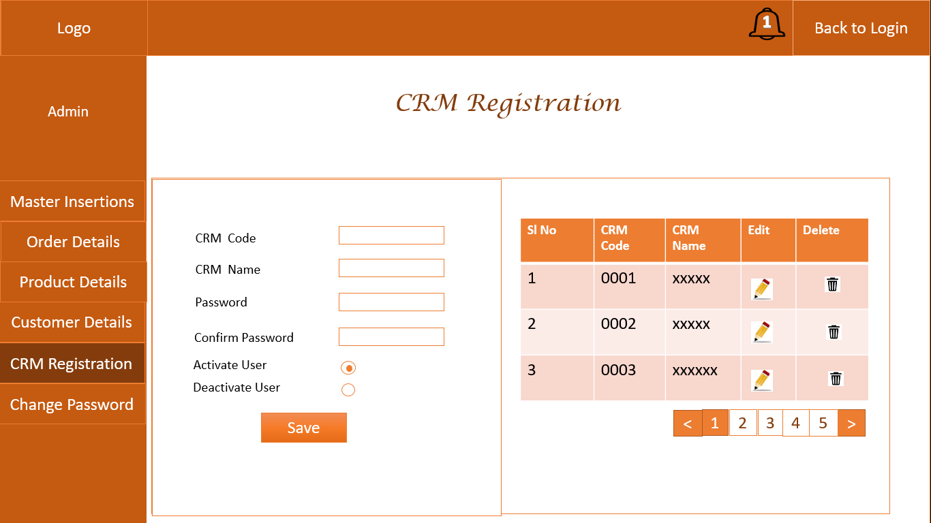

***Figure No: 16***

**WITH OUR**

**SINCERE THANKS.**

CONFIDENTIALITY NOTICE:

This Proposal is conﬁdential and contains proprietary information and intellectual property of Verbanet Technologies LLC. Neither this proposal nor any of the information contained herein may be reproduced or disclosed under any circumstances without the express written permission of Verbanet Technologies L.L.C (hereby known under its brand name of Verbat in the United Arab Emirates). 2019. All Rights Reserved.