**Basic Hardware Setup**

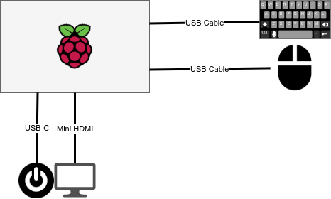

The raspberry Pi Device should be connected to a mouse and keyboard using USB cables. Make sure to connect the cables to identical USB slots (one on top of the other). On the other side of the casing you can attache the mini HDMI cable for the LCD monitor (Note that there are 2 hdmi slots. Connect the cable to the leftmost slot). The power adapter can be connected to a USB-C slot next to the HDMI cable slot .

**Raspberry Boot up (Normal)**

When you power on the Raspberry, it will boot directly to the PWA application. The screen may display a blank screen (might even be a 404) for a few seconds before the actual images are loaded. Most keys on the keyboard will be non-functional at this point.

**To Disable the PWA Application**

Press ALT-F4 to disable the PWA app and exit to main screen. This is a minimalistic screen.

Right click on the foilder and open terminal. (If a folder is not present, right click to create folder)

In the terminal type “**stopkiosk.sh**”.

To reboot the machine, type “**reboot**” at the prompt. The machine will now reboot to the Raspbian OS

**Connecting to the network**

**The Easy Way**

When the OS reboots, you will enter the normal operating mode of the machine. On the top right you will see the wireless activity

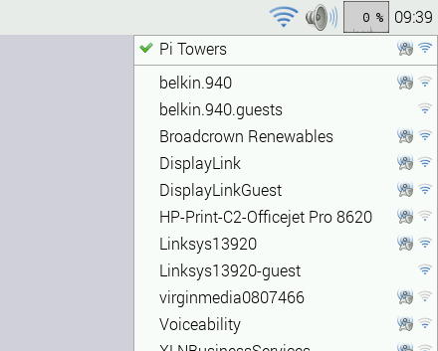

You may select the apprpriate SSID and connect with a known password.

As indicated before this is the easy way out. This method of access will give you complete control of the machine. Ideally we want to ensure that the system plays nothing but the PWA application. To ensure this

1. click on the terminal icon (Black rectangle) next to the raspberry icon (top left). On the screen type “sudo raspi-config”

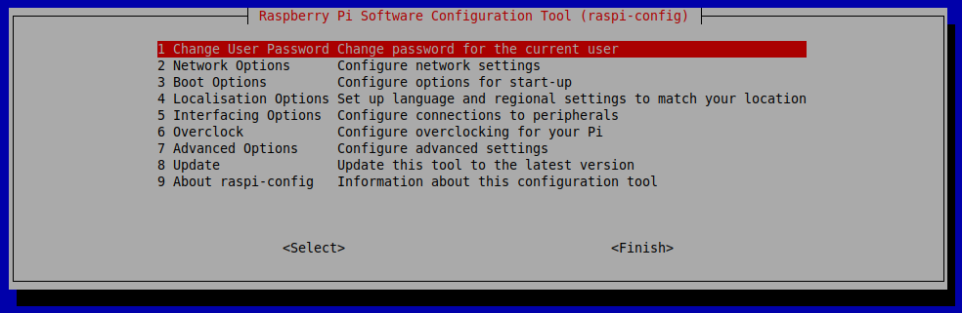

On the screen select “**boot options**” and “**boot to client**”

Reboot the computer. You will now be logged into the console.

**Console Boot**

When Raspberry boots into the console, It will first check for the availability of wireless networks. If it finds that a network has been already configured, it will boot into the PWA application or the desktop.

If not, It will pause before it diplays all the available networks it finds. At the prompt you will enter the SSID and password. Unfortunately there is no margin for error at this point. Both the SSIS and pass word is case sensitive. The application will reboot once the configuration is completed.

**Boot Failures**

Ever so often the OS will fail to identify the available network. It may or may not display the SSID. Very likely it will ask you for a new SSID and Password.

If you are fairly sure that the UN & PW have been enetered correctly with a strong network presence. Just reboot the machine (Cntrl-Alt-Del) or “**Cntrl-C**” and type “**startx**”

**Misc.**

**Kiosk Mode**: At the command prompt type “**startkiosk.sh**” and reboot the machine. This will put the machine in the kiosk mode

**Quit Kiosk:** At the command prompt tytpe “**stopkiosk.sh**”. Reboot the machine.

**Reset wireless**: Type “**resetwireless.sh**” at the command prompt. Provide the original SSID and password (exactly – case sensititve). If machine has never been configured for wireles... running this does nothing.

**Configure wireless**: This script does not have to be typed. This will automatically run the computer boots up and you just have to follow the onscreen directions.

When the device is delivered to client, make sure that it is configured to boot to desktop using the **raspi-config** command