**Scope**

Client has requested a quote to create a hosting and data migration soltion with an option for displaying the data hosted using a custom web application.

The data is expected to be hosted either in Saudi Arabia with a suitable cloud solution or on premises. Verbat has identified a company called STS located in Saudi Arabia to provide cloud based solutions to host and migrate the data. Verbat shall take responsibility for migrating the data from the client location to SQL server on the Cloud server as well as develop the web based reporting solution.

Solution Strategy

The solution consists of 3 moving parts

1. Cleint provides a sanitized and denormalized data located on their premises

2. Verbat shall implement a strategy to migrate the data to the cloud provider database

3. Verbat shall develop a web based application that contains upto 12 reporting templates / reports

**Hosting Charges**

The charges below are indicative. The features are typical for cloud solution providers. However the cloud vendor could just be selling a box that houses SQL server. In which case, none of this applies

|  |  |  |  |
| --- | --- | --- | --- |
| **Description** | **Quantity** | **Unit Price** | **Total** |
| Data inbound charges | 1 TB |  |  |
| Data outbound charges | 1 TB |  |  |
| Data at rest charge | 1 TB |  |  |
| SQL Server Licence |  |  |  |
| BYOL Support |  |  |  |
| Memory utilization | 1 TB |  |  |
| CPU utilization | % |  |  |
| Per Core | 1 core |  |  |
| DTU | 1 dtu |  |  |
| Processor grade |  |  |  |
| Storage medium charges |  |  |  |
|  |  |  |  |

**Web based reporting**

|  |  |  |
| --- | --- | --- |
| Description | Hours | Days |
| Business Analysis | 40 | 5 |
| Design | 24 | 3 |
| Project Management | 24 | 3 |
| 8 hrs / report X 12 | 96 | 12 |
| Web application development (Login / Security / logging / Search / Filtering / Ordering / export to pdf & excel) | 48 | 8 |
| QA | 32 | 4 |

**Data Migration**

|  |  |  |
| --- | --- | --- |
| Description | Hours | Days |
| Basic data sanitatizing | 12 | 1.5 |
| Data migration scripts / table | 30 mins |  |
| Installation of SQL server on target | 8 | 1 |
| Prepare for migration (configure database, Tune DB for reporting,  create Schedules, triggers etc) | 12 | 1.5 |
| QA | 8 | 1 |
| Deployment | 8 | 1 |

**Architecture (Based on initial understanding)**

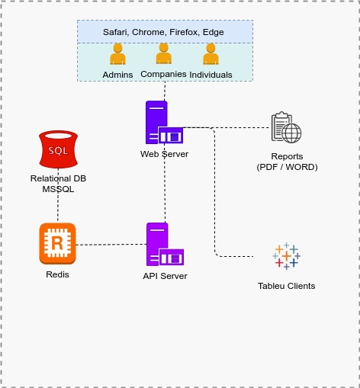

**Assumptions**

1. It is auusumed that the cloud provider has requisiste infrastructure or capabilities to support data migration barring which the data would have to be migrated manually

2. Client shall provide a sanitized and denormailized data for report consumption

3. The provided estimate covers the development of 12 reports