# **IOS & Android Front End App**

**Select City Page**

1. The first time he opens the app, we’ll ask to choose a city and based on it we will show brands that deliver to his city. ( Each brand will choose cities to deliver to from Admin Panel ) After he choose we will take him to home page.

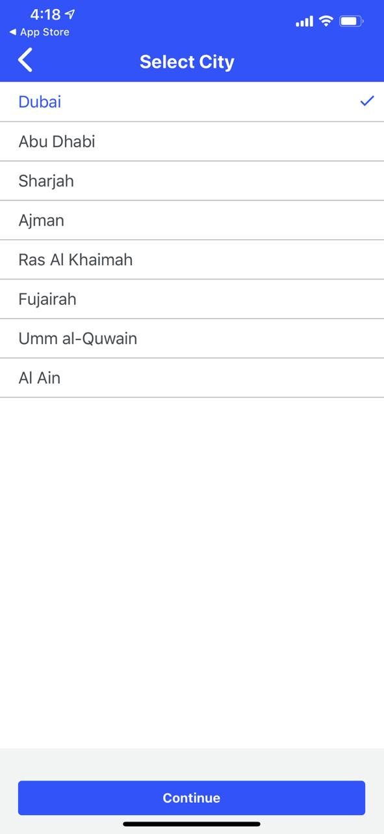

**Home Page**

1. 2 Categories in home page ( like Waterwa ), if he clicked on second category the shops will change to what’s in the second category ( Shops attached to category from Admin Panel )
2. Slide banner for ads to take the clicker to a shop page, we insert the photo from Admin panel
3. Users can see if the shop has discounts ( Icon )
4. Users can see all the shops in home page, if I click on the shop Ill visit the shop page

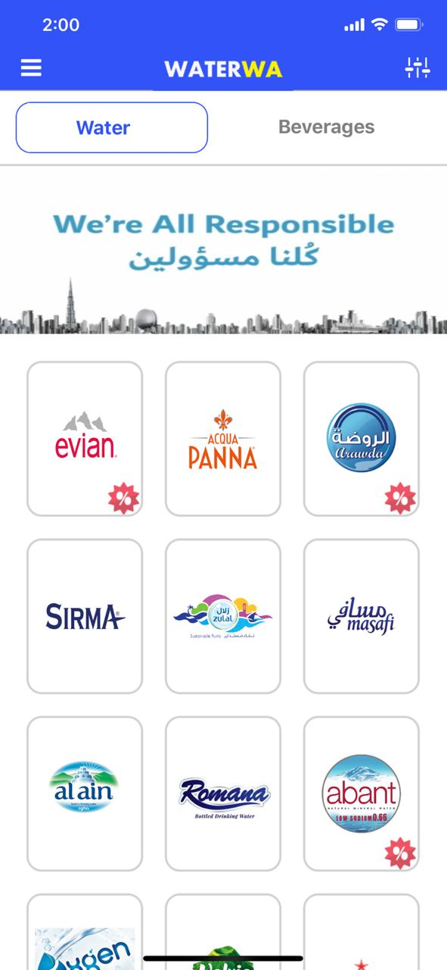

**Evian Shop Page**

1. A an image banner at the shop store ( Optional to add from Admin Panel )
2. Shop category Filter ( Optional to add from Admin Panel )
3. Seeing product data such as Name, Description Price
4. Once I add products a bottom banner will pop up showing store details such as Minimum Order, How many days to deliver, delivery price ( Data for each shop be added from Admin Panel ) and also the total price
5. Once I click on Place Order I will go to register page

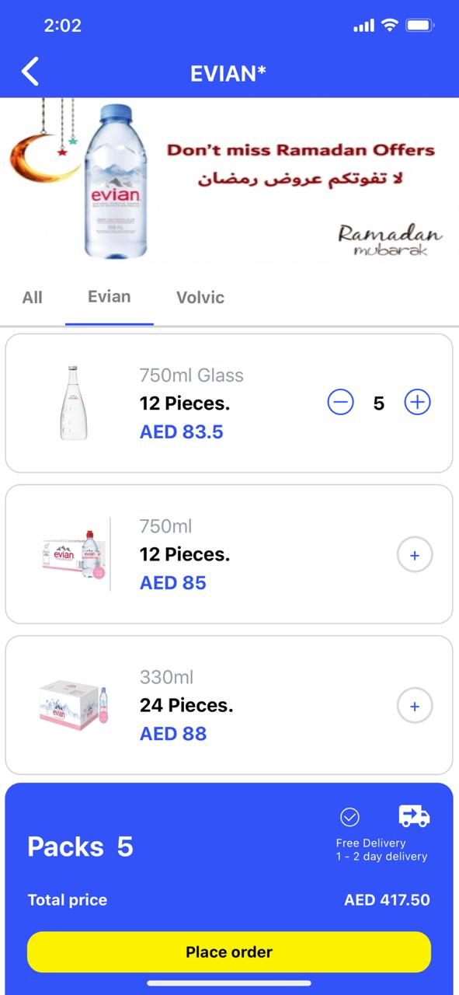

**Register Page**

1. User will put his data ( Name, Email, password, phone number ) in text field on 2 different pages
2. User will put his address, search for area, and he can save multiple address & Delete addresses

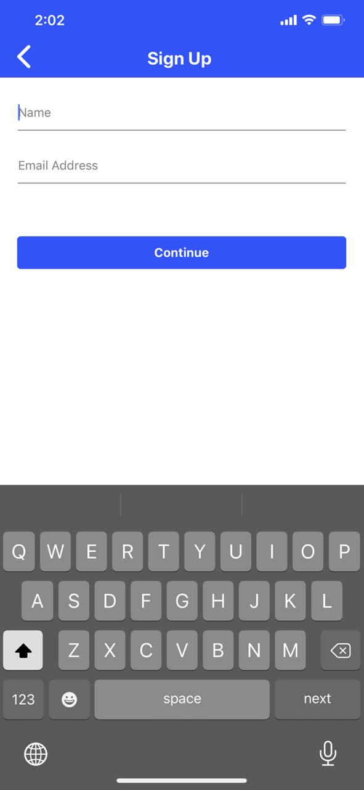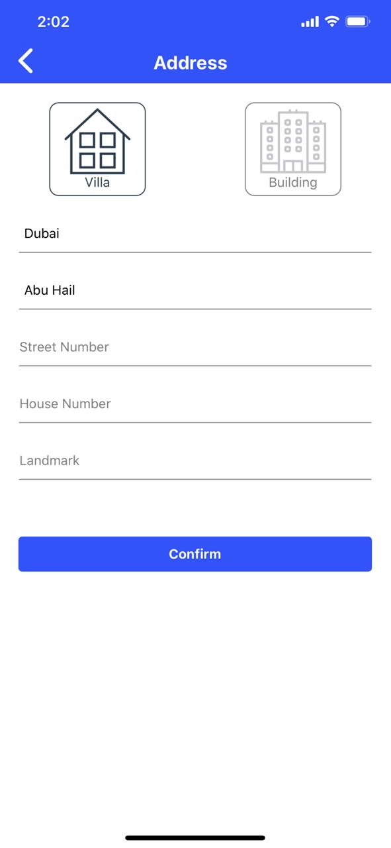

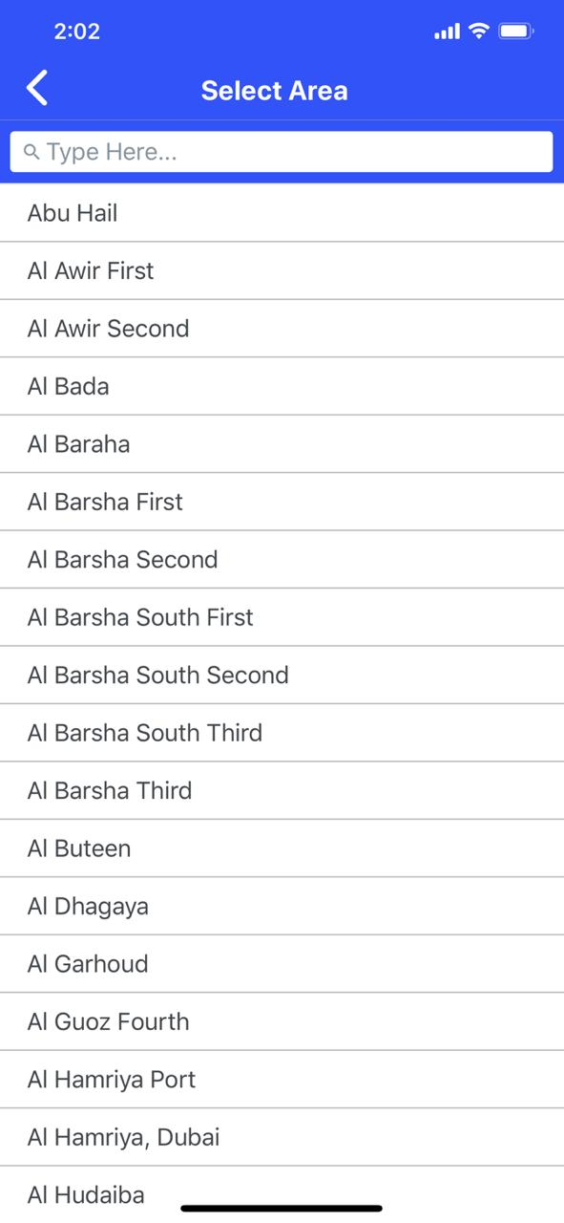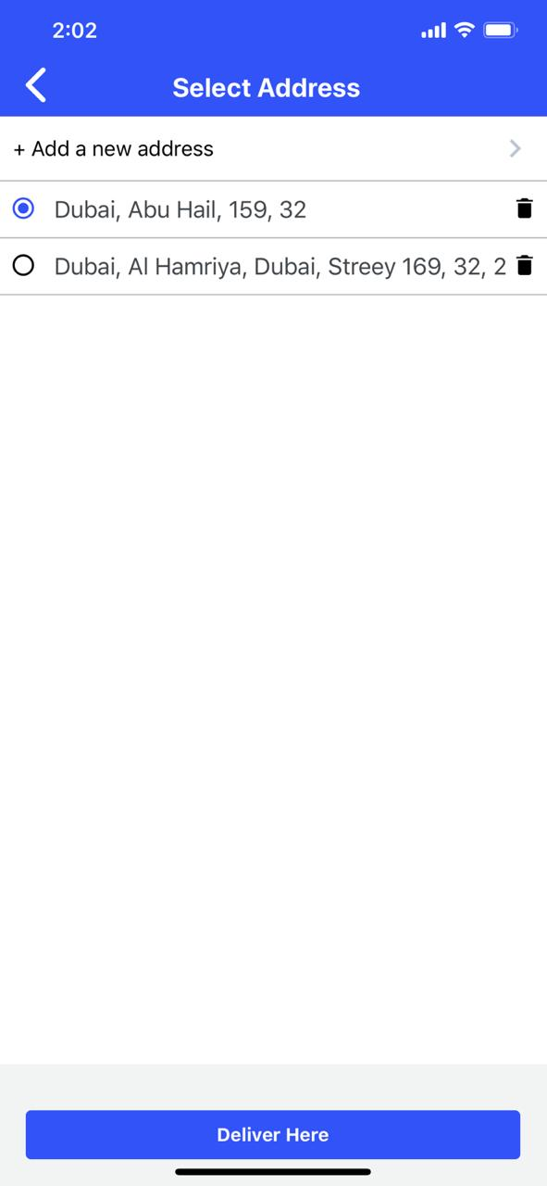

**Check out Page**

1. User will see his details ( Name, number, address ) and he can edit it
2. He can choose delivery time
3. He will see what he ordered and brand name
4. He can choose to pay by card Payment gateway or COD ( Chosen in Admin Panel )
5. He can apply coupon code ( Chosen in Admin Panel )
6. He will see the total price
7. He will be able to place order
8. He can cancel the order with a button
9. After placing the order it will send the order to Admin App & Send an email to the brand, each brand will have an email ( Added from Admin Panel )

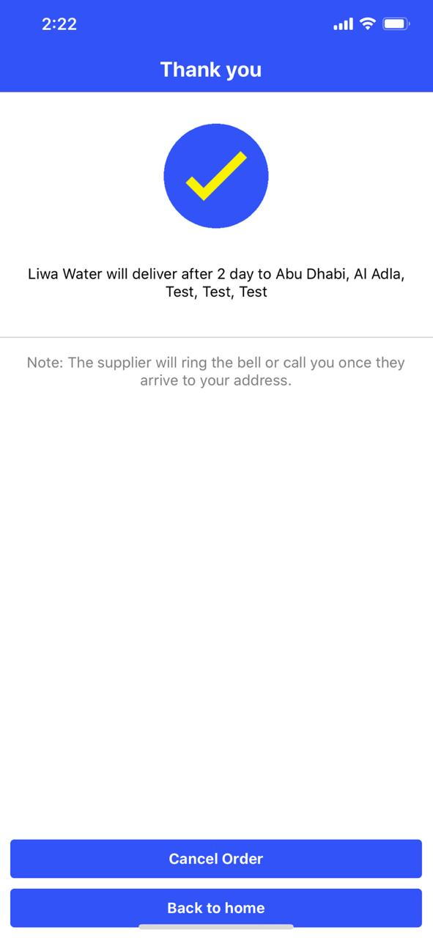

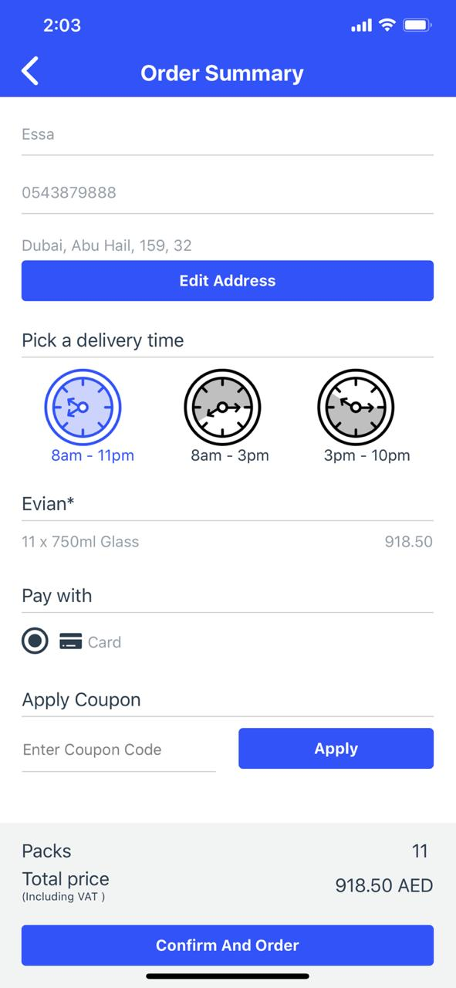

**Home Page Slider**

1. My account page where I can change my email & password
2. My Orders page where I can see all my orders, view the orders, and I can cancel order or Re-Order the same order with1 Click
3. My address book page where I can manage all my addresses, delete or add new address
4. Change my city to a different city and see the brands that deliver to my city
5. Change Language from English to Arabic, by clicking it’ll load the app and change language
6. Customer can contact us by WhatsApp, by clicking it’ll open WhatsApp on our number
7. Help center where he can email us & read terms & Privacy policy

**Home page Slider**

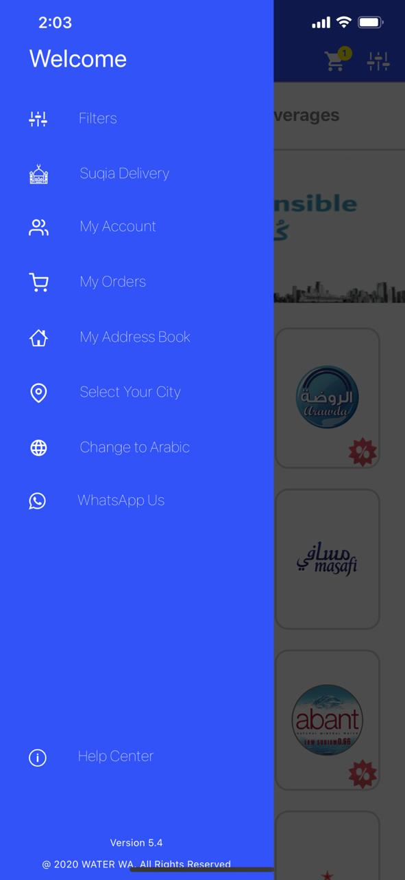

**My account & Orders page**

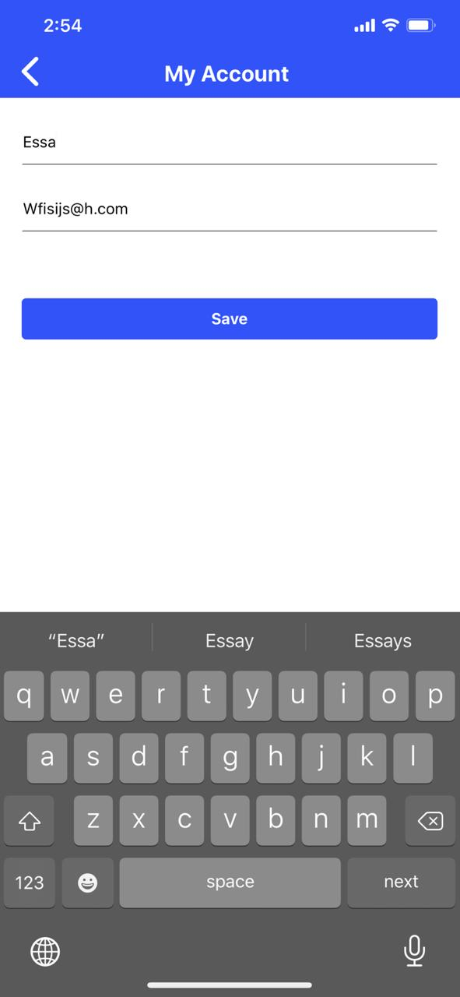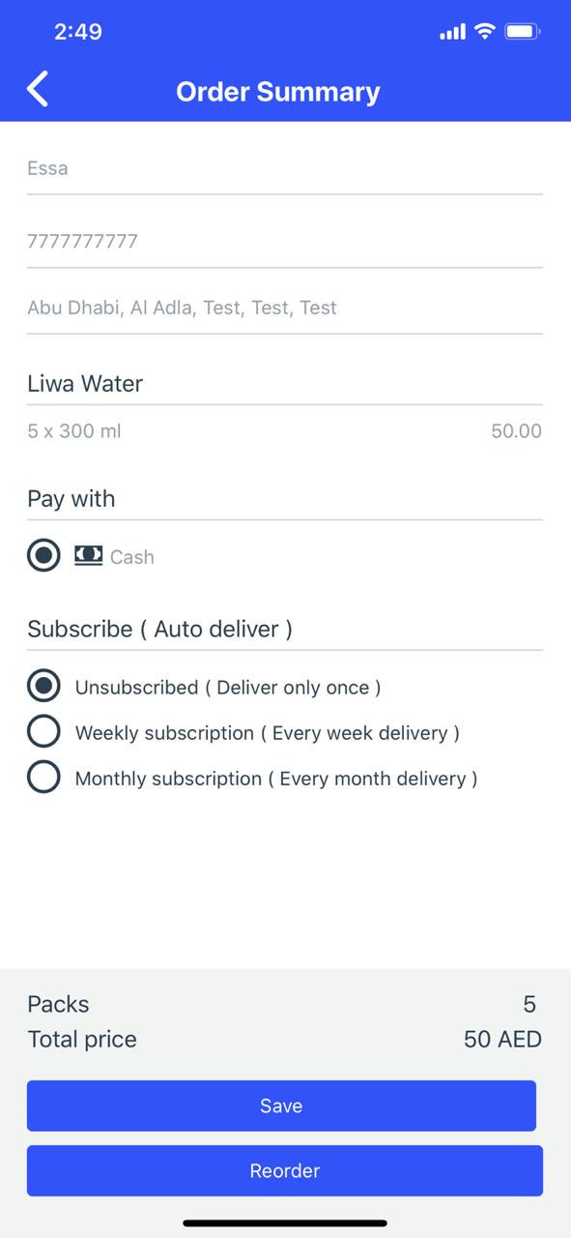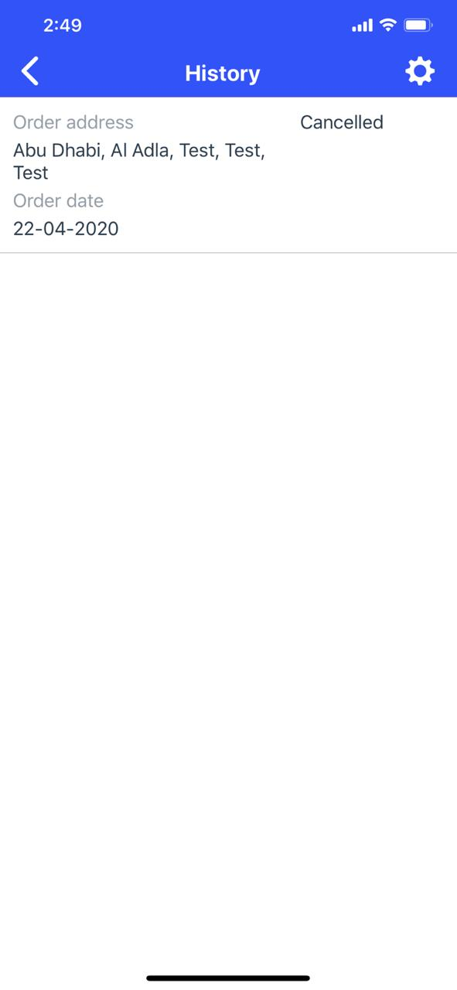

**My address book page & Change city page & Help center**

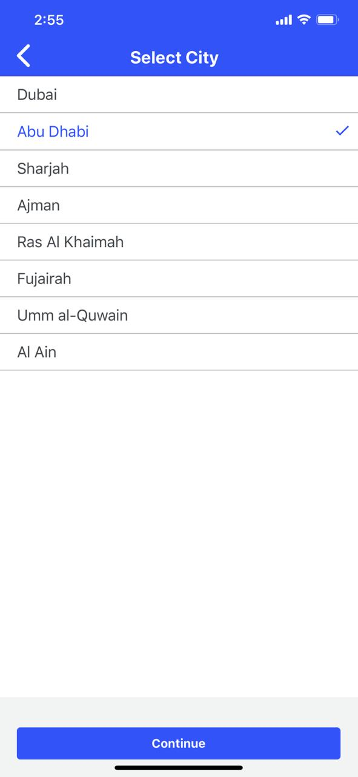 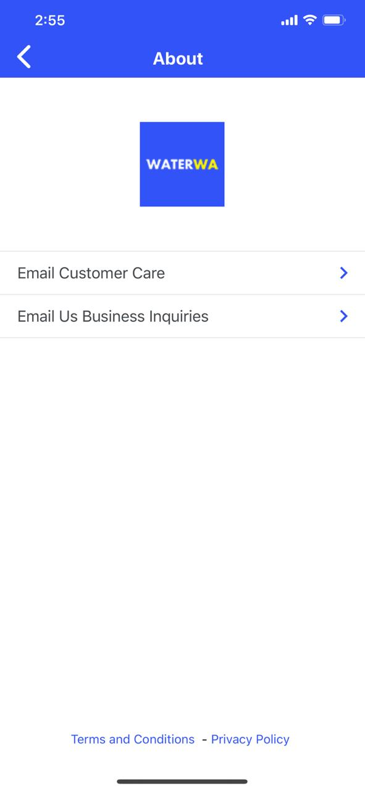

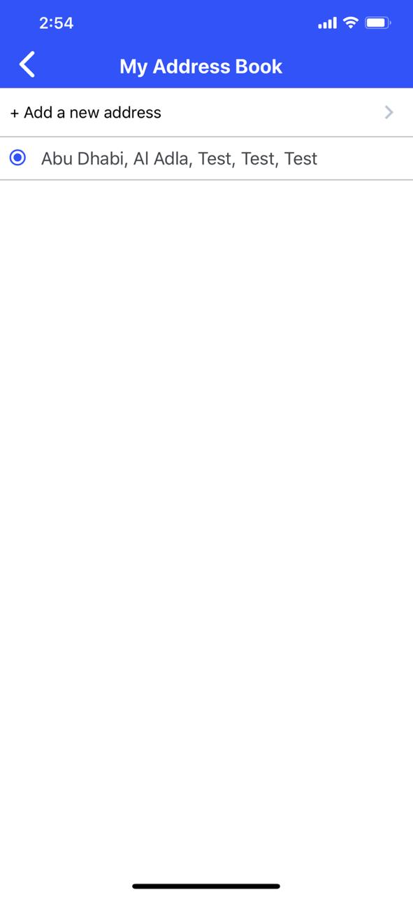

# **IOS Admin App**

**Admin Home Page**

1. There is two tabs. Orders tab showing all the orders with Address, Name, contact number, and total price.
2. Completed tab is showing all the completed orders, once I open the order to see the order details I can click on Complete button to move from Orders tab to Completed tab
3. I can also click on the name and be able to call the customer immediately if I had questions

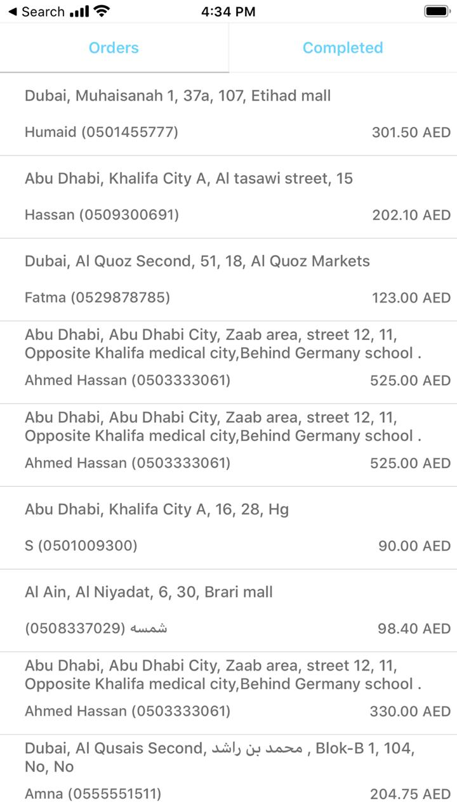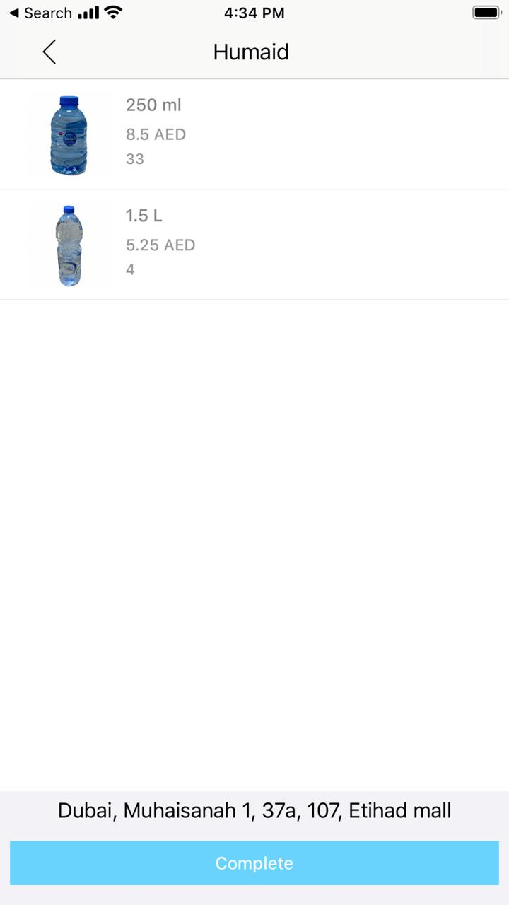

# **Admin Panel Website**

**I need a website link like Majstore/AdminPanel.com for me only to use where there will be**

1. **Login page where I have to put the user name & Password which you’ll create for me, so other people won’t be able to log in except me as I won’t share the user and pass**
2. **Add category tab: I will be able to add a category for tabs Like Water / Beverages ( In Arabic / English )**
3. **Add Brands tab: I will be able to add brands with brand name ( In Arabic / English ), in which category they belong ( Water or Beverage or both ) Brand Email, Brand Logo, Brand Banner, Minimium Order, Number of days of delivery, select the cities they deliver too, Payment type if COD or Credit Card or Both, and I can rank brands if I put number 1 it will be the number 1 shop ( prioritizing )**
4. **Add Filter tab: I will be able to add filter subcategories for brands, each brand will have their filter such as Chocolate, Coffee, etc..**
5. **Add Products tab: I will be able to add products with product name (In Arabic / English), attach it to the brand, attach it to brand filter, product price, add discounted price if they have discount, and add description to the product.**
6. **Add Banner: Add banner to show in home page and attach it to a shop, if user clicked on the banner he’ll go to that shop**
7. **Notification center: I can send text and all users see the text as notification**
8. **I can add coupons name and select if it can be used once only or once per user , and put an expiry date, and how much amount it discounts**
9. **I can see all the orders ( Pending & Completed )**
10. **I can export orders in an excel sheet, select a date like 2-2-2020 to 4-4-2020 and it’ll show me in an excel sheet all the orders**

* **AWS Hosting**
* **MySQL DataBase**
* **PHP Web services**